

Postgraduate/Distance Learning
Assignment coversheet & feedback form

THIS SHEET MUST BE THE FIRST PAGE OF THE ASSIGNMENT YOU ARE SUBMITTING (DO NOT SEND AS A SEPARATE FILE)

For completion by the student:
Student Name: Anne Louise Day-Jones

Student University Email: 1704596@student.uwtsd.ac.uk
Module code: (AHAN7003)  Module title: HISTORY OF ASTROLOGY | Student ID number: 1704596 |  |  | Educational support needs:  No

Assignment title: Discuss the role of astrology in the European medieval world using at least two primary sources from either literature or art.
.

Assignment due date: 4 June, 2018
This assignment is for the 1st 2nd 3rd X 4th 5th 6th module of the degree
I confirm that this is my original work and that I have adhered to the University policy on plagiarism.
Signed ……………………………………………………………
Email submission:if you are submitting this form via email, please tick this box
(as a substitute for your signature) to confirm that you agree to the above declaration.
Assignment Mark
1st Marker’s Provisional mark
2nd Marker’s/Moderator’s provisional mark
External Examiner’s mark (if relevant)
Final Mark

NB. All marks are provisional until confirmed by the Final Examination Board.

For completion by Marker 1 :
Comments:

Marker’s signature: |  |  | Date:
For completion by Marker 2/Moderator:

Comments:

Marker’s Signature: |  | Date:
External Examiner’s comments (if relevant)

External Examiner’s Signature: |  | Date:

Discuss the role of astrology in the European medieval world using at least two primary sources from either literature or art

Word count: 3016

Introduction

Astrology offered the Medieval world, what Campion has called, ‘an overarching organizing principle of quite extraordinary power,’ and Thorndike has stressed the historical role of astrology as ‘science’, stating that ‘ … during the long period of scientific development before Sir Isaac Newton … [the] universal natural law was astrological.’ This essay will discuss the ‘overarching’ and ‘universal’ role of astrology in the European medieval world using two primary sources: The Creation of the World, painted by Giusto de’ Menabuoi (1320-1391) c. 1375 in Padua, Italy, and the Room of the Arts and Planets, painter unknown, c. 1410 in Foligno, Italy. Both these sources are artworks and are used here in light of Gunzburg’s assertion that ‘non-textual documents, such as images, can and should also influence how we understand a period or culture.’

Astrology’s important roles in the Medieval world as determiner and descriptor of character, as a predictor of the future, as well as its central role in magic and medicine, are not spoken to directly in The Creation or the Room of the Arts and Planets – rather these works embody astrology’s primary role as providing a paradigm within which astrological prediction, magic and medicine functioned. After an introduction to the primary sources, this essay will focus on astrology’s role as a map of the cosmos, as a map of time and the neo-Platonic web of sympathies, and finally on its inspirational role.

Introduction to Primary Sources

The translation of works by Ptolemy, Aristotle and Arabic astrologers in the 12th century had what Campion calls ‘revolutionary consequences… on European cosmology – and intellectual thought in general.’ Both Padua, in Northern Italy, and Foligno, 400km to the south, were intellectual centres for learning at the time the artworks were created. Canova states that Padua was ‘one of the most important cultural and scientific centres in Europe’ where ‘new astrological doctrines flourished.’ Equally, the Trinci family held a court, that was, according to Dunlop, ‘a small but important centre of the new antique learning’.

The Creation of the World

The Creation of the World is part of a large fresco cycle in the baptistery of Padua Cathedral. The pictorial program includes Paradise (in the bell of the dome), Scenes from Genesis (of which The Creation forms part) around the upper segment of the vault surrounding Paradise, and The Lives of Jesus and John the Baptist, Miracle of Pentecost and motifs from the Apocalypse. Menabuoi was commissioned to decorate the Baptistery by Fina di Pataro Buzzacarina, wife of the lord of Padua, probably for her tomb, which was situated against the West wall and towards which the Creator in Paradise and the figure of the Virgin Mary are oriented.

The Creation shows the Creator against a golden sphere, surrounded by and perhaps supported by angels; (see Figure 1) his right hand is raised, blessing the newly created cosmos, towards which his left hand gestures, as if offering his creation to the viewer’s gaze. Only God’s head, surrounded by a gold halo, enters the dark blue space beyond. At his feet are a series of concentric circles. The outermost circle is dark blue containing the images of the zodiac, inside of which different colored circles follow depicting the planetary spheres. Below the 7 planetary spheres is a red circle – for the sun – and a blue circle with 8 cloud-like shapes depicting the winds. The innermost circle contains a realistic map of the world, one of the first realistic maps to be used in a Creation scene.

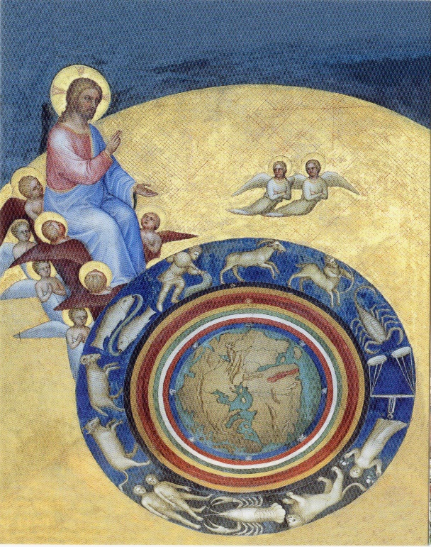

Figure 1. Giusto de’ Menabuoi, (c. 1350), The Creation of the World, fresco. Photograph: Revolvy.

Room of the Arts and Planets

The painted rooms of the Palazzo Trinci are dated to around 1410-1415; the artist is unknown, but may have been Gentile da Fabriano (1370-1427). The Room of the Arts and Planets (a modern name for the room, which may initially have been named the Camera delle Rose) has frescoes on all four walls, depicting the Liberal Arts - personified as women sitting on elaborate thrones – and the zodiacal planetary Gods. The sequence is as follows, left to right on entering through the loggia: Rhetoric, Arithmetic, Astronomy, Philosophy (the identity is lost, but assumed to be Philosophy), Geometry, Music, Dialectic, Grammar (see Figure 4), The Moon, Mars, Mercury, Jupiter, (see Figure 2) Venus, Saturn, and finally the Sun on the other side of the loggia entrance (see Figure 3). Below the figures, in a frieze that runs all around the room, are verses in Latin, Greek and French. Small roundels of varying sizes and positions seems to float next to the planetary gods; in each is a depiction of one of the 7 ages of man (see Figure 5.) Around the outside of this image is a green sphere, followed by a sphere half white, half dark, within which is a golden sun, and finally a blue sphere for the circumference.
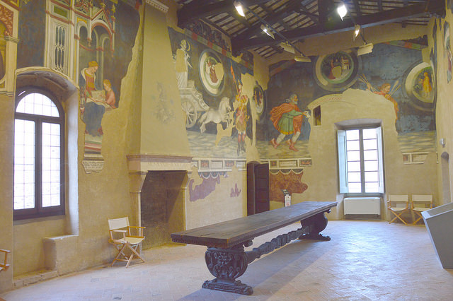

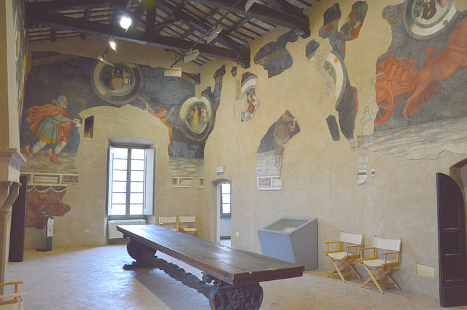
Figure 2 top. Painter unknown, Room of the Arts and Planets, (c.1410), fresco, showing The Moon, Mars, Mercury and Jupiter. Photo: Andrea Carloni.

Figure 3 bottom. Painter unknown, Room of the Arts and Planets, (c.1410), fresco, showing Mercury, and Jupiter, Venus (lost), Saturn and The Sun. Photo: Andrea Carloni.
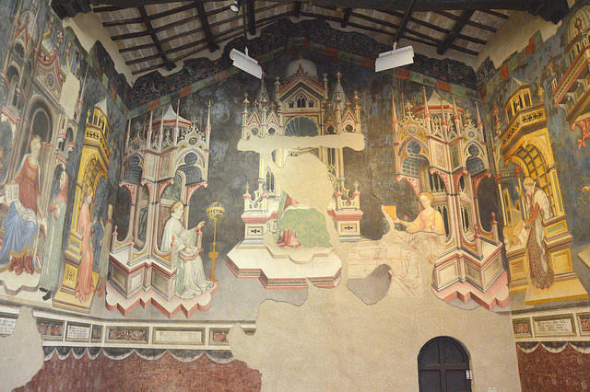
Figure 4. Painter unknown, Room of the Arts and Planets, (c.1410), fresco, showing Astronomy (centre right), Philosophy and Geometry. Photo: Andrea Carloni.

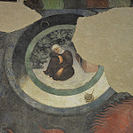

Figure 5. Painter unknown, Decrepitude, Room of the Arts and Planets, (c.1410), fresco. Photo: Andrea Carloni.

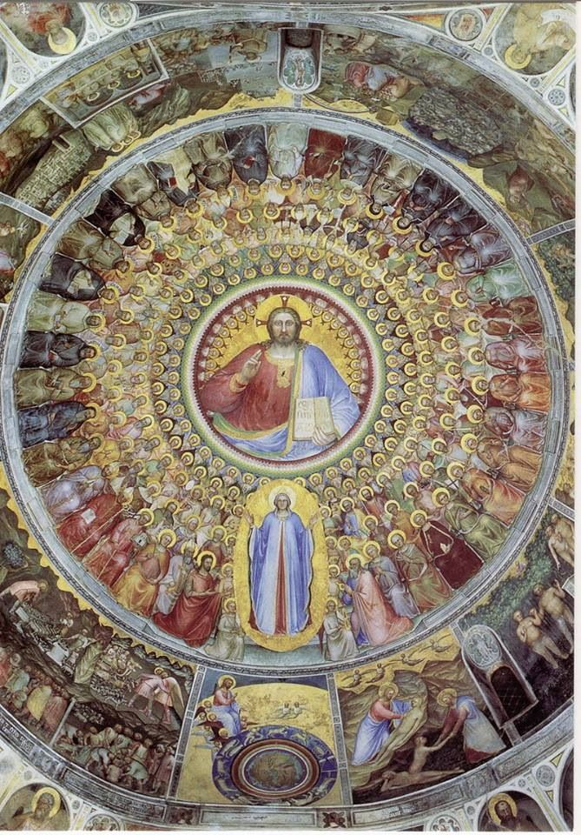

Figure 6. Giusto de’ Menabuoi, (c. 1350), Padua Baptistery ceiling, fresco, showing Paradise, The Virgin and The Creation of the World. Photo: Mauro Magliani.

A Map of the Cosmos

Campion states that astrology ‘flourished’ alongside the Medieval Church, and the prominent circle of the zodiac signs in The Creation seem to bear witness to this ‘flourishing’, even within the Church. As a compositional element the signs of the zodiac are emphasised by colour – they are white, like the angels, in an otherwise richly coloured composition - and by the repetition of the circular form, both within the Creation and in the way the circles and spheres of the Creation echo the circles around Paradise (Figures 1 and 6.) Poeschke suggests that they are simply symbolic of the fixed stars, however it seems clear that they are meant to be the signs of the zodiac, because, as noted by Lipincott, if the spheres beneath God’s feet are read like a natal chart, they mark the date of Creation – that is, the world’s ‘birthday’. It is hard to imagine a more important moment than the moment of Creation; that this moment should be depicted astrologically, speaks both to the all-pervasive nature of astrology at the time, as well as to its role as a symbolic language – the viewer would be expected to make the connection between the Ascendant at the far left of the spheres marking the moment of birth, the sign of Aries, denoting Spring and also, according to Lippincott, the date of the Annunciation (March 25).The image of a natal chart is striking in this composition, because of its association with horoscopic and predictive astrology. The idea that an individual’s character was determined astrologically was problematic for Christian theology as it implied, amongst other things, limitations on free will and had implications on the soul’s salvation or damnation. Indeed, less than 50 years before the decoration of the Baptistery, Pietro d’Abano a teacher instrumental in bringing astrological learning to Padua from Paris, who had ‘enchant[ed] the entire Paduan society with the new doctrines’, was sentenced to death for the heretical implications of those same doctrines.

Nonetheless, the astrological imagery in The Creation is clear; as an illustration of how the cosmos was created, it shows God setting the cosmic spheres in motion - He is both Aristotle’s ‘Prime Mover’ and the God of The Bible, blessing and seeming to offer to the viewer a vision of an ordered, ‘astrological’ universe. As an illustration of what was created, the planetary spheres are shown encircling the earth and exerting their influence on the sub-lunar sphere. This influence was widely accepted in the Medieval mind – the Dominican monk, Magus Albertus (1200-1280) wrote, for example, that ‘The stars…have the power to alter the elements, to change the complexion of men, to affect human mutations, and moreover, to provoke an inclination to action and even to determine the issue of battles’. What was debatable, was how far that influence extended. Notably, in The Creation, God is outside His creation, underlining His omnipotence; God’s head is outside even the sphere of the Empyrean – the principal of planetary influence was not heretical as long as God’s influence was superior and the human soul had choice. Campion states that

‘Medieval cosmology was a combination of the classical and the scriptural… the obvious point of agreement was provided by the logical extension of scriptural teachings that, if God was truly omnipotent, he could do whatever he wanted. If he wanted to set up a universe in which nature was governed by Aristotelian celestial motion and influences, he could do so.’

Thus in The Creation we have just such a ‘combination’; one that includes Biblical understanding and an astrological, ‘scientific’ map of the cosmos, its accuracy perhaps emphasised by the new realistic map of the world drawn from observation from explorations. The astrological map illustrates the very structure of the Cosmos and the forces affecting life on earth, which was, at this moment in what Campion calls astrology’s ’crisis-ridden relationship with conservative Christian cosmology’, momentarily finding a truce in the composition of The Creation, with God both as outside of the astrological cosmos and at its very heart, at the centre of Paradise.

A Map of Time

In the Timaeus, Plato writes that that ‘the sun and moon and five other stars, which are called the planets, were created … in order to distinguish and preserve the numbers of time’ and it is to astrology’s role as an organising principal of Time – as both symbol and tool of Time keeping - to which this discussion will now turn in greater detail, examining the Room of the Arts and Planets.

If The Creation is in part a map of the cosmos, the Room of the Arts and Planets can be seen as a map of the cycles of time. Time is described astrologically, either directly – in the portraits of the planetary gods themselves – or indirectly through a complex system of neo-Platonic sympathies and associations. Here, instead of the frozen moment of Creation, there is an image of time racing and flowing. The vividly colored planetary gods all face the same way the same way and the course of their movement is begun and ended with the charging horse-drawn chariots of the Sun and Moon.

The frescoes depict a complex web of time periods; the passing year is perhaps most immediately apparent, as represented by the planetary gods that rule the 12 zodiac signs of the year, but other time motifs are layered in. The days of the week are indicated by the hebdomadal rather than astronomical/astrological order of the planets, that is, they are in a sequence relating to the days of the week (see below). In the roundels, next to their associated planets, are depicted the 7 Ages of Man. Sears states that ‘Man, the microcosm, was believed to have a sympathy with the planets, to be daily affected by their movements’ and that therefore ‘the idea emerged that each planet had dominion over a single phase of man. Ptolemy lays out one series of correspondences in his Tetrabiblos, a text which was widely available in the late Medieval period. Speaking of the first age, infancy, he writes:

‘Hence, the first age of infancy, which endures for four years, agreeing in number with the quadrennial period of the Moon, is consequently adapted to her... Its mental incompleteness is likewise in accordance with its familiar relation to the Moon, and her operative influence.’

Within the outer circumference of each roundel, the associated symbolic position of the sun is shown, marking one day from dawn to dusk. The sequence is as follows:

Moon, Monday, about 7 o’clock, Decrepitude
Mars, Tuesday, about 9 o’clock, Infancy
Mercury, Wednesday, 11 o’clock, Adolescence
Jupiter, Thursday, about noon, Youth
Venus, Friday, about 1 o’clock, Maturity
Saturn, Saturday, about 2 o’clock, Age missing
Sun, Sunday, about 8 o’clock, Senescence

Intriguingly, however, in this room, the Ages of Man do not link up with traditional associations. This lack of order in a room that seems to be a celebration of cosmic and temporal order and the web of sympathies connecting microcosm to macrocosm, raises questions and highlights Evans’ statement that ‘the language of historical documents is never transparent, and historians have long been aware that they cannot simply gaze through it to the historical reality behind.’ Perhaps the schema was simply dictated by the fact that, with the planets placed in hebdomadal order it was impossible to have the ‘traditional’ associations of ages with each planet. The painter could, nonetheless, have begun the cycle with Moon’s traditional association of infancy – instead he chose to begin with old age. Blume has documented how these roundels were influenced by Francesco da Barberino’s cycle of the Ages of Man, which they closely resemble, and Sears has suggested that perhaps it was fidelity to Alberto’s illustrations that dictated this schema. Dunlop concludes it was a poetic choice. While this may be the case, there is, perhaps, an underlying rationale that is obscure to modern eyes, such as the astrological rationale proposed by Gunzburg to explain the compositions above the zodiac signs in the Palazzo della Ragione in Padua. Gunzburg posited that these compositions - hitherto assumed by Canova and others to be simply ‘creative confusion’ and ‘fantasy rather than … scientific rigour’ – were in fact illustrations of the constellations overhead at the time of year represented by the zodiac signs.

The Room of the Arts and Planets bears witness to astrology’s role as an organizing and linking principal; the central figures of the planetary gods link the microcosm to the macrocosm, a single day to a year, a human life to the great cycles of planetary time. Even sacred time is noted in the canonical hours – the traditional hours for monastic prayer - which are also layered in to the schema, referenced in the text underneath the images. Prime, for example, is associated with the first prayer of the morning and is next to the figure of the Moon. In this way the round of Christian prayer and the Christian day also form part of the all-encompassing astrological system of cosmic order.

Astrology’s inspirational function

That Astrology had a transcendent role in Classical thought is explicitly stated by Ptolemy:

‘With regard to virtuous conduct in practical actions and character, this science, above all things, could make men see clearly; from the constancy, order, symmetry and calm which are associated with the divine, it makes its followers lovers of this divine beauty, accustoming them and reforming their natures, as it were, to a similar spiritual state.’

Plato similarly stated that ‘God devised and bestowed upon us vision to the end that we might behold the revolutions of Reason in the Heaven and use them for the revolvings of the reasonable that is within us'. Hence in The Creation, Giusto may have intended the image of the regular, harmonious spheres to inspire its Medieval viewers to a similar state of virtuous contemplation. Its placement, between The Crucifixion and Paradise may have also been intended as a map of the soul’s journey after death, back through the planetary spheres to God (see figure 7). As the frescoes were commissioned to be fitting decorations for the tomb towards which these compositions are oriented, such a theme is not inconceivable. In the Room of the Arts and Planets, the misery of old age and inevitable death are emphasised in Stoic fashion by the texts under the images. Even the text under Infantia speaks of the ‘“misfortune and misery of life,”’ whilst the text under the final text speaks of cruel death extinguishing everything. If a lifetime speeds by, as the planetary gods do in this room, then perhaps the painter meant to emphasise that which doesn’t move - the still figures of the enthroned Arts, in particular Astronomy, Philosophy and Geometry, which are literally and figuratively central sources of illumination in the room.

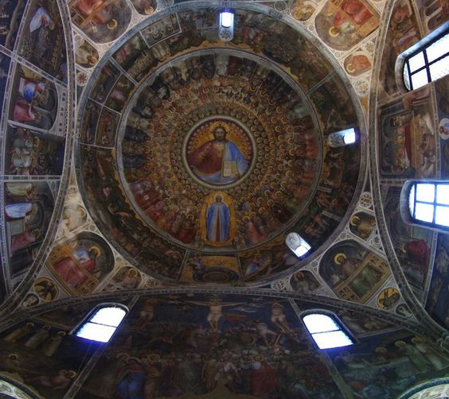

Figure 7. Giusto de’ Menabuoi, (c. 1350), Padua Baptistery ceiling, fresco, showing Paradise, The Virgin, The Creation of the World and The Crucifixion. Photo: Mauro Magliani.

CONCLUSION

Two primary source documents were used, both artworks, to discuss the role of astrology in the Medieval Age: Giusto de’ Menabuoi’s The Creation of the World in the Padua Baptistery and the Room of the Arts and Planets, painter unknown, in Foligno. Both artworks were shown to have been made in a milieu that was steeped in the new astrological learning that flooded European cultural centres in the 12th century and it was therefore assumed that these artworks not only represented this learning but were made to be understood and contemplated by their audience.

The role of astrology as medieval science was discussed through the representation of the structure of the universe and planetary influences on mankind in The Creation as well as some aspects of astrology’s relationship with Christian theology. Also discussed was astrology’s role in the functioning – and understanding – of Time in all its manifestations, through the compositions in the Room of the Arts and Planets, as well as the potent power of astrological concepts to unite seemingly disparate elements. Finally it was suggested that the astrological references in both works served to inspire the viewer to rise above the mundane in contemplating the perfect geometrical order of the Aristotelian cosmos, which was noted as a primary purpose of astrology in classical texts, and which in the Medieval period was merged with contemplation of the Christian God who stood outside the astrological influences and laws. In conclusion, these works demonstrate what Campion called the ‘extraordinary power’ of astrology in the Medieval ages as an overarching organizing principle, as well as a rich and potent symbolic language.

BIBLIOGRAPHY

Blume, Dieter, ‘Francesco da Barberino. The Experinece of Exile and the Allegory of Love’, in Exile, Avignon and Italy during the first half of the 14th Century, ed. Elisa Brilli, Laura Fenelli, Gerhard Wolf, (Florence: SISMEL · edizioni del Galluzzo, 2015), pp. 171-192
Campion, Nicholas, A History of Western Astrology Volume II, The Medieval and Modern Worlds, (London: Continuum, 2009)

Canova, Giordana Mariani Canova, ‘Padua and the Stars: Medieval Painting and Illuminated Manuscripts’, The Inspiration of Astronomical Phenomena VI, ASP Conference Series, Vol. 441. (San Francisco: Astronomical Society of the Pacific, 2011)

Dunlop, Anne, Painted Palaces: The Rise of Secular Art in Early Renaissance Italy, (Pennsylvania: Pennsylvania State University Press, 2009)

Edson, Evelyn, ‘World Maps and Easter Tables: Medieval Maps in Context’, Imago Mundi, Vol. 48 (1996), 25-42

Evans, Richard, In Defence of History, (London: Granta Books 1997)

Gunzburg, Darrelyn, ‘Giotto’s Sky: The Fresco Paintings of the First Floor Salone of the Palazzo della Ragione, Padua, Italy’, Journal for the Study of Religion, Nature and Culture, Vol 7, No 4 (2013)

Lippincott, Kristen, ‘Giovanni di Paolo’s ‘Creation of the World’ and the Tradition of the ‘Thema Mundi’ in Late Medieval and Renaissance Art’, The Burlington Magazine, Vol. 132, No. 1048 (Jul., 1990) 460-468

Moyer, Ann, ‘The Astronomers’ Game: Astrology and University Culture in the Fifteenth and Sixteenth Centuries, Early Science and Medicine, Vol. 4, No. 3 (1999), 228-250

Norman, Diana ‘Astrology, antiquity and empiricism: art and learning’ in Siena, Florence, and Padua: Interpretative essays, ed. by Diana Norman (Yale: Yale University Press, 1995)

Plato, Timaeus, trans. R.G.Bury, Cambridge Mass., London: Harvard University Press, 1931
http://classics.mit.edu/Plato/timaeus.html

Ptolemy, Claudius, Tetrabiblos, trans. F.E.Robbins, Cambridge Mass., London: Harvard University Press, 1930, Book 4, Chapter 10
http://www.kronosofia.dk/frames/side/biblioteket/tetrabiblos/tetrabiblos.html

Poeschke, Joachim, Italian Frescoes: The Age of Giotto 1280-1400, (New York, London: Abeville Press Publishers, 2005)

Sears, Elizabeth, The Ages of Man: Medieval Interpretations of the Life Cycle, (New Jersey: Princeton University Press, 1986)

Spiazzi, Anna Maria, ‘Giusto de’ Menabuoi,’ in Giotto e il suo tempo, ed. by V. Sgarbi, (Milan, 2000), pp. 190-204

Thorndike, Lynn, ‘The True Place of Astrology in the History of Science’, Isis, Vol. 46, No. 3 (Sep. 1955), 273-278

Woodward, David, ‘Reality, Symbolism, Time, and Space in Medieval World Maps’, Annals of the Association of American Geographers, Vol. 75, No. 4 (Dec, 1985), 510-521

Nicholas Campion, A History of Western Astrology Volume II, The Medieval and Modern Worlds, (London: Continuum, 2009), p.30, Lynn Thorndike, ‘The True Place of Astrology in the History of Science’, Isis, Vol. 46, No. 3, (Sep. 1955), p. 273.
Darrelyn Gunzburg , ‘Giotto’s Sky: The Fresco Paintings of the First Floor Salone of the Palazzo della Ragione, Padua, Italy’, Journal for the Study of Religion, Nature and Culture, Vol 7, No 4 (2013), 408.
Campion, History, p. 43.
Giordana Mariani Canova, ‘Padua and the Stars: Medieval Painting and Illuminated Manuscripts’, The Inspiration of Astronomical Phenomena VI, ASP Conference Series, Vol. 441. (San Francisco: Astronomical Society of the Pacific, 2011), 111.
Dunlop, Anne, Painted Palaces: The Rise of Secular Art in Early Renaissance Italy, (Pennsylvania: Pennsylvania State University Press, 2009), p. 85.
Joachim Poeschke, Joachim, Italian Frescoes: The Age of Giotto 1280-1400, (New York, London: Abeville Press Publishers, 2005), p. 404.
Diana Norman, ‘Astrology, antiquity and empiricism: art and learning’ in Siena, Florence, and Padua: Interpretative essays, ed. by Diana Norman (Yale: Yale University Press, 1995), p. 210.
Anna Maria Spiazzi, ‘Giusto de’ Menabuoi,’ in Giotto e il suo tempo, ed. by V. Sgarbi, (Milan, 2000), pp. 190-204, in Poeschke, Italian Frescoes, p. 405.
Dunlop, Painted Palaces, p. 75.
Dunlop, Painted Palaces p. 74.
Dunlop, Painted Palaces p. 74.
Poeschke, Italian Frescoes, p. 404, Kristen Lippincott, ‘Giovanni di Paolo’s “Creation of the World” and the Tradition of the “Thema Mundi” in Late Medieval and Renaissance Art’, The Burlington Magazine, Vol. 132, No. 1048 (Jul, 1990) 467.
Lippincott, ‘Giovanni di Paolo’,467.
Giordana Mariani Canova, ‘Padua and the Stars: Medieval Painting and Illuminated Manuscripts’, The Inspiration of Astronomical Phenomena VI, ASP Conference Series, Vol. 441. (San Francisco: Astronomical Society of the Pacific, 2011), p113.
Albertus Magnus, in Zambelli, The Speculum Astronomiae, p. 67, in Campion, History, p. 48, Thomas Aquinas, Summa Contra Gentiles: Book 3: Providence, Part 2, trans. Vernon J. Bourke, (Indiana: University of Notre Dame Press, 1975) Chapter 91, Paragraph 2.
Campion, p76.
David Woodward, ‘Reality, Symbolism, Time, and Space in Medieval World Maps’, Annals of the Association of American Geographers, Vol. 75, No. 4 (Dec, 1985), p. 512
Campion, History, p. 84.
Plato, Timaeus, trans. Benjamin Jowett http://classics.mit.edu/Plato/timaeus.html [accessed 6 July, 2018]
Elizabeth Sears, The Ages of Man: Medieval Interpretations of the Life Cycle, (New Jersey: Princeton University Press, 1986) p.48.
Ptolemy, Claudius, Tetrabiblos, trans. F.E.Robbins, Cambridge Mass., London: Harvard University Press, 1930, Book 4, Chapter 10.
Evans, In Defence, p104
Dieter Blume, ‘Francesco da Barberino. The Experinece of Exile and the Allegory of Love’, in Exile, Avignon and Italy during the first half of the 14th Century, ed. Elisa Brilli, Laura Fenelli, Gerhard Wolf, (Florence: SISMEL · edizioni del Galluzzo, 2015), 171-192, pp. 20-21.
Dunlop, Painted Palaces p. 75.
Gunzburg, ‘Giotto’s Sky’, pp.122, 127.
Plato, Timaeus, trans. Benjamin Jowett http://classics.mit.edu/Plato/timaeus.html [accessed 6 July, 2018]
Sears, The Ages, p. 106.
Dunlop, Painted Palaces p. 75.
Campion, History, p.30.

