
Games Architecture & mechanics – part 1: gAMES physics
Steffan Davies


Table of Contents
Task 1 2
Euler’s method 2
Midpoint 2
Runge Kutta 4th Order (RK4) 2
Backwards (Back) Euler 2
Verlet Integration 2
C++ Program – Euler’s Method 3
Task 2 3
Distance between two points 3
Distance squared between two points 3
Projection of one vector onto another 3
Tests 4
Appendix 4
Appendix 1 4
Appendix 2 5
Appendix 3 5
References 6
Bibliography 7

Task 1

Euler’s method
Euler’s method (also known as Explicit Euler) is considered one of the simplest numerical integration methods that can be used by game developers[1]. This method involves the use of time-steps. Starting from an initial position and velocity, each time-step is used to record and calculate the difference in position and velocity from the previous time-step to the current time-step[2].
Even though it is easy to implement[2], it is not the most accurate method for numerical integration[2], [3]. It would be more accurate to say that each calculation is an approximation point. If the time-steps are smaller, it can lead closer to the actual result but overtime the error will increase[2].

Midpoint
The Midpoint method is very similar to Euler’s method. Instead of creating one approximation point at each time-step, it creates two approximation points. The additional approximation point is a halfway point (a half-step)[2]. This method does provide better approximations that are closer to the actual results than Euler’s method but these are still approximations and not fully accurate results[2]. Midpoint and Euler’s method are both under a large class of algorithms known as Runge-Kutta methods[2].

Runge Kutta 4th Order (RK4)
The Runge Kutta 4th order (RK4) method is the most commonly known method of the Runge Kutta methods[2], [3], [4]. The difference between this method and Euler’s method is that Euler’s method does one calculation at each step and RK4 does four calculations at each step. This makes RK4 a much more accurate method than Euler’s method[5]. This does however come with a disadvantage. Even though it produces much more accurate calculations, it is a lot more computationally expensive[2].

Backwards (Back) Euler
Backwards Euler (also known as Implicit Euler) is different from the other integration methods and the techniques that are used to complete calculations. Instead of solving the equation at the current time-step, it would solve the equation at the next time-step. From that time step, it would then return back to the previous time-step[2], [3]. This method would be well suited for simulating stiff equations that become unstable with other methods[4] and a variety of things in games such as springs, changes in acceleration etc[3].

Verlet Integration
Verlet integration is more commonly used in molecular dynamics[2]. The difference between this method and Euler’s method is that Verlet integration calculates the position from the acceleration instead of the velocity[3]. This method is mainly used in videogames to simulate projectiles trajectories such bullets being fired from a gun as well as particle systems, examples being smoke, waterfalls etc[3].
Other uses in games would also include ragdoll physics and simulating cloth [2], [3]. A disadvantage for Verlet integration is that this method would not produce accurate calculations for the velocity position, and it would only provide an approximation.

C++ Program – Euler’s Method
A C++ program was developed to calculate the velocity and position of a spring powered model dragster car. To create this simulation, Euler’s method will be used to calculate the results. Each time-step would be at 0.06 seconds. After the results have been calculated, the information would then be loaded into Excel to produce graphs. The graphs which show the position, velocity and acceleration can be seen in the Appendix.
Looking at the results, after 8 metres has been reached, the velocity has stopped increasing and started to decrease. The acceleration started to decrease after a couple of time-steps. This was as expected.

Task 2

Distance between two points
Each point would have a vector, made up of x, y and z values. The x value from one vector would then be subtracted from the x value from the other vector. The same would need to be done for the y and z values as well. Once the subtractions are all done, the x, y and z values would then need to be squared then added together, creating a total value. The last step is then to a square root on the total value. After this, the distance between two points will have been calculated.

Distance squared between two points
To calculate the distance squared between two points, you will be following the same steps needed to calculate the distance between two points. One point will need to be subtracted by the other point by subtracting the x, y and z values. Then each value will have to be squared and then added up to give a total value. This total value is the calculated distance squared between two points.

Projection of one vector onto another
To calculate what the projection of one vector onto another would be, you will first have to calculate the dot product of both vectors. To do this, you will have to multiply the x value of one vector by the x value of the other vector. This will also need to be done for the y and z values. After this is done, you will then need to add the total x, y and z values together to calculate the dot product.
After the dot product has been calculated, you will then need to calculate the length of the vector that is going in the same direction as the vector projection. The length can be calculated by multiplying the x, y and z values by themselves (square) and then adding them up. One the length has been calculated, you will then need to divide the dot product by the length, then scale the total of that division.

Tests
Test No | Description | Expected Result | Actual Result | Pass/Fail
1 | Distance between two points | Calculated distance between two points should equal 18.71 | The distance between two points has been calculated at 18.7083. Rounded up to two decimal places would calculate at 18.71. | Pass
2 | Distance squared between two points | The calculated distance squared between should equal 350. | The distance squared between two points calculated at 350. | Pass
3 | Projection of one vector onto another

Appendix

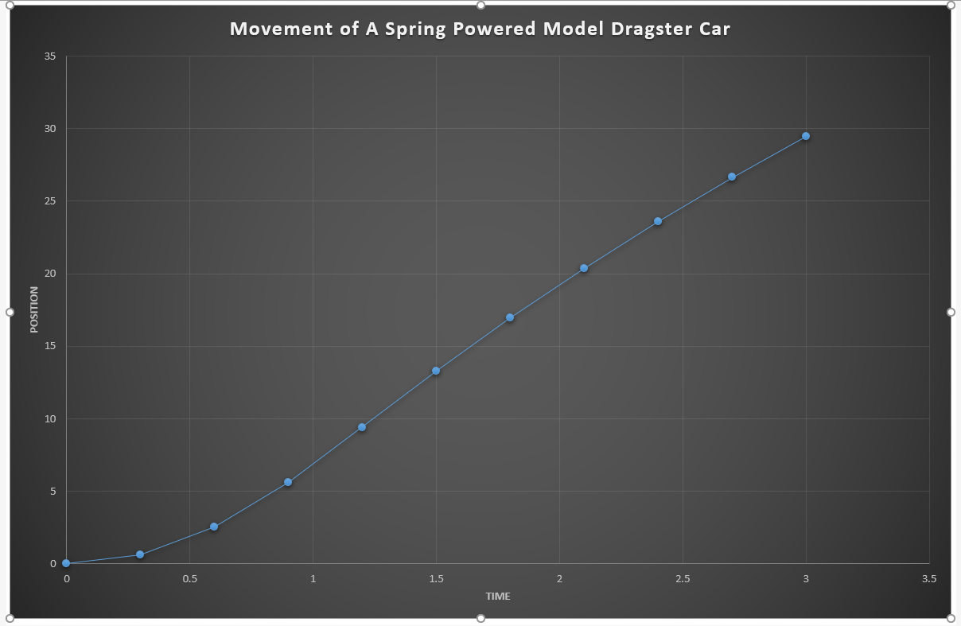
Appendix 1

This graph highlights the calculated approximate position of the dragster car.

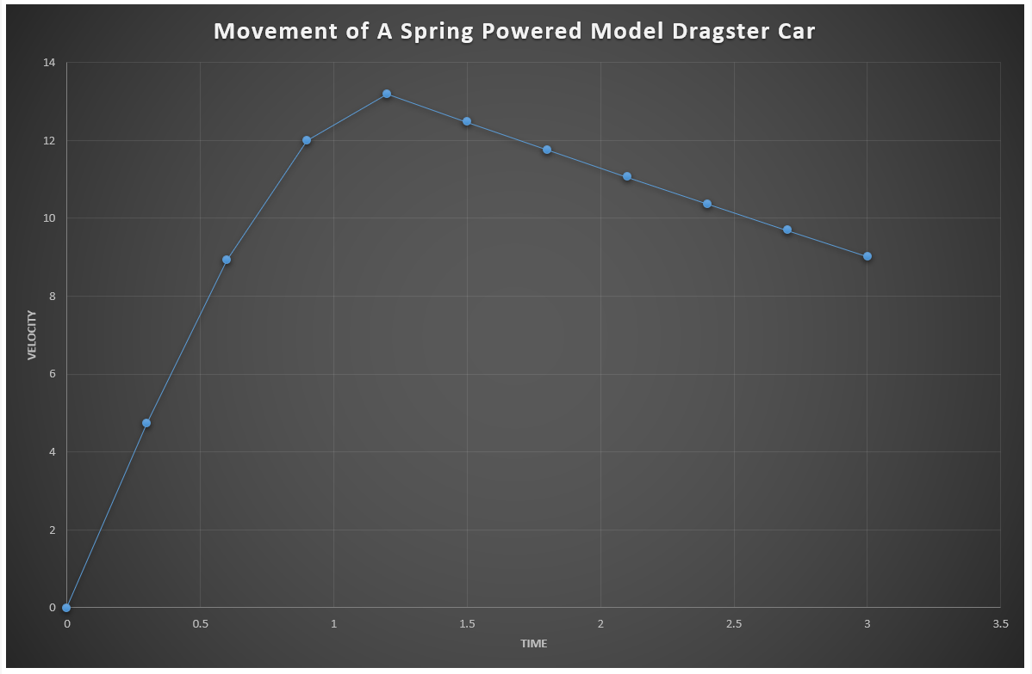
Appendix 2

This graph highlights the calculated approximate velocity of the dragster car.

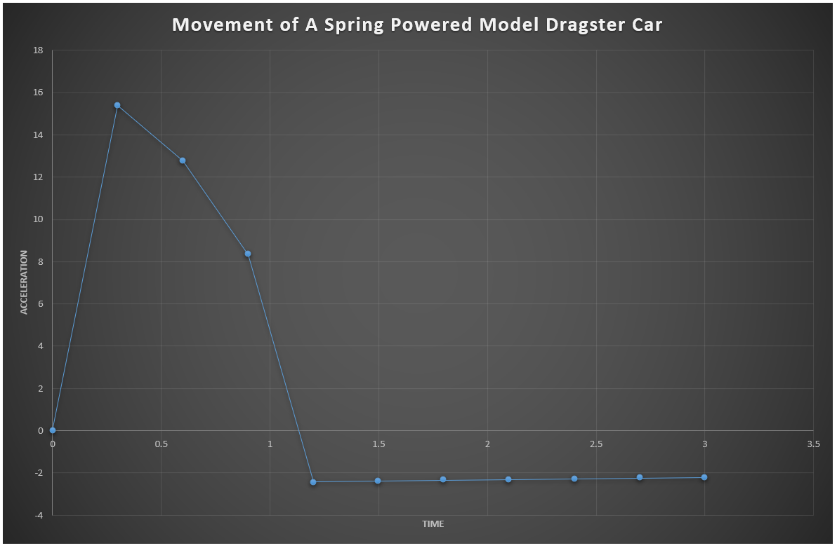
Appendix 3

This graph highlights the calculated approximate acceleration of the dragster car.

References

[1] “Understanding Games Development | A blog related to understanding games development.” [Online]. Available: https://jdickinsongames.wordpress.com/. [Accessed: 15-Dec-2018].
[2] J. M. Van Verth and L. M. Bishop, Essential Mathematics For Games & Interactive Applications, 2nd ed. Elsevier, 2008.
[3] “Numerical Integration in Games Development | Understanding Games Development.” [Online]. Available: https://jdickinsongames.wordpress.com/2015/01/22/numerical-integration-in-games-development-2/. [Accessed: 12-Jan-2019].
[4] “Integration Basics | Gaffer On Games.” [Online]. Available: https://gafferongames.com/post/integration_basics/. [Accessed: 01-Feb-2019].
[5] D. M. Bourg and B. Bywalec, Physics for Game Developers, 2nd ed. O’Reilly, 2013.

Bibliography

[1] “Understanding Games Development | A blog related to understanding games development.” [Online]. Available: https://jdickinsongames.wordpress.com/. [Accessed: 15-Dec-2019].
[2] J. M. Van Verth and L. M. Bishop, Essential Mathematics For Games & Interactive Applications, 2nd ed. Elsevier, 2008.
[3] “Numerical Integration in Games Development | Understanding Games Development.” [Online]. Available: https://jdickinsongames.wordpress.com/2015/01/22/numerical-integration-in-games-development-2/. [Accessed: 12-Jan-2019].
[4] “Integration Basics | Gaffer On Games.” [Online]. Available: https://gafferongames.com/post/integration_basics/. [Accessed: 01-Feb-2019].
[5] D. M. Bourg and B. Bywalec, Physics for Game Developers, 2nd ed. O’Reilly, 2013.
[6] “A Verlet based approach for 2D game physics - Math and Physics - GameDev.net.” [Online]. Available: https://www.gamedev.net/articles/programming/math-and-physics/a-verlet-based-approach-for-2d-game-physics-r2714/. [Accessed: 04-Feb-2019].
[7] “Runge-Kutta method.”
[8] J. H. Mathews and K. D. Fink, Numerical Methods Using MATLAB, 3rd ed. Prentice Hall College Div;, 1998.
[9] “Numerical Methods 5.1. Introduction.”
[10] “projections and distances.” [Online]. Available: http://www.math.lsa.umich.edu/~glarose/classes/calcIII/web/13_5/. [Accessed: 01-Feb-2019].

