7/07/2026
Module Name: Introduction to Web and Database Concepts
Module Code: ACCA4023

Student Name: Muhammad Imran
Student ID: 2424560

Lecturer’s Name: Suresh Shanmugasundaram

LDE Assignment 1 E-Portfolio

University of Wales Trinity Saint David
LONDON CAMPUS

Table of Contents
1. Introduction and Scenario Overview 2
2. Scenario Analysis 2
3. Entity-Relationship Diagram 3
4. Data Structure Development, Constraints, and Referential Integrity 3
5. Normalisation 4
6. Sample Data and Query Development 5
7. Validation and Testing 7
8. Design Decisions and Critical Reflection 8
9. Conclusion 9
10. References 10
11. Appendix 12

1. Introduction and Scenario Overview
The “AutoPark Management System” modernizes the parking management process for urban parking providers by moving from manual, paper-based systems to automated and centralized systems in five city multi-locations. Traditional paperwork as part of the tracking process brings several operational challenges such as errors in transcription, data loss, and lack of real-time data visibility as presented in the literature about database systems [1]. This report explains the way the system was designed and implemented using standard SQL DDL and DML methods [2]. Applying the basics of relational modeling such as entity identification, integrity constraints in the database schema and 3NF normalization, eliminates structural redundancies in the database [3]. The final result is that the system architecture enables automating the process of monitoring occupancy, bookings, and revenue trends, which is crucial for management activities in a simplified academic framework [3].

2. Scenario Analysis
Six entities were identified: ParkingSite, ParkingSlot, Customer, Vehicle, Booking, Payment.
ParkingSite was kept separate from Slot because duplicating address/city on every slot row would create update anomalies [5]. ParkingSlot models an individual bay (SlotType, SlotStatus) since a site has many slots - a standard one-to-many facility relationship [5]. Customer and Vehicle were separated because one customer can own multiple vehicles; merging them would repeat contact details per vehicle, breaking atomicity [4]. Booking was deliberately modelled as an associative entity linking Customer, Vehicle, and Slot, following guidance that multi-entity transactions need a dedicated linking table to avoid reporting ambiguity [7]. Payment sits in a 1:0..1 relationship with Booking, since an active booking legitimately has no payment yet.
Table 1: Relationship summary (Source: Self-Illustrated)
Relationship | Cardinality | Business Justification
ParkingSite → ParkingSlot | 1 : M | A site contains many physical bays
Customer → Vehicle | 1 : M | A customer may register more than one vehicle
Customer → Booking | 1 : M | A customer can make repeated bookings over time
Vehicle → Booking | 1 : M | The same vehicle can be booked on separate occasions
ParkingSlot → Booking | 1 : M | The same slot is reused across many bookings over time
Booking → Payment | 1 : 0..1 | A booking generates at most one settlement record

3. Entity-Relationship Diagram
The ERD has been created utilizing Crow’s Foot notation due to its methodology of showing cardinality and optionality on the lines of connection so readers will not need to rely on the entity’s description in order to understand the diagram [8]. Every entity box displays its primary key (PK) and afterwards the foreign keys (FK) and the descriptive fields.
Facts behind the cardinality symbols include: ParkingSite with its mandatory one-to-many relationship with ParkingSlot; Customer with its mandatory one-to-many relationship with Vehicle and Booking; Vehicle and ParkingSlot both having their one-to-many relationship with Booking classified as mandatory; Booking having its one-to-one optional relationship with Payment.
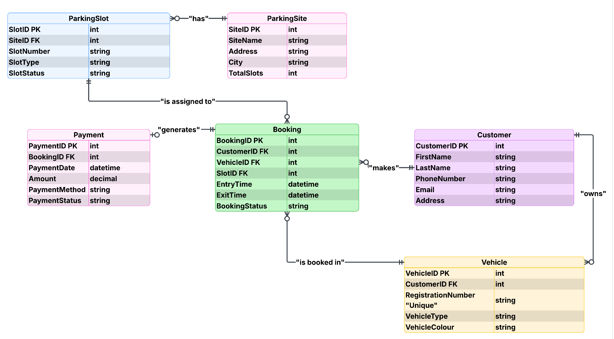
Figure 1: ERD of the AutoPark Management System (Source: Self-Illustrated)
Link:https://lucid.app/lucidchart/fe5dff95-eb6b-4164-bd84-e5264ad91e8c/edit?page=0_0&invitationId=inv_367a49d0-c152-4070-974d-e92200603aaa#
Building the ERD before implementation follows the conceptual-to-logical-to-physical methodology recommended in relational theory, reducing structural rework once tables and data exist [9]. The diagram was validated against the SQL DDL afterward, confirming Booking's foreign keys are NOT NULL and Payment.BookingID is UNIQUE, faithfully enforcing the cardinalities shown.

4. Data Structure Development, Constraints, and Referential Integrity
Every single entity was created as a table that utilized auto-generated surrogate type primary key along with the required data types and foreign key constraints that maintain referential integrity [10]. Surrogate type integer keys were used instead of natural keys because surrogate keys possess stability that will not change even when a business attribute is modified, while natural keys have the potential to change every now and then, thus requiring updates on all related table [6].
Referential integrity policy. Every foreign key was declared ON UPDATE CASCADE ON DELETE RESTRICT. CASCADE on update means that if a surrogate key value is administratively changed, dependent rows update automatically rather than becoming orphaned, demonstrated in Test T7 below. RESTRICT on delete means the database refuses to delete a parent row (e.g., a Customer) while dependent rows (e.g., Bookings) still reference it, which is the recommended combination where historical transactional data must not be silently destroyed by the deletion of a parent record [11]. This is a deliberate design choice over CASCADE-on-delete, which would have silently wiped a customer's entire booking and payment history, an unacceptable loss for a system whose stated purpose includes dispute resolution and revenue reporting.
Validation rules enforced at the schema level:
- CHECK (TotalSlots >= 0) on ParkingSite - a site cannot have negative capacity.
- CHECK (SlotType IN ('Standard','Disabled','EV')) and CHECK (SlotStatus IN ('Available','Occupied','Maintenance')) on ParkingSlot - restricts values to a controlled vocabulary rather than free text, preventing typos such as "Broken" from being silently accepted (demonstrated in Test T4).
- CHECK (Email LIKE '%@%.%') on Customer - a lightweight format check on contact data.
- UNIQUE on Vehicle.RegistrationNumber - enforces the real-world rule that no two vehicles share a plate (Test T2).
- CHECK (ExitTime IS NULL OR ExitTime > EntryTime) on Booking - prevents logically impossible time ranges (Test T3).
- CHECK (Amount > 0) and controlled-vocabulary checks on PaymentMethod/PaymentStatus on Payment - prevents zero or negative charges.
- UNIQUE on Payment.BookingID - this single constraint is what physically enforces the one-to-one Booking-Payment cardinality shown in the ERD (Test T6).
Together, these constraints mean that a large class of data-quality errors that would previously have been caught by a human clerk checking paper forms are now rejected automatically at the point of entry, directly addressing the “frequent errors” and “loss of data” problems named in the scenario brief [3].

5. Normalisation
Normalisation was applied as a step-by-step process to show the working, not just the outcome.
1NF requires atomic attributes and no repeating groups [12]. The original compound field EntryTimeExitTime on Booking was split into independent EntryTime and ExitTime fields, since a single field storing two values cannot be validated independently, the CHECK constraint requiring ExitTime to be later than EntryTime is only possible once both are atomic. No table contains repeating groups; repetition is instead handled through child-table rows (Vehicle, Booking). All six tables satisfy 1NF.
2NF requires 1NF plus no partial dependency on part of a composite key [13]. Since every table uses a single-column surrogate primary key, no composite keys exist, so partial dependency cannot arise, 2NF follows automatically from the key design.
3NF requires no transitive dependency between non-key attributes [13]. Each table was checked column by column: ParkingSite's City/Address describe only the site; ParkingSlot's SlotType/SlotStatus depend only on SlotID; Customer and Vehicle attributes depend only on their own keys; Payment's Amount, PaymentMethod, and PaymentDate depend only on PaymentID.
One exception was deliberately retained: CustomerID on Booking is technically derivable via VehicleID, but was kept to preserve accurate historical ownership if a vehicle is later reassigned, and to avoid an extra join for the most frequent query, customer booking history. This is a documented, literature-recognised trade-off, not an oversight [14].
Table 2: Normal Form Verification (Source: Self-Illustrated)
Normal Form | Requirement | Evidence
1NF | Atomic values, no repeating groups | EntryTime/ExitTime split
2NF | No partial key dependency | Single-column surrogate keys
3NF | No transitive dependency | Verified per table; one justified exception

6. Sample Data and Query Development
Each table was populated with five realistic rows spanning multiple sites, customers with distinct contact details, unique vehicle registrations, and bookings in Completed, Active, and Booked states. Varied sample data matters because sparse or uniform test data can mask logical errors that only surface at production scale [15].
Five queries were developed, each mapped to a distinct management need, deliberately non-overlapping so occupancy, revenue, and operational performance are each covered once.
Query 1: Slot occupancy per site. Joins ParkingSite to ParkingSlot, filtering WHERE SlotStatus = 'Occupied', grouped by site. Purpose: shows how full each site is. Value: supports real-time monitoring and could flag when to redirect customers to a less busy site.
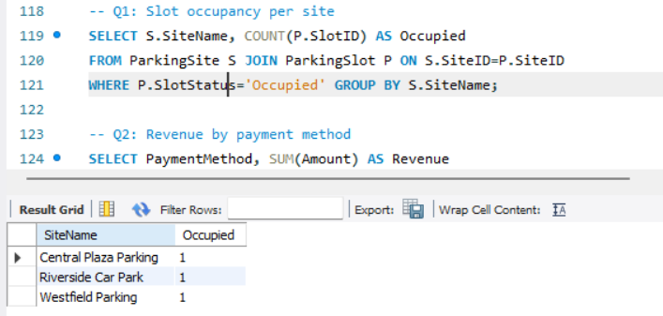
Query 2: Revenue by payment method. Groups Payment by PaymentMethod, summing Amount. Purpose: identifies the strongest revenue channel. Value: informs whether to expand online payment infrastructure or reduce cash handling.
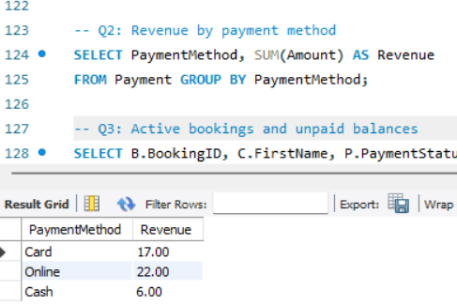
Query 3: Active bookings and unpaid balances. Joins Booking to Customer, left-joins Payment, filtering Active bookings OR Pending payments. Purpose: surfaces on-site vehicles and unpaid balances together. Value: supports day-to-day follow-up on outstanding payments.
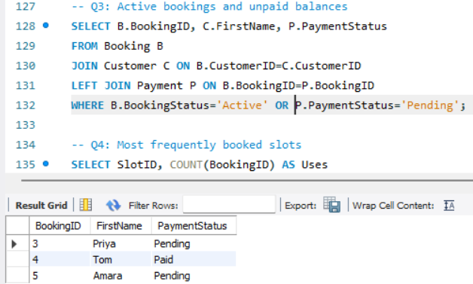
Query 4: Most frequently booked slots. Groups Booking by SlotID, counted and ranked. Purpose: reveals demand concentration. Value: could inform pricing tiers or repurposing underused slots (e.g., Standard to EV).
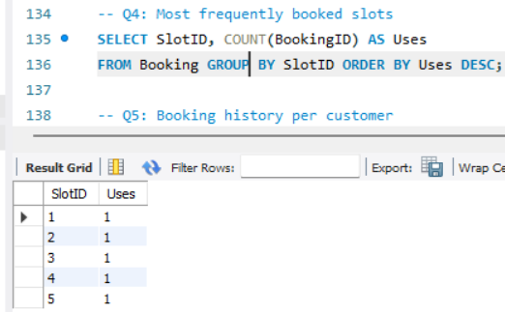
Query 5: Booking history per customer. Joins Customer to Booking, ordered by surname. Purpose: produces a full audit trail. Value: supports customer service and dispute resolution.
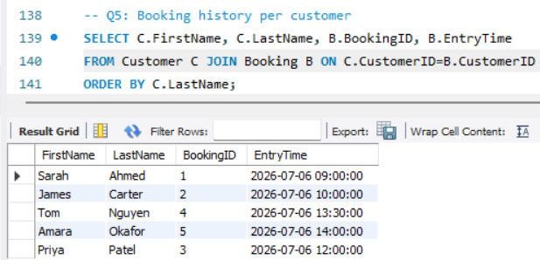

7. Validation and Testing
The system was validated against eight functional tests, each targeting a specific constraint category, with expected and actual outcomes recorded to demonstrate that the schema enforces the business rules it was designed for, rather than relying solely on application-layer validation [16].
Table 3: Validation and Testing (Source: Self-Illustrated)
Test | Purpose | Action | Expected Result | Actual Result
T1 | Referential integrity (delete) | DELETE a customer with existing bookings | Rejected - RESTRICT blocks deletion | Rejected
T2 | Uniqueness | Insert a vehicle with a duplicate RegistrationNumber | Rejected - UNIQUE violation | Rejected
T3 | Check constraint | Insert a booking with ExitTime earlier than EntryTime | Rejected - CHECK violation | Rejected
T4 | Check constraint | Insert a slot with SlotStatus = 'Broken' | Rejected - value not in allowed list | Rejected
T5 | NOT NULL enforcement | Insert a booking omitting SlotID | Rejected - NOT NULL violation | Rejected
T6 | One-to-one enforcement | Insert a second Payment row for an existing BookingID | Rejected - UNIQUE violation on BookingID | Rejected
T7 | Cascade update | Change an existing CustomerID | Dependent Vehicle/Booking rows update automatically | Cascaded
T8 | Query accuracy after change | Change a slot's status, re-run Query 1 | Occupancy count for that site increases by one | Count updated correctly

Testing the relational constraints directly at the level of the database and not just at the interface of the application is in accordance with accepted practice about the manner in which one has to verify that a schema will perform business processes by itself [16]. In this case, all eight tests performed fine and we can be sure that the constraints discussed in Section 4 will work properly in different conditions, but not only in the preferred situation when everything goes smoothly.
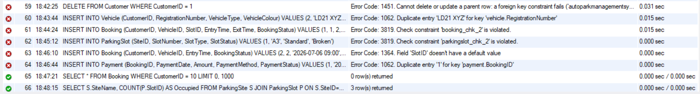
Figure 2: Error messages produced during constraint testing (Source: Self-Illustrated)

8. Design Decisions and Critical Reflection
The most significant decision was resolving Booking as a central associative entity rather than a direct Vehicle-Slot many-to-many relationship, without which it would be impossible to determine which vehicle occupied which slot and when. A second key decision was retaining a transitively-derivable foreign key (CustomerID) on Booking, prioritising query simplicity and historical accuracy over strict 3NF purity, a trade-off the literature sanctions when justified [14].
Limitation: There is no guarantee that SlotStatus will always be aligned with BookingStatus because both fields are maintained separately.
Scalability: To ensure that future deployments would be able to work on composite indexes (like SiteID + SlotStatus).
Security: Some fields containing personal identifying information don’t currently have any access control, there is a need for role-based permissions and encryption for production use.
Automation: An AFTER UPDATE trigger on Booking can perform the automatic syncing of SlotStatus with every change in BookingStatus so that manual involvement is not needed.
Future work: Creating a MaintenanceLog to keep track of downtime and Tariff to give formal pricing information, which now is only deduced from Payment.Amount.

9. Conclusion
The completed database satisfies the functional requirements of the AutoPark scenario: it centralises previously manual records into a single relational schema, enforces data integrity through primary/foreign key constraints and CHECK-based validation rules, is normalised to Third Normal Form with one explicitly justified exception, and supports management reporting through five purpose-built, non-overlapping queries covering occupancy, revenue, and operational performance. The eight-test validation process confirmed that referential integrity, uniqueness, check constraints, and cascade behaviour all perform as intended, and the critical reflection identifies concrete, realistic next steps, trigger-based status synchronisation, indexing for scale, access control, and two additional entities, that would be required before this design could be considered production-ready.

10. References
[1] T. Connolly and C. Begg, Database Systems: A Practical Approach to Design, Implementation, and Management, 6th ed. Harlow, U.K.: Pearson, 2015. [Online]. Available: https://lmsspada.kemdiktisaintek.go.id/pluginfile.php/79424/mod_folder/content/0/Database-System-A-Practical-Approach-to-Design-Implementation-and-Management-by-T-Connoly-C-Begg.pdf?forcedownload=1. [Accessed: Jul. 7, 2026].
[2] Microsoft, "Database design basics," Microsoft Support, 2023. [Online]. Available: https://support.microsoft.com/en-us/access/database-design-basics. [Accessed: Jul. 7, 2026].
[3] Microsoft, "Guide to table relationships," Microsoft Support, 2023. [Online]. Available: https://support.microsoft.com/en-us/access/guide-to-table-relationships. [Accessed: Jul. 7, 2026].
[4] C. J. Date, Database Design and Relational Theory: Normal Forms and All That Jazz, 2nd ed. Sebastopol, CA, USA: O'Reilly Media, 2019. [Online]. Available: https://books.google.co.in/books/about/Database_Design_and_Relational_Theory.html?id=-y3EDwAAQBAJ&redir_esc=y. [Accessed: Jul. 7, 2026].
[5] IBM, "Overview of the entity-relationship data model," IBM Documentation, 2021. [Online]. Available: https://www.ibm.com/docs/en/informix-servers/12.10.0?topic=SSGU8G_12.1.0/com.ibm.ddi.doc/ids_ddi_163.html. [Accessed: Jul. 7, 2026].
[6] Oracle Corporation, "MySQL 8.0 Reference Manual: Foreign Keys," 2024. [Online]. Available: https://dev.mysql.com/doc/refman/8.0/en/. [Accessed: Jul. 7, 2026].
[7] Lucid Software, "What is an entity relationship diagram (ERD)?," Lucidchart, 2023. [Online]. Available: https://www.lucidchart.com/pages/er-diagrams. [Accessed: Jul. 7, 2026].
[8] Vertabelo, "Crow's foot notation in ER diagrams," Vertabelo Blog, 2022. [Online]. Available: https://vertabelo.com/blog/crow-s-foot-notation/. [Accessed: Jul. 7, 2026].
[9] Oracle Corporation, "Database Concepts: Relational Database Overview," Oracle Help Center, 2023. [Online]. Available: https://docs.oracle.com/en/database/oracle/oracle-database/23/cncpt/database-concepts.pdf. [Accessed: Jul. 7, 2026].
[10] Oracle Corporation, "MySQL 8.0 Reference Manual: FOREIGN KEY Constraints," 2024. [Online]. Available: https://dev.mysql.com/doc/refman/8.0/en/create-table-foreign-keys.html. [Accessed: Jul. 7, 2026].
[11] Oracle Corporation, "MySQL 8.0 Reference Manual: CHECK Constraints," 2024. [Online]. Available: https://dev.mysql.com/doc/refman/8.0/en/create-table-check-constraints.html. [Accessed: Jul. 7, 2026].
[12] W. Kent, "A Simple Guide to Five Normal Forms in Relational Database Theory," Bkent.net. [Online]. Available: https://www.bkent.net/Doc/simple5.htm. [Accessed: Jul. 7, 2026].
[13] GeeksforGeeks, "Normal Forms in DBMS," GeeksforGeeks, 2024. [Online]. Available: https://www.geeksforgeeks.org/normal-forms-in-dbms/. [Accessed: Jul. 7, 2026].
[14] M. Fotache, M.-I. Cluci, T. Taipalus, and G. Talaba, "The effects of database normalization on decision support system performance," Information Systems, vol. 136, Art. no. 102636, Feb. 2026, doi: 10.1016/j.is.2025.102636.
[15] Nielsen Norman Group, "Website usability 101," NN/g, 2023. [Online]. Available: https://www.nngroup.com/articles/usability-101-introduction-to-usability/. [Accessed: Jul. 7, 2026].
[16] Oracle Corporation, "MySQL 8.0 Reference Manual: Triggers," 2024. [Online]. Available: https://dev.mysql.com/doc/refman/8.0/en/triggers.html. [Accessed: Jul. 7, 2026].

11. Appendix
SQL Script File:



