AUTISM IN A PRIMARY SCHOOL


A comprehensive guide on various methods to support children with autism in mainstream schooling.

CONTENTS

- Introduction
- So… What is Autism and Inclusion?

Introduction
Starting the new school year with a fresh classroom of pupils can be challenging; learning names, faces, and various personalities, all of which are unique to the child. Adding in different kinds of additional learning needs can add to the challenge. Learning how each individual child has their own various needs and learning styles, and how to tailor to them as best you can is its own challenge!
In this guide, the focus is supporting children with Autism Spectrum Disorder and how to ensure inclusion in lessons and various activities. An inclusive classroom is such a priority! Making sure everyone is able to take part and enjoy their activity, even if it isn’t the same way as some other children!
There is so many strategies out there to help ensure those with ASD are included in all activities! Methods, theories, discoveries, all of which can be implemented into classrooms to help support inclusivity all around. The ones in this guide wont all be specific to autism either, they may be useful with children who have other kinds of ALN too. However, this guide will be ASD-central.
So get ready to learn some interesting theories and strategies, old and new, and how they can be implemented into your classroom with real-life scenarios to follow! Try a few strategies out, but it is important to consider that not all children will respond positively to every strategy mentioned. Some may not work well with some strategies and work amazingly with others, and that’s okay! Its all about finding out what works for each child, and doing your best to implement them into your classroom.
So… What is Autism and Inclusion?
Firstly, lets take a look at Autism, or ASD. According NHS, 2022. Autism is a disorder with various symptoms, however not all apply to every person who has ASD. It is important to remember that every person with ASD is different, and some may need help with things that others don’t. And that’s okay! It doesn’t make them any less autistic than those who require a bit more help!
According to the World Health Organization, 2023, approximately 1 in 100 children have autism. That’s a lot! That means for a school of 1,000 children, there is approximately 10 children with autism, but this statistic only includes those who have a formal diagnosis. Referring back to (2), a lot of autism diagnoses don’t occur until later in life. With this in mind, it’s important to be aware of signs and symptoms of autism and be aware that not all children with autism may be diagnosed early. It is important to keep in mind that children may need support without having an autism diagnosis, or any diagnosis for that matter. However having a diagnosis for ASD can help the child themselves and everyone around them, to understand why they are struggling with certain aspects of their life, and work out how best to support them.
Onto the symptoms, Those with autism can experience various different types of symptoms, effecting them in different areas of their lives. Some of which can include:
- Difficulties regarding communication and interaction. They may not be very expressive, or they may sound rude at times. The social cues we all learn as we grow up are not as easily understood by some people with ASD, so they may communicate differently, and that’s okay! They may also communicate the same as any Neurotypical person, which is also okay!
- They may struggle to understand how others think and feel. They may not be able to understand your facial expression, or your tone, or hidden meanings as neurotypical people use day to day, it comes naturally to neurotypical people, but doesn’t to some people with autism!
- They may experience sensory issues. Things such as bright lights, loud noises and busy places, physical touch, these can all be super overwhelming for some people with autism! One scenario that may be triggering for a person with autism would be in a busy classroom, with music playing in the background, while approximately 30 children are all doing various activities. This is taking place on a Friday afternoon during golden time, where there is messy play, loud musical instruments, chatting amongst friends. There is also a lot of ‘disorder’ in general, which is different from the typical classroom set up they are used to within the week. It is also important to remember that in this scenario, it is Friday afternoon, when the child has gone through 4 days already of stress, sensory overload, being in a classroom that may not be suited to their needs. All of this can pile up and be overwhelming, even on a Monday after a relaxing weekend! It is hard to handle these things as a neurotypical person, so imagine being extra aware of your senses! Things such as the tags in your clothing, seams in your socks, both of which can be triggers for sensory issues. Not only children with autism have sensory issues, but it is common among children and adults with ASD.
- They may experience anxiety about unfamiliar situations and social events. A lot of children with ASD prefer routine and structure. They like to know whats happening, when, where, and be there on time. Any difference in routine and day structure can be overwhelming if not referenced ahead of time to allow them time to adjust. They may also find new situations overwhelming even with preparation and prior knowledge about the event!
- They may also take longer to process and understand information than their neurotypical peers.
- They may also be prone to repetition, whether it be in speech/thoughts, or actions. They may say the same thing often, make the same noises, or repeat the same actions, such as tapping things in the same order.

These are only a few of the symptoms those with ASD may experience, and their symptoms are not limited to the list. Every autistic person has various different experiences in different areas.
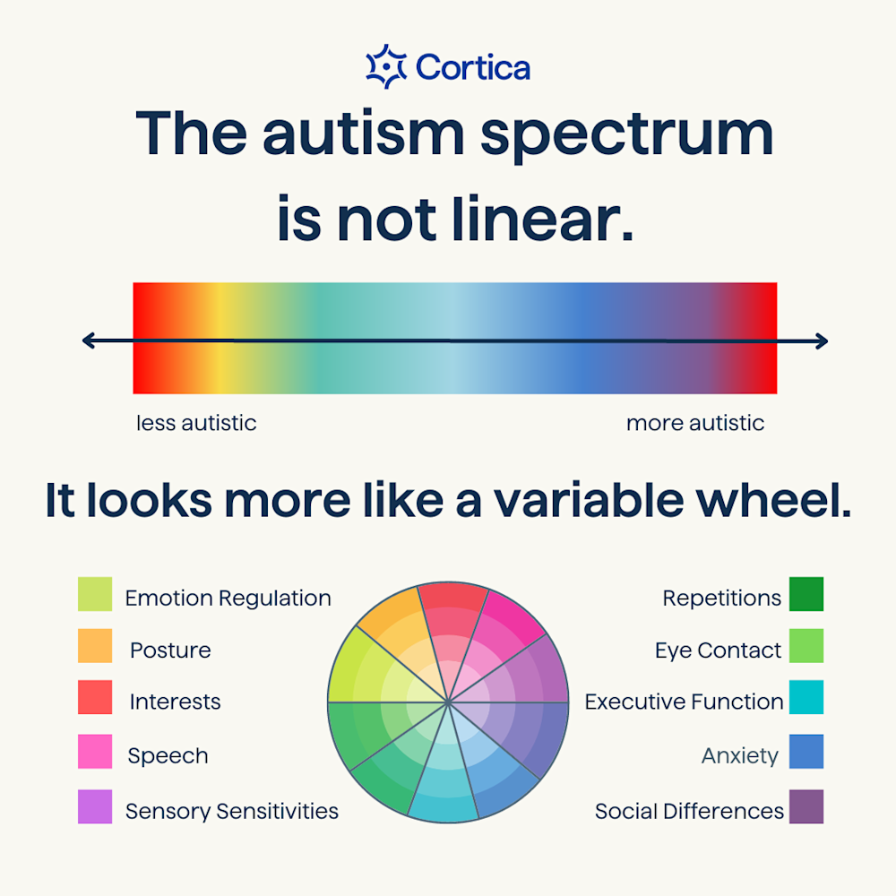
Something important to consider is that ASD is a spectrum, rather than a black and white disorder. Hence the word spectrum in the name! One method of explaining this would be the colour wheel method, which uses a coloured pie chart for an individual, and shows where they may struggle more and less.
- Child A has more sensory issues, less social differences, however struggles with emotional regulation and eye contact.
- Child B experiences little to no struggles with sensory issues, however does struggle a lot with social differences and maintaining an appropriate amount of eye contact. They do not struggle with emotional regulation most of the time, however they do have some struggles infrequently.
Both children are autistic! However, their autism presents differently, and therefore their wheels will appear differently.
Moving on, it is important to have a working definition of inclusion moving forward! So, its time to move on and focus on what inclusion actually means.
According to Orkney Islands Council, N/A. Inclusion can mean multiple different things. For the purpose of this guidance, inclusion will be defined as working towards increasing the presence, participation and achievement of all kinds of learners in educational establishments.
Simplified, including all pupils and helping them to reach their goals in your classroom.
Children require support in order to reach their full potential, which is why being a teacher is a noble profession! Talking more specifically about children with ASD, they may have additional challenges to overcome on the way to reaching their goals. For example, Child A is working in a group with child B and child C. Child A has ASD, whereas child B and C do not. Child A struggles in social situations, and has sensory issues regarding sound. Child A struggles with the group project and feels anxious going into school due to this. Child B and child C do not understand why child A is struggling and leave them out often.
Is child A being included?

Some important legislation going forward…

Legislation is a huge part of working in a school, and a huge part of inclusion. Without legislation, every school would be run completely differently based on the head-teacher’s wishes, which would lead to inconsistency across the board. Legislation helps ensure that each and every school has a set guideline on how to run their school, ensure everyone is included and has opportunities, and knows they are safe and where to turn if they should need support, as well as what support they can expect.
This section is all about what kinds of legislation apply to inclusion! There is a lot more out there than just these, however these are a few highlighted pieces to keep in mind.
First up is the equality act 2010. This act (Douglas Pyper, A. U., 2025.) is a combination of most previous laws regarding equality. This law focuses on protected characteristics, and those who care for them. It prohibits various kinds of conduct, and creates duties for those around the individual.
The act prohibits:
- Discrimination – According to Cambridge, N/A., Discrimination can be defined as ‘treating a person or particulat group of people differently, especially in a worse way from the way you treat other people, because of their race, gender, sexuality, etc.
- Harassment – According to Local Government Association, N/A., which references the Protection from Harassment Act 1997, harassment makes a victim feel distressed, humiliated, threatened and afraid of further action. Harassment can occur through:
  - Phone calls
  - Letters
  - In person
  - Emails
  - Damage to the person’s property
  - Threats
  - Bodily harm
  - Verbal abuse in person or online
The equality act focuses on harassment due to disability or additional learning needs.
Next is the Social Services and Wellbeing Act (Wales) 2014. This will herein be shortened to SSWB. According to Local Government Association, N/A., The SSWB act focuses on promoting wellbeing and helping individuals have a say in their own care and support, what they are able to do, and what they want to do. These individuals need care and support and have different protected characteristics.
The act has 5 main principles to follow:
- Voice and control – Voice and control allows the individual to have a say in their own care. The individual (or a trusted adult) can communicate issues and wishes regarding their care in order to achieve the best possible outcome. This can apply in a school setting too. Allowing children to advocate for themselves can be beneficial and ensure they thrive in their environment.
- Prevention and early intervention – intervening and providing support early can help support children in their future development and reduce later issues. This can help them prepare for the future, and thrive in society.
- Wellbeing – Ensuring their mental and physical wellbeing is good can help the child feel better physically and mentally, and allow them to reach their full potential.
- Co-production – It is crucial that all individuals work with the person to ensure the plan moving forward is one that focuses on their needs and wishes above all else. The person is the priority and their care must be tailored to them. This is also known as person-centred care.
- Multi agency working - Ensuring all bodies working together to support the child are on the same page and have a plan that works can help ensure the best outcome for the child. E.G, the teachers, LSAs, and family of the pupil all working together with the pupil themselves to ensure they thrive in the school environment.
This act provides a good guideline for individuals working with children with additional learning needs such as ASD. Ensuring that the child is advocating for themselves where possible, they are allowed the freedom to have a say in their own care and support plan and what will happen going forward, and making sure that everyone is on the same page in order to help ensure the child reaches their full potential is all crucial aspects of looking after a child with autism!
Third is the Additional Learning Needs and Education Tribunal (Wales) Act 2018, herein shortened to ALNET. ALNET focuses on creating a new framework for supporting those under 18 with additional learning needs. Welsh Government, N/A., says that ALNET replaces previous legislation, and focuses on creating an ‘individual development plan’ to assist the child moving forward. According to Swansea Council, 2023., an individual development plan has a plethora of information included in it to help staff assist the child. This information includes:
- A description of the child’s additional learning needs
- The agreed upon learning provision
- The parties responsible for delivering the IDP
- The outcome, agreed by all, that the child will be working towards.
What do the theories say?
The first theorist is Vygotsky. According to sh, M. S., 1896-1934., Vygotsky advocated for something called a ‘full-inclusion model’ which focused on having all children with ALN in a mainstream classroom. These classes would:
- Have teachers trained to support students with ALN to help each individual child.
- Theoretically improve the social skills of those with ALN.
- Adapt as the child develops in order to support them as they need currently.
- Instead of having children in their own school for children with ALN, they are in a mainstream environment.
This theory has some valid points, however some children may not be suitable for mainstream schools, and there may not be enough staff to accommodate children with ALN and help them thrive. Two case studies will explain how this theory can be applied, and whether or not it is suitable in various instances:
Case study A:
- Female, 7
- Mainstream classroom
- Autistic
- Struggles with sensory issues, verbal communication, social interaction
- Finds making friends difficult, finds it hard to meet like-minded children
- Tends to isolate herself and favours her own company
- Prone to meltdowns and can be destructive at times

This child is not suited to being in a mainstream classroom with one teacher and one LSA. She will not be able to thrive in that environment, as mainstream classrooms can be loud, and overwhelming, and she may not be able to get involved in various kinds of tasks, especially group work, as she struggles to interact with her peers.
In an ALN classroom, she will have more support around her, an IDP to ensure all staff understand what she needs and how best to help her, and proper plans in place to help reduce meltdowns and help her thrive. She is more likely to find likeminded individuals, and struggle less with the loud and uncomfortable setting of a mainstream class, something not all children are suited to.
Case study B:
- Male, age 8
- In a mainstream classroom
- Repetitive motions are common
- Behaviours that challenge are less frequent, but there
- Has strong interests in statistics
- Loud and sometimes disruptive
- Appreciates routine and structure
This child is more suited to being in a mainstream classroom. He requires less one-on-one support, although it will be available to support him. He will be more likely to make friends and participate in activities, however some activities he is unsure of may lead to frustration and challenging behaviours.
This child may not be suited to an ALN classroom. This is due to his lack of need for specific additional support, and he is likely to thrive in a mainstream environment. His challenging behaviours may worsen due to his environment, and he may not learn at the same pace he would in a typical mainstream classroom. Child B would better thrive in a mainstream environment.
The second theory is from Al-Shammari, Z. F. P. E. a. F. C., 2019., and focuses on ‘behaviourism based inclusive education practices’. Behaviourism focuses on associating consequences with negative behaviours in order to encourage positive behaviours. According to the source, inclusive education settings have a clear focus on behaviour and performance, and focus on approaches such as giving direct instruction. Children with ALN have shown positive responses to behaviourism, likely due to the clear guidelines in what to do.
These clear guidelines can help show structure to the lesson, and help them understand what to do now, next and later. Having clear guidelines can help children with ALN understand what is expected of them and help them achieve goals.
However this may not always apply in educational settings, such as mainstream classrooms. With the Curriculum for Wales coming into effect and children being given more freedom of choice, some children with ALN such as ASD may struggle to see a set routine in their day, leading to stress and overwhelm.
Case study
The following case study has been selected due to its focus on ALN and it being a primary school. The case study was taken from Estyn, 2020., for analysis.
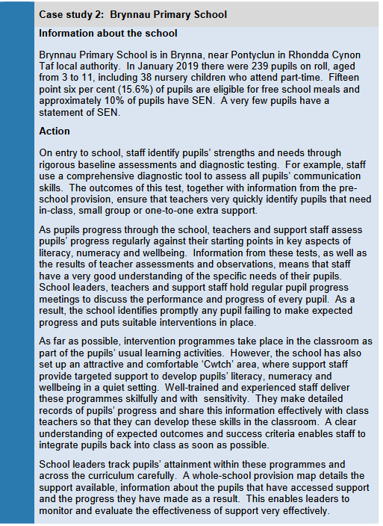
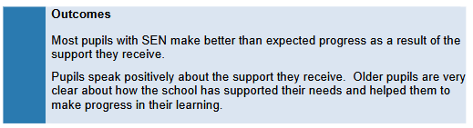
So, what parts of this case study lead to a positive outcome?:
- The ‘cwtch’ area is available as a quiet setting for learning
- Pupils are assessed regularly to ensure up-to-date records of support needs are kept
- Intervention programmes are conducted in-class to help support children who need additional learning in certain subjects
- Upon entry into the school, a student’s needs are assessed to help form a support plan (if necessary at all) early on. This maximises the results of the support
- If necessary, one-to-one or small group support is available
- Steps are taken to ensure the best possible outcome is reached for each and every child, and if this is not the case, the plan is revised and changes are made in order to better achieve this in the future
Now, onto the weaknesses in this case study.
- The cwtch area or something similar could be utilised as a sensory area, somewhere darker and quieter that contains mood lighting, calm sounds, fidget toys and blankets, etc. This can help those who require a calmer quieter environment occasionally to take the time they need to self regulate and calm themselves in order to return to the classroom environment when they are ready.
- Interventions taking place in the classroom may isolate the children taking part, as they are taken to their own table and doing separate work in order to help them catch up.
- Not all children’s ALN may be recognised and supported. It is important to ensure that everyone has the knowledge, understanding and training to ensure they are able to identify various symptoms of ALN, and get them the support they may require. Ensuring this takes place can ensure that children are more included in the typical classroom environment while making sure their additional needs are met and tailored to.
No school is perfect. Ensuring every member of staff is up to date on the relevant training, understands how to recognise various different additional learning needs and is aware of how to approach the subject, communicate with parents and work towards each child’s highest potential, while also needing to create an inclusive classroom that helps all children feel welcome and have spaces if they should need them, can be extremely challenging. However, once the relevant training is provided and worked through, the children are given an inclusive environment to work in and the teachers have taken the time to learn about them all as individuals, the children will thrive, develop and grow to be strong, caring individuals. Some children just need an extra bit of support to help them, and that is part of being a teacher. Being able to provide students with that additional support and work together with classroom staff and parents to ensure that each child has the support they need and the ability to reach their full potential can have an amazing impact on the children, and change the course of their lives.
So, it is important to take the theories, take the legislation, and keep it in mind when going in to September. Because understanding each bit of information, and learning and growing as a person can do wonders for your classroom and the environment you create as a teacher.
Conclusion

Ensuring that each and every child’s needs are fully met can be difficult, and the expectations on teachers are high, however, with the right tools and understanding, it can be made that little bit easier. Allowing children the necessary support and care they need to thrive can be rewarding and allow them to have a bright future ahead of them. Working with primary-age children with ASD can be a challenge, however allowing them this support and care at a younger age can help build the building blocks and allow them to move on to secondary school with their own set of tools to keep building up with. Without these tools and this support from teachers, children with ASD may fail to thrive in their environment and may find it difficult to transition onward to secondary school and further. So it is important to keep in mind that teaching children with Autism Spectrum Disorder is challenging at first sight, but can be rewarding and an overall positive experience for all involved.
So, when you move on to your new class each September, make sure any IDP’s are ready, children are allowed free speech regarding their care, and you get to know each child and their learning style. Primary age is an important age for support and growth, so it is important as teachers to help support that growth and help allow them the space to grow and become amazing members of society despite their additional challenges.

References
Al-Shammari, Z. F. P. E. a. F. C., 2019. Theories based Inclusive Education Practices. Education Quarterly Reviews, 2(2), pp. 408-414.
Cambridge, N/A. discrimination. [Online] Available at:https://dictionary.cambridge.org/dictionary/english/discrimination#google_vignette [Accessed 14 January 2025].
Douglas Pyper, A. U., 2025. A short introduction to equality law and policy. [Online] Available at: https://commonslibrary.parliament.uk/research-briefings/cbp-9448/ [Accessed 14 January 2025].
Estyn, 2020. Pupils with special educational needs in mainstream schools, N/A: Estyn.
Iash, M. S., 1896-1934. Towards inclusive socio-cultural theories and practices Nigeria, Katsina: Umaru Musa Yar'adua University.
Local Government Association, N/A. Definition of harassment, abuse and intimidation. [Online] Available at: https://www.local.gov.uk/definition-harassment-abuse-and-intimidation[Accessed 14 January 2025].
Local Government Association, N/A. Definition of harassment, abuse and intimidation. [Online] Available at: https://www.local.gov.uk/definition-harassment-abuse-and-intimidation[Accessed 14 January 2025].
NHS, 2022. What is autism?. [Online] Available at: https://www.nhs.uk/conditions/autism/what-is-autism/ [Accessed 14 January 2025].
Orkney Islands Council, N/A. Defining Inclusion. [Online] Available at: https://www.orkney.gov.uk/our-services/education-and-learning/pupil-support/education-is-for-all/visions-values-and-definitions/defining-inclusion/[Accessed 14 January 2025].
Swansea Council, 2023. ALN - Individual Development Plan (IDP). [Online] Available at: https://swansea.gov.uk/alnIDP?lang=en [Accessed 14 January 2025].
Welsh Government, N/A. Additional Learning Needs and Education Tribunal (Wales) Act 2018. [Online] Available at: https://law.gov.wales/additional-learning-needs-and-education-tribunal-wales-act-2018 [Accessed 14 January 2025].
World Health Organization, 2023. Autism. [Online] Available at: https://www.who.int/news-room/fact-sheets/detail/autism-spectrum-disorders [Accessed 14 January 2025].

