Enterprise and Entrepreneurship
LCLM4006
Title: Business Plan of EVIFIC

Task 1: Individual Written Business Plan

Name: Robert Rusnac
Student Number: 2435669
Lecturer’s Name: Konstantina Mari

Executive Summary
The proposed business EVIFIC would sell EV conversion kits to vehicle owners helping transition internal combustion vehicles. The contents of the plan denote that EVIFIC would offer customers with conversion kits as well as fitting services to help customers transition to EV vehicles. The marketing initiatives would include use of competitive pricing, social media marketing, and diversification via support for pedestrian vehicles. The financial projections show the business would gain traction from the second year and try to draw in venture capital to further improve the reserve capital of the firm and improve its total stored conversion kits.

Table of Contents
Task 1: Individual Written Business Plan 4
1. Introduction 4
2. Overview of business Idea 5
3. Market Research 7
3.1 PESTLE Analysis 7
3.2 Competitive Analysis 9
4. Marketing Communications 10
5. Financials 11
6. Conclusion 13
Reference List 14

Task 1: Individual Written Business Plan

1. Introduction
Entrepreneurship pertains to the process of identification of market opportunities to capitalise on trends using a new business venture. Entrepreneurship focuses on starting and growing individual ventures that aim to address a current market trend or area of moderation (Wise et al. 2024). The business plan entails the idea of detailing an EV conversion kit business titled “EVIFIC”. The areas of consideration detailed in the plan include market analysis, marketing strategies, and financials.

2. Overview of business Idea
Product/Services Offered
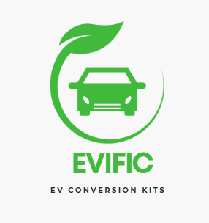
Figure 1: EVIFIC Logo
The proposed business titled EVIFIC would offer EV conversion kits to customers that would help transition internal combustion engines to EV ones. As per the views of Thammasiriroj et al. (2025), the EV conversion industry seeks to retrofit classic cars with electric powertrains to transition to an EV vehicle and eliminate the need for an internal combustion engine. The business model proposes the sales of detailed kits that would help transition cars to EV vehicles. The kits would include an electric motor, Lithium Ion batteries, on-board charger, and an electronic pedal assembly to help existing car owners to transition to EV and alleviate costs.
Management Structure
EVIFIC would adopt a flat management structure to accommodate the limited number of employees considering its startup nature. As per the views of Reitzig (2022), flat organisations are decentralised and have limited managerial hierarchy. The benefits of flat structure include faster decision-making and empowerment of employees by offering autonomy. Initially, three key employees would constitute the business with each one having been paid approx £ 1000 monthly, wherein they would constitute managerial roles. The business would seek out the use of delegation wherein production and assembly would be delegated to automobile factories and marketing would be done through agencies.

Legal Format
The private limited company label would be acquired by EVIFIC legally to establish the business as a separate legal entity. Private limited companies have key benefits in terms of raising capital from external sources since it can be registered on the stock market and are limited in terms of debt remediation. Private limited companies are also highly credible and help to improve the amount of funding accessible for a company. Thus, the private limited legal format would allow EVIFIC to easily seek investment and protect the founders from legal debts in case of financial losses.

3. Market Research

3.1 PESTLE Analysis
Factor | Description | Impact
Political | - Corporate taxation for companies with profits under £50,000 pay statutory tax of 19% (GOV UK, 2025) | High
Economic | - UK consumer price inflation as of January 2026 was around 3% (Trading Economics, 2026) | High
Social | - Government survey details that 64% of cars owned by customers were petrol variants and 32% diesel variants (GOV UK, 2022) | High
Technological | - The annual R&D budget of £13.9 billion is depicted by the Department of Science, Innovation and Technology (GOV UK, 2025a) | Moderate
Legal | - The Environment Protection Act of 1990 regulates emission limits and provisions for vehicle emission rates (Legislation GOV, 2025) | Low
Environmental | - An estimated 28,000 tonnes of EV batteries would require recycling by 2030 (SMMT, 2025) | High

Analysis
The aforementioned PESTLE analysis demonstrates the external market factors influencing EVIFIC’s apparent growth in the UK automotive market. The political factors show a high corporate taxation rate of 19% on SMEs for companies having profits below £50,000 in the UK. The political factors depict that high taxation would enforce EVIFIC to maximise sales in order to improve profit margins. The economic factors detail that inflation of 3% has been attributed to increase in commodity prices (Trading Economics, 2026). The growing inflation rate would affect business-pricing leading to higher price setting that may affect customer acquisition. Similarly, the Social factor denotes the large number of petrol and diesel vehicle owners, representing the viable market for EVIFIC to facilitate conversion to EV vehicles. Thus, the key factors affecting the business would be the rising inflation, high taxes, and large presence of non-EV vehicles in the UK market.
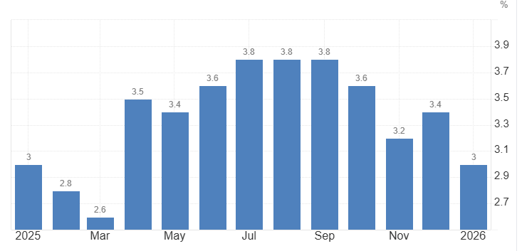
Figure 2: Inflation Rate in the UK
(Source: Trading Economics, 2026)
The outcomes of technological factors detail that a growing R&D budget for the government would allow the business to source funding easily. The legal factors depict that the environmental protection law would be applicable on the business since it deals with vehicular emissions. On the contrary, the EV conversion kits provided by EVIFIC would contribute to the growing number of e-waste (lithium batteries) in the UK once the battery life expires. Thus, EVIFIC needs to identify measures of improving its battery life in order to support its sustainability stance.

3.2 Competitive Analysis
The prominent primary competitors of EVIFIC would constitute brands that offer EV conversion kits to consumers. This would include brands such as Electrogenic, eDub conversions and Relik Electric that offer conversion kits to customers. For example, Electrogenic offers conversion kits for prominent vehicles such as Mazda MX5, Land Rover Defender, Porsche 911, and Volkswagen mini (Electrogenic, 2026). The secondary competitors of the brand constitute brands that sell EV vehicles directly to consumers such as RBW electric cars, Polestar and Switch Mobility.
The competitors of the EVIFIC selling EV conversion kits are limited to only a handful of models with limited consideration for commercial consumer vehicles. EVIFIC would gain a competitive edge by creating a unique EV conversion kit supported by almost all types of popular consumer vehicles (two and four wheelers separately). Car models that would be prioritised include ones that have higher sales potency such as Ford Puma, Kia Sportage, Mini coopers, and Nissan Juke etc. Moreover, the EVIFIC would also aim to offer retrofitting services wherein customers can either buy the kits outright or submit their vehicles to be fitted with EV components. Hence, the focus on consumer vehicle electrification would support the sustainable cause of EVIFIC and allow it to gain market share.

4. Marketing Communications
Product
EVIFIC’s product strategy would observe use of differentiation by focusing on EV conversion of vehicles that are commonly used by consumers. The existing companies in the UK offering EV conversion kits focus either on sports vehicles or on delivery trucks. Thus, EVIFIC would help transition internal combustion vehicles to EV and market its support for popular pedestrian cars.
Price
Standard EV conversion kits constitute higher prices since they include a number of expensive parts such as the lithium batteries and central computing systems. The competitive pricing strategy would be adopted by EVIFIC wherein the firm would prioritise undercutting prices of competitors to gain a price advantage. The tentative price for standard 4 wheeler conversion kits would be set at £ 10,000 for 4 wheelers and £ 5,000 for two wheelers.
Place
The B2B and B2C sales strategies would be adopted to maximise sales advantages. B2B sales would prioritise sales to car dealerships and B2C would be done from the company’s own website and its offline stores.
Promotion
The promotional strategies adopted for EVIFIC would include use of social media campaigns and Influencer marketing to maximise consumer adoption. The average demographics of Instagram and Facebook include 2 billion and 2.97 billion consisting of young adult populations (Mishnick and Wise, 2024). Facebook and Instagram would serve as the key promotional channels wherein social campaigns would be run depicting the benefits of EV. The campaigns would detail out the cost-effective measure of conversion to EV and the environmental benefits of the procedure. Similarly, influencers related to marketing of automobile and racing related content would be brought on to promote the product. Influencer marketing would help transition immediate customers to the service and lead the firm to improve its financial marketing returns respectively.

5. Financials
Funding required, funding Sources and startup expenses expected during first month
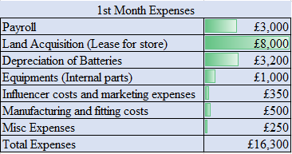
Figure 3: Start-up expenses during the first month
The aforementioned table above denotes the initial expenses of the business during the initial month denoting a total expense of around £ 16,300. The core expenses would occur from the acquisition of land for store and the costs associated with payroll and deprecation costs. The initial year of the business would be bootstrapped and hence the initial funding for the start-up would be paid from own pocket. Venture capital type of funding would be openly welcomed from the second year wherein the funding sources would include either angel investors or venture capital firms.
Budget, cash flow and breakeven
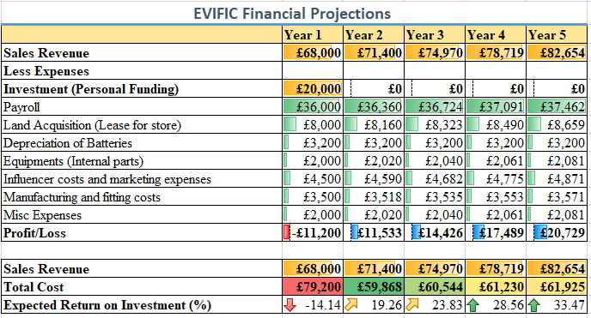
Figure 4: Cash Flow and Budget projections
The cash flow projections detail that the initial investment of £20,000 pounds would be given during business initiation and the estimated sales revenue for the first year would be around £68,000 pounds. The statement depicts that the firm would not be profitable during the initial year and incurs losses of around £11,200 observing profits from the second year. The expected returns on investment would range between 19-33% for the first five years and would grow further given the legislative pushes towards adoption of EV.
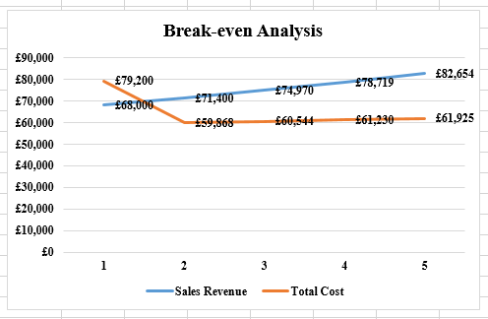
Figure 5: Break Even Analysis
The break-even analysis denotes that the firm would break-even prior to the second year. The first year would observe losses since sales revenues would be lower than the initial costs of investment done for the business but it would increase from year two.

6. Conclusion
The business plan concludes that EVIFIC would find heightened success in the UK automotive industry since it aims to transition existing vehicles to be EV compliant. The business would break even from the second year and would use marketing campaigns and influencers to boot product acquisition.

Reference List
Electrogenic (2026) Conversion Kits. Available at: https://www.electrogenic.co.uk/kits/conversion-kits/ (Accessed: 23 March 2026)
GOV UK (2022) National Travel Survey 2021. Available at: https://www.gov.uk/government/statistics/national-travel-survey-2021/national-travel-survey-2021-household-car-availability-and-trends-in-car-trips (Accessed: 23 March 2026)
GOV UK (2025) Corporate Tax Rates. Available at: https://www.gov.uk/government/publications/rates-and-allowances-corporation-tax/rates-and-allowances-corporation-tax (Accessed: 23 March 2026)
GOV UK (2025a) DSIT research and development allocations for 2025/2026. Available at: https://www.gov.uk/government/publications/dsit-research-and-development-rd-allocations-for-20252026/dsit-research-and-development-rd-allocations-for-20252026 (Accessed: 23 March 2026)
Legislation Gov (2025) Environmental Protection Act 1990. Available at: https://www.legislation.gov.uk/ukpga/1990/43/contents (Accessed: 23 March 2026)
Mishnick, N. and Wise, D. (2024) Social Media Engagement: An Analysis of the Impact of Social Media Campaigns on Facebook, Instagram, and LinkedIn. International Journal of Technology in Education, 7(3), pp.535-549.
Reitzig, M. (2022) Get better at flatter. Springer International Publishing.
SMMT (2025) Electric Vehicle Battery Recycling. Available at: https://www.smmt.co.uk/article/electric-vehicle-battery-recycling/ (Accessed: 23 March 2026)
Thammasiriroj, W., Poompipatpong, C. and Khumpunja, P. (2025) ‘The potential of Thailand in advancing the classic car EV conversion industry: A transition strategy’. World Electric Vehicle Journal, 16(3), p.122. Available at: https://www.mdpi.com/2032-6653/16/3/122
Trading Economics (2026) United Kingdom Inflation Rate. Available at: https://tradingeconomics.com/united-kingdom/inflation-cpi (Accessed: 23 March 2026)
Wise, S., Zacharakis, A., Corbett, A.C. and Bygrave, W.D. (2024) Entrepreneurship. John Wiley and Sons.

