

Marketing Environment Analysis and Competitive Growth Strategy: Tata Steel’s Lower-Carbon Transition

Programme: Master of Business Administration

Module: Marketing Management

Module code: LCMB7024

Student name: Vaishali Godhaniya

Student ID: 2610916

Word count: 2,628

Lecturer’s Name: Taonga Kaonga Sobere-Snithers(Birmingham)

Submission date: 22 October 2026

Table of Contents
1 Task 1: Marketing Environment Analysis 2
1.1 Company Selection and Analytical Scope 2
1.2 Environmental Influence: Decarbonisation and Resource Constraints 3
1.2.1 Environmental Performance as a Market Requirement 3
1.2.2 Electricity and Scrap as Strategic Constraints 4
1.3 Political and Legal Actors 6
1.4 Social Factors: Sustainability Expectations and Public Trust 8
2 Task 2: Strategic Growth and Competitive Positioning 9
2.1 Recommended Ansoff Strategy: Product Development 9
2.2 Competitive Advantage Through Focused Differentiation 10
2.3 Marketing Responsibilities and Technology 12
2.4 Implementation and Commercial Controls 12
3 Task 3: Managerial and Professional Reflection 13
3.1 Rationale for Key Decisions 13
3.2 Strategic Judgement and Leadership Communication 14
3.3 Limitations and Further Evidence 15
4 References 16

Task 1: Marketing Environment Analysis

Company Selection and Analytical Scope
Tata Steel is a great example of how environmental forces are changing Industrial marketing. Whilst acknowledging that the environmental performance of the entire multinational group cannot be reflected in the actual performance of each site, this report focuses on its UK business and the Port Talbot transition. The 2025-2026 Tata Steel report features a £1.25 billion electric arc furnace (EAF) project, an annual capacity of 3.2 million tonnes and a 90% cut in onsite carbon emissions. These are investment plans and expected results; not numbers for completed decarbonisation (Tata Steel, 2026).
This report uses the PESTLE framework to critically analyse three external factors which have an impact on the transition of Tata Steel towards making lower carbon steel: environmental, economic and technological. A special focus is on environmental constraints such as carbon emissions, resource availability and the reduction of environmental impact of steel production. Economic factors are explored, including electricity prices, investment needed, and market conditions; and technological factors are explored, including electric arc furnace developments, scrap processing and emissions measurement. The analysis is based on the opportunities and constraints these external developments provide for Tata Steel's production decisions, costs and competitive positioning (Fan & Friedmann, 2021; Kim et al., 2022 and Algers et al., 2025).

Environmental Influence: Decarbonisation and Resource Constraints

Environmental Performance as a Market Requirement
Steel production through conventional methods are under threat from environmental pressures as it is becoming more and more difficult to reconcile the carbon-intensive approach with customers' decarbonisation targets. But without revealing its boundary of emissions, its route of production and its baseline of comparison, “green steel” is not a precise enough proposition. The decarbonisation of steel represents a sequence of coordinated technological, infrastructural and institutional transformations, and is by no means a policy of equipment replacement that creates environmental superiority along the value chain (Fan & Friedmann, 2021; Kim et al., 2022; Qian et al., 2024).
Tata Steel's forecasted on-site reductions is shown in Figure 1 (based on an indexed baseline). The difference is relevant to the market: if the buyer is buying finished steel, they will want product-level evidence that includes electricity, feedstock, and the associated processing operations. There is thus a need for marketing to include validated carbon intensity per tonne, in addition to performance data. The reduction of the site's projected footprint would equate to a reduction in the lifecycle footprint of each product, which would overestimate the evidence available (Suer et al., 2022; Qian et al., 2024; de Freitas Netto et al., 2020).
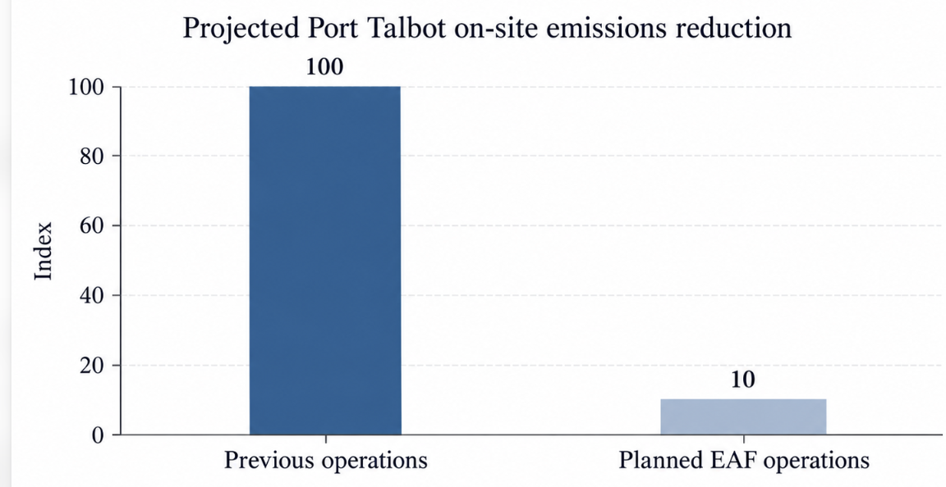
Figure 1. Indexed comparison of previous and projected Port Talbot on-site emissions. Source: Author’s own work based on Tata Steel (2026).

Electricity and Scrap as Strategic Constraints
The environment benefits from EAF production, as there is an opportunity for recycling of scrap; however, these benefits are dependent on the quality of feedstock and supply of electricity. Similarly, studies on hydrogen steelmaking show that the carbon benefit is related to the electricity used to produce the hydrogen. Therefore, technological labelling can be used as a substitute for the lifecycle assessment, and the results of the hydrogen-based routes should not be mapped directly to the investment of Port Talbot's scrap-based EAF (Bhaskar et al., 2020; Rechberger et al., 2020; Toktarova et al., 2021).
Availability of scrap is also different from region to region. According to Watari, Giurco and Cullen (2023), there are benefits for areas with existing stocks of steel, but the developing economies are subjected to more constraints. However, the availability of plenty of scrap does not guarantee that it is adequate feedstock for challenging applications. Completeness and accuracy of the compositional information is important, and contamination can affect production quality and is commercially significant, which is why sorting traceability and supplier coordination is important. Tata Steel should therefore consider the supply of reliable scraps as part of its 'customer value infrastructure' and not just a purchasing matter (Compañero et al., 2021; Raabe et al., 2024; Sari et al., 2026).
For Tata Steel, resource efficiency is an important aspect of reacting to environmental pressures. With the resource-constrained scenario modelled by Watari and McLellan (2024), a global steel production capacity of about 30% less than the projected BAU demand in 2050 is feasible. Business-as-usual is the study's base demand pathway, without the extra demand reduction measures being modeled in the resource-constrained analysis. The conditional finding calls into question growth strategies that rely solely on an expansion in volume. Tata Steel has instead a potential opportunity to add value by assisting with longer product life cycles, better yield in manufacturing, and by assisting customers to design products which need less steel. These are approaches that involve commercial development and resource efficiency (Watari & McLellan, 2024; Bocken et al., 2025). A similar study (Watari, Cabrera Serrenho, et al., 2023) on the analysis of steel and cement supply potential under various carbon-budget scenarios is presented in Figure 2.
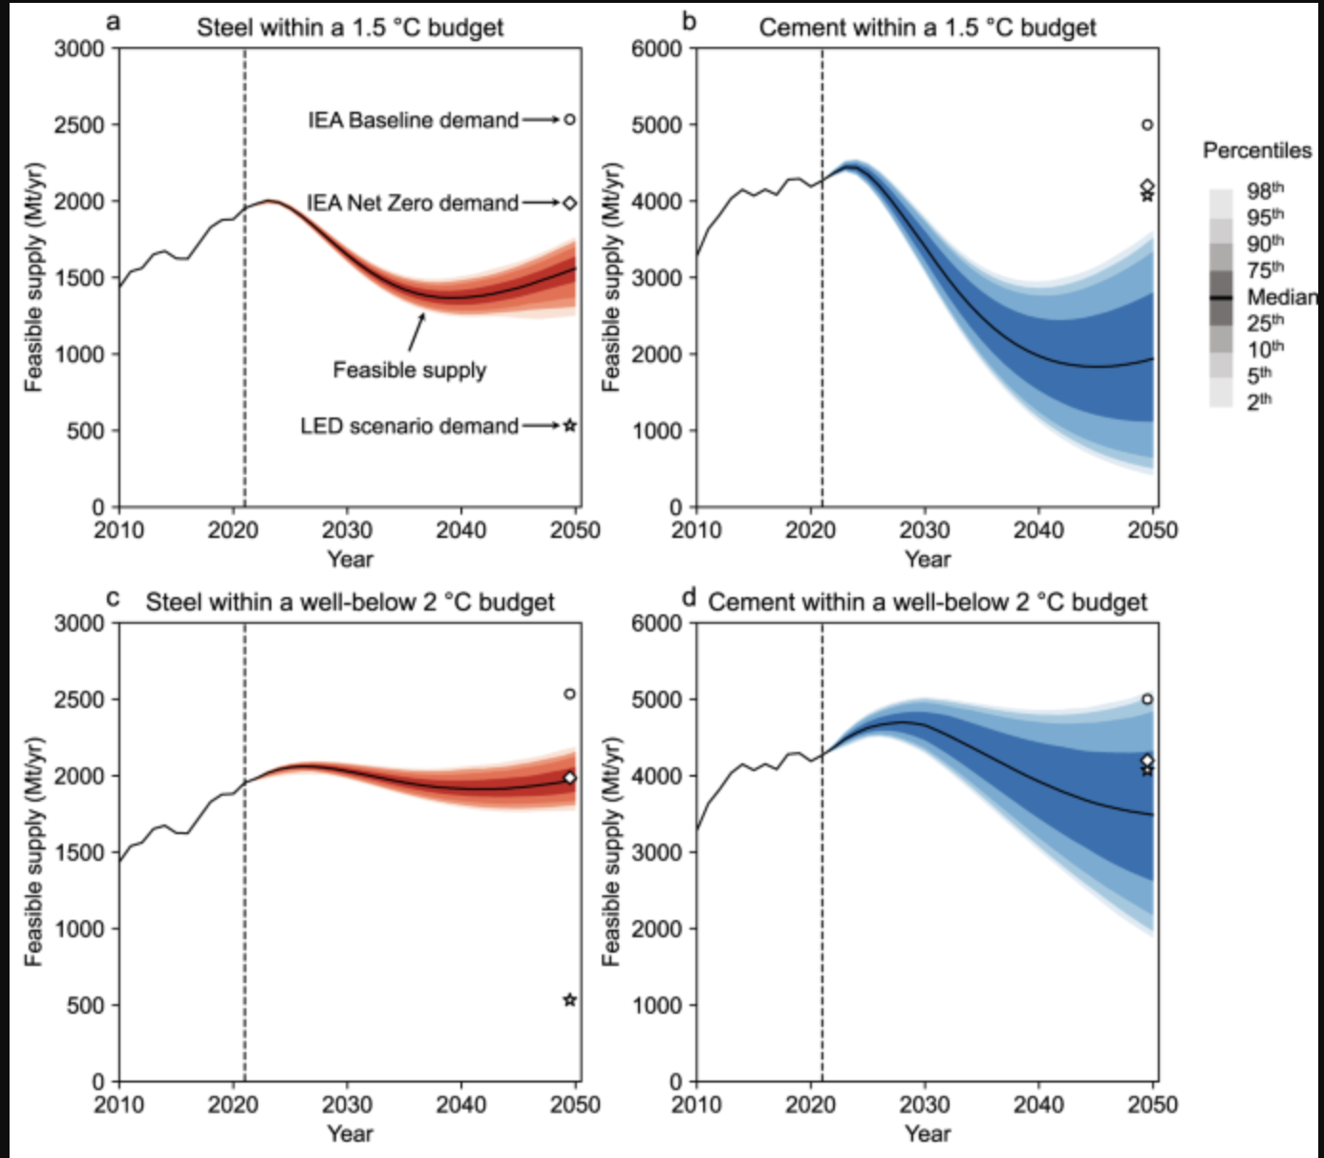
Figure 2. Original published graph of feasible steel and cement supply under carbon-budget constraints Source: Watari, Cabrera Serrenho, et al. (2023)

Political and Legal Actors
The transition is influenced by government support (investment, carbon pricing and carbon trading). The UK Government will fund up to £500m (40%) of the £1.25 billion announced investment, the other 60% coming from Tata Steel. This subsidy lessens the financing burden on the company, but does not guarantee that the operating costs or customer demand from the company or future margins will be competitive (Tata Steel UK, 2024). There are complementary policy and market arrangements that are necessary for industrial decarbonisation, and many studies show that subsidy measures, in isolation, are insufficient (Fan & Friedmann, 2021; Algers et al., 2025).

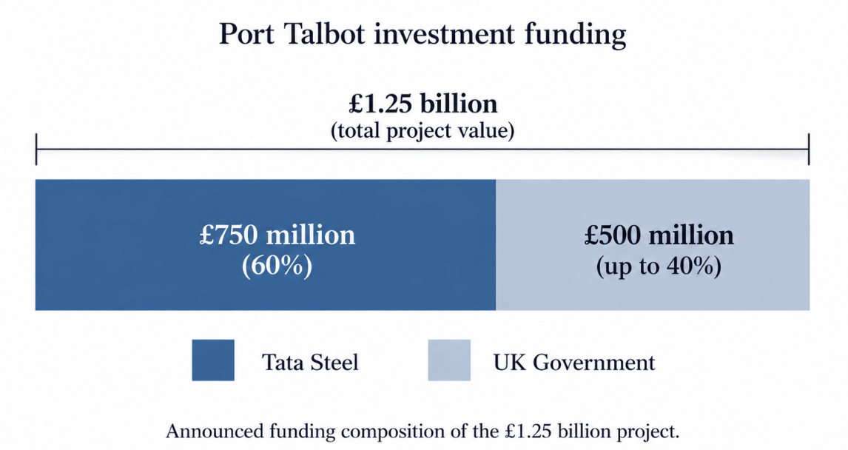
Figure 3. Announced funding composition of the Port Talbot investment Source: Author’s own work based on Tata Steel UK (2024).
The UK Carbon Border Adjustment Mechanism (CBAM) will start on 1 January 2027 for certain products, including iron and steel. It is a measure to counter carbon leakage through imposing a similar carbon price on the relevant imports. But, because of its product-specific nature, it cannot be assumed that all imported products that compete will be treated the same. The marketing department should share regulatory changes with customers in terms that they can apply to their procurement process, backed by valid, reported emissions data and not vague assertions of competitive advantage in the UK (HM Revenue & Customs [HMRC] 2026, Qian et al., 2024 and Kim et al., 2022).
The distributional effects of the transition are just as crucial to the public legitimacy of the transition. Decarbonisation can help maintain industrial jobs while generating challenges for employment and communities. As Wang and Lo (2021) demonstrate, a just transition is a transition that involves labour, governance and broader justice issues. Communications can thus limit the consideration for stakeholders who will incur adjustment costs, if those stakeholders are the only ones who are not discussed. Tata Steel should report on retraining, workforce engagement and community outcomes in its reporting, separate from, and not as though, a carbon reduction is a criterion for social sustainability (Wang & Lo, 2021; Montgomery et al., 2024; Bocken et al., 2025).

Social Factors: Sustainability Expectations and Public Trust
Pressure from societal expectations about environmental responsibility drives steel producers to prove that they are making credible strides to reduce carbon in steel production. Studies showed that trust, perceived benefits and credibility of environmental claims impact reactions to sustainability communication (Szabo & Webster, 2021; Eyasu & Negash, 2026). These expectations will make it even more crucial for Tata Steel to back up environmental claims and to make clear what has been achieved and what remains to be done. But, positive attitudes towards sustainability do not always result in higher prices or purchases. This means that Tata Steel needs to respond to the public's expectations, and not rely on the reputational goodwill to lead to commercial returns (Montgomery et al., 2024).
Social pressures also stem from the expectation that industrial decarbonisation will not come at the cost of livelihoods and will take into account communities that are impacted by restructuring. The just transition literature focuses on participation, fairness in terms of sharing transition costs and benefits (Wang & Lo, 2021). Workforce consultation, retraining and transparent reporting of community outcomes are important considerations when applied to Tata Steel. Transition presented entirely in carbon reduction terms could fail to bring people to the table, who are feeling the economic and social impacts of the transition, and may lead to a lack of support from stakeholders. Tata Steel's response should therefore not only involve environmental improvement, but it should also be demonstrated through social responsibility and accept that there are compromises between production changes and jobs and the long-term industrial viability (Wang & Lo, 2021; Bocken et al., 2025; Montgomery et al., 2024).
Table 1 summarises the environmental, political and legal, and social factors considered. These factors combine to drive Tata Steel's transition, providing impetus to lower environmental footprint, meet policy needs, and uphold public confidence.
Table 1. External influences and marketing implications
Influence | Opportunity | Principal challenge | Marketing response
Environmental factors | Lower-carbon products and greater material circularity | Resource constraints and the need to demonstrate lifecycle emissions reductions | Communicate verified product-level emissions and traceability
Political and legal factors | Investment support and measures addressing carbon leakage | Policy dependence and compliance requirements | Provide accurate environmental documentation and regulatory reporting
Social factors | Stronger public trust through credible environmental and social responsibility | Greenwashing concerns and the effects of restructuring on workers and communities | Substantiate claims and transparently communicate consultation, retraining and community outcomes
Source: Author’s own synthesis based on Kim et al. (2022), Qian et al. (2024), and Eyasu and Negash (2026).

Task 2: Strategic Growth and Competitive Positioning

Recommended Ansoff Strategy: Product Development
The product development is advised to be Tata Steel's key growth path based on two reasons: firstly to provide an improved lower-carbon steel portfolio to its current industrial customers. Ansoff's (1957) Matrix depicts four growth strategies, which include market penetration, market development, product development and diversification. Product development is the introduction of new or improved products to the marketplace. The proposed offering would offer Tata Steel customers the technical specifications they need, as well as the independently verified lower embodied-carbon performance, with material traceability and technical support. The improvement that is intended is therefore a measurable environmental attribute in the customer offering and backed by reliable evidence (Ansoff, 1957; Bocken & Geradts, 2020; Qian et al., 2024).
This recommendation is based on the environmental pressures, political and legal requirements, and social expectations identified in Task 1. In the first instance, Tata Steel needs to engage with current customers to qualify the improved offering and determine if the environmental attributes have an impact on the purchasing process. This strategy is compared with the other Ansoff strategies in Table 2. Market penetration may be necessary to retain customers during the transition and market development may follow the successful qualification in existing markets. Diversification would add further product and market volatility into an already challenging transition process. Therefore, it is preferable to first go in the direction of product development, provided environmental improvement is confirmed, technical acceptance and commercial viability are ensured (Ansoff, 1957; Bocken & Geradts, 2020; Algers et al., 2025).
Table 2. Application of the Ansoff Matrix
 | Existing markets | New markets
Existing products | Market penetration: retain accounts through service and supply reliability | Market development: expand established products into additional applications
New or enhanced products | Product development—priority: verified lower-carbon grades and services | Diversification: simultaneous entry into unfamiliar offerings and customer groups
Source: Adapted from Ansoff (1957); company applications are the author’s proposals.

Competitive Advantage Through Focused Differentiation
Tata Steel should first aim at differentiation to the customers for whom the embodied-carbon reduction is verified and can make a significant impact on the procurement decision. Porter's (1985) framework backs up a competing by distinctive value in a selected segment. It would be hard to motivate a broad cost leadership, in the absence of evidence of favourable electricity, scrap and conversion costs. However, differentiation can easily be copied by rivals and customers may not be prepared to pay premium prices for differences made in just the language used to market the products or services (Porter, 1985; Fan & Friedmann, 2021; Szabo & Webster, 2021).
The offer added value is a mix of certified environmental performance, technical qualification, traceability and customer integration. Such additional capacities are more sustainable than a generic “green” certification. Closed-loop arrangements could involve the return of appropriate customer scrap to the production system and joint engineering projects would enhance yields and minimise material needs. But their worth is dependent on the specification of the feedstock, the logistics and the contractual governance. However, the concept of circularity needs to be assessed based on measurable operational results, not on the basis of recycling (Compañero et al., 2021; Raabe et al., 2024; Sari et al., 2026).
The conditional relationship of capability investment and competitive outcomes is shown in Figure 4. Technology only plays a part in advantage if there is reliable evidence coupled with customer acceptance and commercial execution linked to the purchasing behaviour.
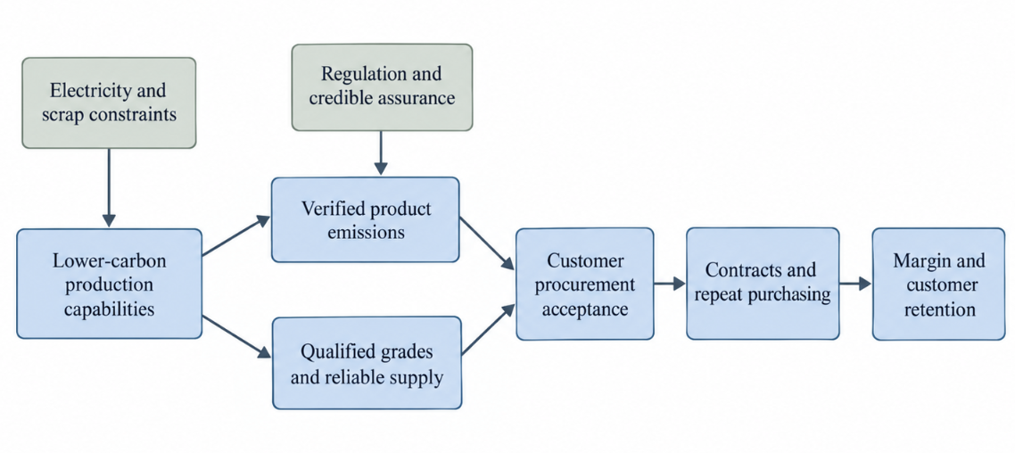
Figure 4. Proposed pathway from decarbonisation capabilities to competitive advantage Source: Author’s own work based on Bocken and Geradts (2020), Qian et al. (2024), and Porter (1985).

Marketing Responsibilities and Technology
Marketing to coordinate the discovery, positioning and evidence-based communication. Account teams should differentiate between customers that have mandatory emissions targets and those customers that have general sustainability preferences. Carbon Boundaries, grade and delivery commitments should be included in the contracts. Communication should distinguish any improvements that are planned from any improvements that have been achieved, as future-oriented claims are susceptible to becoming a form of greenwashing if conditions for their achievement remain unclear (Montgomery et al., 2024; de Freitas Netto et al., 2020; Eyasu & Negash, 2026).
Controlled access to product documentation, qualification records and approved environmental statements by digital customer portals. While AI can help with demand forecasting and prioritisation of accounts, human oversight should be the final say in determining claims and strategies. Digital reach is not a good indicator of success in this market, but rather are qualified opportunities, contractual conversion and repeat purchasing. These recommendations link the organisational role of marketing with recent technological developments, thus tackling LO1 and LO2 (Huang & Rust, 2021; Dwivedi et al., 2021; Bashar et al., 2026).

Implementation and Commercial Controls
Implementations should be made via customer research, pilot qualification and stepped up expansion. Additional contracts should be contingent upon actual product results, carbon data backed by a third party and favorable contract margins. Test cases with no premium and higher electricity prices and delayed qualification in the decision making. Table 3 sets out proposed controls, but does not provide invented company targets. Lastly, growth must be assessed not just via tonnes, but also via customer value and profitable applications, taking into account the potential contradiction between growth and resource efficiency (Toktarova et al., 2021; Watari & McLellan, 2024; Bocken et al., 2025).
Table 3. Proposed management controls
Dimension | Measure | Decision requirement
Environmental credibility | Verified emissions per tonne | Consistent boundaries and independent assurance
Technical performance | Qualification results and rejection rates | Compliance with customer specifications
Demand | Contracted volume and conversion | Purchasing commitments beyond stated interest
Commercial viability | Contribution margin under stress scenarios | Acceptable returns with limited premiums
Social legitimacy | Retraining and stakeholder outcomes | Transparent assessment of transition effects
Source: Author’s proposed controls based on Qian et al. (2024), Toktarova et al. (2021), and Wang and Lo (2021).

Task 3: Managerial and Professional Reflection

Rationale for Key Decisions
I selected Tata Steel because its Port Talbot transition provides a practical case for examining how environmental pressures influence production investment and marketing strategy. However, relying on a prominent company’s disclosures creates a risk of accepting corporate claims without sufficient critical evaluation. I therefore distinguished between announced investment commitments, projected environmental benefits and demonstrated commercial outcomes. This distinction strengthened my recommendation by avoiding the assumption that technological investment automatically produces customer acceptance or competitive advantage. It also highlighted the importance of independently verified emissions data when evaluating the credibility of a lower-carbon product offering (Kim et al., 2022; Qian et al., 2024; Montgomery et al., 2024).
I prioritised environmental factors because emissions reduction and resource constraints directly affect Tata Steel’s transition towards lower-carbon production. Political and legal factors were selected to examine how government support and regulatory requirements influence the transition, while social factors addressed public trust and expectations concerning workers and affected communities. These categories provided a focused basis for evaluating external pressures and developing recommendations. However, selecting only these influences limited the analysis: economic conditions and technological developments also require consideration before implementation. A fuller assessment would examine electricity costs, scrap availability and production capabilities alongside the selected factors (Fan & Friedmann, 2021; Wang & Lo, 2021; Algers et al., 2025).

Strategic Judgement and Leadership Communication
My smartest strategic move was to suggest development of products for established customers as opposed to significant market growth. Joint qualification is possible through existing relationships, but does not eliminate procurement risk because of the relationship. I also saw that if production-process innovation is not meaningful, it remains only production-process innovation and is not product development. This qualification makes the Ansoff recommendation more defendable and not an automatic yes to invest (Ansoff, 1957; Bocken & Geradts, 2020; Verhoef et al., 2021).
When presenting the recommendation to senior leadership, I would specify three conditions for expanding the proposed lower-carbon product range: independently verified reductions in product-level embodied carbon, successful qualification against customers’ technical specifications, and purchasing commitments that support acceptable margins. The principal uncertainties concern customers’ willingness to pay, electricity and scrap costs, and the time required for product qualification. Positive attitudes towards sustainability would not establish that customers will accept higher prices (Eyasu & Negash, 2026). I would therefore recommend customer interviews, controlled product trials and financial sensitivity analysis before wider commercial commitments. This would allow leadership to assess whether the strategy remains viable under lower premiums, higher input costs or delayed customer acceptance. I would also evaluate growth through improved customer value and material efficiency, recognising that longer product lifetimes and reduced manufacturing waste may create value without increasing sales volumes (Watari & McLellan, 2024; Bocken et al., 2025).

Limitations and Further Evidence
This analysis is based on secondary sources that has varying aims and scope. Company disclosures can be helpful when it comes to investment plans, but do not necessarily prove environmental claims. Many studies of technology in the academic world employ modelled conditions which might not apply to Port Talbot. In addition, consumer marketing results should not be taken for granted in industrial procurement. The wide range of references thus reinforces the conceptual analysis but cannot be used as a substitute for primary commercial evidence (Suer et al., 2022; Szabo & Webster, 2021; Watari, Cabrera Serrenho, et al., 2023).
I would conduct interviews with customers, grade-level lifecycle assessments, qualification results, contract for electric, and competitor's specifications before completing the strategy. Downside scenarios and investment alternatives should be analyzed in the financial analysis. Beyond emissions, consultation with workforce and community representatives would be a way to address legitimacy. Professionally, this exercise helps reinforce the importance of clear communication of uncertainty and of using commercial, technical and ethical evidence. This leads to a conditional recommendation: lower carbon product development should be pursued as long as the demand and delivery possibility allows for sustainable returns (Toktarova et al., 2021; Wang & Lo, 2021; Algers et al., 2025).

References
Algers, J., Åhman, M., & Nilsson, L. J. (2025). Steel decarbonization—from optimization to transformation. Annual Review of Environment and Resources, 50, 433–454. https://www.annualreviews.org/content/journals/10.1146/annurev-environ-111523-101851
Ansoff, H. I. (1957). Strategies for diversification. Harvard Business Review, 35(5), 113–124. https://books.google.com/books/about/Strategies_for_Diversification.html?id=_opJvwEACAAJ
Bashar, A., Alkadash, T., Nyagadza, B., & Muposhi, A. (2026). Sustainable digital marketing (SDM): Review, taxonomy, conceptualisation and future research avenues mapping. Quality & Quantity, 60, 4045–4070. https://link.springer.com/article/10.1007/s11135-025-02438-7
Bhaskar, A., Assadi, M., & Nikpey Somehsaraei, H. (2020). Decarbonization of the iron and steel industry with direct reduction of iron ore with green hydrogen. Energies, 13(3), Article 758. https://www.mdpi.com/1996-1073/13/3/758
Bocken, N. M. P., & Geradts, T. H. J. (2020). Barriers and drivers to sustainable business model innovation: Organization design and dynamic capabilities. Long Range Planning, 53(4), Article 101950. https://www.sciencedirect.com/science/article/pii/S0024630119301062
Bocken, N. M. P., Niessen, L., Gossen, M., Das, A., & Zielińska, M. (2025). Marketing in the anthropocene: A future agenda for research and practice. AMS Review, 15, 23–47. https://link.springer.com/article/10.1007/s13162-025-00300-5
Compañero, R. J., Feldmann, A., & Tilliander, A. (2021). Circular steel: How information and actor incentives impact the recyclability of scrap. Journal of Sustainable Metallurgy, 7, 1654–1670. https://link.springer.com/article/10.1007/s40831-021-00436-1
de Freitas Netto, S. V., Sobral, M. F. F., Ribeiro, A. R. B., & Soares, G. R. L. (2020). Concepts and forms of greenwashing: A systematic review. Environmental Sciences Europe, 32, Article 19. https://link.springer.com/article/10.1186/s12302-020-0300-3
Dwivedi, Y. K., Ismagilova, E., Hughes, D. L., Carlson, J., Filieri, R., Jacobson, J., Jain, V., Karjaluoto, H., Kefi, H., Krishen, A. S., Kumar, V., Rahman, M. M., Raman, R., Rauschnabel, P. A., Rowley, J., Salo, J., Tran, G. A., & Wang, Y. (2021). Setting the future of digital and social media marketing research: Perspectives and research propositions. International Journal of Information Management, 59, Article 102168. https://www.sciencedirect.com/science/article/pii/S0268401220308082
Eyasu, A., & Negash, M. (2026). How and when green marketing works: A systematic review of consumer responses, moderators, and boundary conditions. Future Business Journal, 12, Article 127. https://link.springer.com/article/10.1186/s43093-026-00839-0
Fan, Z., & Friedmann, S. J. (2021). Low-carbon production of iron and steel: Technology options, economic assessment, and policy. Joule, 5(4), 829–862. https://www.sciencedirect.com/science/article/pii/S2542435121000957
HM Revenue & Customs. (2026). Carbon Border Adjustment Mechanism (CBAM): Policy summary. https://www.gov.uk/government/publications/carbon-border-adjustment-mechanism-cbam-policy-summary/carbon-border-adjustment-mechanism-cbam-policy-summary
Huang, M.-H., & Rust, R. T. (2021). A strategic framework for artificial intelligence in marketing. Journal of the Academy of Marketing Science, 49, 30–50. https://link.springer.com/article/10.1007/s11747-020-00749-9
Kim, J., Sovacool, B. K., Bazilian, M., Griffiths, S., Lee, J., Yang, M., & Lee, J. (2022). Decarbonizing the iron and steel industry: A systematic review of sociotechnical systems, technological innovations, and policy options. Energy Research & Social Science, 89, Article 102565. https://www.sciencedirect.com/science/article/pii/S2214629622000706
Montgomery, A. W., Lyon, T. P., & Barg, J. (2024). No end in sight? A greenwash review and research agenda. Organization & Environment, 37(2), 221–256. https://journals.sagepub.com/doi/10.1177/10860266231168905
Moodaley, W., & Telukdarie, A. (2023). Greenwashing, sustainability reporting, and artificial intelligence: A systematic literature review. Sustainability, 15(2), Article 1481. https://www.mdpi.com/2071-1050/15/2/1481
Porter, M. E. (1985). Competitive advantage: Creating and sustaining superior performance. Free Press. https://books.google.com/books/about/Competitive_Advantage.html?id=86PbNAEACAAJ
Qian, Y., Li, Y., Hao, Y., Yu, T., & Hu, H. (2024). Greenhouse gas control in steel manufacturing: Inventory, assurance, and strategic reduction review. Carbon Research, 3, Article 27. https://link.springer.com/article/10.1007/s44246-024-00118-z
Raabe, D., Jovičević-Klug, M., Ponge, D., Gramlich, A., Kwiatkowski da Silva, A., Grundy, A. N., Springer, H., Souza Filho, I., & Ma, Y. (2024). Circular steel for fast decarbonization: Thermodynamics, kinetics, and microstructure behind upcycling scrap into high-performance sheet steel. Annual Review of Materials Research, 54, 247–297. https://www.annualreviews.org/content/journals/10.1146/annurev-matsci-080222-123648
Rechberger, K., Spanlang, A., Sasiain Conde, A., Wolfmeir, H., & Harris, C. (2020). Green hydrogen-based direct reduction for low-carbon steelmaking. Steel Research International, 91(11), Article 2000110. https://onlinelibrary.wiley.com/doi/full/10.1002/srin.202000110
Sari, W. P., Fitrady, A., Cahyaningsih, A., Nugrahaningsih, F., Husada, S., Suprayogi, W., Pujanarto, S. R., & Widyaparaga, A. (2026). Metal scrap value chains and global benchmarking for green manufacturing and industrial decarbonization. Discover Sustainability, 7, Article 998. https://link.springer.com/article/10.1007/s43621-026-03392-6
Suer, J., Traverso, M., & Jäger, N. (2022). Review of life cycle assessments for steel and environmental analysis of future steel production scenarios. Sustainability, 14(21), Article 14131. https://www.mdpi.com/2071-1050/14/21/14131
Szabo, S., & Webster, J. (2021). Perceived greenwashing: The effects of green marketing on environmental and product perceptions. Journal of Business Ethics, 171, 719–739. https://link.springer.com/article/10.1007/s10551-020-04461-0
Tata Steel. (2026). Integrated report & annual accounts 2025–26. https://www.tatasteel.com/investors/integrated-report-2025-26/pdf/tatasteel-iar-2025-26.pdf
Tata Steel UK. (2024). Tata Steel signs contract for green steelmaking technology. https://www.tatasteeluk.com/corporate/news/tata-steel-signs-contract-for-green-steelmaking-technology
Toktarova, A., Göransson, L., & Johnsson, F. (2021). Design of clean steel production with hydrogen: Impact of electricity system composition. Energies, 14(24), Article 8349. https://www.mdpi.com/1996-1073/14/24/8349
Verhoef, P. C., Broekhuizen, T., Bart, Y., Bhattacharya, A., Dong, J. Q., Fabian, N., & Haenlein, M. (2021). Digital transformation: A multidisciplinary reflection and research agenda. Journal of Business Research, 122, 889–901. https://www.sciencedirect.com/science/article/pii/S0148296319305478
Wang, X., & Lo, K. (2021). Just transition: A conceptual review. Energy Research & Social Science, 82, Article 102291. https://www.sciencedirect.com/science/article/pii/S2214629621003832
Watari, T., Cabrera Serrenho, A., Gast, L., Cullen, J., & Allwood, J. (2023). Feasible supply of steel and cement within a carbon budget is likely to fall short of expected global demand. Nature Communications, 14, Article 7895. https://www.nature.com/articles/s41467-023-43684-3
Watari, T., Giurco, D., & Cullen, J. (2023). Scrap endowment and inequalities in global steel decarbonization. Journal of Cleaner Production, 425, Article 139041. https://www.sciencedirect.com/science/article/pii/S0959652623031992
Watari, T., & McLellan, B. (2024). Decarbonizing the global steel industry in a resource-constrained future—a systems perspective. Philosophical Transactions of the Royal Society A: Mathematical, Physical and Engineering Sciences, 382(2284), Article 20230233. https://pmc.ncbi.nlm.nih.gov/articles/PMC11542903/

