

LEVEL/ LEFEL 4

MODULE CODE/ COD Y MODIWL: BMSW4004
PROBLEM SOLVING AND DECISION MAKING

ASSESSMENT TYPE/ MATH O ASESU: ASSIGNMENT
ASSESSMENT/COMPONENT/ ASESIAD/CYDRAN: 1
Re-sit Submission
Presentation with Speaker notes
Submitted by: Tahmina Sharmin
University ID: 1816429
Re-submission date: 23-08-20

Topic: Discrimination and racism in Workplace
Introduction

Speaker Notes: The concept of solving problems is defined to be an essential skill that one needs to develop in any professional field. Solving of problems is considered by most researchers and academics to be the focus of our day to day lives. Given that issues are unavoidable in our daily actions and endeavors decision have become a part of life and we tend to apply these decisions towards resolving these issues (Khan, 2016) Working at the Bakers Court home in my role I uncounted various problems and sues mostly discrimination and racism from some coworkers and service users. It is essential we get to understand initially what discrimination and racisms means, this refers to the act of making unjust bias to another based on who they are or where they come from. It considered to be a prejudice or justified and Racism is considered to be discrimination of another person based on their race, ethnicity and skin color (Van Laer and Janssens, 2011). Racism and discrimination has been a topic of debate for a long time and though there has been evidence of an improvement in the situation there is still a long way to go as it still exist in our daily live and also places of work. The presentation will be addressing discrimination and racism at the home and outline its scope, possible outcomes and solutions.
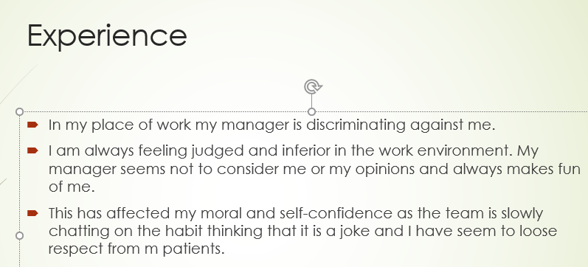
Speaker Notes: Working at the Bakers Court home. It has always been my desire to be of service to the elderly having being raised up with my grandmother I found it very satisfying for me to be there for those who need me. I took pride in my role at the workplace and given the nature of my work I was always working under teams and managed in our various roles offering support for the best delivery of care and social service. However, though in the beginning it was working fine after our manager changed I started experiencing discrimination and being from another ethnic divide I experienced racism. Being a minority taking into consideration the ethnic status of all those working there I felt alone and this was made worse when the new manager would constantly take cases from me quoting I am not competent enough and re-assigning them and constantly calling me names and always arguing me in public in front of co-workers and patients (Offermann et al., 2014). It all started so innocently ad I ignored them thinking it was pranks or jokes on me but it became consistent and it always annoying e. It continued for a while and this really impact my enthusiasm and performance and I developed some fear of even being around my co-workers who would not stand up for me even when I’ve clearly been discriminated and all this made the working environment unbearable and I find myself avoiding and only speaking when expected to and this affected my care delivery.

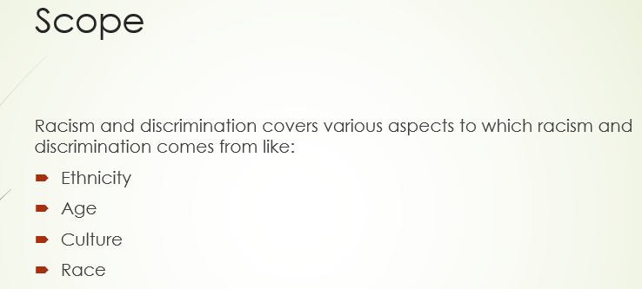
Speaker Notes: Drawing from history racisms and discrimination has always existed and it was considered to be very open and rampant then. It has highlighted that discrimination since its onset has always started from a point of power dynamics and superiority were one person or party felt superior over another and therefore, look down on the other (Gee and Ro, 2019). He dynamics in superiority was drawn from various issues and one of t the earliest forms of discrimination has been discrimination based on sex and gender where women were considered lesser compared to the male counterparts and it was often attributed and crops up from the kind of culture and societal cues and belief system the people ascribed to. It went further to include age which has remained the society till now where the older people and generation consider the younger people incompetent and unworthy of somethings (Green, 2013). On the other hand, ethnicity was one which was found to be very adverse as people with another skin color, culture or set of beliefs were different and not deserving of life privileges. This has been evidenced well throughout history with the racial and ethnic divide ruling various nations for a while where people from a particular racial divide were not allowed their rights and freedoms cause another race considered itself superior and worthy over the other. Though this has changed with time discrimination and racisms hasn’t left the society as there exists mild discrimination in our daily lives.

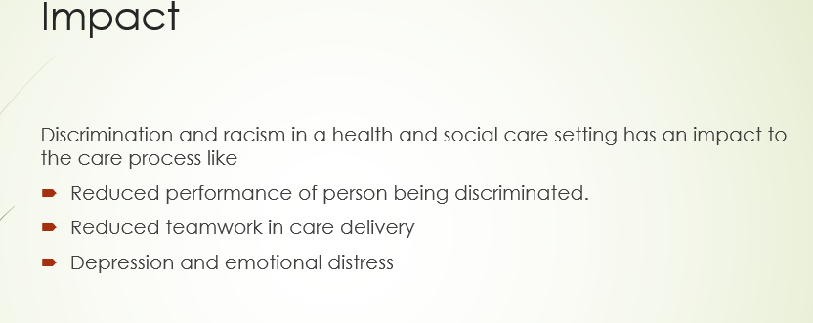
Speaker Notes: Racism and discrimination has numerous impacts in various ways and it seems to affect the one being discriminated upon even more. To be able to understand the impact discrimination and racism has we need to start from history were we see its evident that when people were being discriminated against need on their ethnicity and race it causes drift in how the society operated and history proved it brought about damaged relationships and people (Jones et al., 2016). Others through this did not have access to essential services like medicine and primary care and This was evident also in cultures where people were discriminated against based on their sex where for instance, women were seen to be inferior to men and were often mistreated. A dominant impact to discrimination and racism is the emotional stress which comes with this the one being discriminated against always goes through emotional turmoil and it tends to impact how they socialize and interact with others and bring about self-doubt and insecure and evidence has proved that it often brews enmity. At the work place I experience significant impact to the discrimination i received as I was able to notice that my performance in my delivery of care significantly reduced given that no longer felt appreciated or even needed and always sought to avoid and keep to myself and I ignored my diligence in my role (Kabat-Farr and Cortina, 2012). Later on as the issues started catching on to the co-workers it impacted out cohesion and team work and our multidisciplinary team became a burden as I was afraid of being discriminated while doing my work and being around them. After a while I started getting depressed as I was not sure how best to handle the situation and I was also not willing to give up my role and work in the care home.
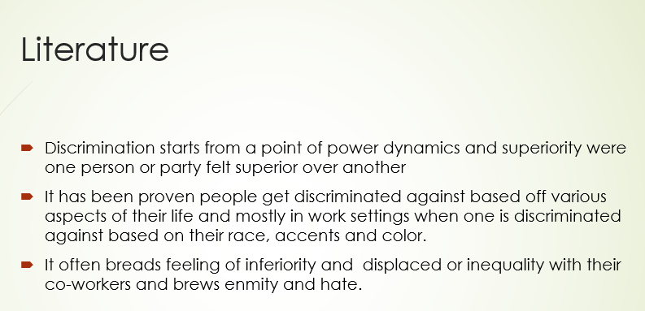
Speaker Notes: Being a part of a certain race and social group with a particular tradition and language is referred to as ethnicity and has been a significant aspect of the society for a long time and it happens to impact different people differently. And it is still within the society that individuals can be discriminated against based on their ethnic group and also sex where it has been evident with discrimination on gender where people often tend to fight for the rights of women, the gender gap and women equality and representation. Drawing from the Equality Act passed in the year 2010 race Is defined to be an individual’s nationality, color and origin and from this we can clearly see the various forms and types of discrimination:
Direct Discrimination- This type of discrimination occurs when an individual is discriminated against based on what race they are.
Indirect Discrimination – This type of discrimination often occurs for instance when an organization discriminates on an individual indirectly through policy and rules that sets these people at a disadvantage.
Harrasment – This happens when one makes another feel humiliated and offended.
Victimization – This occurs when an individual is wrongly just because of who they are according to the Equality act.
It is clear from the impacts of discrimination and racism that it has various cons and I choose discrimination and racism as I consider this a vice that needs to end and has no space in our current society and way of life and given its devastating effect to the people on the receiving end it is important to shed the light to the mild forms of discrimination that still exist in our society.

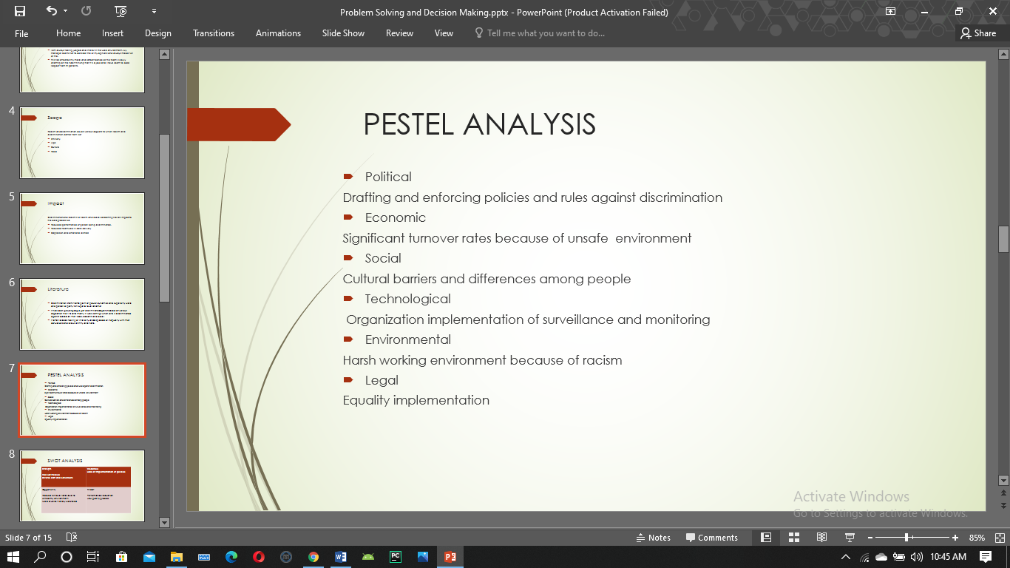
Speaker Notes: This type of analysis is considered one of the major tools applied in the management of organizations it is defined to be a significant asset which helps in the analysis of the issues within an organization with the aim of providing informative and evidence based solutions to these issues. The tool takes into consideration all aspects and variables off the organizations which has significance in the daily operation of the organization
Political
- Drafting and enforcing policies and rules against discrimination
Economic
- Significant turnover rates because of unsafe environment
Social
- Cultural barriers and differences among people
Technological
- Organization implementation of surveillance and monitoring
Environmental
- Harsh working environment because of racism
Legal
- Equality implementation

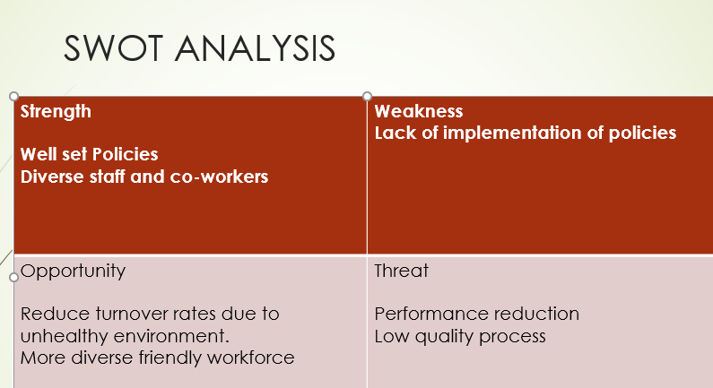
Speaker Notes: The SWOT analysis is considered to be a framework which is applied to evaluate and organize the competitive positions and develop strategic and informed plans. Th tool takes into consideration the internal, external factors that impacts the organization and its current and future potential.
Strength
- Well set Policies
- Diverse staff and co-workers
Weakness
- Lack of implementation of policies
Opportunity
- Reduce turnover rates due to unhealthy environment.
- More diverse friendly workforce
Threat
- Performance reduction
- Low quality process

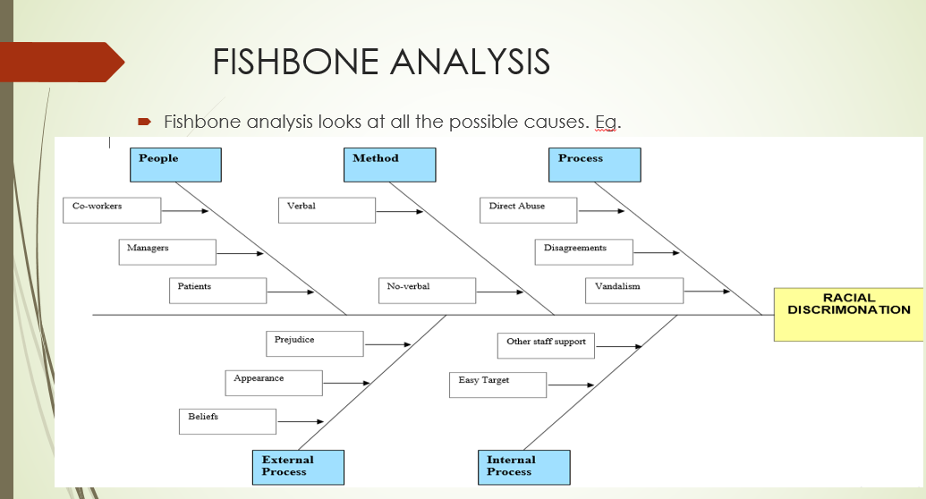
Speaker Notes: The fishbone analysis is defined to be the essential tools for offering a well-defined structure applied in the identification of the root cause factors to the issues and their impact the identified issues have (Okechukwu et al., 2014). It is considered essential which allows you to evaluate the issue and make an informed decision and this helps in improving the understanding of the issues through a structured view and help identify solutions.

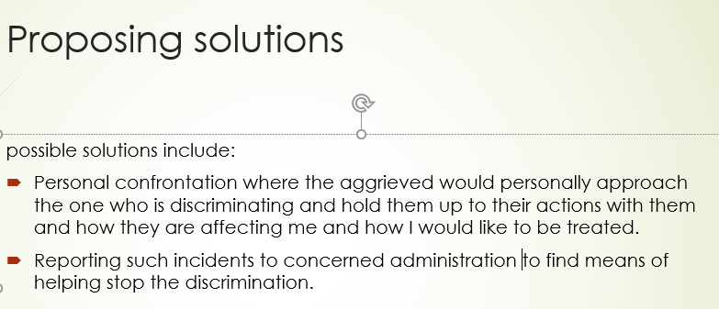
Speaker Notes: Given the impact of discrimination and racism it is essential that reliable means and actions be taken towards making possible solutions t the issues analysis and revealed through the fishbone analysis to impact and bring about discrimination in the work environment including internal and external factors (Fiske and Lee, 2018). The available solutions would include personal confrontation by the aggrieved party to stand ground over the one discriminating and making them aware of their actions and also reporting the incidents of racism and discrimination to the relevant parties to ensure that they are handled.

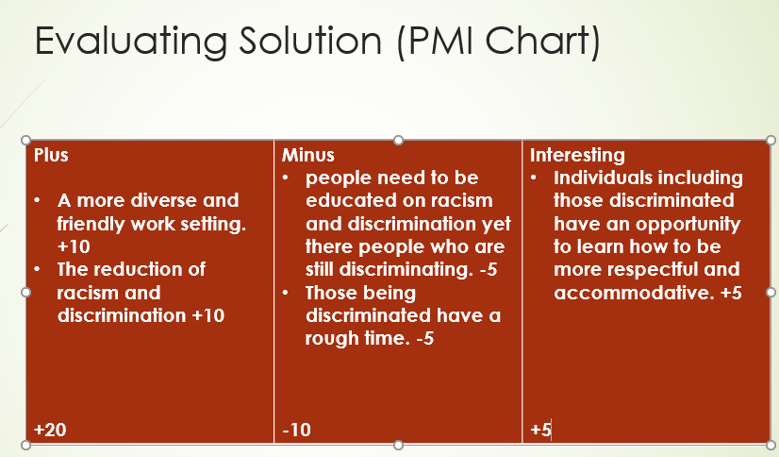
Speaker Notes: The analysis is the concept often applied to discuss ideas and decisions for progress and it refers to both the negative and positive one and considered the neutral points for more deliberation and decision.
Plus | Minus | Interesting
- A more diverse and friendly work setting. +10  - The reduction of racism and discrimination +10  +20 | - people need to be educated on racism and discrimination yet their people who are still discriminating. -5  - Those being discriminated have a rough time. -5  -10 | - Individuals including those discriminated have an opportunity to learn how to be more respectful and accommodative. +5  +5

The is based on the rate of discrimination in the workplace based on the he current situation. It highlights the plus is more than the negatives thus the home need to start considering the implementation of policies and culture against discrimination and racism.

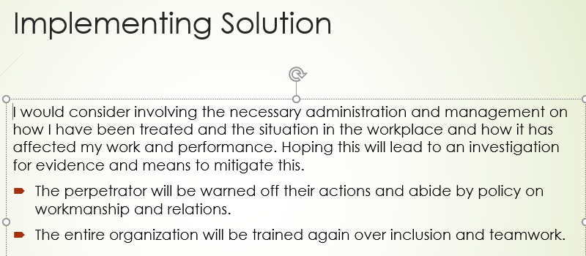
Speaker: Notes: To be able to address the issue on discrimination and racism the best means would be through implementing recommendations on the proposed solutions which would include personal confrontation by the aggrieved party to stand ground over the one discriminating and making them aware of their actions and also reporting the incidents of racism and discrimination to the relevant parties to ensure that they are handled.

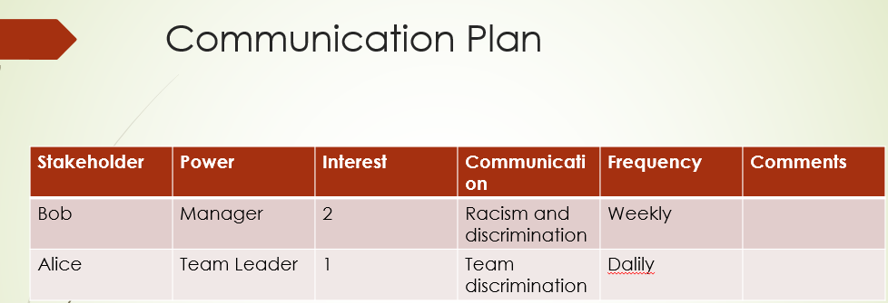
Speaker Notes: The implementation of the proposed solution will be applied by the relevant stakeholders and would include the team leaders and managers who I would report to.

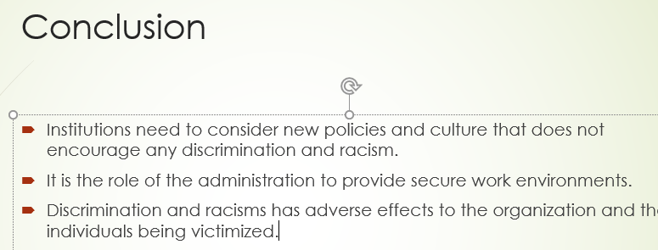
Speaker Notes: In conclusion, it is clear that mild forms of discriminations and racisms till exist in our daily live and workplaces through great strides have been made to mitigate it. It is therefore, imperative for organizations to offer reliable and safe work environments free and safe from any form of discrimination and racism.

Reference List
Fiske, S.T. and Lee, T.L., 2018. Stereotypes and prejudice creating discrimination in the workplace. Cambridge University.
Gee, G.C. and Ro, A., 2019. Racism and discrimination in health: Context, research, policy, and action, pp.364-402.
Green, T.K., 2013. Discrimination in workplace dynamics. Harv. CR-CLL Rev., 38, p.91.
Jones, K.P., Arena, D.F., Nittrouer, C.L., Alonso, N.M. and Lindsey, A.P., 2016. Subtle discrimination in the workplace cycles, 10(1), pp.51-76.
Kabat-Farr, D. and Cortina, L.M., 2012. Selective incivility: Gender, race, and the discriminatory workplace. In Gender and the dysfunctional workplace. Edward Elgar Publishing.
Khan, C., 2016. “The blind spot”: racism and discrimination in the workplace: The Future of Second-and Third-Tier Centers, p.61.
Offermann, L.R., Basford, T.E., Graebner, R., Jaffer, S., De Graaf, S.B. and Kaminsky, S.E., 2014. Perceptions of subtle racial discrimination in the workplace. Cultural Diversity and Ethnic Minority Psychology, 20(4), p.499.
Okechukwu, C.A., Souza, K., Davis, K.D. and De Castro, A.B., 2014. Contribution of workplace injustice to occupational health disparities. American journal of industrial medicine, 57(5), pp.573-586.
Van Laer, K. and Janssens, M., 2011. Ethnic minority professionals’ experiences with subtle discrimination in the workplace. Human Relations, 64(9), pp.1203-1227.

