
Ataur Rahman (2430256)
Research, build, and deploy a Virtualised Enterprise network.

BSc. Applied Computing.

Network Operating Systems and Services.

ACCA5023.

Lecturer: Dr. Sadeque Imam Shaikh
University of Wales Trinity Saint David
(London Campus)

Student Name: Ataur Rahman
Student Number: 2430256
Group: 01
Team: 01
Date: 08/03/2026

Table of Contents
1. Assessment Title: 1
2. Table of Contents 2
Introduction 1
Task 1 2
Task 2 4
2.1. Choose your Hypervisor: 4
2.2. Download and Setup: 5
2.2.1 Evidence of Download and installation. 5
2.2.2 Deploy your network as per the given topology: 8
2.3. Configure IP Addressing 11
2.3.1. Use appropriate IP addresses to configure your network. 12
2.3.2. The above topology gives network address for the networks 14
2.4. Test and Troubleshoot 16
2.4.1. Perform Connectivity tests 16
Task 3 19
References 20

Introduction
Topology (For Coursework 1)
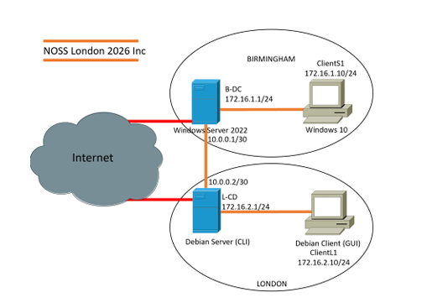

Task 1
Hypervisor:

A computer traditionally works on a one-to-one relationship between the hardware and Operating System, such as Micosoft OS or MAC OS. A Hypervisor changes this dynamic by creating a vrtual environment where it sits between the hardware and Operating System with a one-to-many architecture. This means it isolates the virtual machines in their own environment, splitting direct access to the cpu, memory and storage, within a safe and secure environment. “Hypervisors are base technologies of virtualization (sic) that enable multiple virtual machines (VMs)to run on a single physical host at the same time. Depending on the scenario of deployment, their architecture and functional characteristics are different, which leads to two broad categories: Type 1(bare metal) and Type 2 (hosted) hypervisors [1].”

Type 1 (Bare Metal) hypervisors like VMware ESXi or Proxmox offer superior performance and security by running directly on the hardware, making them the standard for cloud infrastructure and enterprise server consolidation. Conversely, Type 2 (Hosted) hypervisors run as applications on a host OS, providing a user-friendly environment for software development and malware sandboxing, though they suffer from higher latency. The primary advantages include massive cost savings through hardware reduction and enhanced reliability via isolated virtual environments. However, disadvantages involve increased architectural complexity and potential "resource contention" if hardware is over-provisioned. Today, these tools are indispensable for modern IT, enabling legacy app support and the scalable power of global data centers by transforming rigid physical servers into flexible, software-defined resources.
“Many different hypervisors--both open source and commercial-- exist today and are widely used in parallel and distributed computing. While the goals of these hypervisors are the same, the underlying technologies vary [2].”

IP Addressing:
An IP (Internet Protocol) Address is a unique numerical label (address) assigned to every device on a network. It’s principle role is to identify a speficic hardware node and for digital data to reach it. When an email is sen or website visited, the network uses these addresses to route ‘packets’ of data from the source t the relevant destination.

IP addresses are split into two main parts: IPv4, which uses a 32-bit format and IPv6, a 128-bit hexadecimal system. To manage

Research on Network Services:

Research on riuting:

Research on N

Task 2

2.1. Choose your Hypervisor:

2.2. Download and Setup:

2.2.1 Evidence of Download and installation.
Creation of Virtual machine windows 1 and 2 (1 screenshot)
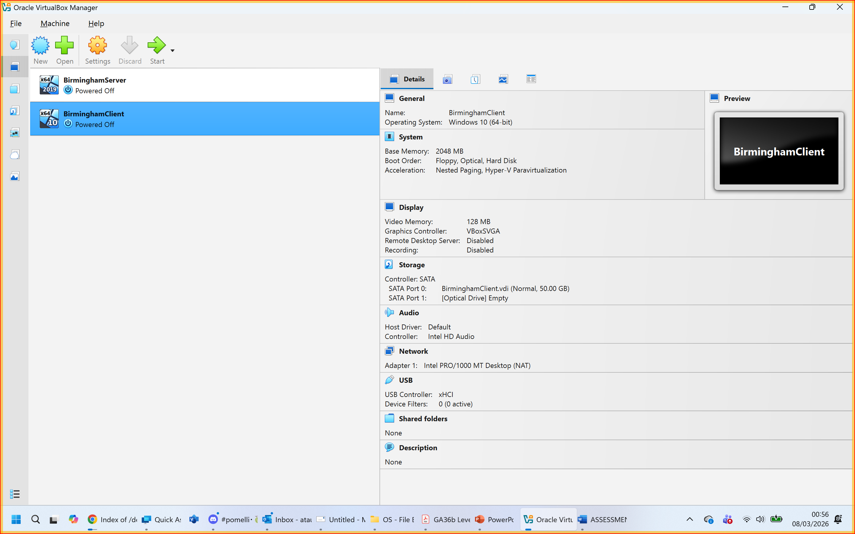
Figure 1: Virtualmachines for Birmingham Windows 2019 Server and Windows 10 Client.

Notes

Creation of Virtual machine Linux Devian 1 and 2(1 screenshot)
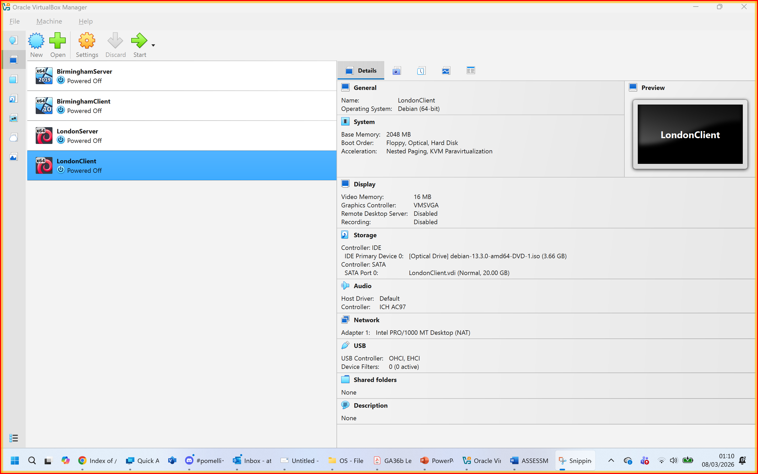
Figure 2: Virtualmachines for London Debian Server and Debian Client.
Installation of windows and Linux OS (Start 4 Machines and take desktop screenshots) (4 screenshots)
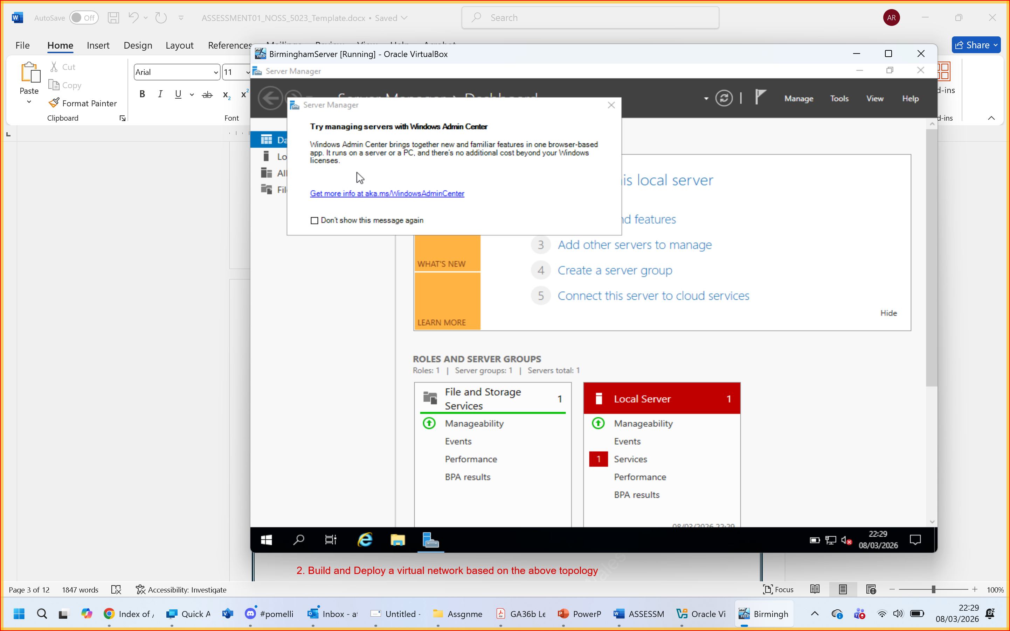
Figure 3: Windows Server 2019 for Birmingham Branch
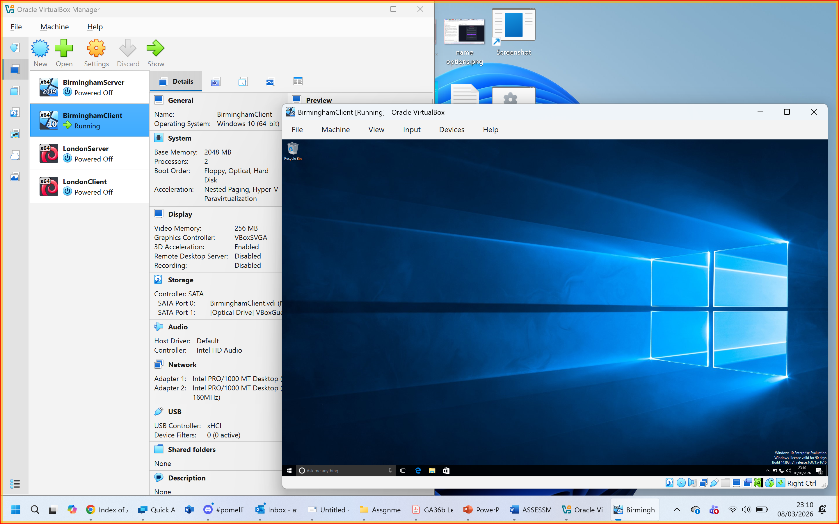
Figure 4: Windows 10 Client for Birmingham branch
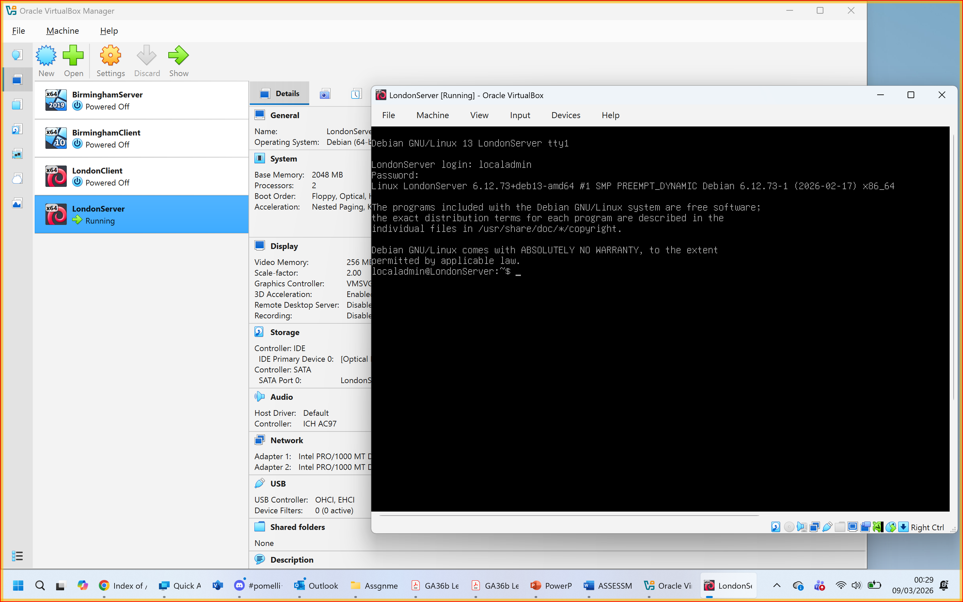
Figure 5:Debian Linux Server for London Branch.
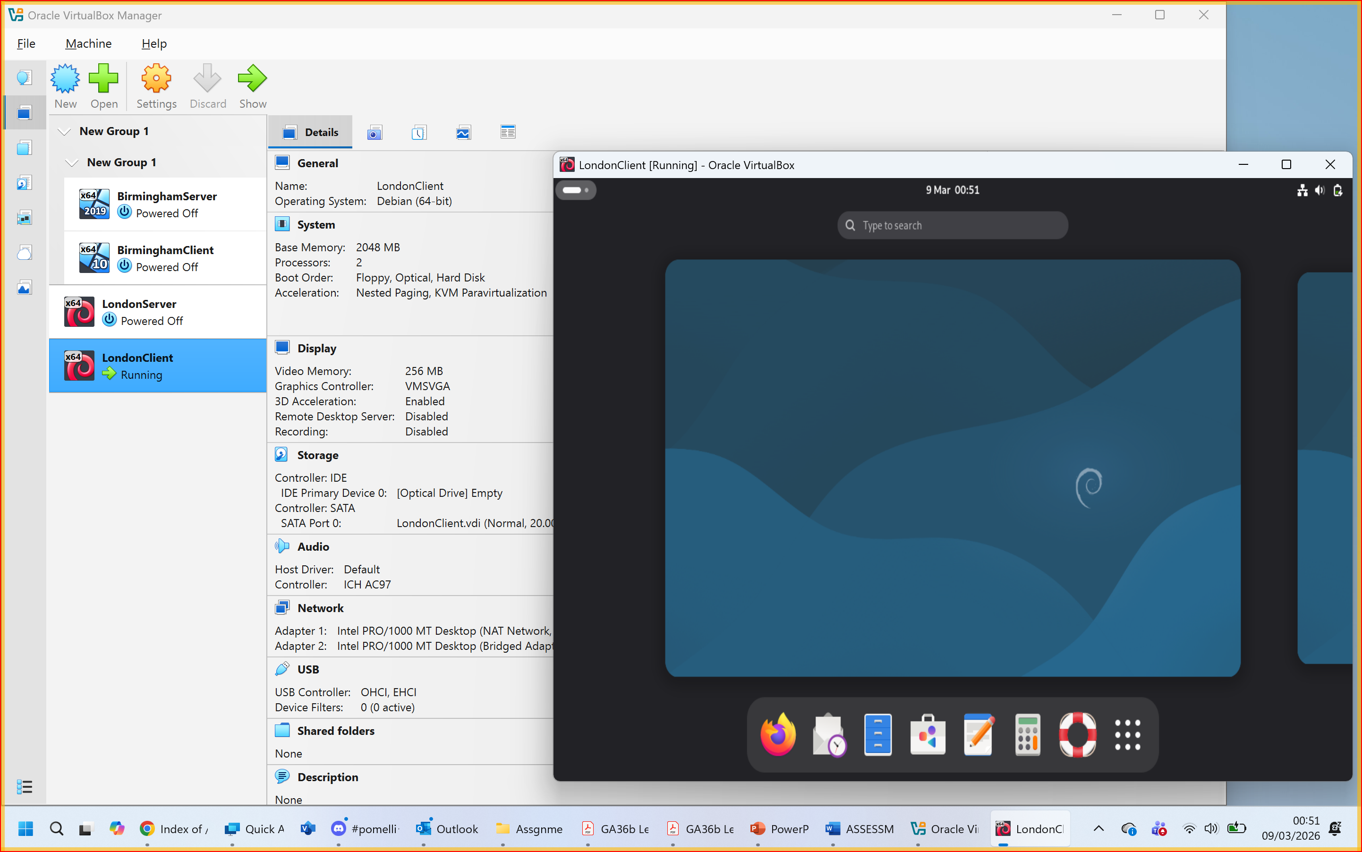
Figure 6: Linux Debian Client for London branch

2.2.2 Deploy your network as per the given topology:
Creation of Network with NAT Network1 for windows (1 screenshot)
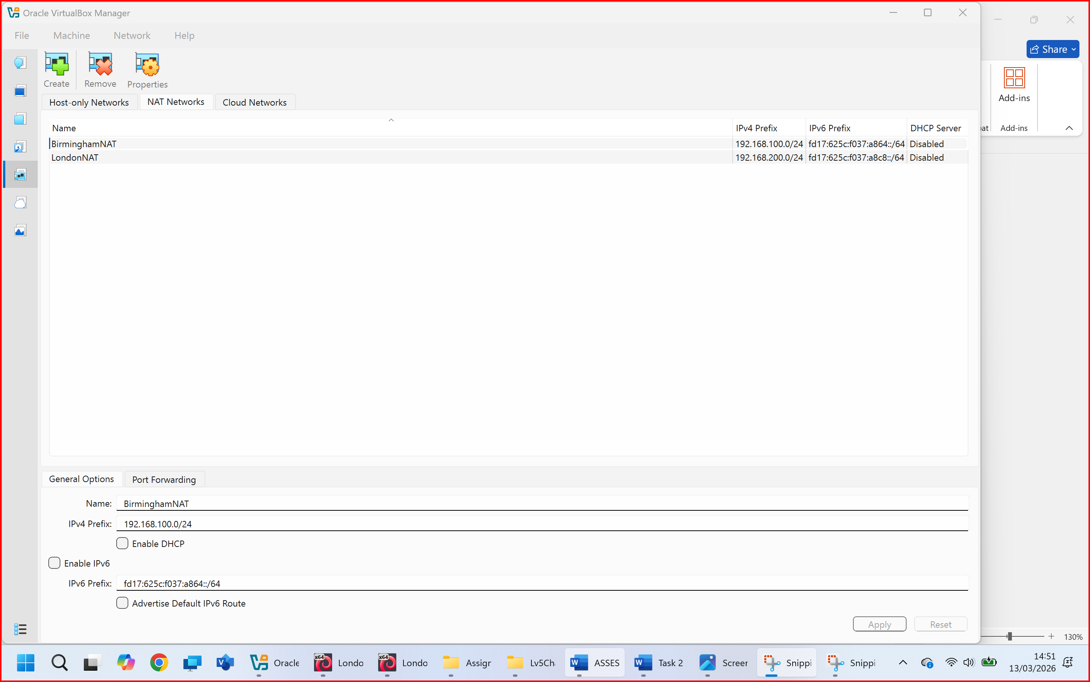
Figure 7: BirminghamNAT is For Birmingham Network in virtualmachine
Creation of Network with NAT Network 2 for Linux (1 screenshot)
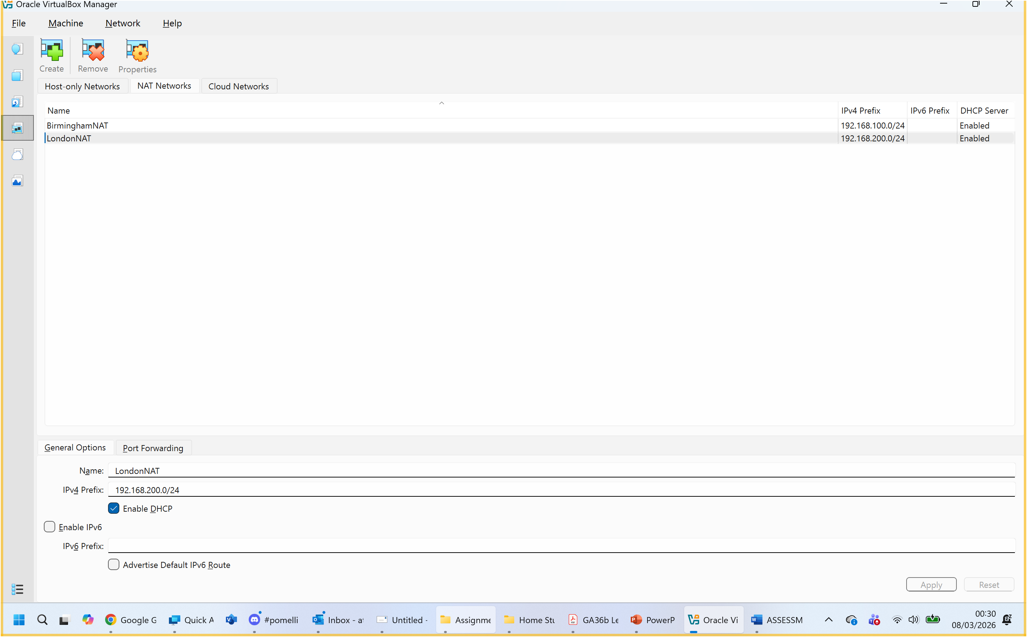
Figure 8: LondonNAT is For London Network in virtualmachine
Evidence of 2 Windows PCs are connected with NAT Network1 (2 screenshot)
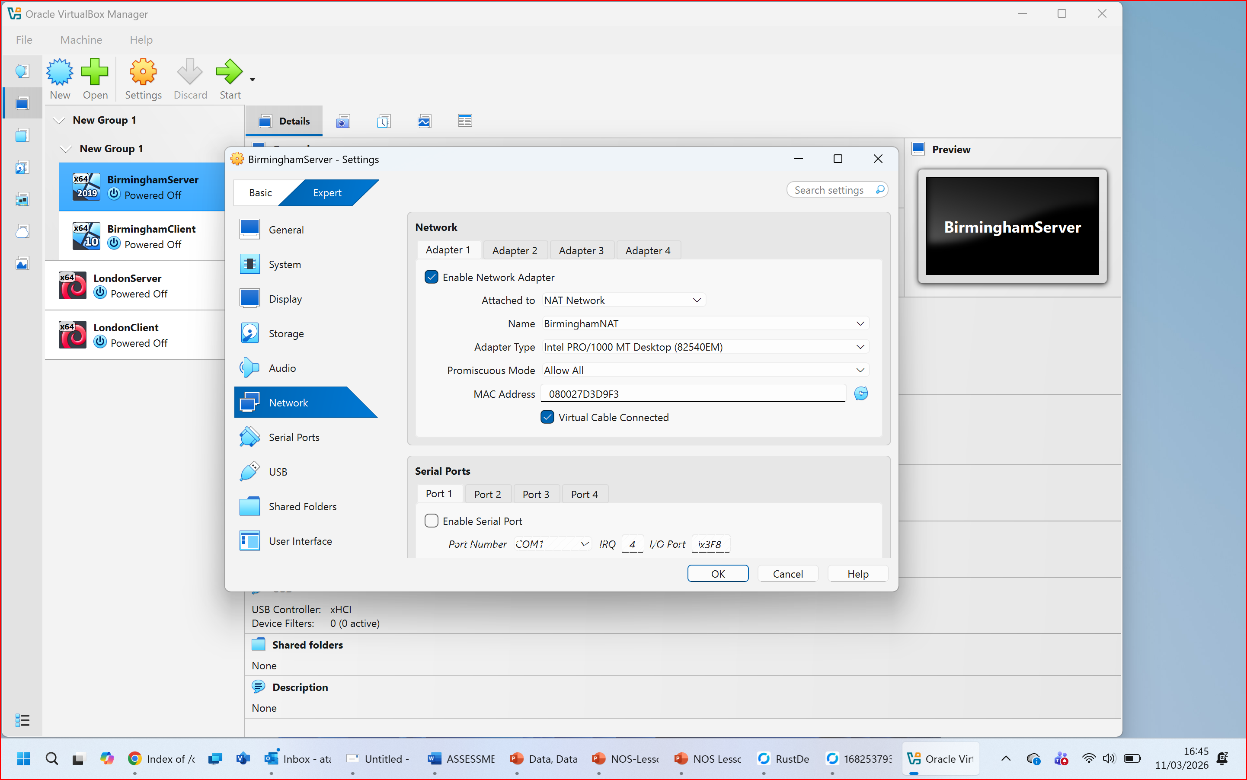
Figure 9: Windows Server 2019 (BriminghamServer) Adaptor1 Configure to BirminghamNAT
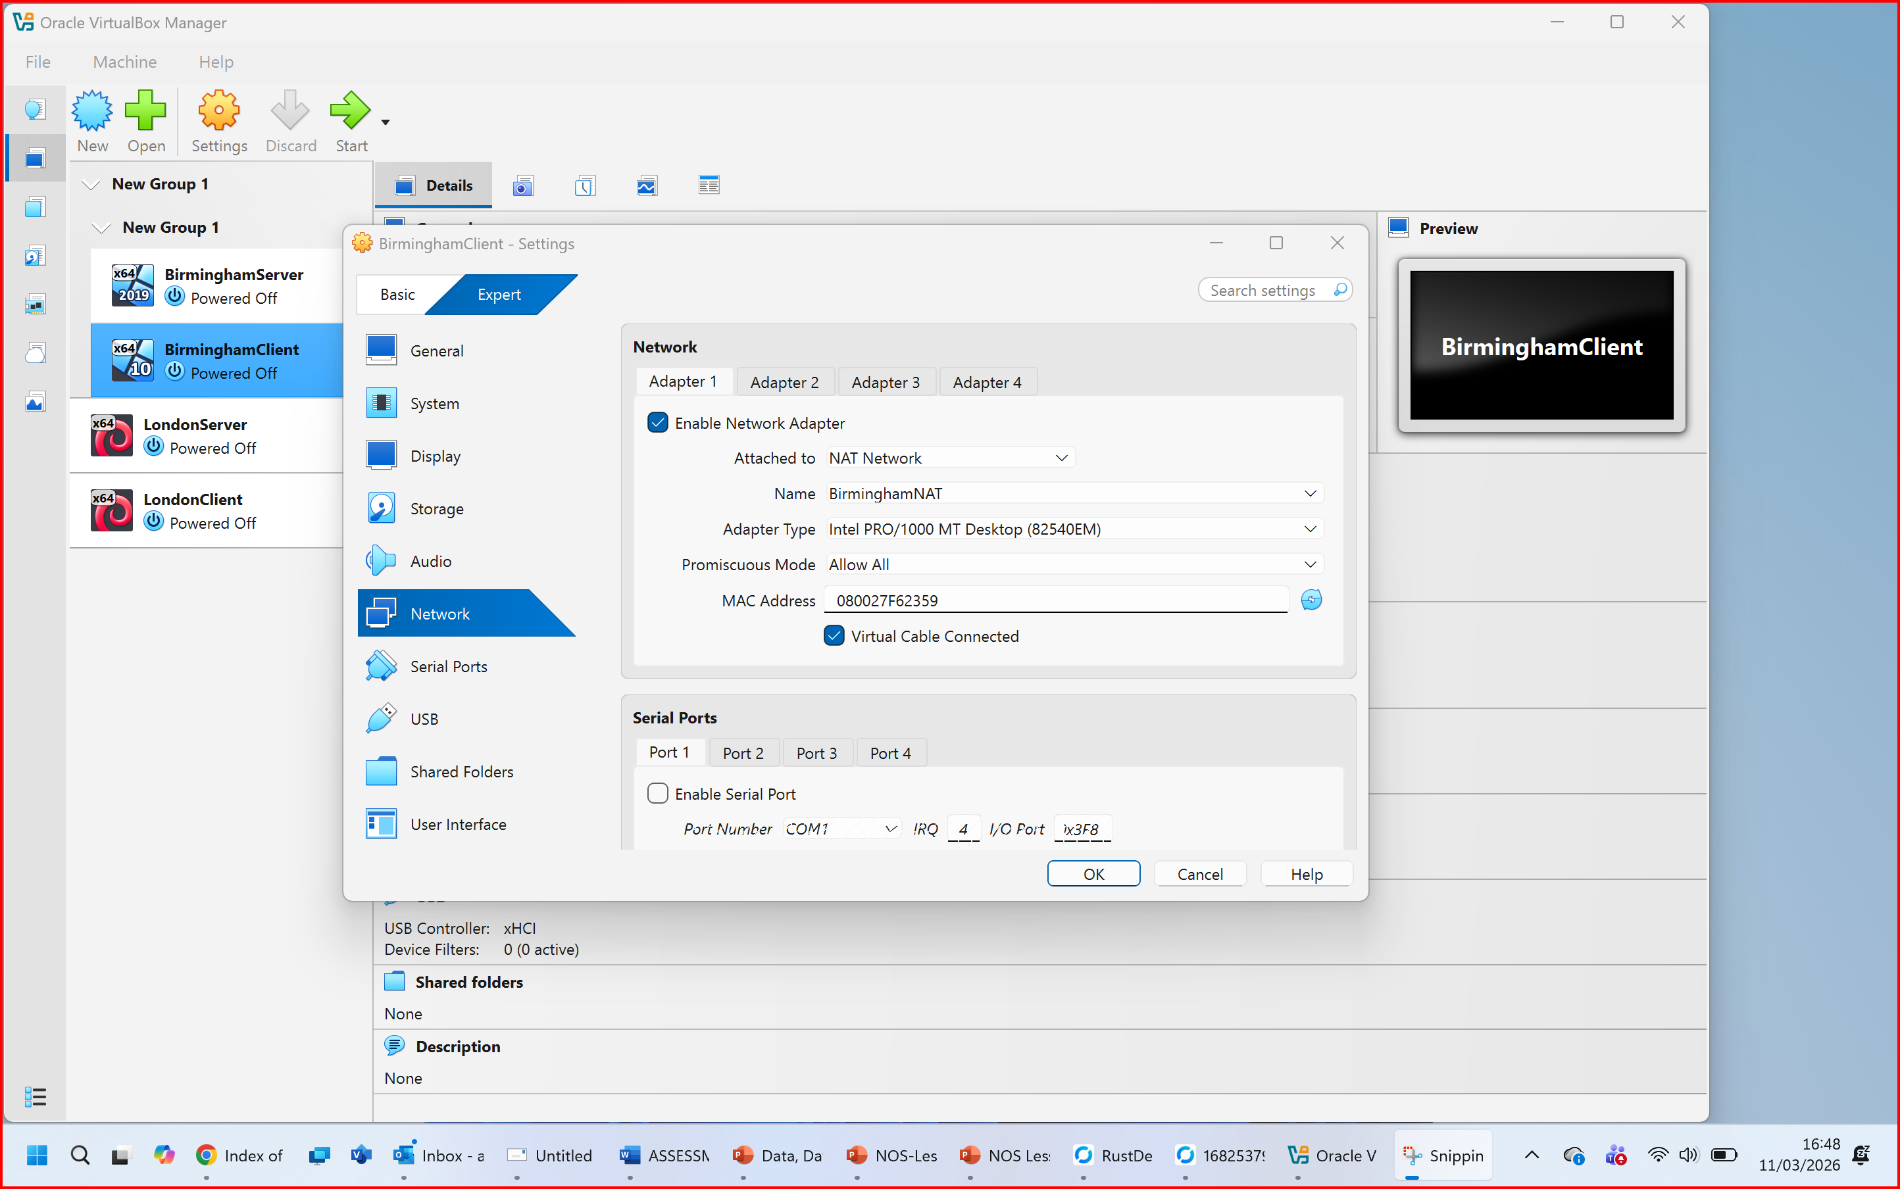
Figure 10: Windows 10 (BriminghamClient) Adaptor1 Configure to BirminghamNAT
Evidence of 2 Linux PCs are connected with NAT Network2 (2 screenshot)
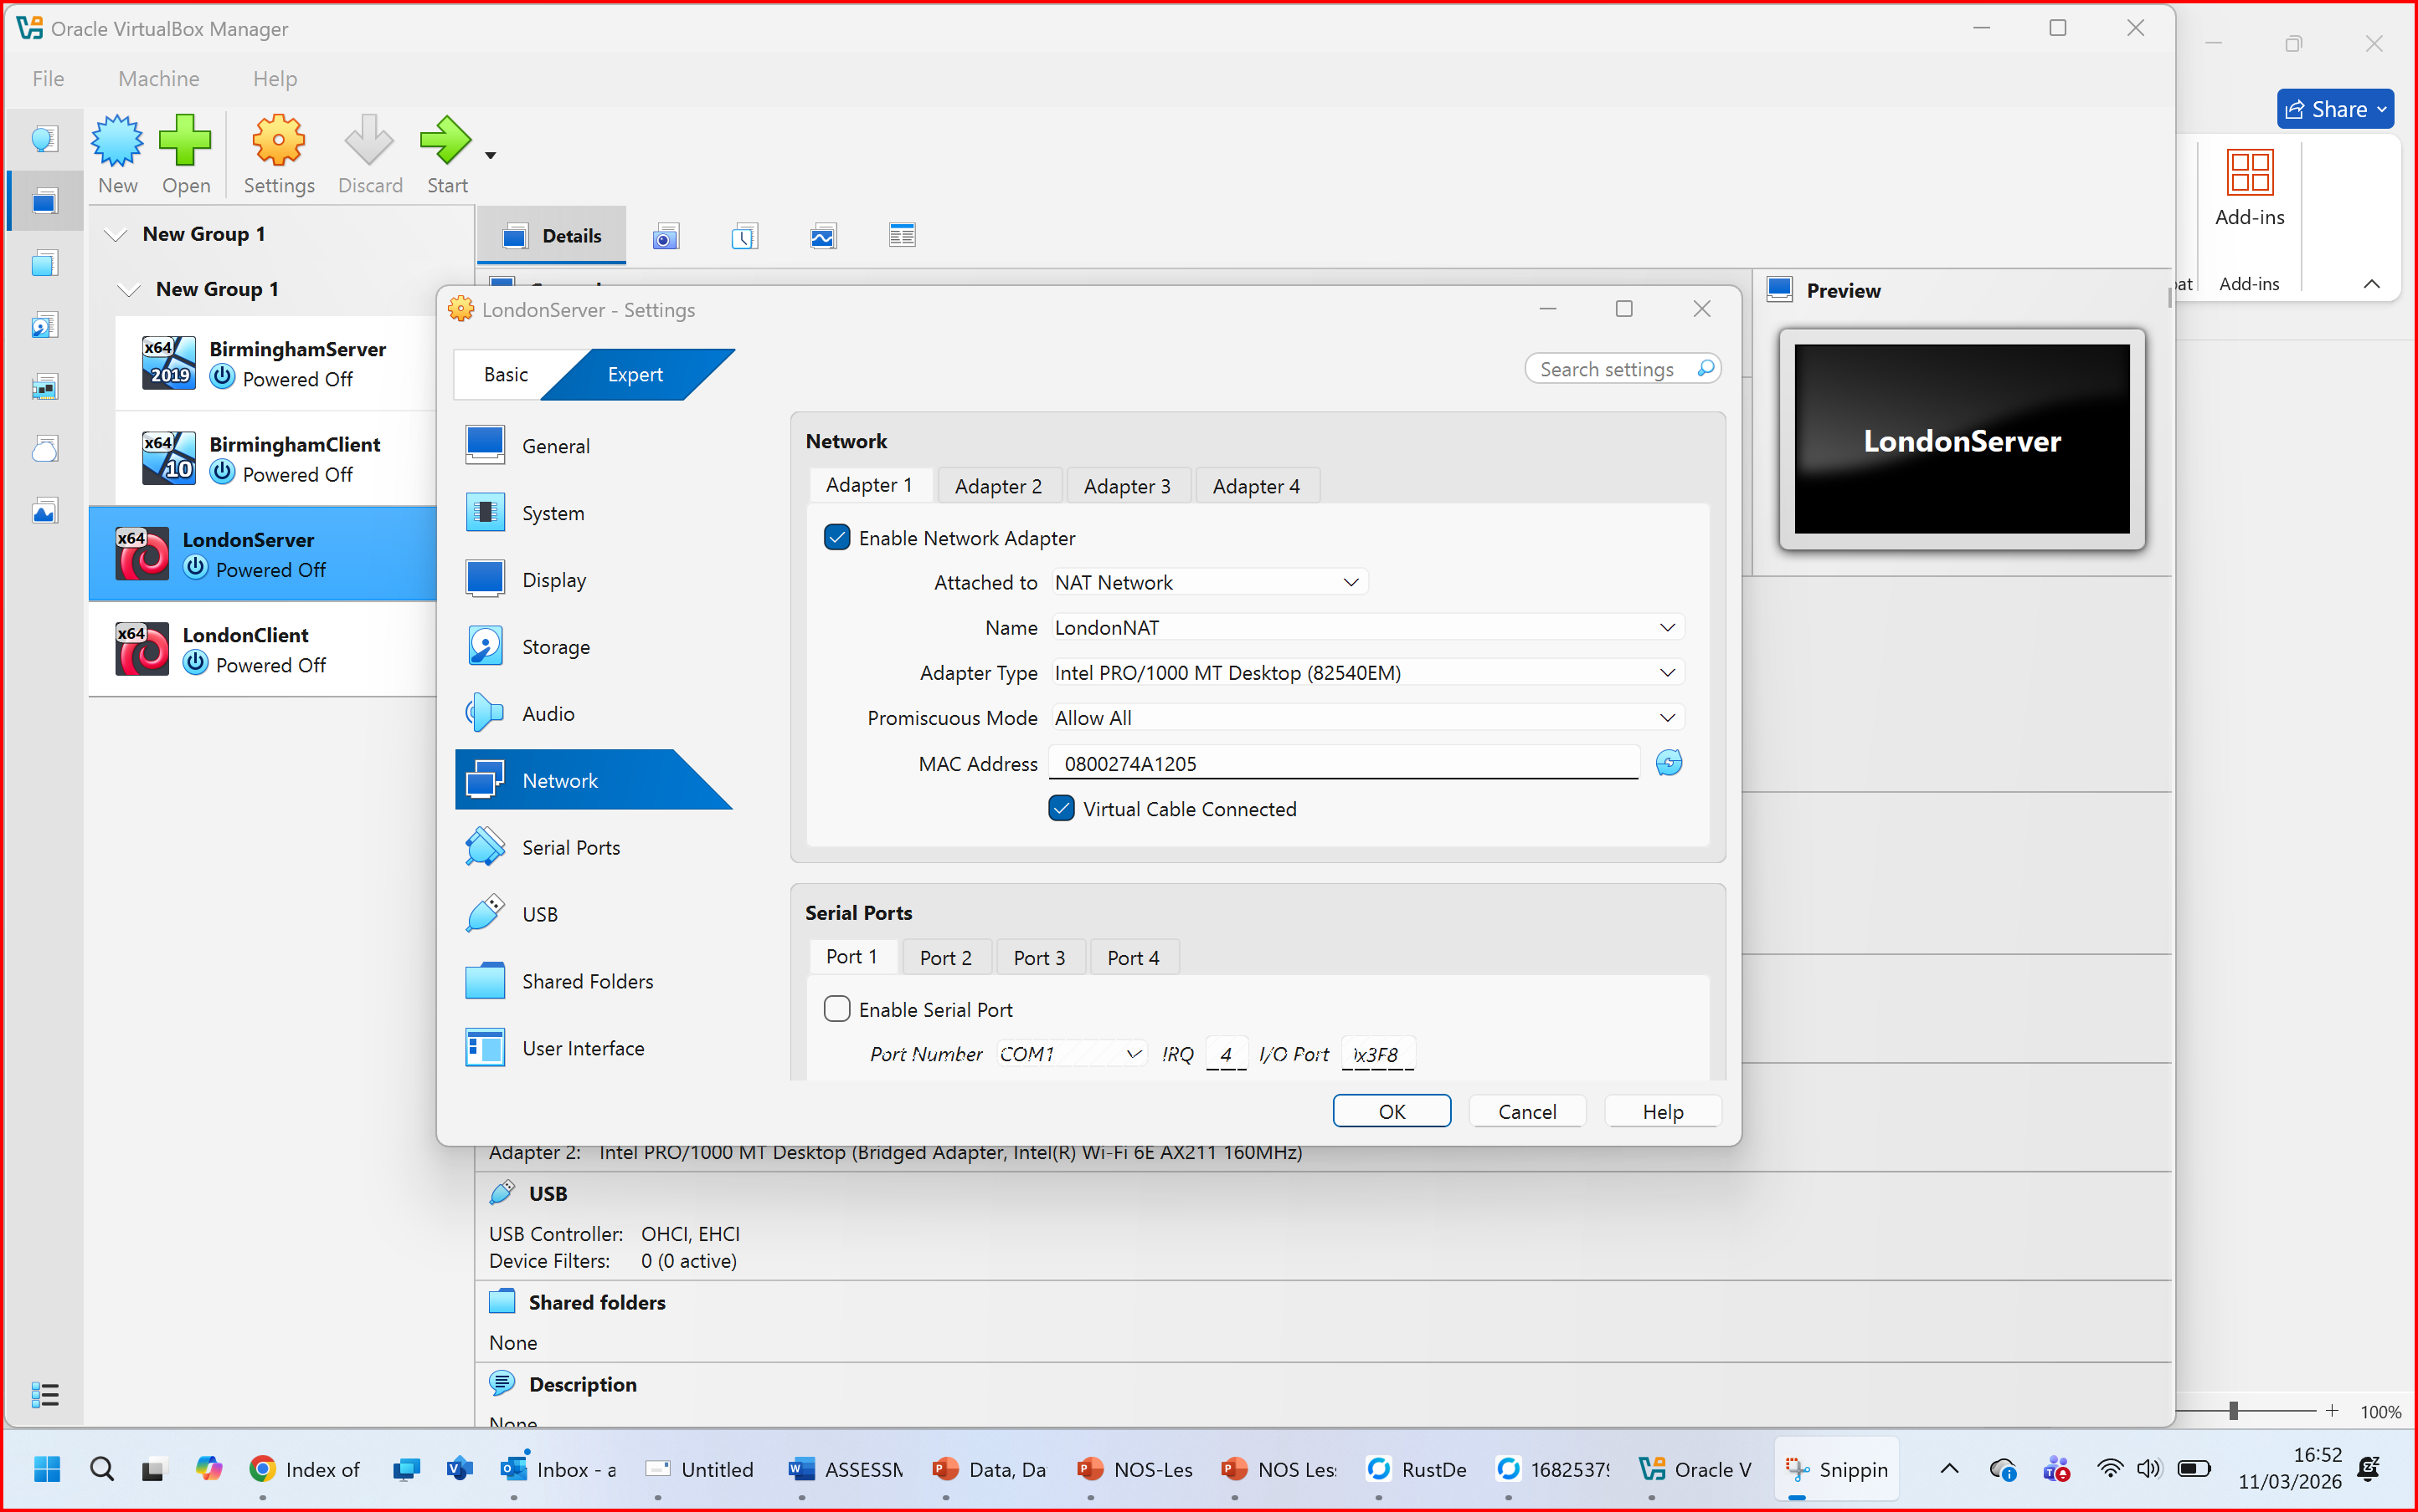
Figure 11: Linux Server (LondonServer) Adapter1 configured to LondonNAT.
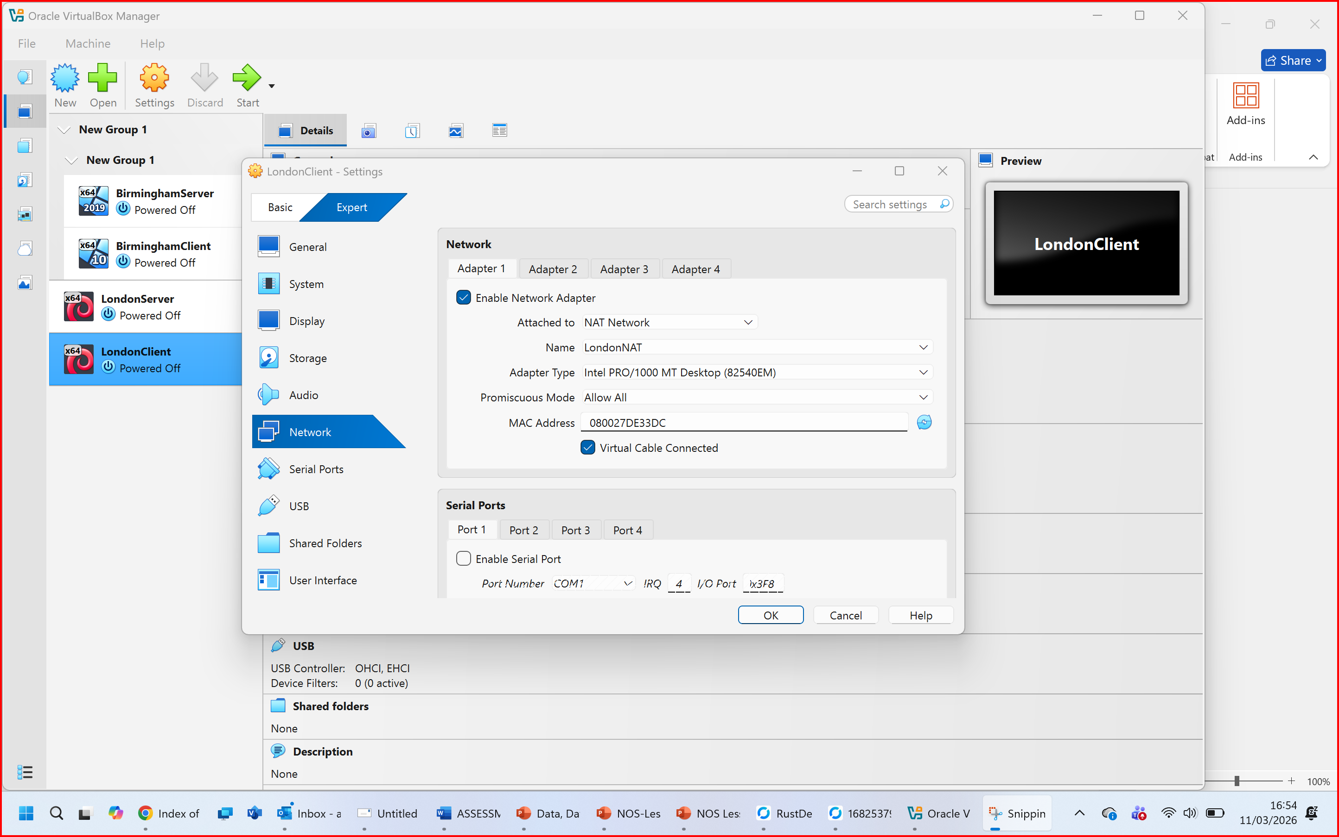
Figure 12: LinuxClient (LondonClient) Adaptor1 configured to LondonNAT

2.3. Configure IP Addressing
Figure 13 Topologlyogy for Coursework 1
IP Addressing Design
Site | Device | IP Address | Subnet | Gateway
Birmingham | BirminghamServer | 192.168.100.10 | /24 | 192.168.100.1
Birmingham | BirminghamClient | 192.168.100.50 | /24 | 192.168.100.1
London | LondonServer | 192.168.200.30 | /24 | 192.168.200.1
London | LondonClient | 192.168.200.40 | /24 | 192.168.200.1
Table 1: VLSM IP Addressing Scheme for NOSSLONDON2026

2.3.1. IP addresses to configure network.
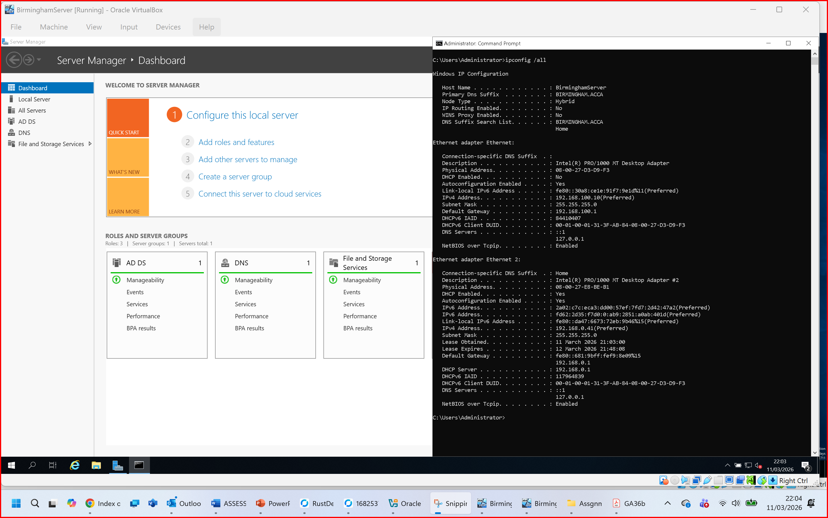
Figure 14: Windows Server 2019 IP Configuration for BirminghamServer.
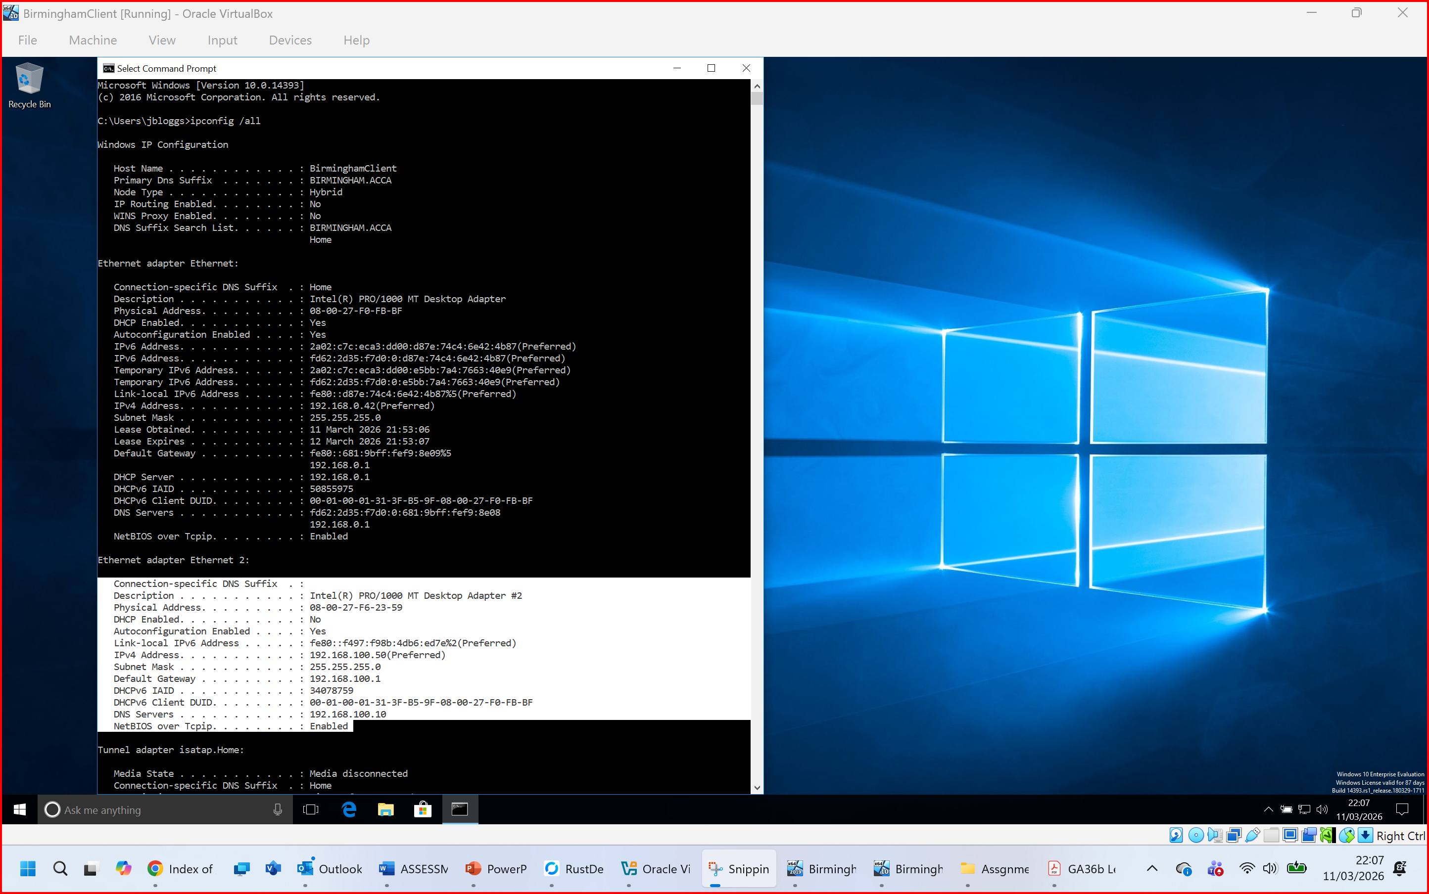
Figure 15: Windows 10 Client IP Configuration for BirminghamClient.

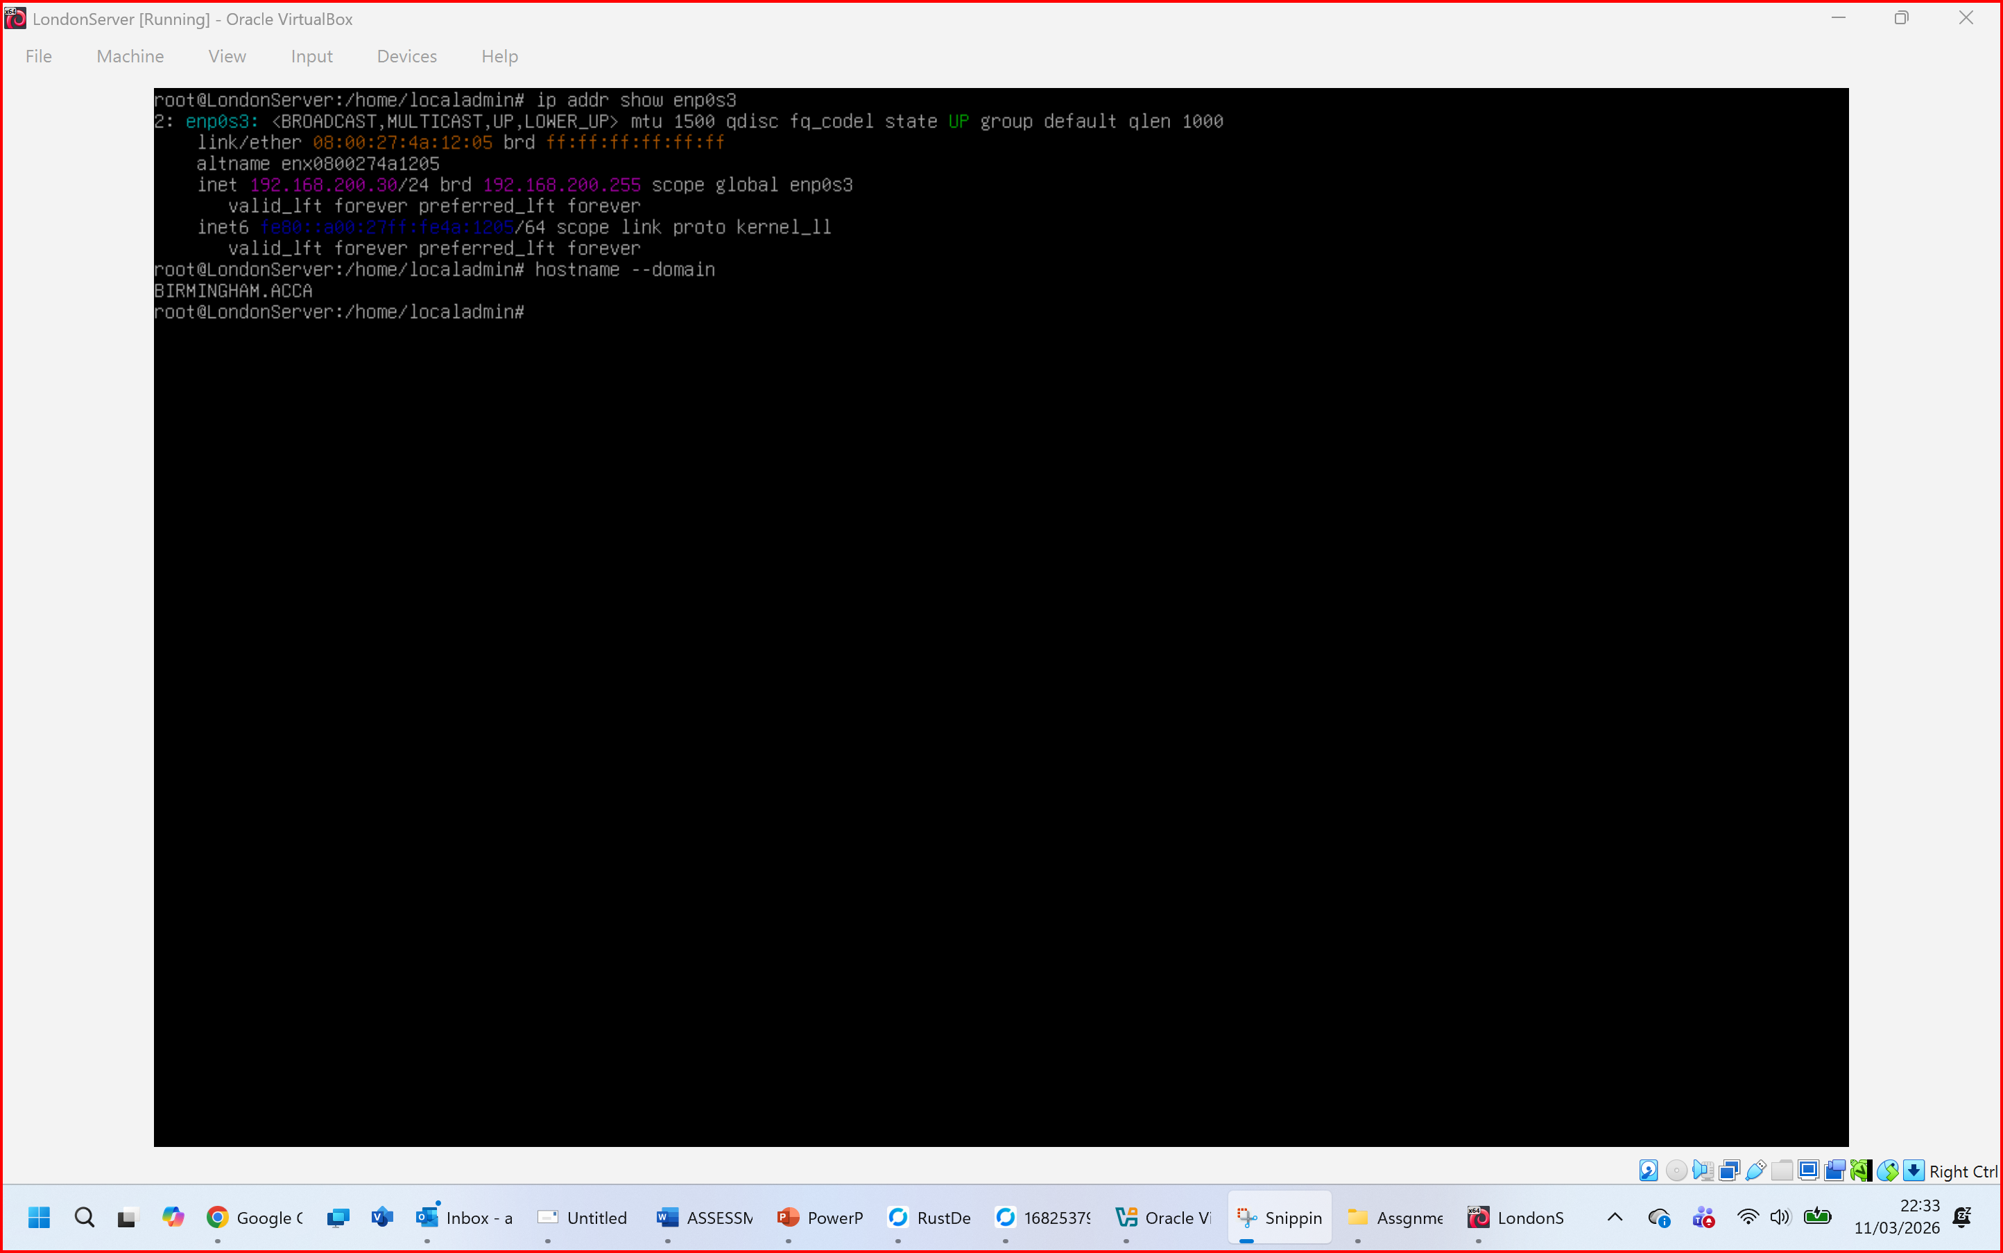
Figure 16: Debian LinuxServer IP Configuration for LondonServer.
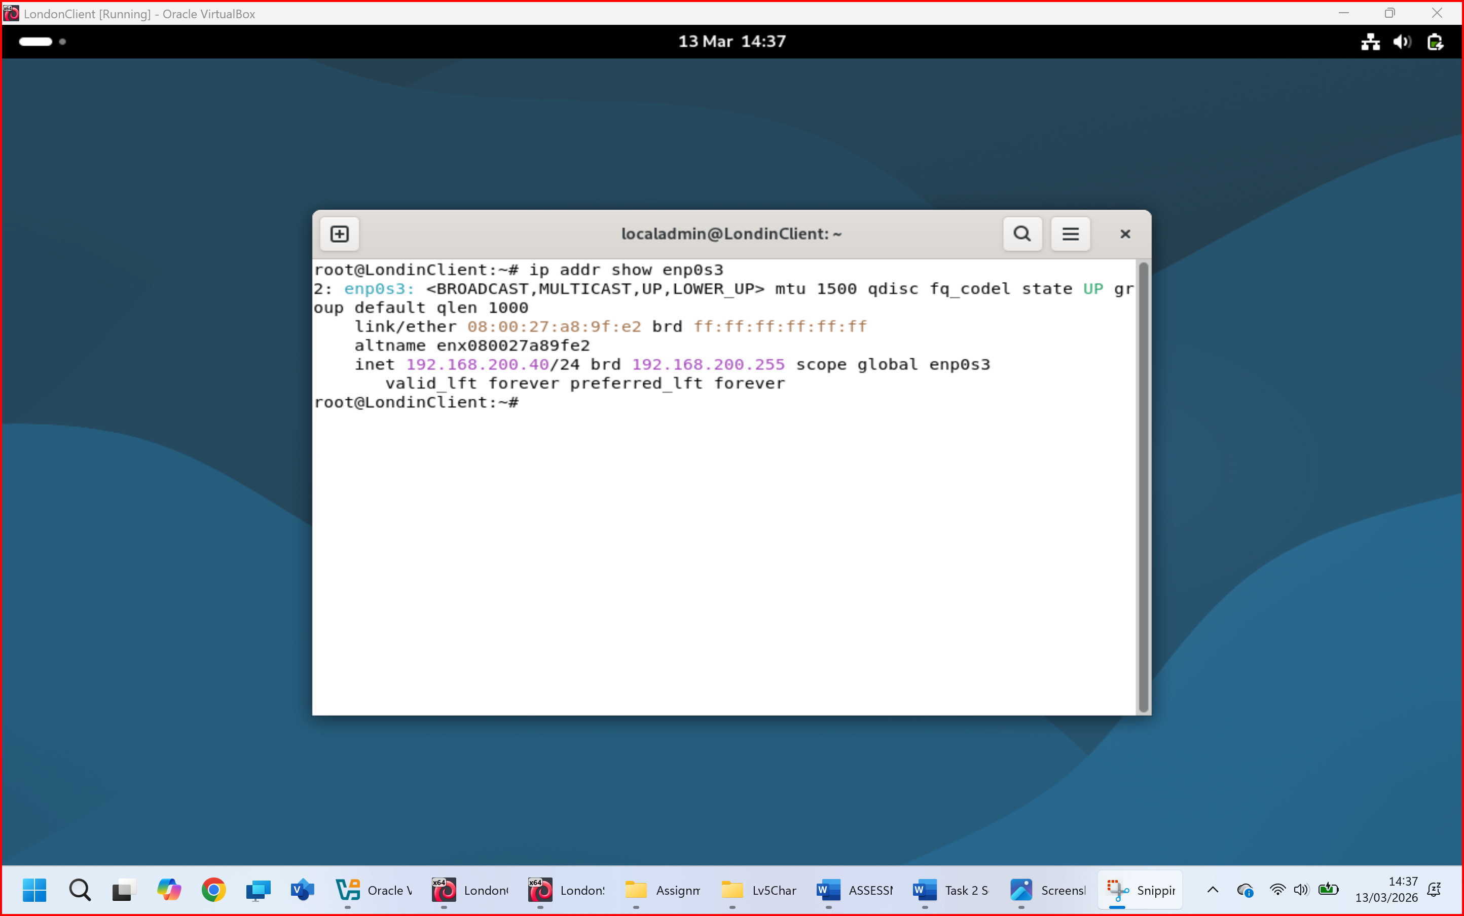
Figure 17: Debian Linux Client London

2.3.2. The above topology gives network address for the networks
Network IP address from NAT Network1 for windows (1 screenshot)
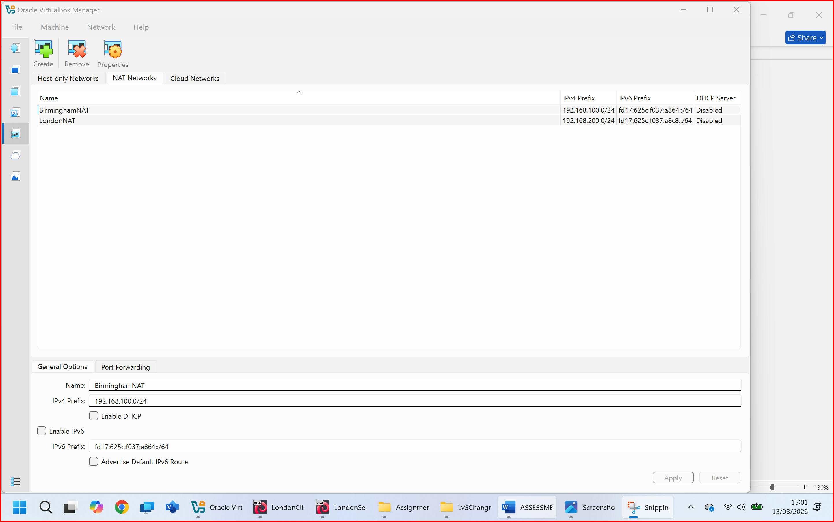
Figure 18: Network 1 topology for Birmingham
Network IP address from NAT Network 2 for Linux (1 screenshot)
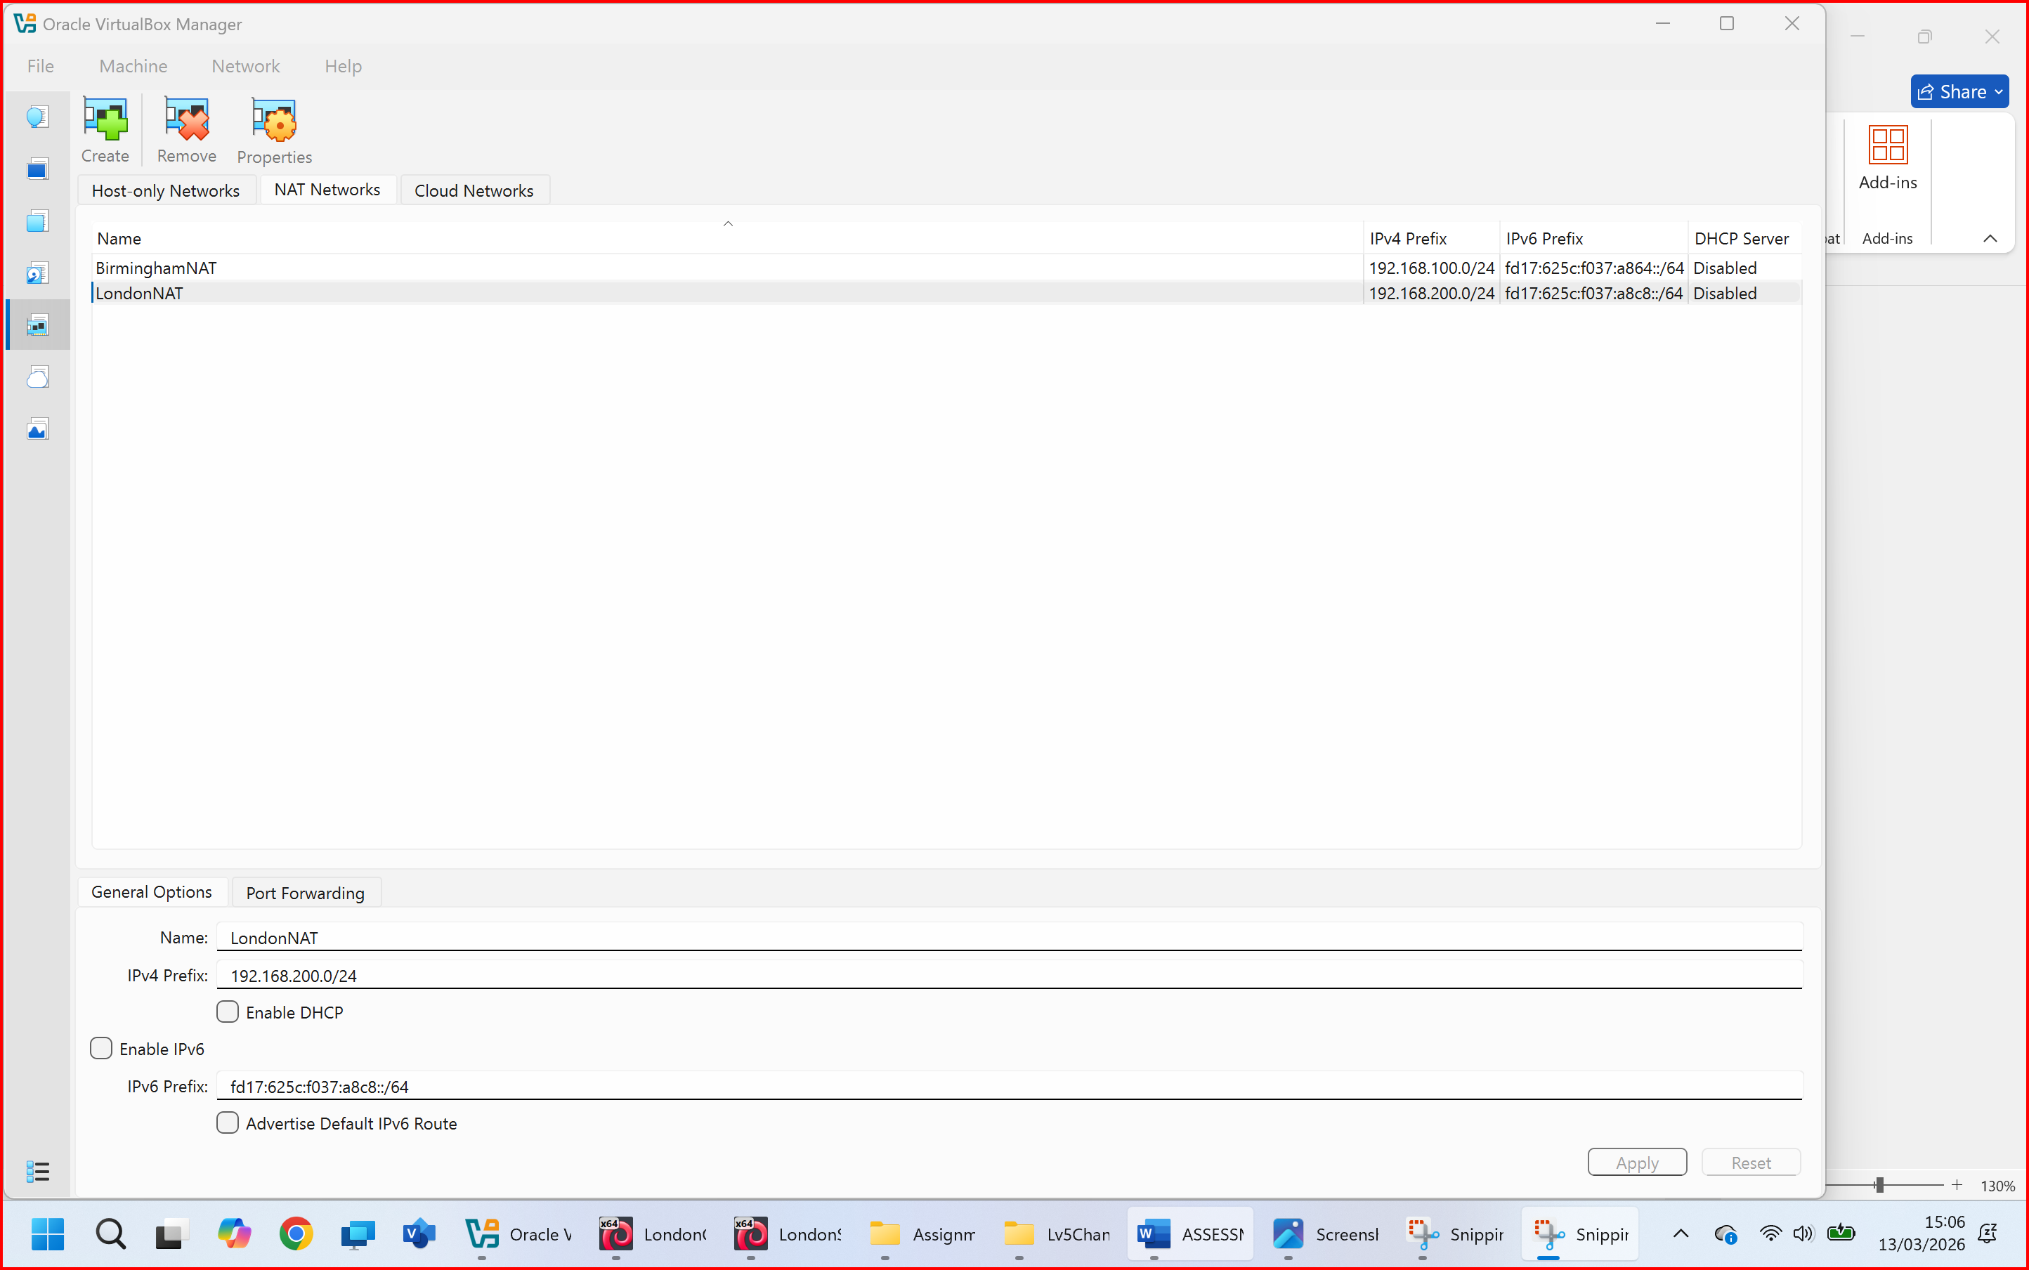
Figure 19: Network 2 topology for London

2.4. Test and Troubleshoot

2.4.1. Perform Connectivity tests
Outcome 1: Successful connectivity within windows network. (2 screenshots) (Ping 192.168.100.10 and Ping 192.168.100.50)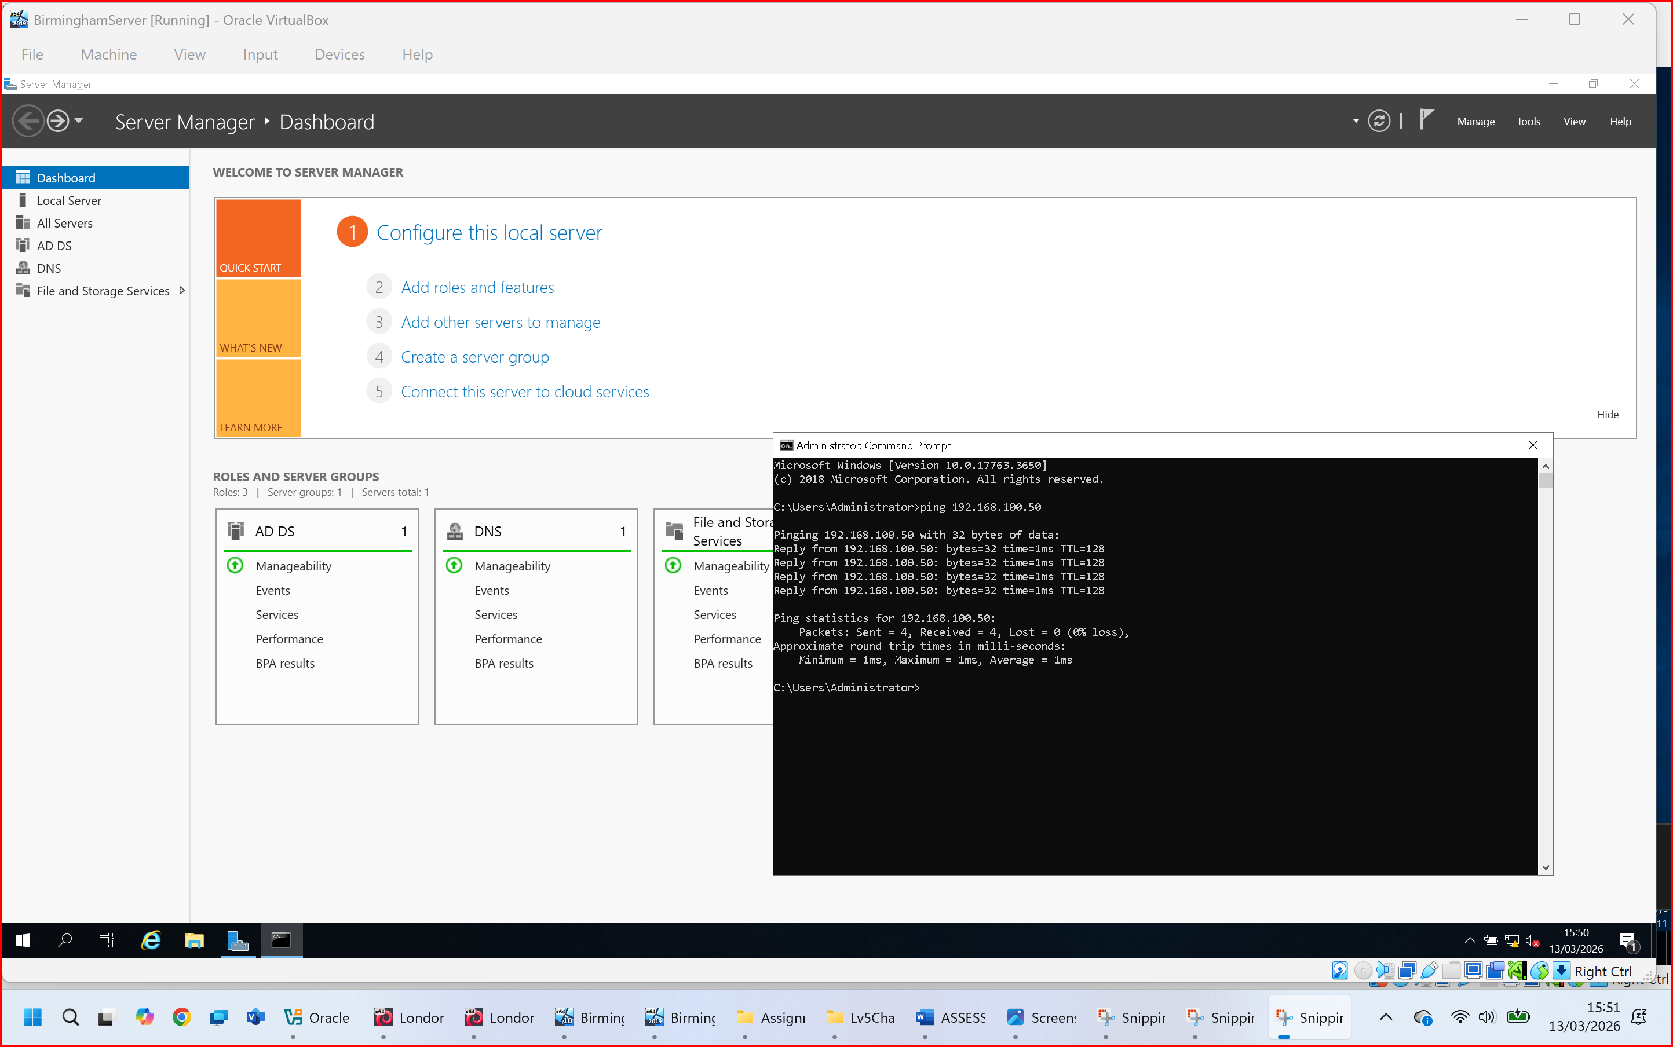
Figure 20:Succesful ping from Brimingham Server to Birmingham Client.
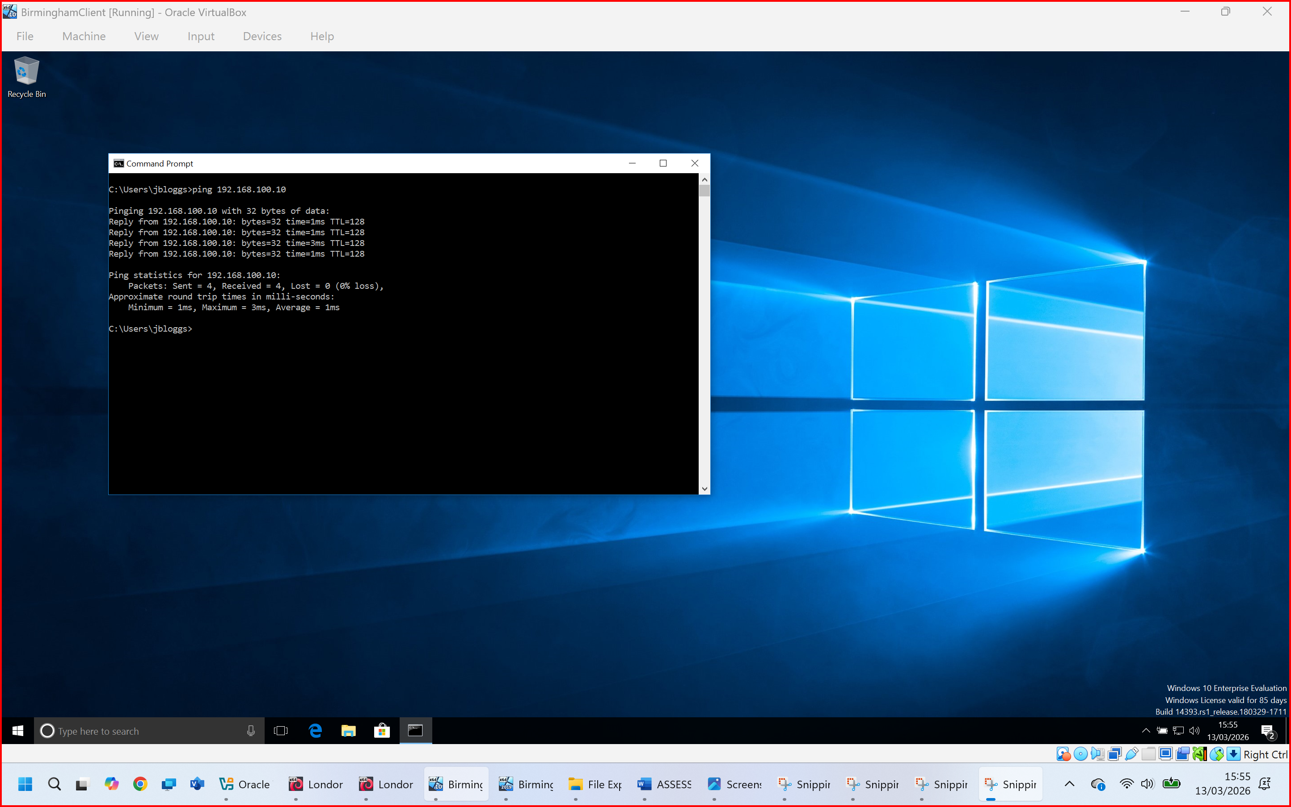
Figure 21: Successful ping from Birmingham Client to Birmingham Server.
Successful connectivity within Linux network. (2 screenshots) (Ping 192.168.200.30 and Ping 192.168.200.40)
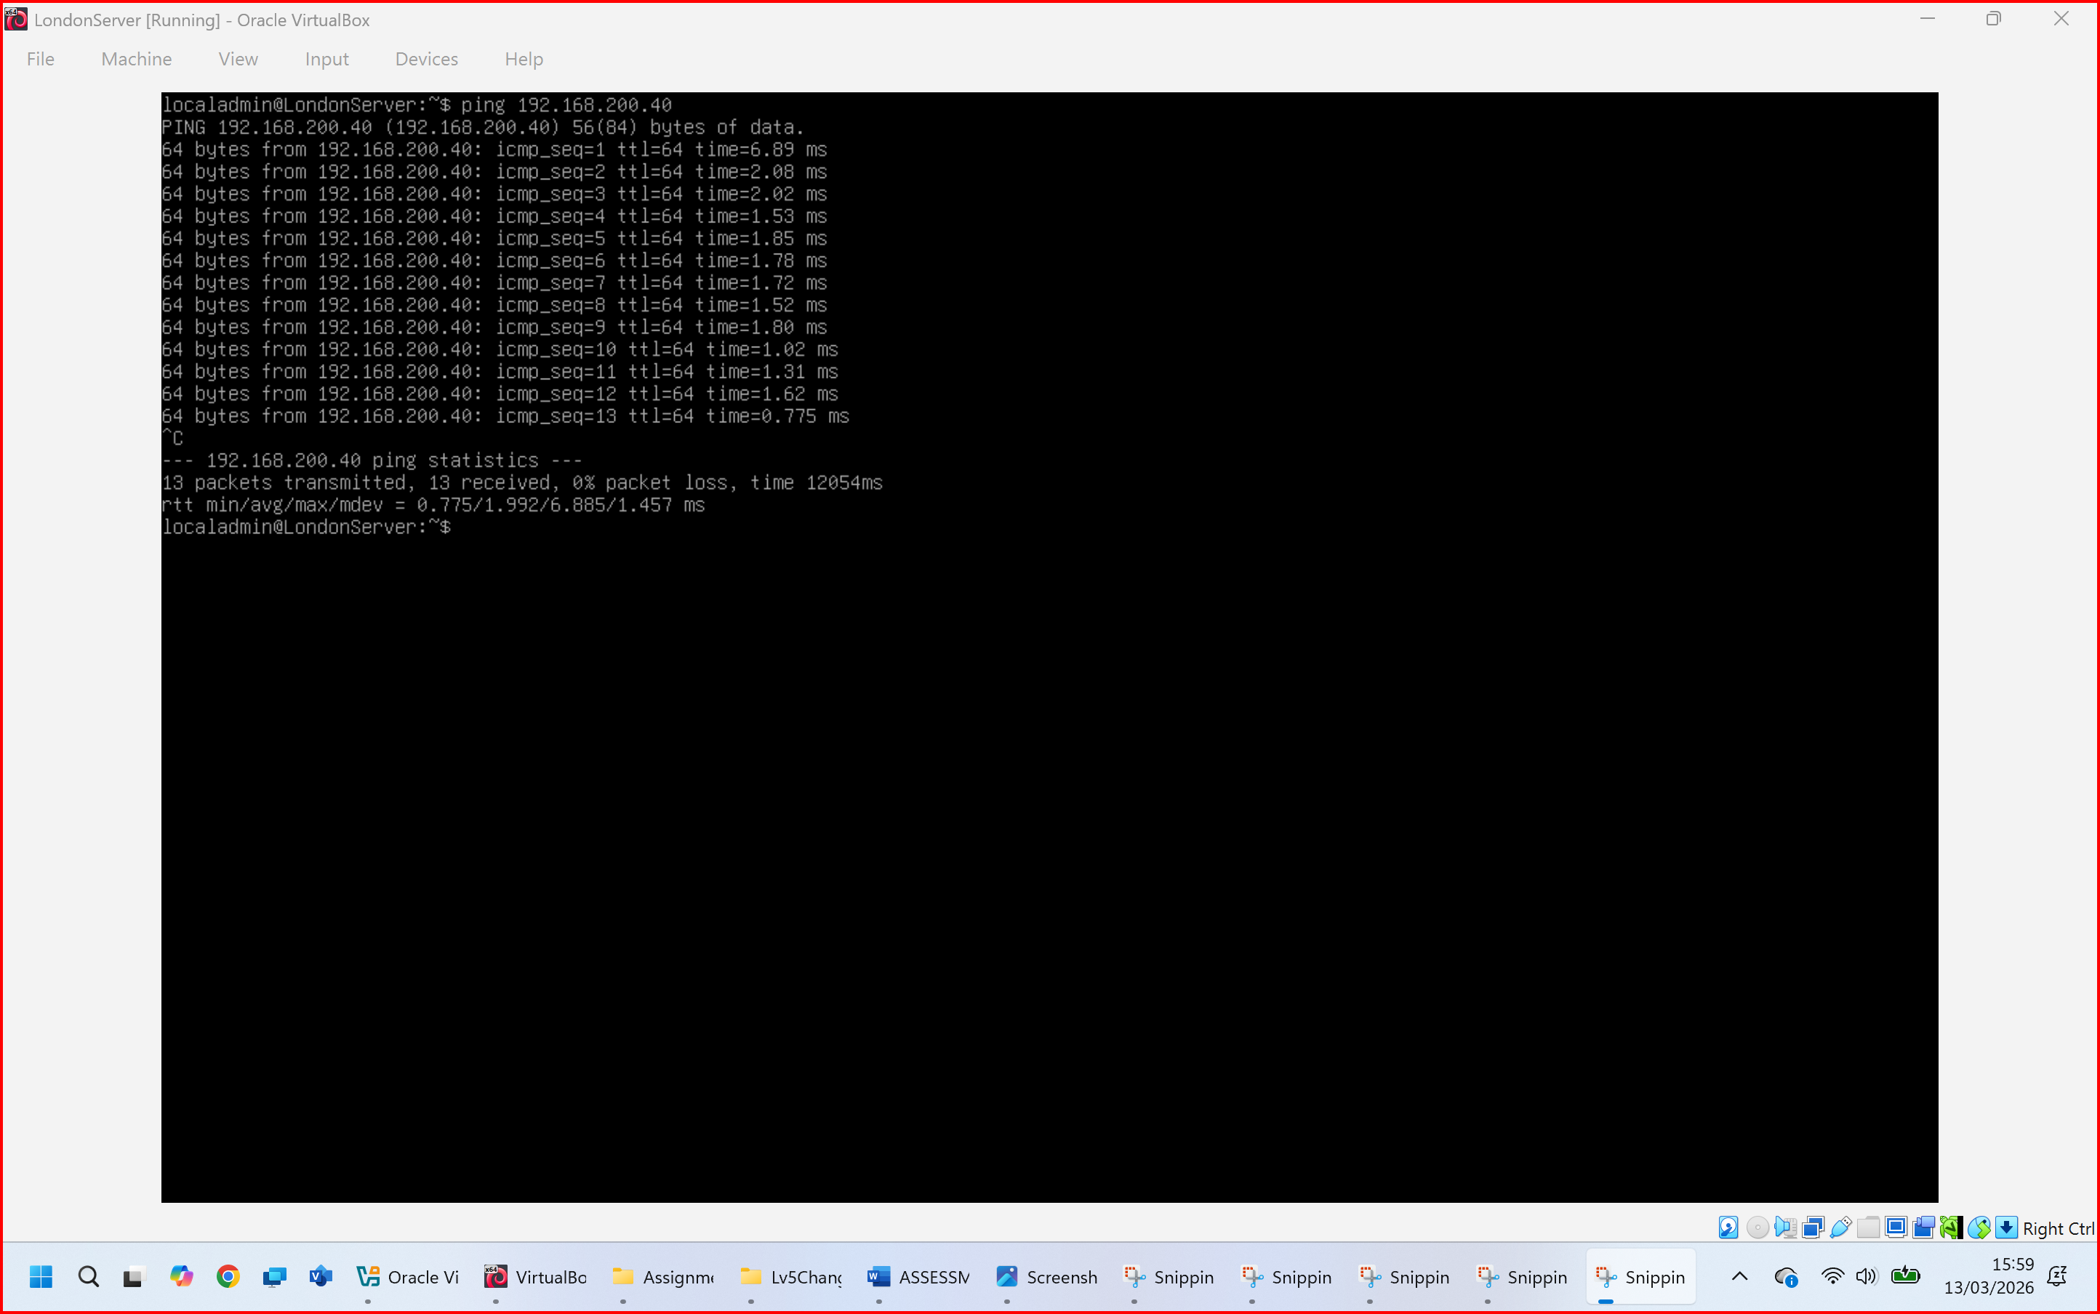
Figure 22: Successful ping from London Server to London Client.
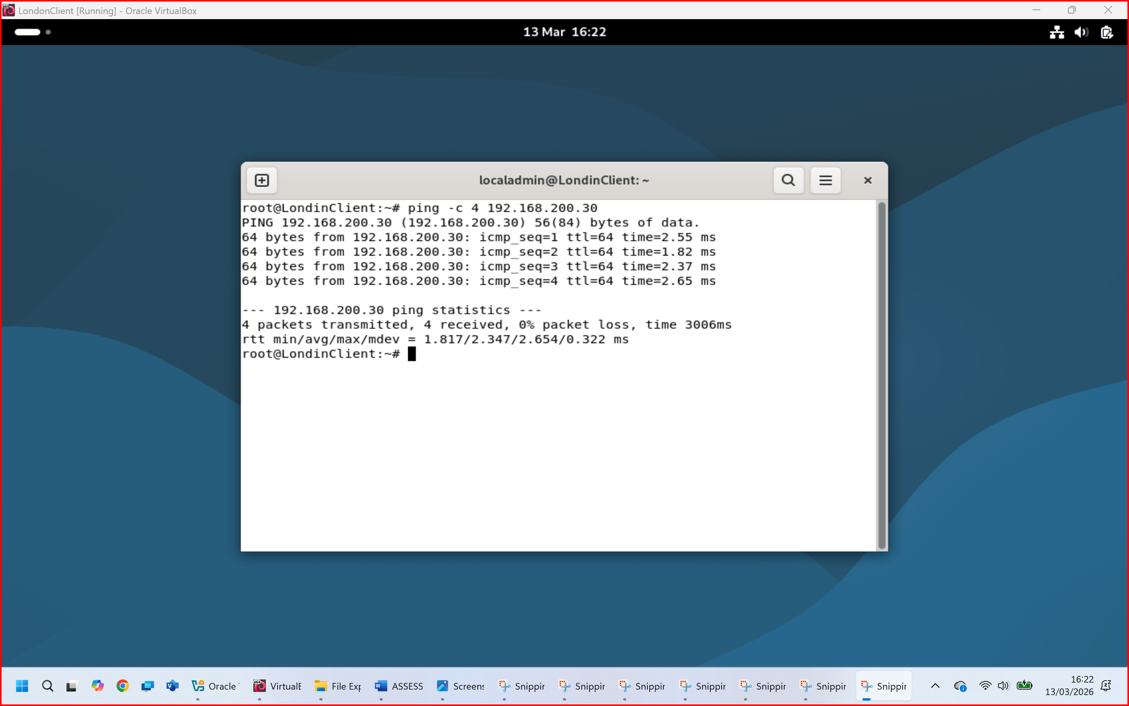
Figure 23: Successful ping from London Client to London Server.
Outcome 2: Unsuccessful connectivity between Linux and windows networks (2 screenshots).
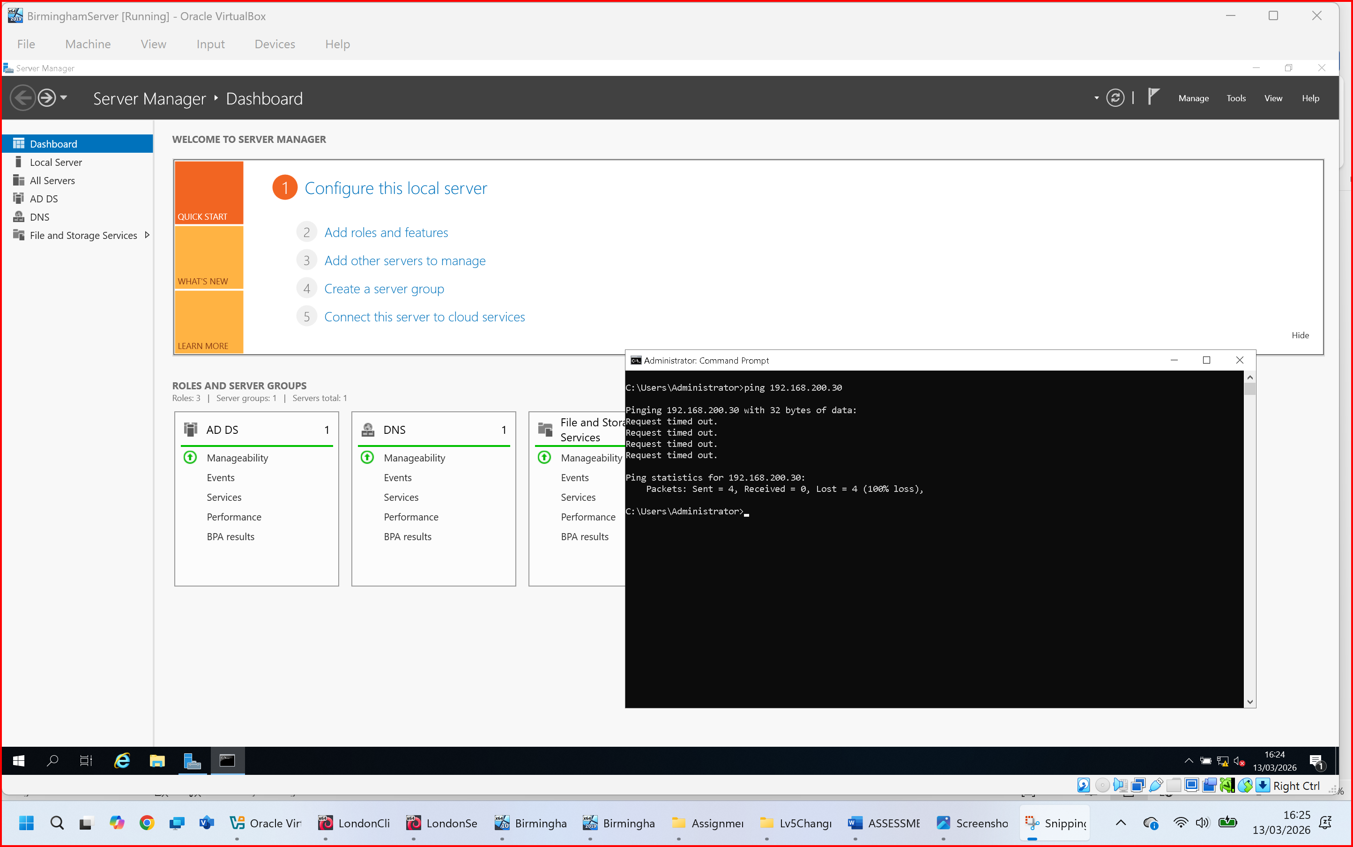
Figure 24: Successful ping from Birmingham Server to London Server.
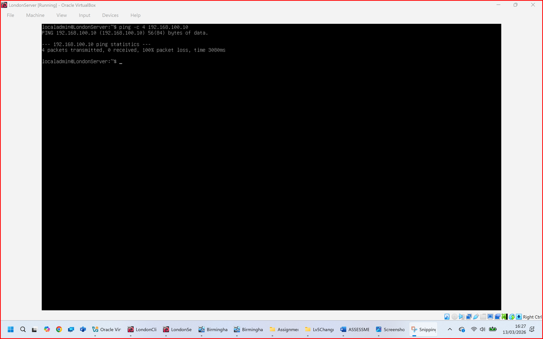
Figure 25: Successful ping from London Server to Birmingham Server – with 100% packet loss.

Task 3
Reflection: I am submitting this assignment in this unfinished state due to not being able to finish the final elements of task 2 due to a struggle with time. However, I will be requesting an extension for another 48 hours, and if it is granted, I will finish this and re-upload accordingly. Thank you.

References

[1] Bahri, A. R. D., Shadman, B., Mukhtiyar, F., Soon, L. L., Xinyi, X., & Amin, N. U. (2025). The Role and Impact of Hypervisor Technology in Modern IT Infrastructure.
[2] Fayyad-Kazan, H., Perneel, L., & Timmerman, M. (2013). Benchmarking the performance of Microsoft Hyper-V server, VMware ESXi and Xen hypervisors. Journal of Emerging Trends in Computing and Information Sciences, 4(12), 922–933.

