Archaeology and the Ottoman Empire
Wenjing Yu 1804905 HPAH6009
Content
Definition 2
Purpose 2
Method 2
Object 3
Academic sub-disciplines 3
Different view 4
Origin and History 4
Imitation and development 6
Future contributions 10

Definition
Archaeology studies the past human society mainly through the reconstruction and analysis of ancient people's material, cultural and environmental information, including artifacts, buildings, biological legacies and cultural landscapes. Archaeology, it has been rightly said, is a source of history, not just a humble auxiliary discipline.[1]

Purpose
Archaeology aims to learn more about past societies and human development. More than 99% of human history is in prehistoric history. At that time, people did not use words, so they did not leave a written record of themselves for our study. In the absence of such writing resources, the only way to understand prehistoric society is archaeology. Many significant developments in human history took place in prehistoric times, including human evolution in the Paleolithic Age, when the human race developed from Australopithecus in Africa and eventually became a contemporary Homo sapiens. Archaeology also finds many messages about the evolution of human technology, such as the ability to use fire. If there were no archaeology, we would not be able to understand the evolution and technological changes of human beings in the age of no writing.[2]

Method
An archaeological investigation often consists of several distinct stages, each of which uses unique research methods. Before any actual archaeological work can be carried out, archaeologists must first reach a consensus on the clear objectives they want to achieve. After that, an archaeological field survey of a site was conducted to find as much information as possible about the site and its surrounding areas. Secondly, the excavation work is carried out to collect any archaeological characteristics buried underground. Thirdly, the data collected from the excavation are studied and whether the original research objectives set by archaeologists are achieved. The information is then published for use by other archaeologists and historians, who believe it is a good thing, even if it is sometimes overlooked.[3]

Object
The object of archaeological research is physical objects. Mainly material remains, or relics and remains. These relics should be the legacy of ancient human activities. Archaeological research focuses on the past, including various materials left over from past cultures. So its object of study belongs to the ancient times before a certain time. For example, the lower limit of Archaeology in Britain is the Norman invasion (1066), the collapse of the Carolingian Dynasty in France (987), the discovery of the New World by Columbus in America (1492), and the demise of the Ming Dynasty in China (1644). In recent years, Medieval Archeology, which emerged in Britain, pushed the time limit to 1640. Industrial Archeology in the Americas studies the remains of early modern industry. With the progress of the times, these lower bounds will naturally move backwards.

Academic sub-disciplines
Like most disciplines, archaeology has many branches, some of which are based on specific research methods or material types (e.g., stone analysis, prehistoric music, archaeobotany), geography or age (e.g. Near East archaeology, medieval archaeology), other subjects (e.g. marine archaeology, landscape archaeology, battlefield archaeology), or a particular subject. The definite archaeological culture or civilization (e.g. Egyptology, Indology, Sinology).
While there are still some main subjects like Historical archaeology, Ethnoarchaeology, Experimental archaeology, Archaeometry and Cultural resources management.
Historical archaeology studies cultures with some form of writing. Ethnoarchaeology is an archaeological study of living people. Ethnoarchaeology uses ethnographic studies to enhance and improve their analogies and then uses these analogies to interpret archaeological records. In short, ethnography is the application of ethnography in archaeology. Experimental archaeology is the application of experimental methods to the development of highly controlled observations to analyze the processes that create and influence archaeological records. Archaeometry aims to systematize archaeological measurement. It emphasizes the application of analytical techniques from physics, chemistry, and engineering. It is a field of research that frequently focuses on the definition of the chemical composition of archaeological remains for source analysis. Although archaeology can be an independent subject, it can also be an applied science, that is, to study archaeological sites threatened by development plans. In this case, archaeology becomes a funded research activity under the management of cultural resources, which is called heritage management in Britain.

Different view

Origin and History
Blue and white porcelain originated in the Tang dynasty[4] and almost stagnated in the Song dynasty [5]until the Yuan dynasty. Although the existence of Tang blue and white porcelain and Song blue and white porcelain is beyond doubt, the quantity is too small, the production is too rough, and the Tang and Song documents recording blue and white porcelain cannot be searched. Therefore, before the Yuan dynasty, blue and white porcelain is not a common phenomenon of ceramics at least. In the Qing palace royal supplies, also cannot find the shadow of the Yuan blue and white. So we almost can say the blue and white porcelain of Yuan dynasty was produced in Jingdezhen, China, and mainly sold abroad.
Up to now statistics, Yuan blue and white porcelain in the domestic about 100 pieces, more than 200 pieces of foreign, mainly distributed in museums or art galleries of Egypt's Cairo, Iran's Tehran, Istanbul, Turkey, Britain, the United States and Japan. Among them, Iran and Turkish collections have the best in both quantity and quality. The wealth of Chinese porcelain stored in the Topkapi palace in Turkey is amazing. History tells us that long before Topkapi palace was built, Chinese porcelain had already flowed into Turkey for the Ottoman palace to enjoy. Chinese blue and white porcelain was called "faure" or "faery" by ottomans, meaning Chinese emperor. The blue and white porcelain of Yuan dynasty in the middle and late 14th century was the treasure of Topkapi palace.[6] There are 40 pieces of 14th-century blue and white porcelain in the museum, among which 12 are plates (8 are ringed plates and 4 are rounded plates), 6 are plum bottles, 4 are bowls, 4 are cans, 3 are gourd bottles, 1 is a bottle, 1 is a pot, 1 is a cover and cannot be recovered. [7] The temple of Sheikh·Safi·Eddin, also known as the temple of Ardebil, is located in Ardebil in northwestern Iran. In 1611, Safavid dynasty, Shah Aberss the second has given the royal porcelain, stored them in one of the auxiliary palace, and he also stamped all the porcelains. In 1935, 750 pieces of porcelain were collected by the Islamic museum of Iran's national museum. In the 14th century, there were 32 pieces of blue and white porcelain: 10 pieces of round edge dish, 9 pieces of kuikou dish, 1 piece of big bowl with big edge, 1 piece of large open bowl, 1 piece of big bowl with big edge, 2 pieces of high-necked pot, 1 piece of high-necked pot, 1 piece of round edge pot, 4 pieces of plum vase and 2 pieces of flat vase.[8]
The decoration of blue and white porcelain in Yuan dynasty mainly comes from the decoration structure in west Asia, but the participation of Han culture also plays a great role. Although there is no clear stipulation, people are divided into four classes which are Mongol and Semu, Han and South in the Yuan dynasty. The Han's status on Yuan blue and white not in accordance with the aesthetic development of the Han people, in Asia and the early period of Islamic Mongolia cultural viewpoint, because Allah is everywhere at all times, "without" space actually does not exist, the space will only lead to the appearance of devil, so it should be filled with thick dense grain. Islamic decorative art, as the leading role, is closely related to Persian meticulous painting, advocating complexity and disliking blank, which makes the decoration of blue and white in Yuan dynasty produce on the premise of full density, and not for the purpose of aesthetic appreciation and consumption of Han culture. However, due to the strength of Han culture and the production system of Yuan porcelain that "officials take care of people to make", the blue and white of Yuan dynasty grew up in a production environment full of Han culture according to the requirements of Mongolian and Islamic nationalities.
While Yuan blue and white still have many Han traditional cultural factors. From the perspective of theme decoration, the theme decoration of blue and white in Yuan dynasty has traditional Chinese patterns, such as peony, lotus, dragon, phoenix, kirin, pine, bamboo and plum. From the perspective of auxiliary decoration, wave pattern, echo pattern, banana leaf pattern and so on mostly appear in the decoration of traditional Chinese implements. Plants on Yuan blue and white lines is very developed, although can basically found in the traditional pattern since the Tang and Song dynasty, it still because the plant pattern is given priority to with the curve of the indirect, such as flower, fruit, leaf, grass plant design in series, which are mainly pattern, or filling in the gaps, spread regularly, line penetrated the whole pattern, twine knitting, luxuriant design of labyrinth, and constitute a kind of complex, luxuriant, make people strongly feel the "arabesque" mean in the Yuan blue and white pattern.[9]

Imitation and development
As the porcelain with national characteristics, blue and white porcelain occupies a very important place in the history of world ceramics. Among the blue and white porcelain exported to all over the world, the blue and white porcelain around the 14th century is famous for its exquisite workmanship. Iran and Turkey have a huge collection of exquisite blue and white porcelain of Yuan Dynasty, which is the wisdom crystallization of Chinese and Islamic people. Studying the issues related to the blue and white porcelain of Iran and Turkey in Yuan Dynasty can not only understand the politics, culture and economy of China and Islamic countries at that time, but also help to understand the process of collision and integration between Chinese and western cultures.
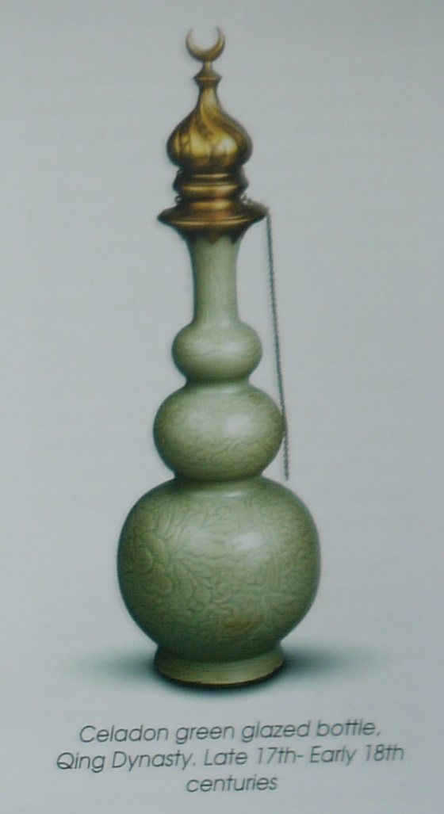
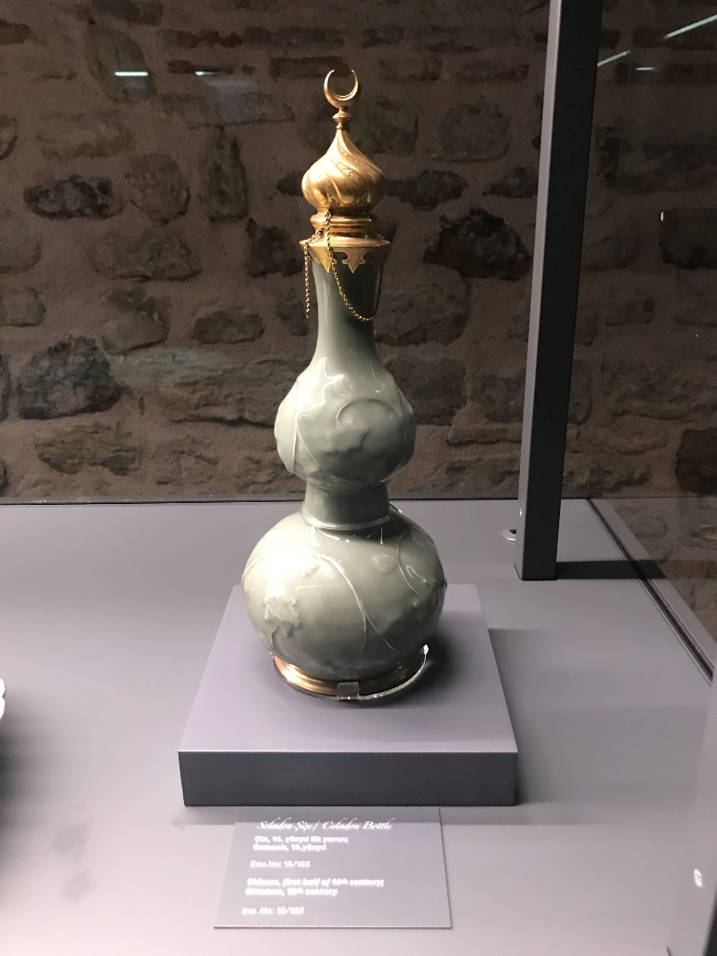
"Iznik ceramics culture" first refers to the Islamic ceramics culture in central and western Asia centering on the Ottoman empire of Turkey from the 15th century, when the blue and white porcelain in Jingdezhen in the early Ming dynasty became the symbol of Chinese culture that attracted worldwide attention after replacing silk. Talking about Turkish ceramics cannot be about the Iznik separately but Turkey in general instead. Turkey used to be called dingling, turkic and huihe people in Chinese literature which has a long history. Together with Persia and other nomadic peoples in western Asia, it has repeatedly wiped out the most characteristic of the civilization in the near east of western Asia in the history of human culture. Turkey first learned how to make tiles from Iran, but the techniques for daily use and decorative porcelain were introduced from China during the Ottoman period. From the perspective of Gombrich's art history process, an impetus for imitation is the first generation of craftsmen to speculate on the glory of distant regions, and then the next generation will adopt their own familiar cultural methods after accumulating experience, and then form a new artistic language. Early Arab through continued for several centuries of land silk road to Turkey to bring a lot of beautiful, Tang tri-colored glazed pottery of Tang white porcelain, celadon, etc., both from the commercial and aesthetic point of view, there is no doubt that all of Asia countries especially Turkey big strong appeal and extensive influence, in the centuries inspired imitators. This was the case in Iznik, a small Ottoman town. In the Persian period, Iznik pottery began to absorb the lotus petals, waves, clouds, dark flowers and other decorative patterns of Chinese ceramics. 14 or 15 centuries especially the Ottoman empire, China's blue-and-white porcelain was continuously transported to the middle and near east through trade or military conquest and other factors, which had a great impact on the production of Turkey's Iznik ceramics, especially the alla porcelana, a copy of the Ming dynasty grape pattern during the Ottoman period.
Left: Chinese glazed bottle
Right: Ottoman glazed bottle
Iznik was already a major trade route between Anatolia and the east in Byzantine times. It was also the first center to be occupied by the Ottoman Empire in the 13th century. The influence of Chinese blue and white porcelain on Iznik ceramics is so great that the production of imitated Chinese blue and white Iznik porcelain can still be seen everywhere. But compared with Chinese porcelain more than 1300℃ of the sintering temperature, Iznik ceramics are only made in 1200℃, carcass cover white make-up soil, cross section are pale, quality of a material is loose. In another way, it can’t be called as porcelain but still ceramic. While Iznik potter is inspired by the Chinese blue and white porcelain production clones from the 15th century, but the necessary material to make high-temperature porcelain called in kaolin didn’t know by western world until about the 17th century. At that time, Iznik potters, due to the deficiency of material, imitating blue and white porcelain in technology or technology is an almost impossible to do but it is worth trying. Not knowing the existence of kaolin, they could not burn the high-temperature transparent porcelain of Jingdezhen, but they could produce the almost authentic blue and white porcelain of Jingdezhen by decorating the clay surface with cobalt and applying transparent tin glaze. Therefore, the west uses “true porcelain” to define the difference between Chinese blue and white porcelain and Turkish blue and white porcelain.
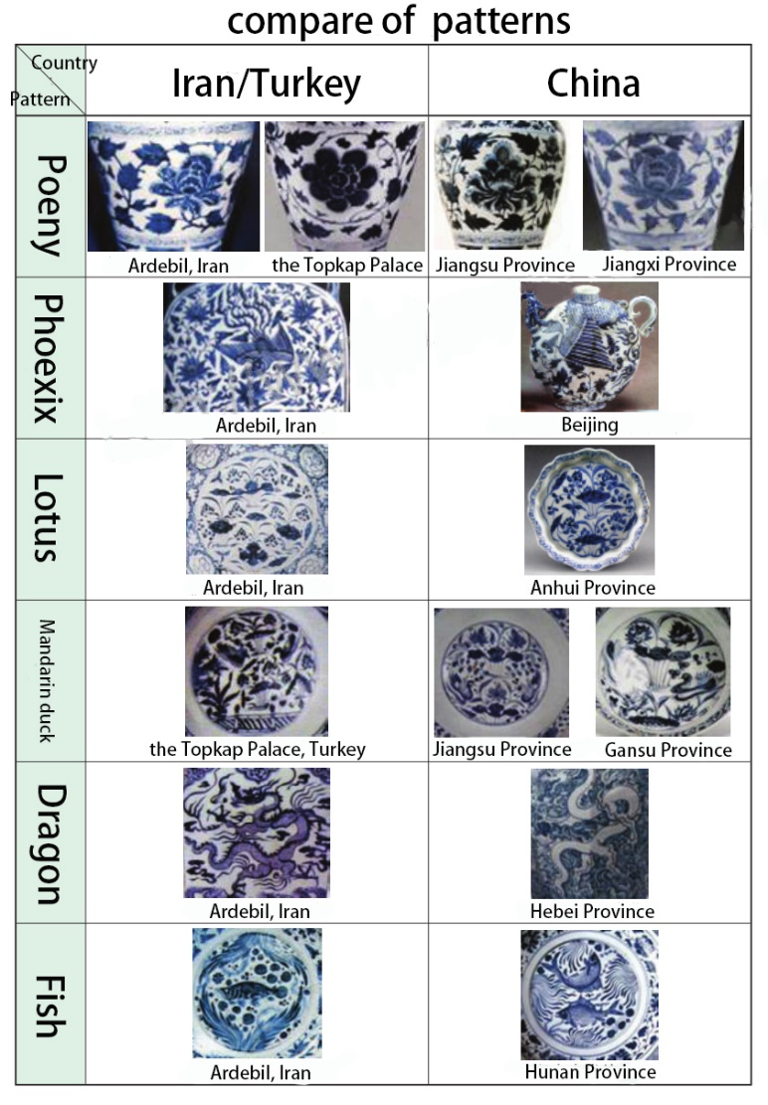
In addition, there are a large number of blue and white porcelain images depicted in the detail painting scene, which also provides direct evidence for us. In combination with the example of Iznik pottery, it depicts how the highly valued and expensive Chinese blue and white porcelain has a great impact on Iznik's ceramic tradition. The most exquisite and once the most breathtaking innovation of Iznik ceramics is how it was inspired by the overall arrangement of Chinese blue and white porcelain decoration. Through the combination of fine paintings and blue and white porcelain at that time, it created such an exquisite ceramic culture with blue as the main style and full density. These evidence shows Iznik first imitated Yuan blue and white decoration style and learning from it, and then in centuries became a highly personalized and originality, Iznik, delicate flower leaf veins adornment element, like Yuan blue and white, and gradually become a kind of cultural symbols of the Islamic world. The influence of blue and white porcelain originating from China is reflected in all aspects of the majority of Turkish blue and white porcelain produced in Iznik town to varying degrees. From completely copying the Chinese prototype to turkification of Chinese patterns, we can find the source of this Chinese style by tracking its development path. Although after the 18th century due to the development of new technology innovation and aesthetic, Iznik ceramic gradually deviate from the prototype, but rooted in blue and white porcelain blood contact, so that the whole in the 16th century and even longer, no matter from glaze and modelling, or design and aesthetic, Iznik ceramic still continue the tradition of following the Chinese blue and white porcelain.
But for now, it seems that this kind of to simulate gradually formed its own style is an important part of the history of human culture, we are not without successors after the unprecedented absolutely original, the pottery is more tribute to the Chinese Yuan blue and white than a simply imitation.

Future contributions
Archaeology is not only a subject, but a method to learn a culture as well. I would like to introduce a concept in Chinese Archaeology which is called dual attestation. It is to verify the records of unearthed cultural relics and historical books. That means archaeology can make supplementary instructions and vice versa, and archaeology can also correct writing material. For example, use the blue and white porcelain discussed just now, because of archaeology we can have material to compare and get a conclusion that blue and white porcelain is a half-blood in decoration and have strong connection with west Asia instead of an independent invention of China. So in the future, when it comes to the analysis part, I think the best and the most accurate way is to combine all the writing documents all over the world we have now. If it is possible, people attend to one excavation should from different country to make sure we can have different view about one issue. Apart from that, similar as what we have found now, archaeology will contribute to the study of Ottoman Empire in correcting and supplement writing documents, like isotope dating, and also, with the support of new technique, we can even find something new to show their own character.

[1] Pyddoke, E. (1965). What is archaeology?. New York: Roy Publishers, p.16.
[2] Greene, K. (2010). Archaeology: An introduction. London: Routledge.
[3] Renfrew and Bahn (2004 [1991]:75)
[4] Brief introduce to archaeological work of Tangcheng site, Yangzhou, 1975. (1977). Cultural Heritage, (9).
[5] Song dynasty blue and white porcelain excavated from two bases in Zhejiang. (1980). Cultural Heritage, (4).
[6] Xu, M. (2007). Chinese Yuan porcelain. p.149.
[7] Krahl, R., Nurdan, E. and Ayers, J. (1986). Chinese ceramics in the Topkapi Saray Museum, Istanbul. London: Sotheby's Publications.
[8] Pope, J. (1981). Chinese porcelains from the Ardebil Shrine. London: Sotheby Parke Bernet.
[9] Kang, Q. (2013). Interaction and Intertexuality of Blue＆White porcelain — On the Culture Interaction between Jingdezhen and Isnikby Means of Blue&White. China Ceremics, 49(12), pp.105-106.

