

Assessment 1 – AS1 Jabir Haasan Ibrahim
:
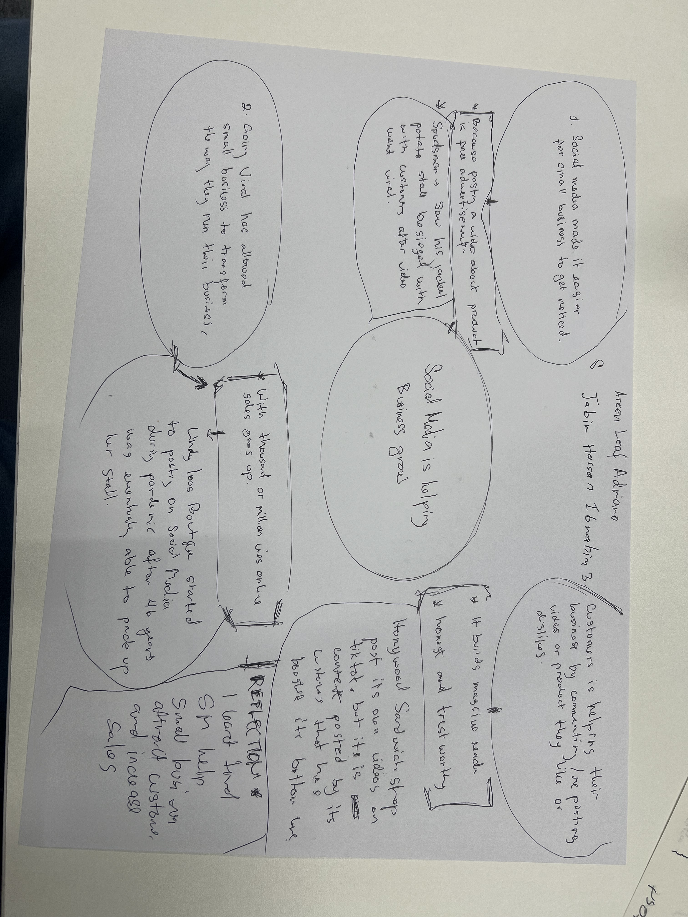

#
.

- What is the main idea of the whole text?
Social media helps small businesses become popular, attract customers and increase sales.

- What is one key point that supports the main idea, and which specific example from the text shows this?
Social media videos can bring more customers to a business. For example, customers travelled three hours to try the chicken burger at Honeywood sandwich shop.

- What is a different key point that supports the main idea, and which specific example from the text shows this?

Social media helps businesses reach customers in other countries. For example, lindy loo’s Boutique sells clothes across the UK and Australia. This shows that social media can help small business reach people in different places and sell more products to new customers.

- Which part of the text do you think is most important, and why?
I think social media videos are most important because they help small businesses attract more customers. Videos can show people what a business sells and make them interested in visiting or buying products. This can help the business become more popular and increase its sales.

Reflection:
- What did you find difficult in this task (including in-class components), and why was it difficult?
I found some words in the text difficult to understand because English is not my first language. Sometimes I needed to the text more than once to understand the meaning. I also found it difficult to choose the main ideas and specific example. However, reading the text carefully helped me understand how social media can help small businesses grow.

- What helped you with this difficulty, and how did it help you?

Reading the text more than once and discussing it in class helped me understand the main ideas.

