

Module Title: Marketing Management
Module Code: LCMB7024

Assignment Title: Marketing Environment Analysis of BHP
Student Name: Yovan Bhaveshbhai Jetani

Student ID Number: 2532585

Submission date: 24/07/2025

Word Count: 2674

Table of Contents
Introduction 5
Task 1: Marketing Environment Analysis 5
1.1 Selection of a major mining corporation 5
1.2 Critical Evaluation of two external marketing environment factors 6
Task 2: Strategic Growth and Competitive Positioning 10
2.1 Strategic Growth Approach Using the Ansoff Matrix 10
2.2 Competitive Advantage by using 4ps of Marketing Mix 13
Task 3: Critical Reflection on AI Usage 16
3.1 Tool Disclosure 16
3.2 Critical Analysis of AI Output 16
3.3 Contribution Analysis 17
3.4 Ethical and Professional Reflection 17
Conclusion 18
Reference List 19

List of Figures
Figure 1: Overview of BHP and its mining operations 6
Figure 2: PESTLE Table 7
Figure 3: Extreme weather patterns experienced in Australia 8
Figure 4: Carbon emission level of Australia for the last 2 decades 9
Figure 5: Financial Figure of BHP in 2025 12
Figure 6: FY2025 of BHP 13
Figure 7: Results of BHP approach to reduce Carbon Emission 15
Figure 8: BHP’s emission results till 2023 16
Figure 9: Marketing Mix Table of BHP 17

List of Tables
Table 1: Key Highlights of Natural Environment 9
Table 2: Key Highlights of Legal Factors 9
Table 3: Ansoff Matrix Key Highlights 11
Table 4: 4PS Highlights 13

Introduction
The corporate initiatives undertaken by multinational enterprises for developing and executive product and service endorsement plans can be referred to as marketing management for achieving future organisational targets (Kotler et al. 2024; Kotler et al. 2023). The report is about the Australia-based mining corporation known as BHP (Broken Hill Proprietary) for examining the current external environment for locating viable market challenges in the form of high carbon emissions.

Task 1: Marketing Environment Analysis

1.1 Selection of a major mining corporation
Broken Hill Proprietary (BHP) can be considered an Australia-based multinational mining enterprise established in 1851 for generating quality raw materials for global industries. Presently. BHP has almost 90,000 employees operating in diverse locations around the globe for extracting quality natural minerals without compromising the surrounding environmental elements (BHP, 2026). In the financial year of 2024, BHP also generated almost 49.2 billion US dollars of economic contributions through mining operations across Australia and other continents (BHP, 2026). On the other hand, the corporate leadership of BHP have also implemented adequate net-zero operations since 2020, allowing the mining firm to lower GHG production by almost 32% in daily operations (BHP, 2026). Therefore, the selection of BHP has been a viable option here for signifying the current mining ecosystem of Australia being affected by both environmental and legal pressures for lowering organisational carbon footprint.
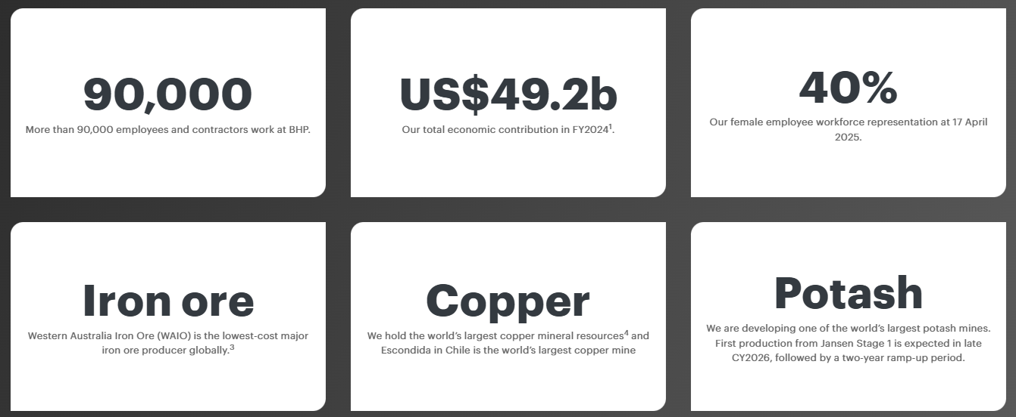

Figure 1: Overview of BHP and its mining operations
(Source: BHP, 2026)

1.2 Critical Evaluation of two external marketing environment factors
Both natural environmental and legal elements currently present in the Australian marketplace have a direct influence towards the future mining operations of BHP in attracting new clients.
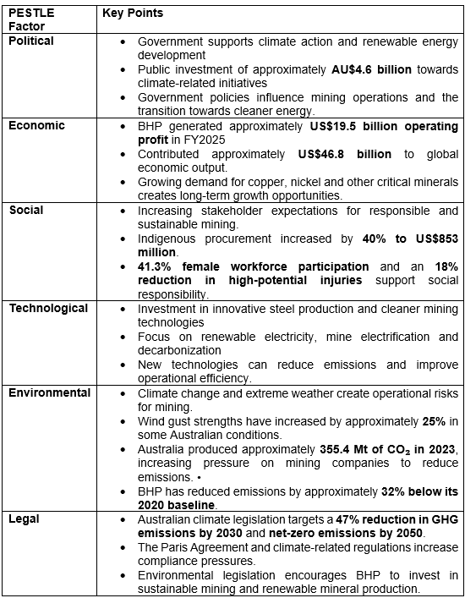

Figure 2: PESTLE Table
(Source: Self-Created)
Natural Environment Actor
The environmental elements from the PESTLE analysis have been utilised here that can help demonstrate the current GHG emissions for Australia. In the instance of natural environmental conditions, elements such as climate change, heightened need for sustainable resources and rapid environmental degradation because of pollution have transformed the mining operations. The continuous usage of fossil fuels has exacerbated climate change conditions throughout the Australian continent that can potentially result in 0.4 degrees to 2-degree temperature increase by 2030 (CSIRO, 2026). For example, global warming has also brought about extreme weather patterns in different parts of Australia, with a nearly 25% increase in wind gust strengths that can cause massive disadvantages in mining operations (CSIRO, 2026). The variability in temperature, precipitation and storms has negatively influenced the mining operations for major Australian brands such as BHP in maintaining sustainable profits. It can be mentioned that BHP officials ought to strengthen their sustainable and eco-friendly operations to positively contribute towards climate change concerns and mitigate the possibility of extreme weather. Therefore, global warming issues have a direct influence towards the natural environment of Australia and the rest of the world where BHP operates.
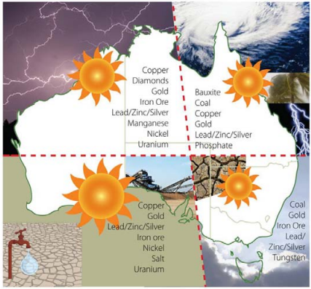

Figure 3: Extreme weather patterns experienced in Australia
(Source: CSIRO, 2026)
The heightened GHG emissions have also negatively influenced the natural environment of Australia due to continuous usage of fossil-based energy sources in daily industrial operations. For example, in the fiscal year of 2023, Australia and its subsequent industries have contributed almost 1% to the global carbon emissions rate (IEA, 2026). Between 2000 and 2023, the carbon emission level in the Australian markets has increased by almost 6% every year, which contributes towards heightened reliance on fossil fuel sources (IEA, 2026). Apart from that, nearly 355.415 metric tonnes of carbon emissions have been generated in Australia, which have adversely affected the local environmental elements and gradually elevated pollution levels (IEA, 2026). Therefore, the current administrative body of mining corporations such as BHP needs to increase investment towards sustainable energy sources such as solar and wind power to lower GHG production from the Australian continent.
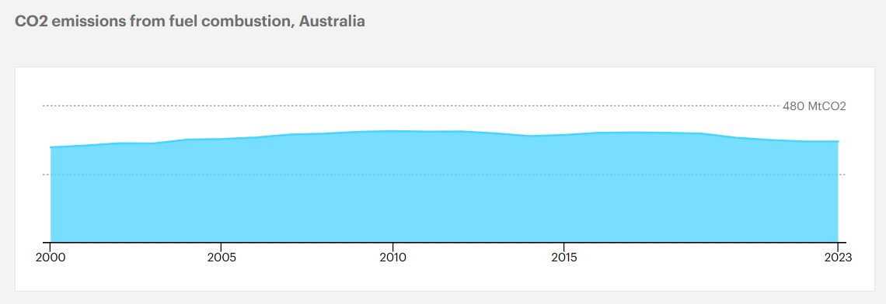

Figure 4: Carbon emission level of Australia for the last 2 decades
(Source: IEA, 2026)
The BHP leadership have also undertaken multiple decarbonisation efforts to address the degrading environmental conditions of Australia to mitigate climate change and GHG emission levels. For instance, the creation of innovative steel production technology has proven to be useful for the BHP administration towards gradually lowering GHG emissions by almost 30% produced during the blast furnace usage (BHP, 2026). The development of BHP's 2030 plan also utilises the Biological Diversity conventions, UN SDGs and Paris Agreement for adopting an eco-friendly organisational culture in the near future (BHP, 2026). Hence, the use of innovative steel processing technology and global environmental policies has helped improve the brand value for BHP among Australian clients.
Natural Environment Factor | Key Highlights
Climate Change | - Rising temperatures (0.4–2°C by 2030)  - 25% stronger wind gusts disrupt mining operations.
Carbon Emissions | - Australia emitted 355.4 Mt CO₂ in 2023.  - Increasing pressure for cleaner energy.
BHP Response | - Reduced blast furnace emissions by 30%  - Aligned 2030 strategy with UN SDGs  - Paris Agreement, and biodiversity goals to strengthen sustainability.

Table 1: Key Highlights of Natural Environment
(Source: Self-Created)
Legal Actors
The legal elements from the PESTLE analysis have been utilised here to show the current carbon policies implemented by the Australian government. For Instance, the Climate Change Act is a legislative policy of the Australian government to diminish national carbon emissions levels by 2050, which can prove to be a major advantage towards lowering fossil fuel-based systems. The Australian government has also set an initial plan for achieving a 47% reduction in GHG emissions levels by 2030 to address the environmental degradation caused since 2005 (GOV AU, 2024). On the other hand, in the 2023-24 national budget, the local government has invested almost 4.6 billion dollars of revenue towards addressing climate change-related problems (GOV AU, 2024). Therefore, the delivery of financial capital towards climate action and subsequent legislation created by Australia can provide adequate guidance towards GHP officials towards transforming organisational mining operations.
Legal Factor | Key Highlights
Climate Change Act | Targets 47% GHG reduction by 2030 and net-zero emissions by 2050, supported by AU$4.6bn climate investment.
Paris Agreement Commitment | Australia is expanding renewable mineral production with 50 lithium, 17 cobalt, and 60 nickel mines, creating opportunities for BHP’s sustainable mining strategy.

Table 2: Key Highlights of Legal Factors
(Source: Self-Created)
The local governmental bodies in Australia, such as MCA, have also facilitated their commitment towards the Paris Agreement towards developing innovative technologies to take positive climate actions. Around 50 new lithium mines, 17 cobalt mines and 60 new nickel mines have been dedicated in Australia for developing renewable energy infrastructure for storing electricity (Mineral Council of Australia, 2024). Therefore, the current leadership of BHP also needs to focus on maintaining feasible operations for deriving useful minerals such as cobalt and lithium used to develop sustainable energy infrastructure for solar power.

Task 2: Strategic Growth and Competitive Positioning

2.1 Strategic Growth Approach Using the Ansoff Matrix
BHP is best placed to shift to less carbon-intensive materials through a Sustainable Growth Strategy that will underpin BHP's long-term growth and sustainability. There are four ways of implementing this strategy, using the tools to be provided by the Ansoff Matrix:
Ansoff Strategy | Key Highlights
Market Penetration | - US$19.5bn operating profit  - stronger customer trust through emissions reduction.
Market Development | - US$46.8bn global economic contribution  - US$10.4bn government payments  - 40% Indigenous procurement growth.
Product Development | - 2Mt copper production  - Safer and more diverse workforce supporting low-carbon products.
Diversification | - Investing in renewable technologies  - Green industrial applications for long-term sustainable growth.

Table 3: Ansoff Matrix Key Highlights
(Source: Self-Created)
- Market Penetration: Sustainable Growth Strategy with its existing products to boost their sales as well as improving their perceptions of current operational sustainability. As per BHP Annual Report (2025), BHP achieved US $19.5 billion profit from operations in FY2025 and distributed a 110 US cents dividend per share, demonstrating solid financial and market confidence that possess an advantage for BHP. Furthermore, BHP is well placed to use its greenhouse gas emissions reduction as part of Scope 1 and Scope 2. This enhances existing customer relationships as a result of these sustainability benefits.
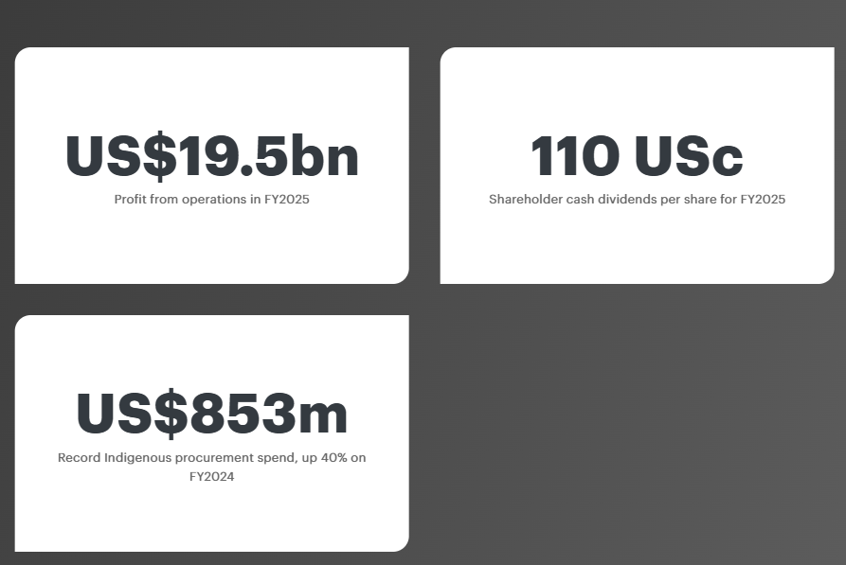

Figure 5: Financial Figure of BHP in 2025
(Source: BHP Annual Report 2025)
- Market Development: Production of minerals in a responsible manner for the international market with a strong focus on Sustainable Growth Strategy. As per BHP's Annual Report (2025), BHP's total contribution of US $46.8 billion to gross global economic output and payment of US $10.4 billion to governments further emphasised its healthy presence on a global scale and its capacity to drive economic growth globally which signifies an advantage to its operations. As per BHP's Annual Report (2025), its commitment to Indigenous procurement saw a 40% increase for FY2024 to $853 million and underscores the critical role of inclusive supply chains and sustainable sourcing.
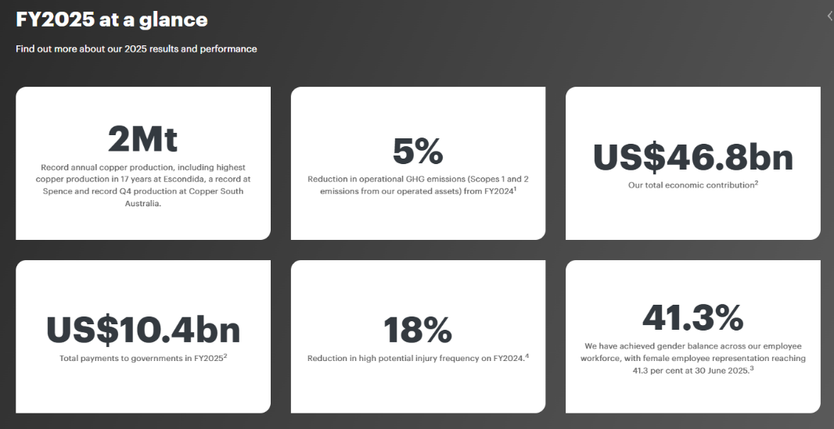

Figure 6: FY2025 of BHP
(Source: BHP Annual Report 2025)
- Product Development: This approach fits best with BHP's Sustainable Growth Strategy as it would help the company introduce new lower-carbon mineral products to its existing customers in other sectors of industry (Johnson et al., 2017). BHP has coordinated the annual production of two million tons of copper in one year. Its supply chain can be tailored to support the production of the critically important minerals for EVs and other renewables that provide an advantage for them . As per BHP's Annual Report (2025), a 18% decrease in high-potential injuries and a 41.3% proportion of female participation in the workplace have also demonstrated BHP's stance on diversity and safety in its sustainable approach.
- Diversification: Adopting the Sustainable Growth Strategy in all new products, service offerings and markets in general, such as into new technologies that generate renewable energy or other green industrial applications can provide a disadvantage to their operations (Islam et al., 2022). BHP has good financial resources and a natural aspect of investment for diversification and commercial risk too that isn't in BHP's comfort zone.

2.2 Competitive Advantage by using TBL framework
BHP has the opportunity to create a sustainable competitive advantage by moving towards a lower-carbon business model at a faster pace by using the TBL framework:
TBL Dimension | Key Highlights
Planet | - Reducing emissions by 26%  - Investing US$4bn in decarbonisation, renewable energy, and mine electrification by 2030.
People | - Cutting operational emissions by 5%  - Achieved US$19.5bn operating profit  - Strengthened reputation through sustainability initiatives.
Profit | - Recording 2Mt copper production  - Emissions 32% below 2020 baseline and 41.3% women workforce  - 18% fewer high-potential injuries, supporting long-term competitive advantage.

Table 4: TBL Highlights
(Source: Self-Created)
Planet
Investment in cleaner production technologies is one of the key sources for achieving competitive advantage (Hooley et al., 2024). As per L (2023), BHP has reduced carbon emissions from the year 2022 with a decrease of 26% from the previous year level. BHP has signed up for approximately US$4bn to reduce carbon emissions till the end of 2030. These initiatives will support decarbonisation, which include operational efficiency improvements, renewable electricity and electrification of mines (BHP, 2024). The investments not only minimise the emissions generated in the operation but also enable the company to use them as a source for meeting customers' demand for environmentally friendly supply chains for their minerals needs.
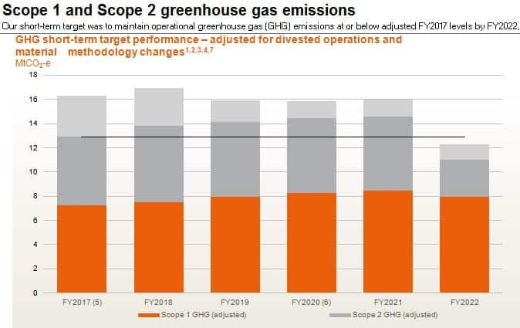

Figure 7: Results of BHP approach to reduce Carbon Emission
(Source: L, 2023)
People
Environmental performance also contributes to the company's disadvantages as it could hamper their reputation and the trust of its customers. In FY2025, BHP achieved a 5% reduction in operational greenhouse gas emissions, including a downward trend in scope 1 and scope 2 emissions, proving SBP's strategy to tackle emissions is yielding results (BHP Annual Report, 2025). The enhancement makes BHP's offerings more appealing to manufacturers looking to decarbonise their value chain. As per Zheng et al. (2024), the company also achieved an operating profit of US$19.5 billion, demonstrating that making investments in sustainability doesn't come at the cost of good financial performance.
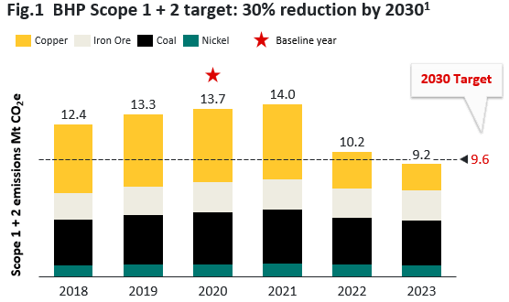

Figure 8: BHP’s emission results till 2023
(Source: Digital, 2026)
Profit
The International Energy Agency (2024) estimates that investment in clean energy will be over $2 trillion in 2024, requiring a significant increase in demand for minerals like copper and nickel. This is vital to EVs and other renewable energy systems and their batteries. BHP is uniquely well placed to capitalise on this market opportunity, as it is ranked as the world's biggest copper producer in FY25 with copper production which provides an advantage for them. This reached record highs of 2 million tonnes, meeting the increased demand of its customers and building its market share on the global cleantech side (Xiong, 2025). The competitive advantage is further cemented by having strong stakeholder relationships. As per Digital (2026), BHP’s emissions in 2023 were 32% below the 2020 baseline, after adjusting for recent acquisitions and divestments. The advantage indicate the company's commitment to responsible business practices, which further reinforces its social license to operate and improves relationships between the company, governments and local communities. Moreover, BHP achieved a 41.3% representation of women in its workforce while decreasing its frequency of high-potential injuries by 18% (Agu et al., 2024). This demonstrates ongoing efforts to enhance the safety of the workplace and diversity of employees.
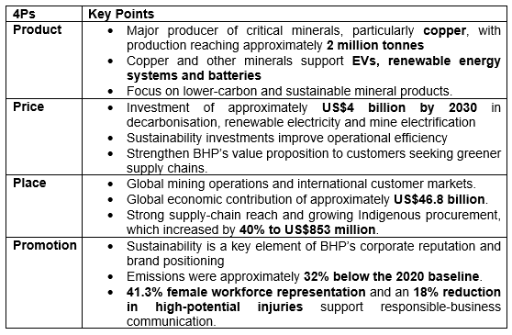

Figure 9: Marketing Mix Table of BHP
(Source: Self-Created)

Task 3: Critical Reflection on AI Usage

3.1 Tool Disclosure
During the conduct of university assessments, I have utilised AI technology for performing detailed research on topics that helped me towards locating adequate resources on obscure subject matters. For instance, almost 80% of doctoral students have mentioned using various AI tools such as ChatGPT and Google Gemini for performing critical research tasks without any major disruptions (El Hani et al. 2025). I have personally felt that the AI technology usage has greatly improved my research skills in locating viable websites and journal articles on diverse tasks. The artificial intelligence has also been useful in the identification of industry trends and reports published by both the government and the corporation itself, thus increasing the validity of the research.

3.2 Critical Analysis of AI Output
During the usage of AI systems, I have utilised the Retrieval-Augmented Generation (RAG) features involved with different smart systems for locating the source documents that can help me to verify system accuracy levels. I have also performed a detailed consistency check for the AI feedback provided by the system to locate potential hallucinations and system errors that can degrade my task standards. In my opinion, the utilisation of Human-in-the-Loop (HITL) interventions has proven to be an effective technique for improving the AI feedback quality through lowering error factors. The factual accuracy of the AI-produced responses has been verified with the help of peer-reviewed journal articles.

3.3 Contribution Analysis
AI did most of the work to generate first drafts, assist with summarising theoretical concepts, and provide appropriate report structures. It also helped refine sentence structure and provided a way to structure information into sections. The critical analysis and evaluation of BHP's marketing environment, the choice of the sustainable growth strategy and the justification of the product development strategy and recommendations to secure competitive advantage (Gholiagha et al., 2026). My own interpretations of academic literature, the former literature being sourced from company reports. I independently chose the numerical evidence, incorporated a wide range of sources, edited arguments and made sure that the report covered the assessment criteria. I have individually improved the structure of the paper and provided the critical discussion along with the most up-to-date statistics from credible sources. All of the conclusions and recommendations which I have provided have been based on my personal opinion, after analysing the relevant academic and industrial sources.

3.4 Ethical and Professional Reflection
Leveraging AI in marketing analysis offers several advantages, including making the process more efficient, generating ideas and aiding in data interpretation. AI outputs should be used wisely, however, as it may produce false information or a reference list or conclusion that is unreliable if outputs are not verified. However, any use of AI must be ethical, free from plagiarism and trans clear, which includes proper attribution of any sources that were used (Gholiagha et al., 2026). It is essential for marketing professionals to make sure that AI is used to assist rather than replace thinking and decision-making. It is important to use the AI tool in a responsible way while maintaining human supervision throughout the whole assessment process. Ethical judgment should play a key role in the assessment of the information credibility.

Conclusion
Within the analysis of BHP’s marketing environment, the effect of environmental and legal factors on the company’s performance and sustainability was taken into account. More specifically, it is evident that such elements as climate change, carbon emissions, and environmental regulations had an effect on the strategy of the firm and made it develop more responsible attitudes towards mining activities.

Reference List
Core Text
Kotler, P., Armstrong, G., Harris, L.C. and He, H. (2024) Principles of marketing. 19th edn. Harlow: Pearson.
Hooley, G. J., Nicoulaud, B., Rudd, J. M., and Lee, N. (2024) Marketing strategy and competitive positioning. Eighth edition. Harlow, England; Pearson.
Johnson, G., Whittington, R., Scholes, K., Angwin, D., and Regnér, P. (2017) Exploring strategy: text and cases. Eleventh edition. Harlow: Pearson Education Limited.
Journal Articles
Agu, E.E., Iyelolu, T.V., Idemudia, C. and Ijomah, T.I., (2024). Exploring the relationship between sustainable business practices and increased brand loyalty. International Journal of Management & Entrepreneurship Research, 6(8), pp.2463-2475. https://www.researchgate.net/profile/Tochukwu-Ijomah-2/publication/383847817_Exploring_the_relationship_between_sustainable_business_practices_and_increased_brand_loyalty/links/66dc447d2390e50b2c7212e7/Exploring-the-relationship-between-sustainable-business-practices-and-increased-brand-loyalty.pdf
EL HANI, Z., KARROUM, J., ELOUADI, A. and MOUMEN, A., (2025). Artificial intelligence in academic research: Benefits, challenges, and ethical dimensions in doctoral studies. Moroccan Journal of Quantitative & Qualitative Research, 7(2), p.1. https://scholar.archive.org/work/cyrpzu7wqjak5hisdhgkf4iu6q/access/wayback/https://revues.imist.ma/index.php/MJQR/article/download/55186/29035
Gholiagha, S., Neyer, J., Sienknecht, M., Wolska, M.A., Kiesel, D., Riehmann, P., Voigt, J., Wiegmann, M., López García, I., Girgensohn, K. and Stein, B., (2026). From annotation to reflection: how participatory AI training enhances critical thinking. AI & SOCIETY, 41(3), pp.1937-1950. https://link.springer.com/article/10.1007/s00146-025-02539-9
Islam, A., Wahab, S.A. and Latiff, A.A., (2022). Annexing a smart sustainable business growth model for small and medium enterprises (SMEs). World Journal of Entrepreneurship, Management and Sustainable Development, 18(2), pp.1-24. https://www.researchgate.net/profile/Dr-Ariful-Islam/publication/354034695_Annexing_a_Smart_Sustainable_Business_Growth_Model_for_Small_and_Medium_Enterprises_SMEs/links/61b8c614a6251b553aba95b9/Annexing-a-Smart-Sustainable-Business-Growth-Model-for-Small-and-Medium-Enterprises-SMEs.pdf
Xiong, M. (2025). Broken Hill Proprietary Billiton report: Analysis of Available Strategies to Hedge Risks by Using Futures Contracts, Foreign Exchange Futures. http://www.aeph.press/uploadfile/202312/60771d03f2a9e.pdf
Zheng, L.J., Zhang, J.Z., Lee, L.Y.S., Jasimuddin, S.M. and Kamal, M.M., (2024). Digital technology integration in business model innovation for carbon neutrality: An evolutionary process model for SMEs. Journal of Environmental Management, 359, p.120978. https://www.sciencedirect.com/science/article/pii/S0301479724009642
Web References
BHP (2024) Climate Transition Action Plan 2024. Available at: https://www.bhp.com/sustainability/climate-change/climate-transition-action-plan
BHP (2026a) About us, Available at: https://www.bhp.com/about [Accessed: 21st July 2026]
BHP (2026b) Sustainability, Available at: https://www.bhp.com/sustainability [Accessed: 21st July 2026]
BHP Annual Report (2025) Annual Report 2025. Our products help build a better, clearer future. Available at: https://www.bhp.com/investor-hub/reports-and-presentations/annual-report
CSIRO (2026) Climate adaptation in the Australian mining and exploration industries, Available at: https://research.csiro.au/climate/wp-content/uploads/sites/54/2016/03/5_WorkingPaper5_CAF_pdf-Standard.pdf [Accessed: 21st July 2026]
Digital, B. (2026) BHP decarbonisation roadmap. Available at: https://www.skarnassociates.com/insights/bhp-decarbonisation-roadmap
GOV AU (2024) Australian Government Climate Change Commitments, Policies and Programs, Available at: https://www.aofm.gov.au/sites/default/files/2024-02-02/Climate%20change%20slides%20updated%20February%202024.pdf [Accessed: 21st July 2026]
IEA (2026) CO2 emissions from fuel combustion in Australia, Available at: https://www.iea.org/countries/australia/emissions [Accessed: 21st July 2026]
International Energy Agency (IEA) (2024) World Energy Investment 2024. Available at: https://www.iea.org/reports/world-energy-investment-2024
L, J. (2023) BHP to Spend $4B to Decarbonise by 2030, Carbon Emissions Spikes Up Near-Term, Carbon Credits. Available at: https://carboncredits.com/bhp-to-spend-4b-to-decarbonise-by-2030-carbon-emissions-spikes-up-near-term/
Mineral Council of Australia (2024) Energy and climate change, Available at: https://minerals.org.au/policies/energy-and-climate-change/ [Accessed: 21st July 2026]

