Adan Ajmal
Team working and communication for success within the workplace
BMSW4002
Dami Pokubo
25th October 2021

Table of context
Introduction 1
Developing an effective team in relation to the case study2
Conclusion 3
References4

Introduction
This report will analyse the necessity and importance of effective team working and communication within the workplace and business environments. The focus of this report is on a furnishing company called Comfy Homes and how individuals in this company work together to form an effective team for optimal success in this business.
Teamwork-
Teamwork is defined in various ways and is interpreted differently by most individuals although according to Tuckman (1965) most groups go through a 5-stage process. Similar to Wheelan (1999) who worked off Tuckman’s theory theorising that groups go through a 4-stage process although not all experts agree with these theories, they are also other theories such as Meredith Belbin’s
Generally speaking, a team is defined by a group of individuals who have a common goal or objective to achieve. Most groups roles are assigned to each individual with the leader participating in teamwork and events. Working together and cohesively is essential in team work as it allows the business to run as smooth as possible to ensure the maximum amount of profit.
The impact of effective teamworking
For Comfy Homes to efficiently work together as a team they will have to come together setting aside any differences that they may have to ensure optimal success in reaching their shared goal. Some teams go through a phase in the beginning where team members are still trying to figure out one another as Wheelan (1965) and Tuckman (1999) state in their theories, looking for a team leader and a disagreement will also occur during different stages. This behaviour would be expected from a group of mixed individuals who have come together to work as a team as they may come from different backgrounds, religions, individual beliefs and cultures and as they all have different opinions and perspectives of how things should be done. Disagreements and conflicts may happen like lack of communication, compassion and understanding from individual team members. There are other issues that may occur within like communication barriers, members being of different genders, health and disagreements over technology. An example of this in relation to the case study is that there is a new piece of technology that will benefit the business. It is a machine that allows Comfy Homes to repair ripped fabrics almost instantly, the team members are disagreeing on whether or not this purchase should be made as it is expensive but in purchasing this they could improve their sales massively as they will not be waiting on sending furniture back and forth to be repaired they can just repair it at the shop meaning an increase in sales as more products are available in store.
A team may work differently to a group as a “group” of people is typically defined as a bunch of different people coming together to form a group working alone to fulfil a common task, unlike a team where they must work together effectively to accomplish a shared goal. A team should be diverse and focused. They should be able to communicate well with one another and contribute for the best result and maximum profit.
Developing an effective team in relation to the case study.
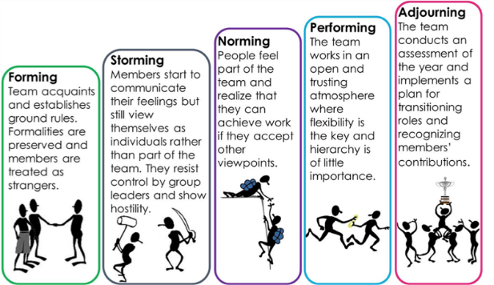
Tuckman’s Theory (1965)
He believed that teams go through 5 stages
Forming
Storming
Norming
Article title: | Tuckman’s stages of group development | NS4B - Net Solution For Business
Website title: | Ns4business.com.br
URL: | https://ns4business.com.br/tuckmans-stages-of-group-development/

Adjourning
The forming stage is when the team establishes members, everybody is trying to fit in and find their role within the team. The second stage is storming when members start to communicate with one another and are now sharing opinions and starting to voice their feelings towards one another. During this stage there may, be conflict over leadership and individual team roles. Moving on from these stages they go through 3 more stages. The norming stage members now know their position within the team, they will have a strong sense of identity and position. The team will now have a structured set of expectations and what behaviours expected from them. This will be vital for Comfy Homes as it will allow the team to effectively work cohesively together knowing their roles in the team and what behaviours and protocols that are expected from them in this environment for their business to operate successfully. This also aligns within the performing and adjourning stage as the team now understands the given task and sets a permanent set of roles which they can follow and abide by to continue working together successfully. The performing stage is when the time has come for team member to motivate one another and get the things they need done, by this stage they should now be able to trust one another, liaise with one another and find solutions to any disagreements or problems that may occur within. Once the team has transitioned through each of these 4 stages, they will move on to the final stage adjourning. Adjourning is when the team has now successfully reached their goal and target and go their separate ways unless they need to continue working together.
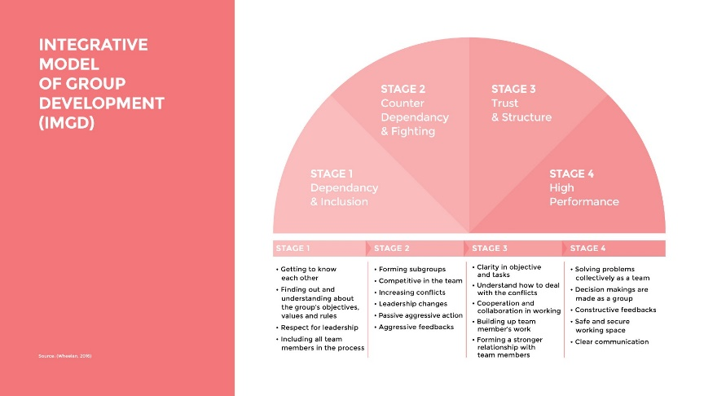
Wheelan’s Theory (1999)
Wheelan has a similar theory to Tuckman it consists of 4 stages
Dependency and Inclusion
Counter dependency and fight
Trust and Structure
Work and productivity
The theory was that groups go through a process of working together to achieve their objective. Wheelan believes that teams that have worked together for longer periods of time compared to those who have worked together for a shorter period of time behaviours tend to vary, as their behaviour patterns very on the time periods that the group has been working together.
Wheelan’s theory can also be applied to the case study above as Comfy Homes staff that have been working together for a longer period of time work together better to reach their goals and objectives as this would means that the members have successfully gone through all 4 phases of this theory and now are operating well as a team ensuring that business is flowing smoothly, selling more home furnishings resulting in maximum profit for the company. Whereas a group that has been working together for a shorter period of time would still be going through the stages of forming a group/team. Meaning that this could hinder the quality of their work as they will still be in the process of negotiating and developing ideas unlike the group who have been working together for longer who will have shared ownership and responsibilities and set roles.
The similarities between Wheelan and Tuckman’s theories are that they both focus on the relationship of members of the team and describe the developmental strategies that teams go through. The difference between the two is simply that Wheelan built of Tuckman’s model and said that the time that the group has spent together also affects their behavioural pattern.
The types of roles that are needed to form a cohesive and affective team in relation to the case study
For the furnishing company Comfy homes to form a cohesive and effective team, Belbin’s team roles are very important. Belbin believed for teams to be effective that there are 9 roles within a group. The monitor evaluator, the specialist, the shaper, the coordinator and many more. Belbin believed that in order for a team to achieve success most members of the team assume to either one of these specific roles, each individual working in a particular way to get the best results and it helps minimise people’s weakness as well as highlight their strengths in order to put their skills to the best use enabling the team to work together more cohesively. “Belbin and others argued that the combination of personalities in a team or the combination of individual team member roles could significantly improve or diminish the ability of a team to complete a particular task”
Comfy homes have a team from various different backgrounds and personalities. In order for them to work cohesively they must establish each of their roles and how they can use their specific qualities to better the company for long term success. For example, the manage that possess the completer/finisher quality may be given the role of team leader as they have an eye for attention meaning they can look at other team members and work with them to develop their role in them and think strategically to ensure the objective is met. The team worker would be good for doing on floor sales as they know how to work well amongst others as well as the person who carries the specialist quality as they are action orientated.
Gersick (1988) is another theory on how groups work. The difference between Gersick’s theory is that her model is more aligned with the given task dimensions whereas Tuckman and Gersick focus more on the relationships between team members through the given developmental stages.
Phase1 (stability) | Transition (Instability) | Phase2 (stability)

Conclusion
To conclude this report teamwork is clearly an essential part of the business in order for them to gain success and for the growth of the company, no one person alone can carry the company /team/group alone. It is also important as all the unique personalities coming together can put their own individual talents and experiences together this means that their will be more ideas and relevant opinions being put forward to better the company. This will also allow them to work as one cohesively, eventually helping them to reach their shared gaol more effectively.
Having different individuals allows the team to think ne new and different ways this would prove to be very important for the case study above. Each member of team from Comfy Homes has different talents and experiences meaning that they can impart their knowledge with one another allowing for new sales techniques and ideas are presented for this furnishing company to further progress and grown for them to make profit.
Apart from Tuckman and Wheelan’s theories that are used in this report there are many other theories on how teams / groups work together and the different stages they go through, such as Fisher’s theory (1907). The theory consists of 4 stages orientation, conflict, emergence and reinforcement. This method shows how interaction between team or group members decisions change as they progress. There is also others such as Tubbs System Model e.c.t. “a small amount of interpersonal tension can be helpful, too much can engender negative emotional contagion that can sabotage trust and good will.”
(Griffiths and Dunham, 2015, p15)
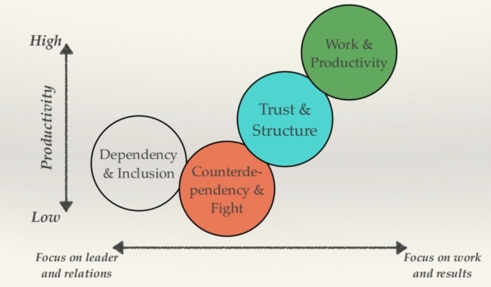

Tuckman and Wheelan’s theory have shown to be effective in the above case study, the team did go through different developmental stages. Tuckman and Wheelan’s theory provide the team members with a useful theory on how they should be working in a business environment and in how using these theories people like the team leader and members can assess how the team will form in order for them to work together and effectively it almost sets out an example of what they are to expect when entering or joining a team/group. Tuckman and Wheelan’s theory also prepare the team leader on how the team will move from stage to stage of either of these theories and hot to correctly and efficiently support them to come together and work cohesively.This report has covered many different theories and techniques on how different individuals unique to one another can come tother to achieve their gaols. It is important for teams to have a understand of one another and for them to be respectful to each other’s opinions. This report also talked about the differences between teams and groups station that even though they are both just groups of people coming together to achieve a common goal or objective they are different in how the work together one being one works solitary and the other cohesively.q
Referencing page
Article title: | Tuckman’s stages of group development | NS4B - Net Solution For Business
Website title: | Ns4business.com.br
URL: | https://ns4business.com.br/tuckmans-stages-of-group-development/

Article title: | Guide for Effective Projects & Teams Management
Website title: | Medium
URL: | https://blog.prototypr.io/guide-for-effective-projects-teams-management-bc6852738dcb

“Belbin and others argued that the combination of personalities in a team or the combination of individual team member roles could significantly improve or diminish the ability of a team to complete a particular task”
(Morgan, 2017, p207)
Wheelan, S.A., (2016), Creating Effective Teams, 5th Ed, London, SAGE
“a small amount of interpersonal tension can be helpful, too much can engender negative emotional contagion that can sabotage trust and good will.”
(Griffiths and Dunham, 2015, p15)
Article title: | isch- | Encyclopedia.com
Website title: | Encyclopedia.com
URL: | https://www.encyclopedia.com/caregiving/dictionaries-thesauruses-pictures-and-press-releases/isch
Morgan, P. (2017), The Business Student’s guide to study and employability, London, SAGE.

