

Project Design and Method Statement

Site: St. Martin’s Cathedral, Leicester.

NGR: SK 583044

Client: Messenger Construction Ltd.

Planning Authority: Leicester City Council

Planning Ref: 20192261

ULAS Job No: 21-562

Acc No/Site Code: A21.2021

Filename/Version | Checked by | Date | Reason for Issue
21-562 DRAFT | M Morris | 21/10/21 | Draft for comment
21-562v1 | M Morris | 16/03/2022 | General edits and updated research objectives and methodology
21-562v2 | M Morris | 16/06/2022 | General edits and updated project objectives following comments from Cathedral Archaeologist

University of Leicester
Archaeological Services
University Rd., Leicester, LE1 7RH
Tel: (0116) 2522848 Fax: (0116) 2522614

Contents

1. Introduction 1
Definition and scope of the project 1
2. Background 1
Context of the Project 1
Historical and Archaeological Background 2
3. Aims and Objectives 3
Research Objectives 3
4. Constraints 4
5. Methodology 5
Human Remains 5
Contingency Provisions 7
Monitoring 7
6. Finds 7
Treasure 7
7. Environmental Samples 8
Scientific Dating 8
8. Timetable and Personnel 8
9. Post Excavation Analysis and Reporting 9
Publication and dissemination of results 10
10. Public Engagement and Publicity 10
11. Health and Safety 10
12. Insurance 10
13. Quality Assurance 10
14. Staff Training and CPD 11
15. Bibliography 11
Appendix: Figures 13

Figures
Figure 1: Site Location 13
Figure 2: Location of Development Area (highlighted) 14
Figure 3: Location of Test Pits within the Song School 14
Figure 4: Location of Brick-Lined burials from previous work 15
Figure 5: Results of the ground-penetrating radar survey of the development area (potential voids in green) 16
Figure 6: Plan showing location of proposed basement area of HLC structure. Supplied by Client 17
Figure 7: North/south section across proposed basement of HLC structure. Supplied by Client. 17

Project Design and Method Statement for
Archaeological Excavation

1. Introduction

Definition and scope of the project
  - This document is a Project Design and Method Statement for a phase of archaeological Excavation at St. Martin’s Cathedral, Leicester (SK 583044) in accordance with National Planning Policy Framework (NPPF): Section 16 Conserving and Enhancing the Historic Environment (MHCLG 2021) and Cathedrals Fabric Commission for England (CFCE 2019) and will be submitted to the Leicester City Planning Archaeologist (hereafter referred to as the City Archaeologist) and to the Archaeological Consultant to the Cathedral (hereafter referred to as the Cathedral Archaeologist) for approval prior to any archaeological work taking place. The document is meant to be reactive to discoveries and will be subject to revision as circumstances dictate.
  - As part of the Leicester Cathedral Revealed project, a new Heritage Learning Centre (HLC) will be built on the footprint of the Song School, which was built in the 1930s and located in the SE corner of the Cathedral. The new building will incorporate a double basement to depth of c.7.5m and is intended to provide for a series of functions including a teaching and display area, a zone for meetings, and below ground in the first basement, an area for lavatories and a volunteer’s rest room, and in the deeper basement, a storage area for furniture and other cathedral equipment.
1.3 This document covers the main phase of archaeological excavation of the basement footprint following the installation of the piles for the new HLC structure, as specified by the Cathedral Archaeologist (Dixon 2020).
1.4 The fieldwork specified below is intended to provide a record of the archaeological remains in mitigation of the impact of the proposed groundworks, and meet the requirements of the planning condition. This document should be read in conjunction with the project WSI (Dixon 2020) which addresses the requirements from the City Archaeologist and the Cathedral Archaeologist for a scheme of work comprising an archaeological excavation.

2. Background

Context of the Project
2.1 The site lies adjacent to the Great South Aisle and St Dunstan’s Chapel Leicester cathedral (Figure 1 and Figure 2). As part of the mitigation for the projected work, excavations and continuous monitoring will take place to identify the nature of the stratification and investigate and record any buried archaeological features.
2.2 The new development lies within an area once part of the cemetery of St Martin’s. This area of the cemetery was repurposed in the late 1930s, when a large single-story wing was added to the south of the chancel, to accommodate a range of functions, including a song school, storage, and chapter vestry and other services. This building is now in only fair condition and is inadequate for the cathedral’s developing needs, and so approval has been sought and recently granted for the replacement of the 1930s building with a larger and more usefully planned structure (LCC planning application 20182729).
2.3 On 15 February 2019, the Cathedral Fabric Commission for England granted conditional approval for “Leicester Cathedral Revealed” – Restoration and repairs to the historic cathedral interior and creation of a new Heritage Learning Centre on the south-east front.” (CFCE 2019).
2.4 Condition 17 requires that “the Cathedral Archaeologist shall hold a watching brief for the works on the Song School site; that if anything of archaeological significance is uncovered which would be disturbed or destroyed by the works, works shall stop to allow for consultation with the Cathedral Archaeologist and shall not recommence until a mitigation strategy is agreed by him; that a report of the excavation shall be prepared by the Cathedral Archaeologist and placed in the Cathedral Archives; and that if any human remains are uncovered they shall be treated with due care and decency and in accordance with the guidelines set out in the Advisory Panel on the Archaeology of Burials in England’s Guidance for Best Practice for the Treatment of Human Remains Excavated from Christian Burial Grounds in England (2nd edition, 2017).”
2.5 On 20 February 2019, Leicester City Council, as local planning authority, granted condition planning approval for “demolition of single storey extension: construction of two storey above ground and two storey below ground building for a learning centre, store and volunteers area (Class D1)” (LCC planning application 20182729).
2.6 Condition 2 requires that “no demolition shall take place in relation to the Old Song School or new development in relation to the Heritage Learning Centre until the applicant has secured the implementation of an appropriate programme of archaeological work with a Written Scheme of Investigation (WSI), which has first been submitted to and approved in writing by the City Council as local planning authority. The scheme must include an assessment of significance, research questions, and:
- A programme and methodology for site investigation, excavation and recording of archaeological deposits to an agreed depth below final formation levels, or to undisturbed natural geology;
- A method statement for the excavation, recording and analysis of human remains;
- The programme for post-excavation assessment;
- Provisions for the analysis of the site investigation and recording;
- Provisions for the publication and dissemination of the analyses and records of the site investigation;
- Provision for archive deposition of the analysis and records of the site investigation.

Historical and Archaeological Background
2.7 The parish church of St Martin became Leicester Cathedral in 1927. The building has a nave and aisles, outer south aisle, south and north porches, a chancel and chancel chapels and was heavily restored in the 19th century. The tower and spire were rebuilt in the 1860s by Raphael Brandon who also rebuilt the north arcade (1846-8), the chancel chapels (1865) and the clerestorey. The north aisle was restored in 1880 and the south in 1896-8. (Pevsner 1984, 208).
2.8 The Ordnance Survey Geological Survey of Great Britain Sheet 156 indicates that the underlying geology consists of Mercia mudstone, with overlying river sands and gravels. The natural ground lies at 3.34 - 4.70m below the present ground surface of c.61 - 63m OD.
2.9 The archaeological potential of the area has been discussed in a Desk-Based Assessment produced for the Leicester Cathedral Revealed project (Dixon 2018) and previous archaeological fieldwork that has been undertaken in the vicinity confirms that the site is located within an area of high archaeological potential, within the heart of Roman and medieval Leicester, with the possibility of remains of Roman, medieval and post-medieval date. Possible late Saxon remains have also been recorded directly to the north-west of the area.
2.10 A series of test pits excavated within the upstanding Song School in 2016 (Figure 3) were monitored and revealed indications of the likely depths of archaeological deposits in the area (Dixon 2016, revised 2017). Most pertinent to the present work, a stone slab covering brick-lined burial vault was identified close to the southern wall of the building at a depth of c.0-.7m below the level of the Song School floor. Further known burials of a similar character were revealed during work in the churchyard just to the south of the Song School in 2014 (Higgins 2014 & Figure 4).
2.11 A Ground Penetrating Radar Survey undertaken prior to the removal of the Song School floor slab revealed a number of void areas that proved to represent the locations of burials, as well as previously unrecognised service channels (Figure 5).

2.12 HLC Phase 1 excavation (October 2021 – January 2022)
Archaeological monitoring of groundworks began in October 2021, following the demolition of the Old Song School. After the removal of the floor slab, during work to reduce the underlying ground, it was rapidly discovered that burials still survived intact at a very shallow depth and above the proposed formation level for the piling mat. This necessitated a 10-week long rescue excavation to record and lift 125 individuals from the upper 300mm of burial soil, enabling groundwork to resume.

The burials dated from the early 18th through to the mid-19th century (the churchyard shut in 1856). The 19th-century burials were all in coffins with the graves dug in rows at right-angles to the Cathedral. Most were earthfast graves but there were ten brick-lined graves, five multi-tiered and five single-tiered, scattered through the rows. The single-tiered graves and the upper chambers of the multi-tiered graves were all excavated during this phase of work, whilst the lower chambers of the multi-tiered graves were left untouched for Phase 2. Coffin wood and coffin furniture survived reasonably well in the brick-lined graves but bone did not. The opposite was true in the earth-fast burials, where bone preservation was generally good but only metal coffin furniture survived. These 19th-century graves were dug into a burial soil full of earlier 18th-century graves, with the earliest confirmed burial in this phase of work being 1738.

2.13 HLC watching brief (January – May 2022)
Groundwork to install the piling mat, piling guide wall, piles and capping beam for the HLC basement resumed in January 2022, running through to May 2022. An intermittent watching brief was maintained on this work and monitoring of this work provided further useful insights into the expected archaeological sequence excavated in Phase 2.

The soil sequence observed during the piling and the removal of the Old Song School’s concrete footings, which extended over 2.5m into the ground, identified human remains in dark soil down to a depth of 1m (the burial soil) below the piling mat. Beneath this was a further 0.5m of dark earth which probably represented the ground level pre-churchyard (possible Anglo-Saxon layers). This may also contain some burials but this will likely be fewer than in the overlying burial soil. Beneath the dark earth was a further 0.5m of mixed deposits which, by their character, appeared to represent Roman layers. A 'dirty' orange gravel approximately 2m down may be natural alluvial material. Cleaner yellow sand approximately 2.5m down was the natural substrate, with red clay beneath it.

Auguring of two piles, one on the north side of the basement wall and one in a corresponding location on the south side hit tightly packed stone rubble about 2.5m down. On the south side, where the auger managed to break through, this was identified as unmortared granite. This may be a north/south orientated wall footing, possibly of Roman date. Otherwise, Roman building material (i.e. mortar, painted wall plaster etc) was largely absent from the soil layers although some ceramic building material (box flue and roof tiles) and a large quantity of pottery was recovered.

2.14 Pre-cemetery Archaeological Deposits

The nature of the investigations so far undertaken has not made it possible to characterise the pre-cemetery archaeological deposits other than to recognise their presence and establish their approximate depth. The presence of a ‘dark-earth’ beneath the cemetery deposits may be a former topsoil into which some of the earliest burials from the cemetery have been cut into, but at present the date of this layer is unknown. It may also contain evidence for human activity in the area prior to the establishment of the churchyard, such as pits, which may help to provide a chronology, but until the top of the deposit is exposed further characterisation will be difficult.

The underlying layer has produced large sherds of Roman pottery and an indication of structural deposits through the discovery of an area of granite blocks during the piling. As with the ‘dark-earth’ characterising this part of the archaeological sequence will not be fully possible until it is revealed more fully across the excavation area.

Once the pre-cemetery deposits are reached during the excavation, and they have been characterised by the excavation team, an appropriate level of mitigation will be discussed and agreed by ULAS, the Cathedral Archaeologist and the Leicester City planning Archaeologist, and the Project Design and Method Statement will be updated accordingly.

3. Aims and Objectives
3.1 The main objectives of the archaeological work are:
- To identify, record and excavate human burials from the affected area of the Cathedral churchyard, following best practice guidelines.
- To establish the character, extent and date range and significance of any surviving archaeological deposits beneath the cemetery layers.
- To establish the ecofactual and environmental potential of any archaeological deposits and features encountered.
- To promote the ongoing results of the project through public engagement.
- To produce an archive and report of the excavation results.
3.2 Within the stated project aims, the principal objective of the recording is to establish the nature, extent, date, depth and significance of the heritage assets within their local and regional context.

Research Objectives
3.3 The site has the potential to add to research objectives on the Roman, early medieval, high medieval, post-medieval and modern periods, identified within The Archaeology of the East Midlands: An Archaeological Resource Assessment and Research Agenda, Leicester Archaeology Monograph 13, (Cooper 2006 ed), and East Midlands Heritage: An Updated Research Agenda and Strategy for the Historic Environment of the East Midlands (Knight et al. 2012), and updated here:
https://archaeologydataservice.ac.uk/researchframeworks/eastmidlands/wiki/:
3.4 The following general research objectives have the potential to be addressed by this project:
5. ROMANO-BRITISH (AD 43-c.410)
5.3 Growth of urban centres
5.3.2: How does the distribution of towns correlate with Iron Age foci, and how far may their social, political and economic roles have overlapped?
5.3.4: How were towns organised, what roles did they perform and how may their morphology and functions have varied over time?
6. EARLY MEDIEVAL (c. AD 410–1066)
6.2 Ritual and belief
6.2.6: How can we enhance further our understanding of the development of pre-Viking churches, cathedrals and monasteries?
6.5 Inland Towns, ‘central places’ and burhs
6.5.1: How may Anglo-Saxon and British communities have utilised late Roman towns and their immediate environs?
6.5.3: What was the impact of the Danish occupation upon urban development and what were the differences between Danish and non-Danish burhs and other urban settlements?
7. HIGH MEDIEVAL (1066–1485)
7.5 Religion
7.5.1: Can we identify additional pre-Conquest church, minster and monastic sites and elucidate the development of later monastic settlement (particularly the regionally important Gilbertine and Templar orders)?
7.5.6: What may we deduce from scientific analyses of cemetery populations about changes in diet, mortality and other demographic variables, both within the region and between social groups?
8. POST-MEDIEVAL (1485–1750)
8.6 Ecclesiastical structures, estates and burials
8.6.3: How can we ensure appropriate recording of churches and chapels, graveyards, artefacts of burial and remembrance and human remains (with their major potential for elucidating diet, health and demography)?
9. MODERN (1750 TO PRESENT)
9.3 Cultural diversity and religion
9.3.4: What may be deduced from cemetery studies about changing attitudes to burial and remembrance and evolving funerary architecture?

3.5 The Phase 1 excavation revealed some fascinating new insights into post-medieval and early modern burial practices in Leicester which will compliment data previously collected from the excavation of two 19th-century non-conformist cemeteries beneath the Highcross Leicester retail quarter. The following site specific research objectives have been identified as a result of the work carried out to date on this project:
- Significance of the excavation: Previous excavations in the city have examined medieval cemeteries and 19th-century cemeteries but for the first time this project will enable us to examine a continuous burial sequence from the early medieval period through to the mid-19th century, giving us a unique opportunity to chart how coffins and burial practices have evolved over the past 1,000 years.

- Coffin shape: Single-break coffins (the classic coffin shape) appear to have been universally used but there were subtle variations in design which may suggest different manufacturers or fashion choices.
- Coffin style: There were notable changes in decoration style between some of the 18th-century coffins, with initials and dates picked out on the coffin lid with upholstery nails, and most of the 19th-century coffins which had die-stamped tinplate nameplates on which personal information was painted. Some of these nameplates were identifiable in early 19th-century coffin furniture catalogues. There were also two burials with brass nameplates. A great variety of coffin grips were also recovered, with one stamped with the manufacturing mark of Edward Lingard of Birmingham (active in 1826).

- Insights into Leicester’s population & wealth: The variety, quantity and quality of these fittings was probably predicated on the taste, wealth and aspirations of the deceased’s family. As more of the burial ground at St Martins is excavated during Phase 2, we will gain further insight into the changing use and style of coffins in Leicester, and the history of the town’s funerary trade.

- Contemporary clothing and burial preparation: Good evidence was also recovered for how the deceased were dressed inside the coffin – including shroud pins, buttons and earrings, and in one rare instance of preservation, woollen stockings. Other finds from the burial soil included a wide range of domestic refuse which will provide invaluable dating evidence for the burial ground.

This information will complement the forthcoming osteological analysis of the skeletal remains and provide one of the fullest pictures of how life changed in Leicester through the medieval and post-medieval periods – a period of major social upheaval and transition, including epidemic diseases, the arrival of new global commodities such as tobacco, and the transformation of a small market borough into an industrial city.

3.6 Research aims will be assessed and updated during the course of the fieldwork.

4. Constraints
4.1 The Client will be asked to provide all information reasonably obtainable on contamination and the location of live services before the archaeological works commence.
4.2 The excavation will be at depth in a confined space. The Client will be asked to provide safe access and egress to the works for the excavators and a safe means of removing soil and equipment from the excavation area.

5. Methodology
5.1 All work will be carried out in accordance with the Chartered Institute for Archaeologists (CIfA) Standard and Guidance for Archaeological Excavation (2020a) and adhere to their Code of Conduct (2021).
5.2 The accession number (A21.2021) will be used to identify all records and artefacts.
5.3 The work will involve a program of archaeological excavation within the footprint of the basement of the HLC structure, an area measuring approximately 12m by 11m (Figure 6 and Figure 7). The site will be stripped, to attempt to expose and identify the modern interventions within the footprint of the present building. This stripping will be by machine if appropriate, and will be the subject of constant monitoring to identify any features which predate the 1930s structure. Once stripped to a level below the modern surface, stripping work will cease for sufficient time for archaeologists to examine the surface, and section and record any features, after which further excavation will take place, by hand, down to the natural geological strata which is anticipated to be c.5m below present ground level.
5.4 All archaeological deposits encountered will be recorded and excavated using standard ULAS procedures. Sufficient proportions of any archaeological features or deposits will be hand excavated in order to provide the stratigraphic and chronological sequence of deposits, recognising and excavating structural evidence and recovering economic, artefactual and environmental evidence.
5.5 Where possible, in the absence of human remains and in agreement with the contractor and local authority, excavation under supervision of deposits by the use of a small machine using a toothless bucket may be considered appropriate.
5.6 A record of the full extent in plan of all archaeological deposits encountered will be made using an appropriate system related to the OS grid. Measured drawings of all archaeological features will be prepared and tied into the overall site plan. Relevant heights will be taken as appropriate and the OD height calculated.
5.7 A photographic record of the investigations will be prepared. This will include photographs illustrating in both detail and general context the principal features and finds discovered. The photographic record will also include 'working shots' to illustrate more generally the nature of the archaeological operation mounted.
5.8 All photographs will be taken in colour and will include a suitable scale bar, north arrow and information to identify the site and where appropriate the context.
5.9 The photographic record will follow the standards set out in Historic England 2015, Digital Image Capture and File Storage and the standards required by Archaeology Data Service (ADS) for storage and archiving https://archaeologydataservice.ac.uk
/advice/Downloads.xhtml
5.10 This record will be compiled and checked during the course of the excavations, and all site records and finds will be kept securely.

Human Remains
5.11 It is thought very unlikely that any human remains discovered will postdate the closure of the cemetery in c.1856, and so the remains will not be subject to the Human Tissue Act, 2004, nor require a license to examine them. For the same reason neither the Coroner nor the Police need to be informed of human remains older than 100 years.
5.12 In accordance with Condition 17 of the approval of works from the Cathedrals Fabric Commission for England, all human remains uncovered will be treated with due care and decency and in accordance with the guidelines set out in the Advisory Panel on the Archaeology of Burials in England’s Guidance for Best Practice for the Treatment of Human Remains Excavated from Christion Burial Grounds in England (Mays 2017). Reference will also be made to the following documents: Large Burial Ground. Guidance on Sampling in Archaeological Fieldwork Projects (Mays et al 2015) and The Role of the Human Osteologist in an Archaeological Fieldwork Project (Historic England 2018).
5.13 All excavation and post-excavation analysis will be in accordance with the standards set out in CIfA Technical Paper 7: Guidelines to the Standards for Recording Human remains (CIfA 2004) and Updated Guidelines to the Standards for Recording Human Remains (CIfA 2017). The final placing of human remains following analysis will be subject to the requirements of the Cathedral.
5.14 All human remains will be excavated and recorded using standard ULAS procedures. Skeletons will be assessed and categorised on site for bone preservation and burial completeness and excavated and recorded according to the following criteria:
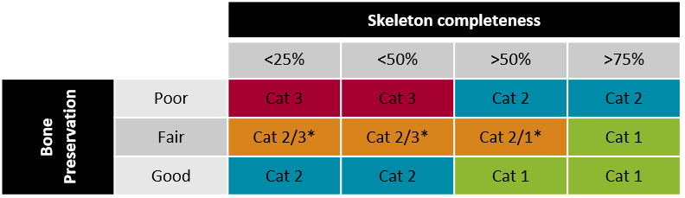
*depending on what parts of the skeleton survive.
Checklist:
- Standard excavation
- Standard recording
- Photograph
- SFM model
- Survey

- Ask supervisor about sampling

- Bagged and boxed in own box

Other factors which may determine Cat 1 include:
- Clear coffin / other grave features
- Clear trauma / pathology
- Preservation of specific areas of the skeleton
- Project-specific research questions
- Young age of skeleton (e.g. neonatal burial).

Category 1
Checklist:
- Quick excavation
- Standard recording
- Photograph
- SFM model or photograph with 2 geo-reference markers depending on survival. Check with supervisor
- Survey

- NO sample

- Bagged and boxed in own box or shared box

Other factors which may determine Cat 2 include:
- Possible coffin / other grave features
- Preservation of specific areas of the skeleton.
- Young age of skeleton (e.g. neonatal burial).
Category 2
Checklist:
- Quick excavation
- Standard recording
- Photograph with 2 geo-reference markers
- Survey

- NO SFM model

- NO sample

- Bagged and boxed in shared box
Category 3

Contingency Provisions
5.15 In the event that significant and or numerous archaeological deposits are made during the excavation sufficient contingency time and resources are to be made available to clarify the character or extent of additional features. The contingency will only be initiated after consultation with the Client, Leicester Cathedral and the Planning Authority. Following assessment of the archaeological remains ULAS shall, where required, implement an amended written scheme of investigation on behalf of the Client as appropriate

Monitoring
5.16 Notification of the start of the site works will be made to the City Archaeologist and to the Cathedral Archaeologist prior to commencement of the recording work in order that monitoring arrangements can be made. All monitoring shall be carried out in accordance with the CIfA Standard and Guidance for Archaeological Excavation (2020a).
5.17 Internal monitoring procedures will be undertaken including visits to the site by the project manager and the project osteologists. These will ensure that project targets are met and professional standards are maintained. Provision will be made for external monitoring meetings with the Planning Authority, Leicester Cathedral and the Client, if required.
5.18 Unlimited access to monitor the project will be available to the Client and his representatives Leicester Cathedral, the planning authority, the Planning Archaeologist and the Cathedral Archaeologist, subject to the health and safety requirements of the site.

6. Finds
6.1 All finds and samples will be bagged separately and related to the context record. All artefacts will be recovered and retained for processing and analysis in accordance with CIfA’s Standard and guidance for the collection, documentation, conservation and research of archaeological materials (2020b).
6.2 All identified finds and artefacts are to be retained however, certain classes of building material will, in some circumstances, be discarded after recording, with the approval of the City Archaeologist.
6.3 All objects or remains of archaeological interest, discovered in or under the site during the carrying out of the project by ULAS or during works carried out on the site by the Client other than articles subject to the Treasure Act, shall be deemed to be the property of ULAS provided that ULAS after due examination shall transfer ownership of all archaeological discoveries unconditionally to the appropriate authority for storage in perpetuity.

Treasure
6.4 In the event of discovery of artefacts that might constitute Treasure under the definition of The Treasure Act 1996 and its revisions (Treasure (Designation) Order 2002), these will be excavated and removed to a safe place. The Client, Leicester Cathedral, Coroner, the Planning Archaeologist and the Finds Liaison Officer (FLO) will be informed immediately. A treasure receipt will be completed and submitted to the Coroner’s Office and the FLO within 14 days.

7. Environmental Samples
7.1 All environmental work will be undertaken in accordance with Historic England guidelines (Campbell et al. 2011).
7.2 Although the environmental potential of the site is uncertain, if significant archaeological features are sample excavated, the following environmental sampling strategy will be adopted, following consultation with the ULAS Environmental Officer.
- A range of features to represent all feature types, areas and phases will be selected on a judgmental basis. The criteria for selection will be that deposits are datable, well-sealed and with little intrusive or residual material.
- Any buried soils or well-sealed deposits with concentrations of carbonised material present will be intensively sampled taking a known proportion of the deposit.
- Spot samples will be taken where concentrations of environmental remains are located.
- Waterlogged remains, if present, will be sampled for pollen, plant macrofossils, insect remains and radiocarbon dating provided that they are uncontaminated.
7.3 All collected samples will be labelled with context and sequential sample numbers.
7.4 Appropriate contexts (i.e. datable) will be bulk sampled (50 litres or the whole context depending on size) for the recovery of carbonised plant remains and insects.
7.5 Recovery of small animal bones, bird bone and large molluscs will normally be achieved through processing other bulk samples or 50 litre samples may be taken specifically to sample particularly rich deposits.
7.6 Wet sieving with flotation will be carried out using a York Archaeological Trust sieving tank with a 0.5mm mesh and a 0.3mm flotation sieve. The small size mesh will be used initially as flotation of plant remains may be incomplete and some may remain in the residue. The residue >0.5mm from the tank will be separated into coarse fractions of over 4mm and fine fractions of >0.5-4mm. The coarse fractions will be sorted for finds. The fine fractions and flots will be evaluated and prioritised; only those with remains apparent will be sorted. The prioritised flots will not be sorted until the analysis stage when phasing information is available. Flots will be scanned and plant remains from selected contexts will be identified and further sampling, sieving and sorting targeted towards higher potential deposits.
7.7 Where evidence of industrial processes are present (e.g. indicated by the presence of slag or hearth bases), samples will be taken for the analysis of industrial residues (e.g. hammer scale).

Scientific Dating
7.8 Due care will be taken to identify deposits and structures which may have potential for scientific dating. Suitable samples for radiocarbon dating will be subsampled from the processed and identified plant remains in the bulk samples and monolith sample (if taken) as deemed appropriate. Consideration will also be given to the use of Dendrochronology, Archaeomagnetic dating, Thermoluminescence and Optical Luminescence Dating (TL and OSL). Specialists will be consulted in this regard and where deemed appropriate to provide advice and where necessary supervise sampling, take readings and undertake post-excavation reporting.

8. Timetable and Personnel
8.1 The groundworks are due to start provisionally in May 2022. This project will be under the management of John Thomas MCIfA, Deputy Director, ULAS. The Project Manager will direct the overall conduct of the excavation as required during the period of fieldwork. Day to day responsibility will rest with the Site Director and Site Supervisor who will be on-site throughout the project.
8.2 The site Director will carry out the post-excavation work, with time allocated within the costing of the project for analysis of any artefacts found on the site by the relevant in-house specialists at ULAS.
8.3 ULAS uses in-house specialists for the majority of post-excavation work as follows:
Environmental analysis and reporting: | Rachel Small MA  Will Johnson MA
Prehistoric and Roman Pottery: | Nicholas Cooper BSc, Dip post-ex, FSA, MCIfA  Elizabeth Johnson BSc MA (Roman pottery) member SGRP
Post-Roman Pottery: | Paul Blinkhorn BA (external)
Animal bone | Jennifer Browning BA, MA, MCIfA  Rachel Small MA  Will Johnson MA
Human bone | Jennifer Browning BA, MA, MCIfA  Rachel Small BSc  York Osteological Unit (external)  Dr. Sarah Inskip &SAAH Osteologists working on the Tobacco Health & History project
Small Finds | Nicholas Cooper BSc, Dip post-ex, FSA, MCIfA
Industrial residues and building materials | Heidi Addison BA
Wood/Geoarchaeology | Matthew Beamish, MA (cantab), MCIfA

9. Post Excavation Analysis and Reporting
9.1 Following completion of fieldwork, all artefacts and samples will be processed, assessed, conserved and packaged in accordance with CIfA 2020b and 2020c, ULAS procedures and the relevant guidance for transferring archaeological archives.
9.2 A draft report will usually follow a reasonable period of time. The report will include:
- A non-technical summary
- The aims and methods adopted in the course of the evaluation.
- A description of the nature, extent, date, condition and significance of all archaeological deposits recorded during groundworks
- The anticipated degree of survival of archaeological deposits.
- The anticipated archaeological impact of the current proposals.
- Appropriate illustrative material including maps, plans, sections, drawings and photographs.
- A summary of artefacts, specialist reports and a consideration of the evidence within its local, regional, national context.
- An index of the contents and location of the archive.
- Bibliography.
9.3 A draft digital version of the report will be provided for the Client, Leicester Cathedral and the Local Planning Authority for approval. Once approved it will be deposited with the Historic Environment Record (1 copy) on the understanding that it will become a public document after an appropriate period of time and the planning authority.
9.4 An, indexed, site archive will be prepared and deposited with the agreed museum in accordance with CIfA 2020c, Archaeological Archives: A Guide to Best Practice in Creation, Compilation, Transfer and Curation (Brown 2011) and the relevant museum guidelines.

Publication and dissemination of results
9.5 The copyright of all original finished documents shall remain vested in ULAS and ULAS will be entitled as of right to publish any material in any form produced as a result of its investigations.
9.6 Arrangements will be made for an appropriate level of academic publication of the results of the excavations. A summary report will be published in the local journal where available. Where wider dissemination is appropriate and the significance of the results warrant, a full copy of the report in an appropriate format shall be submitted for publication in relevant academic journals.
9.7 ULAS supports the Online Access to the Index of Archaeological Investigations (OASIS) project. An online OASIS form will be completed detailing the results of the project. Once a report has become a public document following its incorporation into the HER it will be uploaded onto the web-site.

10. Public Engagement and Publicity
10.1 ULAS will work with the Client and their Contractors, and Leicester Cathedral to provide suitable public involvement during the course of the fieldwork (e.g. hard hat tours, open days, blog posts etc.). The results of the project will also be made available via the ADS website, publication and if significant archaeological deposits are found talks and presentations to the local population can be provided.
10.1 ULAS shall acknowledge the contribution of the Client, Leicester Cathedral and the National Lottery Heritage Fund in any displays, broadcasts or publications relating to the site or in which the report may be included.

11. Health and Safety
11.1 All work will be conducted in accordance with the Health and Safety at Work Act 1974 and all subsequent Health and Safety legislation, University of Leicester Statement Of Safety Policy Health and Safety and Environmental policies as well as any Principal Contractor’s policies or procedures. A site specific Risk Assessment and Method Statement will be formulated prior to commencement of fieldwork. This will be monitored on site and updated as necessary.
11.2 The safety of ULAS staff will take priority over the desire to record archaeological deposits.

12. Insurance
12.1 All ULAS work is covered by the University of Leicester's Public Liability, Professional Indemnity and Employers Liability Insurance as documented in the RAMS.

13. Quality Assurance
13.1 ULAS is a Registered Organisation (RO) with the Chartered Institute for Archaeologists and endorses the Code of Conduct (CIfA 2021). All ULAS Project Managers hold either full Member or Associate status within the CIfA and all ULAS Projects are overseen by the Project Manager who is responsible for the quality of the project.

14. Staff Training and CPD
14.1 All ULAS staff are subject to University of Leicester’s Personal Development Discussion (PDD) strategy which reviews personal performance, identifies targets and areas for improvement and identified the need for appropriate. All members of staff are required to maintain a Personal Development Plan.

15. Bibliography
Brown, D., 2011, Archaeological Archives: A guide to best practice in creation, compilation, transfer and curation (2nd edition). Archaeological Archives Forum.
Campbell, G., Moffett, L. and Straker, L., 2011, Environmental Archaeology: A Guide to the Theory and Practice of Methods, from Sampling and Recovery to Post-excavation (second edition). English Heritage.
CFCE, 2019, LEICESTER CATHEDRAL: “Leicester Cathedral Revealed” – Restoration and repairs to the historic cathedral interior and creation of a new Heritage Learning Centre on the south-east front. Cathedrals Fabric Commission for England.
CIfA 2004, Technical Paper 7: Guidelines to the Standards for Recording Human remains. Chartered Institute for Archaeologists.
CIfA 2017, Updated Guidelines to the Standards for Recording Human Remains. Chartered Institute for Archaeologists.
CIfA 2020a, Standard and Guidance for an Archaeological Excavation. Chartered Institute for Archaeologists.
CIfA 2020b, Standard and guidance for the collection, documentation, conservation and research of archaeological materials. Chartered Institute for Archaeologists.
CIfA 2020c, Standard and Guidance for the creation, compilation, transfer and deposition of archaeological archives. Chartered Institute for Archaeologists.
CIfA 2021, Code of Conduct. Chartered Institute for Archaeologists.
DCMS (Department for Culture, media and sport) 1996, The Treasure Act 1996 Code of Practice
https://assets.publishing.service.gov.uk/government/uploads/system/
uploads/attachment_data/file/77532/TreasureAct1996CodeofPractice2ndRevision.pdf
Dixon, P. 2016 (re.2017) Excavations at the Song School, Leicester Cathedral. Philip Dixon Associates.
Dixon, P. 2018 Leicester Cathedral: A Desktop Assessment. Philip Dixon Associates.
Dixon, P. 2020, Work at the Cathedral of St Martin, Leicester: Project Specification for Archaeological Excavation, Monitoring and Recording. Philip Dixon Associates.
Cooper, N., (ed.), 2006, The Archaeology of the East Midlands: An Archaeological Resource Assessment and Research Agenda. Leicester Archaeological Monographs No. 13. University of Leicester Archaeological Services.
Higgins, T., 2014, Archaeological Monitoring of Groundworks, Cathedral Square Leicester. ULAS Report 2014-236
Historic England 2015, Digital Image Capture and File Storage. Swindon. Historic England.
Historic England 2018 The Role of the Human Osteologist in an Archaeological Fieldwork Project. Swindon. Historic England.
Knight, D., Vyner, B., and Allen, C., 2012, East Midlands Heritage: An updated research agenda and strategy for the Historic Environment of the East Midlands. University of Nottingham and York Archaeological Trust.
Mays, S. (ed) 2017, Guidance for Best Practice for the Treatment of Human Remains Excavated from Christian Burial Grounds in England (2nd edition). Advisory Panel for the Archaeology of Burials in England.
http://www.archaeologyuk.org/apabe/pdf/APABE_ ToHREfCBG_FINAL_WEB.pdf
Mays, S., Sidell, J., Sloane, B., White, W. and Elders, J. 2015, Large Burial Grounds.
Guidance on Sampling in Archaeological Fieldwork Projects. London: Advisory Panel on the Archaeology of Burials in England.

http://www.archaeologyuk.org/apabe/pdf/Large_Burial_Grounds.pdf

MHCLG, 2021, National Planning Policy Framework (revised). Ministry of Housing, Communities and Local Government.
Pevsner, N., 1984, The Buildings of England: Leicestershire and Rutland. Pevsner Architectural Guides.

Appendix: Figures

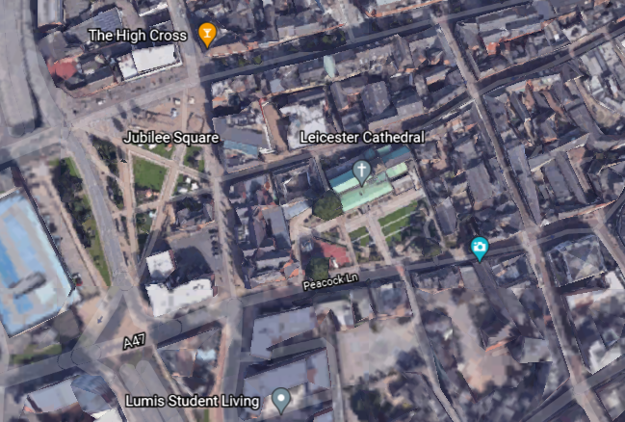
Figure 1: Site Location
Contains OS data © Crown copyright [and database right] 2021

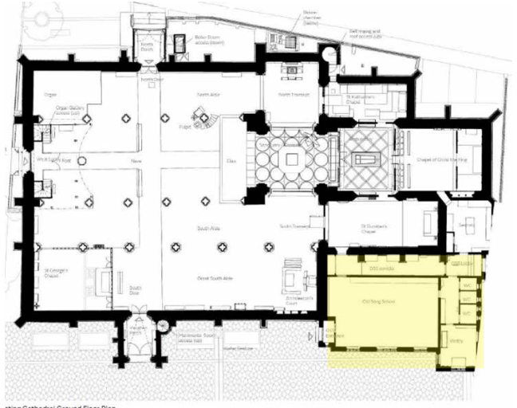
Figure 2: Location of Development Area (highlighted)

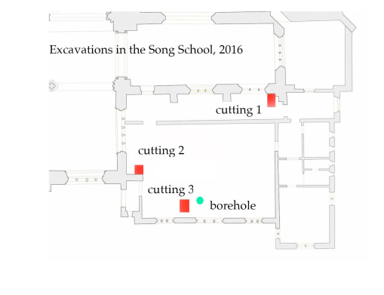
Figure 3: Location of Test Pits within the Song School

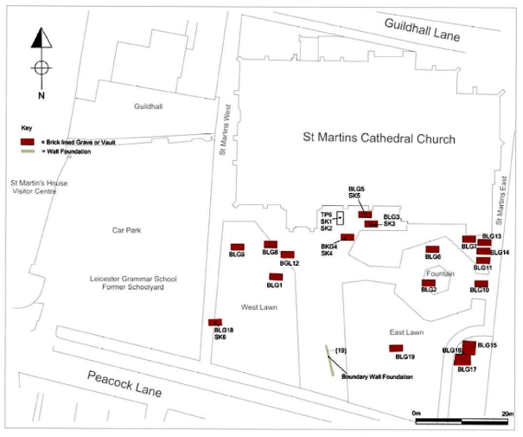
Figure 4: Location of Brick-Lined burials from previous work

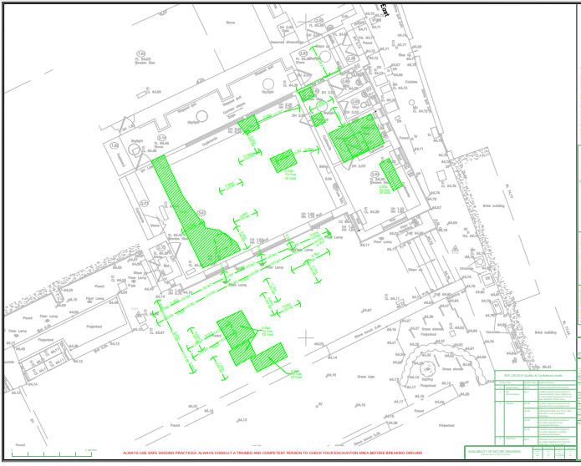
Figure 5: Results of the ground-penetrating radar survey of the development area (potential voids in green)

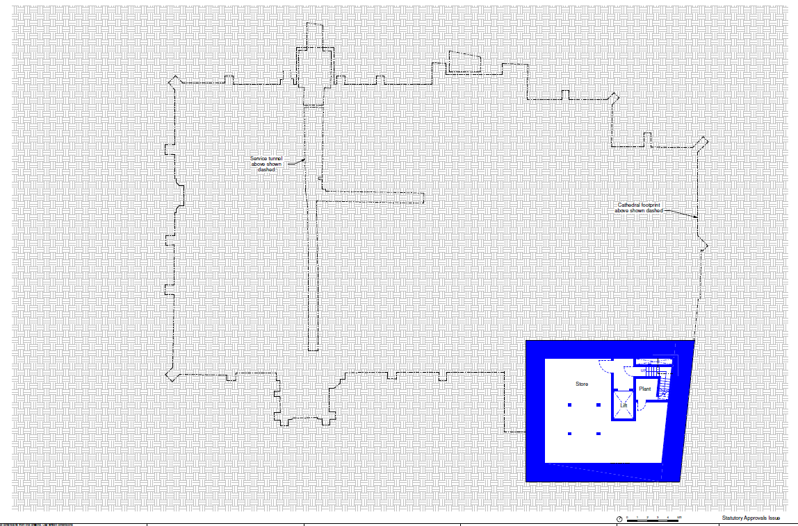
Figure 6: Plan showing location of proposed basement area of HLC structure. Supplied by Client

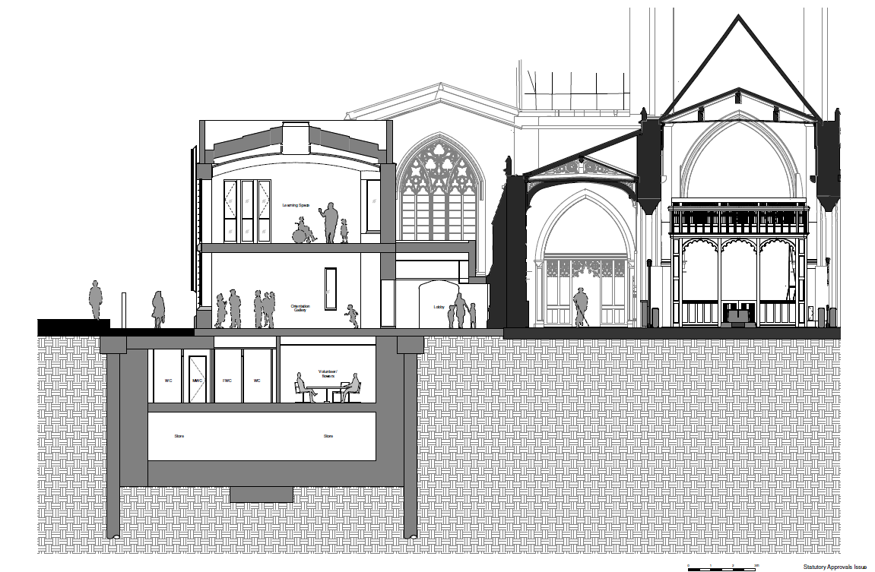
Figure 7: North/south section across proposed basement of HLC structure. Supplied by Client.



