Harry Woollands
2214706
LeaRNING IN THE DIGITAL ERA
Assignment 1: E-Portfolio
BENG2-PT Embedded Electronic Systems
Contents
E-Portfolio 2
Task 1 3
Task 2 4
Task 3 5
Task 4 6

E-Portfolio

Link to view E-Portfolio: https://sites.google.com/view/harry-woollands-assignment/home

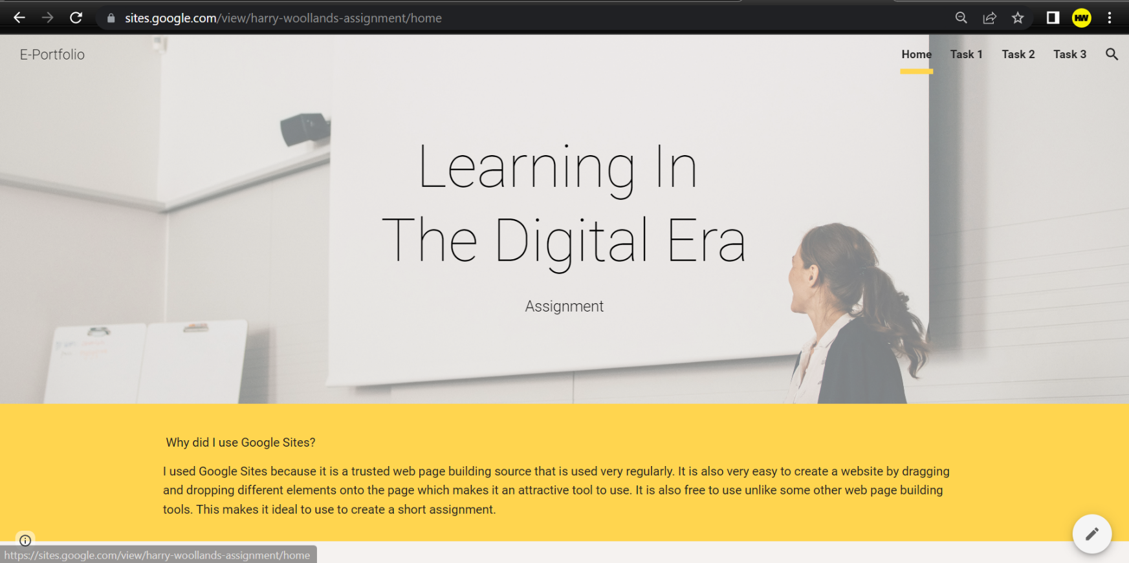
Screenshot of my E-portfolio homepage:

Task 1
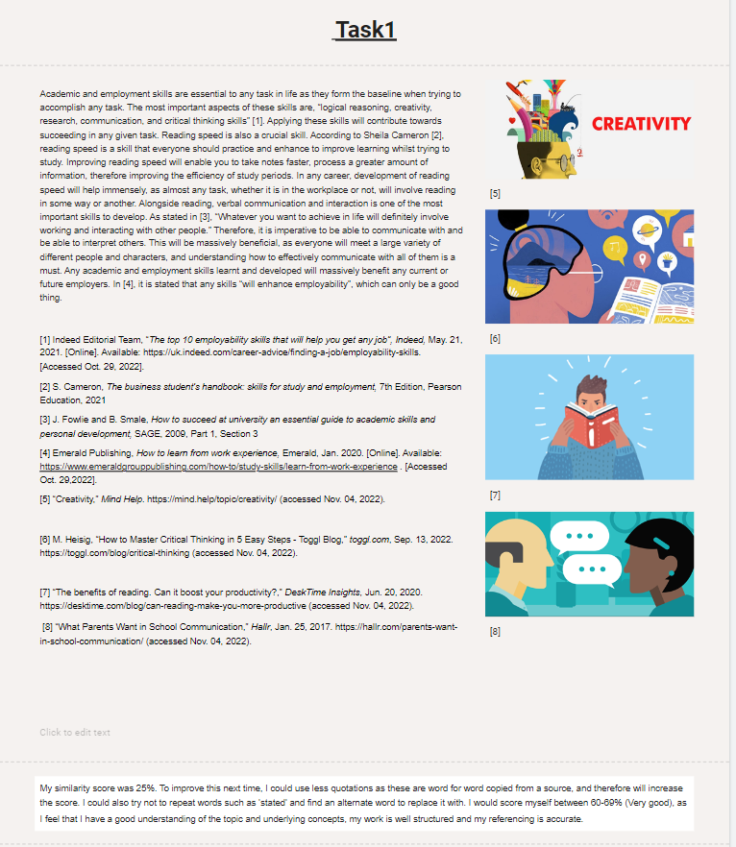
Screenshot of task 1 in my E-portfolio:

Task 2

Link to view the poster: https://drive.google.com/file/d/1s_kohEcSjsO7esFDsu4ajpeLsVhpsVNl/view?usp=sharing

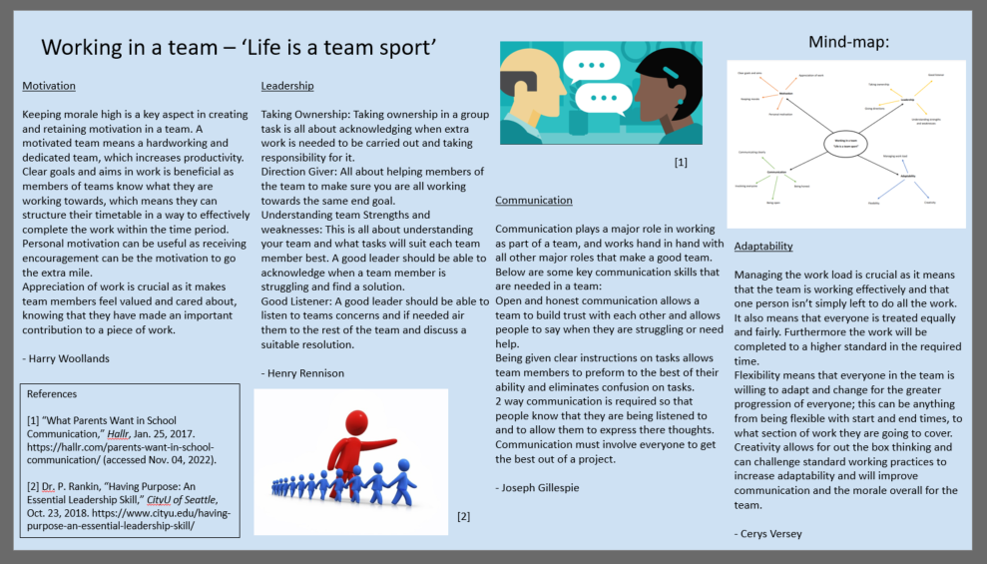
Screenshot of task 2:

Task 3

Screenshot of task 3 in my E-portfolio:
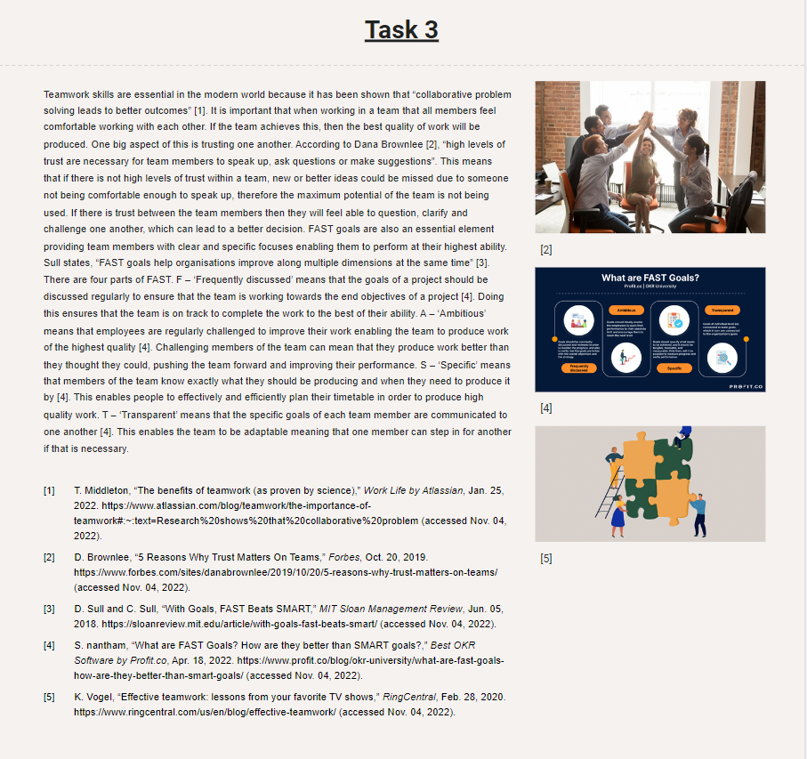

Task 4

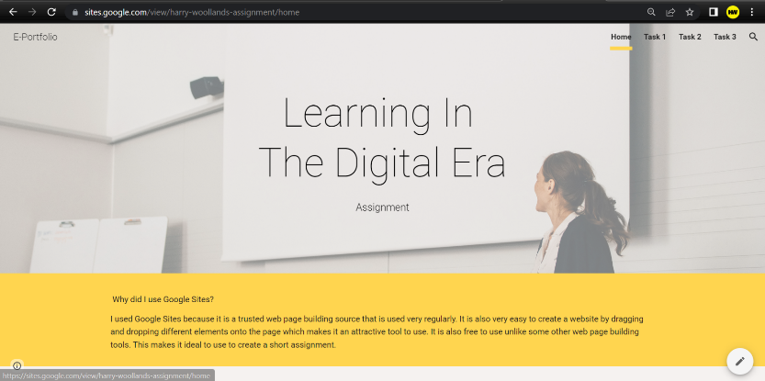
Screenshots of all pages of my E-portfolio:


