Adele McCann – 2416685
Changemakers: Creativity and Value Creation
(BMHP5014_BIRM)
Category: Birmingham Campus
Lecturer – Zarah Ahmed

Component 2: Written Assignment

MindEase: An Innovative Community Mental Health Anti-Stigma Campaign for Young People in the UK

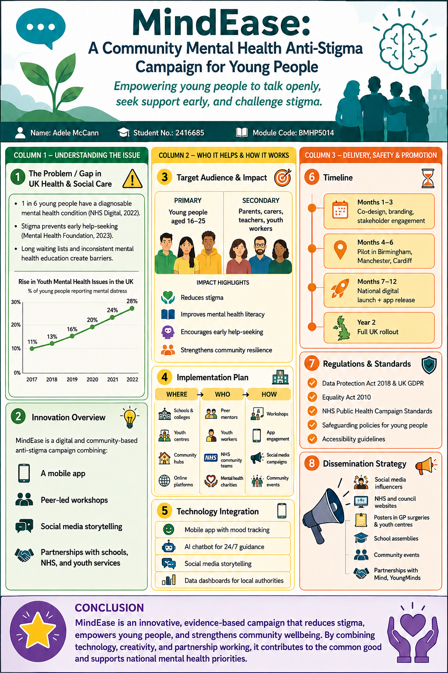
MindEase: A Community Mental Health Anti-Stigma Campaign for Young People
Mental health challenges among young people in the UK have reached unprecedented levels, with rising rates of anxiety, depression, self-harm, and emotional distress. Despite this, stigma remains one of the most significant barriers preventing young people from seeking help early. My innovation, MindEase, is a community-driven mental health anti-stigma campaign designed to empower young people aged 16–25 to understand, talk about, and seek support for their mental health.
MindEase builds on the principles of creativity, innovation, and value creation by using digital technology, peer-led engagement, and community partnerships to create a supportive environment where mental health conversations are normalised. The campaign aims to reduce stigma, increase mental health literacy, and encourage early help-seeking, ultimately improving wellbeing and reducing pressure on NHS services.
The need for this innovation is clear. According to NHS Digital (2022), one in six young people now has a diagnosable mental health condition. However, many do not access support until they reach crisis point. The Mental Health Foundation (2023) highlights that stigma, fear of judgement, and lack of understanding are major reasons why young people avoid seeking help. This delay leads to poorer outcomes, increased risk of self-harm, and long-term social disadvantage. MindEase directly addresses these issues by providing accessible, relatable, and youth-friendly mental health education and support.
The campaign is grounded in the belief that young people are more likely to engage with mental health content when it is delivered by peers, through creative media, and in spaces where they feel safe. Therefore, MindEase uses a combination of digital tools, community workshops, and storytelling to challenge stigma. The digital component includes a mobile app offering mood-tracking, psychoeducation, and signposting to NHS and voluntary sector services. An AI-supported chatbot provides 24/7 guidance, helping young people access information anonymously and without fear of judgement. This aligns with research showing that digital interventions can significantly improve mental health outcomes and reduce barriers to support (Hollis et al., 2017).
The community element of MindEase is equally important. The campaign will be delivered in schools, colleges, youth centres, and community hubs, with workshops co-designed and co-facilitated by young people. This peer-led approach ensures cultural relevance, authenticity, and trust. Workshops will focus on understanding mental health, recognising early signs of distress, challenging stereotypes, and building resilience. They will also include creative activities such as art, storytelling, and digital media production, allowing young people to express their experiences and challenge stigma in their own voices.
MindEase also aligns with key UK policies and legislation. (The NHS Long Term Plan 2019) emphasises the importance of early intervention, community-based support, and reducing stigma. The campaign supports these priorities by promoting preventative mental health education and encouraging early help-seeking. The Equality Act 2010 ensures that all young people, including those from minority and marginalised groups, can access the campaign without discrimination. The Data Protection Act 2018 and UK GDPR guide the safe handling of personal data within the app and digital platforms. Safeguarding policies ensure that all interactions with young people are safe, ethical, and compliant with professional standards.
Professional services play a crucial role in the implementation of MindEase. The campaign will work closely with NHS Mental Health Trusts, local authorities, GPs, school counsellors, youth workers, and charities such as Mind and YoungMinds. These partnerships ensure that young people are signposted to appropriate support and that the campaign complements existing services rather than replacing them. By strengthening collaboration between health, education, and community sectors, MindEase contributes to a more integrated and responsive mental health support system.
A key strength of MindEase is its ability to engage the general public. Stigma reduction requires collective action, and the campaign encourages parents, carers, teachers, and community members to participate. Public engagement activities include social media campaigns, community events, and awareness workshops. By involving the wider community, MindEase promotes understanding, empathy, and shared responsibility for supporting young people’s mental health.
The use of technology enhances the campaign’s reach and effectiveness. Young people are highly active on digital platforms, making social media an ideal space for mental health messaging. MindEase will use TikTok, Instagram, and YouTube to share short videos, personal stories, and educational content. Influencers and youth ambassadors will help amplify the message, making it more relatable and engaging. The mobile app provides ongoing support, while data dashboards allow local authorities to monitor engagement trends and identify areas where additional support is needed.
The timeline for MindEase is structured to ensure effective development, testing, and rollout. The first three months focus on research, co-design, and stakeholder engagement. Months four to six involve piloting the campaign in three UK cities—Birmingham, Manchester, and Cardiff. This pilot phase allows for evaluation and refinement. Months seven to twelve include the national digital launch and app release. In year two, the campaign expands across the UK, integrating with schools, colleges, and NHS community services.
MindEase creates value by improving mental health outcomes, reducing stigma, and strengthening community resilience. It supports young people to recognise early signs of distress, seek help sooner, and feel confident discussing their mental health. This contributes to the common good by reducing inequalities, promoting inclusion, and supporting national mental health priorities. By combining creativity, innovation, and evidence-based practice, MindEase offers a powerful solution to one of the most pressing challenges facing young people today.
In conclusion, MindEase is a timely, relevant, and impactful innovation that addresses a critical gap in UK mental health support. Through digital engagement, community partnerships, and creative communication, the campaign empowers young people, reduces stigma, and promotes early intervention. MindEase contributes to a healthier, more inclusive society where mental health is understood, supported, and openly discussed.

References
Brandon, M., Sidebotham, P., Bailey, S., Belderson, P., Hawley, C., Ellis, C. and Megson, M. (2020) Complexity and Challenge: A Triennial Analysis of Serious Case Reviews 2014–2017. London: Department for Education. Available at: https://www.gov.uk/government/publications/analysis-of-serious-case-reviews-2014-to-2017 (Accessed: 7 July 2026).
Department for Education (2021) Keeping Children Safe in Education. London: Department for Education. Available at: https://www.gov.uk/government/publications/keeping-children-safe-in-education (Accessed: 5 July 2026).
Equality Act (2010) Equality Act 2010. London: The Stationery Office. Available at: https://www.legislation.gov.uk/ukpga/2010/15/contents (Accessed: 7 July 2026).
Hollis, C., Falconer, C.J., Martin, J.L., Whittington, C., Stockton, S., Glazebrook, C. and Davies, E.B. (2017) ‘Annual Research Review: Digital health interventions for children and young people with mental health problems – a systematic and meta-review’, Journal of Child Psychology and Psychiatry, 58(4), pp. 474–503. Available at: https://doi.org/10.1111/jcpp.12663 (Accessed: 6 July 2026).
Information Commissioner’s Office (2021) Guide to the UK General Data Protection Regulation (UK GDPR). Wilmslow: ICO. Available at: https://ico.org.uk/for-organisations/guide-to-data-protection/guide-to-the-general-data-protection-regulation-gdpr (Accessed: 7 July 2026).
Mental Health Foundation (2023) Stigma and Mental Health. London: Mental Health Foundation. Available at: https://www.mentalhealth.org.uk/explore-mental-health/a-z-topics/stigma (Accessed: 6 July 2026).
Mind (2023) Mental Health Problems: Support and Information. London: Mind. Available at: https://www.mind.org.uk/information-support (Accessed: 5 July 2026).
NHS Digital (2022) Mental Health of Children and Young People in England 2022. Leeds: NHS Digital. Available at: https://digital.nhs.uk/data-and-information/publications/statistical/mental-health-of-children-and-young-people-in-england (Accessed: 7 July 2026).
NHS England (2019) The NHS Long Term Plan. London: NHS England. Available at: https://www.longtermplan.nhs.uk (Accessed: 4 July 2026).
NHS Education for Scotland (2020) Trauma-Informed Practice Toolkit. Edinburgh: NHS Scotland. Available at: https://www.nes.scot.nhs.uk/our-work/trauma-informed-practice (Accessed: 7 July 2026).
Royal College of Psychiatrists (2021) Digital Technology and Mental Health. London: RCPsych. Available at: https://www.rcpsych.ac.uk/mental-health/parents-and-young-people/digital-technology (Accessed: 7 July 2026).
YoungMinds (2023) Young People’s Mental Health Statistics. London: YoungMinds. Available at: https://www.youngminds.org.uk/about-us/media-centre/mental-health-stats (Accessed: 4 July 2026).

