

Programme: Master of Business Administration
Module: Marketing Management
Module code: LCMB7024
Title: Portfolio: Brand Development
Lecturer: Dian Mayasari
Student Name: Raj Nalinkumar Bharucha
Student ID: 2510180
Submission Date- 19th November 2025
Existing Company: Nike
Brand Name- Aero
Table of Content
Introduction....................................................................................................................................3
1. STDP Strategy.............................................................................................................................4
2. Critical Analysis of Marketing Mix..............................................................................................7
3. Product Promotion Poster .......................................................................................................12
4. Reflection of Portfolio...............................................................................................................14
References ...................................................................................................................................15

Introduction to Nike and the AERO Brand Concept

Nike, Inc. is a global leader in athletic footwear, apparel, and sports equipment. Founded in 1964 by Bill Bowerman and Phil Knight, the company began as Blue Ribbon Sports before officially becoming Nike in 1971—named after the Greek goddess of victory. Recognized worldwide by its iconic Swoosh logo and the slogan “Just Do It,” Nike has grown into one of the most influential and innovative brands in sports and lifestyle culture.

Nike is a global brand of athletic and lifestyle, known by its culture-based innovation, performance technology, and influence throughout the world. With the consumer behavior turning towards eco-friendly, sustainable and ethically-produced items and eco-friendly and cost-effective fashion, the prospects of Nike in its environmentally-friendly goods have gained more and more relevance. In reaction to these tendencies, Nike has put forward its own sub-brand, AERO, which represents fashionable, comfortable, and environmentally friendly shoes designed to be used on a daily basis.

AERO is supported by the Nike design legacy but branded differently by its environmentally conscious identity. The label has shoes that are produced using recycled polyester, plant-based foam, and lightweight comfort tech that can be used on a daily basis. With an average price of between 35 and 90, AERO is affordable to sustainability, especially to young consumers and middle-income families. The idea is in line with the increasing pressure of environmental friendliness of products related to lifestyle without high prices in the world market. The central message in the AERO is helping individuals to realize their eco-conscious style by being fashionable, which is represented in its slogan: Step into Style. Stride with Confidence. and hashtag WearChangeWithAero.

1. STDP strategy:

1.1 Segmentation:

The Aero segmentation strategy will be based on demographic, psychographic, behavioural and geographic to ensure that Aero captures a wide but at the same time a strategically useful market.
- Demographic Segmentation:

AERO is aimed at persons between the ages of 16-60 years of both sexes. This age group represents new users who are interested in fashionable and contemporary shoes as well as older people who want to be comfortable and sustainable. The target market comprises of students, employees, professionals, amateur athletes and daily commuters. The level of income is in the low and middle-income category, because the brand appeals to low-income earners.
- Psychographic Segmentation:

AERO is very attractive to the people who are conscious of sustainability, self-expression, and ethical consumption. These consumers are concerned with the brands that are reputable of their personal values and allow them to live in a more environmentally friendly way. Another way that AERO can be associated with people who are style-driven is through the value of fashionable and minimalist footwear to match the modern day.
- Behavioural Segmentation:

The behavioural segment incorporates those users who want to be comfortable, lightweight, and have eco-friendly materials. They love the quality of long-lasting and are influenced by familiar brands such as Nike but are solicited to eco-friendly alternatives. These consumers tend to react well to influencer marketing, product narrative, and transparency of the brand.
- Geographic Segmentation:

AERO would fit in the high sustainability awareness and urban mobility market. The main markets are the UK, Europe and large urban centres around the world where Nike already has a good retail distribution and e-connect.

1.2 Targeting:

Depending on segmentation, AERO targets two key target segments:

Main Target Audience (16-35 years old):

This consists of teenagers, college students, and young professionals who are trendy and sustainable. They are also very active in digital media, subscribe to the influencers, and base their buying choices on style, cost, and values. They buy the products that enable them to convey identity and AERO eco-fashion proposition is very appealing to them.

Secondary Target Audience (3660 years):

This market segment comprises of the working adults who are concerned with comfort, longevity and ethical production. They might not adhere to the current trends, but appreciate quality that is long-term and responsible production. Aero targets them with practicality, comfort technology and plausible branding via Nike.

1.3 Differentiation:

There are five major aspects that AERO distinguishes itself:

- Sustainable Materials:

Compared to most competitors, who provide eco-products at a premium price, AERO is affordable, uses recycled polyester and plant-based foam, and is directly concerned with environmental issues.

- Technology + Comfort:

The AERO shoes have a lightweight performance technology that is inspired by Nike and provides cushioning to sustain extended walking, commuting or standing.

- Mid-Market Pricing Strategy:

Sustainable footwear is usually pricier than its competitors such as Adidas and Puma. The range of products (£35-90) offered by AERO helps in its market penetration strategy, as it can be adopted fast.

- Brand Purpose & Emotional Identity:

AERO targets the customers who desire to express their green preferences in fashion. Its message is on individual expression and green lifestyle identity.

- Powered by Nike:

The Nike is a Powered brand is credible and trusted immediately, and therefore AERO will be singled out in the eco-footwear brands that are not recognized globally.

1.4 Positioning:

AERO sets itself as a low priced, earth-friendly, lifestyle shoe brand that provides sustainability devoid of compromising comfort, appeal, and affordability. It is focused on style, daily performance and environmental sustainability - which separates it both of the high-end sustainable brands and mass-market lifestyle footwear.

The positioning statement of AERO:

AERO is a cost-effective eco-fashion footwear company based on Nike, and offered to individuals who desire to express their sustainable lifestyle by wearing stylish and comfortable everyday shoes.

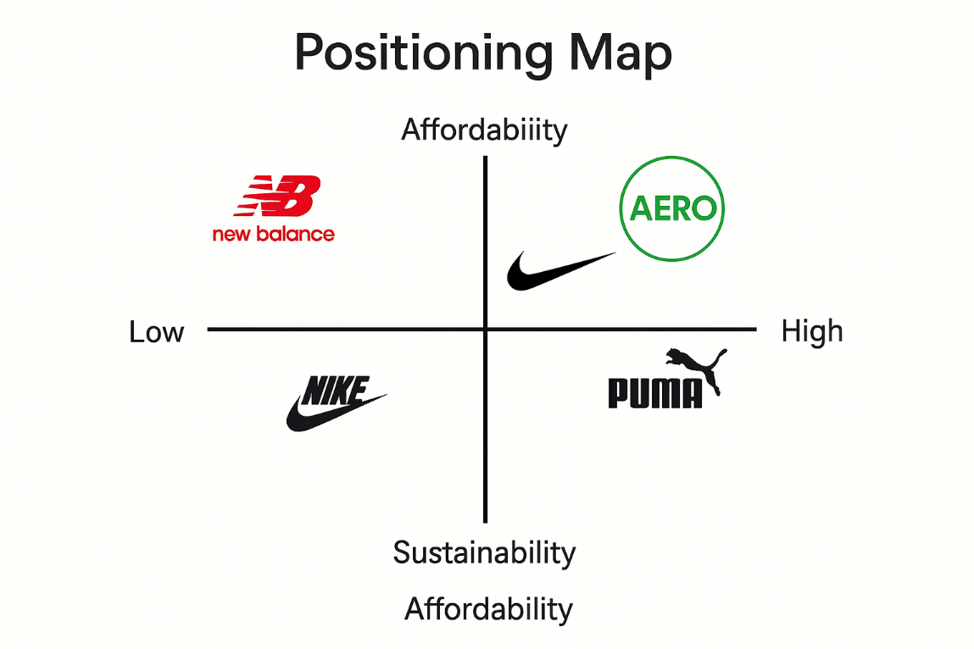

2. Marketing Mix (4Ps):

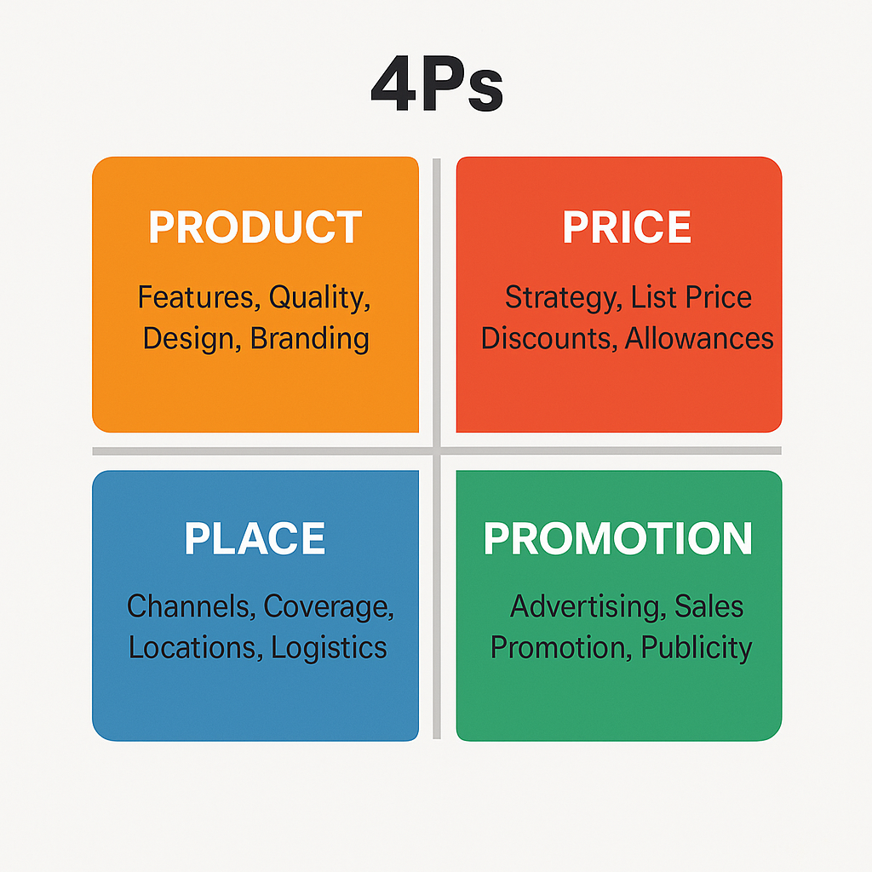

1. Product:

The main product of AERO is the eco-friendly footwear line produced in polyester uppers made of recycled materials and soles made of plant-based foams. These materials are very environmental friendly and they also increase comfort. The engineering of Nike makes it long lasting in performance, breathable, and ergonomic. AERO shoes are lightweight, multi-purpose, and can be used in everyday life, in athleisure, and in everyday sports.

The product characteristics of AERO are:

• Breathable upper material, soft.

• Lightweight foam cushioning made of plants.

• Sole that has flexibility to enhance movement.

• Minimalistic form that is attractive to fashion nowadays.

• Packaging made of biodegradable materials that are recyclable.

In AERO, there is also a special sustainability label inside the shoe indicating the percentage of recycling materials. The design style incorporates natural colours and contemporary designs, which are an indicator of environmental friendliness and new fashion.

Product strategy is in line with the brand purpose of AERO, sustainable, stylish, everyday comfort.

2. Price:

AERO uses market penetration pricing strategy with a range of between 35 to 90. Such a price is much cheaper than high-quality sustainable shoes sold by Adidas or Allbirds. It is expected to focused on early adopters, brand exposure and mass-market buying.

Some factors of pricing are:

• Target appeal to children and young adults.

• Availability to the average customers.

• Competitiveness in positioning with Puma, Adidas and more mid-tier products of Nike.

- promoting repeat business.

The pricing model of AERO also helps the company in its mission to make sustainability affordable and not exclusive.

3. Place:

AERO Distribution: Multi-channel distribution.

a. Nike Retail Stores:

AERO will be launched in the Nike flagship stores where consumers will have a chance to have direct contact with the product.

b. Online Channels:

• Nike.com

• Aero’s dedicated web page

• Amazon

• Online sports stores (JD Sports, Footlocker)

Distribution is being enhanced via online distribution, which increases accessibility and utilizes the high e-commerce penetration of Nike.

c. Multi-brand Stores:

Physical availability is enhanced through partnerships with JD Sports, Decathlon, and other retailers of sportswear.

d. Mobile Sustainability Stations.

Pop-up exhibitions in higher education institutions, sporting tournaments and urban fetes further strengthen the environmental friendly mission of the brand.

The place strategy of AERO seeks to achieve high visibility, easy access and good digital interaction.

4. Promotion:

The promotional mix of AERO is centered on the emotional branding, the influencer visibility, and sustainability consciousness.

Promotional Tactics:

1. Celebrity and Athlete Endorsements:

Partnerships with world celebrities and sportspeople will increase the authority. AERO will be worn by sponsored athletes in major events so as to gain visibility.

2. Student Rallies and Festival Discounts.

The penetration will be enhanced further with young consumers through seasonal discounts, student offers and bundle pricing.

3. Digital Marketing

AERO will use:

• Instagram and Tik Tok campaign: influencers.

• YouTube fitness creators

• Hashtags WearChangeWithAero.

• Story-based inspirational advertisements.

4. Eco-Focused Advertising

Promotions will highlight:

• Reduced carbon footprint

• Vegan materials

• Recycled components

This reinforces the sustainable status of AERO.

5. Community Programs

AERO will be involved in the local environmental activities and sponsoring eco-events, which will form a brand-loyalty among the community.

3. Promotion Poster

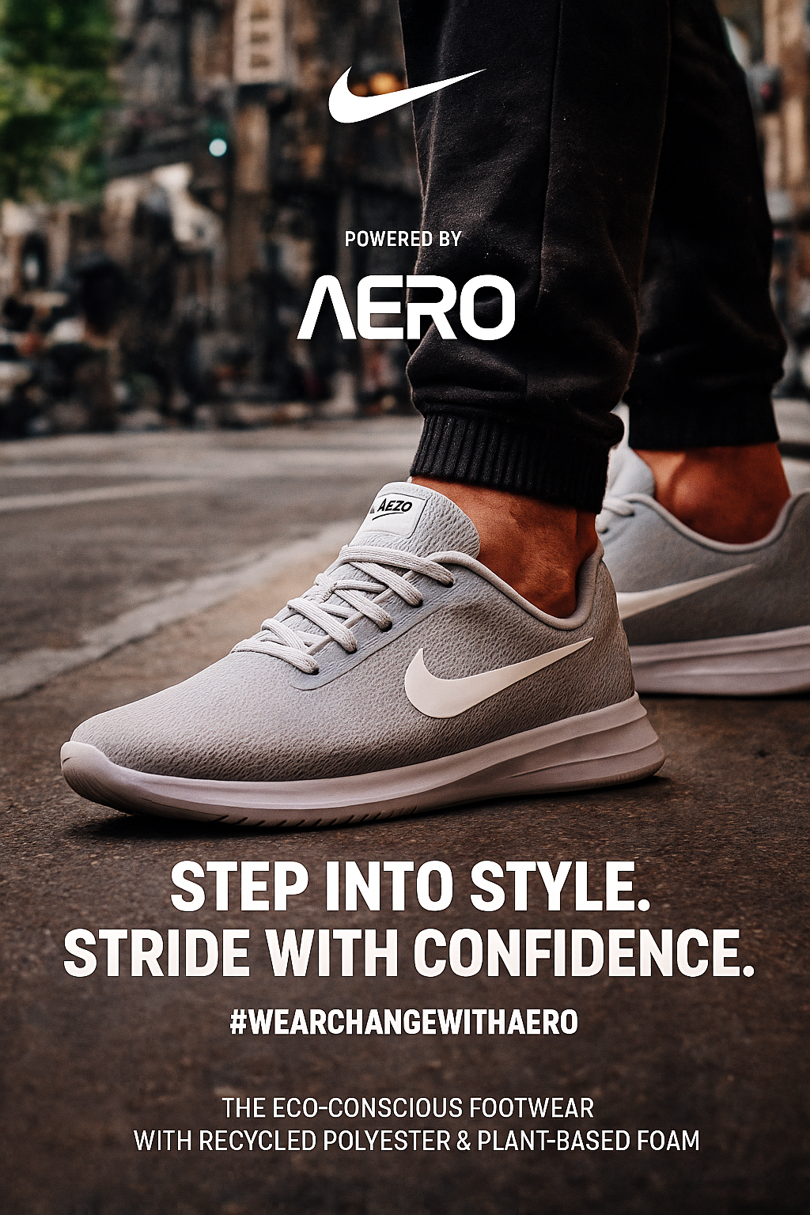

3.1 Marketing Pitch:

Today, I have the privilege to launch a new sustainable Nike-powered brand of footwear called AERO. AERO has been designed to address one of the largest issues in the modern footwear one needs is environmentally friendly shoes, but they are limited to high prices and are not comfortable to use every day. AERO, responds to this by providing stylish, lightweight and eco-friendly footwear at a price range of between £35-90 of an affordable range.

The AERO shoes are made of recycled polyester and plant-based foam in order to produce less waste and provide the comfort that users require during commuting, walking, work and everyday activities. We are targeting young customers who appreciate eco-friendly fashion and adults who want to feel comfortable on a long-term basis.

With the support of the Nike international brand image, AERO incorporates a reliable performance with contemporary design. Our marketing plan will consist of promotions with well-known personalities all over the world, sponsoring athletes, collaboration with universities, and festival promotions to attract different consumer segments.

Competing with such brands as Adidas or Puma, AERO has an opportunity of competing by providing sustainability at an actual affordable cost. Your message: Step into Style. Stride with Confidence. we are asking our customers to make a statement about their eco-consciousness and join the change movement.

AERO is not a simple shoe it is a lifestyle of wearing what you believe in.

#WearChangeWithAero.”

4. Reflection:

The AERO brand concept development presented a valuable chance to comprehend the way of how the brands are developed, positioned, and communicated in a competitive market. Among the insights that I consider the most valuable, there was the fact that the concept of sustainability has changed its trend to become a core expectation of consumers of the modern world. This informed the initial phases of brand development that assisted me to mould AERO as a reaction to actualizing market behaviour that was on a change.

The STDP process also enhanced my analytical skills as it necessitated me to subdivide the larger market into segments and determine the consumers who will respond to the AERO the most. I got to know the ways in which both demographic and psychographic characteristics of the population such as age and income affect pricing strategy, and product design and messaging, respectively. The selection of the target groups assisted me in developing an emotional bond between the brand and its prospective buyers.

The creation of marketing mix helped me to think logically in the context of product, price, place and promotion. I also understood that an effective brand strategy is built on the ability to ensure that all four elements are congruent with the primary purpose. As an example, the environmentally friendly materials used by AERO affected the product, as well as the advertising story and cost. The move to affordability middle price helped the market penetration plan and aligned with the financial abilities of the target market.

The pitch preparation enhanced my communication and storytelling abilities. It needed to be clear, structured, and self-assured to condense an entire marketing strategy into a 3-minute persuasive pitch. I got to know the priority given to the most interesting brand elements, which are the problem, the solution, and the value. This experience has made me learn how organizations convey ideas to stakeholders in a good manner.

In the event that I engage in the same project in future, I would improve my methodology by including more primary research, including consumer surveys or interviews. This would give actual feedback in the market and enhance strategic rationale. Furthermore, I would look more into competitor benchmarking to narrow down AERO differentiation and positioning even further.

On the whole, this project allowed me to acquire the critical marketing skills, such as strategic planning, inventive branding, logical thinking, and effective persuasion. It has equipped me to approach branding challenges in the real world, with greater confidence and in a more professional manner.

References
Baines, P., Fill, C. and Rosengren, S., 2017. Marketing. 4th ed. Oxford: Oxford University Press.
Blythe, J., 2019. Principles and Practice of Marketing. 4th ed. London: Cengage Learning.
Clifton, R., 2014. The Economist: Brands and Branding. 3rd ed. London: The Economist.
Euromonitor International, 2023. Sustainable Footwear Market: Global Industry Report. Available at: https://www.euromonitor.com [Accessed 18 November 2025].
Ferrell, O.C. and Hartline, M., 2014. Marketing Strategy. 6th ed. Boston: Cengage.
Hollensen, S., 2020. Marketing Management: A Relationship Approach. 4th ed. Harlow: Pearson.
Kotler, P. and Armstrong, G., 2022. Principles of Marketing. 18th ed. Harlow: Pearson.
Kotler, P. and Keller, K.L., 2016. Marketing Management. 16th ed. Harlow: Pearson Education Limited.
Mintel, 2024. Footwear Retailing UK – Market Report. Available at: https://www.mintel.com [Accessed 18 November 2025].
Nike Inc., 2024. Nike Impact Report: Move to Zero Sustainability Strategy. Available at: https://www.nike.com/sustainability [Accessed 18 November 2025].
Solomon, M.R., 2020. Consumer Behaviour: Buying, Having and Being. 13th ed. Harlow: Pearson.
Statista, 2024. Global Athletic Footwear Market — Sustainability Trends. Available at: https://www.statista.com [Accessed 18 November 2025].
Tybout, A.M. and Calkins, T., 2013. Kellogg on Branding. 2nd ed. New Jersey: Wiley.
UN Environment Programme (UNEP), 2023. Sustainable Fashion Industry Report. Available at: https://www.unep.org [Accessed 18 November 2025].
Euromonitor International, 2023. Global Sustainable Footwear Market Report. Available at: https://www.euromonitor.com [Accessed 18 November 2025].

