A Report into the equipment and units used to refine products at Valero Pembroke Refinery.

By Jack Franklin

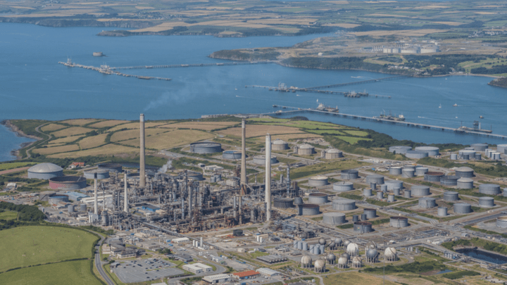

Table of Contents
Task 1 (LO4) 3
Task 2 LO3 6
Bibliography 13

Task 1 (LO4)
Throughout Valero refinery there are a number of different pumps working all over the place to send product from one location on the refinery to the next, this is essential for the way the refinery works and the right pump can control the speed at which a set amount of liquid is transferred in line with the amount required for the operation.
Steam turbines main principle.
“a steam turbine is a rotary heat engine that converts thermal energy contained in the steam to mechanical energy or to electrical energy.” Thermal Engineering. (2019). Steam turbines are used as pump on the Sulphur recovery unit to send feed into the fin fans at the top of the unit. They are used as back up to electrical driven pumps as the steam is always readily available and kick in when a low flow in sensed. Steam is created in the utilities area of the site where boilers are used to create steam. This is then sent via a number of different pipelines to all areas of the refinery including to the steam turbines on the sulphur recovery unit. When open onto the turbine the steam applies pressure onto the rotor (a series of blades mounted on the turbine shaft) to allow it to turn the shaft which allows the turbine to turn the pump and pump the product, the amount of steam can be altered to increase or decrease the load on the pump by the use of a governor.
Main parts of the turbine
Rotor – Consist of a number of blades mounted onto the turbine shaft. The type of blades depends on the type of turbine so they are all different. The blades need to be strong to withstand the high amount of stress they will go under when working under high pressures and high speeds.
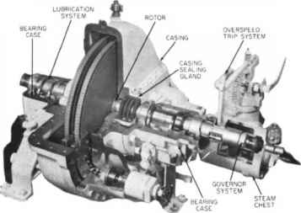
Diaphragm – Are attached to the turbine casings to hold the blades in place between the different stages of the turbine. They are factory machined to fit perfectly inside the turbine to not allow steam leaks and to not allow the turbine blades to move to be able to contact the housing and cause serious damage. Needs checking for leaks when maintenance is completed.
Figure 1 Construction Details - Centrifugal Pumps.
Shaft – The shaft is installed along the centre axis of the turbine and attached to the rotor. This allows the turbine to catch the steam and turn it into kinetic energy. Shaft will require constant maintenance to check for vibration and ensure alignment.
Casing – Casing will hold all the parts into place and protect it all from the outside environment. The casing must be able to withstand high vibration, temperatures, and pressures.
Governor – This is used control the amount of steam allowed to enter the turbine thus controlling the speed of the pump at the other end.

Conditions that can lead to failure
Mechanical seal leaks – Leaks can happen due to the wear and tear of the seals throughout there working life, most seals will have a set working life before they are likely to fail Planned maintenance should be in place to check and replace these seals after a set period or after the turbine has been worked for so long to remove the risk of these leaks.
Oil – Oil is required for the turbine to operate correctly; this should be checked on all rounds completed by the operator that one there is clean and useable oil on the turbine and second that the oil is the correct oil for the turbine. If the oil has all disappeared or changed colour it will indicate to the operator that there is a problem with the turbine that needs to be investigated.
Impeller wear and tear – The impeller as well as the bearings on the turbine will also have a set working life and will need preventative maintenance in place to be able to inspect these parts and change them before they fail which could cause secondary damage to more areas of the turbine.
Safety checks - safety checks should be completed on the turbine at set periods of time, this will include speed and trip checks to ensure that the turbine is operating at the correct speed and that the safety trip installed is working at the speed set so that the turbine cannot overload.
Daily checks – Vibration and temperature checks should be carried out daily by the operations team as these will be the first signs that there is an issue with the turbine. Spotting these early signs can led to the turbine being taken out of service and not failing unexpectedly.
framework in place to eliminate the risk posed by the hazards
At Valero all the risks associated with the turbine will be included in the risk assessment attached to each turbine. This will take everything into consideration from all the information gathered from suppliers to past experiences to be able to come up with running parameters for the turbine and the chance and likelihood of parts failing. This will allow Valero to come up with a set maintenance plan to allow these parts to be fixed before failure and keep the turbine available for as long as possible.
Aswell as the risk assessment a procedure will be written for every aspect of the turbine, from start up, to general operation to bringing the turbine out of service. This will give the employee a step-by-step guide on how Valero want the work carried out to complete the job the safest possible way. If any errors are noticed in this procedure, they should be reported to management to be changed.

Task 2 LO3
Valero refinery in Pembroke is spread over 450 acres and has the capacity to process over 270000 barrels of crude oil daily and to hold over 10.5 million barrels of different products. To be able to process all that crude oil and make other products the refinery uses different process units to turn crude oil into a range of different products and different specifications. These units range from black to white oil and from cracking and olefins to blending and shipping where the finished products are sent out to the consumer.

Alkylation Unit.
The Alkylation unit is a catalytic process which uses Hydrofluoric Acid (HF) as a catalyst. It works by combining olefins and isobutane in the presence of HF Acid to make Alkylate which has a high-octane number (RON=94) which is great for motor fuel blending. Feed goes from the de-ethaniser where the water and ethane is extracted and the iC4 driers into the acid settler where it mixes with the aced catalyst and rises so the HF acid can be removed. This removal of the acid means propane then comes out of the depropaniser and alkylate out of the isostripper.

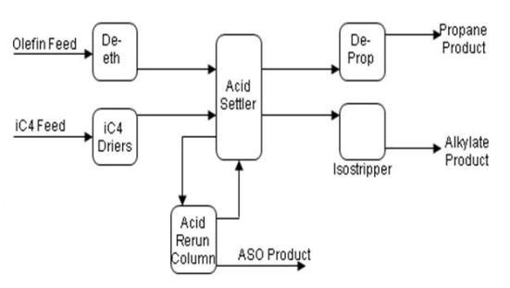
Valero Pembroke’s HF acid Alkylation unit is the third largest in the world and produces over 1800 barrels of Alkylate an hour.
CDU (Crude Distillation Unit)
Imported crude is sent to this unit via the desalters and fed into a distillation column, where it is split into different distillate fractions such as Gas/gasoline, Kerosene, Light gas oil, Heavy gas oil and Residue by their own specific boiling points . The crude is then heated by heat exchangers heated by waste heat from other units before it enters the column around 342.8 °C and at a pressure slightly above atmospheric. The vertical column contains steel trays to be able to separate and collect the liquids. This allows for easier separation of the different products. This means the heavier fuel oil will remain at the base of the column to be removed while the lighter components such as kerosine, naphtha and gas can be taken off at the side draws before the new separated components can be sent off to other units to be distilled even more. The CDU can run at maximum of 1500 m³/hr of crude oil. This is around 226,433 US barrels per day.
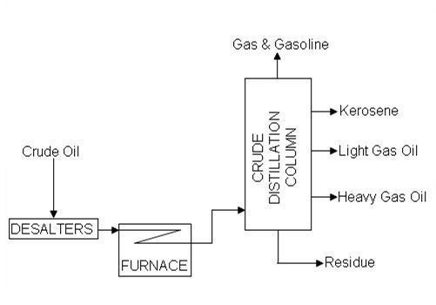
Figure 1: General arrangement of Crude Distillation Unit

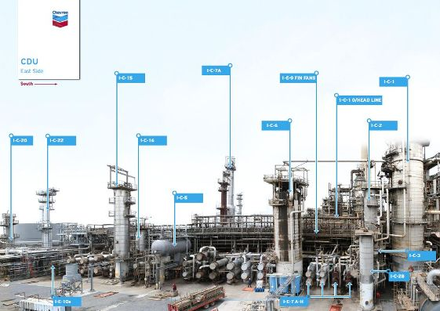
Crude Unit from East
SRU (Sulphur Recovery Unit)/ARU (Amine Recovery Unit)
H2S is produced throughout the refinery and must be removed as it can be fatal to humans if breathed in. The gas is absorbed into amine in the amine scrubbers around the site and then sent to the ARU where the H2S and amine are separated in a distillation column and the H2S routed to the SRU where it is sent through a fixed bed catalyst and a range of heat exchangers to make elemental sulphur which can be stored in the sulphur pits before being disposed of safely. The ARU and SRU unit in fact have 2 of the exact same units back-to-back. This allows for double the operation when they are both in use or allows for one whole system to be shut down for maintenance while the other system allows the refinery to keep operating.

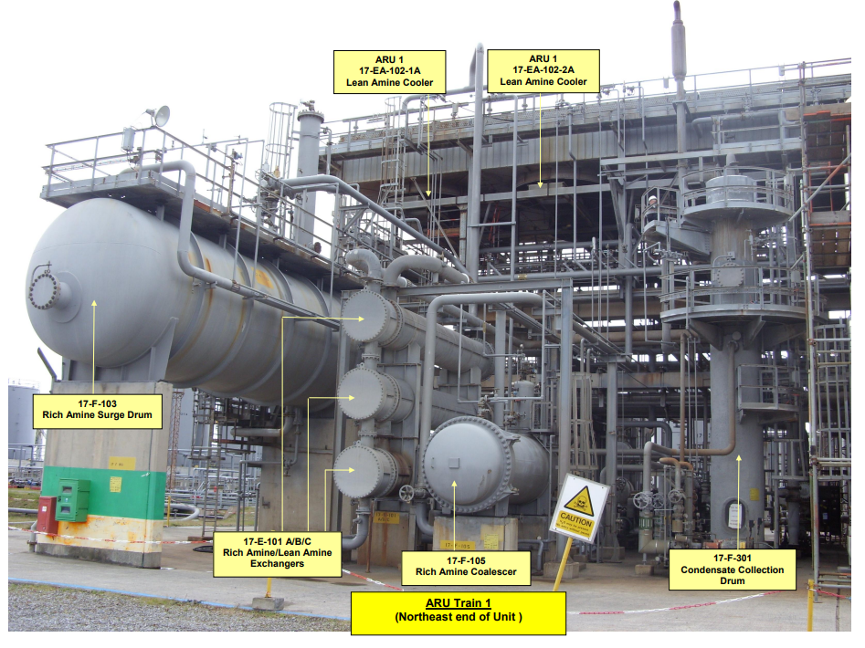
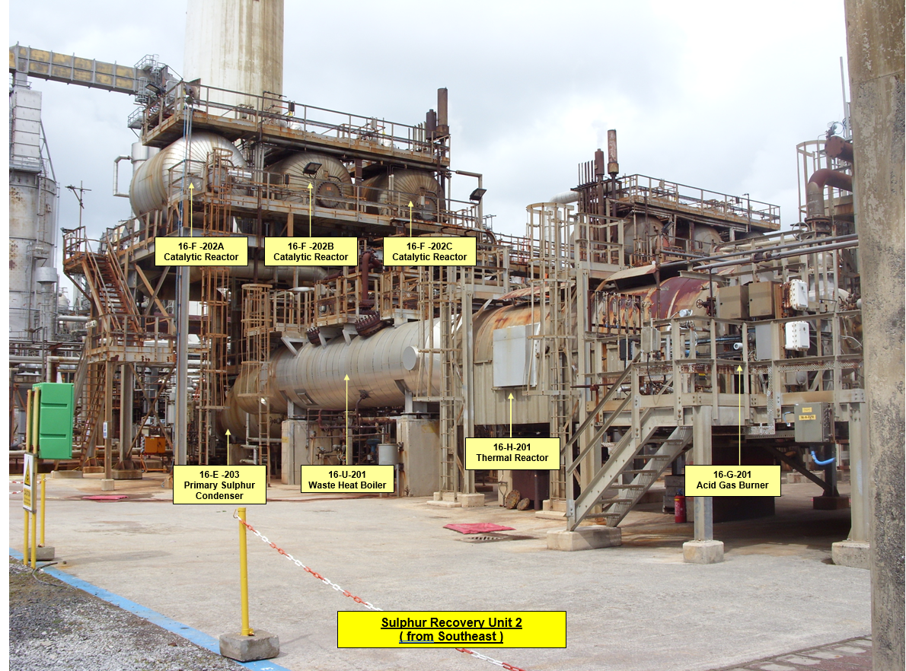
The steam plant and Utilities
The steam plant is designed to produce enough steam to help operate the refinery on a day to day need, it does this using its 8 eight boilers: seven high pressure (HP) boilers and one medium pressure (MP) boiler.
These maintain three steam headers:
- HP at 31.7 kg/cm² (producing around 340 Tonne/hr)
- MP at 17.6 kg/cm²
- LP at 2.8 kg/cm²
Raw water is entered into the boilers through 5 different filters which are all in a parallel line and can be removed individually for maintenance to be undertaken while till in operation. Once the raw water has passed through these filters, they enter the 6 feeding softeners which are loss in parallel to completely treat the water. This fully treated water is then sent to the de-aerator where the Low-pressure steam is injected into the treated water and condensate. This is done to remove all oxygen and any other impurities which could cause corrosion.
Services provided by the Utilities section are:
• Fuel Gas for the sites fired heaters
• Fuel Oil for the heaters with oil firing capabilities - due to decline with the introduction of the natural gas line at the end of 2011
• Steam - HP, MP & LP steam
• Nitrogen
• Instrument Air
• Potable Water
• Utility Air
• Utility Water
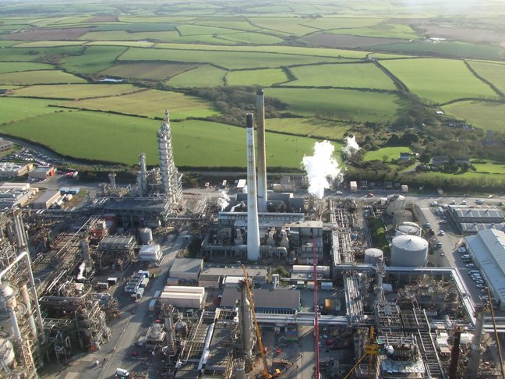
• Fire Water
Figure 2 Utilities from above

Jetty.
The jetty consists of 8 berths which has been in operation from 1964 which bring in imports onto site such as Crude oil, Refrigerated Butane, LPG, Gasoline Blend stocks and Fuel Oil.

The jetty imports roughly 10 crudes ships a month loaded with either 80’000 or 150’000 crude parcels imported via 2 sealines 36” & 42” which are then water drawn to remove any water and then used to feed the units to allow other products to be made.
Once these products are made and blended throughout the site, they are then exported back to the buyer via the jetty down a number of different sealines. These are then transported all over the world.
Over 92% of the product Valero sell passes through the jetty with 6% leaving via the pipeline which connects Valero to terminals all down the country. The last 2% leaves via road which is loaded in the RTW section of the site.

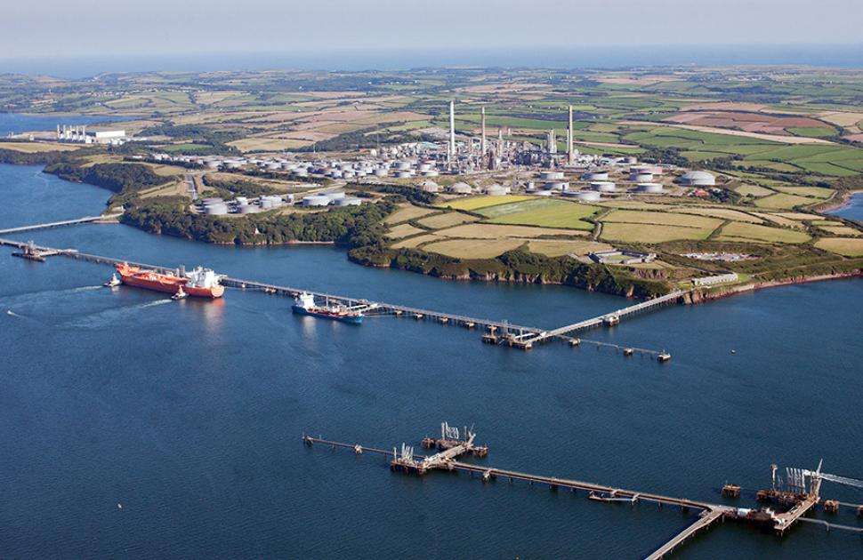
Figure 3 Pembroke Refinery.

Bibliography

Thermal Engineering. (2019). What is Steam Turbine - Description and Characteristics - Definition. [online] Available at: https://www.thermal-engineering.org/what-is-steam-turbine-description-and-characteristics-definition/?utm_content=cmp-true.
‌ savree.com. (n.d.). Turbine Driven Centrifugal Pump Explained - saVRee. [online] Available at: https://savree.com/en/encyclopedia/turbine-driven-centrifugal-pump [Accessed 27 Apr. 2023].
Partlow, W. (2022). Construction Details - Centrifugal Pumps. [online] Beyond Discovery. Available at: https://www.beyonddiscovery.org/centrifugal-pumps-3/construction-details.html [Accessed 27 Apr. 2023].

‌ Valero. (n.d.). Pembroke Refinery. [online] Available at: https://www.valero.com/about/locations/pembroke-refinery.
‌

‌

