Written Assignment

Name: Soabia Rafiq
Student ID: 2015530
Module Code: BMHP5015_BIRM
Lecturer’s Name: Dr Tayo Korede

Table of Contents

Introduction 3

Unit 1 – Brand You 4

Unit 2 – It’s a Small World 5

Unit 3 – Opportunity Knocks 6

Unit 4 – The Pursuit of Happiness 7

Personal Developmental Plan 9

Recommendations & Conclusion 12

References 13

Introduction

The basis of this assignment is to gain an understanding of the modules that are the topics of Brand You (Ambition is Critical), It’s a Small World (Network Society), Opportunity Knocks (Identifying Career Opportunities) and The Pursuit of Happiness (Future Me). In this assignment there will also be a discussion about how Ambition is Critical as this is very important in everyday living. There will also be a discussion on Network Society, Identifying Career Opportunities and Future me. This are important in this assignment as this is part of shaping someone’s future. This will help gain the knowledge that is needed in order to gain a perspective in everyday living. This will help attain future goals of an individual and also helping sustain in the employment world. There will also be a PDP (Personal Development Plan) to show the writers future goals in order to get to where they want.

Unit 1 – Ambition is Critical

According to Marques (2017) stated that ambition is the motivating force that motivates us to go beyond what is thought to be possible. Ambition is a great leadership attribute because it promotes innovation, creative thinking, and also an entrepreneurial spirit. Ambitious leaders are performance-oriented because they always strive to improve themselves and their organisations. Aspiration, like numerous other traits, has several dimensions: it may be both positive and destructive. If driven too far, ambition may become a liability rather than a benefit. As a result of intolerant, micro-managing, and excessive control, this can result in increased workaholism, stress, health difficulties, as well as a toxic work environment, resulting in disgruntled co-workers (Marques, 2017).

According to Hirschi and Spurk (2021) they stated furthermore, above employee-rated proactivity and generalised self-efficacy, leader aspiration, but just not self-rated ambition, was substantially positively connected to greater supervisor-rated work performance and promotability. Beyond success striving, we discovered increased ambition was positively connected to stronger affective organisational commitment, especially when more organisational career options were recognised. Despite adjusting for perceived organisational career chances and accomplishment striving, ambition was nevertheless associated with greater organisational turnover intentions (Hirchi & Spurk, 2021).

According to Pennington and More (2010) stated that organizational sustainability necessitates that businesses include environmental, social, and economic goals into their operations. As a result, it has resulted in a significant growth in the number of institutions focusing on social and environmental issues. Sustainable reports cannot be trusted to accurately reflect firms' ecological and social sustainability efforts. With concerns about reporting organisations' real commitment to environmental sustainability, this article examines different frameworks for assessing organisations' progress toward sustainability and suggests a complete approach (Pennington & More, 2010).

According to Keskin, Diehl and Molenaar (2013) stated that sustainability drives the innovation process in new enterprises. Conferring to popular thinking, young and new enterprises have an edge in terms of creativity and, as such, are viable candidates for proposing creative solutions to sustainability concerns (Keskin, Diehl & Molenaar, 2013).


(Figure 1: Ambition)
(Dreamstime, 2022)

\
Unit 2 – Network Society

According to Thacker et al., (2019) they stated that infrastructure systems are the backbone of every civilization, delivering vital services. In order to boost economic output and employment, we discovered that infrastructure impacts the achievement of all of Sustainable Development Goals whether it is directly or indirectly (SDGs). We classify infrastructure's positive and negative consequences, as well as the interdependence of infrastructure sectors. To guarantee that the correct infrastructure is created, policymakers must build long-term ideas of sustainable critical infrastructures that are influenced by the SDGs, as well as adaptive plans that can demonstrate their vision (Thacker et al., 2019).

According to Hanyang Guo et al., (2020) they stated that the network of supply chains is evolving as a result of the fast growth of information technology, implying a higher level of reliance between organisations. Traditional techniques to evaluating production capabilities rely on centralised procedures with restricted exchange of performance and assessment data. Furthermore, existing assessment methods rely heavily on arbitrary manual operation with insufficient data. Furthermore, blockchain technology is being used to allow public and distributed information sharing and storage as well as to facilitate fair and automated data trade. A simulation experiment is used to assess the proposed system. It illustrated how to use the suggested approach to choose appropriate upstream firms. The system's effective development might assist to improve production efficiency, minimise risk, and provide more reasonable and durable production management in the supply chain network (Hanyang-Guo et al., 2019).

According to Helmi et al., (2021) stated that The suggested framework is general and adaptable since it may be used to design both major distribution channels (DNs) and microgrids. The technique given here may be adopted inside any decision-making system and telecommunication tool for optimal environmental sustainability planning (Helmi et al., 2021).

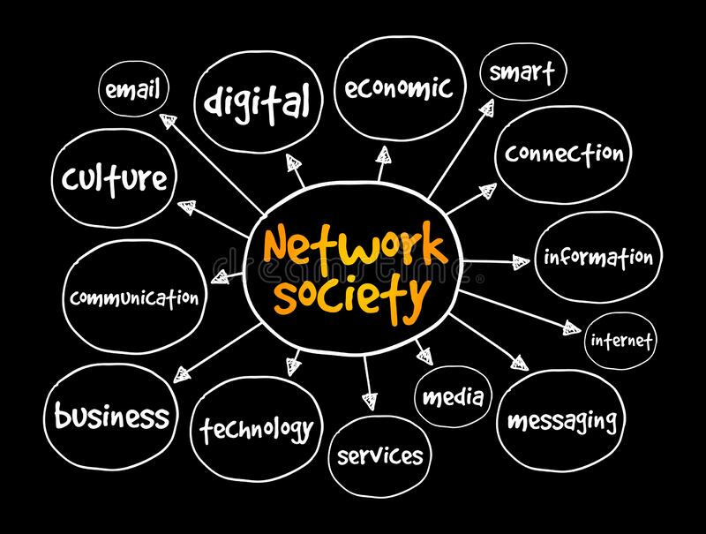
(Figure 2: Network Society)

(Dreamstime, 2022)

Unit 3 – Identifying Career Opportunities

According to Ike et al., (2019) stated that these Goals for Sustainable Development (SDGs) are a collection of 17 broad objectives that express that intended result of sustainable development. Through corporate sustainability efforts, the private sector may help achieve these goals. Each Sustainability Development Goal is considered equally important; it is up to specific companies to define and prioritise its implementation. Policymakers in host nations should guarantee that SDGs as like schooling and institutional frameworks are all in existence to attract multinational corporations (Ike et al., 2019).

According to Bal et al., (2020) they stated that to investigate how illusions about the professional world and the role of the person in the workplace impact the usage of sustainable careers. The writers contend that the idea for sustainable careers is based on the individual's neoliberal illusion. The research finishes by offering an alternative notion of sustainable careers based on a self-respect towards sustainability, that offers a different conceptual understanding of environmentally friendly careers in the modern workplace, refining its dimensions and utility in career theorising (Bal et al., 2020).


(Figure 3 – Career)

(Vectorstock, 2022)

Unit 4 – Future Me

According to Cai et al., (2015) stated that the moderating and mediating models for the relationships between ego, proactiveness, career choice, future work self, and career adaptability using career building theory and self-verification theory. The favourable influence for self-esteem on career search was bigger among students with a more proactive disposition. Individuals with a greater degree of proactive personality had bigger indirect impacts for self-esteem on prospective work self and career flexibility through career exploration, lending credence to the proposed moderated mediation model. As people's career patterns become increasingly boundaryless and non-linear, career building theory stresses two types of self-regulatory tools that help people handle difficulties and enhance individual fit during their career growth. Career adaptivity is considered as a motivating force that directs people' career construction actions. It relates to someone's desire to engage in the process of attaining person-environment integration. Individuals require adaptable skills in addition to modifiability to handle activities throughout career changes. The notion of career flexibility suggested these talents. Because future work self and career flexibility are crucial in individuals' professional growth, researchers have begun to focus on both individual and environmental determinants of such two significant self-regulatory resources. In other words, people with better self-esteem and a more proactive personality are still more than likely to participate in career exploration activities, which helps people build a more distinct potential work self with higher career flexibility (Cai et al., , 2015).

According to Merino-Tejedor, Hontangas and Boada-Grau (2016) stated that the links with adaptive preparedness (i.e., self-regulation), career building and adapting responses (i.e., vocational coping behaviours), and adaption outcome (university commitment, exhaustion, and professional individuality). The scores' validity was supported by the substantial relationships found seen between CAAS and the adaptive preparedness, adapting, and adaption measures. Furthermore, this study investigated a predictive basis of variable mediation, lending credence to the differentiation between the three aspects contributing to adaptation (Merino-Tejedor, Hontangas & Boada-Grau, 2016).
PDP | Skills | Current Ability | Target Ability | Development Opportunity | Criteria to Judge Success | Time Frame | Evidence
1st Priority | After completing the four modules and comprehending the many themes, I realised the difficulty in comprehending | My present skill level is considered basic. I am timid when it comes to networking, so I stick to familiar individuals in my neighbourhood and close relatives, but I suffer with individuals I don't know. | my desired capacity to expand my professional and interpersonal networks outside my immediate community I'd like to network with accomplished management professionals in a social atmosphere. | I want to go to networking events and build a professional workspace, as well as join LinkedIn and utilize it to gain publicity from a professional platform. | to keep track of my advancement and networking success | 2-6 Months. | Being recognised through LinkedIn and gain a following and join an ambitious company.
2nd Priority | Implement the four modules into my working life to ensure that this is followed from what I have achieved my previous goal. | To be able to pass on the knowledge to support the staff I will be leading in a manager role along with supporting the management team I will be in. | Ensure that I have extensive skills like being able to ensure that I have a professional approach. | To ensure that any training to better my role is completed to make myself a better leader. | Being able to utilise the skills in chosen career path. | 1 Years. | Being able to aim further in my chosen career and ensure that I have a broader mindset.
3rd Priority | Ensure that I am in my chosen career and dependant on what I have learnt to ensure that I am able to do so. | Utilize my graduated skills in my chosen career. Ensure that I have mastered the required skills of being a good leader and role model. | To ensure that I have the right mindset on how to be approachable and communicate with colleagues and ensure professional approach is always implemented | To be able to ensure that the right legislation is followed throughout and always willing to learn new ways into making things better for staff | Being able to be a role model to the staff around me and ensure that I can deliver good care qualities and enhance any existing skills | 3 years | Being able to reside in this my chosen career path in a leadership role and acquire the skills to demonstrate this.

Conclusion & Recommendation

With this conclusion I have learnt from this is have an ambition to be able to further my career. Having this will help me get to my end goal. This is to ensure that I better my own career and ensure that I have learnt the main criteria. This is where I have learnt to set goals and write them down. I am very organised in general and know that I can set targets and know how to achieve them. I can also reset the timeframe by ensuring that I work my way up to the goal. In order for me to become a good leader I need to utilize the skills I have which are:

- Communication & Listening Skills
- Using Microsoft Word, Excel, PowerPoint etc.
- Using knowledge to fit the job description
- Being able to understand where I lack
- And I can also multi-task

With this topic I have learn the connections in hierarchies where it will benefit me in the future. I have learnt that in order to network in society there has to be a balance of confidence to ensure that I can strive. This is where I can achieve success in life.
In unit 3 I have learnt how to cultivate certain pointers on how to progress further. In the university I had gone to a career’s fair, and I approached many different representatives, but I just didn’t know how to start off the conversation in a professional manner. This unit has taught me how to be confident and ensure that I have the right mindset and understand what I want.

The recommendation would be to ensure the key findings of what is learnt in the units can be incorporated in everyday living (Professional Career). The main recommendation is to ensure that the information that is being given is fully understood and ensure this information can be put into practice. This can be put into perspective of any chosen career so that this can be implemented into any workforce.

References

Bal, P.M., Matthews, L., Dóci, E. and McCarthy, L.P., 2020. An ideological analysis of sustainable careers: Identifying the role of fantasy and a way forward. Career Development International.

Cai, Z., Guan, Y., Li, H., Shi, W., Guo, K., Liu, Y., Li, Q., Han, X., Jiang, P., Fang, Z. and Hua, H., 2015. Self-esteem and proactive personality as predictors of future work self and career adaptability: An examination of mediating and moderating processes. Journal of Vocational behavior, 86, pp.86-94.

Dreamstime., 2022. Ambition Handwritten Word Text With Rainbow Colours and Vibrant Swoosh. Dreamstime, p.1.

Dreamstime., 2022. Network Society Mind Map, Business concept for Presentations and Reports. Dreamstime, p.1.

Helmi, A.M., Carli, R., Dotoli, M. and Ramadan, H.S., 2021. Efficient and sustainable reconfiguration of distribution networks via metaheuristic optimization. IEEE Transactions on Automation Science and Engineering, 19(1), pp.82-98.

Hirschi, A. and Spurk, D., 2021. Ambitious employees: Why and when ambition relates to performance and organizational commitment. Journal of Vocational Behaviour, 127, p.103576.

Ike, M., Donovan, J.D., Topple, C. and Masli, E.K., 2019. The process of selecting and prioritising corporate sustainability issues: Insights for achieving the Sustainable Development Goals. Journal of Cleaner Production, 236, p.117661.

Keskin, D., Diehl, J.C. and Molenaar, N., 2013. Innovation process of new ventures driven by sustainability. Journal of cleaner production, 45, pp.50-60.

Li, Z., Guo, H., Barenji, A.V., Wang, W.M., Guan, Y. and Huang, G.Q., 2020. A sustainable production capability evaluation mechanism based on blockchain, LSTM, analytic hierarchy process for supply chain network. International Journal of Production Research, 58(24), pp.7399-7419.

Marques, J., 2017. Leadership and Ambition. In Leadership Today (pp. 353-370). Springer, Cham.

Merino-Tejedor, E., Hontangas, P.M. and Boada-Grau, J., 2016. Career adaptability and its relation to self-regulation, career construction, and academic engagement among Spanish university students. Journal of Vocational Behavior, 93, pp.92-102.

Pennington, L.K. and More, E., 2010. Sustainability reporting: rhetoric versus reality?. Employment Relations Record, 10(1), pp.24-39.

Thacker, S., Adshead, D., Fay, M., Hallegatte, S., Harvey, M., Meller, H., O’Regan, N., Rozenberg, J., Watkins, G. and Hall, J.W., 2019. Infrastructure for sustainable development. Nature Sustainability, 2(4), pp.324-331.

Vectorstock., 2022. Career opportunities colorful vector images, p1.

