

RESULT

ASSIGNMENT DETAILS AND FEEDBACK
SOUTH WEST WALES CENTRE FOR TEACHER EDUCATION
Sections marked with * should be completed by module lead
Student name: | Chloe Pritchard | Student P number: | 1704239
Programme: * | Secondary Post Graduate Certificate in Education
Module: * | Curriculum Development and Enhancement | Module Level (6 or 7): | Level 7
Module code: * | ECSP7002 | Contribution to Overall  Module Assessment (%): * | 100
Module Lead:* | Jan Barnes
Assignment Title:* | Reflections on Teaching and Learning | Assignment No (x of x): | 1
Start date:* |  | Submission deadline:* | 14th May 2018 –full submission
Return date of provisional marks & written feedback:* | 11th June 2018

Referencing: | In the main body of your submission you must give credit to authors on whose research your work is based. Append to your submission a reference list that indicates the books, articles, etc. that you have read or quoted in order to complete this assignment (e.g. for books: surname of author and initials, year of publication, title of book, edition, publisher: place of publication).
Submission: | All assignments must be submitted to Turnitin unless otherwise instructed by the Lecturer.  Note: the Turnitin version is the primary submission and acts as a receipt for the student. Late submission of the electronic version of the assignment will result in a late penalty. Penalties for late submission: Up to one week late, maximum grade D. Over one week late, Refer. Only the Extenuating Circumstances Panel may grant an extension. | Date:

Module lead to tick to indicate if a hard copy version of the assignment must be submitted.* | YES
 | NO | √

Researching the impact of a carefully designed scheme of work on pupils’ use of misconceptions in Algebra and associated assessment for learning.

Misconceptions in mathematics are apparent in school children of all ages and lead to them struggling through school and later in life. In this report I will be exploring the depth of misconceptions pupils have when learning and practising Algebra, as the teaching of Algebra is essential in pupils grasping the abstract concepts (Mitchell, 2006). I will be conducting a test, creating learning materials and evaluating the effects on the pupils’ misconceptions to see whether I can find suitable methods to eradicate these misconceptions.

School X is an 11 – 19 school, which takes in pupils from two local valleys, has 1219 pupils on roll with 25.2% pupils receiving free school meals. The school is a hub for moderate learning difficulties the local authority and pupils outside of the catchment area will be brought to the school. The class I have conducted my research with is a year nine set five class. In School X each year is in one column sets and there are nine to ten sets, where the bottom set is a moderate learning difficulties class. Set five is the middle band and at key stage four depending on ability, will be entered for either intermediate or foundation tier mathematics exams.
Literature Review
Misconception is an error that produce a wrong answer and within mathematics error are usually a misconception rather than a careless mistake and unless these errors are addressed will appear over and over, and where a misconception is shared, the addressing should take place within a classroom (Tanner & Jones, 2003; Chambers & Timlin, 2013; NCETM, 2016).

Kuchemann (1981) categorised students’ understanding of letters in algebra into two sets:
‘1. The letter is ignored, given an arbitrary value, or used as the name of an object.
2. The letter is used as a specific unknown number or generalised number.’
He then broke these sets into a further six subsets which can be listed as:
‘1. Letter evaluated where the letter is assigned a numerical value and no algebraic manipulation needs to be performed.
2. Letter not used, where the pupils ignore the letter.
3. Letter used as an object, where the letter is an object for example a for apple.
4. Letter used as a specific unknown, where the pupils see the letter as an unknown but operate on it directly.
5. Letter used as a generalised number, where the letter can take several values rather than just one.
6. Letter used as a variable, where the letter represents a range of values and a relationship exists between two sets of values.’

Statements one to three show little understanding of algebra and only general arithmetic is needed to be able to perform these actions. Only when pupils have grasped statement four to six will pupils be classed as having an understanding of algebra (Tanner & Jones, 2000).

In tackling misconceptions pupils first need have the correct mindset for mathematics. Routine methods and formal questions for work on algebra leave pupils feeling that they do not understand what they have learned therefore leaving them feelings of failure and which then lead to them having a negative mindset towards learning more mathematics (Brown et al., 2010). Kieran (1992) suggests that the curriculum focuses too much on rules of simplifying and manipulating rather than finding relationships and procedures. This view is also taken by Booth (1986) and Welder (2006) who discuss how students see algebra just as a set of rules and having no relevant use to them. Dweck (2015) discusses how by helping pupils flourish on challenges and to learn from their setbacks, they can then thrive long and short term with a growth mindset. If pupils are displaying these misconceptions and their view is unchangeable then the introduction algebra needs to be addressed. Assumptions made from results taught in pupils’ earlier mathematics education and the ‘pattern’ approach to teaching algebra can both be attributed to the creation of misconceptions of pupils (Chambers & Timlin, 2013; MacGregor &Stacey, 1997). Tanner and Jones (2000) take further by discussing how the use of ‘metaphors or analogies’ may lead to pupils becoming close minded towards different concepts and not being able to expand their understanding of and build upon these concepts.

The methods in which children learn need to be taken into account when teaching algebra and their levels of understanding need to be assessed. Children should be challenged and presented with problems where they have to discover the rules and relationships in which algebra is based upon. When tackling problems children are presented with a challenge where they feel like they are learning and feel the challenge is worthwhile (Kuchemann,1981). Tanner and Jones (2000) further discuss how pupils should be encouraged to use algebra from an early age, or as early as possible, and how tasks should be used so that pupils can find relationships between variables themselves and how to represent them. Pupils may also struggle with the pace in which algebra is taught and teachers and textbooks need be aware of the difficulties and misconceptions that come with learning algebra (Herscovics, & Linchevski, 1994).

Macgregor & Stacey (1997) discuss how letters in algebra should first be introduced. Pupils need to understand that letters form the alphabet can represent any number and not just represent the number of letter from the alphabet. Letters are not used the same in algebra as they are in English and the rules are not the same. It should be emphasized that the letters do not stand for the name of things but for a number. Collof and Tennant (2014) describe how some teachers teach algebra through the ‘fruit salad’ method, for example, let a represent an apple, then if we wrote 2a + 3a =5a then we have 2 apples add 3 apples equals five apples. But what happens when -a + 4a is introduced, pupils will be confused as to how can you have minus one apples. Therefore, this method of teaching needs to be avoided. The ‘Fruit salad’ may hinder pupils when multiplying in algebra, as how would one explain an apple times another apple. This is an example of letter used as an object. Macgregor & Stacey (1997) suggest changing the way teachers describe what the letters mean for example rather than letting g stand for the number of grams rather than just the weight and that g is a number and not just the word weight. Kuchemann (1981) argues however that first introducing pupils to algebra using a letter as an object is a method in which pupils can begin to understand the concept of algebra but only with the future aim of the letter becoming the number of objects.

Pupils are taught in arithmetic that there will be one answer but in algebra this is not the case (Booth, 1988). Booth further discusses how answers can be left with the inclusion of plus and minus signs as the focus is the derivation and relationships of expression and to find the simplified expression. In a study conducted by Booth pupils were asked to find the perimeter of a shape. They were given the lengths of the sides, but the number of sides were represented with a letter. Pupils responses ranged from 14 as n is the fourteenth letter of the alphabet, and some getting the right answer but not understanding that they were left with correct answer as responses but concluded that the answer was not ‘proper’ as the definitive answer was not just numerical If there are letters in the expression you have to find their value. Therefore, its needs to be stressed that answers can have operations within them (Macgregor & Stacey, 1997). Pupils’ don’t understand that the expression 2x + 5 can mean add five to two times x, which they are usually comfortable with, but it can also be an object, the final answer. Tanner and Jones (2000) further suggest that when working with numbers and at the beginning of teaching algebra discuss with pupils how numbers can be written in a variety of forms, for example the number 15 can be written as 15, 5 + 5 + 5 but also 3 x 5 but using the equal sign to show that these expressions are all equal.

In mathematics, mostly ordering of operations goes unnoticed since the child performs operations in the order required by the question. Only when specifically addressed to problems arise. This is not the case when it comes to algebra and the use of brackets and order become important (Booth, 1982) In another study conducted by Booth pupils were able to correctly identify the method the needed to use but only a small number were able to recognise that brackets needed to be included in their answers. Booth also found that students find the expression 5 x e + 2 and 5 x (e + 2) to being equivalent. Liebenberg, Sasman,and Olivier (1999), as like Tanner and Jones (2000) previously, discuss how addressing this misconception they first began to look at different ways the pupils can make up different numbers using different operations. This allowed pupils to think about how they needed to structure their expressions and think about properties of operations. Then when addressing the same for algebraic expressions they presented pupils with a variety of expressions, then put in numbers to find answers, they were then asked to see if any of the expressions gave the same answer. Afterwards the pupils were asked to write expressions which were equivalent. Therefore, pupils should have a sound understanding of numerical equivalence and use of order before they venture into algebraic equivalence. The use of numbers should be used to clarify pupils understanding of algebraic expressions.

Misconceptions in Algebra may first arise if pupils do not have a sound understanding of arithmetic with integers and how to use negative numbers. Algebraic equations and word problems may prove difficult if pupils do not understand operating with negative numbers, and students tend to make many errors involving positive and negative numbers when solving equations (Gallardo, 2002; Welder, 2006) When dealing with negative number in algebra pupils need to recognise that the number as direction (Booth & Koedinger, 2008). When collecting like term if the pupils fail to recognise the negative sign is attached to the number then they will inherently end up with the wrong answer. When presented with a larger number taken away from a smaller number, pupils have the tendency to invert the numbers so that they make ‘sense’ and pupils struggle to comprehend that the minus sign is attached to the term and not just an operation (Vlassis, 2004). Vlassis suggest that the use of rules about the minus sign leads to confusion for pupils and when they need to learn new concepts and are reluctant to change and therefore suggests that pupils take part in activities to discover what the negative sign means for themselves. Carraher et. Al. (2006) further discuss how pupils need a solid understanding of negative numbers in any situation that pupils need to add or subtract and suggest that the use of tables, graphs and number lines are methods which show the patterns of negative numbers clearly and concise.

In a study conducted by Sarwadi and Shahrill (2014), pupils were asked questions where they had to simplify expressions in index notation. Pupils answers reflected that they perceived the base number and index to be separate. In another study by Lim (2010) pupils either forgot that the index existed, for example simplifying expressions correctly but then not including the exponent on the variable, or pupils applied the operation on the exponent to the coefficient rather than the variable. Lim further discovered that pupils would simplify the expression a x a with the term 2a. Lim suggests that in teaching how to simplify algebraic expressions teachers should go into depth and explain why, rather than repeat rules and procedures. Ziegler, Edelsbrunner and Stern (2017), discusses how algebraic addition needs to be clearly distinguished from the methods of multiplication as pupils who complete repeated procedures may learn to do it instinctively, and therefore apply those methods to questions which appear to look similar.

A suggestion to tackle misconceptions in the classroom is to use cognitive conflict, a term coined by Piaget. He believed that through children’s’ social interactions that discussions about intellectual views could arise, and different perspectives exist (Tudge & Rogoff, 1999). Chambers and Timlin (2013) discuss how using this method has more long-term effects on the pupils learning rather than the pupil just correcting the pupil’s mistake. Cognitive conflict is showing a pupil a problem and showing that their method and answer is illogical and that it cannot be correct. Showing these outcomes have been shown to be more effective in addressing pupils’ misconceptions and if the teacher has found a pupils’ misconception, they should choose problems which will show these impossible outcomes (Tanner & Jones, 2000: Bell, 1993). Wiliam (2006) describes how using cognitive conflict is also a helpful tool in assessing pupils’ learning. They should encounter activities that make them think about whether the mathematics is correct, and their methods are wrong or the reverse, that’s their methods are correct, and the mathematics is wrong. Resolving conflicts can better the understanding of pupils’ and therefore take their learning further.

To conclude this literature review I will discuss the key aspects to tackling misconceptions. Tanner and Jones (2000) suggest how teaching should include a variety of strategies that include discussions about misconceptions, and feedback should be a question of why pupils are wrong rather than being correct or incorrect. Macgregor and Stacey (1997) suggest that pupils should first describe in words what they see, and to be aware of what pupils already believe about Algebra before entering your classroom. Then in your classroom use algebra more often and spread throughout topics so that pupils understand its wider uses.

School Policy and Practice and the Diagnostic Test

The class would have encountered Algebra in previous years through using letters to represent numbers and simple expressions and to write and create formula using words and letters. In the department’s program of learning (POL) the topic of Algebra follows Integers, Powers and roots, therefore the pupils would have been learning about prime numbers, directed numbers and briefly touched upon the rules of indices, leading nicely into the topic of Algebra. In the creation of the program of learning the department follow the scheme of a textbook relating to the tier of exam the pupils will sit. Thus, the class I conducted my research on follow a Foundation textbook. The textbook follows a standard pattern of example then an exercise of repetitive questions with some challenge questions at the end. Pupils during the topic would learn how to expand single brackets; expand brackets and collect like terms; factorize expressions; expand a pair of brackets; and simplify by writing answers in index form (Appendix 1).

The diagnostic test (Appendix 2) will include 10 questions and will include questions linked to the POL and misconceptions previously researched. The purpose of the diagnostic test is to identify any misconceptions that the pupils has. The first and second questions are ‘is the following statement true or false ‘x + y = xy’’, ‘Simplify 3y + 5x’ respectively. Question 2 is based upon the investigation by Booth (1998) and how pupils fail to see how an answer can include an operation. The misconception answers pupils may write for this question will be the juxtaposition of the x and y and/or the addition of the numbers. Some pupils may not even answer this question as they cannot see what an answer could be. Question three is an example of a letter being a specific unknown. This is an adaptation of a question by Kuchermann (1981) to see whether the pupils can correctly add the x term to the x term. Pupils may right xx + 7y. Question 3 will test pupils understanding of the negative sign, therefore to address the misconception referred to by Vlassiss (2204) that pupils will reverse the expression when the larger number is taken from the smaller number so that it is the other way around.

To check pupils understanding of order of operations questions six, seven and ten have been put in place. In question six pupils will need to recognize that brackets will need to be included in the answer so that the whole expression is multiplied by three and the number seven. Question seven is the reverse, testing whether the pupils understand that both terms inside the bracket need to be multiplied by 3. The questions are a variation of those used by Booth (1982) Question 9 focuses on the pupils’ ability to simplify expressions into index from. The question is adapted from the study by Lim (2010), where the pupils will need to recognize the final answer in b to the power of six and not six multiplied by b.

Question eight is to test whether pupils see the letter as an object (Kuchermann, 1981) or whether pupils recognize the letters represent the lengths of each side of the shape. Misconceptions that may arise with this question is pupils possibly multiplying the letters, ‘hhhhg’, ‘4g, g’ or close to the answer 4h + 1g. The final question of the test is examining whether the pupils understand what the letter ‘e’ stands for. Booth (1982) discuss how pupils may ignore the letter e, multiply what they have and just put the e back in the answer somehow. Answers that may arise for this question could be ‘6e2’, ‘12e’, ‘e12’.

Methodology and Ethics

When completing classroom research ethics must be taken into consideration, therefore when preparing for my research I followed the Ethical Guidelines for Educational Research (BERA, 2011). BERA guidelines state that individuals in the research will be treated fairly and participants must understand the process of the research they will partake in and who the data will be reported too. Therefore, I presented the pupils with an information sheet and form (Appendix 3) telling them exactly what they will be partaking in and what will happen with their data. It also included how pupils would be able to withdraw from the study if they so wish and BERA guidelines state that the researcher may not use any coercion to keep pupils in the study. Pupils data will be anonymous and stored carefully in line with the Data Protection act (1998). The researcher will be the only person to handle the data and once the research is complete all data will be destroyed. The research will abide by the university regulations and the Ethics form had been cleared by the university.

BERA (2011) state that researchers methods must be ‘fit for purpose’. Takala (1994) claims that a teachers practice is improved if it is supported by their own research and therefore take part in Action Research. Action research includes identifying a problem, proposing a solution, testing the solution through intervention and then evaluating the process and considering the future of one’s own teaching practice (Takala, 1994). Critical self-reflection is key in action research and teachers have to think about every action they take in lessons. The reflections are to improve pupils learning and the teachers own learning and practice (McNiff, 2013).

In Action research the teacher takes on the dual role as teacher and researcher. This is difficult as the teacher needs to teach the curriculum and make sure students pass any exams, but as a researcher, the teacher wants to bring change and make sure pupils can understand why certain concepts are the way they are (Halai, 2011). In this case BERA (2011) guidelines advises that the teacher the teacher will need to account for how the research will impact on the students. The teacher carefully considers the situation in the classroom and how the research will affect the pupils and the teacher will have to continuously evaluate and reflect on their strategy. The teacher/researcher also has the responsibility to end the research at an appropriate time and be able to take the most relevant information form the research (Checkland & Holwell, 2007). The question of pupil confidentiality also comes into question as the teacher needs to decide how much information to tell the pupils. Therefore, the pupils are able to ask and receive their own results, but the class will not receive everyone’s results. The teacher will also have to take into consideration of when is an informal conversation and when is the conversation apart of the research data (Cohen, Manion, L & Morrison, 2002)

The Intervention will take place over four lessons so that each topic is covered and will begin with an initial diagnostic test and end with that same diagnostic test to compare results. The diagnostic test contained 10 questions, with nine questions requiring one answer and the final question being multiple choice. Gathering pre and post data can determine the course of an intervention and the aim of the tests is to show whether the intervention implemented has worked. Limitations of a pre and post-test include the researcher interpreting data too much and should consider what has happened during observation. (Marsden & Torgerson, 2012).

A key aspect of the research is to have a dialogue with the pupils to understand whether or not they still have misconceptions, thus the method of assessment needs to be addressed. The ways feedback is used in the classroom will need to insure it will show pupils how to improve on their work and ensure both teach and student can address any misconceptions. Richardson (2017) suggests limiting the use of hand ups and encourage the use of whiteboards. Therefore. the teacher is able to see everyone’s answers at once and there is no anxiety of pupils being embarrassed by saying the wrong answer. Teacher can therefore see immediately whether a pupil has a misconception relating to the question posed. However, the teacher needs to be wary of pupils’ responses but still need to be flexible with the lesson while achieving the lesson objective, if a misconception which wasn’t anticipated how will the teacher address it (Tanner & Jones, 2006)

Throughout the intervention, the basis of questioning was based on achieving a cognitive conflict within the pupils. Therefore, plenty of true or false questions will be posed to let pupils question whether the mathematics is correct or whether their methods are correct, and the mathematics is wrong (Wiliam, 2006). These types of questions also show the pupils a variety of mathematical questions that have illogical outcomes, and therefore have plenty of opportunity to pose the type of questions needed to raise questions in pupils (Tanner & Jones, 2000: Bell, 1993). True or false questions will raise questions in pupils and will create discussion between pupils, and through recognizing others wrong answers pupils have the opportunity to improve their independent learning. Wiliam (2006) states that activities that address common mistakes can be helpful for pupils in their own feedback and also in teacher’s feedback to address whether the pupil can recognize the mistake. Through questioning the teacher has to listen carefully, encourage answers and take them all seriously (Wiliam, 2006). This approach aids the use of cognitive conflict in the classroom as pupils are able to think about others’ responses and then process whether they are right or wrong. It gives the teacher and pupils insight on whether that pupil has a misconception or if pupils argue a different answer whether they have a misconception. Then through social interactions with peers and the teacher can discuss any inconsistencies.

Evaluation

To begin my intervention, I conducted a pre-diagnostic test. Pupils were unaware of the test and had no previous ‘revision; time. In the class there was nineteen pupils and three were absent. Every pupil was presented with the diagnostic test and had twenty minutes to complete it, all pupils completed the test in less than ten minutes. The results of the pre-test are presented in figure 1.

Figure 1.

The highest score in the test was three out of ten and the lowest four pupils had a score of zero. All pupils completed most questions and only 12% of the overall answers. The scores imply that pupils have misconceptions rather than not knowing what the question is asking. Only participant 19 did not complete any questions due to no previous contact with algebra.

After completing the diagnostic test, I asked pupils to complete a mind map of everything the previously know about algebra, most pupils only provided the answer of ‘it involves letters’ and could not relay any further information. Further to that pupils had their whiteboards and were presented with the questions ‘What does a stand for?’, ‘What does 2a stand for?’, etc. Pupils responses included 1, apple, 2 + a. When questioned why pupils thought a stood for one they concluded that as a is the first letter of the alphabet it stands for one. This was a sign that pupils had been exposed to ‘fruit salad’ algebra (Collof and Tennant, 2014).

Figure 2

The first question on the diagnostic test (Appendix 2) was to question whether the pupils could recognize that ‘x + y’ is not equal to ‘xy’. Four out of nineteen pupils (21%) answered the question correct indicating that most pupils do not have an understanding of ‘juxtaposition’. From the work of Ziegler, Edelsbrunner and Stern (2017), it is suggested that pupils do not understand the different methods applied to addition and multiplication for algebraic expressions. Thus, in lessons, I first used a true and false test to gage how pupils thought when approached with right and wrong questions and through evaluating their answers through the use of mini whiteboards, so that pupils could display their answers without anxiety (Richardson, 2017). The true and false activity (Appendix 5) gaged where pupils thinking was concerning the misconceptions and using the whiteboards was a helpful tool in displaying pupils’ thoughts as most pupils had left their workings on their boards. The true or false activity also was a cognitive conflict style activity where pupils had to figure put whether the maths was correct (Wiliam, 2006). As pupils still had the misconception the activity did not work as intended as the pupils were still not clear on the concept. Therefore, the eradicating of this misconception was to be worked on in the methods included for the second question of the test.

Question two in the pre-test the most prevalent answer was ‘8yx’. Pupils had juxtaposed the answer and answer appeared similar to a study conducted by Booth (1998). The question was to test whether pupils could see that the expression was in its simplest form, but answers indicate that pupils were uncomfortable in leaving the answer including an operation. Further like question one pupils may have confused methods of multiplication for addition as discussed by Ziegler, Edelsbrunner and Stern (2017). However, pupils summed together the three and five to make eight. During the intervention, to stress that some algebraic expressions are already in their simplest form pupils were presented with multiple expressions and where to sort the expressions into a table, one column that could be simplified and the other where they could not be simplified. Pupils were to complete the activity on their own and then to come back as a group to discuss their ideas, to share their intellectual ideas as suggested by Wiliam (2006). If a pupil disclosed an answer another pupil disagreed with the pupils displayed confidence and discussed ideas. Eventually pupils arrived at the correct groupings through their own social discussions, as advised by Piaget (Tudge & Rogoff, 1999). The assessment technique for this activity proved to work well within the lesson as pupils were essentially assessing each other and as the teacher listening I could gage which pupils fully understood the concept and who still had misconceptions.

Questions three and four questioned how pupils collect like terms. Questions three first questioned how pupils would add a term to an expression and as mentioned previously by Ziegler, Edelsbrunner and Stern (2017) pupils confused addition for multiplication. Multiple pupils correctly grouped the x terms together but then confused addition for multiplication and rather than 2a had x to the power of 2 in their answers. This is the opposite to what Lim had observed in their study, which found that pupils would simplify a multiplied by a to 2a. Other answers included the pupils adding all the coefficients together then juxtaposing the letter. The pupils correctly identified that x had the invisible coefficient of 1 but did not realise they could not add together coefficients of different letters. Question four and five tested whether pupils would correctly address the negative sign in the expression. Like question three, some pupils worked through the coefficients and juxtaposed the variables. Some pupils switched the larger and smaller numbers around so that they would not be left with a negative answer as discussed by Vlassis (2004) and in question five many pupils were left with just the answer of 10 and took the y away from the y. Question eight had similar properties to these questions and was to tests whether pupils saw the variables as objects (Kuchermann, 1981). This was the least answered question on the test by pupils but more answered it correctly than questions three and four. To address this misconception in the classroom I ensured that each pupil understood that a letter could represent a number and does not have an assigned number. When describing what each letter represented I was careful to not use the ‘fruit salad’ approach and describe a variable as just one object (Collof and Tennant, 2014). Therefore, when using real life examples, I was to say these letters represent what the length could be and not to just represent a side. To improve this further I could have included units so that I was saying ‘number of metres’ rather than length of a side to be more accurate as described by Macgregor & Stacey (1997).

\The next section of the topic introduced the pupils to multiplying out brackets and then to collect like terms. Therefore, it was vital that pupils understood simplifying expressions before entering this section of algebra. In the pre-test questions six, seven and ten addressed misconceptions when using brackets in algebra. In the pre-test question six was one of three questions which no pupils answered correctly as shown in figure 2. The most common answer was 15f. Pupils recognized they had to multiply by 3 and multiplied the 5 by 3 to arrive at 15, but then did not know what to do with the f, therefore juxtaposed it. Question seven again, most pupils juxtaposed the p and q but correctly identified to multiply by three. To address these misconceptions, I presented the class with a problem where they would have to identify the total cost of apples and bananas eaten in a day. Pupils correctly identified that two different variables were needed and that they needed to be added. I then presented to the pupils that I needed to know the cost after five days. Pupils identified they needed to multiply by five. I then asked, ‘multiply what by five, just the one number?’ Which then provided pupils with a conflict. Pupils noticed that the whole expression needed to be multiplied by five and that brackets were need. Pupils were able to deduce themselves the rules and relationships for this task as suggested by Kuchemann (1981). Pupils were then able to apply what they had learned to expand brackets. I found that using that technique was successful in showing pupils the order of operations in algebra, but I could have used this further rather than setting routine questions afterwards.

Finally question nine investigated pupils understanding of indices. This was the question that had the most correct answers. Pupils may have had a basic understanding as the subject was briefly touched upon in the previous topic. Most pupils arrived at the answer of b to the power of 6 but some had the expected misconception of 6a as shown in the study by Lim (2006). When clarifying understanding the understanding of indices I made sure to use a relational approach (Skemp, 1976). After gaging in conversation with pupils I could the introduce multiplying out bracket with using the letter in front. Through pupil conversation and checking work pupils appeared to have a sound understanding.

To conclude the intervention before the pre-test, I presented pupils with exam questions that I had answered (Appendix 4). Wiliam (2006) discusses how pupils enjoy correcting teachers mistakes and Tanner and Jones (2000) showing pupils illogical outcomes. Pupils appeared to be engaged with this task and most correctly identified mistakes in the first four questions, however the last question posed more difficult due to the use of the divide.

As stated previously I was to test the pupils again using the same test. The post- diagnostic test was administered at the end of the intervention. Pupils once again had twenty minutes to complete the test but finished in less than ten. The results are shown in figure 3 below and are compared to the post test results.

Figure 3

The graph shows a significant improvement from the pre-test to the post with the mean score increasing from 1.5 to 4.3. Only one pupil showed no improvement and one pupil showed a decline. The pupil who showed no progress however had been missing from class many a time due to unforeseen circumstances. No pupils had a zero and pupils who had zero in the pre-test showed the most improvement, participant 19 had no previous background of algebra, improved and gained half marks.
Figure 4 shows the number of pupils who answered each question correctly in the pre and post-tests. In all but question 3 more pupils answered the question correctly pupils had still confused add for multiply and rather than having the answer 2x pupils had the answer x squared. Ziegler, Edelsbrunner and Stern (2017), discussed how pupils may confuse adding and multiplying as they appear ‘similar’. Therefore, pupils may have answered this question incorrectly due to the fact the last lesson was based upon multiplication. Pupils also continued to show the misconception of confusing addition and multiplication in questions one and eight. Only ten answered one correctly and only a quarter answered number eight correctly. Pupils had a firm understanding of the use of indices but because of the comparable properties of the addition of indices, the methods were applied to many of the questions. Thus, the assessment techniques used for this section needs to be revised.

To answer question ten correctly pupils had to identify any correct expressions and not circle any misconceptions. This question was the hardest on the test and I was advised against using it, however I was curious to see whether after the intervention pupils could answer it. In the pre-test no pupils answered it correctly however in the post test three pupils had at least one answer correct. This leads me to believe that the assessment technique used during the brackets topic had some effect. However, I think results would have further improved had I used more examples where the pupils built their own rules rather than repetitive practice (Kuchermann, 1981).

Figure 4

The most improved question was question seven ‘3(p+q)’ and over half the pupils answered correctly. Some pupils still either juxtaposed the letters, substituted the number three in for the letters, or used the multiply sign rather than the addition. The technique suggested by Kuchermann (1981) where pupils were able to identify relationships and rules needed to work with algebraic expressions proved effective as questions six, seven and ten all showed improvement.

While both graphs show improvement, it may not be down to the intervention. It may be down to the fact pupils had learned new techniques or previous skills they had were reminded to them. However, certain assessment strategies in the intervention appeared to work well. The use of mini whiteboards worked well in identifying misconceptions immediately and group discussions gave pupils the opportunity to discuss and discrepancies in thinking.

Conclusions

In conclusion, despite the limitations of this research project, from the results, there is reason to believe that the intervention eradicated some of the misconceptions pupils had. Whether that be because they had the misconception or just learned a new method. The most common misconception that arose with the group of participants was the juxtaposition of letters and ignoring the use of addition and multiplication signs. Therefore, the methods taught within this intervention were probably too similar as the post diagnostic showed that some pupils still showed some of the misconceptions. Thus, strategies for these misconceptions need to be more varied and pupils need to clearly understand the differences between multiplication and addition in algebra. By the end of the intervention pupils seemed comfortable in the computation of indices but still applied the same methods when all the questions require is addition as discussed by Ziegler, Edelsbrunner and Stern (2017). What I recommend from these results is that the teaching of addition and multiplication needs to be varied and clear differences need to be displayed. The use of numbers similar to suggestions from Tanner and Jones (2000) and Sasman,and Olivier (1999) for identifying similar expressions but to show conflict so that the pupils can see that the two operations do not arrive at the same answer.

The most successful strategy that showed the most improvement in pupils was proposed by Kuchermann (1981). presenting the pupils with a question and having them find the relationships and rules needed to interpret the algebra themselves. Pupils were able to understand why brackets were used and how to use them. Pupils were then able to interpret that information to multiply out brackets correctly. In the post test pupils were able to compute with brackets better than left with just a simplest expression and juxtaposition occurred less. This leads me to believe that letting pupils use their own methods for finding rules and relationships more effective than teaching them rules and procedures the curriculum is based too much on (Kieran, 1992; Booth, 1986; Welder, 2006). I recommend from this section of the research that as much as you can when introducing algebra concepts, let the students discover rules and relationships for themselves, or as much as they can.

By the end of the intervention pupils could correctly identify that a letter as a variable rather than an object (Kuchermann, 1981). The use of addressing variables as for example ‘number of metres’ and the ‘cost’ rather than using the fruit salad method mentioned by Collof and Tennant (2014) proved useful in removing pupils thought of ‘a stands for apple’ or ‘a is 1, as a is the first letter of the alphabet’ proved successful. I recommend that throughout the topic pupils are clear on what the variable stands for by asking them during the examples and throughout their work. Having class discussions can let pupils clarify with each other what the variables stand for and let them address any conflicts they have.

The use of mini whiteboards proved effective in identifying misconceptions instantly and to promote conversation between pupils and pupils did not have any problems showing their answers on the whiteboards addressing the anxieties Richardson (2017) mentioned. Conversation between pupils did arise and they discussed answers and presented conflicting ideas, and from Chambers and Timlin (2013) the effects will have a longer effect of the pupils’ perception of misconceptions. The use of true and false questioning proved effecting in addressing pupils’ misconceptions and developing the social discussion mentioned by Piaget (Tudge & Rogoff, 1999). Pupils did discuss each-others views but it is debatable if it eradicated any misconceptions the pupils had, and further research would have been better to see whether this had a longer lasting effect. I would recommend the use of mini whiteboards due to the instant data the teacher can obtain, and true or false questioning is effective in the identification of misconceptions. However, take the questions further to develop the understanding of why it is wrong further the discussion and show more examples.

Methods within the intervention need to be improved and further methods could be added to make it more effective. A topic pack (Appendix 5) has been created which is aimed at year nine middle band pupils. The topic pack is tailored towards the Welsh Joint Education Committee (WJEC) exam board and should be taught in approximately four hours. Overall the intervention appeared to be successful in removing some misconceptions, but limitations need to be considered when measuring the success of the intervention.

Limitations and future development

Many limitations are applied to this research as firstly, I only had the opportunity to apply the intervention to one class. Ideally, I would have had the opportunity to apply the intervention to many classes of a range of abilities, as the class who experienced the intervention was of one ability and small in comparison to other classes in the school and classes in different schools. The use of control and comparisons groups can better validate opinions and lower the risks of wrong interpretations of test data. Having comparison groups can help researchers determine how effective interventions are (Marsden & Torgerson, 2012). Unreliability may arise depending on how prepared the students are for the test (Cohen, Manion, & Morrison, K., 2002). Some students may have been taught the topic before and have misconceptions where some students have never encountered algebra before therefore rather than having a misconception, pupils don’t actually understand the question and if an improvement is shown then they may have just learned ‘something’ new.

The teacher also needs to take into consideration their relationship with the students as the teacher will take the dual role as researcher and teacher. The teacher marking test could be unreliable as there could be errors in marking. Inconsistencies and the relationship between the teacher and the pupil. The teacher could interpret the pupil for understanding something due to knowing their ‘style’ but in fact the pupil may not understand, and the teacher has awarded the mark (Cohen, Manion, & Morrison, K., 2002). The intervention may not prove effective in other classrooms due to teaching style and the ability of the students. Teachers tailor their teaching style to the needs of the pupils within the classroom. A longer intervention period may be required to check the validity of the claims of student thought process. As Chamber and Timlin (2013) claim the long effects of cognitive conflict, four hours Is not a long time period to validate this claim.

Further methodologies could be applied to the research to enhance the data. For example, questionnaires and interviews could be used to see the extent of misconceptions shared between the pupils. A questionnaire can gather further information on what the student is trying to say rather than gaining information that the researcher wants. The questionnaire may take a lot of time to design and refine but the benefits include a quick data analysis (Cohen, Manion, & Morrison, K., 2002). Additionally, the teacher coud provide pupils with a diary where they can record what they think about the teacher’s lesson, to understand the classroom environment and to check pupils progress (Hopkins, 2014). This would further enhance the data and provide the teacher with a clearer picture of how effective the intervention is. A further improvement involves teaching lessons to a class beforehand before teaching on the observation class. Mostofo and Zambo (2015) found that the confidence of teachers included in research was improved when they had the opportunity to practice the intervention.

References
Bell, A., 1993. Principles for the design of teaching. Educational Studies in Mathematics, 24(1), pp.5-34.
BERA. (2011). Ethical Guidelines for Educational Research. London: British Educational Research Association.
Booth, J.L. and Koedinger, K.R., 2008, January. Key misconceptions in algebraic problem solving. In Proceedings of the Annual Meeting of the Cognitive Science Society (Vol. 30, No. 30).
Booth, L. R. (1986). Difficulties in algebra. Australian Mathematics Teacher, 42(3), 2-4.
Booth, L.R., 1982. Getting the answer wrong. Mathematics in School, 11(2), pp.4-6.
Booth, L.R., 1982. Ordering Your Operations. Mathematics in School, 11(3), pp.5-6.
Booth, L.R., 1988. Children’s difficulties in beginning algebra. The ideas of algebra, K-12, 19, pp.20-32.
Carraher, D.W., Schliemann, A.D., Brizuela, B.M. and Earnest, D., 2006. Arithmetic and algebra in early mathematics education. Journal for Research in Mathematics education, pp.87-115.
Chambers, P. and Timlin, R., 2013. Teaching mathematics in the secondary school. Sage.
Checkland, P. and Holwell, S., 2007. Action research. In Information systems action research (pp. 3-17). Springer, Boston, MA.
Cohen, L., Manion, L. and Morrison, K., 2002. Research methods in education. routledge.
Dweck, C., 2015. Carol Dweck revisits the growth mindset. Education Week, 35(5), pp.20-24.
Halai, Nn 2011, 'How teachers become action researchers in Pakistan: emerging patterns from a qualitative metasynthesis', Educational Action Research, 19, 2, pp. 201-214, Education Source, EBSCOhost, viewed 12 May 2018.
Herscovics, N. and Linchevski, L., 1994. A cognitive gap between arithmetic and algebra. Educational studies in mathematics, 27(1), pp.59-78.
Hodgen, J., Küchemann, D., Brown, M. and Coe, R., 2010. Lower secondary school students' attitudes to mathematics: evidence from a large-scale survey in England. Research in Mathematics Education, 12(2), pp.155-156.
Hopkins, D., 2014. A teacher's guide to classroom research. McGraw-Hill Education (UK).
Kieran, C. (1992). The learning and teaching of school algebra. In D. A. Grouws (Ed.), Handbook of research on mathematics teaching and learning (pp. 390-419). New York: Macmillan
Kuchemann, D.: 1981, ‘Algebra’, in K. Hart (ed.), ¨ Children’s Understanding of Mathematics: 11-16, Murray, London, pp. 102–119.
Liebenberg, R., Sasman, M. and Olivier, A., 1999. From numerical equivalence to algebraic equivalence. Mathematics learning and teaching initiative (MALATI), pp.5-9.
Lim, K.S., 2010. An error analysis of Form 2 (Grade 7) students in simplifying algebraic expressions: A descriptive study.
MacGregor, M. and Stacey, K., 1997. Ideas about symbolism that students bring to algebra. The Mathematics Teacher, 90(2), pp. 110-113.
MacGregor, M. and Stacey, K., 1997. Ideas about symbolism that students bring to algebra. The Mathematics Teacher, 90(2), pp.110-113.
MacGregor, M. and Stacey, K., 1997. Students' understanding of algebraic notation: 11–15. Educational studies in mathematics, 33(1), pp.1-19.
Marsden, E. and Torgerson, C.J., 2012. Single group, pre-and post-test research designs: Some methodological concerns. Oxford Review of Education, 38(5), pp.583-616.
McNiff, J., 2013. Action research: Principles and practice. Routledge.
Mitchell, S 2006, ‘Year 7 Algebra', Mathematics Teaching, 199, pp. 6-7, Academic Search Premier, EBSCOhost, viewed 29 April 2018.
Mostofo, J, & Zambo, R 2015, 'Improving instruction in the mathematics methods classroom through action research', Educational Action Research, 23, 4, pp. 497-513, Education Source, EBSCOhost, viewed 13 May 2018.
National centre of excellence in the teaching of mathematics (NCETM), 2016. Secondary Marking Guidance. [www] https://www.ncetm.org.uk/public/files/40764571/Secondary+Marking+Guidance+(October+2016).pdf (Accessed 1st May,2018)
Richardson, J., 2017. Banish maths anxiety and get pupils diving in to your lessons. The times educational supplement, (5260).
Sarwadi, H.R.H. and Shahrill, M., 2014. Understanding students’ mathematical errors and misconceptions: The case of year 11 repeating students. Mathematics Education Trends and Research, 2014, pp.1-10.
Skemp, R.R., (1976). Relational understanding and instrumental understanding. Mathematics teaching, 77(1), pp.20-26.
Takala, S., 1994. Action Research in the Classroom.
Tanner, H. and Jones, S., 2003. Becoming a successful teacher of mathematics. Routledge.
Tanner, H. and Jones, S., 2003. Becoming a successful teacher of mathematics. Routledge.
Tanner, H. and Jones, S., 2006. Teachers‟ interpretations of effective whole class interactive teaching. University of Wales Swansea.
Tennant, G. And Colloff, K., 2014. Fruit Salad Algebra: Alive and Kicking! Mathematics teaching, (239), pp. 40-43.
Tudge, J. and Rogoff, B., 1999. Peer influences on cognitive development: Piagetian and Vygotskian perspectives. Lev Vygotsky: critical assessments, 3, pp.32-56.
Vlassis, J., 2004. Making sense of the minus sign or becoming flexible in ‘negativity’. Learning and instruction, 14(5), pp.469-484.
Welder, R.M., 2006, January. Prerequisite knowledge for the learning of algebra. In Conference on Statistics, Mathematics and Related Fields, Honolulu, Hawaii.
Wiliam, D., 2006. Mathematics inside the black box: Assessment for learning in the mathematics classroom. Granada Learning.
Ziegler, E., Edelsbrunner, P.A. and Stern, E., 2017. The Relative Merits of Explicit and Implicit Learning of Contrasted Algebra Principles. Educational Psychology Review, pp.1-28.

Appendix
Appendix 1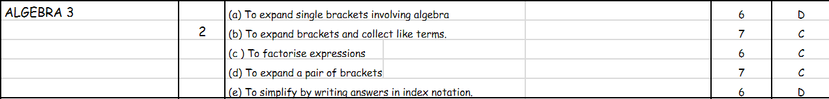
Algebra topic from the department Program of Learning.
Appendix 2
Diagnostic test.
Algebra Misconceptions Diagnostic Test

- Is the following statement true or false?
‘ x + y = xy ’

- Simplify 3y + 5x

- Add x to x + 7y

- Simplify 10x +7y -12x + 5y

- Simplify the following 10y – y

- Multiply f + 5 by 3.

- 3 (p + q) =

- Write an expression for the perimeter of the following shape.
h
h

h
h
g

p =

- What is the simplest way to write b x b x b x b x b x b?

- Which of the following can you write for the area of this rectangle? Tick as many as you see fit.
- 6 x e + 2
- 6 x (e + 2)
- 12 e
6
- 6 x e2
- 6 (e + 2)
- e + 2 x 6
e
2
- 6e + 12
- None

Appendix 3
Consent form
Participant Identification Number:

CONSENT FORM

PROJECT TITLE: Investigating Misconceptions in Algebra

Name of Researcher: Miss C Pritchard

Investigating pupils’ misconceptions in Algebra by a pre-written test on Algebra, teaching Algebra and a post-written test on Algebra.

Please initial box

1. I confirm that I have read and understand the information sheet dated for the above study. I have had the opportunity to consider the information, ask questions and have had these answered satisfactorily.

2. I understand that my participation is voluntary and that I am free to withdraw at any time, without giving any reason.

3. I understand that any information given by me may be used in future reports, articles or presentations by the research team.

4. I understand that my name will not appear in any reports, articles or presentations.

5. I agree to take part in the above study.

________________________ ________________ _____________________________
Name of Participant Date Signature
You may decline to participate in this study. You may end your participation in this study at any time. If you decide to remain anonymous, maintaining your anonymity will be a priority and every practical precaution will be taken to disguise your identity. If you prefer anonymity, there will not be any identifying information on audiotapes or transcripts of this or any interview. No-one will hear any audiotapes or see any transcripts without your prior consent. All materials generated from this or any interview will remain confidential.


Participant Identification Number:

participant INFORMATION sheet

PROJECT TITLE: Investigating Misconceptions in Algebra

Dear Participant:

My name is Miss Pritchard and I am studying in the School/Faculty of Education.

I would like to invite you to participate in my research project. This project will research misconceptions in Algebra and aims to investigate pupils’ use of misconceptions in Algebra by pre and post diagnostic tests.

Through your participation in the tests, I hope to ascertain the use of misconceptions in Algebra. All tests will be kept strictly confidential to the researchers involved and at NO time will individual tests be released to the general public. Your participation in this study is completely voluntary so you can withdraw your permission for your test data to be used for my research at any stage.

We thank you in advance for your time and participation. If any questions do arise, feel free to contact me at your convenience.

Yours Sincerely

Miss C Pritchard

Appendix 4
Misconceptions exam question.
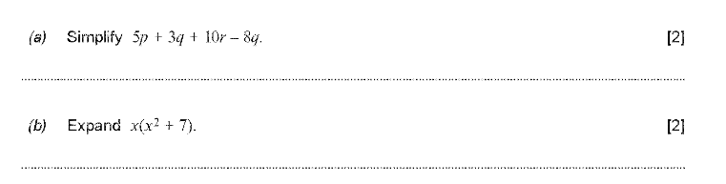
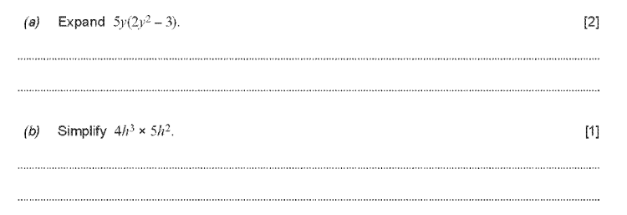
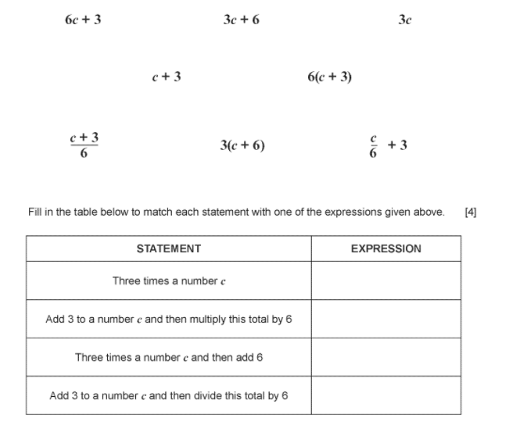
Mark the following worksheet as if you were a teacher. If there are any mistakes explain why they are wrong and how to arrive at the correct answer.
5)
4)
3)
2)
1)
Appendix 5
Topic Pack.
Slideshow
First identify what the pupils understand about variables.
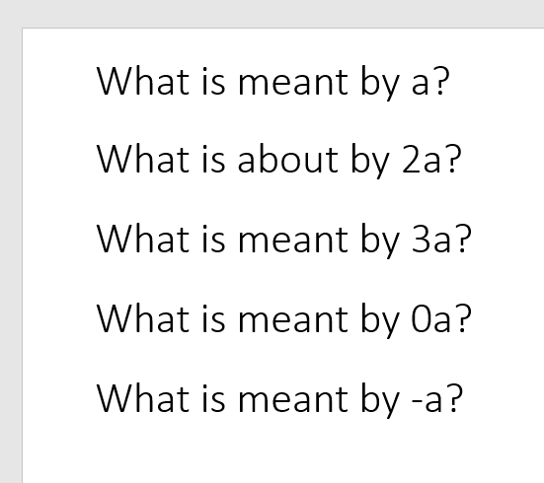
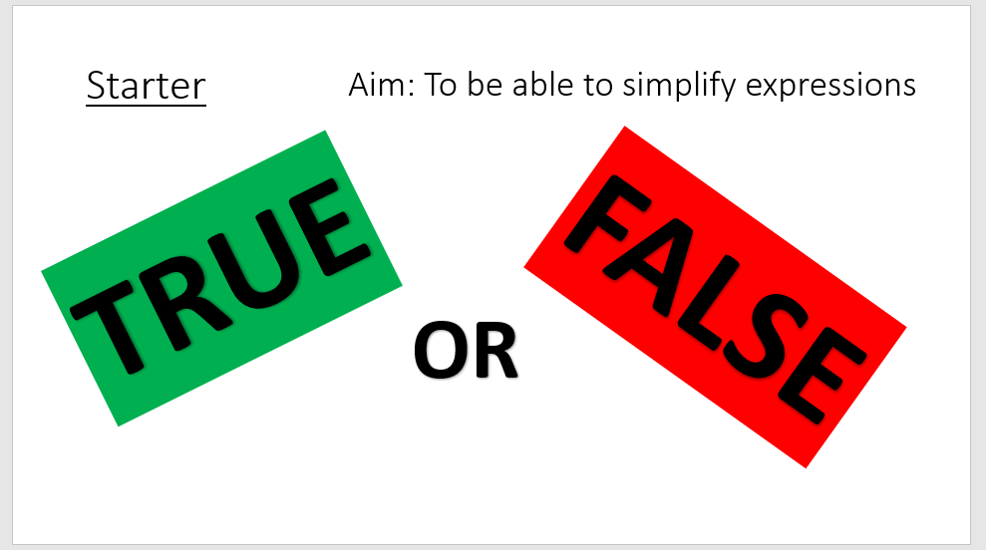
True or False questioning. This can be amended for any part of the topic, here are examples for collecting like terms.
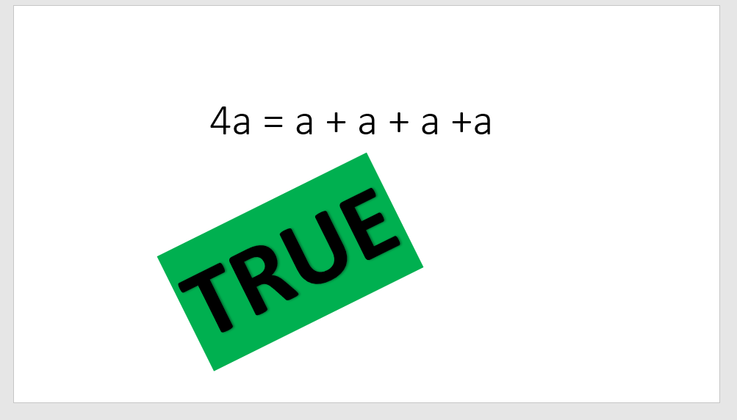
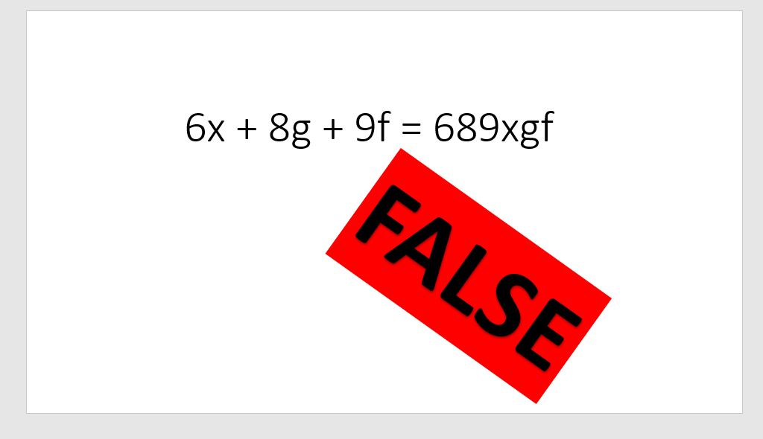
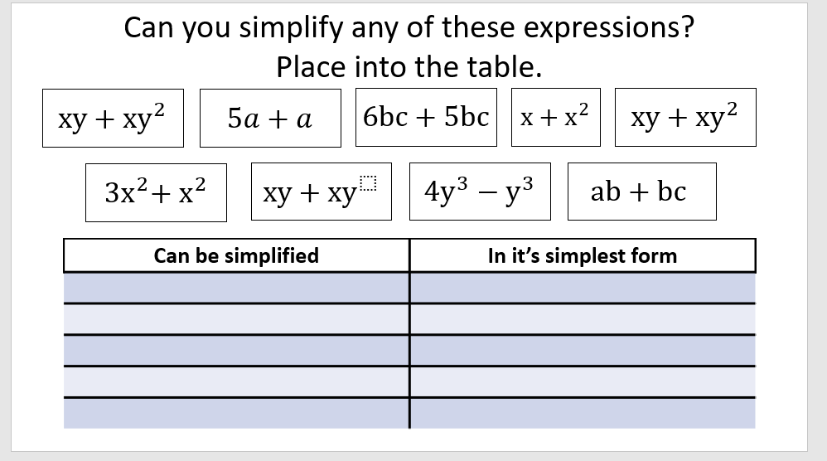
Table for sorting terms by whether they are in their simplest form.

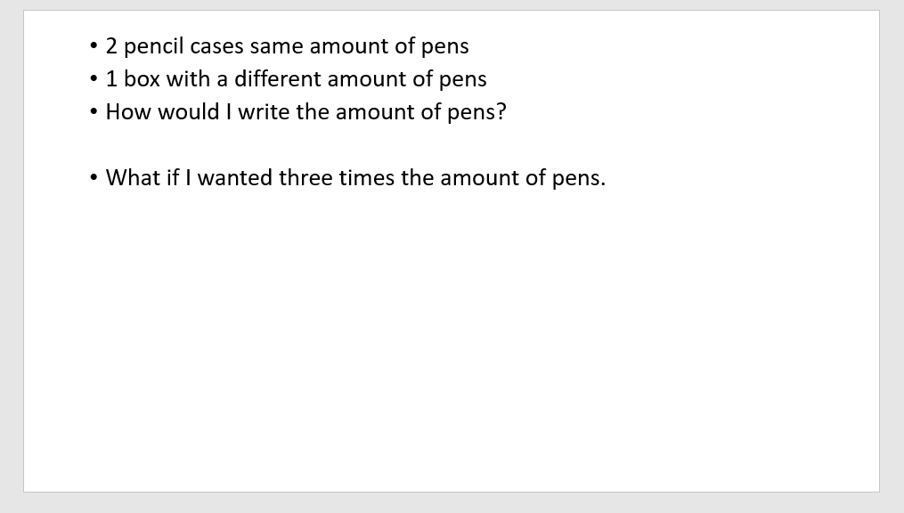
Pupils derive the rules and relationships for the use of brackets from given information.

