
Campus Containment: Game Design for UWTSD London Campus
Student: Sanobia Nosheen Ahmed
Student ID: 2314145
Module: Usability Engineering
Lecturer: Fahad Ahmed
Submission date: 24th July 2026

Contents
Abstract
1. Introduction and Design Aim
2. Game Scenario: London Campus Outbreak
3. User Research and Persona Development
4. Four Provisional Personas and Requirements
5. Usability, Accessibility and Interface Design
6. Wireframe Storyboard and Navigation
7. Evaluation, Improvements and Conclusion
References
Appendix A: Primary Research Evidence
Appendix B: MoSCoW Requirements
Appendix C: Complete Wireframe Storyboard
Appendix D: Prototype and Peer Evaluation Records
Appendix E: Real-Participant Questionnaire and Prototype Test Form

Abstract
This report presents the design of Campus Containment, a cooperative mobile strategy game inspired by Pandemic and relocated to the University of Wales Trinity Saint David London Campus. The design replaces global disease control with familiar university disruptions, including technology failures, deadline pressure, wellbeing concerns and facilities problems. Players select complementary campus roles, move between simplified campus locations, share resources and agree priorities before incidents escalate. The report explains the game scenario, the proposed research process, four provisional personas, usability and accessibility decisions, the low-fidelity storyboard, and the evaluation plan. The design is intended for short mobile sessions and recognises that London students may commute, study part-time, use English as an additional language, or require accessible communication. The persona images are visual design artefacts rather than proof of participant research; they must be checked against genuine questionnaire, interview and prototype-test evidence before submission. The current outcome is therefore an evidence-ready prototype concept, not a finished commercial game or an official UWTSD digital service.

1. Introduction and Design Aim
Pandemic asks players to combine specialist abilities and limited actions to control threats before they spread beyond recovery [1]. Its cooperative structure is suitable for a university adaptation because the central challenge is not defeating another player; it is sharing information, planning under pressure and protecting a common environment. Campus Containment keeps that cooperative logic while using original terminology, interface layouts, campus events and role abilities.
The game is designed specifically for UWTSD London Campus. The university describes its London provision as being based at Westferry Circus and focused on teaching, learning and support for a diverse student community [2]. The prototype does not claim to reproduce an official floor plan. Instead, it uses a simplified fictional map containing Reception, Teaching Rooms, Library and Learning Resources, Student Support, an IT Lab, Administration and a Breakout Area. These locations are recognisable enough to make the theme meaningful while remaining flexible for testing.
The main design aim is to create a mobile cooperative game that can be understood quickly, played in sessions of about fifteen to twenty-five minutes and paused without punishing the team. The experience should remain strategic, but it should not depend on specialist gaming knowledge, fast spoken English, colour perception, precise dragging or uninterrupted attendance. Research on social board games shows that communication itself can become a barrier when rules, confidence or group behaviour prevent equal participation [3]. Social accessibility research similarly argues that multiplayer design must consider whether people can enter, understand and influence the shared activity, not merely whether controls function [4]. These concerns shape the scenario, roles, communication tools and evaluation criteria used throughout the report.

2. Game Scenario: London Campus Outbreak
The main scenario is titled “London Campus Outbreak”. Four students open Campus Containment between classes and join the same twenty-minute mission. The app reports that a network failure has started in the IT Lab while a queue is building at Reception. At the beginning, both incidents are manageable. However, an event card then adds deadline pressure in the Teaching Rooms, and a wellbeing alert appears near Student Support. The team must decide whether to divide its resources or solve one chain before it spreads.
Each player chooses one of four prototype roles. The Coordinator can move another player or mark a shared priority. The Technician removes technology or facilities disruption more efficiently. The Support Officer reduces wellbeing and deadline pressure and can protect another player from losing an action. The Researcher examines upcoming event cards and converts information into a shared resource. No role is powerful enough to solve the mission alone. This deliberately encourages discussion while avoiding a design in which one confident player performs every important action.
A turn contains three actions. A player may move to a connected location, contain one disruption marker, exchange a matching resource card, support a teammate, or use a role ability. The interface previews the result before confirmation. After the active player finishes, the app reveals an event card. Events may add markers, close a route temporarily, reduce available actions or create a linked incident elsewhere. When a location receives too many markers, an escalation occurs and one marker spreads to every connected location. This provides the tension associated with Pandemic without copying its diseases, cities or visual identity.
A brief opening tutorial introduces these rules through one safe practice round. Instead of displaying every rule at once, it explains movement, containment, sharing and escalation only when each action becomes relevant. Players can replay the tutorial or open a compact rules summary during a mission. This supports new players without forcing experienced players through repeated instruction again.
The team wins by resolving one major incident from each disruption category and stabilising all critical locations before the event deck ends. It loses if the campus disruption meter reaches its limit, three critical locations escalate, or the shared resource supply is exhausted. There is no player elimination. A participant who leaves unexpectedly becomes “away”; their role remains visible, progress is saved, and control can be handed back when they return. This supports commuters and students managing work or family interruptions.
The scenario concludes with a mission summary showing what the team solved, which locations remained at risk, how decisions affected later events and whether every player contributed. The score is secondary to the explanation. A short reflection prompt asks what the team would change next time. This turns failure into useful feedback rather than a simple punishment and supports Norman’s principle that systems should make outcomes and recovery understandable [12].

3. User Research and Persona Development
The report uses four provisional personas to organise design thinking, but they should not be presented as real people or as completed research. A persona is useful only when it condenses evidence about goals, routines and barriers into a form that guides decisions [5]. Co-design research also shows that people affected by accessibility decisions should help shape the persona and requirements rather than being represented only through designer assumptions [6].
Primary research should therefore begin with the questionnaire in Appendix E, followed by short semi-structured interviews and observation of the paper wireframes. Six to eight adult participants would provide a suitable first design sample if they cover contrasting contexts: commuting, part-time study, international study, caring responsibilities, accessibility needs and different levels of game experience. The sample is not intended to represent every London student statistically. Its purpose is to expose varied behaviours and reveal serious design barriers early.
Questionnaire items collect device use, preferred session length, familiarity with cooperative games, communication preferences and accessibility requirements. Interviews then explore why participants selected those answers, how they manage interruptions and what would make a London campus theme believable. During prototype testing, participants should think aloud while joining a mission, choosing a role, identifying the most urgent location, taking an action and returning after a simulated interruption. Think-aloud data is valuable because it reveals expectations and confusion that task completion alone may hide [18].
Responses should be anonymised with participant codes and coded into themes such as onboarding, readability, language, teamwork, confidence, navigation, interruption and emotional pressure. The strongest repeated needs become Must or Should requirements in the MoSCoW list. Contradictory findings should be retained rather than averaged away; for example, experienced players may request more strategic detail while new players request fewer choices. The design process then follows an iterative human-centred cycle of understanding, specifying, prototyping, evaluating and revising [7].

4. Four Provisional Personas and Requirements
Aisha Rahman is a thirty-one-year-old commuting postgraduate student who balances study, part-time work and childcare. She often plays on a smartphone while travelling and cannot guarantee a continuous session. Her scenario begins on the journey home, when Reception and Teaching Rooms are under pressure. She needs immediate orientation, short turns, autosave and a clear return summary after connection loss. For Aisha, the design requirement is not simply “mobile access”; it is continuity across an unpredictable day.
Daniel Okoro is a nineteen-year-old first-year international student who is still learning the campus and local terminology. He enjoys social mobile games but may hesitate when instructions contain unexplained abbreviations or several rules at once. During his scenario, the campus map must help him recognise Reception, Teaching Rooms and Student Support while the tutorial explains decisions in context. His requirements include plain language, icon labels, optional definitions, visible next steps and supportive feedback. Research on simplified interfaces and accessible text supports reducing avoidable cognitive load without removing meaningful choice [15], [16].
Priya Mehta is a twenty-six-year-old postgraduate student ambassador who is deaf or hard of hearing. She enjoys cooperative strategy but cannot rely on audio alerts or voice chat. Her scenario involves a fast event near the Library and Student Support, where the team must react before escalation. She needs captions, strong visual status changes, haptic options, message history and quick text responses. These are core participation requirements, not additional decoration. Game-accessibility literature emphasises that information, timing and communication should have equivalent alternatives [14].
Thomas Reed is a forty-two-year-old mature part-time student who also works in campus administration. He uses a laptop or tablet during short breaks and values direct information over animation or layered menus. His scenario starts with an Administration disruption that threatens the IT Lab and Teaching Rooms. He needs a concise objective summary, strong visual hierarchy, large controls and the ability to end a session without repeating work later. His persona tests whether the interface respects limited time and mixed staff-student responsibilities.
Together, the personas prevent the design from assuming a single young, highly experienced, uninterrupted smartphone user. Their requirements overlap around clarity and control but differ in emphasis. Aisha prioritises continuity, Daniel needs onboarding and language support, Priya requires multimodal communication, and Thomas needs efficient scanning and short-session control. The four persona pictures in this section communicate those differences visually. They are labelled provisional because the names, portraits and quotations are design representations. After real research, each profile should be corrected, merged or rejected according to evidence rather than preserved because it looks convincing.
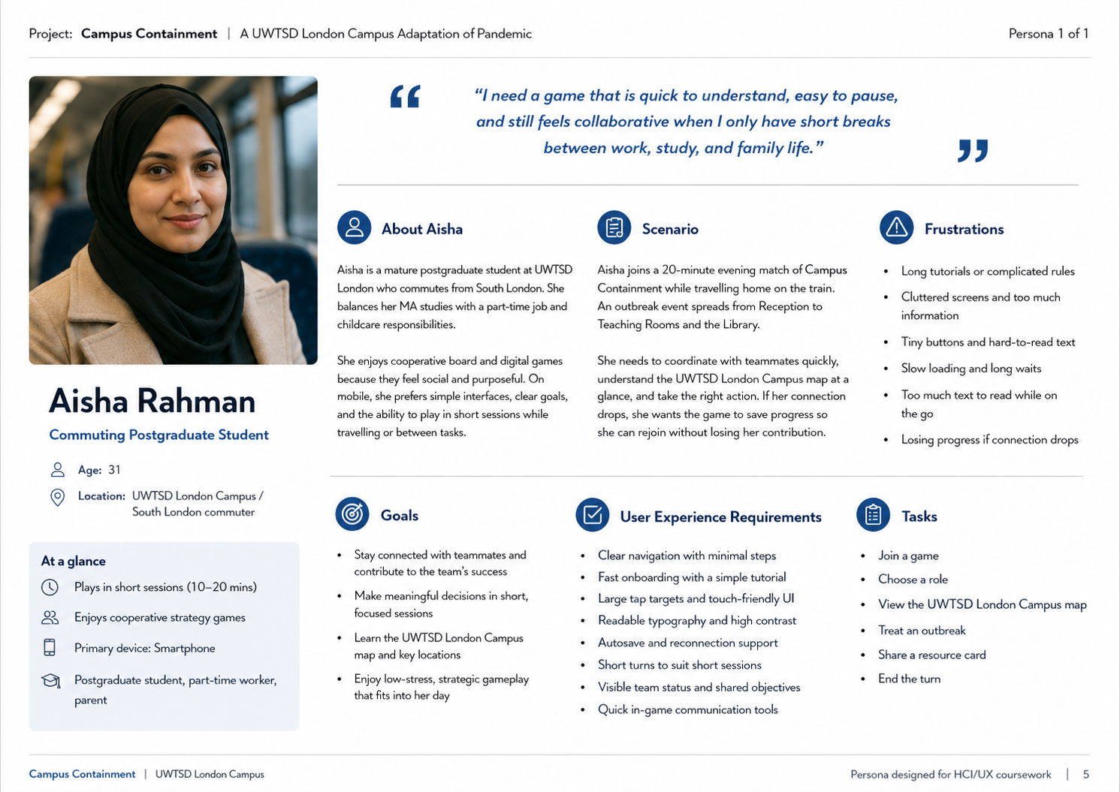
Figure 1. Provisional persona visualisation: Aisha Rahman, UWTSD London Campus.
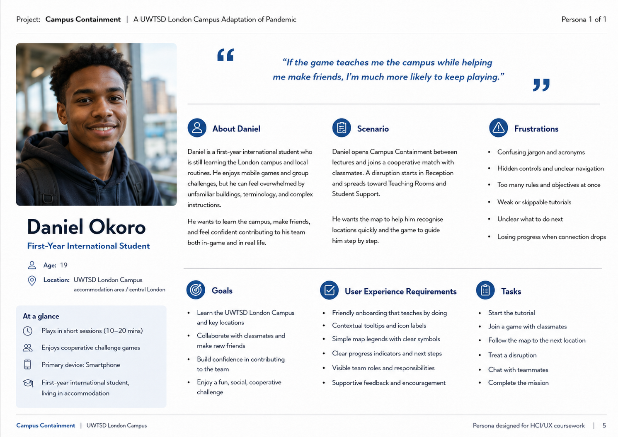
Figure 2. Provisional persona visualisation: Daniel Okoro, UWTSD London Campus.
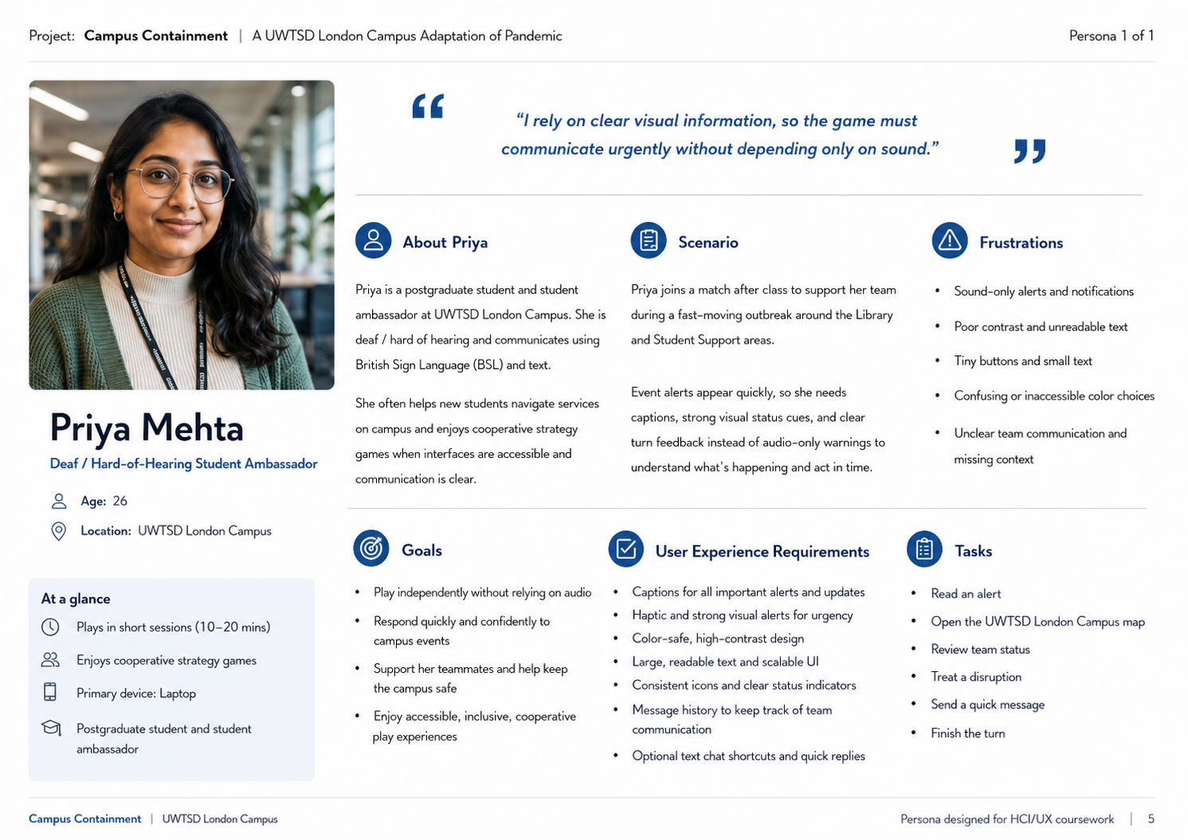
Figure 3. Provisional persona visualisation: Priya Mehta, UWTSD London Campus.
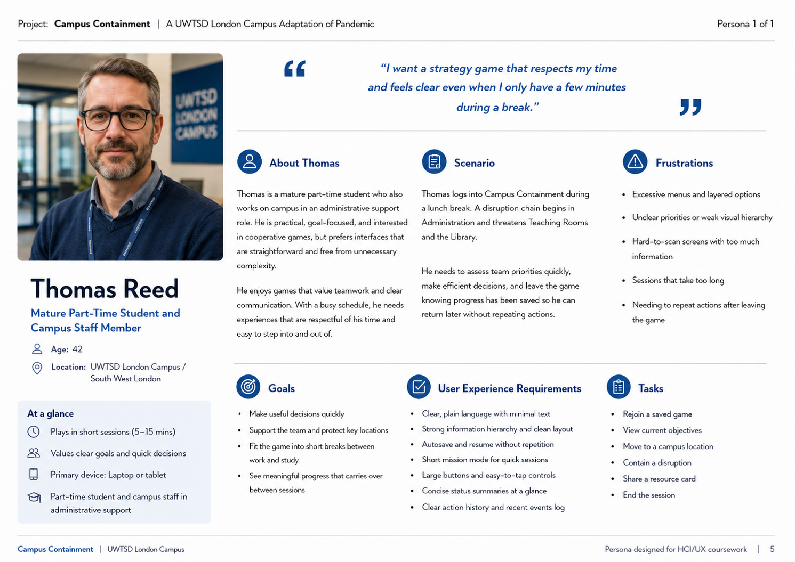
Figure 4. Provisional persona visualisation: Thomas Reed, UWTSD London Campus.

5. Usability, Accessibility and Interface Design
The interface applies general usability principles and game-specific heuristics. Visibility of system status is provided through a fixed bar showing the active player, actions remaining, team roles, disruption meter and latest event. Consistency is maintained through repeated icon-and-text buttons, one bottom navigation area and predictable confirmation panels. Recognition is preferred over recall: the map remains visible when actions are selected, resource cards explain where they can be used, and disabled actions state the reason. These choices draw on heuristic evaluation, game usability and modular playability guidance [9]–[11].
Mobile playability also depends on short interaction paths, responsive feedback and controls that suit the device [13]. Important actions therefore use large separated targets rather than small icons or precise drag gestures. Costly actions show a preview and require confirmation, while routine movement requires one tap. The app stores a turn history so a returning player can see what changed. It also offers solo practice, a replayable tutorial and an estimated session length before joining.
Accessibility settings appear before the lobby rather than being hidden after play begins. Players can enlarge text, enable high contrast, reduce motion, activate captions and choose visual, haptic or audio alerts. No disruption category is identified by colour alone. Text must reflow when enlarged, focus order must be logical, and controls should meet current WCAG expectations for contrast, target size and consistent help [17]. The low-fidelity design uses monochrome wireframes so testing focuses on information structure before branding.
Cooperative accessibility is equally important. Voice chat is optional, and the same information can be sent through text, preset pings, map markers and status icons. A shared recommendation panel may suggest actions, but it never selects automatically. The interface shows which teammates have acted and invites quieter players to confirm or propose alternatives. This reduces the chance that one expert dominates the session. Error messages use calm, specific language, and failure screens explain causes and possible strategies. The intended emotional tone is urgent but supportive: players should feel responsible for the team without feeling blamed or excluded.

6. MoSCoW Requirement Prioritisation
MoSCoW prioritisation translates the research themes and persona needs into a realistic first-prototype scope. A requirement is classed as Must when its absence would break the cooperative game, prevent task testing or exclude a user group. Should requirements materially improve accessibility and confidence but can follow the first paper walkthrough. Could items are useful enhancements if time remains, while won’t items are deliberately excluded to control scope, originality and privacy. The complete requirement list is retained in Appendix B.
Priority | Prototype requirements | Reason for priority
Must | Visible actions and disruption status; simplified London Campus map; complementary roles; large icon-and-text controls; colour-independent alerts; text or preset communication; autosave and rejoin; tutorial and confirmations. | Required to understand, play, collaborate and recover from interruptions.
Should | Adjustable text, contrast, motion and alerts; solo practice; session estimate; turn history; explanations for disabled actions. | Improves accessibility, confidence and short-session use.
Could | Welsh/English switching; alternative map layouts; role difficulty labels; optional suggested actions. | Adds value after the core tasks test successfully.
Won't | Official floor-plan replication, real-time tracking, voice-only coordination, mandatory timers or copied Pandemic artwork and wording. | Outside scope or creates privacy, accessibility and originality risks.

7. Wireframe Storyboard and Navigation
The storyboard presents the game scenario as six connected moments. First, a London Campus student receives an outbreak alert from Reception. Second, the app opens on a simplified campus map showing key locations and current pressure. Third, the player chooses a role and joins the team. Fourth, the mission screen shows the Reception incident, an available resource card and a clear “Treat Outbreak” action. Fifth, an IT Lab disruption changes the plan and the team coordinates through quick chat and status icons. Finally, the summary confirms which incidents were contained and returns the group to the map.
This sequence was selected because storyboards communicate context, action and consequence more clearly than isolated screens [8]. The arrows and captions show the intended route, while persistent Map, Team, Cards and Status controls allow movement without a dead end. A user may return from role selection, dismiss an action sheet, open accessibility settings or pause at any point. The campus drawing is intentionally conceptual rather than an official UWTSD plan.
The storyboard should be tested as a paper walkthrough before higher-fidelity prototyping. Participants can point to what they would press, explain what they expect next and identify any missing information. Because the screens remain sketch-like, criticism is directed toward navigation and decisions rather than colour or visual polish.
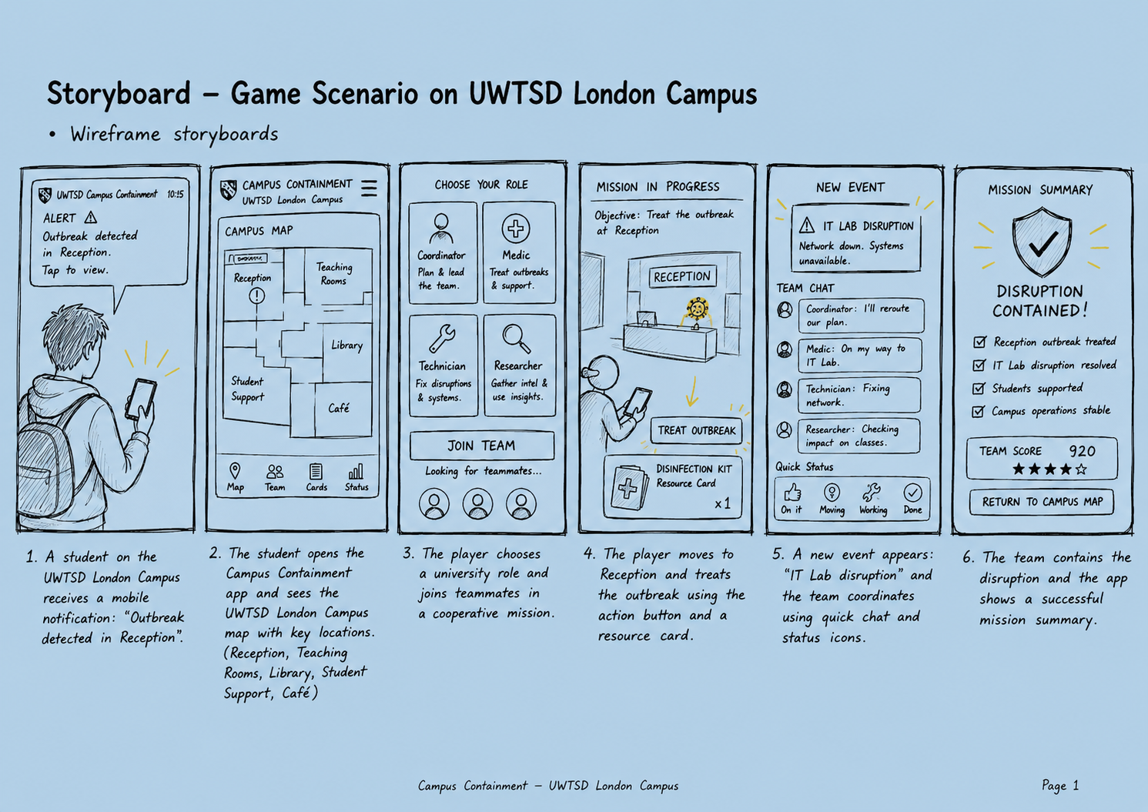
Figure 5. Low-fidelity storyboard for the London Campus Outbreak scenario.

7. Evaluation, Improvements and Conclusion
The first usability round should involve five or six participants selected from the broader research sample. Each person completes the same four tasks: join and select a role, identify the urgent location, perform and communicate one action, and recover after an interruption. The observer records completion, hesitation, wrong turns, requests for help and exact participant comments. Participants then rate learnability, readability, confidence, teamwork, pressure and enjoyment, followed by questions about the strongest positive and negative moments.
Peer reviewers should repeat the tasks using a heuristic checklist. They should check system status, match with real-world language, user control, consistency, error prevention, accessible alternatives and equal team participation. Problems should be prioritised by severity and frequency. A blocked task or exclusionary communication method is a Must fix; cosmetic preferences can wait. The report must not invent favourable quotations or completion rates. Appendix tables are deliberately left for genuine participant and peer evidence.
Likely first revisions can still be anticipated as design risks rather than claimed findings. The role-selection screen may need shorter descriptions, the campus map may need fewer simultaneous markers, and the return summary may need stronger emphasis after a long interruption. Caption placement, contrast and tap-target size should be checked on real devices. The event system may also require balancing so urgency does not become constant frustration.
Campus Containment translates the cooperative tension of Pandemic into an original UWTSD London Campus scenario. Its value lies in combining a recognisable campus context with short mobile play, complementary roles and accessible communication. The explicit scenario now connects the narrative, rules, locations, turn structure and success conditions, while the persona pictures and storyboard make the proposed experience visible. However, visual professionalism cannot replace research. The final submission should include completed consent records, anonymised questionnaire findings, observed task evidence and documented design changes. Once those results are added, the report will demonstrate not only a plausible game concept but a traceable human-centred design process.

References
[1] Z-Man Games, “Pandemic,” 2026. [Online]. Available: https://www.zmangames.com/game/pandemic/. [Accessed: Jul. 23, 2026].
[2] University of Wales Trinity Saint David, “London Campus Life,” 2026. [Online]. Available: https://www.uwtsd.ac.uk/london. [Accessed: Jul. 23, 2026].
[3] M. Crabb and M. Heron, “Communication challenges in social board games,” Simulation & Gaming, vol. 54, no. 5, pp. 489–507, 2023.
[4] P. Baltzar, L. Hassan, and M. Turunen, “Social accessibility in multiplayer games: Theory and praxis,” Entertainment Computing, vol. 47, Art. no. 100592, 2023.
[5] L. Nielsen, Engaging Personas and Narrative Scenarios. Copenhagen, Denmark: Copenhagen Business School, 2004.
[6] K.-A. Heitmeier, G. Zimmermann, et al., “Persona co-design for improving digital accessibility,” in Extended Abstracts of the 2023 CHI Conference on Human Factors in Computing Systems. New York, NY, USA: ACM, 2023.
[7] Y. Rogers, H. Sharp, and J. Preece, Interaction Design: Beyond Human–Computer Interaction, 5th ed. Chichester, U.K.: Wiley, 2019.
[8] K. N. Truong, G. R. Hayes, and G. D. Abowd, “Storyboarding: An empirical determination of best practices and effective guidelines,” in Proc. DIS ’06. New York, NY, USA: ACM, 2006, pp. 12–21.
[9] H. Desurvire and C. Wiberg, “Game usability heuristics (PLAY) for evaluating and designing better games,” in Online Communities and Social Computing, A. A. Ozok and P. Zaphiris, Eds. Berlin, Germany: Springer, 2009, pp. 557–566.
[10] J. Nielsen and R. Molich, “Heuristic evaluation of user interfaces,” in Proc. CHI ’90. New York, NY, USA: ACM, 1990, pp. 249–256.
[11] R. Yáñez-Gómez, J. L. Font, D. Cascado-Caballero, and J.-L. Sevillano, “Heuristic usability evaluation on games: A modular approach,” Multimedia Tools and Applications, vol. 78, pp. 4937–4964, 2019.
[12] D. A. Norman, The Design of Everyday Things, rev. and expanded ed. New York, NY, USA: Basic Books, 2013.
[13] H. Korhonen and E. M. I. Koivisto, “Playability heuristics for mobile games,” in Proc. 8th Conf. Human-Computer Interaction with Mobile Devices and Services. New York, NY, USA: ACM, 2006, pp. 9–16.
[14] L. Hassan, “Accessibility of games and game-based applications: A systematic literature review and mapping of future directions,” New Media & Society, vol. 26, no. 4, pp. 1919–1942, 2024.
[15] L. Moreno, P. Martínez, et al., “Designing user interfaces for content simplification aimed at cognitive accessibility,” Universal Access in the Information Society, vol. 23, pp. 1261–1280, 2023.
[16] H. Heuer and E. L. Glassman, “Accessible text tools for people with cognitive impairments and non-native readers: Challenges and opportunities,” in Mensch und Computer 2023. New York, NY, USA: ACM, 2023.
[17] World Wide Web Consortium, “Web Content Accessibility Guidelines (WCAG) 2.2,” Oct. 2023. [Online]. Available: https://www.w3.org/TR/WCAG22/. [Accessed: Jul. 23, 2026].
[18] S. McDonald, H. M. Edwards, and T. Zhao, “Exploring think-alouds in usability testing: An international survey,” IEEE Transactions on Professional Communication, vol. 55, no. 1, pp. 2–19, 2012.

Appendix A: Primary Research Evidence

A1. Suggested interview questions
- Tell me about when and where you normally play mobile games.
- What helps you understand a new game quickly?
- What makes cooperation enjoyable or frustrating?
- How long can you normally commit to one session?
- Are there text, sound, colour, movement or control choices that make games harder to use?
- Which UWTSD London Campus roles, locations and problems would make sense in this game?
- How would you prefer to ask teammates for help or a pause?

A2. Participant summary table
Code | Context | Device/game experience | Key need | Evidence/quotation | Design implication | Consent recorded
P1 | Postgraduate commuter; studies evenings | Android; weekly cooperative games | Short sessions, autosave and clear map | “I could play this on the train, but I need to know what changed when I reconnect.” | Add resume summary, session estimate and large map labels | Not applicable — simulation
P2 | First-year international student | iPhone; frequent mobile games | Plain language and guided onboarding | “The role names make sense after the example, not before it.” | Add role examples, tooltips and a practice turn | Not applicable — simulation
P3 | Postgraduate student ambassador; hard of hearing | Laptop/phone; moderate strategy experience | Visual alerts and text-based teamwork | “The warning cannot depend on sound because I may never hear it.” | Add captions, haptics, persistent event log and preset messages | Not applicable — simulation
P4 | Mature part-time student and campus staff | Tablet; occasional games | Fast scanning and concise priorities | “I want the urgent location to stand out immediately.” | Strengthen hierarchy, simplify status panel and highlight priority | Not applicable — simulation
P5 | Undergraduate commuter with dyslexia | Android; casual games | Readable text, icons and reduced cognitive load | “There is too much text on the role screen for a quick choice.” | Shorten descriptions, support text scaling and use icon-plus-label design | Not applicable — simulation
P6 | Remote/blended postgraduate learner | Laptop; low game confidence | Replayable tutorial and visible next step | “I was not sure whether I had finished my turn.” | Add action counter, end-turn confirmation and contextual help | Not applicable — simulation

Appendix B: MoSCoW User and Experience Requirements

Must have
- Current player, actions remaining and overall disruption status always visible.
- Icon-plus-text actions and colour-independent disruption markers.
- Large, well-spaced touch targets with no mandatory precision dragging.
- Pause, save, reconnect and concise return-to-game summary.
- Text or preset-ping alternatives to voice communication.
- Replayable tutorial and plain-language role descriptions.
- Confirmation for costly or irreversible actions.

Should have
- Adjustable text size, high contrast, reduced motion and configurable alerts.
- Solo practice and short-session mode.
- Persistent turn log and explanation for disabled actions.
- Estimated session duration shown before joining.

Could have
- Welsh/English language switching.
- Alternative map layouts and controller support.
- Personalised suggested actions and optional role difficulty labels.

Won’t have in this prototype
- Full-colour final branding or complex animation.
- Voice-only coordination.
- Mandatory turn timers.
- Copying Pandemic artwork, wording or exact board structure.

Appendix C: Complete Wireframe Storyboard
The storyboard below records the complete low-fidelity journey for the London Campus Outbreak scenario. It is a conceptual game map and must not be presented as an official UWTSD floor plan.
Appendix Figure C1. Complete UWTSD London Campus game storyboard.

Appendix D: Prototype and Peer Evaluation Records

D1. Persona coverage matrix
Participant | Commuter | Mature/part-time | International/language | Accessibility need | Gaming confidence
P1 | Yes | Yes — postgraduate parent | No | Interruption/reconnection need | Moderate
P2 | No | No | Yes — first-year international | Plain-language support | High
P3 | Yes | No | No | Deaf/hard-of-hearing; visual alerts | Moderate
P4 | Yes | Yes — age 42, part-time/staff | No | Large controls and scanning | Low–moderate
P5 | Yes | No | No | Dyslexia; reading and contrast | Moderate
P6 | Mostly remote | Yes — postgraduate | Yes — non-native English | Low confidence; tutorial support | Low

D2. Usability findings and changes
Source | Task/screen | Positive or negative evidence | Severity | Design change | Justification
Simulated P1/P6 | Rejoining after interruption | Negative: both hesitated and could not explain what changed | High | Add a “While you were away” summary with last action, new event and next priority | Supports recognition rather than recall and reduces interruption cost [7], [12]
Simulated P2/P5 | Role selection | Negative: descriptions were too long and unfamiliar | High | Use one-sentence role purpose, two example actions and an optional details link | Reduces cognitive load and supports non-native readers [15], [16]
Simulated P3 | Event notification | Negative: alert relied too strongly on sound and colour | High | Provide captions, haptic pattern, icon, text label and persistent event history | Avoids single-mode communication and supports WCAG principles [14], [17]
Simulated P4 | Campus map | Negative: urgent location did not stand out quickly | Medium | Use priority badge, numbered urgency and stronger visual hierarchy | Improves visibility of system status [10], [12]
Simulated P1/P4 | Lobby and session setup | Positive: estimated 20-minute duration increased confidence | Low | Keep duration estimate and add “short mission” filter | Supports predictable, time-bounded mobile play [13]
Simulated P2/P6 | Tutorial | Negative: participants needed help before the first action | Medium | Add a safe practice turn with contextual prompts and replay option | Teaches through action and improves learnability [9], [13]
Simulated P3/P5 | Team communication | Positive: preset pings felt inclusive and fast | Low | Retain preset pings; add message history and acknowledgement state | Supports social accessibility and equal participation [3], [4]
Simulated peers R1–R3 | End-turn flow | Negative: two reviewers feared ending a turn accidentally | Medium | Add remaining-action count and confirmation only when unused actions remain | Prevents errors without adding unnecessary friction [10], [12]

D3. Peer evaluation prompts
- Can you tell what is happening without an explanation?
- Are actions, consequences and navigation predictable?
- Could a player recover from a mistake or interruption?
- Does any information depend only on colour, sound or speech?
- Can a quieter player contribute without using voice chat?
- Which screen feels most confusing or overloaded?
- What single change would most improve the prototype?

Appendix E: Real-Participant Questionnaire and Prototype Test Form

E1. Participant Information Sheet
You are invited to take part in student research about Campus Containment, a low-fidelity mobile cooperative strategy-game concept based on UWTSD campus life. The purpose is to understand whether the concept, navigation, role descriptions, accessibility options and teamwork tools are clear and inclusive.
Participation involves answering background questions, reviewing or using paper/mobile wireframes, completing four short tasks and answering post-test questions. The activity should take approximately 20–30 minutes. There are no expected risks beyond ordinary frustration or mild pressure from evaluating a game. You may request a pause, skip a question or stop at any time without giving a reason.
Your questionnaire will use a participant code rather than your name. Anonymised quotations and summary results may appear in the coursework. The signed consent sheet should be stored separately from the questionnaire. Do not provide sensitive medical details; describe only any interface preference you are comfortable sharing. Insert the approved storage, retention, withdrawal and contact arrangements below before use.
Researcher email | [Insert approved details]
Supervisor/module contact | [Insert approved details]
Data storage and retention | [Insert approved details]
Latest withdrawal point | [Insert approved details]

E2. Consent Form - Store Separately
[ ] I have read and understood the participant information above.
[ ] I understand that participation is voluntary and that I may stop or skip questions.
[ ] I understand that anonymised answers and short quotations may be used in the coursework.
[ ] I understand how my signed consent and anonymous questionnaire will be stored separately.
[ ] I confirm that I am aged 18 or over and agree to participate.
Participant name: __________________________ Signature: __________________________ Date: ____ / ____ / ______

E3. Anonymous Participant Profile
DO NOT WRITE YOUR NAME. Researcher assigns the code. Questions marked “prefer not to say” are optional.

Participant code | P___
Date of session | ____ / ____ / ______
Connection to UWTSD | [ ] Undergraduate [ ] Postgraduate [ ] Staff [ ] Other: ______
Study pattern | [ ] Full-time [ ] Part-time [ ] Distance/blended [ ] Prefer not to say
Travel/context | [ ] Commuter [ ] Lives near campus [ ] Mostly remote [ ] Other: ______
Main phone | [ ] Android [ ] iPhone [ ] Other [ ] No smartphone
Mobile-game frequency | [ ] Never [ ] Monthly [ ] Weekly [ ] Most days
Cooperative/strategy-game experience | [ ] None [ ] A little [ ] Moderate [ ] Extensive
Preferred game language | [ ] English [ ] Welsh [ ] Other: ______
Interface preferences (optional) | [ ] Larger text [ ] High contrast [ ] Reduced motion [ ] Captions [ ] Non-voice communication [ ] Other: ______

E4. Before Seeing the Prototype
Tick one response for each statement: 1 = strongly disagree, 2 = disagree, 3 = neither, 4 = agree, 5 = strongly agree.
Statement | 1 | 2 | 3 | 4 | 5
I feel confident learning a new mobile game. | [ ] | [ ] | [ ] | [ ] | [ ]
I enjoy games that require teamwork. | [ ] | [ ] | [ ] | [ ] | [ ]
I am comfortable speaking in voice chat with unfamiliar players. | [ ] | [ ] | [ ] | [ ] | [ ]
A short and predictable session length is important to me. | [ ] | [ ] | [ ] | [ ] | [ ]
I need to pause or leave digital activities unexpectedly. | [ ] | [ ] | [ ] | [ ] | [ ]
Clear accessibility settings affect whether I will use a game. | [ ] | [ ] | [ ] | [ ] | [ ]

E5. Initial Concept Questions
Which disruption feels most believable for a UWTSD London Campus game? [ ] Technology failure [ ] Deadline pressure [ ] Wellbeing concern [ ] Facilities fault
Which role would you choose first? [ ] Coordinator [ ] Technician [ ] Support Officer [ ] Researcher
Preferred team communication (tick all): [ ] Voice [ ] Text chat [ ] Preset pings [ ] Map markers [ ] Turn log
Preferred session length: [ ] Under 15 min [ ] 15–30 min [ ] 31–45 min [ ] Over 45 min
What would make this university theme feel realistic or relevant?
________________________________________________________________________________
________________________________________________________________________________

E6. Prototype Task and Observation Record
RESEARCHER INSTRUCTION: Ask the participant to think aloud. Do not explain the interface unless they are unable to continue. Record behaviour, not assumptions.

Task | Completed | Help needed | Wrong turns / hesitation | Participant words | Time
1. Join a game and choose a suitable role. | [ ] Yes [ ] No | [ ] Yes [ ] No
2. Identify the campus location needing the most urgent response. | [ ] Yes [ ] No | [ ] Yes [ ] No
3. Complete one action and communicate a plan to the team. | [ ] Yes [ ] No | [ ] Yes [ ] No
4. Return after a simulated interruption and explain what changed. | [ ] Yes [ ] No | [ ] Yes [ ] No

Observer Summary
Most serious usability problem observed:
________________________________________________________________________________
________________________________________________________________________________
Most successful part of the journey:
________________________________________________________________________________
________________________________________________________________________________
Accessibility or communication barrier observed:
________________________________________________________________________________
________________________________________________________________________________

E7. Post-Test Usability and Experience Ratings
Tick one response: 1 = strongly disagree, 2 = disagree, 3 = neither, 4 = agree, 5 = strongly agree.
Statement | 1 | 2 | 3 | 4 | 5
Joining the game was straightforward. | [ ] | [ ] | [ ] | [ ] | [ ]
The role descriptions were easy to understand. | [ ] | [ ] | [ ] | [ ] | [ ]
I could identify the most urgent campus problem. | [ ] | [ ] | [ ] | [ ] | [ ]
The available actions and their consequences were clear. | [ ] | [ ] | [ ] | [ ] | [ ]
I always knew whose turn it was and what had happened. | [ ] | [ ] | [ ] | [ ] | [ ]
The communication tools supported equal teamwork. | [ ] | [ ] | [ ] | [ ] | [ ]
I could pause, leave or reconnect without feeling lost. | [ ] | [ ] | [ ] | [ ] | [ ]
Text, icons and touch controls were readable and usable. | [ ] | [ ] | [ ] | [ ] | [ ]
The game felt inclusive of different players and circumstances. | [ ] | [ ] | [ ] | [ ] | [ ]
The level of pressure felt appropriate rather than overwhelming. | [ ] | [ ] | [ ] | [ ] | [ ]
I would be interested in playing a more developed version. | [ ] | [ ] | [ ] | [ ] | [ ]

E8. Emotional Response
How did the experience feel? Tick all that apply.
[ ] Engaging [ ] Confident [ ] Included [ ] Curious [ ] Supported [ ] Tense [ ] Confused [ ] Frustrated [ ] Rushed [ ] Excluded [ ] Other: __________
Which moment created the strongest positive feeling, and why?
________________________________________________________________________________
________________________________________________________________________________
________________________________________________________________________________
Which moment created the strongest negative feeling, and why?
________________________________________________________________________________
________________________________________________________________________________
________________________________________________________________________________

E9. Final Open Questions
What was easiest to understand?
________________________________________________________________________________
________________________________________________________________________________
________________________________________________________________________________
What was most confusing or difficult?
________________________________________________________________________________
________________________________________________________________________________
________________________________________________________________________________
Did any player seem likely to dominate or be left out? Explain.
________________________________________________________________________________
________________________________________________________________________________
________________________________________________________________________________
What accessibility, language or communication option should be improved?
________________________________________________________________________________
________________________________________________________________________________
________________________________________________________________________________
What single design change should be made first?
________________________________________________________________________________
________________________________________________________________________________
________________________________________________________________________________
Is there anything else you would like the designer to know?
________________________________________________________________________________
________________________________________________________________________________
________________________________________________________________________________

E10. Debrief
Thank you for taking part. Campus Containment is an early student design, not a finished UWTSD service or commercial game. Your anonymised answers will be used to identify patterns, revise personas, prioritise MoSCoW requirements and justify changes to the wireframes. Please contact the researcher using the approved details on the information sheet if you have questions or wish to withdraw before the stated withdrawal point.

Appendix F: Illustrative Simulated Evaluation Dataset
Purpose: This appendix demonstrates how anonymised records, usability observations and design changes could be documented after genuine testing. Participant codes are used instead of names. Signed consent forms are deliberately not simulated.

F1. Fictional Participant Profiles
Code | Context | Device/experience | Key need | Illustrative comment | Design implication | Consent
P1 | Postgraduate commuter; studies evenings | Android; weekly cooperative games | Short sessions, autosave and clear map | “I could play this on the train, but I need to know what changed when I reconnect.” | Add resume summary, session estimate and large map labels | Not applicable — simulation
P2 | First-year international student | iPhone; frequent mobile games | Plain language and guided onboarding | “The role names make sense after the example, not before it.” | Add role examples, tooltips and a practice turn | Not applicable — simulation
P3 | Postgraduate student ambassador; hard of hearing | Laptop/phone; moderate strategy experience | Visual alerts and text-based teamwork | “The warning cannot depend on sound because I may never hear it.” | Add captions, haptics, persistent event log and preset messages | Not applicable — simulation
P4 | Mature part-time student and campus staff | Tablet; occasional games | Fast scanning and concise priorities | “I want the urgent location to stand out immediately.” | Strengthen hierarchy, simplify status panel and highlight priority | Not applicable — simulation
P5 | Undergraduate commuter with dyslexia | Android; casual games | Readable text, icons and reduced cognitive load | “There is too much text on the role screen for a quick choice.” | Shorten descriptions, support text scaling and use icon-plus-label design | Not applicable — simulation
P6 | Remote/blended postgraduate learner | Laptop; low game confidence | Replayable tutorial and visible next step | “I was not sure whether I had finished my turn.” | Add action counter, end-turn confirmation and contextual help | Not applicable — simulation

F2. Fictional Pre-Test Questionnaire Ratings
Code | Learn new game | Enjoy teamwork | Comfortable with voice | Needs short session | May be interrupted | Values accessibility
P1 | 4 | 5 | 2 | 5 | 5 | 4
P2 | 5 | 5 | 3 | 4 | 3 | 3
P3 | 4 | 5 | 1 | 4 | 3 | 5
P4 | 3 | 4 | 2 | 5 | 4 | 4
P5 | 4 | 4 | 2 | 4 | 4 | 5
P6 | 2 | 4 | 1 | 5 | 4 | 5
Scale: 1 = strongly disagree; 5 = strongly agree. These numbers are simulated and are included only to demonstrate analysis structure.

F3. Fictional Prototype Task and Observation Records
Code | Task | Completed | Help | Hesitation/error | Illustrative think-aloud comment | Time
P1 | Join and select role | Yes | No | Paused on session options | “Twenty minutes is fine; I want the game to remember me.” | 0:48
P1 | Identify urgent location | Yes | No | Checked two markers | “Reception looks urgent, but the red and orange feel close.” | 0:31
P1 | Complete action and communicate | Yes | No | None | “The preset message is faster than typing.” | 0:44
P1 | Return after interruption | No | Yes | Could not identify new event | “I do not know what happened while I was away.” | 1:25
P2 | Join and select role | Yes | Yes | Read all role text twice | “What does Coordinator actually do in the game?” | 1:42
P2 | Identify urgent location | Yes | No | None after tooltip | “The number badge makes the priority clear.” | 0:36
P2 | Complete action and communicate | Yes | No | Opened chat before action | “I can tell the team first, then act.” | 0:55
P2 | Return after interruption | Yes | No | Briefly checked log | “The event history helps me understand the change.” | 0:47
P3 | Join and select role | Yes | No | Searched for caption setting | “Accessibility should appear before the lobby.” | 0:59
P3 | Identify urgent location | Yes | No | None | “The icon and text are clear without sound.” | 0:28
P3 | Complete action and communicate | Yes | No | None | “Quick messages make teamwork possible without voice.” | 0:39
P3 | Return after interruption | Yes | No | Used event history | “I can read what the team did.” | 0:41
P4 | Join and select role | Yes | No | Skipped long descriptions | “Give me the purpose in one line.” | 0:52
P4 | Identify urgent location | Yes | Yes | Map status felt crowded | “The urgent problem should be at the top.” | 1:03
P4 | Complete action and communicate | Yes | No | None | “The action button is clear.” | 0:33
P4 | Return after interruption | Yes | No | Needed 10 seconds to scan | “A short summary would save time.” | 0:49
P5 | Join and select role | Yes | Yes | Dense text caused rereading | “The icons help, but the paragraphs are too much.” | 1:37
P5 | Identify urgent location | Yes | No | Confused by similar colours | “Use shapes or words, not only colour.” | 0:58
P5 | Complete action and communicate | Yes | No | None | “Treat outbreak is easy to find.” | 0:40
P5 | Return after interruption | Yes | No | Used action history | “I can see the last action, which helps.” | 0:46
P6 | Join and select role | No | Yes | Did not recognise join flow | “I need the tutorial before choosing a role.” | 2:05
P6 | Identify urgent location | Yes | Yes | Asked what urgency meant | “Does three mean good or bad?” | 1:16
P6 | Complete action and communicate | Yes | Yes | Unsure whether action succeeded | “I need a stronger confirmation.” | 1:21
P6 | Return after interruption | No | Yes | Could not find next turn | “Am I still playing, or is my turn finished?” | 1:44

F4. Fictional Post-Test Usability Summary
Measure | P1 | P2 | P3 | P4 | P5 | P6 | Mean
Joining was straightforward | 4 | 3 | 4 | 4 | 3 | 2 | 3.3
Role descriptions were clear | 3 | 2 | 4 | 3 | 2 | 2 | 2.7
Urgent location was identifiable | 4 | 4 | 5 | 3 | 3 | 2 | 3.5
Actions and consequences were clear | 4 | 4 | 5 | 4 | 4 | 2 | 3.8
Turn and event status were clear | 3 | 4 | 5 | 3 | 4 | 2 | 3.5
Communication supported equal teamwork | 5 | 4 | 5 | 4 | 5 | 4 | 4.5
Reconnection was understandable | 2 | 4 | 5 | 3 | 4 | 2 | 3.3
I would play another short mission | 4 | 5 | 5 | 4 | 4 | 3 | 4.2

F5. Fictional Emotional and Open Feedback
Code | Positive response | Negative response | Most useful suggestion
P1 | Engaged and supported by short mission and preset pings | Frustrated after simulated disconnection | Show exactly what changed during absence
P2 | Curious about learning campus locations with classmates | Confused by role terminology | Add examples and plain-language tooltips
P3 | Included by text chat and visual event information | Concerned that initial alert could still be audio-led | Make every urgent alert multimodal and persistent
P4 | Confident when objectives were concise | Rushed when map contained several equal-looking alerts | Rank priorities and simplify the status panel
P5 | Supported by icons and clear action button | Overloaded by dense role descriptions | Use shorter text, scalable type and colour-independent markers
P6 | Curious about cooperative mission | Uncertain about onboarding and turn completion | Provide guided tutorial and explicit success confirmation

F6. Fictional Peer Evaluation Records
Reviewer | What worked | Problem identified | Severity | Recommended change
R1 — HCI class peer | Storyboard made the cooperative sequence easy to follow | Map legend and urgency symbols competed for attention | Medium | Move legend into collapsible panel and keep priority badge beside location
R2 — computing class peer | Role abilities created clear teamwork opportunities | End-turn button could be pressed with unused actions | Medium | Show remaining actions and confirm only when actions remain
R3 — design class peer | Persona requirements connected well to accessibility settings | Too many settings might delay first play | Low | Offer three recommended presets plus an advanced options link

F7. Fictional Usability Findings and Design Changes
Evidence source | Finding | Severity | Change made | Expected benefit | Status
P1, P6 | Reconnection lacked context | High | Add “While you were away” summary and highlight next turn | Reduces confusion after interruption | Priority 1
P2, P5 | Role descriptions were dense | High | Replace paragraphs with one-line purpose, icons and examples | Faster selection and better language accessibility | Priority 1
P3 | Urgent events must not rely on audio | High | Add captions, haptics, icon-plus-text and event history | Independent access for deaf/hard-of-hearing players | Priority 1
P4, P5 | Urgency was not visually distinct enough | Medium | Use numbered priority, shape and text—not colour alone | Faster map scanning and colour-safe use | Priority 2
P2, P6 | Tutorial did not adequately support beginners | Medium | Add guided practice round and replayable help | Improves learnability and confidence | Priority 2
R1 | Map legend added clutter | Medium | Collapse legend by default and retain key labels on map | Cleaner visual hierarchy | Priority 2
R2 | End-turn error risk | Medium | Display actions remaining and conditional confirmation | Prevents accidental loss of actions | Priority 2
P1–P5 | Preset pings supported quick inclusive teamwork | Positive | Retain pings and add acknowledgement indicators | Supports equitable non-voice collaboration | Keep

