

Name: Maria Nawaz
Student Number: 2521133
Module Code: LCHS4003
Module Title: Introduction to Health and Social Care
Lecturer: Dr Helen Parsons

1: EXPLANATION OF THE SERVICE
Definition: Community pharmacy services are a fundamental component of primary care within the UK’s National Health Service (NHS). They operate as the most accessible healthcare environment on the high street, providing professional clinical advice and health evaluation without requiring an appointment.
Core Scope and Purpose:
Medicines Management: Ensuring the safe, legal, and clinically appropriate dispensing of prescribed medications to the public.
Public Health Interventions: Providing essential preventive services such as emergency contraception, smoking cessation support, and national vaccination programs (e.g., Seasonal Flu and COVID-19 jabs).
Inter-professional Partnership Working: Pharmacies bridge the critical gap between General Practices (GPs), acute hospital discharge teams, and social care providers. Through accurate electronic record-keeping, they ensure seamless continuity of care and medication safety for vulnerable patients.
COMMUNITY PHARMACY SERVICES IN THE UK
2: A BRIEF HISTORY OF THE SERVICE
Pre-NHS Era (Before 1948): Before the establishment of nationalized healthcare, pharmacy services were strictly commercial, private enterprises. Patients had to pay out-of-pocket for consultations and remedies, which made essential medicines inaccessible to lower-income communities.
The 1948 Transition: With the launch of the NHS on July 5, 1948, private-sector pharmacists were contracted into the state-funded system under independent contractor frameworks. This marked a historic shift, introducing free dispensing services across the UK.
Evolution from Dispensing to Clinical Care
Traditional Role: In 1948, the pharmacist’s job was mostly technical chemists spent their time compounding formulas and working behind the closed counter.
The Clinical Shift (1980s–2000s): Over the decades, manufacturing moved to pharmaceutical factories, allowing pharmacists to take on a greater role in direct patient care and clinical services. The introduction of the New Medicine Service (NMS) and clinical service contracts officially shifted pharmacy funding to reward health outcomes rather than just prescription volumes.

3: CURRENT FUNCTIONING OF THE SERVICE
Today, community pharmacies are no longer just "chemists"; they function as urgent care walk-in hubs that optimize primary care capacity.
1. The "Pharmacy First" Initiative

Designed to alleviate pressure on general practices, the Pharmacy First scheme empowers community pharmacists to evaluate, diagnose, and directly provide prescription-only medications via Patient Group Directions (PGDs) for seven routine conditions:
Conditions:
- Sinusitis
- Sore throat
- Acute otitis media (earache)
- Infected insect bites
- Impetigo
- Shingles
- Uncomplicated female UTIs
2. Autonomous Prescribing & Digital Infrastructure
Modern pharmacists utilize the Electronic Prescription Service (EPS) and have direct access to Summary Care Records (SCR) to securely update patient histories. Furthermore, newly qualified pharmacists register with Independent Prescriber status, enabling them to safely prescribe medications autonomously without a GP's sign-off.
CONTEMPORARY CHALLENGES (Two Major Challenges)
Challenge 1: Severe Medicine Shortages & Supply Chain Disruptions
The Issue: Global manufacturing bottlenecks, geopolitical instability, and regulatory frictions following Brexit have caused severe shortages of everyday medications (such as HRT, antibiotics, and ADHD treatments).
Impact on Health & Social Care: Pharmacists spend hours every day sourcing alternative medications. This administrative strain causes significant delays in patient care and increases stress and anxiety for patients and staff alike.
Challenge 2: Workforce Burnout & Funding Pressures
The Issue: The rapid expansion of clinical services (like Pharmacy First) has been implemented during a period of rising operational costs and real-terms funding cuts.
Impact on Health & Social Care: Pharmacy teams face extreme workloads without protected learning time (PLT) for staff training. This chronic pressure has led to widespread workforce burnout, recruitment crises, and the permanent closure of numerous community pharmacies, leaving some communities without local access.
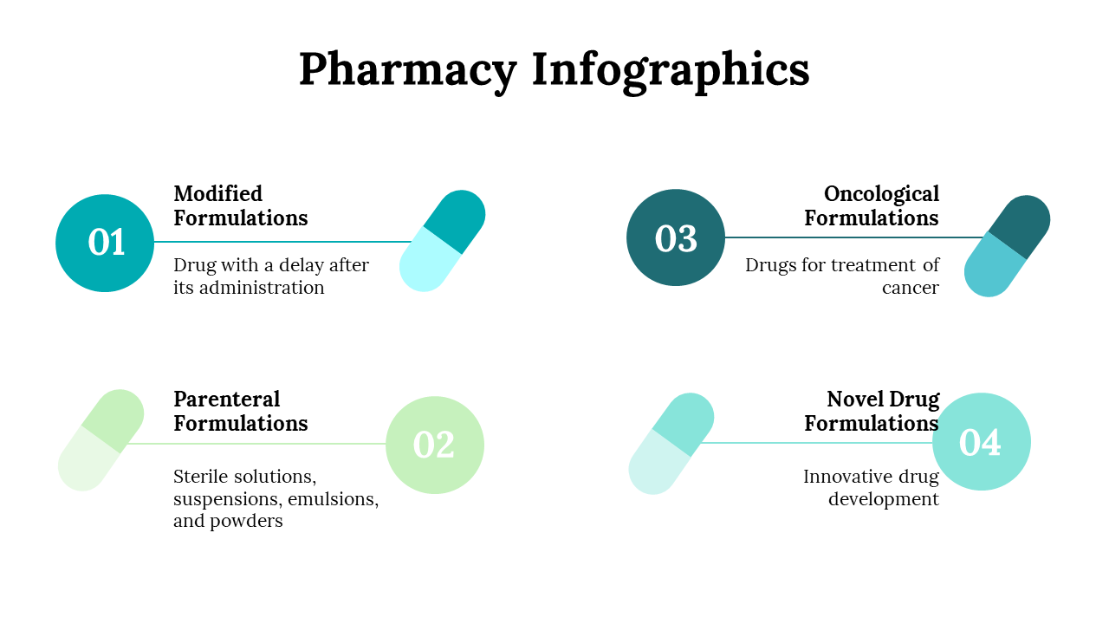
5: SUMMARY & DATA COMPARISON

Modern Challenge | Core Systemic Consequence
Global Drug Shortages | Delays in treating infections; high administrative burden.
Workforce Burnout | Staff attrition, recruitment gaps, and local pharmacy closures

REFERENCES
- Healthwatch (2025) One year on: How is Pharmacy First working for patients? London: Healthwatch England.
- NHS England (2024) Pharmacy First: Service Specification and Clinical Pathways. London: NHS England.
- Paloumpi, E., Ozieranski, P., Watson, M. C. and Jones, M. D. (2023) 'Professional stakeholders’ expectations for the future of community pharmacy practice in England: a qualitative study', BMJ Open, 13(10), p. e075069.
- Pharmaceutical Journal (2018) NHS70: Major moments in pharmacy 1948–2018. Available at: https://pharmaceutical-journal.com (Accessed: 18 June 2026).

Task 2: Essay
Community Mental Health Services
Introduction
Community mental health services in the United Kingdom play a pivotal role in treating adults with severe mental illnesses (SMI) as close to home as possible. (NHS England, 2019). The transition from institutionalised asylum care to integrated community networks represents a profound paradigm shift in health and social care. (Burns, 2022). This essay explores the historical trajectory of these services, critically evaluates their current operational landscape, and highlights their profound impact on enhancing service users' quality of life.

Historical Context and Origins
Historically, individuals experiencing mental health issues were marginalized and housed in austere Victorian asylums. (Burns, 2022). These large institutions, which peaked at over 150,000 inpatients in the mid-1950s, isolated patients from their families and communities. The first real shift toward community care began with the Mental Treatment Act 1930, which permitted voluntary hospital admissions and initiated early outpatient clinics. (Burns, 2022).
However, the modern era of community-based services was truly catalysed by the Mental Health Act 1959 and Health Minister Enoch Powell’s landmark 1961 "Water Towers" speech, which explicitly called for the closure of Victorian asylums. The clinical advent of anti-psychotic medications, alongside a growing social awareness of human rights, drove successive governments to legally mandate local authority care, gradually replacing institutional beds with localized support.
(Burns, 2022)

Critical Evaluation of Modern Functioning
Today, modern services operate under the NHS Community Mental Health Framework, delivering care through Integrated Care Systems (ICSs) and multi-disciplinary Community Mental Health Teams (CMHTs). (NHS England, 2019). These teams pool the expertise of social workers, psychiatrists, and occupational therapists to manage conditions like psychosis and severe depression within neighbourhood settings. (Rethink Mental Illness, 2024)
While the framework’s vision of trauma-informed, person-cantered care is highly progressive, its contemporary execution faces critical scrutiny. A parliamentary review highlighted that implementation remains highly uneven across the UK. Services struggle with long waiting lists and rigid access thresholds, which frequently mean users only receive attention once they reach a crisis point. (Parliament UK, 2025). Furthermore, national data reveals that only 48% of service users rate their experience positively, exposing ongoing shortages in funding and staffing despite recent government investment pledges. (Nuffield Trust, 2024).

Significance in Enhancing Quality of Life
Despite systemic pressures, community care remains vital for enhancing service users' quality of life (Rethink Mental Illness, 2024). Prolonged hospitalization historically stripped individuals of their daily living skills, relationships, and employment (Burns, 2022). Conversely, managing illnesses within the community preserves independence, allowing service users to retain control over their routines and maintain essential support networks. (Rethink Mental Illness, 2024)
Modern community provisions utilize holistic interventions such as Individual Placement and Support (IPS), which actively assists individuals with SMI in securing paid employment. Furthermore, because adults with severe mental illness face premature mortality primarily due to preventable physical health issues, CMHTs now coordinate mandatory physical health checks alongside psychological therapies. (NHS England, 2024). By looking at the "whole person" rather than just treating a psychiatric diagnosis, these services combat social isolation, lower re-admission rates, and promote long-term recovery.

Conclusion
Community mental health services have successfully dismantled the isolated asylum model, shifting focus toward localized, humane treatment. Although modern delivery is frequently challenged by chronic wait times and inconsistent resource allocation, the service remains foundational to social care. Its ability to treat individuals holistically while safeguarding their independence is ultimately irreplaceable in restoring dignity and improving the quality of life for vulnerable citizens.

Reference
Burns, T. (2022) 'Community-Based Mental Health Care in Britain', Consortium Psychiatricum, 3(1), pp. 63-71.
NHS England (2019) The Community Mental Health Framework for Adults and Older Adults. London: NHS England.
NHS England (2024) Community Mental Health Services. Available at: https://www.england.nhs.uk/mental-health/adults/cmhs/ (Accessed: 18 June 2026).
Nuffield Trust (2024) Service users' experience of community mental health services. Available at: https://www.nuffieldtrust.org.uk/resource/service-users-experience-of-community-mental-health-services (Accessed: 18 June 2026).
Parliament UK (2025) Community Mental Health Services: Health and Social Care Committee Report. London: House of Commons.
Rethink Mental Illness (2024) NHS Mental Health Teams: Community, crisis, and early intervention support. Available at: https://www.rethink.org (Accessed: 18 June 2026).

