Economics of Sustainability - The Vaping Industry

BMSP6007

Zoe Vaughan
2015102

Introduction

Due to new laws in the tobacco industry, it has encouraged the invention of a "healthier" alternative to smoking with the creation of e-cigarettes. An electronic cigarette and vaporiser that contains nicotine consumed through smoking, the pen heats up and uses electronic battery power that heats and releases the vapour when inhaled. The U.K. market for e-cigarettes and vaporisers is valued at a whopping $3.67 billion, and its market revenue in Europe is $9.37 billion. Its annual revenue growth in the U.K. in the E-cigarette market is 7.7%. (Statista, 2023).
E-Cigarettes were introduced in 2004, a new way of inhaling nicotine. The e-cigarette comprises a power source, a heating element, and a liquid vaporisation department. It is a nicotine vapour, considered a healthier alternative than smoking cigarettes or tobacco. However, the vape liquid has toxins and traces of nicotine (different nicotine strengths), enabling an addiction. As a result, vaping has become popular worldwide, although it is not FDA-approved. (Drummond et al., 2014).
Smoking replacements such as inhalers, vaporisers, and e-cigarettes have a sales value of 157 million pounds in 2021 of over-the-counter smoking aids. (Mikulic, 2023).

This essay will examine the solutions to address the negative externalities of consumption of the vaping industry and analyse how effective these methods are.

Market Failure of the Vaping Industry

Director of clinical research at the Johns Hopkins Ciccarone Center for the Prevention of Heart Disease, Michael Blaha, stated that in 2020, there was an outbreak of deaths caused by vaping. In addition, research has recently indicated that vaping is, in fact, bad for consumers' lungs and hearts: being linked to chronic heart disease and asthma. The younger generation has also become addicted to nicotine from using vaporisers. (Blaha, 2022).
In 2021, 1 in 14 adults vape in England, with results showing 7.8% of young vapours use disposable vapes, although statistics show that in 2023 there are over 50% of disposable vapes are being used and disposed of in the landfill. (Richards, 2023).
The dangers and health risks regarding vaping are questionable. Although deemed safer than tobacco and cigarettes with no trace of harmful tobacco, carbon monoxide or tar present; however, it stated there are other risks. Symptoms such as nosebleeds, headaches, sore throats and much more have been reported as a cause of vaping. (Richards, 2023).
The Food and Drug Administration has not approved these smoking cessation devices as smoking alternatives. (Blaha, 2022).
In 2022 in England, an article by L.B.C. News (2023) released figures obtained by L.B.C. from N.H.S. Digital, stating that 32 patients under 18 were admitted to hospitals with vaping-related disorders. (Fraser, 2023).
An online article, 'Centres for Disease Control and Prevention' (2020), released hospital admissions statistics stating figures had increased in August and September 2019 due to vaping and the use of e-cigarettes. In February 2020, 2,807 people were hospitalised in the U.S. with lung injuries from vaping.
Sixty-eight deaths were reported in over 29 states in February 2020, and the hospitalised people aged between 15 -75 years old. In addition, 15% were under 18, 37% were 18-24, 24% were 25–34-year-olds, and 24% were aged 35+. (Centres for Disease Control and Prevention, 2019).

There have also been reports of e-cigarettes and vapes overheating and blowing up when inhaled. According to an article by CNN Health (2019), a vaporiser blew up in a teenager's face shattering his jaw. In 2018, over 2,000 reports of explosions and injuries from vapes were recorded from 2015-2017 in the U.S. There have also been two deaths in Florida and Texas from e-cigarette explosions. (Azad, 2019).

A study highlights if e-cigarettes are a replacement for nicotine therapy. Sixteen different e-cigarettes stated a total nicotine level in 15 puffs of a vaporiser generated by a smoking machine revealed a level of nicotine ranging from 0.5 MG – 15.4MG. Although when one cigarette is smoked, the results showed 1.54MG – 2.60 MG.
These results show that vaping has a lower potential nicotine intake but also has a higher nicotine intake than cigarettes. In 2009, F.D.A. promoted a warning that e-cigarettes may be dangerous for health when toxic compounds such as Nitrosamines and Diethylene glycol was detected in two brands of an e-cigarette that are commercially available to buy. Other recent studies have also stated that one nicotine inhaler and 12 different brands of e-cigarette's findings also presented 40 toxic compounds and carcinogens. (Drummond et al., 2014).
A carcinogen is a substance that may cause cancer in living tissue. (Hutter, 2023).

Vapour from e-cigarettes contains potentially harmful compounds stating there are higher levels in e-cigarettes than in actual smoking tobacco. Four carbonyl and two organic compounds were also detected in vapour and heavy metals such as cadmium fumes, nickel, and lead. Data suggest that although e-cigarettes are a healthier alternative than tobacco, the data doesn't predict long-term cancers with the risks of exposure to carcinogens. (Drummond et al., 2014).

The health section of B.B.C. News offers teachers and A-level economists an opportunity to investigate the economist analysis and policy to address market failure regarding vaping. (Richards, 2023).
Consumer behaviour shows figures from 2013-2022; 22% of adults in the U.K. use e-cigarettes, doubling since 2013. (Gelder, 2022). In 2022, data showed that 20.2% of respondents used e-cigarettes, with 4% of 11–15-year-olds admitting to using vaporisers. (Stewart, 2022).
Evidence from data established in 2023 shows 1 in 9 11–18-year-olds vape in England compared to 1 in 25 in 2021. (Richards, 2023).

Solutions and Methods to Improve Market Failure

Following advice from World Health Organisation (WHO) internationally, around 40 countries have completely banned vaping. However, Canada, New Zealand, and the U.S.A. support vaping yet have prevented child use by banning addictive flavours. (Gov UK, 2023).
Irish and Scottish governments are already considering banning the disposal of vapes to reduce their public and environmental health, i.e., littering and waste. (Richards, 2023).
An article by Forbes (2014) stated that taxing e-cigarettes is just a ploy for money grabbing. At that moment, there was insufficient evidence to suggest any health risks associated with vaping. According to the same article, vapes had positive externalities at that time, as data from a study I'm the Journal of Addiction found vapes were more likely to stop smoking. So instead, it was stated in the same article that vapes shouldn't be taxed, tobacco is taxed for medical taxes as smoking is deemed unhealthy yet vapes show no severe harm compared to smoking cigarettes. However, politicians disagreed in 2014, stating e-cigarettes are harmful, saying it will only lead to non-smokers becoming attracted to start smoking – or worse. (Brunon, 2014).

The local government association (L.G.A.) and the medical profession and health charity (A.S.H.) teamed up, warning of the dangers of aping through policy notices suggested to deal with issues with this market failure and the negative consumption externalities of vaping. (Richards, 2023).
Policy notices such as:
- Rules on packaging and advertising
- Sell like cigarettes hidden away.
- Age and only sold to smokers.
- Introduce an indirect tax on single use vapes in the forthcoming March budget.
- Harsher fines for businesses who break the law.

Taxes such as Indirect taxes are a tax on a transaction which create a negative consumption externality to form an addiction. When a third party consumes a product, taxes are introduced when there are harmful effects and consequences for society.

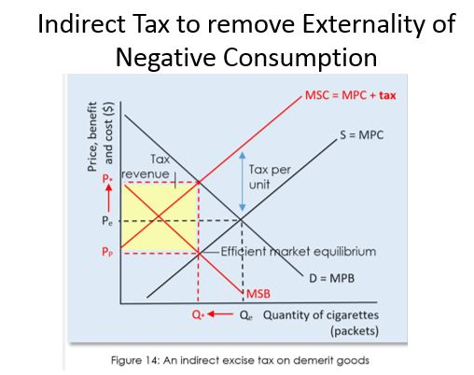

Image retrieved from Externalities – AP Microeconomics. (n.d.).
Indirect taxes make the consumer and the producer pay the marginal external cost of pollution. The majority of countries have an excise tax on cigarettes. Governments forced an excise tax on each unit of product produced and sold by the firm. Consumers and producers share the charge of indirect taxation. Still, because cigarettes are highly addictive, the demand curve is inelastic. Consumers will experience the problem because, for inelastic goods and services, the quantity demanded lowers less than for more elastic goods and services. Examples of consumption taxes are sugar Tax, Petrol and tobacco. Etc.
The new equilibrium achieved after the Tax is at the intersection of M.S.C. and the demand curve (M.P.B.). The tax results in a higher price paid by consumers (P*) and a lower price received by producers (PP). The efficient allocative quantity of the good is being produced
and consumed at a higher price. Thus, the negative externality of consumption
has been incorporated. (Externalities - A.P. Microeconomics, n.d.).

The below diagram shows that as the taxes rise, the marginal cost from MC L to MC H and the number of firms in the market decreases from N.L. to N.H. The tariffs not only reduce the amount sold and increase the price paid, but the taxes also reduce the number of products sold in the market, thereby restraining innovation. (Fruits, 2018).
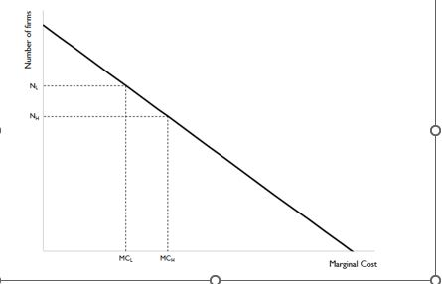

Image from Fruits, (Oct, 2018.). Vapor products, harm reduction, and taxation.

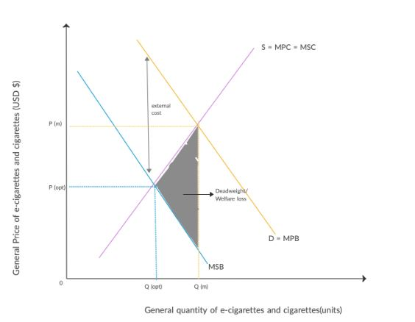
Negative consumption externality caused by e-cigarettes and cigarettes due to nicotine. E-cigarettes vs cigarettes the U.S and U.K.

Image retrieved from Gupta, R. (May, 2020). CIGARETTES AND E CIGARETTES: COMPARISON OF LEGISLATION ON TOBACCO PRODUCTS IN DIFFERENT REGIONS.
The demand curve is a step curve because the demand for e-cigarettes and cigarettes causes an inelastic demand following a price change. The steeper the curve of the demand curve due to its high addictiveness. The intersection of the MBP AND MPC curves finds market price and quantity. (Gupta, 2020).
There are many controversial thoughts on which is safer, healthier, and more of a negative externality between tobacco and nicotine replacements such as vapes and e-cigarettes. E-cigarettes are deemed less harmful yet could potentially cause more nicotine addicts by the addictive vapour flavours. Yet, the U.S.A. states that nicotine in a vapour may result in the consumer sooner or later smoking tobacco, significantly if the price of e-cigarettes increases from added taxes. In the U.S.A., Donald Trump banned the use of certain vaporising flavourings that are highly addictive; however, this may create a negative externality causing legal trade and tax evasion. (Gupta, 2020)
Kentucky, U.S.A. Government, Kentucky house has passed a bill by a 75-17 vote to raise taxes on vaping and other nicotine replacement products an extra 10% from 15% to 25%, estimating $50 million of new tax revenue over the next fiscal 24 months and vaping would be added to the list of smokable products that are subject to a wholesale tax. The new law also doubles the per unit tax on non-smokable and chewable tobacco products but does not affect the tax rate on a pack of cigarettes. When the new law passed, an organisation representing around 400 vape shop owners expressed how their businesses would be negatively affected with potentially less custom. Yet Miller and the Foundation for a Healthy Kentucky described that the price increase on e-cigarettes would control youths vaping and becoming nicotine dependent. Which is creating a crisis. (Sonka, 2020).
The reason for the raise is to ensure the health and safety of the consumers and avoid tobacco-caused illnesses.
Other regulations could be implemented, such as advertising and marketing; cigarettes have plain packaging, and most tobacco packaging now has images with health warnings, not colourful packaging stating the flavours of the product through bright, eye-catching colours. The above statement from the governing board regarding age and the selling of the product to smokers, policies can be put in place which state that a medical professional confirming a smoker who relies on tobacco can then be entitled to purchase the vaping product, enabling people who don't vape or under the legal age to buy a vape. A minimum of vape shops in an area are only allowed.
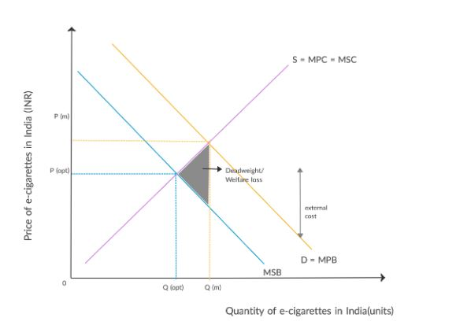
Negative consumption externality caused by e-cigarettes in India.

Image was retrieved from Gupta, R. (May, 2020). CIGARETTES AND E-CIGARETTES: COMPARISON OF LEGISLATION ON TOBACCO PRODUCTS IN DIFFERENT REGIONS.
The above graph shows that the reason for the deadweight loss is that M.P.B. (Marginal Private Benefit) is greater than the M.S.B. (Marginal Social Benefit), and at the point where the M.S.B. interacts with the M.P.C. (Marginal Private Cost) curve. This curve is due to a negative spill over effect on an external party. In November 2019, India's recent bill by Lok Sabha banned all production, import, and sale of e-e-cigarettes all over India and its territories. India's government banned e-cigarettes and vaping to change their negative externalities. However, this caused a shift from e-cigarette addiction to nicotine to becoming a smoker - smoking tobacco. The X.E.D. (Cross elasticity demand) measures the percentage response of demand for one product to a per cent change in price. Gupta, 2020).

Conclusion

The vaping industry clearly shows a negative externality regarding consumption. There's evident to see this product is an apparent market failure regarding children and teenagers having access to e-cigarettes' potentially causing additional health risks long-term, resulting in potentially more pressure on the N.H.S./ the figures above are clear to see that there are already hospital admissions from using vaporisers and nicotine replacement therapies. However, although some studies have reported vaping is, in fact, less harmful than smoking tobacco and cigarettes,' this really can't be analysed as entirely true until there has been enough research over time conducted regarding future hospital admissions because of vaping. The indirect Tax would be an excellent solution; the more expensive the product, the less demand may not be there; however, it could cause other issues regarding illegal trading. Following other countries by banning certain flavours, plain packaging and hidden behind counters like cigarettes are, to make them less appealing to non-smokers and consumers under the legal age. Other laws and policies with higher fines could also be implemented to ensure e-cigarettes and other nicotine replacements are only sold to consumers who smoke - this could be proven at purchase through a medical card or documented identification. The biggest question is, will e-cigarettes and vaping machines be a bigger problem than tobacco in the future with the toxins used for the vaporiser liquid, or will the invention of such aids be successful and a cure? Time will tell.

References

Azad, A. (June, 2019). CNN health. This teens vape exploded, shattering his jaw. https://edition.cnn.com/2019/06/19/health/e-cigarette-vape-explode-teen-study/index.html.
Blaha, J, M. (Jan, 2022). John Hopkins Medicine Health. 5 Vaping Facts You Need to Know. https://www.hopkinsmedicine.org/health/wellness-and-prevention/5-truths-you-need-to-know-about-vaping.
Brunori, D. (June, 2014). Forbes. Taxing e-cigarettes seems crazy. https://www.forbes.com/sites/taxanalysts/2014/06/05/taxing-e-cigarettes-seems-crazy/.
Centers for Disease Control and Prevention. (Sept, 2019). Outbreak of Severe Pulmonary Disease Linked with E-cigarette Product Use. Centers for Disease Control and Prevention; CDC. https://www.cdc.gov/tobacco/basic_information/e-cigarettes/severe-lung-disease.html.
Clifford, J. (Sept, 2014). Micro Unit 2: Supply and Demand. Demand and Supply Explained- Macro Topic 1.4 (Micro Topic 2.1). [Video]. (YouTube). https://youtu.be/LwLh6ax0zTE.
Drummond, M. B., & Upson, D. (2014). Electronic Cigarettes. Potential Harms and Benefits. Annals of the American Thoracic Society, 11(2), 236–242. https://doi.org/10.1513/annalsats.201311-391fr.
Externalities - AP Microeconomics. (n.d.). AP MICROECONOMICS. https://www.microeconomicsap.com/externalities-ap-microeconomics.html

Fraser, K. (Feb 2023). LBC News. Hospital admissions for vaping kids quadruple in a year, as calls grow for more regulation. https://www.lbc.co.uk/news/vape-children-hospital-admissions-quadruple/.
Fruits, E. (Oct, 2018.). Vapor products, harm reduction, and taxation. https://laweconcenter.org/wp-content/uploads/2018/10/Harm-Reduction-White-Paper-v9.1-181001.pdf.
Gelder, V, K. (Sept, 2022). Statista. E-cigarette use among adult smokers in Great Britain 2013-2022. https://www.statista.com/statistics/293609/e-cigarette-use-adult-smokers-great-britain/.
Gelder, V, K. (Jan, 2023). Statista. Adult smoking rates in the United Kingdom (UK) 2019, by country. https://www.statista.com/statistics/422980/adult-smoking-rates-in-the-united-kingdom-by-country-of-the-uk/#statisticContainer.
Gov UK. (April, 2023). Youth Vaping: Call for Evidence. https://www.gov.uk/government/consultations/youth-vaping-call-for-evidence/youth-vaping-call-for-evidence.
Gupta, R. (May, 2020). CIGARETTES AND E-CIGARETTES: COMPARISON OF LEGISLATION ON TOBACCO PRODUCTS IN DIFFERENT REGIONS. https://www.ijeronline.com/documents/volumes/2020/Sept%20-%20Oct%2020/ijer%20V11%20i5%20(so)%202.pdf
Hutter, M, C. (Apri;, 2023). National Human Genome Research Institute. Carcinogen. https://www.genome.gov/genetics-glossary/Carcinogen.
Luther, D. (July, 2022). Law of Supply and Demand Defined. https://www.netsuite.com/portal/resource/articles/erp/law-of-supply-demand.shtml.
Mikulc, M. (April, 2023). Statista. Smoking cessation aids OTC sales value in Great Britain 2009-2021. https://www.statista.com/statistics/521863/otc-smoking-cessation-aids-sales-value-great-britain/.
Richards, J. (Feb, 2023). Externalities & Market Failure-councils urged to keep vapes out of sight of children. https://www.tutor2u.net/economics/blog/externalities-and-market-failure-councils-urged-to-keep-vapes-out-of-sight-of-children.
Stewart, C. (Aug, 2022). Statista. Great Britain: use of e-cigarettes among young people 2022, by age. https://www.statista.com/statistics/979049/great-britain-use-of-e-cigarettes-among-young-people-by-age/.
Stewart, C. (Nov, 2022). Statista. Hospital admissions which can because by smoking in England (UK) 2000-2020. https://www.statista.com/statistics/370292/hospital-admissions-caused-by-smoking-in-england-uk/.
Sonka, J. (Feb, 2020). Kentucky House passes bill raising taxes on vaping, tobacco products. https://eu.courier-journal.com/story/news/politics/2020/02/26/kentucky-house-passes-tax-increase-vaping-tobacco-products/4882429002/.
Statista. (2023). E-cigarettes and vaping in the United Kingdom – statistics & facts. https://www.statista.com/topics/9982/e-cigarettes-and-vaping-in-the-united-kingdom/.

