UNIVERSITY OF WALES TRINITY SAINT DAVID
LONDON CAMPUS
Assignment 2
Learning in the Digital Era
Video Link: https://youtu.be/PcVvEMUugR4

Module Name: Learning in the Digital Era
Module Code: ACCA 4025

Student Name:Umair Umair
Student ID:2528414
Group:2

Lecturer’s Name: Koushik Modak

Table of Contents
Introduction 2
Main Body 2
Conclusion 9
References 9

Introduction
This presentation focuses on self-evaluation and a professional development plan. It reflects on my strengths, weaknesses, and current skills to understand areas that need improvement. It also includes SMART goals to guide my academic progress and future career development. Overall, this presentation shows my plan for personal growth and preparing for future opportunities.

Main Body
Reflective writing is an important part of teachers’ professional development because it helps improve self-awareness, critical thinking, and teaching performance. It allows teachers to review their experiences, understand what went well, and identify areas that need improvement. However, many teachers, especially in developing countries, struggle with reflective writing due to a lack of proper training and exposure to structured reflection models.
Using a systematic framework such as Gibbs’ Reflective Model can guide teachers to reflect more effectively by organizing their thoughts and encouraging deeper analysis of their teaching practices. This process helps them plan improvements, solve problems, and enhance their classroom strategies. Overall, reflective writing supports continuous learning and plays a key role in improving teaching quality and professional growth[1]
Video Link:
Slide 1 COVER PAGE
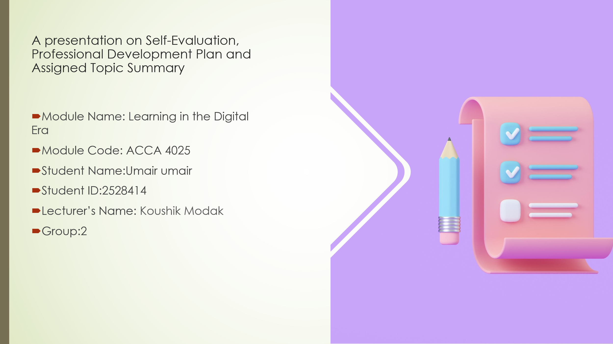
Slide 2 CONTENTS

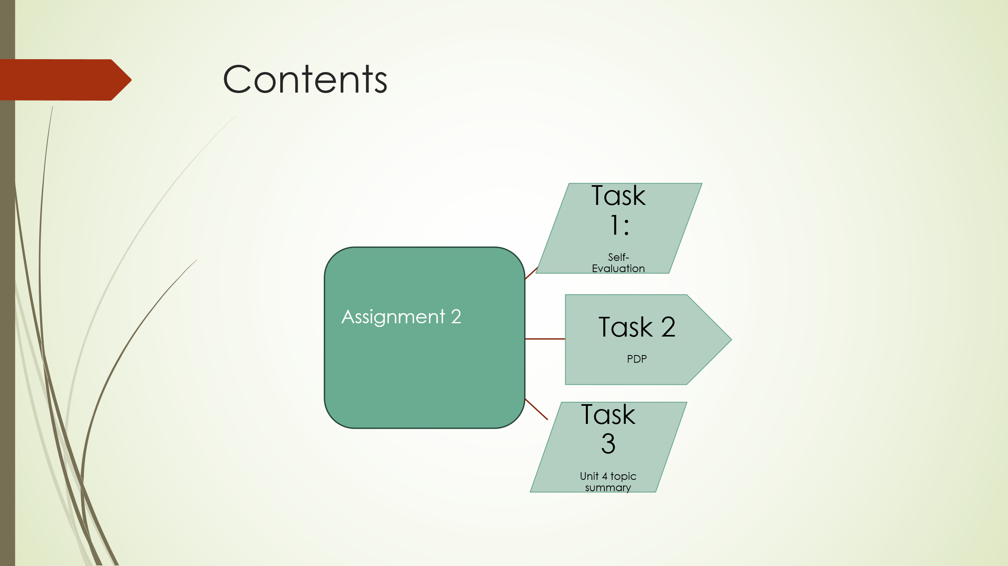
Slide 3 INTRODUCTION
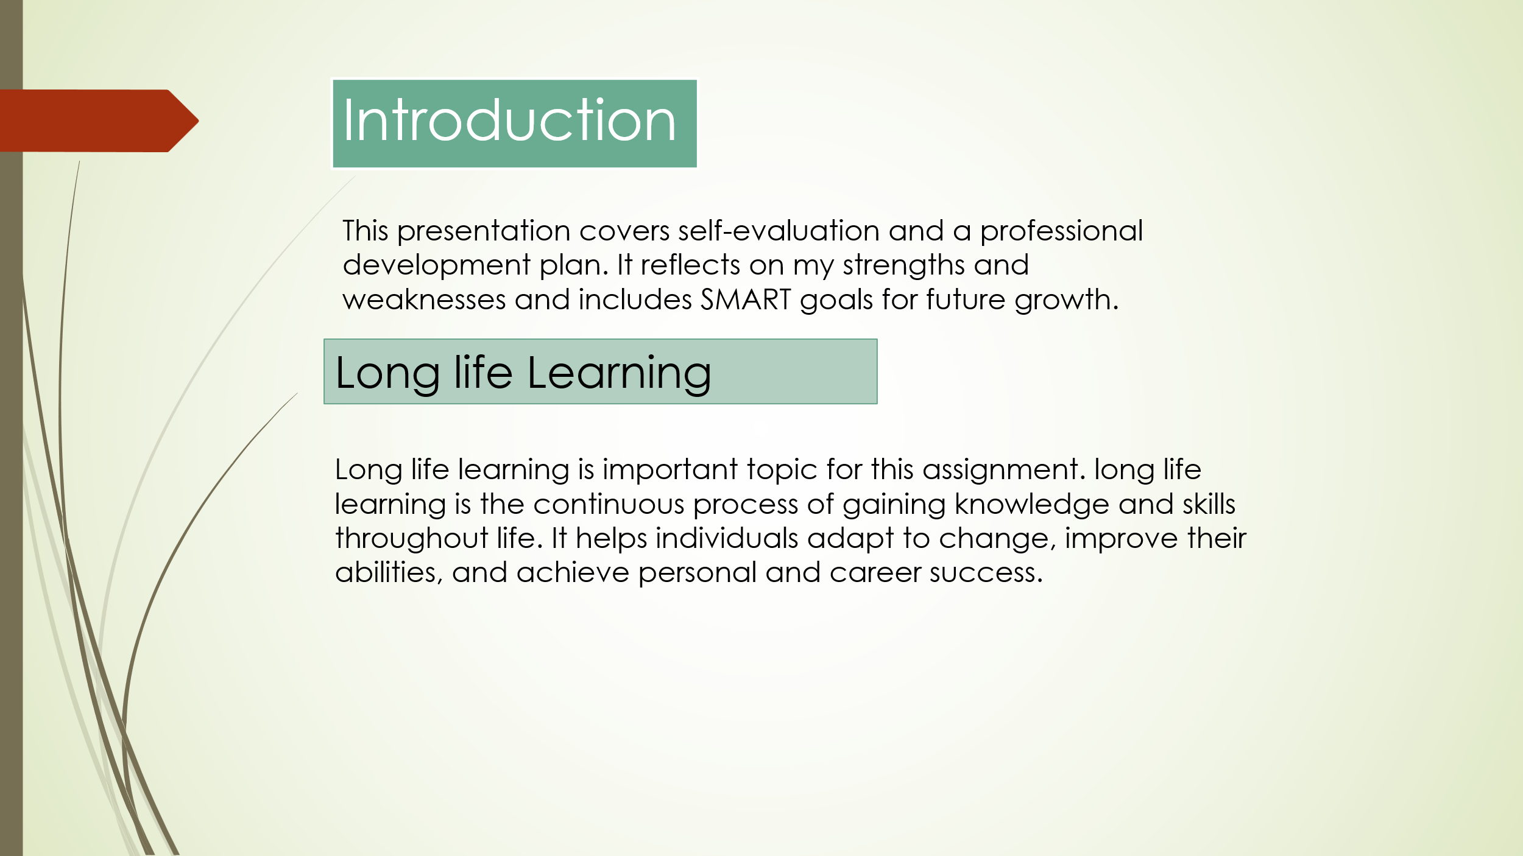

Slide 4 MAIN BODY 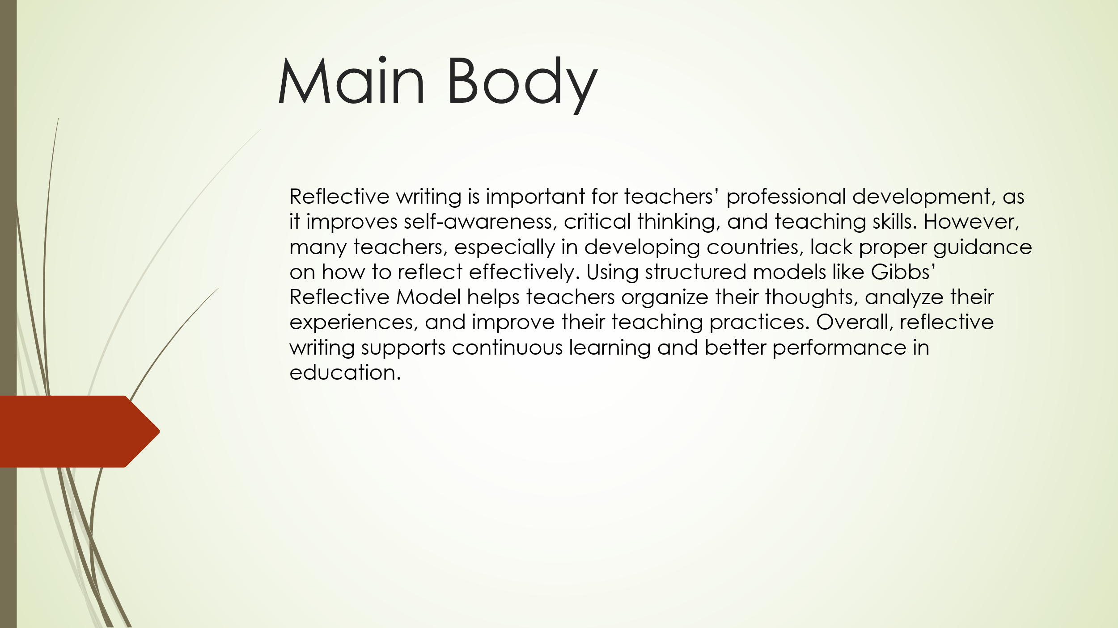

Slide 5 GIBB’s REFLECTIVE MODEL
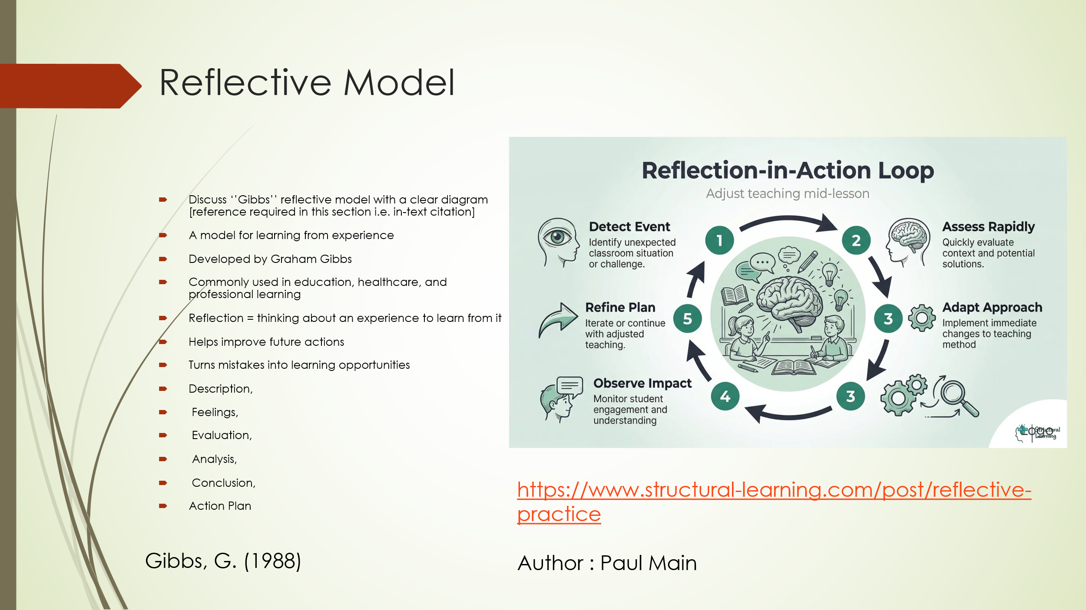
Gibbs’ Reflective Cycle is a structured model used to help individuals reflect on their experiences in a clear and systematic way. It is especially useful in education and professional development because it encourages deeper thinking and improvement.
The cycle includes six stages: Description (what happened), Feelings (thoughts and emotions), Evaluation (what was good or bad), Analysis (why it happened), Conclusion (what was learned), and Action Plan (what to do next time). By following these steps, learners can better understand their experiences and improve future performance.Overall, Gibbs’ model helps develop critical thinking, self-awareness, and continuous improvement in learning and professional practice.

Slide 6 TASK 1: SELF EVALUATION
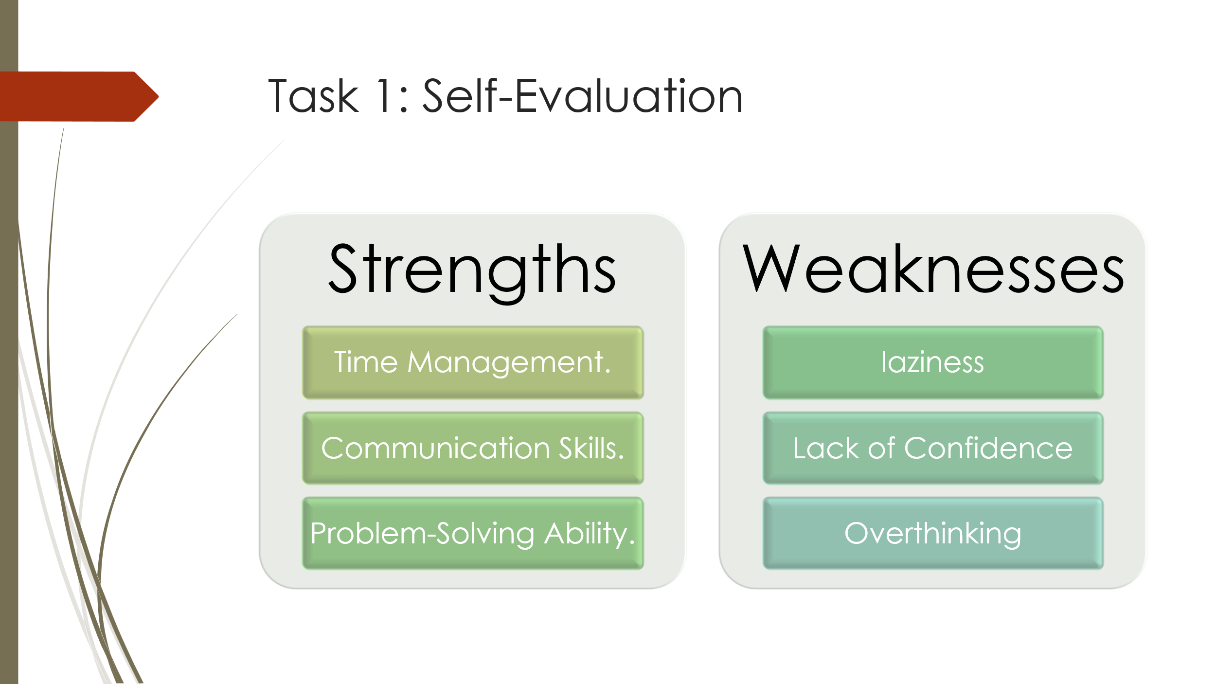
This SWOT analysis reflects on my personal strengths, weaknesses, and skills to understand my current abilities and areas for improvement.
My strengths include good time management, communication skills, and strong problem-solving ability. I can usually plan my tasks, communicate clearly with others, and find solutions when challenges arise.
However, I also have some weaknesses, such as laziness, lack of confidence, and overthinking. These sometimes affect my productivity and make it harder for me to complete tasks efficiently or take initiative.
Overall, this self-evaluation helps me understand myself better and identify areas where I need to improve in order to grow academically and personally.

Slide 7 TRAITS GAINED FROM THE SELF EVALUATION
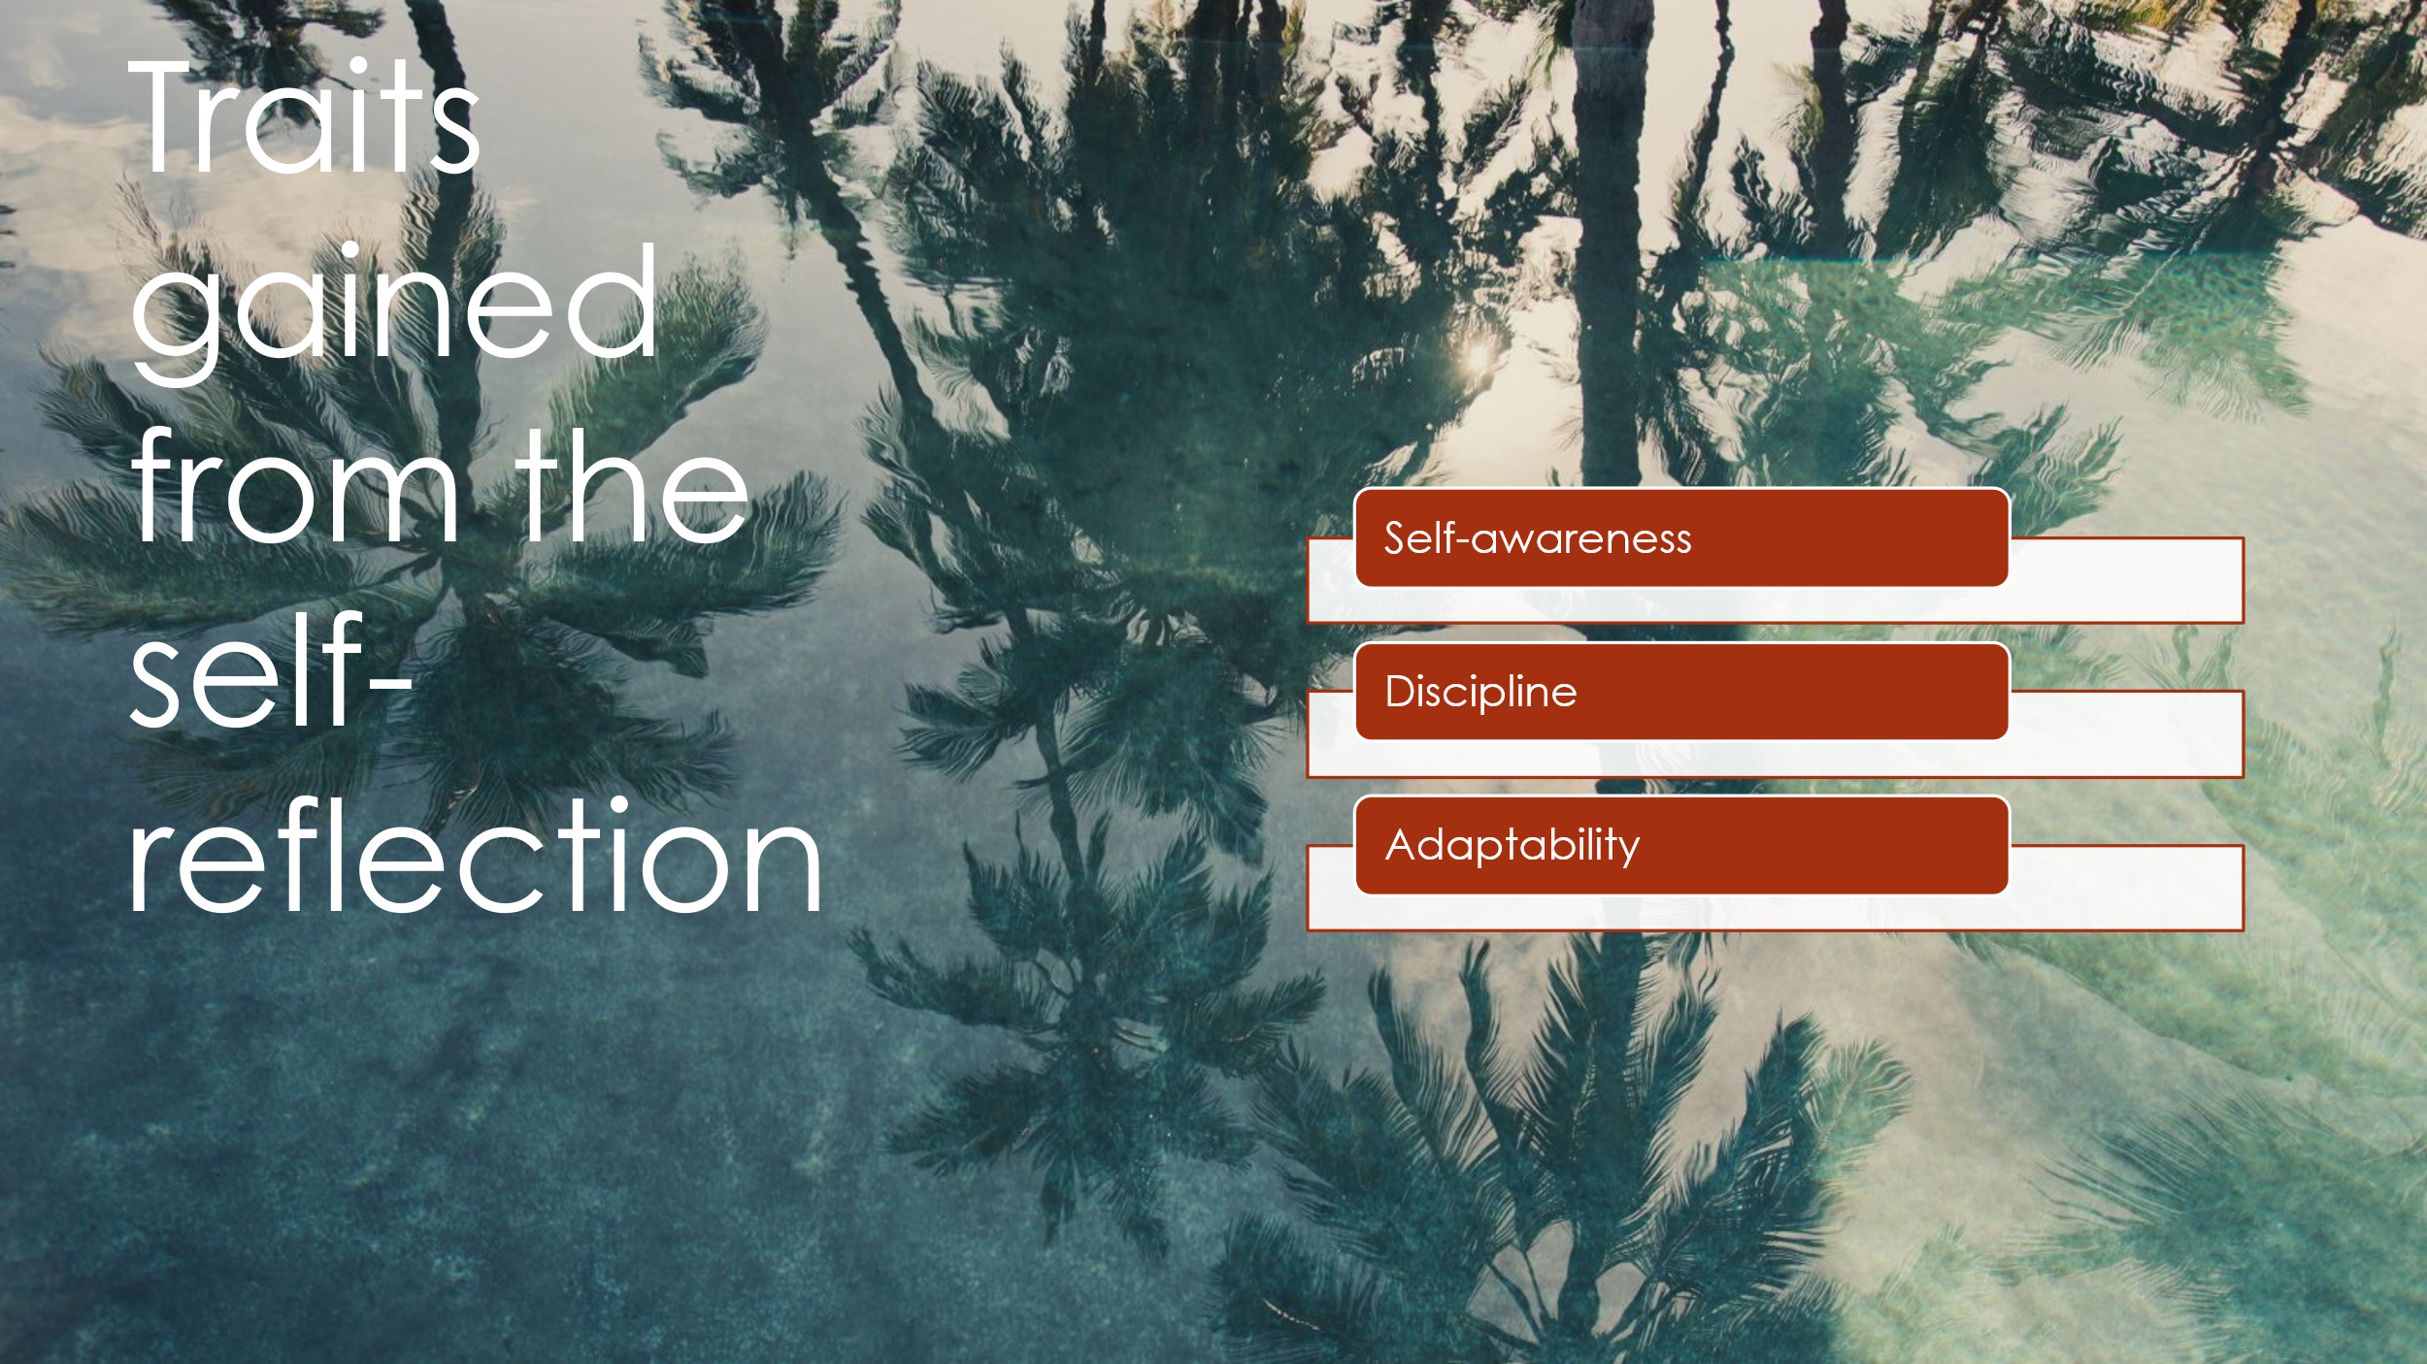

Through self-reflection, I have gained important personal traits that support my growth and development. One of the main traits is self-awareness, which helps me understand my strengths, weaknesses, and behavior more clearly. I also developed discipline, which allows me to stay focused, manage my time better, and complete tasks on time. In addition, I improved my adaptability, which helps me adjust to new situations, challenges, and changes in my learning environment. Overall, these traits help me become more responsible and prepared for future academic and personal success.

Slide 8 PROFESSIONAL DEVELOPMENT PLAN
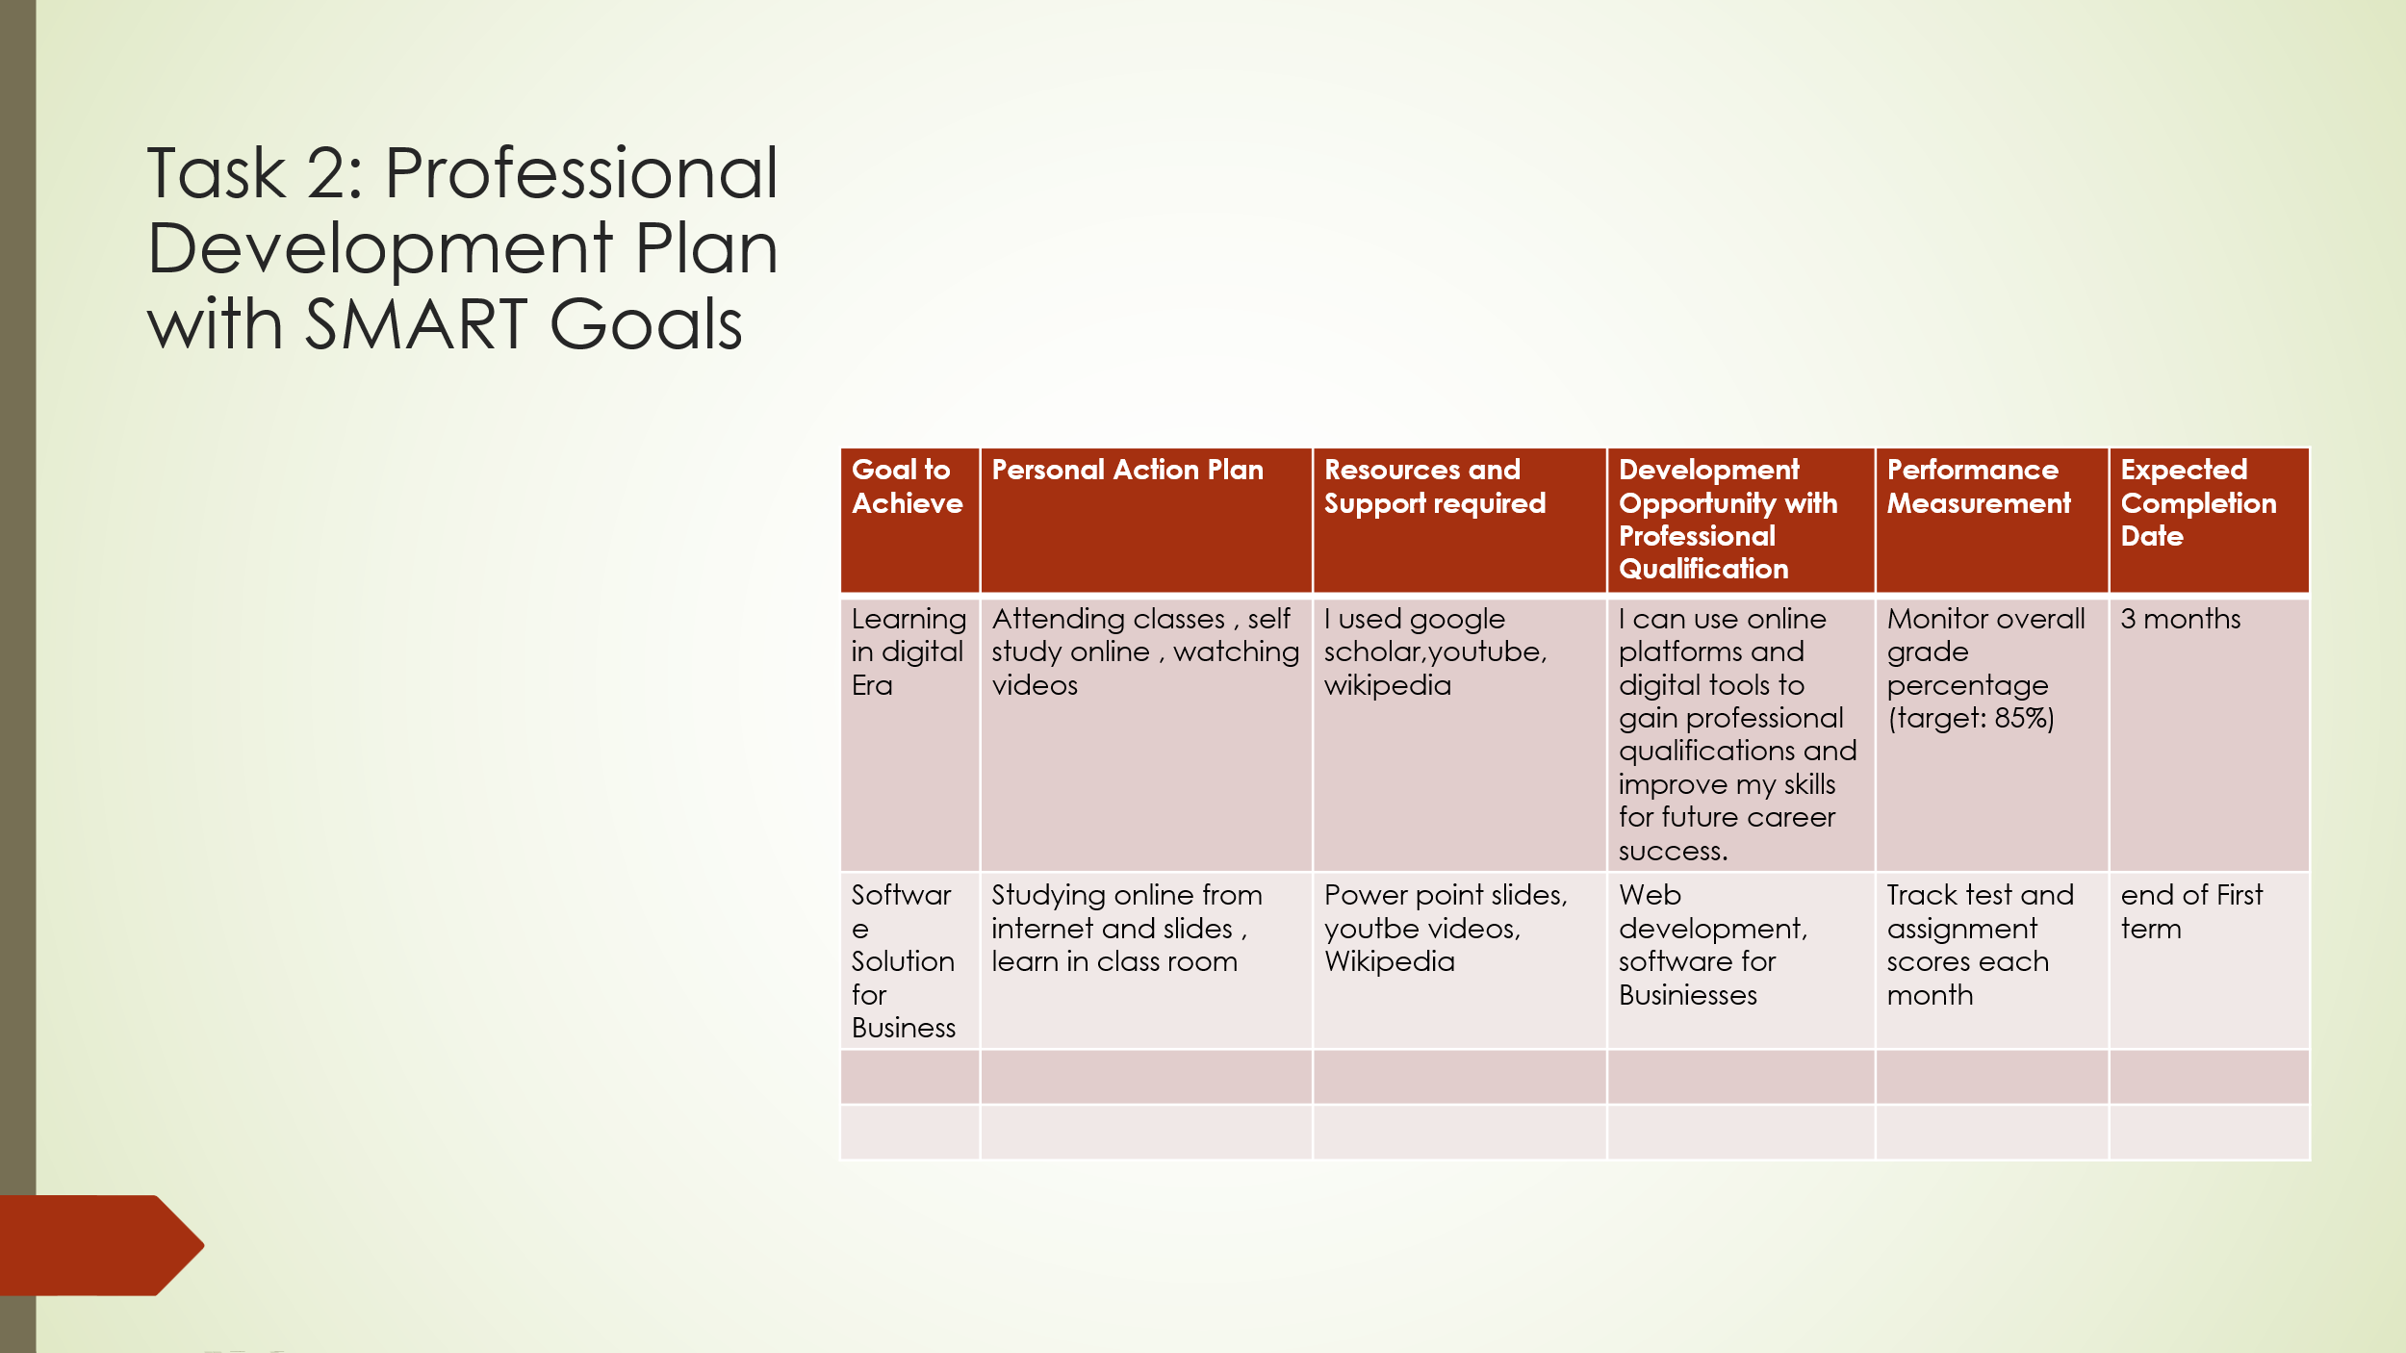
The professional development plan explains how I will improve my skills and knowledge to achieve my future career goals, I used SMART goals to make my goals clear and organized. SMART goals help me stay focused because they are specific
, measurable, achievable , relevant and time-bound.
In my plan,I included goals such as learning digital era skills and understanding software solution for business . to achieve these goals, I will attend classes, study online ,watch educational videos ,and use class room materials , I will also use resources like google scholar ,youtube ,Wikipedia and power point slides to support my learning,
My plan will help me develop important skills in digital tools web development, and business software that can support my future career. I will measure my progress through goal test scores and assignments with a target of achieving high marks such as completing some goals within three months and by the end of first term to help me stay motivated and complete my goals on time.

Slide 9 UNIT 4 TOPIC SUMMARY
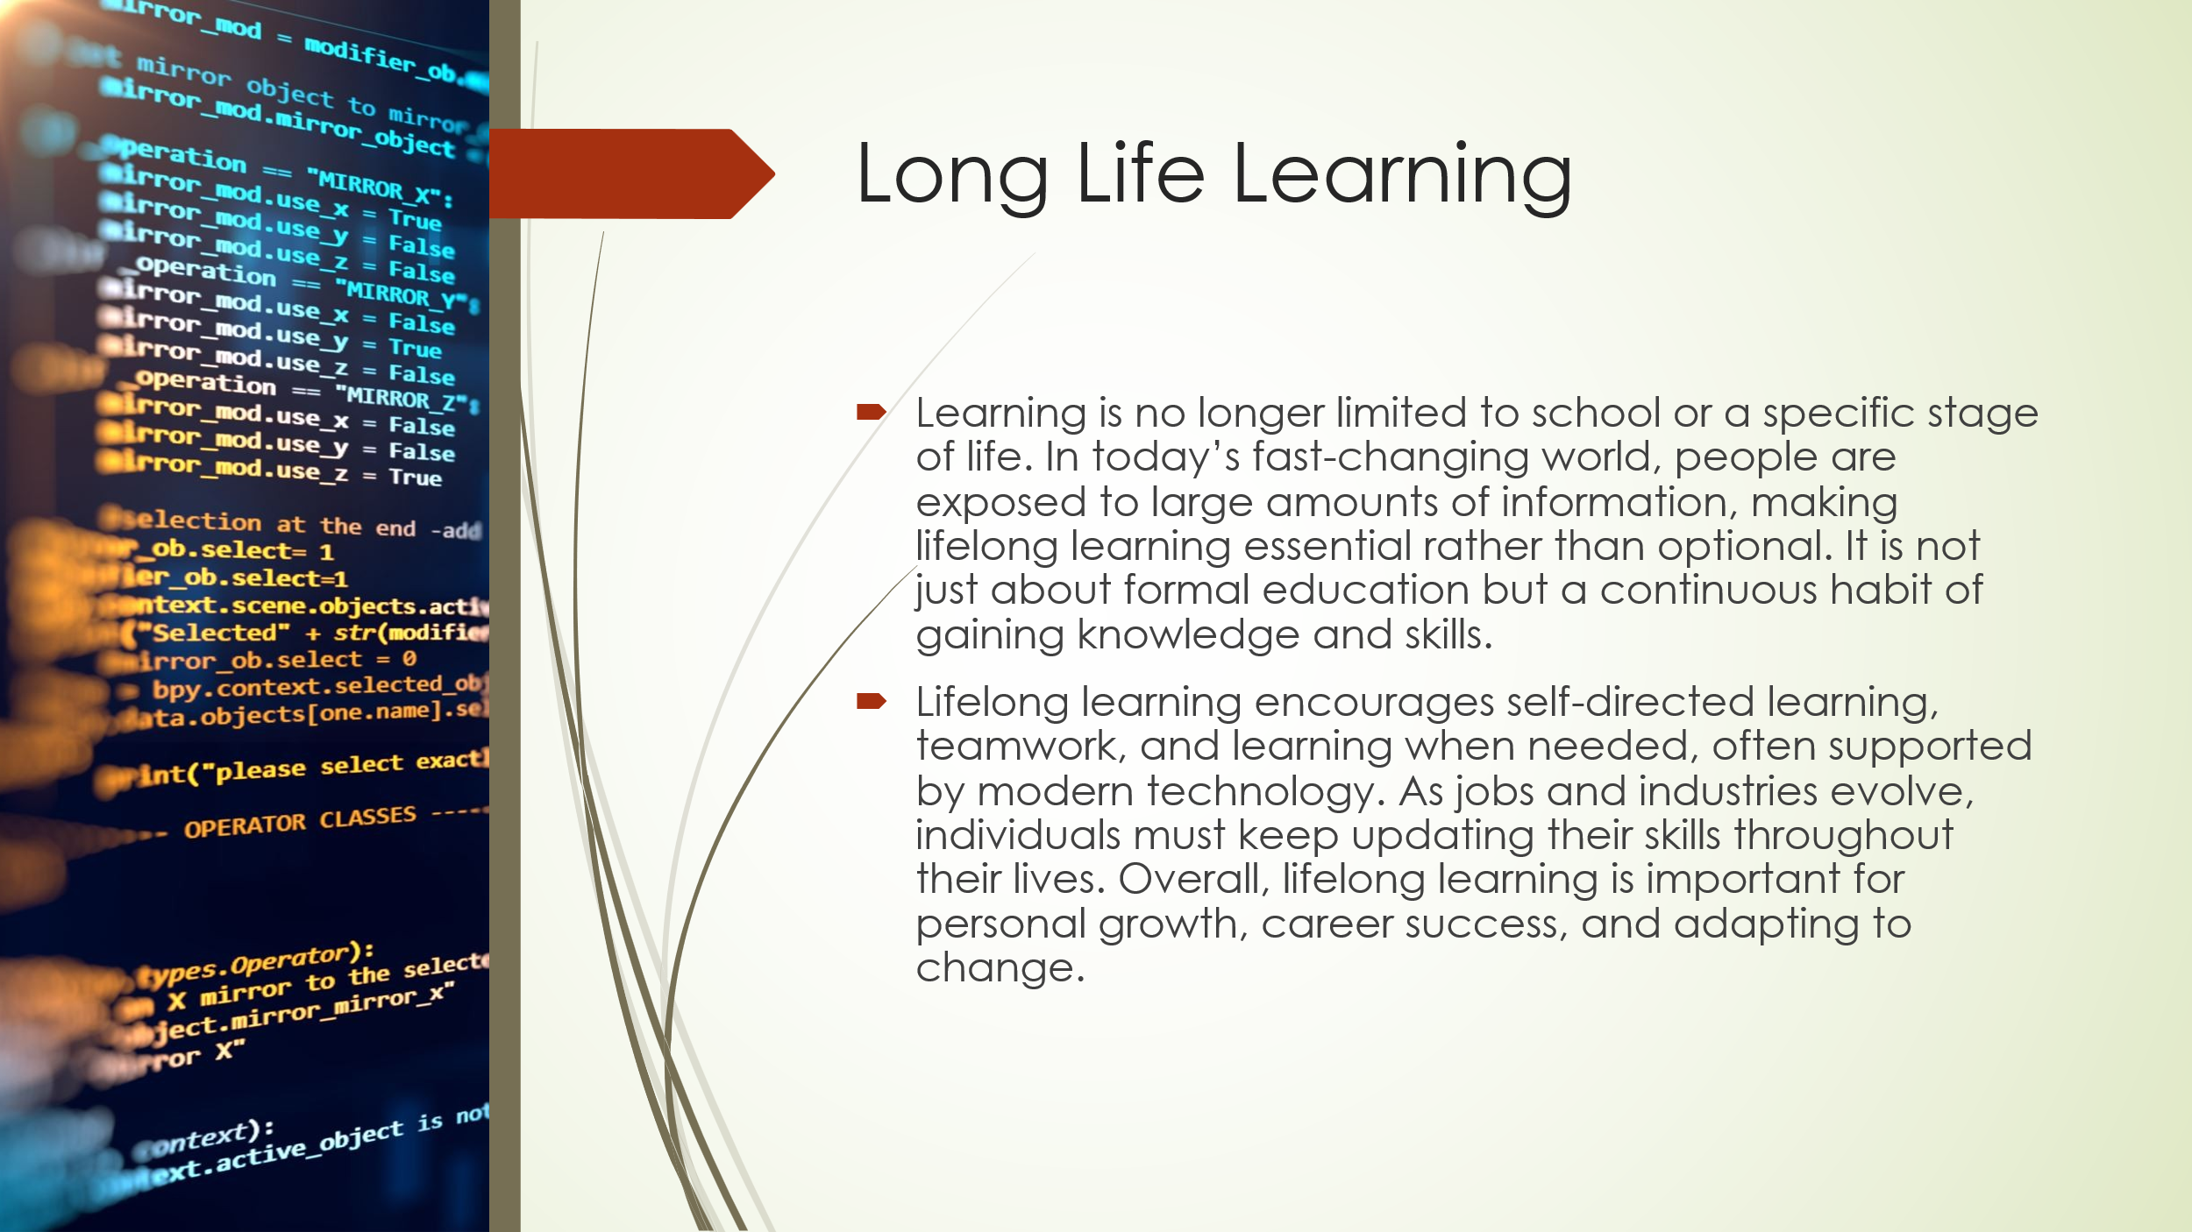
Learning is no longer limited to a specific place like school or a certain time in life. In the past, people gained knowledge in school and then applied it later in the workplace, but this idea is no longer suitable in today’s world. Modern society is filled with a huge amount of information, and future workers will need more knowledge than anyone can fully remember. Because of this, lifelong learning has become essential for shaping the future of society—it is a necessity, not just an option or luxury.Lifelong learning is not only about adult education or training; it is a way of thinking and a habit that individuals should develop. It encourages people to explore new ways of learning, such as self-directed learning, learning when needed, teamwork, and learning within organizations. These methods require the use of modern technology and digital tools to be effective.
As the nature of work and education continues to change rapidly, new approaches to learning are required. For example, there is a growing demand for high-technology jobs, which require continuous learning because it is impossible to learn everything in advance. In addition, careers are constantly evolving, making it necessary for individuals to keep updating their skills throughout their lives. There is also a widening gap between educated and less-educated individuals, highlighting the importance of equal learning opportunities.Overall, lifelong learning focuses on developing new ways and environments that support continuous education and skill development, going beyond traditional training methods to meet the needs of a changing world.[1].

Slide 10 CONCLUSION

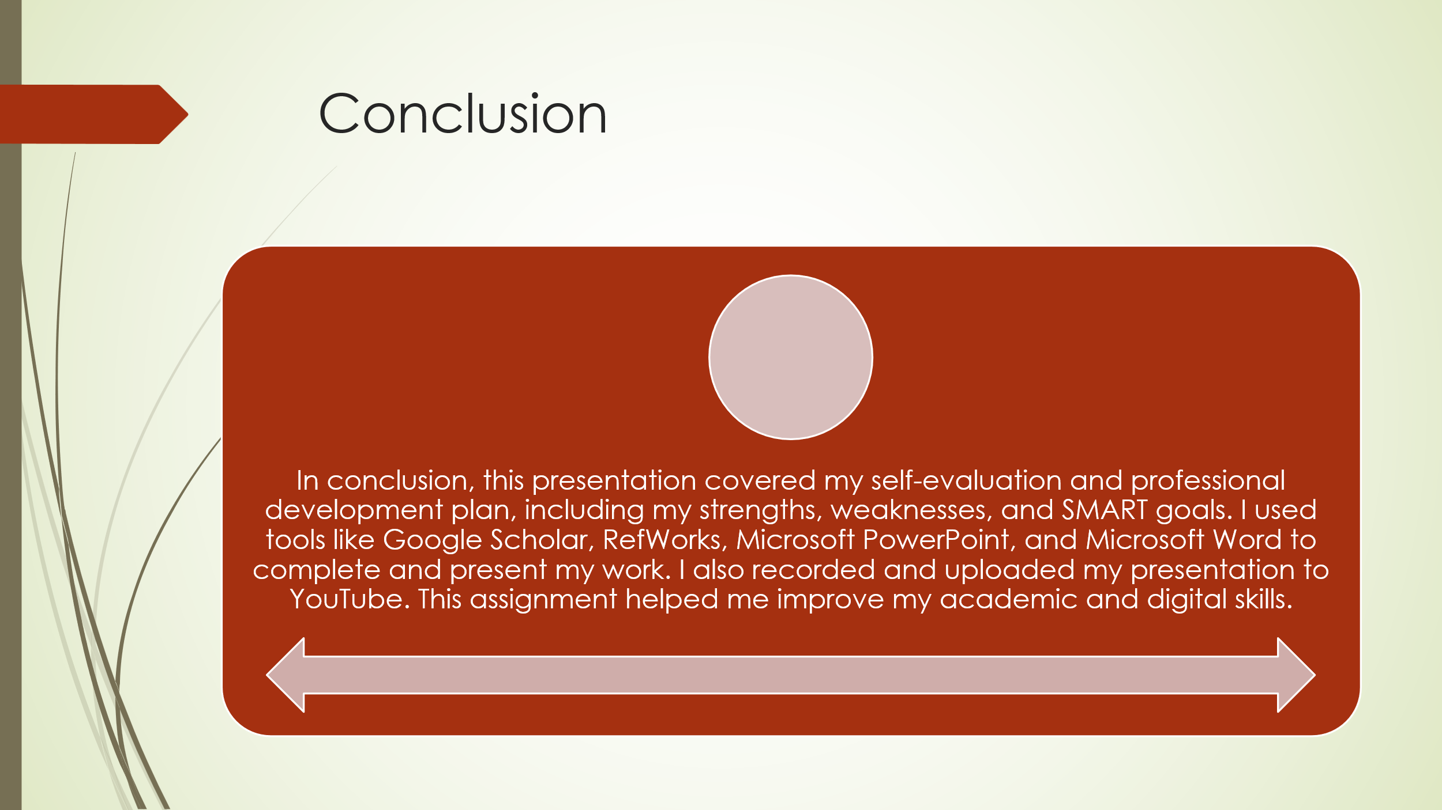R2

Slide 11 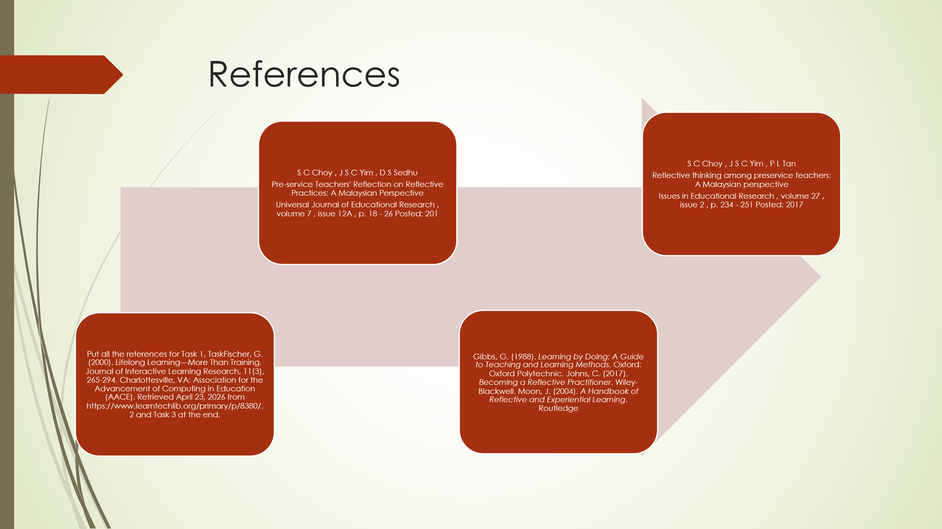

Conclusion
In conclusion, this presentation covered my self-evaluation and professional development plan, highlighting my strengths, weaknesses, and SMART goals for future growth. Throughout this assignment, I applied various digital skills and tools to complete and present my work effectively. I used Google Scholar and RefWorks for research and citations, and created my slides using Microsoft PowerPoint. I also used Microsoft Word to compile my assignment and attached my slides for submission. Additionally, I recorded my presentation and uploaded it to YouTube for evaluation.The main lesson I learned from this assignment is how to plan, organize, and present information in a structured and professional way. I also improved my time management,research, and digital skills. Overall, this assignment helped me become more confident in using technology and preparing for future academic and career tasks.
From my personal evaluation, I realize that I need to continue improving my time management and consistency in completing tasks earlier. I recommend that I keep practicing digital tools and presentation skills, as they are important for both academic success and future career opportunities.

References

Fischer, G. (2000). Lifelong Learning—More Than Training. Journal of Interactive Learning Research, 11(3), 265-294. Charlottesville, VA: Association for the Advancement of Computing in Education (AACE). Retrieved April 23, 2026 from https://www.learntechlib.org/primary/p/8380/.
• Gibbs, G. (1988). Learning by Doing: A Guide to Teaching and Learning Methods. Oxford: Oxford Polytechnic.
• Johns, C. (2017). Becoming a Reflective Practitioner. Wiley-Blackwell.
• Moon, J. (2004). A Handbook of Reflective and Experiential Learning. Routledge

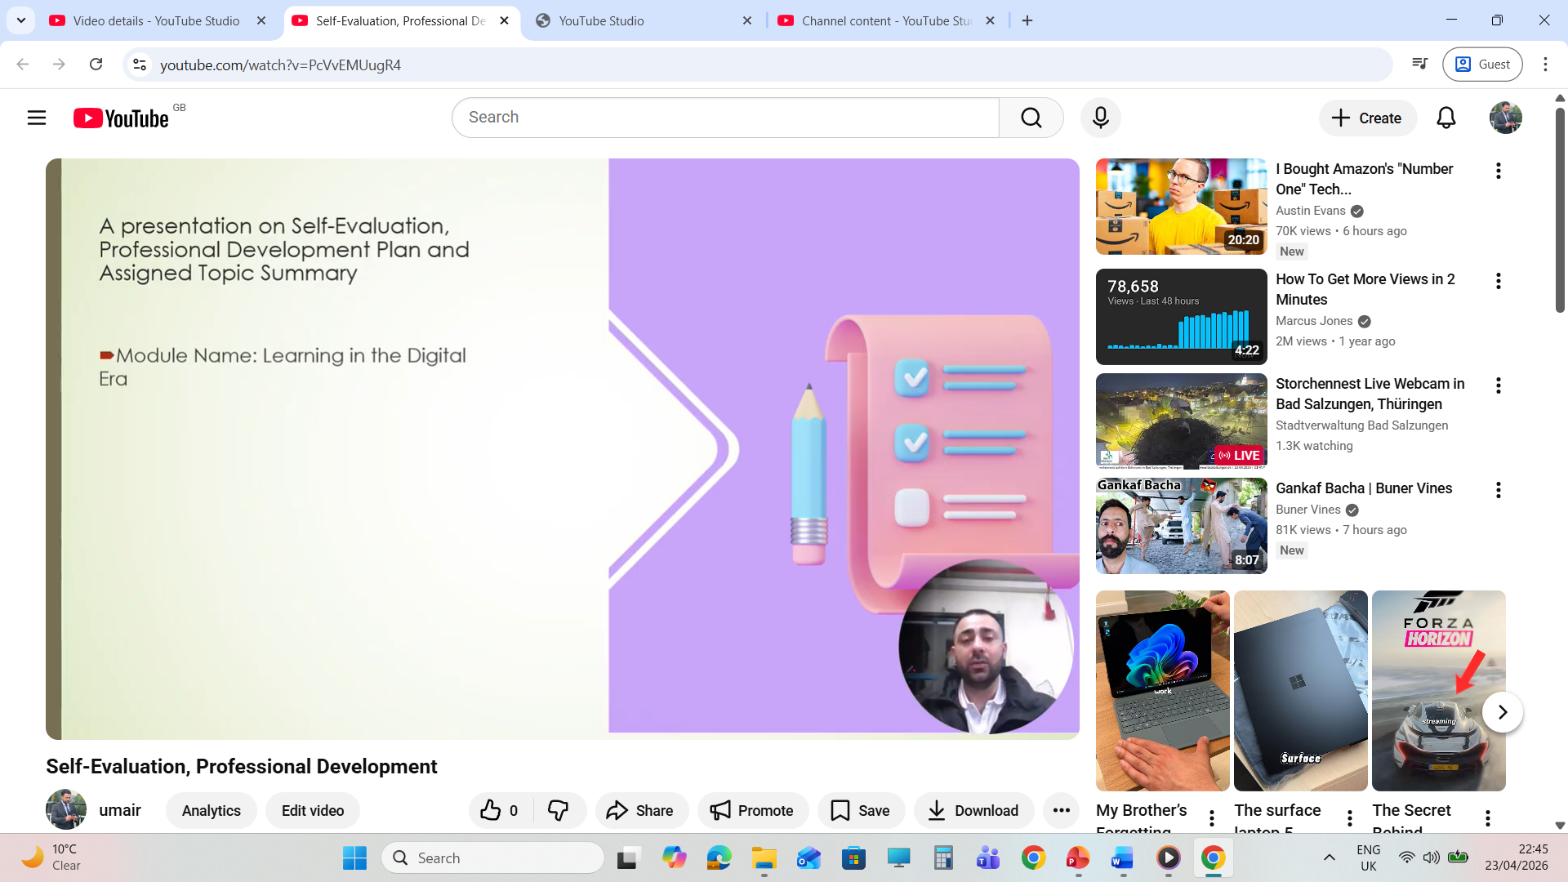

Video Link : https://youtu.be/PcVvEMUugR4

