Programme: BA International Hotel Management

Module: Managing Hotel Administration

Module code: BMIH6004

Student Name: Wazadur Rob Chowdhury
Student ID: 222426

Word Count: 1282
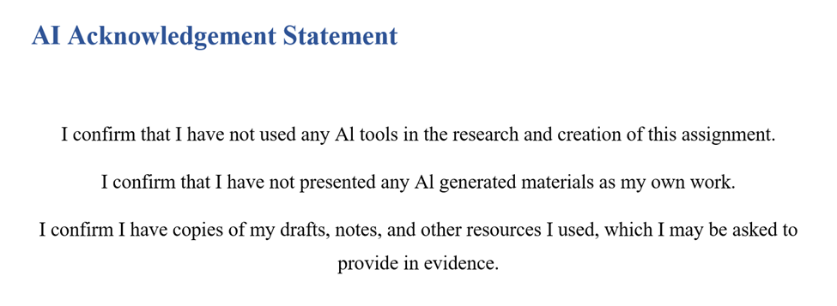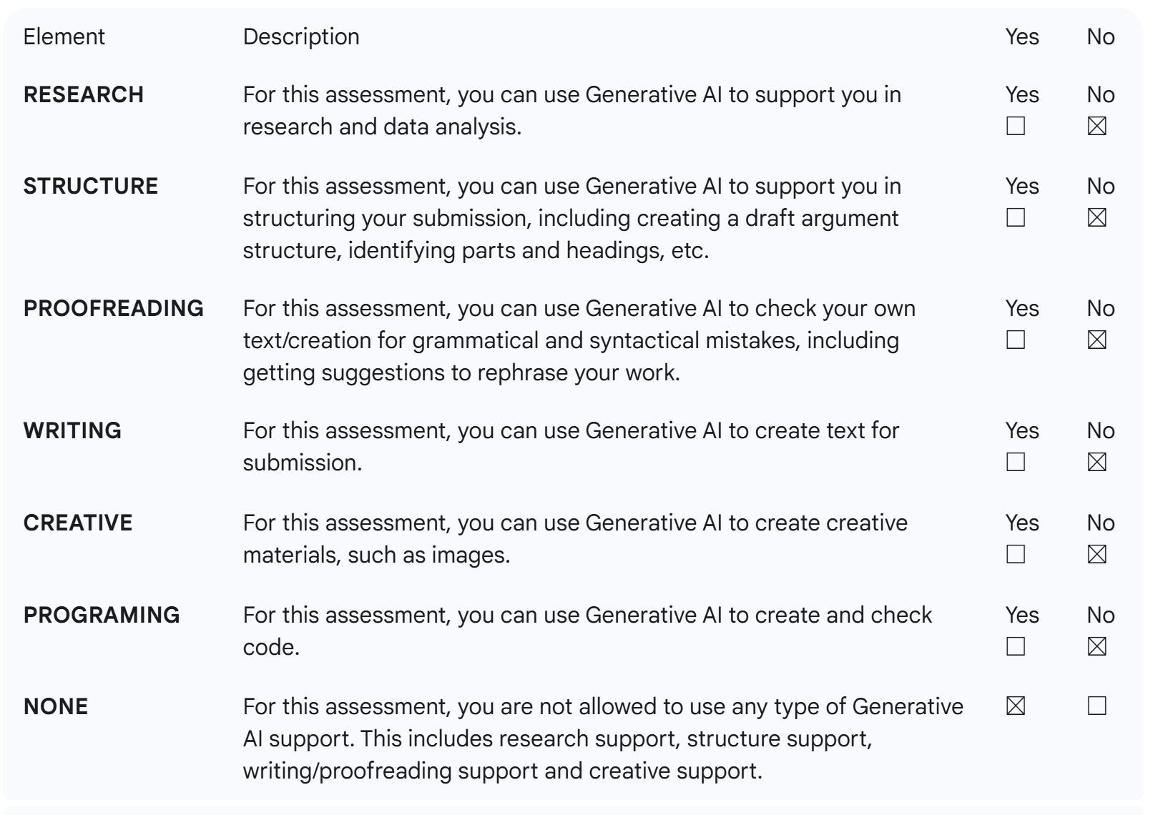

Contents
Introduction 4
Section 1: Role Reflection 4
Description 4
Feelings 4
Evaluation & Analysis 5
Action Plan 6
Section 2: Discussion of Key Hotel Administration Issues 6
Section 3: Future Trends in Hotel Administration 7
Conclusion 7
References 9

Introduction
At my 10-week placement at Acorn Lodge Gatwick, I was posted to the administration department as a floor manager trainee. The duties that this department will undertake are guest check-in and check-out, reservations management, arrangements of housekeeping, guest queries, billing and payment systems, and the overall running efficiency of the hotel. The placement was a practical experience of administrative and supervisory processes. The learning objectives of mine were:
- Cultivate leadership and supervisory capability in a front-desk team.
- Enhance operational effectiveness through the hotel PMS/CRM and finance applications.
- Develop a critical reflection of training and development needs and a professional action plan.
In this section, I will reflect on my role through the Gibbs cycle.

Section 1: Role Reflection

Description
My main role was to appraise the front-desk activities and assist the shift manager, and also maintain a good level of coordination among the reception, housekeeping, and guest services as a Trainee Floor Manager. My immediate manager, H. Rashid, gave me tips on how to solve a problem, delegate and make operational decisions. Checking in on reservations, working on late check-outs, billing verifications, listening to guests and groups, communicating with the housekeeping staff, and overseeing junior reception employees were some of my daily tasks. Also, I helped report occupancy changes, daily revenue and shift changes, which gave me a solid overview of the operational flow.

Feelings
First, I was worried about how to manage my administrative work and the supervision of staff. Of special concern to me was the issue of dealing with overbookings, solving billing problems, and patron satisfaction when under pressure. Nevertheless, I was also encouraged to practice theoretical learning that I acquired during my studies, specifically, Service Operations Management and Personnel Resourcing and Development, to practice with real-life scenarios.

Evaluation & Analysis
When making a placement, I experienced the following two important situations:
Incident 1: Overbooking Conflict: There was one evening when two guests came with confirmed bookings, and they did not find any available room as a result of a mistake in the PMS. I rushed to coordinate with the housekeeping on how to get an available room within a short time, resettled a suite to one of the guests, and offered a free dinner to provide an apology. This required effective leadership and communication as well as problem-solving: I assigned some room readiness chores, instructed the reception personnel on how to deal with guest expectations, and maintained my composure not to overblow it. This situation provided the significance of work knowledge, awareness of the PMS systems, and positive active control over the teams (Kasavana and Brooks, 1998; Bardi, 2010).
Incident 2: Billing Dilemma: One of the guests was challenged to pay a late check-out fee. I checked PMS and financial records, realised the mistake, and provided a new invoice. My explanation of the billing process was also clear, and I preferred to remain professional and empathetic. This experience helped me entrench my knowledge of administrative accuracy, communication with guests and technical competence. I have noted that the coaching competencies of H. Rashid played a major role in helping me to be assertive and retain quality in my service delivery.
The situations showed my strengths, which were my leadership skills during a crisis, strong communication skills, technical PMS/CRM skills, and teamwork. Some of the weaknesses encompassed resistance to giving out assignments at the start and being too preoccupied with simple procedural issues that sometimes slowed down the work.

Action Plan
To pursue a profession, I would like to:
- Earn a graduate-level PMS course in three months.
- Shadow the Revenue/Reservations Manager at the very least twice a week to have a closer look at the operations.
- To enhance the management of guest complaints, attend a conflict resolution workshop.
- Use SMART goals in order to enhance delegation and time management between shifts.

Section 2: Discussion of Key Hotel Administration Issues
One of the major administrative challenges that were experienced at Acorn Lodge Gatwick is the ineffective use of the PMS/CRM system. Although this system allows the process of reservations and billing, and housekeeping coordination, there were various mistakes resulting because staff trained inconsistently: errors like incorrect room assignment, incorrect registration, and delayed billing were evident. It has been demonstrated in literature that technology adoption in itself is not enough; the effective use is a matter of competence among staff and incorporation of system workflow within the day-to-day running of the business (Blal, 2014; Johnston, Clark and Shulver, 2012).
The reluctance and lack of knowledge of the staff towards PMS led to delays in operations, particularly during times of high occupancy. I noted that H. Rashid mentored employees in critical situations, but they still made mistakes in the long-term to come due to the fact that formal training programs did not exist. It is found that training interventions help to enhance PMS efficiency, decrease human error, and improve service delivery (Buhalis and Leung, 2018; Baum, 2015). The use of frequent refresher seminars and online guides may help to mitigate the threat of operational risks considerably and raise the satisfaction of guests.
In addition, when compared with other hotel management systems, it was realised that certain PMS solutions have easier interfaces and automated reporting, which means that people do not have to input data manually (Kasavana and Brooks, 1998). Using these insights in conjunction with the theory in the Personnel resourcing and development module (learnt during level 5) would emphasise the significance of connecting human capital development and operation technology. The trained personnel are able to maximise the ability of the system, and it makes systems efficient in booking in or billing correctly and allocation of resources. This proves that the efficiency of technologies and human abilities have to develop at the same pace to ensure operational excellence (Bardi, 2010; Johnston, Clark and Shulver, 2012).

Section 3: Future Trends in Hotel Administration
The upcoming changes in hotel management are the use of AI in hotel operations, improvement of PMS integration, and changing customer demands (Kumawat et al., 2025; Buhalis and Leung, 2018). AI can be used to automate check-ins and personalise the experiences of guests, forecast occupancy rates, and streamline the way revenue is managed. In one case, AI-enhanced systems can indicate over-bookings or recommend an upgrade, eliminating the need to have front-desk staff involved.
Alterations in consumer expectations, such as contact-free services, personalisation and rapid solutions to problems, demand that administrative personnel find a balance between technology and human services. The employees have to read AI outputs correctly without losing personal communication with customers. My placement experience indicates that the future Floor Managers would require both technical expertise and managerial skills to balance the leadership of teams in the context of incorporating new tools (Buhalis and Leung, 2018; Kasavana and Brooks, 1998).
Moreover, technology advances may facilitate professional development since they can be used to employ data analytics to understand the training requirements, to empower the staff to be developed in specific ways, to increase the efficiency of operations, and to elevate the satisfaction of the guests. These adjustments are in line with my action plan as they will provide me with flexibility in the ever-changing hospitality environment.

Conclusion
The experience at Acorn Lodge Gatwick helped me to improve my leadership, operational, and technical working skills related to front-desk administration. The linkage between theory and practice and reflection helped me to attain my learning objectives as a result of practical experience. The fact that PMS was inefficient led to the realisation of the necessity to train staff, and the appearance of new trends in AI and technology stressed the importance of constant professional growth. My action plan will guarantee my further reinforcement of the human and technological factors of hotel administration.

References
Acorn Lodge Gatwick (2025) ‘Acorn Lodge Gatwick Hotel – About Us’. Available at: https://www.acornlodge.co.uk (Accessed: 30 October 2025).
Bardi, J.A. (2010) Hotel Front Office Management. 5th ed. Hoboken: Wiley.
Baum, T. (2015) ‘Human resources in tourism: Still waiting for change?’, Tourism Management, 50, pp.204–212.
Blal, I. (2014) The Property Management System: an operational perspective. CABI Digital Library.
Buhalis, D. and Leung, R. (2018) ‘Smart hospitality — Interconnectivity and interoperability towards an ecosystem’, International Journal of Hospitality Management, 71, pp.41–50.
Fallon, M. and Rutherford, D. (2010) Hotel Management and Operations. London: Wiley.
Gibbs, G. (1988) Learning by Doing: A Guide to Teaching and Learning Methods. Oxford Polytechnic: Further Education Unit.
Hagg, E. (2013) Internship Guide: Work Placements Step by Step. 5th ed. The Hague: Eleven International Publishing.
Johnston, R., Clark, G. and Shulver, M. (2012) Service Operations Management: Improving Service Delivery. 5th ed. London: Pearson.
Kasavana, M.L. and Brooks, R.M. (1998) Managing Front Office Operations. 5th ed. East Lansing, MI: Educational Institute of the American Hotel & Motel Association.
Kumawat, E., et al. (2025) ‘Artificial intelligence through the lens of hospitality: Adoption, impacts and employee experience’, Journal of Hospitality and Tourism Technology.
QAA (2018) UK Quality Code, Advice and Guidance: Work-based Learning. London: Quality Assurance Agency.

