Business Skills for International Hotel Industry
Report
M4X 01917

Rohan Dubrey
1905715

Module Leader
Dale Clarke



Contents

  - Introduction----------------------------------------------------------3

  - Commercial Awareness--------------------------------------------3

- Strengths--------------------------------------------------------------4

  - Weaknesses----------------------------------------------------------5

2.2 Opportunities--------------------------------------------------------6

2.3 Threats----------------------------------------------------------------7

- Employability-------------------------------------------------------7

- Conclusion and Recommendation--------------------------------8

- Reference List-------------------------------------------------------9

- Appendix------------------------------------------------------------11

1.0 Introduction

With the hospitality and hotel industry generating a steady growth annually, this sector is at the heart of the economy, being the third-largest employer in the United Kingdom (Ukhospitality.org.uk, 2019). My current academic and employability skills will be analysed throughout this report. It will encapsulate how these skills can be honed, and transferred, intending to gain employment, within the hotel and hospitality industry.
A personal development plan (PDP), and a swot (SWOT) analysis will be initiated to conduct analytical findings. Justification of my approach, with measures in place to accomplish achieving employment, will be outlined.
An academic pursuit required for a career in the hospitality industry will seek to succinctly review a range of methods and periodicals. The aim is to analyse and critically evaluate, my current employability and academic skills, harnessing my SWOT and PDP analysis. Recommendations for academics, to gain the experience and graduate attributes required, to fulfil future roles within the hospitality industry, will also be outlined and elaborated on.

  - Commercial Awareness

With the steady growth of the hospitality industry exponentially and the importance it plays within the economy, it is essential for me as academia, to be commercially aware of this sector (Rowley et al., 2019). On the contrary, some organisations are reluctant to make student commercially aware due to risk of inhouse information becoming public (Elnasr, Sobaih and Jones, 2015).
Periodic analysis is a realistic means for me to be able to do so, using a swot analysis, I will be able to analyse my current academic and employability skills. This analysis will intertwine with a personal development plan created, for futuristic guide and evaluation.
Personal development plans (PDP) are used to develop short term, mid-term and long-term goals to be achieved. PDP is used as a guide for academia to enhance their career, from an academic and employability view (Cottrell, 2015).

2.0 Strengths

Swot analysis is recommended throughout the hospitality industry. Swot is an acronym that identifies a person's Strength, Weaknesses, Opportunities and Threats, as per this report in a strategic manner (Kolbina, 2015). Swot analysis, on the contrary, is seen to carry with its limitations that have also been criticized. This revolves around the time the swot is taken and the political, economic, social and technological changes that are ever-evolving. (GÜREL, 2017).
My swot analysis would not be affected by these limitations, due to periodic analysations and evaluations, making it an effective tool to analyse my current academic and employability skills.

Strengths are defined within swot analysis to allow persons to eliminate or reduce their weaknesses (Kolbina, 2015). "SWOT analysis allows for the creation of a plan of actions necessary for using a company's strengths and for minimizing the effect of its weaknesses to increase the company's opportunities and lower the risk of threats" (Kolbina, 2015, p. 76).
My strength lies within a series of graduate attributes possessed. Being a team worker, and the ability to work under pressure has vastly improved my employability skills. Hospitality at times demands long hours and it is vital for high moral around teammates (Kim, Shin and Umbreit, 2007).
Written and communication skills are within my strength, and forms the basis of my current academic skills, having previously acquired IT and literacy diplomas. Positive approach to tasks with a level of assertiveness, along with communication, organisational and networking skills, have been at the core of my development. These strengths have seen me propelled to my current state, previously participating in networking and public speaking events amongst hoteliers, at the Hotel School Maastricht, Netherlands (European Mise en Place Cup 2016, 2016).

My goals as reflected in my PDP (Appendix 2), are to enhance my current academic level, completing and passing assignments. This will be concentrated on as a short-term goal to be achieved within the next three to six months.
Plans to accomplish will rest within my swot analysis strength to include organisational skills. My mid-term goal is to pass all course work and graduate, fully completing all areas of my hotel training with Marriott, within six months to two years.
The next two to three years will be progressive steps to gain a masters degree and to be utilising my strengths to gain employment within the hotel and hospitality industry.

2.1 Weaknesses

My weaknesses are embedded within my academic capabilities. This is the opposite of my strength and can be a downfall if not recognised. Tantalisingly irritating, is my fear of knowledge in finance and accounting. This is a major academic obstacle at present, concerning employability skills required for industry purpose. Technical skills are lacking in IT operational systems, and spreadsheets, as part of my academic skills. Numeracy plays a vital role in my employability skills needed for my career (Baum, 2011).

Appropriate knowledge of finance, making a budget forecast, and being able to read and understand a balance sheet, are essential skills and knowledge to be learned. These are short term goals included in my PDP (Appendix 2). Research skills and learning to use the front of the house IT system at the Marriott is part of my short-term goal. These skills will be acquired through attending work placements and shadowing managers voluntarily.

My midterm skills goal is to effectively manage spa, front of house, food and beverage area or housekeeping. I plan to understudy the roles and structure of general manager, operational manager and guest relations manager. Obtaining knowledge and skills of this manner will contribute to the hospitality industry (Blanchard, Zigarmi and Zigarmi, 2004). The opportunity given on hotel placement will be utilised effectively.

Long term goals are to obtain an MBA degree and acquire financial analysis and budget management skills, increasing my employability skills. My networking skills will come into effect on the quest of employment.

Additional knowledge will help to combat weaknesses for gaining employment. Identifying weaknesses through my swot analysis has increased my strengths and elevated my chances of gaining employment. This has opened opportunities for me going forward.

2.2 Opportunities

Positive change in diversity within hospitality, have seen the desire for more male spa directors (Paludi, 2012). This is a personal opportunity for me where my current academic and employability skills resonate. This diversity has mitigated for a male of an ethnic minority, to be given the opportunity of a placement, working with the spa director of Fairmont Palms Dubai. This stands out as a current employability skill to include on my curriculum vitae, having already passed the academic theory.
The opportunity to progress onto further studies after completing my BA is an essential part of gaining employment. My PDP has been used to analyse short term goals on gathering resources. I am currently working with a mentor and researching books and journals. In the mid-term, my ability will increase in further reference and research methods. My long-term goal is being reflected on to complete my studies.

Currently, they have been missed opportunities that have impacted my current academic and employability skills. The decision changing over from a specialised spa degree, which would have increased my academic and employability skills as a spa manager. Opportunities should always be utilised to enhance your career, using evaluation to make adroit decisions (Maxwell, 2008). Hotel management BA study will increase knowledge about the industry, making me more rounded being able to relinquish some of the threat from top hospitality schools.

2.3Threats

Threats present barriers amidst my opportunities and can reflect negatively. Demographics concerning obtaining work can be a challenge in areas that do not include diversity (Paludi, 2012). Strong networking from hospitality schools to ensure their alumni are employed and working with luxury five-star brands poses a threat. Industry representatives attend job fairs and networking events, within these schools, recruiting graduates at times before graduation commences (Silkes, Adler and Phillips, 2010).
My current academic and employability skills would merge with strong networking skills, to emerge against alums from these branded schools. My PDP guides to improve networking skills in approaching industry professions for voluntary placement, which is currently being done as a short-term goal. Placement within Marriott will be schedule to combat or alleviate these threats.

3.0 Employability skills

Employability skills have become paramount for graduates globally, with technological advances within the industry. Employment skills require problem-solving, communication, planning and organisational skills (Heppell, 2010). My SWOT and PDP analysis have analysed employability skills within graduate attributes possessed. My SWOT concerning my employability and academic skills will be continually honed and analyse, using my PDP to guide in increasing opportunism, to ensure the right employment is gained in the hotel and hospitality industry.

4.0 Conclusion and Recommendation

Conclusive analysis of my swot and PDP with my current academic and employability skills have produced relative important factors to consider. A reflective account has shown that analysing brings awareness and helps me to focus and improve on areas needed to gain employment in the hospitality industry.
Recommendations are to attend (CPD) industry networking events and conferences, where commercial awareness and connections are likely to increase my chances of gaining employment.

5.0 Reference List

Baum, T. (2011). Hospitality management. 4th ed. Los Angeles: Sage.

Blanchard, K., Zigarmi, P. and Zigarmi, D. (2004). Leadership and the One Minute Manager. London: Harper Collins.

Cottrell, S. (2015). Skills for Success. 3rd ed. London: Palgrave Macmillan.

Elnasr Sobaih, A. and Jones, E. (2015). Bridging the hospitality and tourism university–industry research gap in developing countries: The case of Egypt. Tourism and Hospitality Research, 15(3), pp.161-177.

European Mise en Place Cup 2016. (2016). [video] Available at: https://www.youtube.com/watch?v=Wkyzg37szvg [Accessed 25 Oct. 2019].

Ford, R. and Dickson, D. (2008). The Father of Guestology. Journal of Applied Management and Entrepreneurship, 13(3), pp.80-99.

GÜREL, E. (2017). SWOT ANALYSIS: A THEORETICAL REVIEW. Journal of International Social Research, 10(51), pp.994-1006.

Heppell, M. (2010). 5 star service. 2nd ed. Great Britain: Pearson.

Heppell, M. (n.d.). Five star service - how to deliver exceptional customer service. London: Prentice Hall.

Johnston, R., Clark, G. and Shulver, M. (2012). Service Operations Management. Harlow, United Kingdom: Pearson Education Limited.

Kim, H., Shin, K. and Umbreit, W. (2007). Hotel job burnout: The role of personality characteristics. International Journal of Hospitality Management, 26(2), pp.421-434.

Kotler, P. (2014). Kotler on marketing. London: Free Press.
Martin (2015). Business Model of Hilton Hotels. [online] Cleverism. Available at: https://www.cleverism.com/business-model-hilton-hotels/ [Accessed 24 Oct. 2019].

Maxwell, J. (2008). The choice is yours. Petaling Jaya: Advantage Quest Publications.

Paludi, M. (2012). Managing diversity in today's workplace. Santa Barbara, Calif. [u.a.]: Praeger.

Rowley, G., Purcell, K., Richardson, M., Shackleton, R., Howe, S. and Whitley, P. (2019). Employers Skill Survey: Case Study Hospitality Sector. [online] Dera.ioe.ac.uk. Available at: https://dera.ioe.ac.uk/15174/1/Employers%20skill%20survey%20-%20case%20study%20-%20hospitality%20sector.pdf [Accessed 25 Oct. 2019].

Rutherford, D. and Fallon, M. (2010). Hotel Management and Operations. London: Wiley.

Silkes, C., Adler, H. and Phillips, P. (2010). Hospitality Career Fairs: Student Perceptions of Value and Usefulness. Journal of Human Resources in Hospitality & Tourism, 9(2), pp.117-130.

Sobaih, A. (2015). Hospitality Employment Issues in Developing Countries: The Case of Egypt. Journal of Human Resources in Hospitality & Tourism, 14(3), pp.221-243.

6.0 Appendix 1
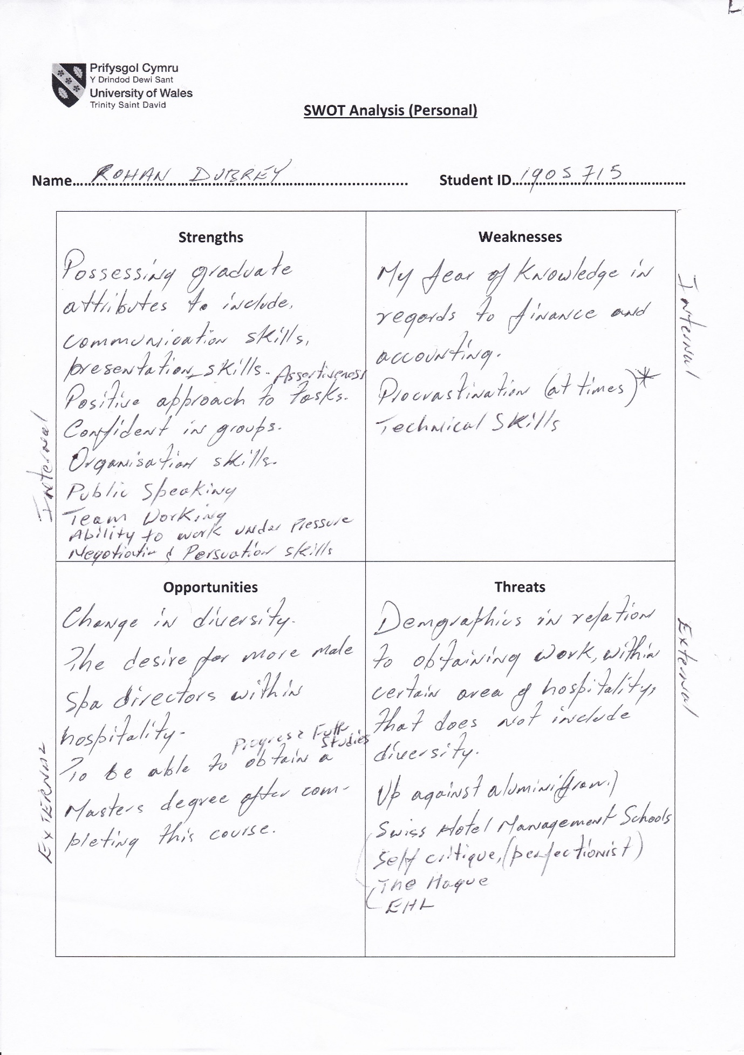

Appendix 2
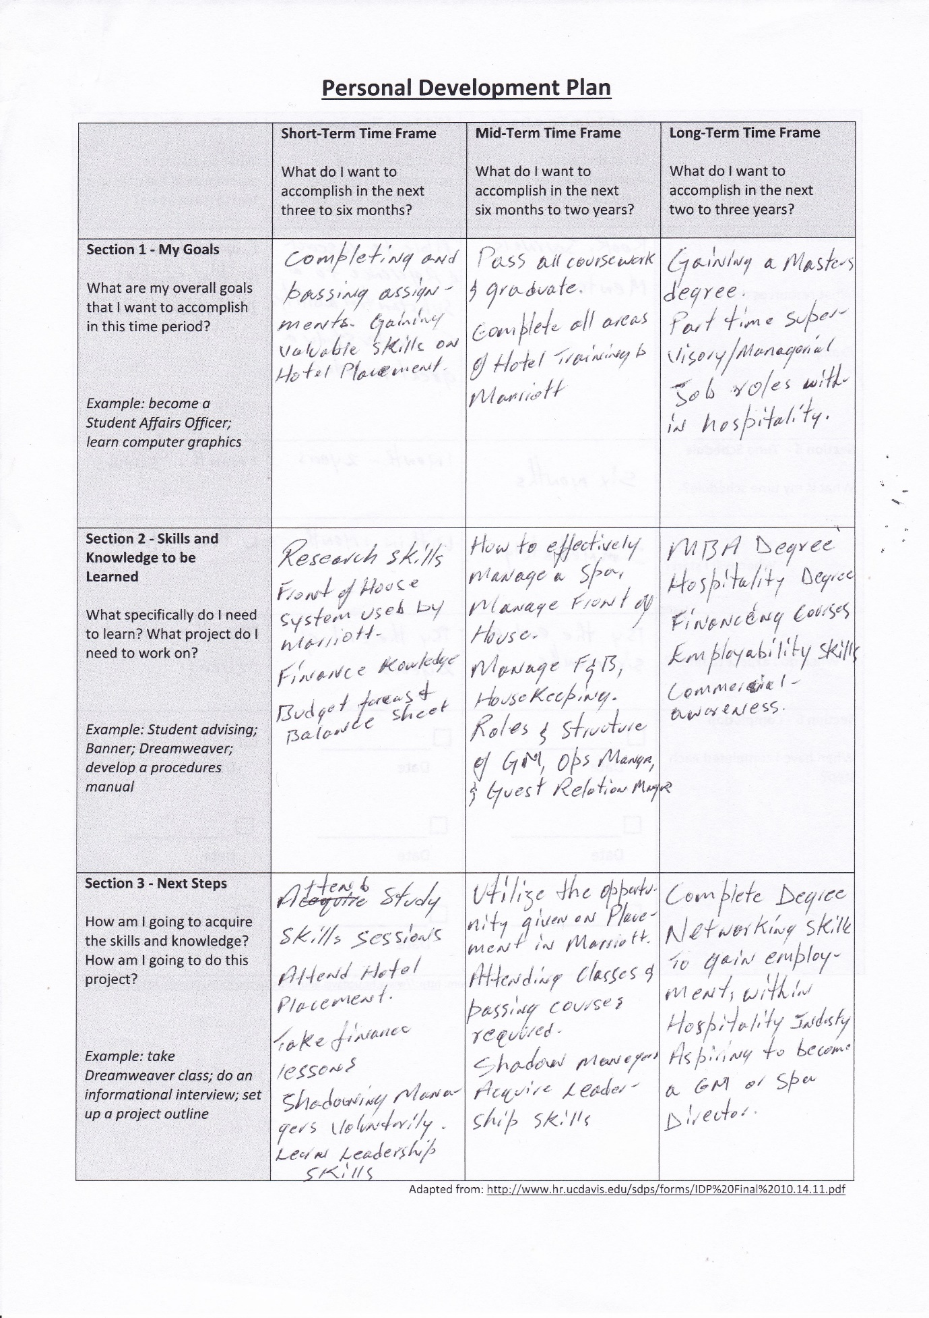

Appendix 2



