

Assessment 1 – Reading Task Template
PART 1: Upload your photo of your A3 in-class notes here:
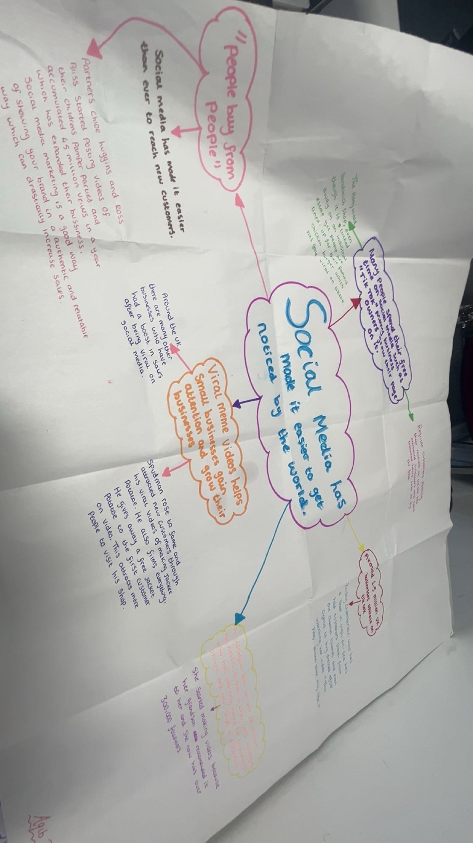

PART 2:
- Answer every question below in 1-3 full sentences.
- Use your own words. Do not use generative AI to answer these questions.
- Include a specific detail from the text when asked.
REMINDER
- The main idea is the overall message of the whole text.
- A key point helps to explain the main idea.
- A specific detail or example from the text shows that the key point is true.

- What is the main idea of the whole text?

To show how social media has become prominent in promotion and that viral videos online help gain attention, which has allowed many businesses to expand and now there are millions of businesses online.

- What is one key point that supports the main idea, and which specific example from the text shows this?
A creator know as spudman rose to fame after posting tiktoks of his spuds and has gained fame and attracted many new customers who travel hours just to try his famous spud.

- What is a different key point that supports the main idea, and which specific example from the text shows this?

Around 1.5 million businesses operate on tiktok in the uk of them is the honywood sandwich shop which even though isn’t in a popular spot still has gained many new customers as viral videos and reviews from other customers help project the business
- Which part of the text do you think is most important, and why?
“people buy from people” this is important because it creates a level of trust between business owners and customers as it shows authenticity.

Reflection:
- What did you find difficult in this task (including in-class components), and why was it difficult? Using mind maps to layout the foundation of your main ideas and the information to support this was difficult because I had to use different skills to get the key information.

- What helped you with this difficulty, and how did it help you? What helped me was the skills I learnt such as skimming, scanning and prediction.

