A Decision Support tool to reduce Care Home admissions to an Emergency Department after a Fall.
Introduction
Falls within Care Homes are one of the most common injuries, resulting in approximately 1 in 3 adults over the age of 65 and 1 in 2 adults over 80 experiencing at least one fall a year (NHS 111 Wales, 2021). Therefore, contributing to around 10% of the calls received by the Ambulance Service each year to triage and transfer a patient to the Emergency Department (Welsh Ambulance Services NHS Trust, 2022). Resulting in an average of 8% of all Emergency Department admissions relating to falls within a Care Home environment for adults over the age of 65 (Wolters et al, 2019). Many of the falls experienced do not result in serious injuries, where admissions to the Emergency Department could be avoided and treatment would be administered by the GP or Community Nursing Team within the Care Home environment.
Processes
When understanding the complexities of each of the processes and the operational activities involved due to a fall, a number of factors must be considered at the point of care with the patient. In the journal Pulset et al (2020) explains that the decision-making process to triage and transfer a patient is complex and is influenced by numerous factors such as medical conditions, frailty, dysphasia, aphasia, patient capacity and medication.
Checkland’s (2000) soft system methodology was applied to gain insight into the overall process from the time a patient falls and the individual processes for each service area. Hence, enabling a structured approach to discover the current problems experienced and establishing whether a digital decision support tool would be beneficial. A rich picture was created to show a visual interpretation of the complete process along with the separate processes for the service areas, where symbols, picture and words were used, this is illustrated in figure 1.
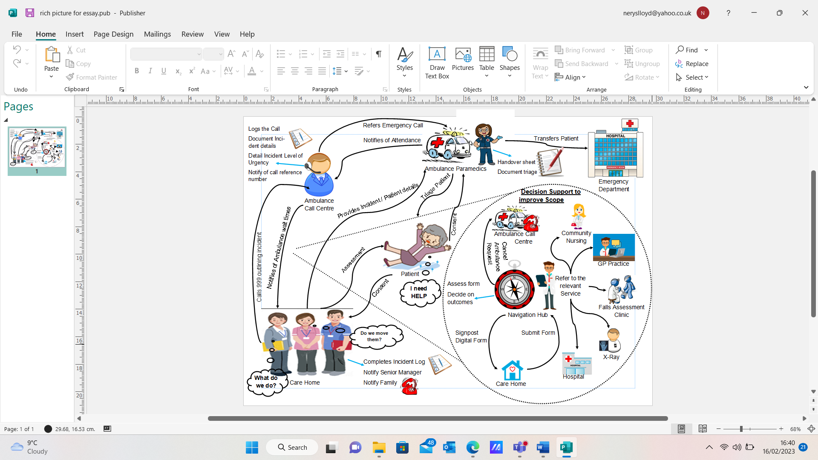
Figure 1 Rich Picture of a Falls Process
The rich picture demonstrates the complexities of assessing a patient who has fallen and outlines the area in scope where the implementation of a decision support aid can be introduced. From applying the methodology, it was noticed that information and knowledge is not actively shared between the services to instigate an effective method of decision-making at each stage of the process. Consequently, the patient experiences repeated questioning along the process, which could hinder the decisions being made at the point of care, where the patient’s health could potentially deteriorate further. Reis da Silva (2023) explains that a patient can encounter physical and psychological affects during and after a fall where their mobility, fear of falling, anxiety or depression, low impact or severe impact injuries, loss of independence can have long term effects.
Care Home Process
Currently, the Care Home staff will contact 999 requesting an ambulance for the patient, where they will relay information relating to the incident and history of the patient. The Care Home staff will ensure the patient is not moved and kept comfortable until the ambulance arrives, not to cause any further injuries (Cooper, 2017). However, Care Homes have access to a digital decision support aid called ISTUMBLE, which can be utilised to assess a patient after a fall, where guidance on when it is appropriate to lift and instructions on how to lift a patient are provided, yet this tool is not widely adopted (Wilson, 2020).
Ambulance Process
By applying the methodology, a two-step process for the Ambulance Services was depicted, where it involves the Ambulance Call Centre and Ambulance Paramedics. The call centre process consists of information of the incident being collated, ongoing care guidance advised, a reference number issued and the expected time of arrival (ETA) notified (Harvey et al, 2021). Therefore, providing the Paramedics with enough information to clarify and initiate active communication with the patient on arrival. The Paramedics will assess the patient to obtain further information relating to the fall to support the decisions that are made on how to lift, treat and whether a transfer to the Emergency Department is required. In the article Mikolaizak et al (2013) states that the decision to transfer to the Emergency Department can be classed as normal practice when an elderly patient falls, as long as the patient consents.
Emergency Department Process
A majority of patients will be transferred to the Emergency department for further assessments to be undertaken for example x-rays, scans and tests, where the Clinicians will decide to discharge or admit the patient. In the journal Leymone et al (2019) identifies that transfers to the emergency department due to a fall within a Care Home are a regular occurrence where 4 out of 5 admissions can be avoided with ongoing care in the community.
Decision Support Tool
A decision support tool would be beneficial to the process where a patient has fallen, as it will enhance the use of the ISTUMBLE App within a Care Home, reduce ambulance requests and reduce the admissions to the Emergency Department. Lytle et al (2015) explains that a decision support tool equips Clinicians, Care providers and patients with knowledge and information at the right point in time in the care pathway to aid decision-making, where it can provide alerts, recommendations and guidance documentation.
The digital decision support tool will be a standalone system, where the Care Home can access an electronic form via a shared web portal by using a QR code or specified access link, using either a static or a mobile device. The design of the digital tool will be based on knowledge-based decision support, which is shown in figure 2.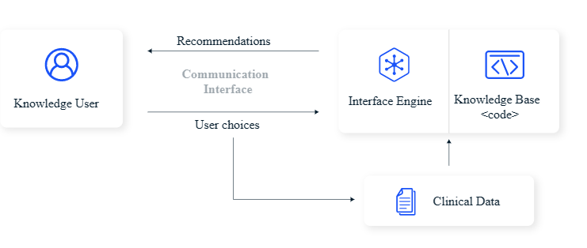
Figure 2 Knowledge-based Decision Support System
In the article Sutton et al (2020) rationalises knowledge based decision support in a practical way where rules are created applying literature-based, practice-based or patient-directed evidence to generate actions or outputs to aid the decision-making process.
The electronic form will require the Care Home staff to enter information regarding the incident, where links will be available for the ISTUMBLE App, guides on manual handling and procedural documents to aid decisions being made during an assessment. Once the assessment has been completed the Care Home staff will submit the digital form electronically via the web portal to the Navigation Hub in the Acute hospital setting, alerting the hub that a patient has fallen. An alert within the decision support system will initiate a review of the digital form, where contact can be made with the Care Home and Ambulance Service on how to proceed with a patient’s care (Abdellatif et al, 2021, p. 987). At any point in time the electronic form can be updated by the Care Home Staff for example if the patient’s condition deteriorates, which will trigger another alert within the Navigation Hub to aid the decision-making process. As a result, enabling the Clinicians to decide whether an ambulance is still required or can that request be cancelled and a referral to a Falls Clinic, Community Nursing, GP or Emergency Department would be most appropriate to aid the patient with recovery.
Advantages and Disadvantages of the Decision Support Tool
A falls decision support system will streamline the process between each of the services where it will enhance the opportunity to share knowledge and information, along with increasing the flow of communication to aid the decision-making process. Jacobsohn et al (2022) express that a decision support tool can provide various functions that can have a positive or negative impact on Clinicians and Patients, where consideration must be placed on how the negative impacts can be alleviated. Table 1 describes the decision support tool functions, advantages, disadvantages and an explanation of how the disadvantages can be overcome.
Table 1 Advantages of a Decision Support Tool, disadvantages and mitigation
Advantages of a Decision Support Tool | Disadvantages of a Decision Support Tool | Mitigation of Disadvantages | Explanation of Mitigation
Patient Safety  Reduces deterioration in health and wellbeing  Improves access to the relevant service to treat a patient  Work Process Improvement  Decision support system will improve access to supporting documentation  Reduces the requirement of Ambulances, limiting the pressure experienced  Improves the use of the ISTUMBLE App  Quality of the falls process is improved  Clinical Decision Support  Decisions are made at the point of care  Improved presentation and access to documentation  Enhances efficiency of Clinicians and Care Home  Financial Costs  Avoiding unnecessary transfers and admissions reducing the resource costs on the services  Reducing the cost of patient length of stays in Acute settings | Alert Fatigue  Too many alerts or alert updates are displayed simultaneously, which could be dismissed  Work Process Disruption  Standalone decisions support systems can cause disruption by having to regularly change between systems  Users Computer Skills  Decision support system may rely on the Users having a competent computer literacy knowledge  Service Management  Can be difficult to maintain links and documentation available in a decision support system | Categorise the alerts to new incident form and updated incident form  Work process modelling  Accessible training  Training materials  Procedures adopted to review content of links and documentation | Selecting appropriate priorities for alerts will reduce alert fatigue  Developed in accordance with work processes and the Users who will be using the system  Face to face training, that is readily available, with adequate resources to aid ongoing support  This will allow for real time updates for the system, where documentation and links are maintained

Literature Review
The literature review follows the Preferred Reporting Items for Systematic Review and Meta-Analyses (PRISMA 2020) statement (Page et al, 2021).
Inclusion and Exclusion Criteria
The aim of the literature review was to establish an understanding of the current decision support tools that are available for Care Homes, Ambulance Services and the Acute hospital environment when an elderly patient experiences a fall. During the review, research was captured around the workflows, processes and the resources available for each of the areas involved. As a result, this review enabled an increased understanding of the advantages and disadvantages of implementing a decision support tool.
The process of identifying the inclusion and exclusion criteria for the review was guided by the Population, Intervention, Comparison, Outcome and Study (PICOS) Framework (Miller and Forrest, 2001) which is presented in table 2.
Table 2 Summary of the PICOS included and excluded in the literature review
 | Inclusion Criteria | Exclusion Criteria
Population | - Patients over 65 years old  - Patients at risk to falls  - Care Homes  - Care Homes with Nursing Care  - Specialised Care Home e.g. Dementia Care  - Ambulance Service Calls for falls within a Care Homes  - Acute Hospital admissions relating to falls within a Care Home  - Services involved in a falls patient care in Acute Hospitals | - Patients under 65 years old  - Inpatients, or patients outside of the Care Home environment that experience falls  - Ambulance calls non related to Care Homes  - Acute Hospital admission non related to Care Homes  - Any conditions that a patient over 65 years old experience not related to a fall
Intervention | - Decision support tools that are being used for falls with elderly patients, Care Homes, Acute settings and Ambulance services  - Any decision support tools that aim to investigate the impacts, barriers and risks of implementation  - Any decision support tool that explains the experiences and effectiveness towards the users | N/A
Comparison | - Compare decision support tools utilised for preventing falls and fall assessments | - No comparison has been made relating to falls in young persons and young adults
Outcomes | - Any outcomes related to the effect of a decision support tool in a Care Home, Acute setting, to direct a patient to a relevant service, lifting a patient after a fall, and requirement needs for an ambulance  - Any outcomes related to the impacts, barriers, user experience of a decision support tool | N/A
Study | - Research that has been conducted in the last 10 years  - Full text Academic documents  - Grey literature e.g. internal documents, conference papers, theses  - Research with high and moderate quality | - Documents with no references  - Documents with only an abstract  - Documents with no abstracts  - Research with very low and low quality
During the literature review references were reviewed to identify additional research that potentially met the inclusion criteria. Previously identified documents referring to decision support tools were reviewed for further information relating to the outcomes defined, were included within the review.
Search Strategy
Databases such as University of Wales Trinity Saint David Library, NHS Wales Library and Google Scholar were utilised to identify relevant academic literature. Google scholar was used as the main source of the research due to the range of resources available and the access to a vast number of online full text documents. In order to establish and gather appropriate research in accordance with the inclusion and exclusion criteria summarised in table 1, the search terms were as follows: (“Care Homes” OR “Ambulance” OR “Emergency Department”) AND (“Falls” OR “Elderly Patient Falls”) AND (“Decision Support Tools” OR “Clinical Decision Support Tools”).
Filters within the databases were applied to reduce the number of search results, to enable appropriate academic documents to be identified. The filters applied to the searches were:
- Creation date of publications – 2010 to present day
- Subject Type – Falls, Older People, Decision Making, Decision Support Systems, Clinical and Primary Care
- Resource Type – Articles, Journals, Books and Dissertations
- Language of literature (English)
Grey literature was considered during the review to assess the types of literature that discussed decision support tools relating to falls. The same search criteria utilised for the academic review was applied to Google, Health Board websites, Governmental websites, Ambulance Service websites and Social Care websites, where unpublished documentation were included in the review. The types of documentation that were captured during this review were conference papers, internal documentation such as strategies or guidance papers and assessment plans.
Selection Process
A structured approach was adopted for the selection process which involved four steps: identifying literature; applying the search criteria to all the databases; duplication review of literature to be excluded and assessing literature by the cited count, titles and abstract in accordance to the inclusion criteria (Tricco et al, 2016). The literature identified after the four steps were implemented, were read in full whilst applying the inclusion criteria required for the research to validate the documents.
Literature Identified
The literature identified during the review is presented in figure 3 (Page et al, 2021).
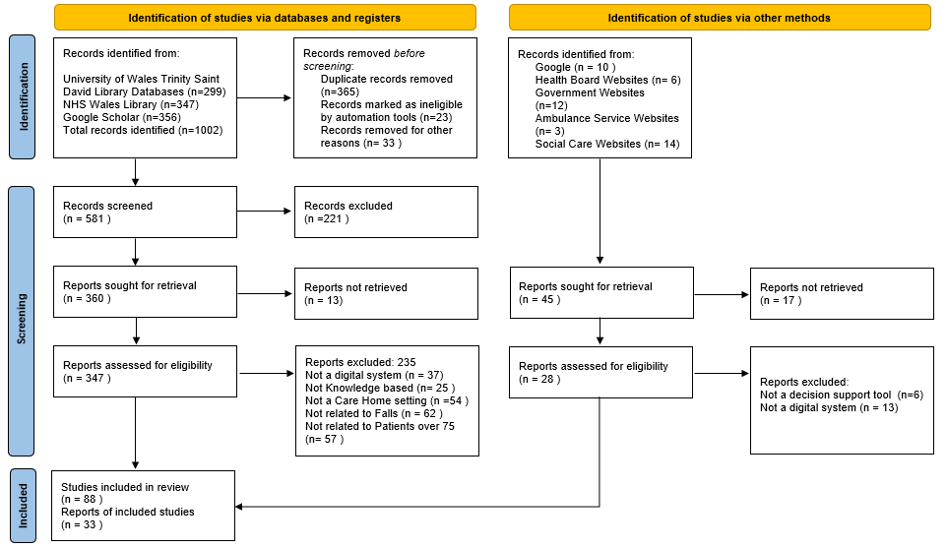
Figure 3 The PRISMA Flow Diagram
The diagram represents the search strategy and the selection process that was utilised, along with explanations for documents that were excluded from the review. A total of 121 documents were identified during the literature review which includes, 112 published documents and 9 grey literature documents.
Of the published documents 31 documents related to falls in a Care Home, 15 documents were identified around the Ambulance service when triaging a fall, 32 documents reported fall admissions and processes within the Emergency Department. Additionally 34 documents were associated with decision support tools regarding falls and similar decision support tools that followed elements of the inclusion criteria. Grey literature relating to decision support tools for elderly patients experiencing falls in a Care Home, was limited and provided an explanation for the processes involved.
The documents retrieved highlighted that there is a lack of knowledge and information sharing where a decision support tool would be beneficial between the services. In the article, Ackerman et al (2022) stated that the vast number of information systems within the Health and Social Care has allowed for integration to take place where a clinical decision support tool can be implemented to aid decision-making. When conducting the literature search it was noticed early on that there were limited documents that included decision support tools for falls in elderly patients. This led to the inclusion criteria being amended to increase the search results to include decision support tools relating to falls for any patients and any decision support tools implemented within Care Homes or the Acute hospital setting.
This enabled research to be obtained from analogous documents referring to barriers, impacts and user experience in relation to a decision support tool. In the journal Halter et al (2011) highlighted the limitations in literature around decision support tools relating to falls in the geriatric population, yet, they found that extending their review to include falls experienced in the younger population provided substantial guidance and comparative studies. The comparable research identified within the review allowed for isolated impacts and experiences to be captured, that would be transferable to a fall’s decision support tool for Health and Social Care.
Quality Assessment
The literature identified within the review were quality assessed using the GRADE approach of the Cochrane Handbook (Higgins et al, 2019). The quality scores assigned to the literature was based on five elements, risk of Bias (Guyatt et al, 2011e), Inconsistency (Guyatt et al, 2011c), Indirectness (Guyatt et al, 2011b), Imprecision (Guyatt et al, 2011a), Publication Bias (Guyatt et al, 2011d). The article type was considered during the grading process, for example, research and journal articles were considered as high quality. When the grading approach was applied the highest score based on the article type was the baseline measure, where the inclusion and exclusion criteria of outcomes were used to obtain information from the documentation following the five elements. A sample of the literature identified and how they were scored is illustrated in table 3.
Table 3 Summary of literature using the GRADING approach to assess quality
Author, Year | Article type | Risk of Bias | Inconsistency | Indirectness | Imprecision | Publication Bias | Quality of Evidence
Lemonyne et al (2019) | Research rticle | Low | Unclear | Low | High | Low | Moderate  ⊕⊕⊕Ο
Ploegmakers et al (2022) | Research Article | High | High | Unclear | Low | Low | Low ⊕⊕ΟΟ
Lytle et al (2015) | Education Article | Low | Low | High | Unclear | Low | Moderate  ⊕⊕⊕Ο
Jacobsohn et al (2022) | Journal Article | Low | Unclear | Low | Unclear | Low | High  ⊕⊕⊕⊕
Abdellatif et al (2021) | Journal Article | Unclear | Low | Low | High | Low | Moderate  ⊕⊕⊕Ο
Lapp et al  (2022) | Review Paper | High | High | High | Low | Low | Very Low  ⊕ΟΟΟ
Osheroff et al (2012) | Research Article | Unclear | High | Unclear | Low | Low | Moderate  ⊕⊕⊕Ο
Laka et al (2021) | Journal Article | Unclear | Low | High | Low | Low | Moderate  ⊕⊕⊕Ο
Cresswell et al, (2012) | Review Paper | Low | Unclear | Low | Unclear | Low | High  ⊕⊕⊕⊕
Snooks et al (2014) | Journal Article | High | Unclear | Unclear | High | Low | Low ⊕⊕ΟΟ
Devaraj et al (2018) | Research Article | Low | Low | Unclear | Low | Low | High  ⊕⊕⊕⊕
Identified Gaps in the Literature
During the review, gaps in the literature were identified in relation to the prospective decision aid of reducing the admissions to the Emergency Department from Care Homes for elderly patients who have experienced a fall. As a result, consideration towards supplementary decision support tools highlighted during the review were adopted as an evidence base to guide the structure of the design, implementation and evaluation. Comparisons between the varying decision support tools available to identify whether alerts, machine learning or whether a knowledge based or non-knowledge based approach would be beneficial.
Implementation Issues
In order to identify the risks and constraints relating to the falls decision support system, two frameworks will be utilised to support the implementation of the new process. These are the Five Rights of Clinical Decision Support (Osheroff et al, 2012) and the Guideline Implementation with Decision Support (GUIDES) checklist (Van de Velde et al, 2018).
The five rights framework is a structured approach to assess whether a decision support system delivers the right information, to the right people, through the right channels, in the right format and at the right time in the work process (Campbell, 2013). Therefore, assisting in the planning of implementation issues for the falls decision support tool by ensuring that each right is addressed, to evaluate the effectiveness of the decision support to the work process.
The concept of the GUIDES checklist is to assist the implementation of a decision support into the work processes through a guideline-based approach which requires an enabling context, appropriate decision support content, an effective system and a successful decision support implementation plan (Van de Velde et al, 2018). As a result enabling the risks and constraints of the falls decision support system to be clearly identified where the effects can be considered.
Risks of a Falls Decision Support System
From applying the two frameworks an analysis of the potential risks identified for the decision support application have been categorised into the following themes;
- Technical
- User Based
- Work Processes
- Knowledge Management
Assessing the risks included in each of these themes will inform the effectiveness and the likelihood of the decision support system’s success, to improve the intended outcomes of the falls process for an elderly patient (Lapp et al, 2022).
Technical
The use of a standalone decision support system was noted as a key risk due to it being perceived as another system which the Users involved in the process will have to use. As a result, the lack of integration between the various systems could deter the acceptance levels of the decision support intervention. Additionally, the risk of accessibility for Users utilising the application will lead to cost implications when considering the devices required to deliver the digital system and the activities that must be completed (Snooks et al, 2014).
User Based
The risks highlighted under this theme refer to the individual characteristics of the Users utilising the decision support system. In the article Ozkaynak et al (2019) highlights that when implementing a digital decision support tool the risks that need to be considered are computer literacy levels, resistance to technology, lack of awareness and understanding of the need for the intervention. Consequently, these risks will inform the development of the training plan required to build confidence in the knowledge base of the Users.
Work Processes
Whilst reviewing the existing work processes for the service areas, risks were established that could potentially have an adverse effect on the successful implementation of a falls decision support tool. Firstly, the decision support tool would be an additional activity incorporated into the existing work process, where it could be perceived as extra work within an already complex and demanding process. Secondly, the manual entry of data required within the system can become time consuming, where it interrupts the care being delivered and the efficiency of the tasks being completed (Ploegmakers et al, 2022). Lastly, the alert functionality in the decision support tool can hinder the work process if they are not easily identifiable to suggest what is new or an update. Resulting in alerts being classed as inappropriate and being dismissed or not actioned in a timely manner.
Knowledge Management
When categorising the risks under this theme the features available in the decision support system for example the ISTUMBLE App, guidance documentation and assessment protocols were examined. A risk was ascertained relating to the maintenance of the knowledge included within the decision support system and how these features would be kept up to date and presented at the appropriate point in the care pathway. In the journal Greenes et al (2018) explains that before any new knowledge can be incorporated into a decision support system, it will need to be validated to ensure accuracy and appropriateness.
To manage the risks of the falls decision support system, the PRINCE2 methodology (Axelos, 2017) regarding risk management will be adopted. The methodology will enable risks to be captured and managed in a structured approach using a risk register, to document, analyse, control and communicate the risks.
Constraints of a Falls Decision Support System
Whilst applying the two frameworks to the decision support system, three areas of constraints were established, these are;
- Governance
- Organisational
- Behavioural Change
In the report NHS England and NHS Improvement (2021) states that a constraint is classed as a limiting factor that can potentially prevent a digital system from achieving it’s intended outcomes and being successfully implemented.
Governance
When capturing patient data and the sharing of patient data between the services through the use of a digital system, the application must adhere to the information governance policies. On the website Hywel Dda University Health Board (2022) explains that information governance is a framework that outlines the ways in which information is controlled and secured, to ensure the data is presented at the right time to the right people when needed. As a result this could have a severe impact on the falls decision support tool due to the patient data being shared between three organisations, where all three information governance policies will have to be followed. As the decision support tool will be utilising a shared web portal between the services, an analysis of the cyber security measures to support the privacy and enable shared access will have to be assessed alongside the information governance policies. Hence, establishing whether honorary contracts between the three service are required to stipulate the guidelines around data capturing, data sharing and the transfer of data.
Organisational
This area of constraint could have a profound impact on the implementation of a falls decision support tool, due to the financial, culture, policies and strategic levels from the three service organisations due to their large organisational structures. As result a key constraint identified was the availability of resources to support the implementation of the decision support tool. Laka et al (2021) states that to achieve a successful implementation of a decision support tool, there must be adequate funding, sufficient staff resources to support training and substantial digital equipment for the Users to utilise once. In addition, the lack of interoperability available because of the three services’ organisational infrastructure will be a constraint on the decision support system. Resulting in the Users capturing the patient’s data more than once in different digital systems because of the organisational policies relating to cyber security and the sharing of information.
Behavioural Change
The constraints highlighted in the governance and organisational areas reflect on the constraints recognised around the physical perceptions perceived by the Users where resistance to change is evident. Additionally, the risks identified can also have a negative impact on the Users’ behaviour to reinforce their resistance towards the decision support system. Resistance to change from a User’s outlook can involve social influences, fear of the unknown, experiences of previous digital systems and reluctance to use the system with the patient (Devaraj et al, 2014). Alternatively, the resistance could be towards the innovation of the decision support system, where the Users are reluctant to engage and contribute. As a result, this will have an impact on the training which is planned for the decision support tool where attendance could potentially be low. Subsequently, the Users might state a of lack of knowledge, lack of confidence in the intervention and a lack of trust.
A Change Management methodology (Smith et al, 2015) will be useful to manage and identify the constraints for the falls decision support system. The methodology can be used to prepare, support and assist individual Users, Teams and organisations to adopt the intended change.
Evaluation
A structured approach to evaluating the falls decision support tool will be developed to assess the user experience, effectiveness, safety and efficiency of the intervention. The evaluation will adopt a systematic and theoretical review of the effects on introducing a decision support tool into the existing work practices to aid the decision-making process when a patient falls, to enable the right decisions to be made for the patient. Cresswell et al (2012) highlights that a methodical evaluation of a decision support system will enable a clear understanding of the effectiveness and efficiency of the initiative to support the improvements in quality and safety of care being delivered.
For an effective evaluation to take place meaningful questions will be created to direct and quantify the approach:
- What is the aim of the evaluation?
- How does a User feel when interacting with the decision support system?
- Did the decision support system display the information in an effective and efficient manner?
- Were the features within the decision support system accessible and useful?
- Did the digital system enhance the decision-making process by reducing ambulance attendances to a Care Home and reduce the admissions to the Emergency Department?
To facilitate an assessment of the proposed questions the following frameworks will be applied, UX Curve (Kujala et al, 2011), Fit Between Individuals, Tasks and Technology (FITT) Framework (Ammenwerth et al, 2006) and the System Usability Scale (Brooke, 1996). A combination of qualitative and quantitative methods will be utilised within these frameworks to collate data to support the assessment of user experience, effectiveness, safety and efficiency of the falls decision support system.
UX Curve Framework
This framework will support the analysis of the user experiences of the decision support tool for all three services involved in the falls process. Kujala et al (2011) highlights that the framework is a straightforward approach to gather data retrospectively on user experience and how user experience is influenced over a period of time. To capture the relevant data, focus groups will be conducted and questionnaires will be devised, where a sample of 10 participants from each of the service areas will be invited to participate.
Two questionnaires will be created where they can be electronically distributed to the sample of Users before and after the focus group sessions. Both questionnaires will follow a standard set of open-ended and closed questions, using a Likert scale to collate the user experience of using the digital system, along with the efficiency and safety experienced by the Users (Diaz-Oreiro et al, 2019). The first questionnaire will initiate the thought process for the Users, enabling them to reflect on their experiences of using the digital intervention from the time it was introduced to the point in time the questionnaire is received. However, the second questionnaire will allow for clarification of what was discussed in the focus groups, to clearly understand the Users’ acceptance and expectations of the decision support system.
Before the focus groups take place a short list of questions will be formed to initiate discussions with the participants, where they can reflect on their experiences of the application. During the focus groups the participants will be given the UX Curve template (Kujala et al, 2011) to draw a curve illustrating their experiences of using the decision support tool and to note the rational for the curves, this is shown in figure 4.
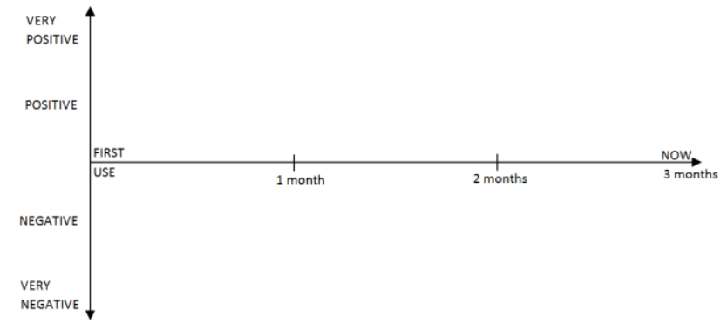
Figure 4 UX Curve Template
The participants will be instructed to draw a curve to demonstrate their thoughts and feelings experienced from the first time the system was used to their current usage. Therefore, facilitating a discussion within the focus groups to describe and explain first impressions as well as the positive or negative experiences of the decision support system. From the data captured within these sessions, an analysis will be conducted to establish any relevant themes and explanations that arise to assess the acceptance, satisfaction and effectiveness of the intervention.
Fit Between Individuals, Tasks and Technology (FITT) Framework
By applying the framework to the evaluation of the falls decision support tool, an assessment can be conducted to identify the effectiveness, efficiency and safety of the system. The relationships between the individual, task and technology will enable a clear understanding of the decision-making process, plus, the effective use of the features available within the system. In the review Lesselroth et al (2011) suggests that the adoption of the FITT framework can distinguish the facilitators and risks for a decision support system to establish the areas of improvement, by identifying whether there is a sufficient fit or an insufficient fit between each of the sections.
When considering the areas involved the three services will be associated with the individual section, the falls decision support tool will be related to the technology section and the new way of working will be classed as the task section. To assess the quality of the fits for each of the sections the following characteristics will be addressed;
- Adoption of the new way of working
- Motivation and interest
- Stability and Usability
- Functionality and complexities of the activities
For the relevant data to be acquired to fully utilise the framework, observational studies and interviews will be carried out.
The observational studies will be conducted in each of the services areas to observe how the Users interact with the digital decision support system when a patient experiences a fall and how it aids their decision-making. A direct observational approach will guide the process of capturing the relevant data, which will also support the data collected via the other frameworks to clarify the outcomes identified. During the observation a checklist will be utilised to capture the experiences, effectiveness and efficiency of the work process, the use of the intervention and the outcomes of the decisions being made (Prgomet et al, 2019).
Interviews will be planned in parallel with the observations where clarification can be gained in the data collated during the observational studies. A semi-structured style of interviewing will instruct the interview process where discussions can be encouraged to elaborate further around isolated areas of the decision support system and its benefits or concerns. In the article McIntosh and Morse (2015) suggests that semi-structured interviews are an ideal approach to determine a User’s perspective and knowledge to a specific subject where an analysis can confirm as well as validate these responses.
System Usability Scale
The usability scale is a tool that can measure how effective a digital system is, by analysing how it is utilised and performs, where patient safety and efficiency are contributing factors (Bloom et al, 2021). This framework involves a survey consisting of 10 standard questions, using a Likert scale where the participants can select one of five responses from strongly agree to strongly disagree. The calculation approach acknowledged in the article by Brooke (1996) will be used, where the odd numbered questions are represented positively and the even numbered questions are represented negatively. When measuring the data collected from the surveys system usability score matrix (Bangor et al 2009) as indicated in figure 5 will be used to assess the falls decision support system.
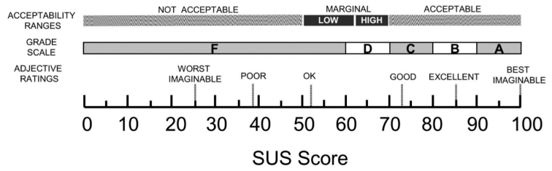
Figure 5 System Usability Score Matrix
Therefore, enabling a constructive analysis of the falls decision support system’s usability, where the effectiveness, efficiency and safety are assessed.
The results obtained during the assessment of the falls decision support system, will be documented in a structured report, where the initial questions that were identified before the assessment are addressed. Additionally, enabling sufficient reasoning and understanding to be documented around user experience, effectiveness, safety and efficiency of the intervention. Recommendation for improvements to the decision support system will be captured at the end of the report to assist the health and social care environments to continually improve their work processes and the digital system, where considerations could be made around interoperability and machine learning.
Conclusion
A digital decision support tool would be advantageous currently to direct patients experiencing the trauma of a fall to the appropriate NHS services. It would reduce the pressures on the Ambulance Services having to respond to calls which could be dealt with on site by alternative methods of diagnosis and treatment. Care Home staff would be confident to utilise the decision support tool as it would become a valid part of their routines relating to patient care after a fall.

Reference List
Abdellatif, A., Bouaud, J., Lafuente-Lafuente, C., Belmin, J. and Séroussi, B. (2021) ‘Computerized decision support systems for nursing homes: a scoping review,’ Journal of the American Medical Directors Association, 22(5), pp.984-994. DOI: 10.1016/j.jamda.2021.01.080
Ackermann, K., Baker, J., Festa, M., McMullan, B., Westbrook, J. and Li, L. (2022) ‘Computerized clinical decision support systems for the early detection of sepsis among pediatric, neonatal, and maternal inpatients: scoping review,’ JMIR Medical Informatics, 10(5), p.e35061. DOI:10.2196/35061
Ammenwerth, E., Iller, C. and Mahler, C. (2006) ‘IT-adoption and the interaction of task, technology and individuals: a fit framework and a case study.’ BMC Medical Informatics and Decision Making, 6(1), pp. 3.
Axelos Global Pest Practice. (2017),Managing Successful Projects with PRINCE2. 6th edn. Norwich: TSO, part of Williams Lea Tag.
Bangor, A., Kortum, P. and Miller, J, (2009) ‘Determining what individual SUS scores mean: Adding an adjective rating scale,’ Journal of usability studies, 4(3), pp. 114-123.
Bloom, B.M., Pott, J., Thomas, S., Gaunt, D.R. and Hughes, T.C. (2021) ‘Usability of electronic health record systems in UK Eds,’ Emergency Medicine Journal, 38(6), pp.410-415. DOI: 10.5061/dryad.7h44j0zsq
Brooke, J. (1996) ‘Sus: a “quick and dirty’usability,’ Usability evaluation in industry, 189(3).
Campbell, R.J. (2013) ‘The five rights of clinical decision support: CDS tools helpful for meeting meaningful use,’ Journal of AHIMA, 84(10), pp.42-47.
Checkland, P. (2000) ‘Soft systems methodology: a thirty year retrospective’, Systems Research and Behavioral Science, 17(S1), pp.11-58.
Cooper, R. (2017) ‘Reducing falls in a care home,’ BMJ Open Quality, 6(1), pp.u214186-w5626. DOI: 10.1136/bmjquality.u214186.w5626
Cresswell, K., Majeed, A., Bates, D.W. and Sheikh, A. (2012) ‘Computerised decision support systems for healthcare professionals: an interpretative review,’ Informatics in Primary Care, 20(2).
Devaraj, S., Sharma, S.K., Fausto, D.J., Viernes, S. and Kharrazi, H. (2014) ‘Barriers and facilitators to clinical decision support systems adoption: A systematic review,’ Journal of Business Administration Research, 3(2), p.36. DOI:10.5430/jbar.v3n2p36
Díaz-Oreiro, I., López, G., Quesada, L. and Guerrero, L.A. (2019) ‘Standardized questionnaires for user experience evaluation: A systematic literature review,’ Multidisciplinary digital publishing institute proceedings, 31(1), p.14. DOI:10.3390/proceedings2019031014
Greenes, R.A., Bates, D.W., Kawamoto, K., Middleton, B., Osheroff, J. and Shahar, Y. (2018) ‘Clinical decision support models and frameworks: seeking to address research issues underlying implementation successes and failures,’ Journal of biomedical informatics, 78, pp.134-143. DOI: 10.1016/j.jbi.2017.12.005
Guyatt, G.H., Oxman, A.D., Kunz, R., Brozek, J., Alonso-Coello, P., Rind, D., Devereaux, P.J., Montori, V.M., Freyschuss, B., Vist, G. and Jaeschke, R. (2011a) ‘GRADE guidelines 6. Rating the quality of evidence—imprecision,’ Journal of clinical epidemiology, 64(12), pp.1283-1293. DOI: 10.1016/j.jclinepi.2011.01.012
Guyatt, G.H., Oxman, A.D., Kunz, R., Woodcock, J., Brozek, J., Helfand, M., Alonso-Coello, P., Falck-Ytter, Y., Jaeschke, R., Vist, G. and Akl, E.A. (2011b) ‘GRADE guidelines: 8. Rating the quality of evidence—indirectness,’ Journal of clinical epidemiology, 64(12), pp.1303-1310. DOI: 10.1136/emj.2009.079566
Guyatt, G.H., Oxman, A.D., Kunz, R., Woodcock, J., Brozek, J., Helfand, M., Alonso-Coello, P., Glasziou, P., Jaeschke, R., Akl, E.A. and Norris, S. (2011c) ‘GRADE guidelines: 7. Rating the quality of evidence—inconsistency,’ Journal of clinical epidemiology, 64(12), pp.1294-1302. DOI: 10.1016/j.jclinepi.2011.03.017
Guyatt, G.H., Oxman, A.D., Montori, V., Vist, G., Kunz, R., Brozek, J., Alonso-Coello, P., Djulbegovic, B., Atkins, D., Falck-Ytter, Y. and Williams Jr, J.W. (2011d) ‘GRADE guidelines: 5. Rating the quality of evidence—publication bias,’ Journal of clinical epidemiology, 64(12), pp.1277-1282. DOI: 10.1016/j.jclinepi.2011.01.011
Guyatt, G.H., Oxman, A.D., Vist, G., Kunz, R., Brozek, J., Alonso-Coello, P., Montori, V., Akl, E.A., Djulbegovic, B., Falck-Ytter, Y. and Norris, S.L. (2011e) ‘GRADE guidelines: 4. Rating the quality of evidence—study limitations (risk of bias),’ Journal of clinical epidemiology, 64(4), pp.407-415. DOI: 10.1016/j.jclinepi.2010.07.017
Halter, M., Vernon, S., Snooks, H., Porter, A., Close, J., Moore, F. and Porsz, S. (2011) ‘Complexity of the decision-making process of ambulance staff for assessment and referral of older people who have fallen: a qualitative study,’ Emergency Medicine Journal, 28(1), pp.44-50.
Harvey, C., Froggatt, S., Lightowler, B. and Hodge, A. (2021) ‘The ambulance service advanced practitioner's role in supporting care homes: a qualitative study of care staff experiences,’ British Journal of Healthcare Management, 27(8), pp.1-8. DOI: 10.12968/bjhc.2020.0145
Higgins, J.P., Thomas, J., Chandler, J., Cumpston, M., Li, T., Page, M.J. and Welch, V.A. eds. (2019) ‘Cochrane handbook for systematic reviews of interventions,’ John Wiley & Sons.
Hywel Dda University Health Board (2022) Information Governance and Caldicott. Available at: https://hduhb.nhs.wales/about-us/governance-arrangements/freedom-of-information/guide-to-our-information/information-governance-and-caldicott (Accessed: 20th February 2023)
Jacobsohn, G.C., Leaf, M., Liao, F., Maru, A.P., Engstrom, C.J., Salwei, M.E., Pankratz, G.T., Eastman, A., Carayon, P., Wiegmann, D.A. and Galang, J.S. (2022) ‘Collaborative design and implementation of a clinical decision support system for automated fall-risk identification and referrals in emergency departments,’ Healthcare, 10(1), pp. 100598. DOI: 10.1016/j.hjdsi.2021.100598
Kujala, S., Roto, V., Väänänen-Vainio-Mattila, K., Karapanos, E. and Sinnelä, A. (2011) ‘UX Curve: A method for evaluating long-term user experience,’ Interacting with computers, 23(5), pp.473-483. DOI: 10.1016/j.intcom.2011.06.005
Laka, M., Milazzo, A. and Merlin, T. (2021) ‘Factors that impact the adoption of clinical decision support systems (CDSS) for antibiotic management,’ International journal of environmental research and public health, 18(4), p.1901. DOI:10.3390/ijerph18041901
Lapp, L., Egan, K., McCann, L., Mackenzie, M., Wales, A. and Maguire, R. (2022) ‘Decision support tools in adult long-term care facilities: scoping review,’ Journal of Medical Internet Research, 24(9), p.e39681. DOI:10.2196/39681
Lemoyne, S.E., Herbots, H.H., De Blick, D., Remmen, R., Monsieurs, K.G. and Van Bogaert, P. (2019) ‘Appropriateness of transferring nursing home residents to emergency departments: a systematic review,’ BMC geriatrics, 19(1), pp.1-9. DOI:10.1186/s12877-019-1028-z
Lesselroth, B.J., Yang, J., McConnachie, J., Brenk, T. and Winterbottom, L. (2011) ‘Addressing the sociotechnical drivers of quality improvement: a case study of post-operative DVT prophylaxis computerised decision support,’ BMJ quality & safety, 20(5), pp.381-389. DOI: 10.1136/bmjqs.2010.042689
Lytle, K.S., Short, N.M., Richesson, R.L. and Horvath, M.M. (2015) ‘Clinical decision support for nurses: a fall risk and prevention example,’ CIN: Computers, Informatics, Nursing, 33(12), pp.530-537. DOI: 10.1097/CIN.0000000000000192
McIntosh, M.J. and Morse, J.M. (2015) ‘Situating and constructing diversity in semi-structured interviews,’ Global qualitative nursing research, 2, p.2333393615597674. DOI: 10.1177/2333393615597674
Mikolaizak, A.S., Simpson, P.M., Tiedemann, A., Lord, S.R. and Close, J.C. (2013) ‘Systematic review of non‐transportation rates and outcomes for older people who have fallen after ambulance service call‐out,’ Australasian journal on ageing, 32(3), pp.147-157. DOI:10.1111/ajag.12023
Miller, & Forrest, J. L. (2001). Enhancing your practice through evidence-based decision making: PICO, learning how to ask good questions. The Journal of Evidence-Based Dental Practice, 1(2), 136–141. DOI:10.1016/S1532-3382(01)70024-3
NHS 111 Wales (2021) Falls. Available at: https://111.wales.nhs.uk/encuclopaedia/f/article/falls (Accessed: 15th February 2023)
NHS England and NHS Improvement (2021) Online Library of Quality, Service Improvement and Redesign tools: Theory of constraints. Available at: https://www.england.nhs.uk/wp-context/uploads/2021/12/qsir-theory-of-constraints.pdf (Accessed: 19th February 2023)
Osheroff, J.A., Teich, J.M and Levick, D. (2012) Improving Outcomes with Clinical Decision Support: An Implementer’s Guide. 2nd edn. Chicago IL: Healthcare Information and Management Systems Society (HIMSS). DOI:10.4324/9780367806125
Ozkaynak, M., Reeder, B., Drake, C., Ferrarone, P., Trautner, B. and Wald, H. (2019) ‘Characterizing workflow to inform clinical decision support systems in nursing homes,’ The Gerontologist, 59(6), pp.1024-1033. DOI: 10.1093/geront/gny100
Page, M.J., McKenzie, J.E., Bossuyt, P.M., Boutron, I., Hoffmann, T.C., Mulrow, C.D., et al. (2021) The PRISMA 2020 statement: an updated guideline for reporting systematic reviews. BMJ 2021; 372:n71.doi:10.1136/bmj.n71
Ploegmakers, K.J., Medlock, S., Linn, A.J., Lin, Y., Seppälä, L.J., Petrovic, M., Topinkova, E., Ryg, J., Mora, M.A.C., Landi, F. and Thaler, H. (2022) ‘Barriers and facilitators in using a clinical decision support system for fall risk management for older people: a European survey,’ European geriatric medicine, 13(2), pp.395-405. DOI:10.1007/s41999-021-00599-w
Prgomet, M., Georgiou, A., Callen, J. and Westbrook, J. (2019) ‘Fit Between Individuals, Tasks, Technology, and Environment (FITTE) Framework: A Proposed Extension of FITT to Evaluate and Optimise Health Information Technology Use.' Studies in health technology and informatics, 264, pp. 744-748. DOI:10.3233/SHTI190322
Pulst, A., Fassmer, A.M. and Schmiemann, G. (2021) Unplanned hospital transfers from nursing homes: who is involved in the transfer decision? Results from the HOMERN study,’ Aging Clinical and Experimental Research, 33, pp.2231-2241. DOI:10.1007/s40520-020-01751-5
Reis da Silva, T.H. (2023) Falls assessment and prevention in the nursing home and community. British journal of community nursing, 28(2), pp.68-72. DOI:10.12968/bjcn.2023.28.2.68
Smith, R., King, D., Sidhu, R., Skelsey, D. (2015), The Effective Change Manager’s Handbook: Essential Guidance to the Change Management Body of Knowledge. London, Philadelphia, Daryaganj: Kogan Page
Snooks, H.A., Carter, B., Dale, J., Foster, T., Humphreys, I., Logan, P.A., Lyons, R.A., Mason, S.M., Phillips, C.J., Sanchez, A. and Wani, M. (2014) ‘Support and Assessment for Fall Emergency Referrals (SAFER 1): cluster randomised trial of computerised clinical decision support for paramedics,’ PloS one, 9(9), p.e106436. DOI: 10.1371/journal.pone.0106436
Sutton, R.T., Pincock, D., Baumgart, D.C., Sadowski, D.C., Fedorak, R.N. and Kroeker, K.I. (2020) ‘An overview of clinical decision support systems: benefits, risks, and strategies for success,’ NPJ digital medicine, 3(1), p.17. DOI:10.1038/s41746-020-0221-y
Tricco, A.C., Lillie, E., Zarin, W., O’brien, K., Colquhoun, H., Kastner, M., Levac, D., Ng, C., Sharpe, J.P., Wilson, K. and Kenny, M. (2016) ‘A scoping review on the conduct and reporting of scoping reviews,’ BMC medical research methodology, 16, pp.1-10. DOI:10.1186/s12874-016-0116-4
Van de Velde, S., Kunnamo, I., Roshanov, P., Kortteisto, T., Aertgeerts, B., Vandvik, P.O. and Flottorp, S. (2018) ‘The GUIDES checklist: development of a tool to improve the successful use of guideline-based computerised clinical decision support,’ Implementation Science, 13(1), pp.1-12. DOI:10.1186/s13012-018-0772-3
Welsh Ambulance Services NHS Trust (2022) Falls Information. https://www.ambulance.wales.nhs.uk/Default.aspx?pageld=205&lan=en (Accessed:15th February 2023)
Wilson, G (2020) Tips for Managing Falls in Care Homes. https://www.vivid.care/advice-tips/tips-managing-falls-care-homes/#stumble (Accessed:16th February 2023)
Wolters, A., Santos, F., Lloyd, T., Lilburne, C. and Steventon, A. (2019) ‘Emergency admissions to hospital from care homes: how often and what for? London: Health Foundation. Available at: https://alumni.health.org.uk/sites/default/files/upload/publications/2019/Emergency-admissions-from-care-homes-IAU-Q02.pdf (Accessed: 16th February 2023)

