Sunday, 4th June 2023 | LAMPETER POST |  |  | Issue#13
Layla Omar-Davies

Women’s March 2017: Facebook meets Feminists
Can social media be an influential political agent within social movements?
It is perhaps a fever dream close to lunacy that Donald Trump intends to run for presidency once again in 2024 after the millions who marched in protest of his last term in office. With accusations of sexual assult, election fraud, falsifying business records, inciting insurection and not one but two impeachments attached to his name, it would seem another term as president would be off the table. However, for some inconvivable reason he appears so have maintained some popularity with voters, having a 43% favourability rating in June 2022. One Trump supporteer went as far as to say it is ‘a great thing’ that Trump will be running for presidency again. 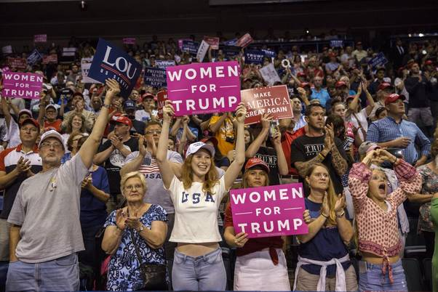  ‘Women for Trump’ signs at 2018 midterm elections – Photo by Victor, J. (A)  Trump also manages to dominate political headlines, albit not always for positive reasons, over 2 years after leaving office. However, some Republicans have lost faith in him and no longer believe that he is the ‘future of America’.  Dissatisfaction with Trump’s administration and his ideals is not a new problem for the former president. We only have to look back at his first day in office, January 21st 2017, to see national and international distaste for comments he made during his electoral campaign and presidency when over 4.1 million Americans and 300,000 people world-wide took to the streets in protest of Trump’s presidency, according to statistics released by the Washington Post. This was due to the vulgar language used by the presidential candidate, specifically in objectifying and belidling women, throughout his campaign.  Discontemptment with the sociopolitical environment that was inflicted upon the nation by Trump’s presidency prompoted American lawyer and grandmother, Taresa Shook to add to the online discourse about the ourage regarding the election outcome.  The Women’s March emerged in response to Trumps objectification of women throughout his presidential campaign. His endless insults about womens looks and intellectuality as well as the leaked tape recording where he |  | boasted about forcing himslef on a woman which he wrote off as ‘locker-room talk’, threatened to reverse progress made to womens rights. Something had to be done.  Information Distribution on Social Media  ‘I think we should march.’  ‘I think we should march’; the entirety of the facebook post which sparked millions to take part in what became known as the Women’s Marches on January 21st 2017.  The day following Trump’s election, November 9th 2016, Shook posted these now famous words to private facebook group, Pansuit Nation, run by Libby Chamberlin. Pantsuit Nation had begun as a pro-Hilary Clinton group set up on October 20th 2016. Chamberline says it was a platform to allow women ‘to be excited about the moment and the fact that a woman was a nominee for a major party’. Little did she know Pantsuit Nation would become a major platform which ignighted the largest one day protest in US history.  This is how the idea for the Women’s March originated on social media, immediantly giving it an international audience. Social media allowed for rapid information desperison on an international scale about the threat Trump’s presidency held to marginalised groups which caused support for the Women’s March to be quickly accumulated based on main concerns of racism, xenophobia, misoginy and islamophobia.  After receiving a positive response to a possible marching protest, Shook created a private Facebook events page for the march which gained over 300,000 users’ interest within the first 24 hours.  ‘Social media makes information available at a magnitude that traditional media could not even dream of.’ -Gilbert, 2021  By promoting the Women’s March online, this allowed for it to reach a wider audience of people from all over the states and those with a variety of different backgrounds. CBS reports individuals flooding into Washington DC from Connecticut, Kentucky, California, Colorado, and Ohio. Furthermore, Variety Magazine recorded ‘Vietnam veterans, nuns, Muslims, suffragettes, three generations of Latinx activists, black | queer folks, trans people, female artists of colour, mothers, daughters, women of size in love, and people marching in wheelchairs.’  It is hard to disagree that social media played a central role in mobilizing the march participants. Especially with an estimated 70% hearing about the march through Facebook and an additional 13% learning about it on Twitter. Therefore, without the Women’s March having an online community, the movement may not have gained such widespread support which was necessary for it to be effective in terms of its overwhelming presence and support between protestors in advocating for feminist related issues.  Organisation and Planning  By using an online RSVP system, this gave march organisers an expectation on march attendance numbers, allowing them to more easily secure permits and avoid logistical issues. This simplified the organisation and co-ordination of such a large group of protesters by creating a clear plan on what, when and where protest events would be taking place across the states.  One big Facebook group was created for the national event along with separate pages for each of the Women’s Marches occurring in all fifty American states.  It was reported that this organisation prompted people who would not usually participate in marches to join the protest because the online planning process laid out exactly what would be occuring during the march. March organisers also commented on this saying that social media streamlined the march and made participation much easier.  Social media also allowed New York organisers an incite into the unexpected volume of protestors on the day. This prompted them to change the direction of the march and notify protestors through social media, on the day to accommodate for the large turn out, keeping everyone safe.  By using the online platforms, smaller protest movements were co-ordinated to support the Women’s March. The Pussyhat Project was created by some protestors and took off on social media. It was an effort to reclaim the term ‘pussy’ in response to Donald Trump’s derogitory 2005 statement, ‘grab them by the pussy’  The project had such a positive response on social media, a website was created dedicated to providing crochet and knitting
Page 7
Sunday, 4th June 2023 | LAMPETER POST |  |  | Issue #13
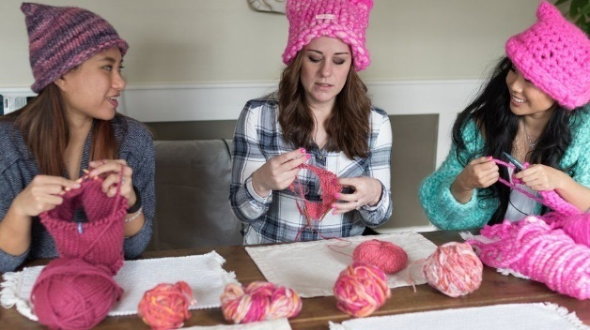  patterns to create the pink wool hats. It was reported that over 100,000 downloads of the patterns were made.  Some members of the pussy hat project team crocheting extra hats in preparation for the Women’s March, image by Stefanie Kamerman (B)  Multiple Online Voices  The day before the event, the Women’s March website listed over 400 organisational parteners. This gave rise to pre protest online discourse where the movement could evolve because there was not just one voice making all the decisions and the march became more inclusive.  The online popularity of the Women’s March sparked celebrity involvement in the protest. An official list of speakers was released prior to the march including Gloria Steinem and Scarlett Johansson. Steinem delivered the famous line ‘Our constitution does not begin with ‘I, the President.’ It begins with, ‘We, the People.’’ during her speech to the crowd of protestors in Washington DC.  Stars with large online following such as Blake Lively, Zendaya and Emma Watson also posted about the Women’s March on social media to raise awareness of the protest.  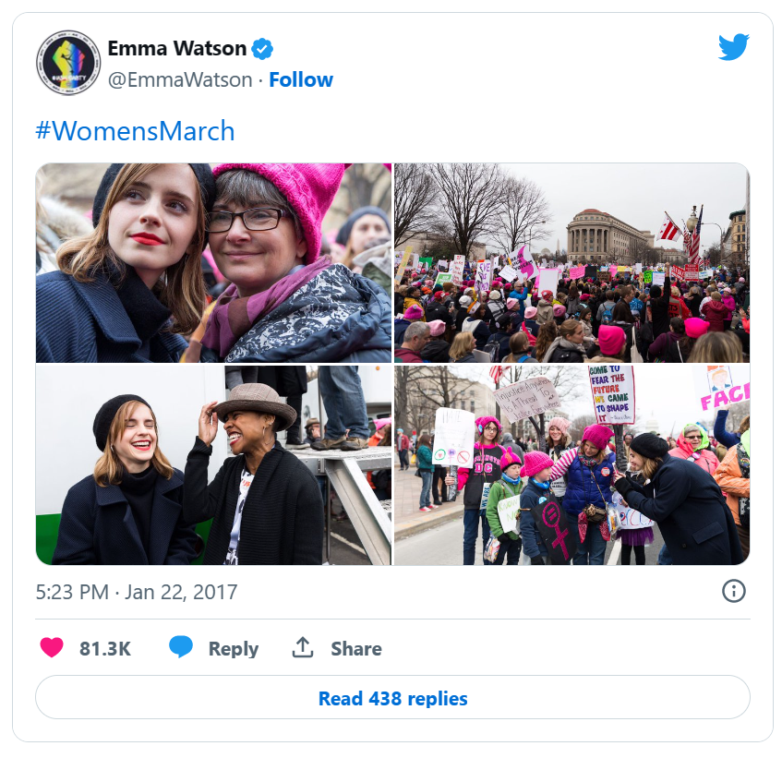  By having A-list names associated to the Women’s March, this skyrocketed its public credibility and widened the reach of the protests message by having it dispersed to various celebrity fandoms and followers.  celebrity activists  To begin with, all march organisers were white women which raised concerns the diversity of the protestors who would be attending the march. After this concern  Emma Watson’s twitter post the day following the Women’s March. (C) |  | was posted online three women of colour who were prominent and experienced activists joined the Women’s March as national co-chairs to create a more inclusive image for the march.  However, how effective was this tactic to help with the lack of representation? For indigineous communities it would seem there was still an atmosphere of exclusion. The movie ‘Women’s March’ follows a young indigious women’s experience of the march where she, and those in her community, felt segrigated from the main protest so held their own ‘micro-protest’ called the Indiginous Woman’s March, still fighting for womens rights but with indiginous inclusion in the protest, in support of the main Women’s March.  Although pre protest discourse on social media did help address issues of racial inclusion, it perhaps was not so effective at representing minority groups whom did not feel wholly apart of the Women’s March community. Interestingly, when discussing issues of inclusion online, there is a lack of disscussion on indiginous exclusion from the march perhaps showing mainstream ignorance towards these smaller communities.  Along with the march organisers, the protests name was also altered due to social media influence. Originally called the ‘Million Women March’ this was changed due to its similarity to the name of the 1997 Philadelphia protest which thousands of African American women participated in, the Million Woman March. It was on social media that this link was first made which ultimatly lead to the renaming of the Women’s March 2017.  Feminist Therapy  The Women’s march has been described as ‘theraputic on a macro scale’ and ‘a global scream for catharsis’, however, is this a one time thing? With a second Trump presidency on the horizon, I surely hope not!  Actress, Scarlett Johansson addressed the need for sustained action in her speech at the Washington DC Women’s March. She described Trump’s inaugaration as ‘an opportunity [that] has presented itself to make real long-term change’ in terms of protecting women’s rights. Perhaps implying that Trump’s presidency had been a wake up call to all feminists that we cannot become complacent with the progress to womens rights that generations before us have fought for.  Post-march, the question now is, how to keep up the fight? There are some ways that the Women’s March has triggered sustainable resistance not only against Trump’s presidency but also to advocate for feminism.  To begin with, Women’s March organizers prefer to describe their 2017 protest as the start of a resistance movement rather than a single-day demonstration. This appears to have | come to fruition as over 6 years after the original protest, the Women’s March community remains active on twitter and continues planning protests around the USA with a mission of ‘dismantling systems of oppression through nonviolent resistance’.  However, the many local groups and major parties dropped out of the national organisation after two of its organisers drew online critism for their support of sexist and anti-semite Louis Farrakhan. This was enough for the media to smear the entire Women’s March movement which went from being praised to trolled within just 2 years.  By turning the clock back to 2017 and taking a deep dive into the first Women’s March, I have been able to determine for myself the role social media played in this movement. My understanding is that social media played a highly important role within the protest from election day 2016 until the day of the Women’s March 2017.  ‘Contemporary social movements such as… the Arab Spring, the Egyptian Revolution and Occupying Wall Street, would not have occurred without the support and influence of social media.’ -Leiser Silva  It had a shorterm impact making the planning and organisation of such a large group more managable because organisers could estimate attendance and easily get plans for the march out to protestors through various social media channels. It acted as a useful political agent in calling attention to problems within society, specifically those effecting women, and attributing these problems to their causes through informative online posts spreading awareness about the movement. By improving peoples knowledge of injustice against women this created anger which prompted nearly 5 million people to join the Women’s March.  Therefore, I do believe that by promoting the Women’s March on social media, this allowed organisers to reach a larger audience causing a higher volume of protestors which made the march more effective because protests carry strength in numbers as this shows the amount of people who are in agreement with the ideas driving the protest which can give the movement credibility.  The long-term impact of social media on the womens march is more limited. It appears to be geared towards raising awareness for feminist related issues rather than physical action so is hard to measure its impact. Although the Women’s March Twitter profile has over 500,000 followers it is impossible to know how many people visit and interact with the profile in a way which develops their understanding over womens rights.
Page 8
Reference list
CBS Sunday Morning. (2017) Historic Women’s March on Washington. 22 January. Available at: (277) Historic Women's March on Washington - YouTube (Accessed: 28 May 2023).
Chapin, E. (2018) 2017 Women’s March: One Year Later. Available at: 2017 Women’s March: One Year Later (mcny.org) (Accessed: 27 May 2023).
Chira, S. (2020) ‘Donald Trump’s Gift to Feminism: The Resistance’, Daedalus, 149(1), pp. 72-85. Available at: Donald Trump’s Gift to Feminism: The Resistance | American Academy of Arts and Sciences (amacad.org) (Accessed: 30 May 2023).
Garfield, L. (2017) ‘Thousands of women will wear pink ‘pussy hats’ the day after Trump’s inauguration’, Insider, (January 18). Available at: Thousands of Women Will Wear Pink 'Pussy Hats' for Women's March on Washington (businessinsider.com) (Accessed: 4 May 2023).
Gilbert, E. (2021) ‘The Role of Social Media in Protests: Mobilizing or Polarizing?’, Initiative, (6 April). Available at: The Role of Social Media in Protests: Mobilising or Polarising? - 89 Initiative | The first European think-do tank (Accessed: 30 May 2023).
History.com Editors. (2021) ‘Women’s March’, History, (19 January). Available at: Women’s March (history.com) (Accessed: 28 May 2023).
Kearney, L. (2016) ‘Hawaii grandma’s plea launches women’s march in Washington’, Returners, (5 December). Available at: Hawaii grandma's plea launches women's march in Washington | Reuters (Accessed: 28 May 2023).
Kuper, S. (2018) ‘How Pantsuit Nation founder Libby Chamberlain took on Trump’, FT Magazine, (12 October). Available at: How Pantsuit Nation founder Libby Chamberlain took on Trump | Financial Times (ft.com) (Accessed: 28 May 2023).
Ovide, S. (2020) ‘How Social Media Has Changed Civil Rights Protests’, The New York Times, (18 June). Available at: How Social Media Has Changed Civil Rights Protests - The New York Times (nytimes.com) (Accessed: 29 May 2023).
Silva, L. (2019) Social Media and Social Movements: A case of Women’s March, Sweden: 27th European Conference on Information Systems. Available at: SOCIAL MEDIA AND SOCIAL MOVEMENTS: A CASE OF WOMENâ•ŽS MARCH (core.ac.uk) (Accessed: 29 May 2023).
Stein, P. (2017) ‘The woman who started the Women’s March with a Facebook post reflects: ‘It was mind boggling’, The Washington Post, (31 January). Available at: The woman who started the Women’s March with a Facebook post reflects: ‘It was mind-boggling’ - The Washington Post (Accessed: 28 May 2023).
Tate, A. (2017) ‘The Women’s March Was Therapy’, Advocate, (24 January). Available at: The Women's March Was Therapy (advocate.com) (Accessed: 27 May 2023).
Wang, G.S. (2023) ‘A Guide to Understanding the Correlation Between Social Media and Protest’, The London School of Economics and Political Science, 15 February. Available at: https://blogs.lse.ac.uk/lseupr/2023/02/15/a-guide-to-understanding-the-correlation-between-social-media-and-protest/ (Accessed: 29 May 2023).

Webber, K.M., Dejmanee, T. and Rhode, F. ‘The 2017 Women’s March on Washington: An Analysis of Protest-Sign Messages’, International Journal of Communication, 12(2018), pp 2289-2313. Available at: 2363-libre.pdf (d1wqtxts1xzle7.cloudfront.net) (Accessed: 29 May 2023).
Women’s March (2017) Directed by M. Hedges. Available at: Prime Video (Accessed: 28 May 2023).

Image A - Women Who Love Trump - WSJ
Image B - 'Pussyhat' knitters join long tradition of crafty activism - BBC News
Image C - https://twitter.com/EmmaWatson/status/823219563567398912?s=20

