Final Maths Exam 2021-2022

Oluwayomi Ogunfiditimi 2116187
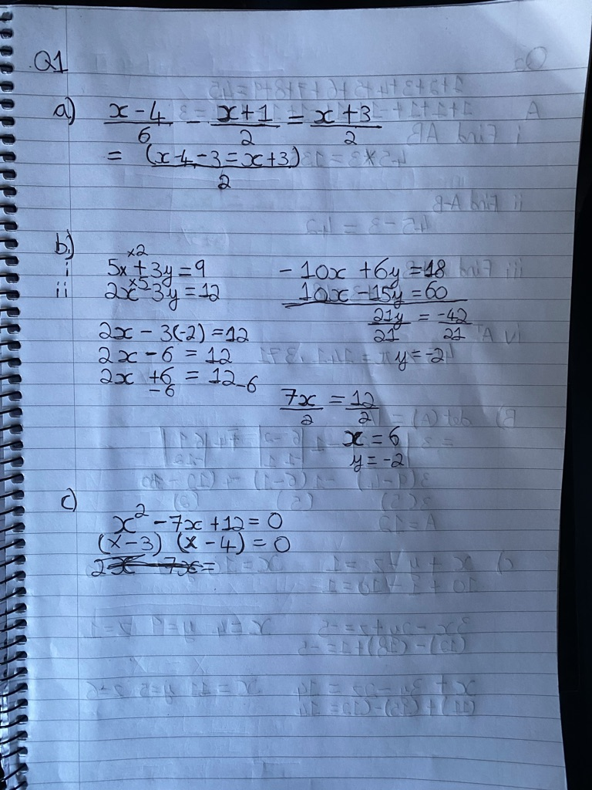
BEng Electrical & Electronic Engineering



