Joe Doyle
2103077
HND Web Development
operating systems Assignment

Contents
Key Functions of General Operating Systems 2
Use of Windows OS CLI commands 2
Use of Linux OS CLI commands 9
Use of Windows OS scripts 10
Use of Linux OS scripts 11
Appendices 11
References 12
Conclusion 12

Key Functions of General Operating Systems
[1]A general operating system is a software program that manages a computer's hardware and software resources and provides common services for computer programs. Some of the key functions of a general operating system include:
- Process management: The operating system manages the execution of multiple processes on a computer. It allocates resources such as memory and CPU time to each process and ensures that they run smoothly without interfering with each other.
- Memory management: The operating system manages the computer's memory, including allocating and deallocating memory for processes, managing virtual memory, and implementing memory protection.
- File management: The operating system manages files and directories on a computer's storage devices. It provides functions for creating, deleting, moving, and renaming files and directories, as well as functions for reading and writing data to files.
- Device management: The operating system manages input/output devices such as keyboards, mice, and printers. It provides device drivers that enable programs to interact with these devices.
- Security management: The operating system provides security features to protect the computer and its data from unauthorized access. It provides user authentication, file permissions, and access control mechanisms.
- Networking: The operating system provides networking features to enable communication between computers. It provides protocols for sending and receiving data over the network, as well as functions for configuring network settings.
- User interface: The operating system provides a user interface that enables users to interact with the computer. This may include a command-line interface or a graphical user interface.

Use of Windows OS CLI commands
The Windows operating system has a command-line interface (CLI) that allows users to perform various tasks using text commands. Here are some commonly used Windows CLI commands and their uses:
- cd - Changes the current directory.
- dir - Displays a list of files and folders in the current directory.
- type - Displays the contents of a file on the screen.
- md - Creates a new directory.
- copy - Copies one or more files from one location to another.
- del - Deletes one or more files.
- ipconfig - Displays the current IP configuration for all network adapters.
- netstat - Displays active network connections and their status.
- Ping - Tests connectivity to a network host by sending ICMP echo packets.
- tasklist - Displays a list of currently running processes.
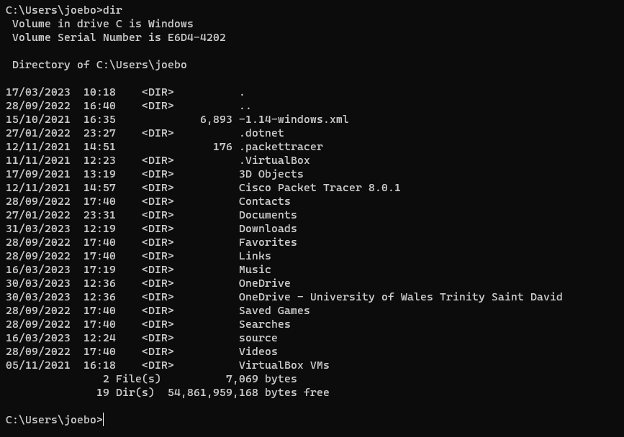

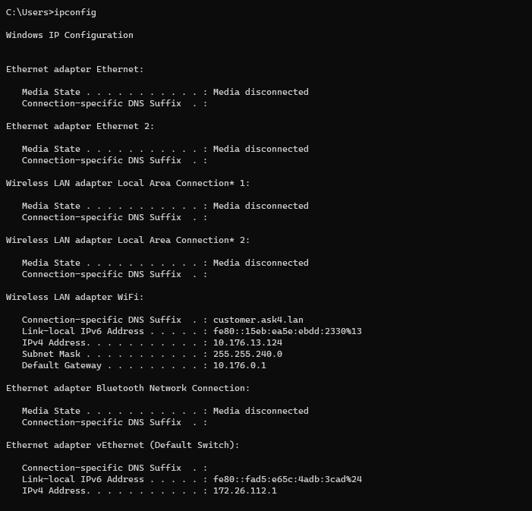
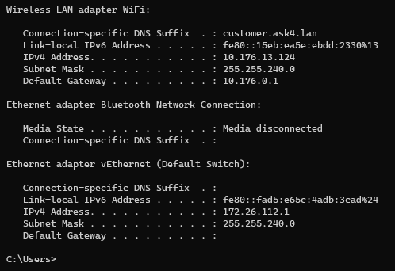

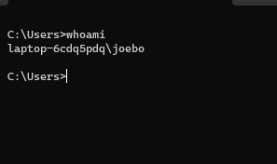

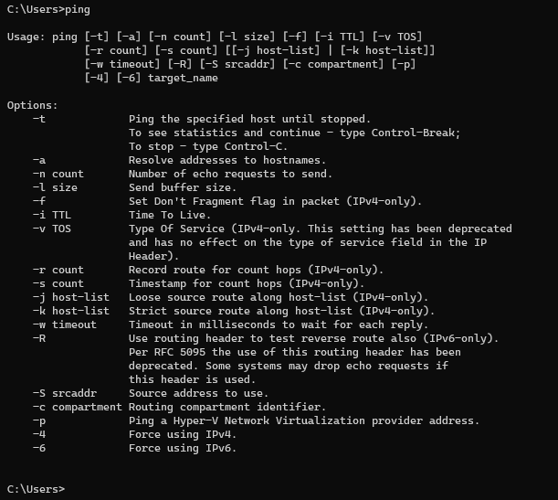

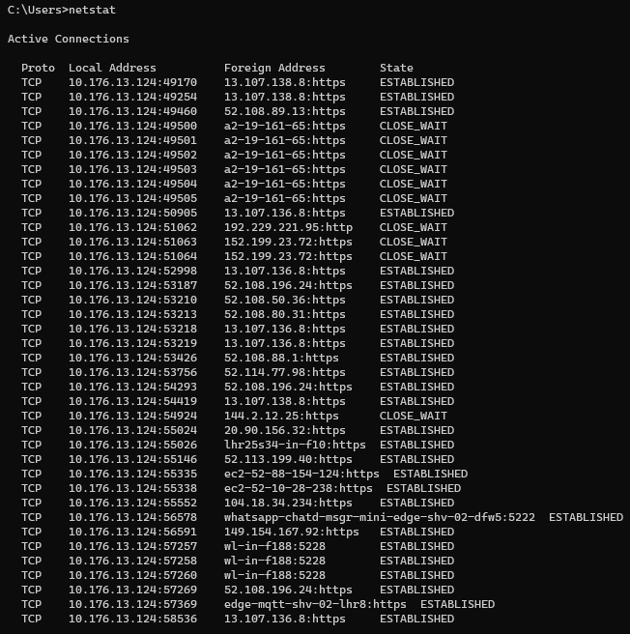
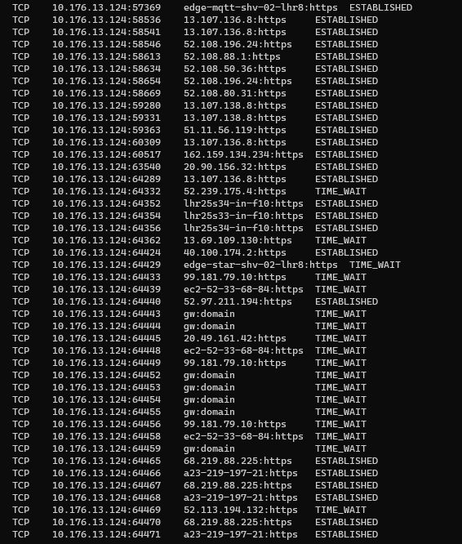
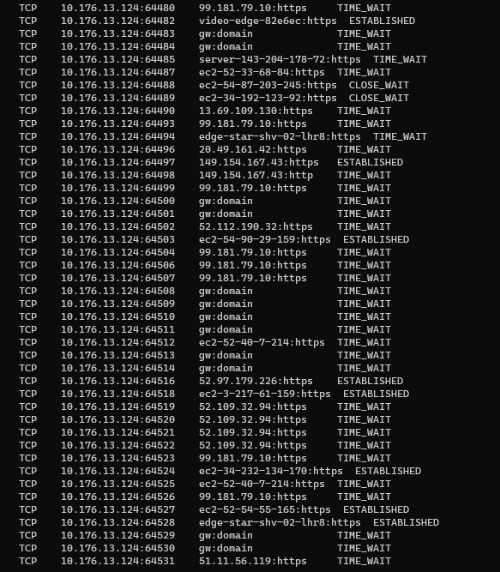
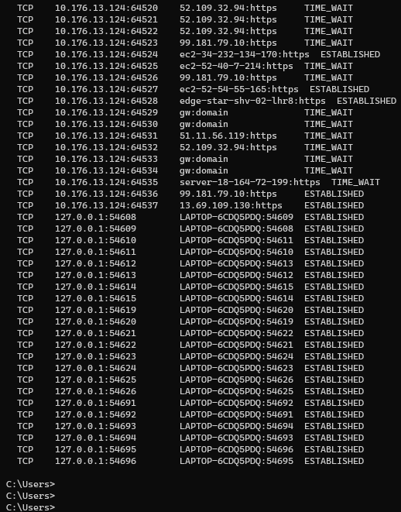

Use of Linux OS CLI commands
The Linux operating system is known for its command-line interface (CLI), which provides users with powerful tools to manage the system and perform various tasks. Here are some commonly used Linux CLI commands along with a brief description and reference for further learning:
- ls - List the files and directories in the current working directory
Reference: https://linux.die.net/man/1/ls
- cd - Change the current working directory.
Reference: https://linux.die.net/man/1/cd
- pwd - Print the current working directory.
Reference: https://linux.die.net/man/1/pwd
- mkdir - Create a new directory.
Reference: https://linux.die.net/man/1/mkdir
- rm - Remove a file or directory.
Reference: https://linux.die.net/man/1/rm
- cp - Copy a file or directory.
Reference: https://linux.die.net/man/1/cp
- mv - Move a file or directory.
Reference: https://linux.die.net/man/1/mv
- chmod - Change the permissions of a file or directory.
Reference: https://linux.die.net/man/1/chmod
- chown - Change the owner of a file or directory.
Reference: https://linux.die.net/man/1/chown
- ps - Display information about running processes.
Reference: https://linux.die.net/man/1/ps
- top - Display information about system resources and processes
Reference: https://linux.die.net/man/1/top
- grep - Search for a pattern in a file or output
Reference: https://linux.die.net/man/1/grep
- tar - Create or extract an archive file.
Reference: https://linux.die.net/man/1/tar
- ssh - Connect to a remote machine securely.
Reference: https://linux.die.net/man/1/ssh
- sudo - Run a command with elevated privileges.
Reference: https://linux.die.net/man/8/sudo

These are just a few examples of the many useful Linux CLI commands available. You can find more information and examples for these commands and many others in the Linux man pages, which provide detailed documentation for each command.

Use of Windows OS scripts
Windows OS scripts are essential tools for automating tasks, managing system resources, and performing complex operations in a Windows environment. These scripts can be written in various scripting languages, such as PowerShell, VBScript, and JScript, among others. They are used extensively in system administration, software development, and cybersecurity.
One of the primary uses of Windows OS scripts is in system administration. Administrators can use scripts to automate the installation and configuration of software packages, manage user accounts and permissions, perform backups and restorations, and monitor system performance. Scripts can also be used to generate reports, automate system updates, and perform other tasks that would otherwise be time-consuming and error prone.
Another common use of Windows OS scripts is in software development. Developers can use scripts to automate the deployment of software applications, manage version control systems, run unit tests, and perform other tasks that are necessary for building and maintaining software applications.
Furthermore, Windows OS scripts can be used in cybersecurity to monitor system logs, detect and respond to security threats, and perform other security-related tasks. They can also be used in data analysis to automate data processing, run statistical analyses, and generate reports.
In conclusion, Windows OS scripts are powerful tools that are widely used in system administration, software development, cybersecurity, and data analysis. They are an essential component of the Windows operating system and are used extensively by system administrators, developers, and security professionals.

Use of Linux OS scripts
[2]Linux OS scripts are powerful tools that enable users to automate repetitive tasks, configure system settings, and perform complex operations with ease. These scripts are written in various scripting languages, such as Bash, Python, Perl, and Ruby, among others. They can be used to accomplish a wide range of tasks, from managing system resources to monitoring network traffic.
One common use of Linux OS scripts is in system administration. Administrators can use scripts to automate the installation and configuration of software packages, perform backups and restorations, manage users and permissions, and monitor system performance. Scripts can also be used to generate reports, automate system updates, and perform other tasks that would otherwise be time-consuming and error prone.
Another use of Linux OS scripts is in web development. Developers can use scripts to automate the deployment of web applications, manage version control systems, run unit tests, and perform other tasks that are necessary for building and maintaining web applications.
Furthermore, Linux OS scripts can be used in cybersecurity to monitor system logs, detect and respond to security threats, and perform other security-related tasks. They can also be used in data analysis to automate data processing, run statistical analysis, and generate reports.
In conclusion, Linux OS scripts are versatile tools that can be used in a wide range of applications, from system administration to web development, cybersecurity, and data analysis. They are an essential component of the Linux operating system and are widely used by system administrators, developers, and security professionals.

Appendices
[3]An operating system (OS) is a software program that manages computer hardware and software resources and provides common services for computer programs. The functions of an operating system can be broadly classified into the following categories:
- Process management: An OS manages the creation, execution, and termination of processes. It allocates system resources such as memory and CPU time to each process and ensures that they do not interfere with each other. This function is crucial to ensure that the computer operates efficiently and without conflicts.
- Memory management: An OS is responsible for managing the computer's memory resources. It allocates memory to processes as needed and ensures that each process has access to the memory it requires. It also performs memory swapping and paging operations to maximize the use of available memory.
- File management: An OS manages the storage of files on the computer's hard disk. It provides a file system that organizes files and directories and controls access to them. It also provides services for creating, opening, closing, reading, and writing files.
- Device management: An OS manages the computer's input and output devices such as keyboards, mice, displays, printers, and network cards. It provides device drivers that enable the computer to communicate with these devices and provides services for handling input/output operations.
- Security: An OS provides security mechanisms to protect the computer system from unauthorized access, viruses, and other threats. It provides user authentication, access control, and encryption services.
- Network management: An OS provides services for networking, including protocols for communication between computers, network interfaces, and services for accessing remote resources.

References

[1] | P. B. G. a. G. G. Abraham Silbershcatz, “Operating Systems Concepts,” [Online]. Available: https://drive.uqu.edu.sa/_/mskhayat/files/MySubjects/2017SS%20Operating%20Systems/Abraham%20Silberschatz-Operating%20System%20Concepts%20(9th,2012_12).pdf. [Accessed 06 April 2023].
[2] | “CRC Mastering Linux,” [Online]. Available: https://www.academia.edu/31667285/CRC_Mastering_Linux. [Accessed 05 04 2023].
[3] | W. Stallings, “Operating Systems:internals and design principles (9th edition),” Pearson Education, [Online]. Available: https://ia802302.us.archive.org/4/items/c-64_20211011/C64.pdf. [Accessed 03 April 2023].

Conclusion
In conclusion, operating systems play a crucial role in modern computing by providing a user-friendly interface for interacting with hardware and software. They manage system resources, facilitate communication between programs and devices, and provide security and stability for the computer system. From the early days of DOS and Unix to the modern era of Windows, macOS, and Linux, operating systems have evolved significantly and continue to do so with the advent of new technologies such as virtualization and cloud computing. As technology continues to advance, operating systems will undoubtedly play an important role in shaping the future of computing.

