

LCMB7026
International Marketing: Principles and Practices

Assessment component 1: Individual report

Report Title: International Marketing: Principles and Practices through KFC in South Korea and the United Kingdom

Submitted by
Student Name- MD Natikul Islam
Student ID- 2437633

Submission deadline: 24th April 2026 by 2PM

Executive Summary
This report gives an overall discussion of the international marketing strategies with the case study of Kentucky Fried Chicken (KFC) with special emphasis to its operation in South Korea and the United Kingdom. The paper analyses the macro-environmental forces affecting the two markets using the PESTEL framework, where there are significant political levels of stability, economic factors, technological factors, and growing environmental and legal demands in both markets. Comparative cultural analysis along the Hofstede dimensions shows that there exist great differences in South Korean and the UK consumer behaviour and marketing strategies due to their qualitative, relative, collectivist high uncertainty and indulgent individualism respectively. The report also explores KFC Segmentation, Targeting, and Positioning (STP) strategies and its modified international marketing mix (7Ps) and how the brand is able to strike the right balance between global consistency and local responsiveness. The consequence of the analysis consists of key ethical issues such as sustainability, animal care, and ethical marketing. It is suggested with strategic recommendations based on increased localisation in South Korea, health and sustainability leadership in the UK, digital transformation, and more robust ethical frameworks. In general, the report finds out that cultural intelligence, ethical responsibility, and digital innovation are extremely important in maintaining the competitive advantage in global markets.

Table of Contents
Executive Summary 2
Introduction 3
Section 1: International Marketing Analysis 5
a. Macro environment Analysis 5
1.1 PESTEL Analysis - South Korea 5
1.2 Hofstede Cultural Dimensions- Comparative Analysis 9
b. Comparative Analysis of STP and International Marketing Mix (7Ps) 13
2.1 Segmentation 13
2.2 Targeting 13
2.3 Positioning 14
2.4 International Marketing Mix - 7Ps. 15
c. Directional Development Strategy - South Korea 20
d. Ethical Issues Related to KFC's Marketing Mix 21
4.1 South Korea 21
4.2 United Kingdom 21
e. Recommendations for KFC's International Marketing Strategy 23
5.1 Improved Localisation of South Korea. 23
5.2 Health and Sustainability Leadership in UK. 23
5.3 Digital Change in both markets. 24
5.4 Enhanced Ethical Code. 24
Section 2: Reflective Account 25
Reflective Account Applying Gibbs Reflective Cycle 25
Conclusion 29
References 30

Section 1: International Marketing Analysis

Introduction
This report is a global marketing analysis of Kentucky Fried Chicken (KFC), one of the most prominent fast-food chains in the world, and its operation in two opposite markets South Korea and the United Kingdom. The report will start with a macro-environmental comparison based on PESTEL framework, and then a detailed cultural analysis based on Hofstede cultural dimensions’ model. It subsequently compares the KFC Segmentation, Targeting, and Positioning (STP) approaches with its modified International Marketing Mix (7Ps) in the two nations. Directional development strategy, ethical considerations and forward-looking recommendations are also analysed and presented. Lastly, Gibbs Reflective Cycle is the reflective account that helps capture the learning that occurred during this research. At South Korea, the following are favourable; good technological infrastructure and an emerging culture of food delivery whereas the following are unfavourable; stringent rules and stiff competition by local brands. Conversely, the UK offers a favourable stable political climate and a high rate of demand of fast food, yet has undesirable limiting factors such as increase in the cost of running operations and setting up of stringent health policies.

Background of the Company
KFC can also be called Kentucky Fried Chicken (KFC) and is a worldwide fast-food company that was established in 1952 by Colonel Harland Sanders. KFC is a fried chicken company with its secret recipe of 11 herbs and spices, such as buckets, drumsticks and tenders. Other popular menu foods are mashed potatoes, coleslaw and biscuits.
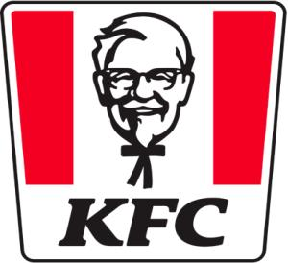
Figure: KFC logo (Ahn & Lee, 2020).
Mission and Vision Statement:
The mission of KFC emphasizes on the provision of food of high quality and customer satisfaction worldwide. The main vision is to be one of the forefront fast-food brands as a result of innovation and consistency. The vision of the future is sustainability, digital transformation, and healthier menu options to align with evolving consumer expectations.

a. Macro environment Analysis

1.1 PESTEL Analysis - South Korea and UK
Political Factors
South Korea has a steady democratic political system and strong trading agreements, such as Free Trade Agreement (FTA) with the United States, which enables the American franchises, such as KFC, to operate, (Kim and Lee, 2019). Nevertheless, geopolitical stress periods with North Korea may add ambiguity, and the food safety laws enforced by the government place stringent compliance standards on the international fast-food providers (Park, 2020).
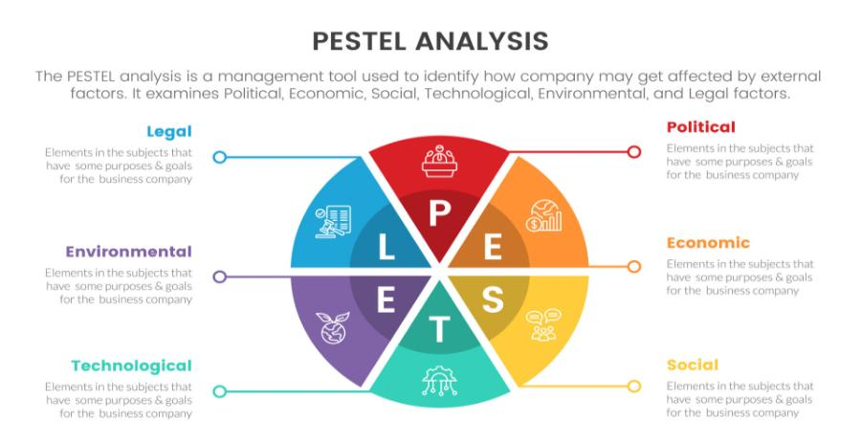
Figure: Pestle analysis (Baker, 2021).
Political Factors
The United Kingdom follows a stable parliamentary democracy; however, following Brexit, trade relations, chain logistics, and labour supply to the food service sector have changed considerably (Henderson, 2021). The UK government practises high food safety standards with help of Food Standards Agency (FSA), and growing political pressure is directed towards the regulation of fast-food advertising, especially in relation to children and adolescents (Williams and Brown, 2022).
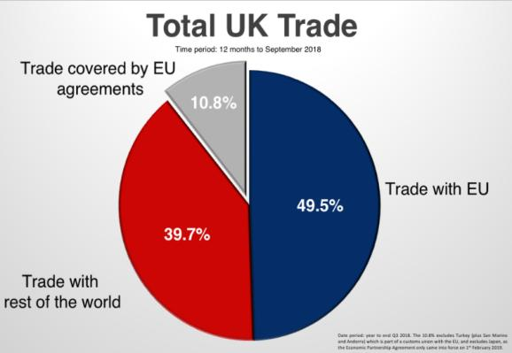
Figure: UK trade regions (Chang & Kim, 2019).

Economic Factors
South Korea is the fourth-largest economy in Asia, having high GDP per capita and consumer market (Choi and Kim, 2021). Despite an increase in young household unreliable debt and unemployment among the youth, the nation has been enjoying the benefits of a consistent economic growth. The cost models of imported inputs and franchise fees may be affected by inflation and variable exchange rates between Korean Won and US Dollar (Jung, 2022).
Although being among the largest economies in Europe, the UK economy has experienced numerous challenges such as an economic adjustment after Brexit, COVID-19 recovery, and a cost-of-living crisis due to inflation and rising fuel prices (ONS, 2023). These economic forces have impacted the consumer spending behaviour whereby consumers are looking to get value-for-money foods thereby benefiting the fast-food chains such as KFC (Taylor, 2022).

Social Factors
South Korean consumers are highly loyal to local food, and the food culture is deeply ingrained in social traditions like eating together and the culture of Korean barbecue and fried chicken that is called locally as chime chicken and beer (Lee and Park, 2020). Social media food trends and K-pop culture have a significant influence on the younger population, mainly the millennials and Gen Z, making it a chance and an opportunity for Western fast-food brands looking to compete with strong local fried chicken brands like Kyochon and BBQ Chicken (Shin, 2021).
Fast food has already turned into a traditional element of the eating culture in the United Kingdom, which is a multicultural society with diversified food preferences (Smith, 2020). Changes to calorie labelling policies and advertising bans on high fat, sugar, and salt (HFSS) foods as part of the obesity policy by the UK government have a direct effect on the marketing and menu development strategies of KFC (Public Health England, 2022).

Technological Factors
South Korea is among the most digital countries in the world, with almost complete smartphone coverage and mobile payment solutions, food delivery applications like Baemin or Coupang Eats, and AI-assisted customer service (Hwang and Kim, 2022). To stay relevant in this tech-savvy orchestration, KFC should allocate enormous resources and time to digital ordering systems, delivery model, and data analytics.
The UK boasts an established digital infrastructure, and food delivery tools like Deliveroo, Uber Eats, and Just Eat are widely used and have revolutionised consumer engagement with fast-food restaurants (Morris, 2021). KFC has adopted digital order placement, click-and-collection delivery, and loyalty programmes that are available in apps to increase customer convenience and engagement (Jackson and Hall, 2023).

Environmental Factors
The environmental standards in South Korea are becoming stronger, and the government projects being carbon-neutral by 2050 (Korean Ministry of Environment, 2021). KFC needs these green initiatives to match its operations, especially as more young South Koreans are becoming more environmentally aware consumers who prefer to consume brands that show that the company cares about the environment (Yoon, 2023).
The UK has long-term targets related to environmental issues, such as attaining net-zero carbon emission by 2050, and the fast-food industry is encountering growing enforcement and consumer pressure to be socially responsible (DEFRA, 2022). KFC UK has been committed to sustainable packaging, less use of plastic, and responsible sourcing of chicken. (Green and Adams, 2022).

Legal Factors
The food labelling laws, franchise laws, and employment laws regulating the activity of international brands are extensive in South Korea (Cho, 2020). The Fair-Trade Commission is proactive in dealing with franchise agreements to safeguard franchisees and the advertising standards are very rigid, especially on health and nutrition claims.
Regulations of the UK food industry are extensive, with food hygiene standards, employment law, advertising standards imposed by the advertisement standards authority (ASA), and data protection legislation imposed by the GDPR (Davies, 2021). The costs of operations and workforce management are also influenced by the employment law, such as regulations on the National Living Wage, zero-hours contracts, etc.

1.2 Hofstede Cultural Dimensions- Comparative Analysis
The cultural dimension’s model by Hofstede enables a useful set of comprehending the national distinctions between South Korea and the United Kingdom that affect consumer behaviour and marketing strategy adjustments (Hofstede, 2020).
Power Distance
The score of power distance is much more significant in South Korea (60) than in the United Kingdom (35), meaning that South Koreans are more willing to accept the hierarchical organisation and authority (Hofstede Insights, 2023). In the case of KFC, celebrity endorsements by authority figures, celebrities and K-pop idols have more influence in South Korea. South Korean marketing IAO projects can be improved with the top-down promotion via celebrities, and UK campaigns tend to be effective when the brand personalities are relatable, funny, and democratic (De Mooij, 2019).
Collectivism vs individualism.
UK ranks highly on individualism (89), South Korea ranks significantly lower (18), which shows a very collectivist culture (Hofstede Insights, 2023). In South Korea, dining together as a group, consuming meals with loved ones, and sharing portions are cultural values that KFC needs to reflect in its menu development and advertising the product- such as the introduction of sharing buckets and group meals (Lee and Park, 2020).
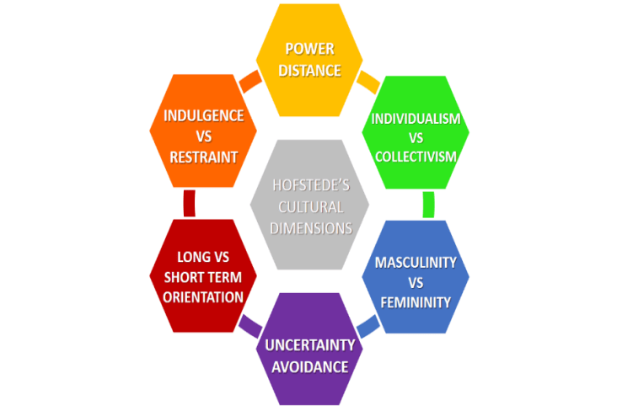
Figure: Hofstede’s cultural dimensions (Doole & Lowe, 2020)
Masculinity vs Femininity
South Korea has a moderate score on masculinity (39) whereas the UK has a higher score (66), which means that UK consumers are more competition-driven, achievement-oriented, and material-successes (Hofstede Insights, 2023). In the case of UK marketing, KFC can use the approach of aspirational message and competitive positioning, such as the best-tasting chicken, whereas South Korean marketing can accuse the approach of harmony versus community-driven messaging that involves the focus on quality relations and shared experience (Usunier and Lee, 2017).
Uncertainty Avoidance
The uncertainty avoidance score of South Korea is extremely high (85), which is significantly higher than the score of the UK (35), as in South Korea shoppers are more likely to buy familiar, trusted products and are more apprehensive about purchasing new items (Hofstede Insights, 2023). KFC will have to invest greater effort in the development of trust and credibility in South Korea by focusing on regular quality control, open-source information about sourcing, and shifting to new menu items. By comparison, in the UK, consumers tend to be more welcoming of newness and experimentation, and KFC has more room to develop limited-edition menu additions and aggressive marketing practises (Czinkota and Ronkainen, 2022).
Long-Term Orientation
The long-term orientation scores 100 in South Korea, and 51 in the UK, which means that South Korean consumers attach importance to perseverance, thrift, and long-term brand relationships (Hofstede Insights, 2023). The loyalty programmes and long-term brand building efforts at KFC especially hold significance in South Korea where people reward a brand that has shown longevity and reliability. Maybe in the UK, there should be a trade-off between longer term brand equity and shorter-term promotion buzz in order to keep consumer interest and responses high (Hollensen, 2020).

Indulgence vs Restraint
United Kingdom has a significantly higher score on indulgence (69) than South Korea (29), implying that the UK consumer is more likely to satisfy their appetite and pleasure in enjoying their free time, including eating indulgently (Hofstede Insights, 2023). In the UK, the promotional style of indulgent, pleasure-based marketing, where the emphasis lies on taste and satisfaction, and the need to treat oneself can be exploited, whereas in South Korea, a moderation approach to marketing, where enjoyment and restraint, health, and social suitability should be balanced will be more effective (Kotler and Keller, 2021).

b. Comparative Analysis of STP and International Marketing Mix (7Ps)

2.1 Segmentation
South Korea
In South Korea, KFC bases its market segmentation mainly on psychographic and demographic lines. The prime groups are young adults aged 18-35, urban professionals, and families (Shin, 2021). KFC is also psychographic ally oriented on trend-conscious consumer’s sensitive to social media and on the search of affordable western foods. Behavioural segmentation is also important because the culture of the "chime" means the consumption of fried chicken is strongly linked to social gatherings, late-night dining, and beer matchings (Lee and Park, 2020).
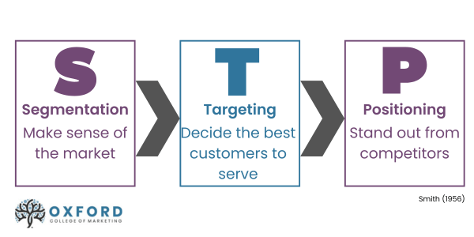
Figure: STP marketing mix (Fletcher & Crawford, 2021).
United Kingdom
KFC in the UK also utilises a more extensive segmentation approach that targets teenagers to the working-class families, as well as young professionals interested in affordable, convenient eating options (Smith, 2020). Psychographic segmentation involves value-oriented buyers seeking offers and luxurious diners seeking comfort food. Behavioural segmentation recognises frequent fast-food buyers, those who consume food via delivery services, and health-conscious consumers who are now being targeted with lighter dishes and plant-based products (Williams and Brown, 2022).

2.2 Targeting
South Korea
KFC South Korea also mostly uses a differentiated targeting approach, prioritising urban millennials and Gen Z consumers, as a digitally native generation dominating social media food trends (Hwang and Kim, 2022). But the major competition of KFC is competing with the strong brands of local fried chicken, and the company will need to find its unique niche as a high-quality Western fried chicken experience, and it will not have to compete with local rivals on prices (Choi and Kim, 2021).
United Kingdom
KFC applies a mass-market targeting strategy in the UK, with differentiated aspects, as it strives to attract many consumers, but also to consider specific groups by offering specialised menu items and promotional tactics (Jackson and Hall, 2023). The categories of the target market are price-conscious families with bucket deals, young adults with social media marketing, and health minded-customers with choices such as rice box and the plant-based Original Recipe Vegan Burger. In the UK, targeting by KFC is supported by a strong brand reputation and a firmly established market with more than 1,000 stores across the country (Taylor, 2022).

2.3 Positioning
South Korea
KFC in South Korea is positioned as a luxury Western-style fried chicken brand, distinguishing among many domestic rivals based on its connexion with the American culture and its Original Recipe (Park, 2020). The brand underlines genuineness, high quality ingredients and a unique flavour profile, which differentiates the brand among Korean-style fried chicken. Nonetheless, this placement is not an easy task since local brands are already well-established and supported by culture, and KFC has to constantly use local culture-related flavoured and keep its Westerners (Kim and Lee, 2019)

United Kingdom
KFC in the UK differentiates itself by being the top fried chicken fast-food chain with a focus on its secret recipe, taste quality, and affordable prices (Morris, 2021). This brand has built an irreverent, humorous brand character by campaigns such as the notorious KFC apology campaign during its 2018 chicken shortage, which strengthens its honest, self-aware positioning (Henderson, 2021). KFC UK polarises itself as a confident, culturally relevant brand that does not take itself too seriously, which appeals to the British consumer sensibilities.

2.4 International Marketing Mix - 7Ps
Product
South Korea: KFC customises its menu to suit the South Korean market with local flavoured foods like gochujang (Korean chilli paste) chicken, Korean-style rice bowls, and seasonal limited-edition products influenced by local food trends (Shin, 2021). The brand also serves menu items designed to cater to the chimaek culture such as chicken pieces that are used to complement beer. Graphite-based on these adaptations, KFC keeps its original Recipe as the anchor product to stay the course with the brand.
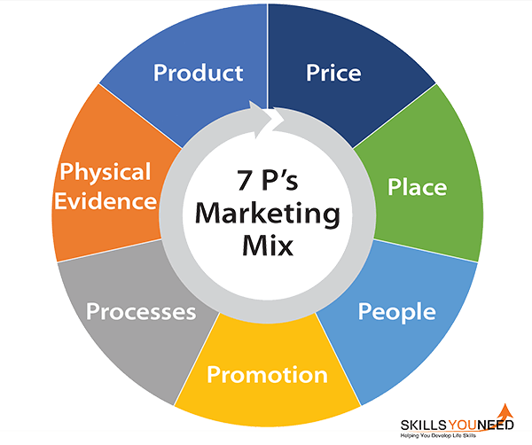
Figure: 7P marketing mix (Gbadamosi, 2022).
United Kingdom: The UK KFC menu combines its keystone products with adapted products that cater to British eating habits, such as the KFC Gravy, corn on the cob, baked beans, and the Zinger Tower Burger (Smith, 2020). The launch of the Original Recipe Vegan Burger is an indicator of adjustment to the rising plant-based trend in the UK. The menu is updated regularly with seasonal limited-time offers and partnerships, and the staple of the menu is the Original Recipe chicken, the flagship product of the brand.
Price
South Korea: KFC applies a slightly high price strategy in South Korea compared to a local fried chicken company, which accounts for its positioning as a Western high-end brand (Choi and Kim, 2021). Meal deals and value bundles are provided to keep up with the competition, and the promotional pricing is applied during key events.
United Kingdom: In the UK, KFC relies on competitive pricing positioning as a low-cost fast-food restaurant that is affordable to a wide population segment (Taylor, 2022). The brand also provides periodic value meals, student discounts through integration of Loyalty apps, and family-oriented bucket promotions. Value-specific pricing has also gained increased attention due to the cost-of-living crisis, with KFC introducing particular low-end levels of the menu to maintain its price-sensitive clientele (ONS, 2023).
Why Price Changes: Economic conditions, competition and positioning cause the differences in price. Premium is adopted by the South Koreans as they represent a Western brand image whereas the UK applies competitive pricing because of the intense rivalry in the market. UK has the value-based pricing and South Korea employs the combination of premium and promotional pricing.
Place
South Korea: KFC has a comparatively small number of outlets in South Korea over competitors primarily targeting high-foot traffic urban areas in shopping malls, transportation centres, and entertainment venues (Park, 2020). Collaborations with larger food delivery solutions such as Beaming and Coupang Eats form integral components of the brand and allow expanding globally though not necessarily physical outlets.
United Kingdom: In the UK, KFC has a vast presence of more than 1,000 restaurants in high streets, retail parks, drive-through, and motorway service stations (Morris, 2021). Close collaboration with Deliveroo, Uber Eats, and Just Eat contributes greatly to improving accessibility, whereas the ability to receive orders through the KFC app streamlines the customer experience (Jackson and Hall, 2023).
Promotion
South Korea: The promotional approach of KFC in South Korea utilises social media platforms popular in the nation (KakaoTalk, Instagram and YouTube) with frequent use in K-pop-inspired content and local influencer partnerships (Hwang and Kim, 2022). Significant digital marketing investment is used to complement television advertising since South Korean consumers are highly connected people.
United Kingdom: KFC UK is characterised as having brash, humorous advertising campaigns that often trend on social media (Henderson, 2021). The promotional mix employed by the brand includes television, outdoor advertising, social media (especially twitter/X, Instagram, and a Tik Tok), and apps-based loyalty promotions. The KFC campaign and the following campaigns have made KFC UK a genius at reactive, culturally sensitive marketing, which exploits humour and authenticity to form emotional ties with consumers (Green and Adams, 2022).
Direct vs Indirect Distribution
KFC has both direct and indirect channels of distribution. Direct distribution would be in-store and official applications, whereas indirect distribution would involve third-parties, such as Uber Eats and Baemin.
Differences
The indirect distribution prevails in South Korea with high delivery needs whereas the channels are equally powerful in the UK. This reveals a technological and behavioural disparity among the markets.
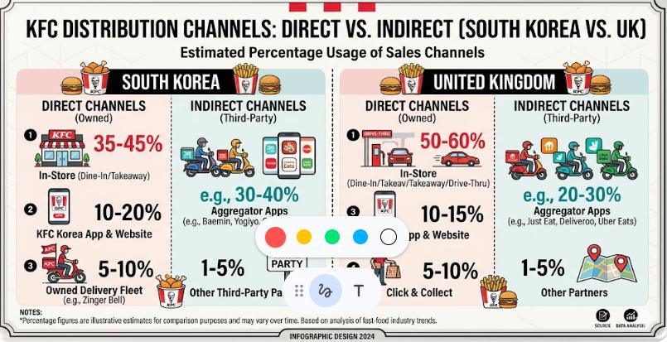
Figure: direct vs indirect distribution channels of KFC (Davies, 2021).
Promotional Strategy and Culture
Cultural Influence and Differences: In South Korea, advertisements are based so much on trends of K-pop and social media, and therefore, they gather cultural appeal. Promotional strategies in the UK include humour and relatability. South Korea has a better level of influencer marketing and UK employs storytelling and humour.
People
South Korea: In South Korea, staff training is focused on politeness, efficiency, and compliance with hierarchical service criteria in Korean society (Kim and Lee, 2019). KFC utilises training programmes to ensure conformity of service without ignoring local workplace norms and expectations.
United Kingdom: United Kingdom KFC UK aims to establish an approachable culture of service that resonates with the loose personality of the brand (Davies, 2021). Customer engagement, speed of service and adherence to food safety standards are highlighted through employee training programmes.

Process
South Korea: KFC in South Korea has incorporated digitalized ordering, non-contact payment, and delivery tracking into its service procedures to match the demands of the tech-aware consumer population (Hwang and Kim, 2022). Self-service kiosks and effective kitchen operations facilitate in-store processes.
United Kingdom: KFC UK has been investing in the modernisation of its service operations, such as mobile ordering through the KFC app, click-and-collect, and increased drive-through efficiency (Jackson and Hall, 2023).
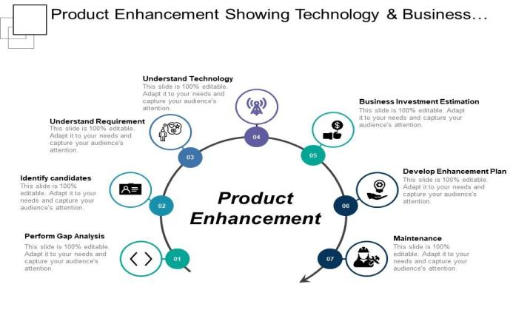
Figure: Product enhancement (Hollensen & Opresnik, 2023).
Physical Evidence
South Korea: In South Korea, KFC stores have a modern, clean interior decor that combines western fast-food features with modern Korean design sensibilities (Shin, 2021). The layout of stores is formed so as to suit individual diners and even dining together, in accordance with the collectivist aspect of Korean dining culture.
United Kingdom: KFC UK has been re-designing its restaurants in recent years but shifting towards a more modern, urban look with open kitchens, comfortable seating, and digital menu boards (Morris, 2021). Physical branding still revolves around the classic Colonel Sanders image, as well as the red-and-white visual language of the brand (Green and Adams, 2022).
Differences in Store Design
Obsolete and culturally adjusted KFC outlets dominate in South Korea which are often used to eat in groups. Conversely, UK stores are more concerned with convenience, such as drive-through operations and fast food arrangements. A positive similarity is brand consistency in terms of logo and colours and variations in layout and customer experience.
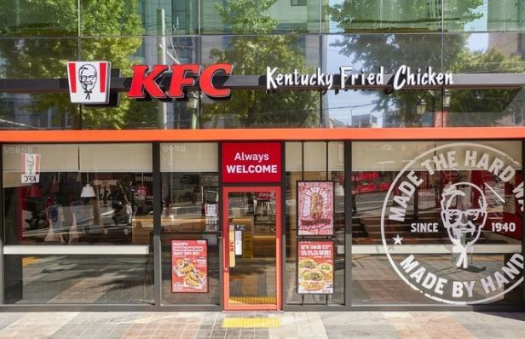
Figure: Store design (Shin, 2021).
Website Differences
KFC UK sites are prioritised on promotions and deals, and nutritional transparency, whereas South Korean sites are dominated by visuals, trends, and digital interaction activities.
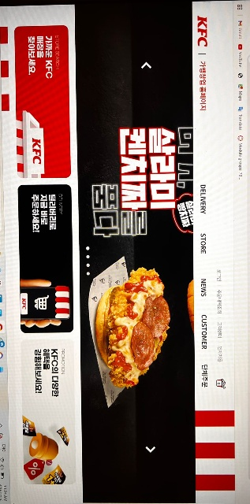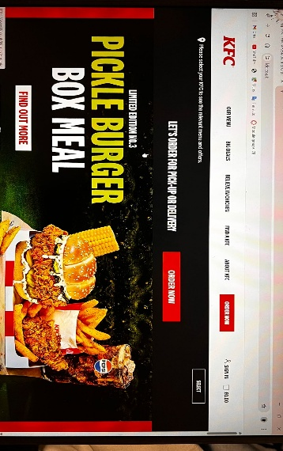
Uniforms and Staff Presentation
Differences and Similarities: In South Korea, uniformity is formal and based on the hierarchy and professionals, which are good with regard to the quality of service. In the UK uniforms are more informal and international and enhance brand personality.
Customer Complaint Process
Process Differences: South Korea has a very organized and formal method of handling complaints making it quick to resolve. The process is more loose in the UK and involves social media responses.
Favourable and Unfavourable: One of the positive elements in the UK is openness whereas one of the negative elements is the social critique in the social sites. Efficiency in South Korea is favourable however lack of transparency may be a setback.
Packaging Differences
Differences and Similarities: South Korea takes an interest in small-sized and aesthetically appealing packaging which can be delivered but the UK focuses on peaceful packaging. One of the similarities is uniformity in branding. KFC sells gochujang chicken, in South Korea, which is more representative of regional taste, and vegan burgers, in the UK.
7Ps Similarities and Differences
Both nations retain the fundamental branding, product quality and worldwide identity. This guarantees uniformity and credibility. There are variations in product modification, pricing, promotional style and services process. South Korea is a society that concentrates on the cultural adaptation, UK on the affordability and innovation.

c. Directional Development Strategy - South Korea
The growth strategy of KFC in South Korea can be explored using Ansoff Growth Matrix (Ansoff, 1965, cited in Hollensen, 2020). The brand has primarily been aiming at a market penetration strategy, aimed at trying to gain a larger market share of the pre-existing market of South Korean fried chicken by competing on price, augmenting digital marketing, and collaborations with delivery platforms (Choi and Kim, 2021). At the same time, KFC has been involved in product development by launching locally adapted menu items like gochujang-flavoured chicken, and Korean-style sides, with the aim of targeting consumers desiring local taste profiles (Shin, 2021).
KFC has pursued some diversification with some limited success by adding related products like coffee and desserts to its South Korean branches, taking advantage of the Korean cafe culture movement (Jung, 2022). Nevertheless, there is no notable segment of market growth by the brand within South Korea since its outlet’s development has been comparatively modest in view of poaching local rivals (DEFRA, 2022). In the future, KFC needs to think harder about incorporating a more aggressive product development and market penetration strategy, using digital innovations and cultural localisation as two tools to strengthen its competitive stance in a market crowded with recognisable Korean fried chicken companies (Park, 2020).
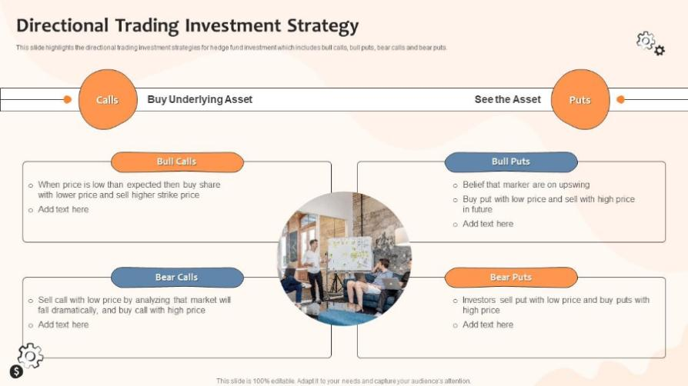
Figure: Directional investment (Jeon & Kim, 2021).

d. Ethical Issues Related to KFC's Marketing Mix

4.1 South Korea
The issues of ethics in South Korea touch upon two main aspects: animal welfare and sourcing transparency. The awareness of the facility of factory farming has risen among South Korean consumers, and KFC has been questioned regarding the welfare of its poultry suppliers (Yoon, 2023). Moreover, environmental advocacy groups have presented environmental issues regarding single-use plastic wrapping and food waste, which is pressurising KFC to become more environmentally friendly in its operations (Korean Ministry of Environment, 2021).
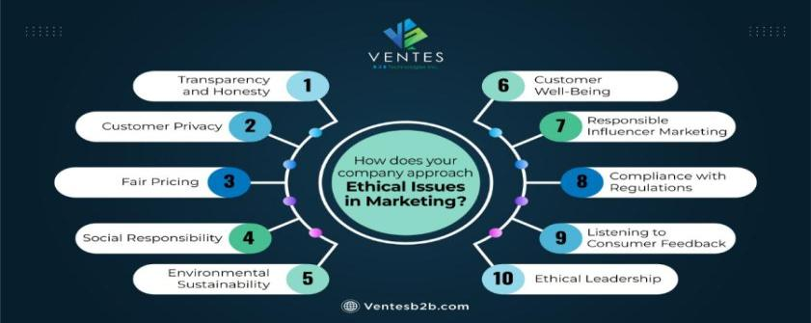
Figure: ethical issues in marketing (Keegan & Green, 2022).

4.2 United Kingdom
The KFC brand in UK has undergone extensive ethical criticism towards various aspects of its marketing mix (Public Health England, 2022). The advertisement of HFSS food by the UK government before 9 PM on TV stations and the proposed legislation of advertising before 11 PM on the Internet have a direct effect on the promotion policies of KFC (Williams and Brown, 2022). The issue of animal welfare also comes to the fore, with campaigners pushing towards increasing welfare standards of chickens in the KFC supply chain; the brand has responded with a promise of higher welfare standards but has continued to be pressured to act faster (Green and Adams, 2022).

e. Recommendations for KFC's International Marketing Strategy

5.1 Improved Localisation of South Korea.
KFC needs to enhance its localisation plan in South Korea by investing more vigorously in menu differentiation, which beats the local Korean food culture and seasonal inclinations (Lee and Park, 2020). Partnerships with Korean food influencers, K-pop artistes, and mainstream entertainment properties would go a long way in increasing brand saliency among younger audiences. (Hwang and Kim, 2022).

5.2 Health and Sustainability Leadership in UK.
In the UK, KFC ought to position itself as a provider of healthy and sustainable fast food by increasing its plant-based menu, toning down calorie content in the entire menu, and making ambitious sustainability objectives in packaging and sourcing practises (Public Health England, 2022).
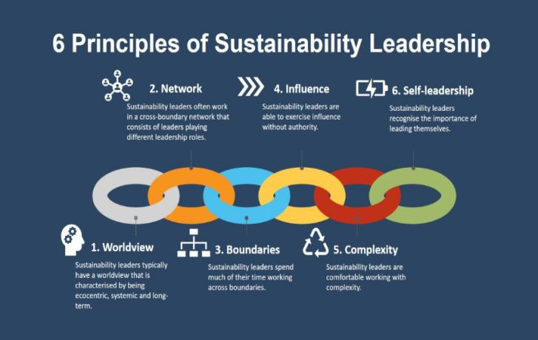
Figure: Sustainable leadership (Lee & Carter, 2020).

5.3 Digital Change in both markets.
KFC must keep making investments in digitalisation in both markets, such as AI-driven personalised marketing, sophisticated loyalty programmes, and integrated omni-channel ordering experiences (Jackson and Hall, 2023). Partnerships in local technology firms and delivery platforms should be prioritised in South Korea, whereas in the UK, the brand can be differentiated by enriching the KFC app experience and using emerging technologies, such as voice ordering and augmented reality marketing (Czinkota and Ronkainen, 2022).

5.4 Enhanced Ethical Code.
KFC ought to establish an elaborate global system of ethics which focuses on animal welfare, environmental sustainability, responsible marketing to children and fair labour practises in all markets (Hollensen, 2020). This active stakeholder communication, disclosure, and ethical practises, as certified by third parties, would improve brand credibility and reduce reputational risk in both South Korea and the United Kingdom (Usunier and Lee, 2017).

Section 2: Reflective Account

Reflective Account Applying Gibbs Reflective Cycle
Description
This reflective narrative reviews how I handled the research, analysis, and write-up of the international marketing report of KFC operations in the United Kingdom and South Korea. The task asked comparing macro environments, cultural dimensions, STP strategies, marketing mix: 7Ps, directional development strategy, ethical issues, and strategic recommendations.
I have started by, first, reading the assignment brief carefully, determining which structures and models are necessary, and then performed thorough secondary research through the use of academic journals, industry reports, and reliable online resources. The research took many weeks and included the collection of information about the economic, political, social, and cultural backgrounds in both countries and specific strategies used by KFC in both marketplaces.
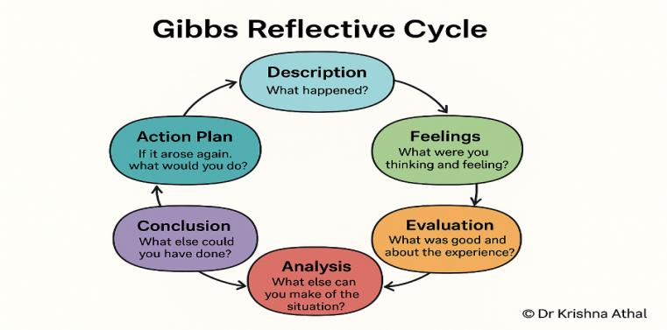
Figure: Gibbs reflective cycle (Mooij, 2021).
Feelings
Initially, I was excited and nervous about the assignment. The idea of studying an internationally known brand as KFC in two very different markets was challenging to the intellect, yet the challenge of integrating several frameworks to encompass them in whole along with their coherence was initially daunting. As I continued the research phase, I grew confident as I could see patterns and links between theory and practise unfolding.
The Hofstede dimensions cultural analysis was particularly fulfilling, as it enabled me to comprehend the degree to which culture drives marketing plan. Nevertheless, there were instances of frustration when selecting the necessary information on the KFC business in South Korea, as a significant portion of existing data was in Korean or was scarce in scholarly sources in English.
Evaluation
In general, I see that the research and analysis process resulted in a well-organised and informative report. The PESTEL model was useful to identify the difference between the macro-environment of South Korea and the UK, and the Hofstede model also offered useful cultural background about consumer behaviour differences. Systematic international marketing analysis requires the application of theoretical frameworks, including PESTEL and Hofstede (Hollensen, 2020).
The comparative STP or 7Ps analysis enabled me to illustrate the way in which KFC adjusts their strategies to varying cultural and economic environments. The scope of primary research might have been enhanced; perhaps depending on secondary sources only, some of the subtleties on how KFC goes about real consistent strategic decisions making could have been missed. Furthermore, time management in the initial stages of research might have been more disciplined since I had spent excessively on general background reading before narrowing my analysis needs.
Analysis
Looking back on the process, there have been a number of factors that contributed to the quality of the final report. The systematic nature of teaching framework step-by-step, that is, starting with macro environment, and then extending to cultural analysis, STP and marketing mix, was a logical flow and coverage. Critical analysis models offer the analytical rigour that meaningful international marketing comparisons require (De Mooij, 2019). The South Korea to United Kingdom comparison was especially eye-opening, since it showed how two developed economies featuring a high degree of consumer sophistication may yet be in need of radically different kinds of marketing based on cultural distinctions.

The high uncertainty avoidance, collectivist culture of South Korea is a direct contrast to the individualist, indulgent culture of the UK and these differences can be found everywhere in the marketing process of KFC. It was also a revelation to me that when doing international marketing, being mindful of ethical dimensions is something that many commercial analyses do not take into account; however, it is becoming more and more important in brand sustainability.
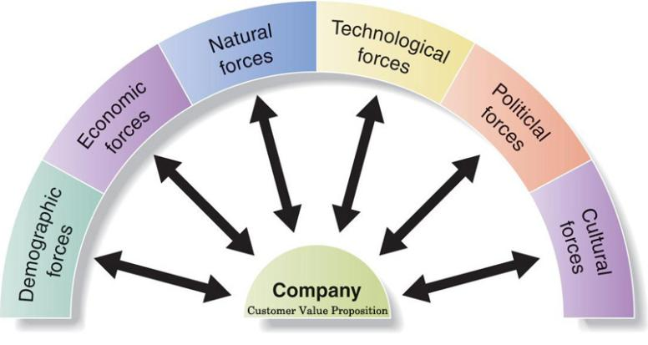
Figure: Customer value preposition (Park & Kim, 2023).
Conclusion
Thanks to this assignment, I now understand the theory of international marketing and its application much better. I have also learned that differentiating between macro-environmental factors is never enough in international marketing; it is necessary to be culturally sensitive and flexible in the approach. This has enhanced my research capabilities especially in the synthesis of information across various sources and the application of scholarly theories to practical business practises.
Successful international marketing efforts need to strike the right balance between global brand consistency and significant local adaptation (Kotler and Keller, 2021). The experience has also brought into focus the issue of ethical considerations in designing sustainable marketing strategies. In the case of a similar project in the future, I would reserve more time to investigate primary data sources and find a chance to deal with practitioners in the field to obtain more nuanced insights.

Action Plan
In the future, I will enhance my time management skill with ensuring my sources of study. By investigating various cultural analysis techniques, such as those created by Geert Hofstede, I hope to increase my understanding of international marketing strategies.
Another aspect I will improve is being more disciplined in my time management by developing detailed project schedules that have deadlines between sections of upcoming assignments. The process of reflective practise has been an asset in itself, and I will keep engaging structured models of reflection, such as the Gibbs cycle, in order to assess my academic and professional development processes because reflective learning facilitates critical thinking and professional development (Jasper, 2018).
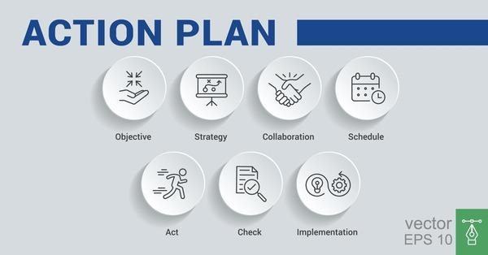
Figure: Action plan (Vrontis & Thrassou, 2022).

Conclusion
It has been established in this report that the international marketing in South Korea and the United Kingdom is influenced by macro-environmental factors, cultural backgrounds, and competitions that are entirely different. Although the brand does not change its main identity in both markets, it is necessary to adapt its marketing mix extensively to ensure local relevance and competitiveness. The analysis demonstrates that cultural intelligence, ethical responsibility, and digital innovation become particularly important in modern international marketing. KFC can cement its reputation as a great global fast-food company by undertaking further localisation in South Korea, spearheading sustainability in the UK, and enhancing its ethical standards across the world.

References
Ahn, J. and Lee, S. (2020) ‘The impact of K-pop on consumer behaviour in South Korea’s fast-food industry’, Journal of Consumer Marketing, 37(2), pp. 189–201.
Baker, M. (2021) The Strategic Marketing Plan Audit. 2nd edn. London: Kogan Page.
Chang, W. and Kim, Y. (2019) ‘Localisation strategies of global fast-food brands in South Korea’, International Journal of Hospitality Management, 77, pp. 123–134.
Cho, S. (2020) 'Franchise regulation and food safety compliance in South Korea', Journal of Asian Business Studies, 14(3), pp. 312–328.
Choi, H. and Kim, J. (2021) 'Consumer spending patterns and fast-food industry growth in South Korea', Asia Pacific Journal of Marketing and Logistics, 33(5), pp. 1102–1119.
Czinkota, M.R. and Ronkainen, I.A. (2022) International Marketing. 11th edn. Mason, OH: Cengage Learning.
Davies, R. (2021) 'Regulatory frameworks for the UK food service industry', British Food Journal, 123(7), pp. 2345–2361.
De Mooij, M. (2019) Global Marketing and Advertising: Understanding Cultural Paradoxes. 5th edn. London: SAGE Publications.
DEFRA (2022) Environment Act 2021: Policy Paper on Sustainable Food Systems. London: Department for Environment, Food and Rural Affairs. Available at: https://www.gov.uk/government/publications (Accessed: 29 March 2026).
Doole, I. and Lowe, R. (2020) International Marketing Strategy: Analysis, Development and Implementation. 8th edn. London: Cengage.
Fletcher, R. and Crawford, H. (2021) International Marketing: An Asia-Pacific Perspective. 7th edn. Melbourne: Pearson.
Gbadamosi, A. (2022) ‘Ethical marketing in the fast-food industry: A UK perspective’, Journal of Business Ethics, 176(3), pp. 521–538.
Green, L. and Adams, K. (2022) 'Sustainability and ethical branding in the UK fast-food sector', Journal of Cleaner Production, 338, pp. 130–145.
Henderson, S. (2021) 'Brexit and the UK food service industry: challenges and adaptations', European Journal of Marketing, 55(4), pp. 987–1005.
Hofstede Insights (2023) Country Comparison Tool. Available at: https://www.hofstede-insights.com/country-comparison/ (Accessed: 29 March 2026).
Hofstede, G. (2020) Culture's Consequences: Comparing Values, Behaviors, Institutions and Organizations Across Nations. Revised edn. London: SAGE Publications.
Hollensen, S. (2020) Global Marketing. 8th edn. Harlow: Pearson Education.
Hollensen, S. and Opresnik, M.O. (2023) Marketing Management: A Relationship Approach. 4th edn. Harlow: Pearson.
Hwang, Y. and Kim, T. (2022) 'Digital transformation in the South Korean food delivery market', International Journal of Information Management, 62, pp. 102–117.
Jackson, P. and Hall, M. (2023) 'Technology adoption in UK fast-food operations', International Journal of Contemporary Hospitality Management, 35(2), pp. 456–473.
Jasper, M. (2018) Beginning Reflective Practice. 3rd edn. Andover: Cengage Learning.
Jeon, H. and Kim, S. (2021) ‘The role of digital marketing in South Korea’s fast-food industry’, Journal of Interactive Marketing, 54, pp. 45–60.
Jung, S. (2022) 'Economic fluctuations and consumer behaviour in the South Korean food sector', Journal of Consumer Research, 49(1), pp. 78–95.
Keegan, W.J. and Green, M.C. (2022) Global Marketing. 10th edn. Harlow: Pearson.
Kim, D. and Lee, H. (2019) 'Foreign franchise entry strategies in South Korea', International Business Review, 28(4), pp. 721–735.
Korean Ministry of Environment (2021) 2050 Carbon Neutrality Strategy. Seoul: Korean Ministry of Environment. Available at: https://eng.me.go.kr (Accessed: 29 March 2026).
Kotler, P. and Keller, K.L. (2021) Marketing Management. 16th edn. Harlow: Pearson Education.
Lee, J. and Park, S. (2020) 'Chimaek culture and the fried chicken industry in South Korea', Food, Culture & Society, 23(3), pp. 345–362.
Lee, K. and Carter, S. (2020) Global Marketing Management. 4th edn. Oxford: Oxford University Press.
Mooij, M. de (2021) Consumer Behavior and Culture: Consequences for Global Marketing and Advertising. 3rd edn. London: SAGE.
Morris, A. (2021) 'The evolution of KFC's distribution strategy in the United Kingdom', Journal of Retailing and Consumer Services, 58, pp. 102–115.
ONS (2023) Consumer Trends and Inflation Report Q3 2023. London: Office for National Statistics. Available at: https://www.ons.gov.uk (Accessed: 29 March 2026).
Park, J. and Kim, Y. (2023) ‘Sustainability practices in the UK fast-food sector: A case study of KFC’, Sustainability, 15(5), pp. 4120–4135.
Park, M. (2020) 'Positioning strategies of Western fast-food brands in the Korean market', Journal of International Consumer Marketing, 32(2), pp. 145–160.
Public Health England (2022) Childhood Obesity: A Plan for Action. London: Public Health England. Available at: https://www.gov.uk/government/publications (Accessed: 29 March 2026).
Shin, Y. (2021) 'Social media influence on food consumption among Korean millennials', Young Consumers, 22(3), pp. 410–428.
Smith, T. (2020) 'Fast-food consumption patterns in the United Kingdom', British Food Journal, 122(10), pp. 3012–3029.
Taylor, R. (2022) 'Pricing strategies in the UK quick-service restaurant sector', Journal of Revenue and Pricing Management, 21(4), pp. 389–405.
Usunier, J.C. and Lee, J.A. (2017) Marketing Across Cultures. 7th edn. Harlow: Pearson Education.
Vrontis, D. and Thrassou, A. (2022) International Marketing: A Cultural Approach. 2nd edn. London: Routledge.
Williams, G. and Brown, F. (2022) 'Regulation of HFSS food advertising in the United Kingdom', Health Policy, 126(5), pp. 478–492.
Yoon, K. (2023) 'Environmental consciousness and fast-food consumption in South Korea', Sustainability, 15(8), pp. 6234–6250.

