Radical Education.
Rebecca Jones
1151223
Swansea Educational School Prospectus.

Swansea Educational School Prospectus by law has to and will offer children a good standard of education that allows children to be educated in linguistics, mathematics, science, technology and health and well-being (Welsh Government, 2014). By educating children in these areas the school is upholding the child’s right to have an education (UNICEF, 2021). Swansea educational school facility will make sure that all children understand their rights to have an education and it is an adult’s duty to share this right with all children (Child Commissioner, 2021). Until the age of eleven providing children with an education is compulsory and The United Nations Universal Declaration of Human Rights (UDHR) state that all education must fully develop an individual’s personality and look at education from a holistic viewpoint (UNICEF, 2021) and under the UDHR, parents have the right to choose an education for their child (UNICEF, 2021).
The Education Act 1966 explains that parents must provide children with an efficient education that is suitable for their age, ability and aptitude, so long as parents or carers can fully provide this for their children, they have the right to send their children to an institute that can provide an education (Legislation.Gov, 2021). This includes home-schooling, summer schools, Steiner schools or other educational environments that appeal to them (Ashman, 2019).
Swansea educational school will be a full-time independent educational school environment that is not governed by its local The Government, this allows Swansea educational school to create a unique prospectus that is providing children with a holistic education for all (Welsh Government, 2014). Swansea educational school will not have to follow the national curriculum and will educate children between the ages of five to sixteen years (Child Law Advice, 2021) through a curriculum that is tailored to their needs, that intends on preparing children for the real world by giving them knowledge through first-hand experiences allowing them to critically evaluate and become independent learners (Gatto, 2000).

School aims:

- To develop children’s knowledge through enabling children to critically think (Florea and Hurjui, 2014).
- Develop children’s holistic development through first-hand experiences (Bento and Dias, 2017).
- Create environments that are fun and creative to naturally encourage a child’s curiosity, by not limiting children to learn and develop in one classroom, by promoting all environments as areas for educational development (Holy, 2015).
- Promote positive and healthy relationships towards food that children can carry with them throughout life (Dudley, Cotton and Peralta, 2015).
- To create independent children who are able to keep up with a fast-developing world and promote the use of technology to help develop them as individual learners (Mitra, 2010).
- To create fully developed individuals that are knowledgeable and ready for the world when leaving Swansea educational school (Browne and Keeley, 2007).
- To provide a cross-curricular curriculum to allow children to understand that links between subjects happen naturally in everyday life (Darling-Hammond, 2010).

Timetable:
9am – 10am: Cooking
10am – 11am: outdoor or indoor topic discussion
11am – 12pm: outdoor or indoor learning/ researching
12pm- 1pm: outdoor play and lunch
1pm – 2pm: outdoor or indoor learning/ researching
2pm- 3pm: Class discussion and presentations.
3:15pm: End of Day.

Critical thinking:

Within today’s society, there seems to be an argument about what education is, what it stands for and how effective it is. The Welsh Government states that its education system is put in place to develop the next generation of children (Welsh Government, 2020). They want children to become capable learners that can learn and grown their life skills through real life experiences so they can apply these skills in their adult life and the working world to enable them to become active and knowledgeable citizens (Welsh Government, 2020). However, there are contrasting opinions to suggest that the current education system in is not an education system that develops children to become critical and individual learners that allow them to keep up with the ever changing and developing society (Curren, 2007).

Critical thinking is a skill that helps individuals overall learning experiences and development (Florea and Hurjui, 2014). It is a way that children can update their pre-existing understanding of information by analysing, comparing and observing new information (Eales-Reynolds, Judge, McCreery and Jones, 2013). Allowing children to be critical enables them to be active in their learning process, encouraging them to solve problems by using multiple examples and life experiences for them to be able to understand and knowledgeable on the full concept of something (Florea and Hurjui, 2014).

Freire found that educational systems are similar all over the world and they have one thing in common where teachers own the knowledge within the school environment (Freire and Freire, 2004). He stated that teachers transfer their own knowledge onto the children, teachers and governments allocate what is knowledge and what they want children to learn (Irwin, 2012). He developed a banking theory where the teacher talks and the child listens, copies and repeats the information, this is not knowledge he called it oppression. (Freire and Freire, 2004) This is a way of society controlling what they want young children to learn by taking the opportunity for them to critically think away from them (Freire and Freire). By not providing children a fair opportunity to understand and investigate the different opinions and information of others schools are not equipping children with the opportunity to develop their skill to become independent capable learners (Welsh Government, 2020).

Swansea educational school want to provide children with the opportunity to play and learn outside, have the use of technology and teacher support to facilitate their learning experience and understand what healthy eating means through first-hand experiences (School food matters, 2007). It gives them the chance to critically evaluate, think and ask questions, to become confident individuals by having the insight into different opinions and viewpoints to become well rounded, knowledgeable individuals (Browne and Keeley, 2007). Children will be encouraged to find information out for themselves with the use of books, technology or by asking many questions to their peers or teachers. By providing children with the chance to find out information fuels their curiosity and allows them to go beneath the surface of what they already know (Cojocariu, and Butnaru, 2014) rather than being given a simple answer where the thought process ends and does not stimulate or develop their minds (Brookfield, 2011).

Healthy eating:
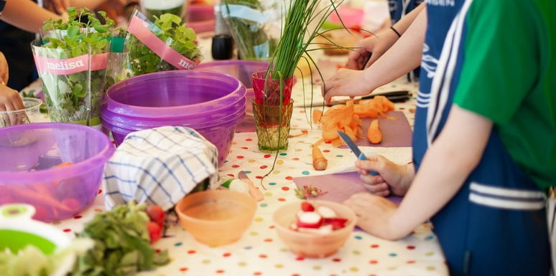

At Swansea educational school facility, the school day will look slightly different from a traditional school setting as its first hour, nine o’clock to ten o’clock will be dedicated to children preparing their breakfast and lunchtime meals. Swansea educational school will provide children with the knowledge and the opportunity to prepare their food through first-hand experiences, allowing them the opportunity to understand a range of different healthy foods and enjoy cooking and eating the meals they have prepared for themselves with their peers (School food matters, 2007). School is one of the main environments where children learn and understand food as they are there for eight hours a day (Hermans, Bruin, Larsen, Mensink and Hoek, 2017). Providing children with the freedom to pick and cook their own food helps develop positive, healthy eating habits and attitudes towards food that children will be able to carry with them throughout their life (Dudley, Cotton and Peralta, 2015). Within Wales one in three children start school obese (Public Health Network Cymru,2020). In Swansea educational school it will be a focus to educate children on healthy foods as being overweight can lead to many health risks as well as educational risks as it can take away the enjoyment and natural development of children engaging with peers in outdoor activities (CDC, 2021).

Studies have shown children who eat breakfast tend to be more focused and engaging individuals (Adolphus, Lawton and Dye, 2013). Food is fuel for the body and the brain so when children do not have to worry about their meal’s children will benefit cognitively, emotionally, socially and physically as it allows children to reach their full potential throughout the day (Littlecott, Moore, Moore, Lynos and Murphey, 2015). Furthermore, children who do not have access to breakfast and stable healthy meals throughout the day were found to have negative associations with concentration, behaviour problems and overall developmental problems (Belot and James, 2011). Swansea educational school offers this service to allow children to be an active member of the play and learning experiences that are offered to them (British Nutrition Foundation, 2018).

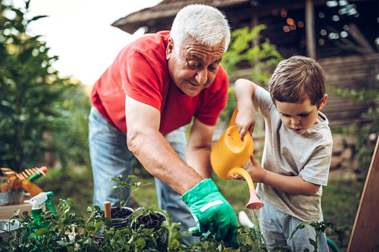
When the children prepare their food, they will be using fresh produce used from the grounds within the school, this is an essential part of the school curriculum that children will help plant, grown and nurture the food the children will be cooking and eating. Every child will have a responsibility to look after the fruit and vegetables that are grown within the school, but they will be working alongside local gardeners that will mentor, support and facilitate the knowledge of gardening of each child (Passy, Morris and Reed, 2010). The gardeners are volunteers from the local area and working alongside these individuals allows the children to build positive relationships, become part of the local community and gain a better understanding of their environment (Mayer-Smith, Bartosh and Peterat).
Outdoor Learning:

At Swansea educational school, outdoor learning will be used as a natural part of a child’s development with most of the day focusing on outdoor play and outdoor learning (Knight, 2013). The outdoors enables children to develop their cognitive, physical, social and emotional well-being and outdoor learning is part of Swansea educational school’s curriculum as it provides children with a holistic approach for their development (Bento and Dias, 2017). Outdoor play allows children to solve problems on their own by promoting their critical thinking skills, it allows them to think creatively, explore and be imaginative (Gray, 2016). Children are creative and curious that when given the opportunity are able to experiment and move freely within the natural environments (Cooper, 2015). Vygotsky also explained through a playful, fun environment a child will create meaning and an understanding of rules, self-regulation language and social communication.

Many theorists believe that children do their best learning before entering a school environment as they are naturally active, curious learners all by themselves and do not need a teacher telling them how to learn, what to learn or where to learn (Holt, 2005). Holt, suggests a typical school environment stops the natural curiosity of a child’s developing mind (Holy, 2015). Holt, is a believer that children do their best learning out of the school environment and due to the typical school environment, children are conditioned to learn in the way the school wants them to learn (Holt and Fromme, 1964). John Gatto supports this theory as he explains education should not be limited to one area or one building. He suggests by keeping children in one building dampens their cognitive, emotional and social development (Gatto, 2002). The schooling system should not be educating children to assume learning only happens in one place when in fact learning and development happens in all environments (Gatto, 2002).
There is evidence to suggest from a different world curriculum that the use of the outdoors is helping develop children holistically (Meyer, Kamens and Benavot, 2017). Finland, for instance, use the outdoors as the main avenue for child development and they believe outdoor play and learning should take priority over Maths, English and Science lessons and all these subjects should be weaved into the outdoor activities to provide children with a cross-curricular approach (Butler, 2016). Throughout the curriculum, a cross-curricular approach will also be greatly stressed on teachers to incorporate into everyday topics and children’s learning. Evidence suggests that not all learning fits into one subject category (Kerry, 2015) and Swansea educational school will incorporate a cross-curricular approach to the curriculum to allow children to understand the natural flow of different subjects in the real world (Darling-Hammond, 2010). Providing this skill to children allows them to effectively problem solve, have fun while learning and develop a child holistically (Kangas, 2019).

Even in the depths of winter, Finland put emphasis on the freedom of movement for children in their natural elements to allow children the ability to take risks, to work together and to experience nature through first-hand experiences (Sandseter and Wyver, 2012). Howards explains these experiences allow children to bring learning into a real-life context, learning through play enables children to develop a positive attitude by understanding learning happens naturally within any activity they do (Howard, 2015). Swansea educational school will enable children to grasp this understanding by providing them with the opportunity to grow and plant vegetables and flowers allowing them to have a fun, interacting, first-hand experience but also with the purpose to learn. These activities will allow the school to provide maths and literacy lessons while gardening through children reading the back of seed packets for instructions or care advice or writing and reading stories inspired by the plants and vegetables grown (Passy, Morris and Reed, 2010). They will have the opportunity to go out and measure the vegetables and flowers while also learning and understanding the season of the year (Passy, Morris and Reed, 2010) providing the school with the freedom to give them a holistic development (Bento and Dias, 2017).

Within the United Kingdom (UK) there are barriers that stop teachers from utilising the outdoor environment to enhance children’s development. For example, teachers lack of confidence, health and safety, curriculum requirements and lack of time (Joyce, 2012). Swansea educational school will tackle these issues as outdoor learning will be a main part of the day. The curriculum will allow teachers to have a high level of autonomy over how their class interacts with the outdoors, and by giving teachers the opportunity to apply topics through their experiences gives the teacher more capability of time management as they understand the task and confidence on how to develop children in the outdoor environment through their own knowledge (Howard, 2015).

Piaget believed that children are little scientists and take an active role in their development (Halfpenny and Pettersen, 2013). He suggested that children will interact with any environment they are put in, creating themselves an opportunity and space to grow their knowledge by taking ownership by leading their own development (Bilton, 2010). Just like Holt and Gatto believe society has created a hegemony where the emphasis is placed on children being educated within a traditional school environment, which views children being educated within a classroom learning from a teacher and curriculum that has been allocated for them (Gatto, 2002). Vygotsky, believed teachers should be facilitators of children’s learning as learning can be created in any space, but also adult’s participation in playful learning motivates and builds child development (Karpov, 2005). That is why Swansea educational school will emphasise children being able to freely develop in the natural environments within the school ground as much as possible with teachers supporting and aiding their development but not leading it (Halfpenny and Pettersen, 2013).

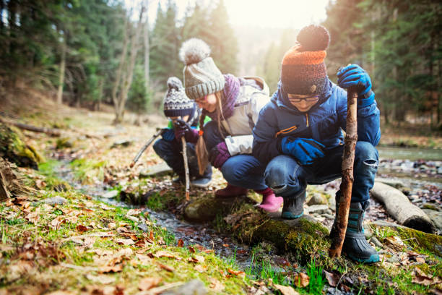
Technology:

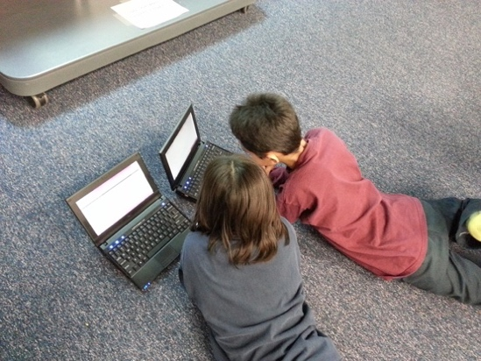
Within Swansea educational school there will be a great opportunity for children to interact and use the internet freely for developmental purposes. Developing children to use the internet is not just beneficial for their overall development but also a life-long skill they will be able to carry with them through life (Mitra, 2010). Hurwitz and Schmitt (2020) suggest there is evidence to show technology will benefit learning as it accelerates development by teaching children to use the internet effectively. Using the internet children gain an understanding of how to self-learn not only what they find interesting but information about anything (Meza-Cordero, 2017). They are able to look up their own research to be able to complete tasks not only in school but also at home (Livingstone, Gui and Stanca, 2016). The internet provides information that not all school teachers, parents or carers might know, so allowing children to log on and find the information themselves, gives them the confidence to share and retain the information they learn, providing them with a rich learning experience (Henry, 2006). The National Institute of Care and Health Excellence (NICE) explain that too much screen time is risky as children may be exposed to inappropriate advertisements and or health risks, that too much time on a device will cut into the opportunities for children to engage in first-hand experiences (Livingstone, Gui and Stanca, 2016). However, Bickham and Moukalled (2019) explains there is little evidence to suggest that children’s overall time usage has little impact on their learning or development.

Swansea educational school will want every child to have their own device so they are able to research with no limits, so every child has access to unlimited information about the topics they are studying (Henry, 2006). Each child will have the opportunity to bring in their own device if they have access to one at home, otherwise, the school will be providing laptops, iPad’s or computers to each child with the help of donations from parents and school fundraisers. One laptop per child is an educational strategy happening around the world, in Costa Rico this initiative is to provide children from underprivileged areas the opportunity and the ability to grow their cognitive development through language and knowledge (Meza-Cordero, 2017). While the initiative has been deemed expensive it has enabled children to be confident when learning on their own, it has enhanced child self-expression, introducing children from underprivileged backgrounds to a modern education system that has revolutionised the conventional teaching techniques by removing textbooks and teachers who are seen as the only source of knowledge within a school environment (Meza-Cordero, 2017).

Each topic studied throughout the curriculum will be carefully supervised however, the lessons will be child-led, the teacher will give children a topic and it will be up to the children to research and find out what they can about the topic. Gray (2013) believes children are biologically designed to educate themselves and should be allowed to embrace their environment as this will facilitate their learning and development. Mitra and Rana (2001) also conclude a child will actively construct their own knowledge, they do not need an environment where a child is spoken to about ideas and knowledge, where they simply absorb the teacher’s information.
Mitra experimented with how access to the internet can help facilitate children’s holistic development after he placed a computer in an Indian slum to see what would happen with children’s learning experience (Mitra and Rana, 2001). Mitra discovered the device sparked children’s curiosity and they started to inspect and learn from this machine (Brito, 2015). As stated above children are naturally curious individuals (Cooper, 2015) and Brito (2015) stated Mitra, believed through unique learning experiences children were able to generate motivation through developing their own knowledge. Basic literacy skills, social skills and confidence improved when they had access to a computer (Mitra and Rana, 2001).
Mitra discovered children did not need teachers feeding them knowledge as they learnt through self-exploration, discovery and collaboration with their peers (Mitra, 2015). However, he found that children were not able to reach their developmental age without adult encouragement, when children were left to their own devices, they could only learn so much (Brito, 2015). Children are deserving of caring adults who facilitate learning but do not judge and or dictate their development (Gray, 2016). It was discovered children needed adults to help facilitate their learning to help them reach their full potential (Dolan, Leat, Mzzoli-Smith, Mitra, Todd and Wall, 2013). Swansea educational school will look to incorporate the work of Mitra’s self-organising learning environment (SOLE) by allowing children the free time to research the given topic, but all learning environments will have a teacher who facilitates, supports, empowers their learning experience so the children are able to reach their full potential through the use of technology and life experiences (Dolan, Leat, Mzzoli-Smith, Mitra, Todd and Wall, 2013).

Assessment:

The education system is criticised for using a standardised system where every child learns the same topic, at the same age, in the same order, a system where practitioners feed children information and in order for children to do well they must listen, memorise and repeat (Freire and Freire, 2004). This learning experience is then measured by exam results where if children do not retain or memorise enough information, they will not get good grades labelling them as underachievers (Irwin, 2012). Research shows each person develops as an individual and to generalise learning puts too much pressure on children to learn and develop at the same rate as every child in their class. (Holt, 2017). This system is allowing children to feel inadequate and feel not good enough in their learning process, this can be damaging to a child’s overall education, health and future, placing them in a box throughout their school life (Gatto, 2002). Being labelled as underachieving when all a child may have needed was a bit of extra time to learn and process certain information could live with them forever through school into the working world (Gatto, 2002). To enable children to become active engaging learners the education system needs to be interactive, creative, enjoyable, relaxed and free from route learning (Robinson and Aronica, 2015).

Mitra argues that the current education system puts a lot of pressure and stress on children to perform well on tests and this does not help their development but in fact allows children to shut down their desire and ability to learn and retain information (Mitra, 2013). When children feel stressed or pressured it sends a signal to their brain creating a threat response where the front part of their brain where they learn will shut down. Children who regularly feel threatened by their school environment will not perform as well and will not get the grades they are expected to get (Mitra, 2013). That is why Swansea educational school will not put pressure on children to perform well in tests and will assess children through their time by observations. This is important to the school to create an environment where children will reach their full potential in their own time in an environment that is relaxed, fun and supportive (Wood and Attfield, 2005).

The Finnish education system has a unique concept when it comes to assessing and testing children (Hancock, 2011). In Finland, practitioners have the responsibility to evaluate the performance of the children in their class (OECD, 2013). Teachers in Finland are able to moderate the children through assessment, taking the pressure off children to be able to perform for a test (Hendrickson, 2012). Hendrickson states Finland want to embed a supportive and encouraging environment for children to develop and grow naturally, an environment where children can feel safe to make mistakes and learn from them, to self-evaluate and develop their skills (Rossi, 1995).
Evidence shows Finland’s method of assessment is proving successful in educating children by looking at their programme for international student assessment (PISA) test results (OECD, 2020). The PISA tests are a global testing system where schools, teachers and children are ranked on their performance, these assessments are performed every three years and presented globally for all to view (OECD, 2019). The most recent PISA test show that Finland has ranked in the top five schools and their results have steadily grown over the last three PISA testing (OECD, 2019).
This is why Swansea educational school will emphasise formative assessment where teachers will have the responsibility and trust of the school and the parents to understand the children and their need’s, adapting their pedagogy within the lessons to help develop each child (Black and William, 2010). Formative assessment is an active process where teachers continually observe and support a child’s development (Runder, 2017). Where teachers update information throughout a task to help keep the child on the correct pathway without controlling their development, the process engages children to understand the information received from a practitioner and take action in developing their method or approach to enhance their development and or knowledge (McCallum and Milner, 2021).

The purpose of formative assessment is to empower children to take ownership of their learning and see education and knowledge as a journey, to not put pressure on a child to perform for a test like summative assessment (Hattie, 2012). Delivery of the feedback, however, needs to be handled carefully to ensure all children understand that the feedback is important, positive and meant to help encourage development not embarrass or insult the child. (McCallum and Milner, 2021) and Sutton (2012) recognises that positive feedback needs to start from the moment children start school to make sure that positive feedback is embedded and an active process of development within Swansea educational school, building feedback in complex, challenging environments practitioners need to help develop a growth mindset to allow all children into understanding learning is an individual journey and may take time.

Learning is a journey and to help children understand this process, aiding children to develop a growth mindset will be heavily liked within the assessment process within Swansea educational school. Swansea educational school will highlight that intelligence and knowledge can be developed with hard work, effort adaptation and perseverance (Dweck, 1999). To develop intelligence and knowledge is to develop the brain muscle and this can be done by always trying to better their development even when they are struggling or fail (Kazkoff and Mitchell, 2017) and positive reinforcement and feedback work hand in hand to help children reach their full potential. It will be the responsibility of Swansea educational school to ensure development and learning do not become static, when a child does not succeed at a task it does not mean they cannot learn the information and should give up (Ayers, 2015). It will be the school’s duty to develop a growth mindset so children can view failure as a means to learn, an opportunity for children to adapt their approach by listening to the positive feedback given to them (Dweck, 2014). Having support from their peers and teachers will encourage children to develop their skills and knowledge by not giving up at the first hurdle (Yeager and Dweck, 2012).

Swansea educational school will allow all children to develop their milestones at their own rate and will not allow children to fail, if a child does not correctly pass when a child is being assessed by its teachers, these teachers will take the responsibility to adapt their pedagogy and support the child in developing different methods of understanding something until they are confident to take up the task up on their own.
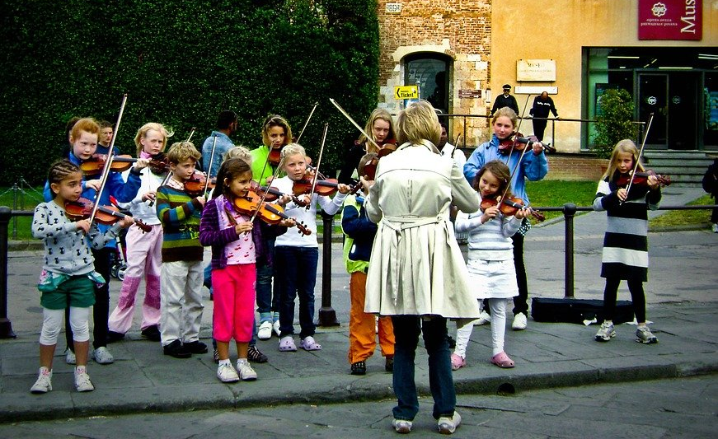

The curriculum:

At Swansea educational school the curriculum will be focused on children leading their own development, an environment where children will learn to be independent, capable individuals who are ambitious through developing their own knowledge with teachers supporting, facilitating their learning experiences (Kumar and Ahmad, 2008).
The school day will start with children and teachers cooking the daily meals, then moving to a setting where the class teacher will talk and discuss a topic and children will be able to take the topic in the direction they want to go. The children will have access to books, iPad’s, computers and teachers to help support their knowledge and learning development, through first-hand experience children will be able to find their passion (Meza-Cordero, 2017).
At Swansea educational school the children will be able to research what they find interesting about a topic for example if the school class topic was about seasons of the year, the children could go look at:
- The colour of the different leaves.
- The consistency of the ground.
- Measure the rainfall for the day.
- Using the internet, they could find out what season is it in a different part of the world and why this happens.
The children will have opportunities to work by using a cross-curricular approach enabling them to understand every event is a learning experience, where they can use multiple skills in a natural way to enhance their development (Howard, 2015).
Children will then have the opportunity to come forward and present their findings at the end of the day. Discussing, explaining and demonstrating what they have understood about the day’s topic, this allows children to develop their cognitive, thinking, questioning and listening skills (Jenkens, 2007) as well as their critical thinking skills as a class (Cojocariu, and Butnaru, 2014).
This will be an opportunity for the teacher to assess what the child or children have learnt and will understand where the children need support in knowledge development for the next day. However, the children will be fully supported throughout the day as all teachers will use formative assessment and assessment for learning at all times (Runder, 2017).

Word count: 4,777

Reference List:

Adolphus, K., Lawton, C.L. and Dye, L., 2013. The effects of breakfast on behavior and academic performance in children and adolescents. Frontiers in human neuroscience, 7, p.425.
Ashley, M., 2005. Can one teacher know enough to teach year six everything? Lessons from Steiner-Waldorf Pedagogy. In British Educational Research Association, Annual Conference, University of Glamorgan, Pontypridd, UK. Retrieved from http://www. ecswe. org/wren/documents/Can_One_Teacher_Know. pdf.

Belot, M. and James, J., 2011. Healthy school meals and educational outcomes. Journal of health economics, 30(3), pp.489-504.

Bento, G. and Dias, G., 2017. The importance of outdoor play for young children's healthy development. Porto biomedical journal, 2(5), pp.157-160.
Bickham, D. S., Moukalled, S. H., & Rich, M. (2019, March). Measuring children’s modern play experiences: Examining links between play and development in the digital age. Chair. In D. S. Bickham (Ed.), Investigating and encouraging play in the contemporary developmental environment. Baltimore, MD: Symposium conducted at the Society for Research in Child Development Biennial Meeting.
Bilton, H., 2010. Outdoor learning in the early years: Management and innovation. Routledge.
British Nutrition Foundation (2018) A quarter of UK secondary school children ave no breakfast. Available at: https://www.nutrition.org.uk/press-office/pressreleases/a-quarter-of-uk-secondary-school-children-have-no-breakfast.html (Accessed 3rd March 2021).

Brookfield, S.D., 2011. Teaching for critical thinking: Tools and techniques to help students question their assumptions. John Wiley & Sons.

Browne, M.N. and Keeley, S.M., 2007. Asking the right questions: A guide to critical thinking. Pearson Education.

Butler, J., 2016. Playing fair. Human Kinetics. Halpenny, A.M. and Pettersen, J., 2013. Introducing Piaget: A guide for practitioners and students in early years education. Routledge.

Cambridge Dictionary (2021) Oppression. Available at: https://dictionary.cambridge.org/dictionary/english/oppression (Accessed 17th March 2021).

Centres for Disease Control and Prevention (2021) Overweight & Obesity. Available at: https://www.cdc.gov/obesity/childhood/causes.html (Accessed 17th March 2021).
Child Law Advice (2021) Education Law Advice. Available at: https://childlawadvice.org.uk/ (Accessed 2nd March 2021).

Children’s Commissioner for Wales (2021) UNCRC. Available at https://www.childcomwales.org.uk/uncrc-childrens-rights/uncrc/ (Accessed 2nd March 2021).

Cojocariu, V.M. and Butnaru, C.E., 2014. Asking questions–critical thinking tools. Procedia-Social and Behavioral Sciences, 128, pp.22-28.
Cooper, A., 2015. Nature and the Outdoor Learning Environment: The Forgotten Resource in Early Childhood Education. International Journal of Early Childhood Environmental Education, 3(1), pp.85-97.

Curren, R (eds) (2007) Philosophy of Education: an Anthology. Oxford: Blackwell.
Darling-Hammond, L., 2010. What we can learn from Finland’s successful school reform. NEA Today Magazine, 29(2), pp.1-9.

Dillon, J., Rickinson, M., Teamey, K., Morris, M., Choi, M.Y., Sanders, D. and Benefield, P., 2006. The value of outdoor learning: evidence from research in the UK and elsewhere. School science review, 87(320), p.107.

Dolan, P., Leat, D., Mazzoli Smith, L., Mitra, S., Todd, L. and Wall, K., 2013. Self-organised learning environments (SOLEs) in an English school: an example of transformative pedagogy?. Online Education Research Journal, 3(11).

Dudley, D.A., Cotton, W.G. and Peralta, L.R., 2015. Teaching approaches and strategies that promote healthy eating in primary school children: a systematic review and meta-analysis. International Journal of Behavioral Nutrition and Physical Activity, 12(1), pp.1-26.
Dweck, C. (2014).​ The power of believing that you can improve​. TED Talk. Retrieved from
Dweck, C.S. (1999). ​Self-theories: Their role in motivation, personality and development
Eales-Reynolds, L.J., Judge, B., McCreery, E. and Jones, P., 2013. Critical thinking skills for education students. Learning Matters.
Estyn (2011) Outdoor learning an evaluation of learning in the outdoors for children under five in foundation phase. Available at: https://www.estyn.gov.wales/system/files/2020-07/Outdoor%2520learning%253A%2520%2520an%2520evaluation%2520of%2520learning%2520in%2520the%2520outdoors%2520for%2520children%2520under%2520five%2520in%2520the%2520Foundation%2520Phase%2520-%2520September%25202011.pdf (Accessed 8th March, 2021).
Florea, N.M. and Hurjui, E., 2015. Critical thinking in elementary school children. Procedia-Social and behavioral sciences, 180, pp.565-572.

Florea, N.M., and Hurjui, E. (2014) Critical thinking in elementary school children. Available at: https://core.ac.uk/download/pdf/82780148.pdf (Accessed 3rd March 2021).

Freire, P. and Freire, A.M.A., 2004. EPZ pedagogy of hope: Reliving pedagogy of the oppressed. A&C Black.

Gatto, J.T., 2000. A different kind of teacher: Solving the crisis of American schooling. Berkeley Hills Books.

Gatto, J.T., 2002. Dumbing us down: The hidden curriculum of compulsory schooling. New Society Publishers.
Gatto, J.T., 2002. Dumbing us down: The hidden curriculum of compulsory schooling. New Society Publishers.

Gray, P. (2013). Free to learn: Why releasing the instinct to play will make our children happier, more self-reliant, and better students for life. New York, Basic Books.
Gray, P. (2016) Children’s natural ways of educating themselves sill work: even for the three R’s. Available at: https://link.springer.com/chapter/10.1007/978-3-319-29986-0_3 (Accessed 8th March 2021).

Gray, P., 2016. Children’s natural ways of educating themselves still work: Even for the three Rs. In Evolutionary perspectives on child development and education (pp. 67-93). Springer, Cham.

Halpenny, A.M. and Pettersen, J., 2013. Introducing Piaget: A guide for practitioners and students in early years education. Routledge.
Hancock, L. N. (September, 2011) Why are Finland's schools successful? The country's achievements in education have other nations, especially the United States, doing their homework. Smithsonian Magazine.
Hattie, J. (2012) Visible Learning for Teachers. Maximizing impact of learning. Routledge. London
Henry, L.A., 2006. SEARCHing for an answer: The critical role of new literacies while reading on the Internet. The reading teacher, 59(7), pp.614-627.

Hermans, R.C., de Bruin, H., Larsen, J.K., Mensink, F. and Hoek, A.C., 2017. Adolescents’ responses to a school-based prevention program promoting healthy eating at school. Frontiers in public health, 5, p.309.

Holt, J., 2005. The underachieving school. Sentient Publications.

Holt, J., 2017. How children learn. Hachette UK.

Holt, J., 2017. How children learn. Hachette UK.

Holt, J.C. and Fromme, A., 1964. How children fail (Vol. 5). New York: Pitman.

Howard, J. (2015) Integrating Outdoor Experience with Curricular Learning. Available at: https://www.wcmt.org.uk/sites/default/files/report-documents/Howard%20J%20Repor%202015%20Final.pdf (Accessed 6th March 2021).

https://gregashman.wordpress.com/2019/09/14/the-right-to-choose-your-childs-education/
https://stmichaelsteiner.hounslow.sch.uk/wp-content/uploads/2019/07/School-Prospectus-2019_2020.pdf
https://www.publichealthnetwork.cymru/en/news/one-in-thirty-children-starting-school-in-wales-is-severely-obese-new-report/

Hurwitz, L.B. and Schmitt, K.L., 2020. Can children benefit from early internet exposure? Short-and long-term links between internet use, digital skill, and academic performance. Computers & Education, 146, p.103750.

Irwin, J., 2012. Paulo Freire's philosophy of education: Origins, developments, impacts and legacies. Bloomsbury Publishing.
Kazakoff, E. and Mitchell, A (2017) Cultivating a Growth mindset with educational technology. Available at:https://www.lexialearning.com/sites/default/files/resources/Cultivating-Growth-Mindset-with-Educational-Technology-White-Paper.pdf (Accessed 15th March 2021).
Kerry, T. ed., 2015. Cross-curricular teaching in the primary school: Planning and facilitating imaginative lessons. Routledge.

Knight, S., 2013. Forest school and outdoor learning in the early years. Sage.
Legislation.Gov (2021) Education Act 1996. Available at: https://www.legislation.gov.uk/ukpga/1996/56/contents (Accessed 2nd March 2021).

Kumar, S. and Ahmad, S., 2008. Meaning, aims and process of education. School of Open Learning, pp.3-6.

Littlecott, H., Moore, G.F., Moore, L., Ronan, AL., and Murphey, S. (2015) Association between breakfast consumption and educational outcomes in 9-11- year-old children. Available at: https://www.cambridge.org/core/journals/public-health-nutrition/article/association-between-breakfast-consumption-and-educational-outcomes-in-911yearold-children/8174B87D235C67D22C0913F66E1ED6B4 (Accessed 4th March 2021).
Livingstone, S., O�lafsson, K., Helsper, E. J., Lupi�an~ez-Villanueva, F., Veltri, G. A., & Folkvord, F. (2017). Maximizing opportunities and minimizing risks for children online: The role of digital skills in emerging strategies of parental mediation. Journal of Communication, 67, 82–105. https://doi.org/10.1111/jcom.12277
Mayer-Smith, J., Bartosh, O. and Peterat, L., 2007. Teaming children and elders to grow food and environmental consciousness. Applied Environmental Education and Communication, 6(1), pp.77-85.
McCallum, S. and Milner, M.M., 2021. The effectiveness of formative assessment: Student views and staff reflections. Assessment & Evaluation in Higher Education, 46(1), pp.1-16.

Meyer, J.W., Kamens, D. and Benavot, A., 2017. School knowledge for the masses: World models and national primary curricular categories in the twentieth century (Vol. 36). Routledge.

Meza‐Cordero, J.A., 2017. Learn to play and play to learn: Evaluation of the one laptop per child program in Costa Rica. Journal of International Development, 29(1), pp.3-31.

Miller, J.P., 2010. Whole child education. University of Toronto Press.

Miller, P. H. (2011). Piaget's theory: Past, present, and future. In U. Goswami (Ed.), The Wiley-Blackwell handbook of childhood cognitive development (p. 649–672). Wiley-Blackwell
Mitra, S (2013) Build a school in the cloud. [video] Available at: https://www.ted.com/talks (Accessed: 9 March 2021).

Mitra, S. and Rana, V. (2002) children and the Internet: experiments with minimally invasive education in India. Available at: https://bera-journals.onlinelibrary.wiley.com/doi/epdf/10.1111/1467-8535.00192 (Accessed 17th March 2021).

Mitra, S. and Rana, V., 2001. Children and the Internet: Experiments with minimally invasive education in India. British journal of educational technology, 32(2), pp.221-232.
Mitra, S.K., 2010. Internationalization of education in India: Emerging trends and strategies. Asian Social Science, 6(6), p.105.
National Foundation for Educational Research (2010) Impact of school gardening on learning. Available at: https://www.nfer.ac.uk/media/2135/rhs01.pdf (Accessed 17th March 2021).

Novak, N.M., Rabiee, M., Tjoa, A.M., McLaren, B.M., Reilly, R., Zvacek, S. and Uhomoibhi, J., 2018. Head in the Clouds: An Initiative for Digital Learning among Roma Communities in Europe. In CSEDU (2) (pp. 384-390).
OECD (2013) Education Policy Outlook Finland. Available at: http://www.oecd.org/education/EDUCATION%20POLICY%20OUTLOOK%20FINLAND_EN. pdf (Accessed 4th March 2021).
OECD (2019) PISA 2018 Results. Available at: https://www.oecd.org/pisa/Combined_Executive_Summaries_PISA_2018.pdf (Accessed 4th March 2021).
OECD (2020) Finland, student performance. Available at: https://gpseducation.oecd.org/CountryProfile?primaryCountry=FIN&treshold=10&topic=PI (Accessed 4th March 2021).
Robinson, K. and Aronica, L., 2015. Creative schools: Revolutionizing education from the ground up. Penguin UK.

Rymanowicz, K. (2016) The importance of critical thinking for young children. Available at: https://www.canr.msu.edu/news/the_importance_of_critical_thinking_for_young_children (Accessed 3rd March).

Sandseter, E.B.H., Little, H. and Wyver, S., 2012. Do theory and pedagogy have an impact on provisions for outdoor learning? A comparison of approaches in Australia and Norway. Journal of Adventure Education & Outdoor Learning, 12(3), pp.167-182.

School Food Matters (2007) Why cooking in schools? Available at: https://www.schoolfoodmatters.org/why-school-food-matters/why-cooking-schools (Accessed 5th March 2021).

Sonia Livingstone, Kjartan Ólafsson, Ellen J. Helsper, Francisco Lupiáñez-Villanueva, Giuseppe A. Veltri, Frans Folkvord, Maximizing Opportunities and Minimizing Risks for Children Online: The Role of Digital Skills in Emerging Strategies of Parental Mediation, Journal of Communication, Volume 67, Issue 1, February 2017, Pages 82–105, https://doi.org/10.1111/jcom.12277
TED Radio Hour (Podcast), 2015-09-04

UNICEF (2021) How we protect children’s rights. Available at: https://www.unicef.org.uk/what-we-do/un-convention-child-rights/ (Accessed 2nd March).

Welsh Government (2014) Independent schools registration and operation guidance. Available at: https://gov.wales/sites/default/files/publications/2018-05/handbook-independent-schools-registration-and-operation-guidance_0.pdf (Accessed 7th March 2021).
Welsh Government (2020) Introduction to curriculum for Wales guidance. Available at: https://hwb.gov.wales/curriculum-for-wales/introduction/ (Accessed 4th March).
Wood, E. and Attfield, J., 2005. Play, learning and the early childhood curriculum. Sage.
Yeager, D. S. & Dweck, C. S. (2012). Mindsets that promote resilience: When students believe that personal characteristics can be developed. ​Educational Psychologist​, ​47​(4), pp. 302-314.

