

Bethan Davies-Jones

Computational Model of Ballistic Impact Lab Report

University of Wales Trinity Saint David
Ordnance Munitions and Explosives – L4 Physics

April 2025

Abstract
An investigation was conducted to evaluate the effect of a high-speed ballistic impact of a copper projectile onto two different target plates, one made of mild steel, and one of high-density polyethylene. This was done through a finite element analysis simulation, and the results were analysed to determine the failures of each plate. This allowed for the conclusion to be drawn that the steel plate was stronger. This information was used to evaluate the uses of body armour made of each material. The limitations of the simulation were considered.

Keywords:
Abaqus, Mild steel, Copper, HDPE, Bullet, FEA

Table of Contents
Abstract ii
List of Figures iv
List of Tables vi
List of Equations vii
List of Abbreviations viii
1 Introduction 1
1.1 Aim of the Simulation 1
1.2 Background Information on Ballistic Impact 1
1.3 Equations 1
2 Material Properties of the Components Modelled 3
2.1 HDPE 3
2.2 Mild Steel 4
2.3 Copper 4
3 Results 6
3.1 Impact of Copper Bullet onto HDPE Plate with Johnson-Cook Damage Model Applied to the Bullet 6
3.2 Impact of Copper Bullet onto HDPE Plate without Johnson-Cook Damage Model Applied to the Bullet 7
3.3 Impact of Copper Bullet onto Mild Steel Plate 12
4 Discussion 15
4.1 Interpretation of Results 15
4.1.1 HDPE Target Plate 15
4.1.2 Mild Steel Target Plate 16
4.1.3 Comparison 16
4.2 Limitations 17
5 Conclusion 18
6 References 19
Appendix A Images of Earlier Versions of the Model Without the Correct Stresses Shown 22

List of Figures
Figure 1 – Copper bullet with Johnson-Cook damage model applied penetrating HDPE plate. 6
Figure 2 – Copper bullet with Johnson-Cook damage model applied after penetrating HDPE plate. 7
Figure 3 – Cross-section of frame 1 of the copper bullet impacting the HDPE plate. 7
Figure 4 – Cross-section of frame 9 of the copper bullet impacting the HDPE plate. 8
Figure 5 – Cross-section of frame 25 of the copper bullet impacting the HDPE plate. 8
Figure 6 – View from above of frame 2 of the copper bullet impacting the HDPE, showing the direct stresses. 9
Figure 7 – View from above of frame 29 of the copper bullet impacting the HDPE plate. 9
Figure 8 – View from above of frame 29 of the copper bullet impacting the HDPE plate. 10
Figure 9 – View from above of frame 100 of the copper bullet impacting the HDPE plate. 10
Figure 10 – Probe values for the direct stress acting on element 22501 of the HDPE target plate simulation in frame 6. 11
Figure 11 – Probe values for the shear stress acting on element 22501 of the HDPE target plate simulation in frame 6. 11
Figure 12 – Velocity-time graph for the copper bullet as it impacted the HDPE plate, with velocity in $ms-1$ and time in $s$. 12
Figure 13 – Cross-section of frame 1 of the copper bullet impacting the mild steel plate. 12
Figure 14 – Cross-section of frame 9 of the copper bullet impacting the mild steel plate. 13
Figure 15 – Probe values for the direct stress acting on element 20701 of the mild steel target plate simulation in frame 7. 13
Figure 16 – Probe values for the shear stress acting on element 20701 of the mild steel target plate simulation in frame 7. 14
Figure 17 – Velocity-time graph for the copper bullet as it impacted the mild steel plate, with velocity in $ms-1$ and time in $s$. 14

List of Tables
Table 1 – Johnson-Cook Plastic Parameters for HDPE [8], [9] 3
Table 2 – Johnson-Cook Damage Parameters for HDPE [8] 3
Table 3 – Plastic and Elastic Properties for HDPE [10], [11] 3
Table 4 – Johnson-Cook Plastic Parameters for Mild Steel [12] 4
Table 5 – Johnson-Cook Damage Parameters for Mild Steel [12] 4
Table 6 – Plastic and Elastic Properties for Mild Steel [13] 4
Table 7 – Johnson-Cook Plastic Parameters for Copper [14] 4
Table 8 – Johnson-Cook Damage Parameters for Copper [14] 5
Table 9 – Plastic and Elastic Properties for Copper [15] 5

List of Equations
Equation 1 – Equation for Johnson-Cook Plastic Model 2
Equation 2 – Equation for Johnson-Cook Damage Model 2

List of Abbreviations
HDPE | High-density polyethylene
FEA | Finite element analysis

Introduction

Aim of the Simulation
This simulation was used to investigate the effect of a high-speed ballistic impact of a copper projectile onto two different target plates, one made of mild steel, and one of high-density polyethylene (HDPE). These materials were chosen due to their uses in the manufacture of body armour [1]. This simulation was used to determine the causes of failure in the target plates.
The simulation was modelled on Abaqus, a suitable programme due to its use of finite element analysis (FEA). This allowed for the simulations to be modelled with more advanced geometry and fibre architecture than an alternative analysis method [2], such as numerical, and allowed for a more accurate evaluation of the results.
The hypothesis was that the bullet would fully penetrate the HDPE plate due to its lower tensile strength, causing it to fail due to shear stresses, and that the steel plate would fail due to direct stresses. This was hypothesised through researching ballistic impacts.

Background Information on Ballistic Impact
When a target and a projectile experience a collision, there will be a transfer of energy between the two. As the projectile impacts the target, its kinetic energy is absorbed, causing stresses and strains within the materials. This is shown through the failure of one of the components, usually through a moving cone formation on the back face of the target, shear stresses, tensile stresses, elastic deformation or frictional energy [3].

Equations
Many equations were used in the computational modelling of the simulation; two notable ones are the Johnson-Cook plastic model and the Johnson-Cook damage model. These two models are important to ballistic simulations because they predict how materials will behave under impact, when strain rates and temperatures influence the results [4].
Equation 1 – Equation for Johnson-Cook Plastic Model
$$σ=\left[A+Bε^{n}\right]\left[1+C ln\left(\frac{\dot{ε}}{{\dot{ε}}_{0}}\right)\right]\left[1-{\left(T^{'}\right)}^{m}\right]$$
Where σ is the equivalent flow stress, $ε$ is the equivalent plastic strain, $ε̇$ is the plastic strain rate, ${\dot{ε}}_{0}$ is a reference strain rate, A is the initial yield strength, B is the strain hardening coefficient, n is the strain hardening exponent [5], C is the strain rate effect, m is the thermal softening effect, T is temperature and $T^{'}=\frac{{T-T}_{0}}{T_{melt}-T_{0}}$, [6].
Equation 2 – Equation for Johnson-Cook Damage Model
$${ε^{0}}_{pl}=\left[D_{1}+D_{2}\exp\left(D_{3}σ\right)\right]\left[1+D_{4}\ln\left(\frac{\dot{ε}}{{\dot{ε}}_{0}}\right)\right]\left(1+ D_{5}T^{'}\right)$$
Where ${ε^{0}}_{pl}$ is ductile failure, $D_{1}$-$D_{5}$ are failure parameters measured at or below the transition temperature [7], and all other symbols are the same as the plastic model.

Material Properties of the Components Modelled
The material properties for each component were thoroughly researched to ensure the accuracy of the simulation.
${\dot{ε}}_{0}$ was taken to be 1 unless stated otherwise.
$θ_{transition}$ was taken to be 293K unless otherwise stated.

HDPE
Table 1 – Johnson-Cook Plastic Parameters for HDPE [8], [9]
A / MPa | B / MPa | n | Melting Temperature / K | m | C
8.859 | 30.56 | 0.3838 | 408 | 1 | 0.0455

Table 2 – Johnson-Cook Damage Parameters for HDPE [8]
$$D_{1}$$ | $$D_{2}$$ | $$D_{3}$$ | $$D_{4}$$ | $$D_{5}$$
0.3 | 0.075 | 0.333 | 0.0005 | 0

Table 3 – Plastic and Elastic Properties for HDPE [10], [11]
Density / $kgm^{-3}$ | Young’s Modulus / MPa | Poisson’s Ratio
952 | 500 | 0.38

Mild Steel
Table 4 – Johnson-Cook Plastic Parameters for Mild Steel [12]
A / MPa | B / MPa | n | Melting Temperature / K | m | C
324.1 | 113.8 | 0.42 | 925 | 1.34 | 0.002

Table 5 – Johnson-Cook Damage Parameters for Mild Steel [12]
$$D_{1}$$ | $$D_{2}$$ | $$D_{3}$$ | $$D_{4}$$ | $$D_{5}$$
0.05 | 3.44 | 2.12 | 0.002 | 0.61

Table 6 – Plastic and Elastic Properties for Mild Steel [13]
Density / $kgm^{-3}$ | Young’s Modulus / MPa | Poisson’s Ratio
7840 | 198,000 | 0.275

Copper
Table 7 – Johnson-Cook Plastic Parameters for Copper [14]
Melting Temperature / K | A / MPa | B / MPa | C | n | m
1356 | 90 | 292 | 0.025 | 0.31 | 1.09

Table 8 – Johnson-Cook Damage Parameters for Copper [14]
$$D_{1}$$ | $$D_{2}$$ | $$D_{3}$$ | $$D_{4}$$ | $$D_{5}$$
0.18 | 1.36 | -3.89 | 0.014 | 1.12

Table 9 – Plastic and Elastic Properties for Copper [15]
Density / $kgm^{-3}$ | Young’s Modulus / MPa | Poisson’s Ratio
8913 | 117,200 | 0.33

Results
The results were formatted as images of the simulation as it was running and velocity-time graphs of the bullets. The images were taken frame by frame, either of cross-sections of the impact or of the top face of the target plate. In the dual-window images, the left window shows the shear stresses, and the right window shows the direct stresses (compression and tension).

Impact of Copper Bullet onto HDPE Plate with Johnson-Cook Damage Model Applied to the Bullet
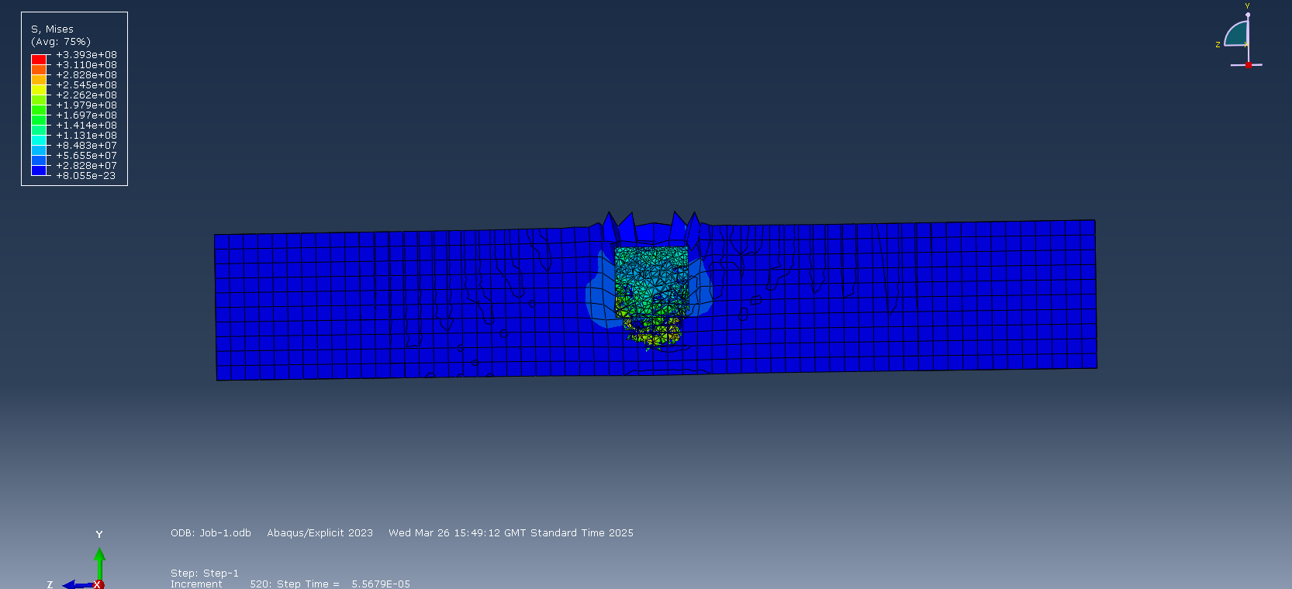
Figure 1 – Copper bullet with Johnson-Cook damage model applied penetrating HDPE plate.
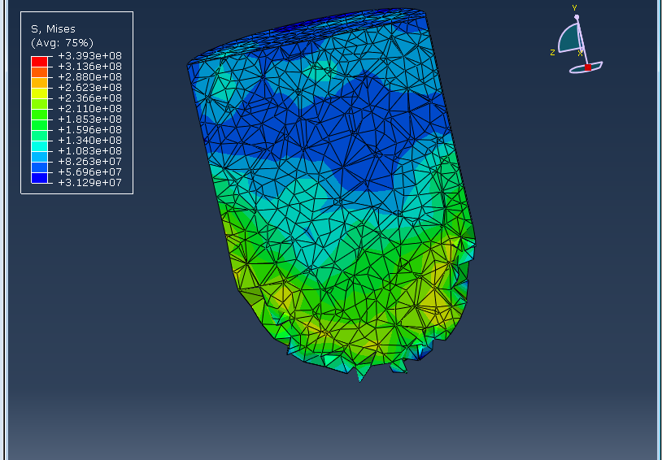
Figure 2 – Copper bullet with Johnson-Cook damage model applied after penetrating HDPE plate.

Impact of Copper Bullet onto HDPE Plate without Johnson-Cook Damage Model Applied to the Bullet
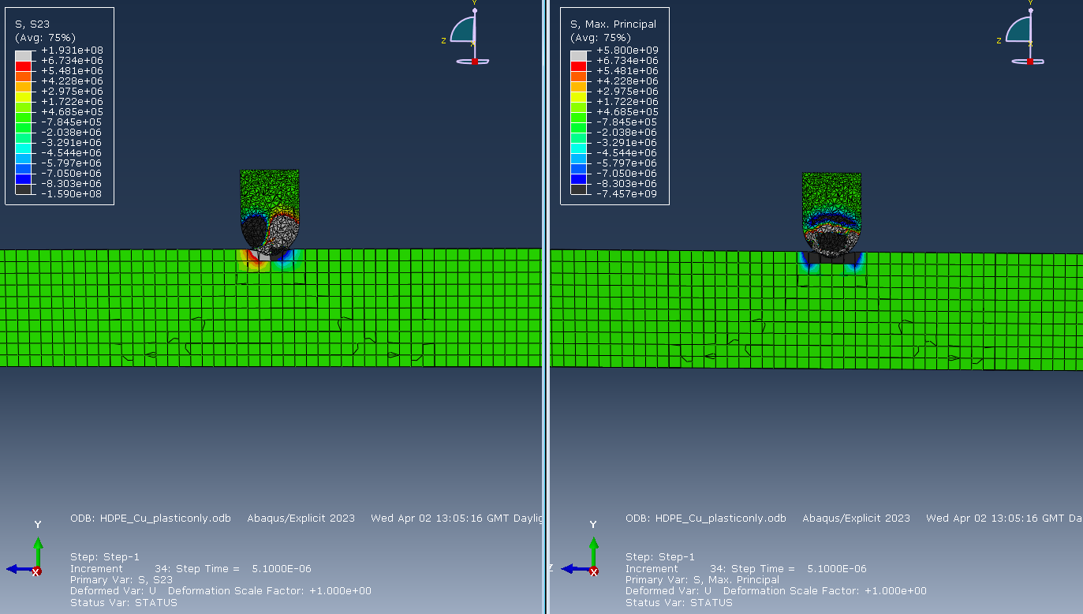
Figure 3 – Cross-section of frame 1 of the copper bullet impacting the HDPE plate.
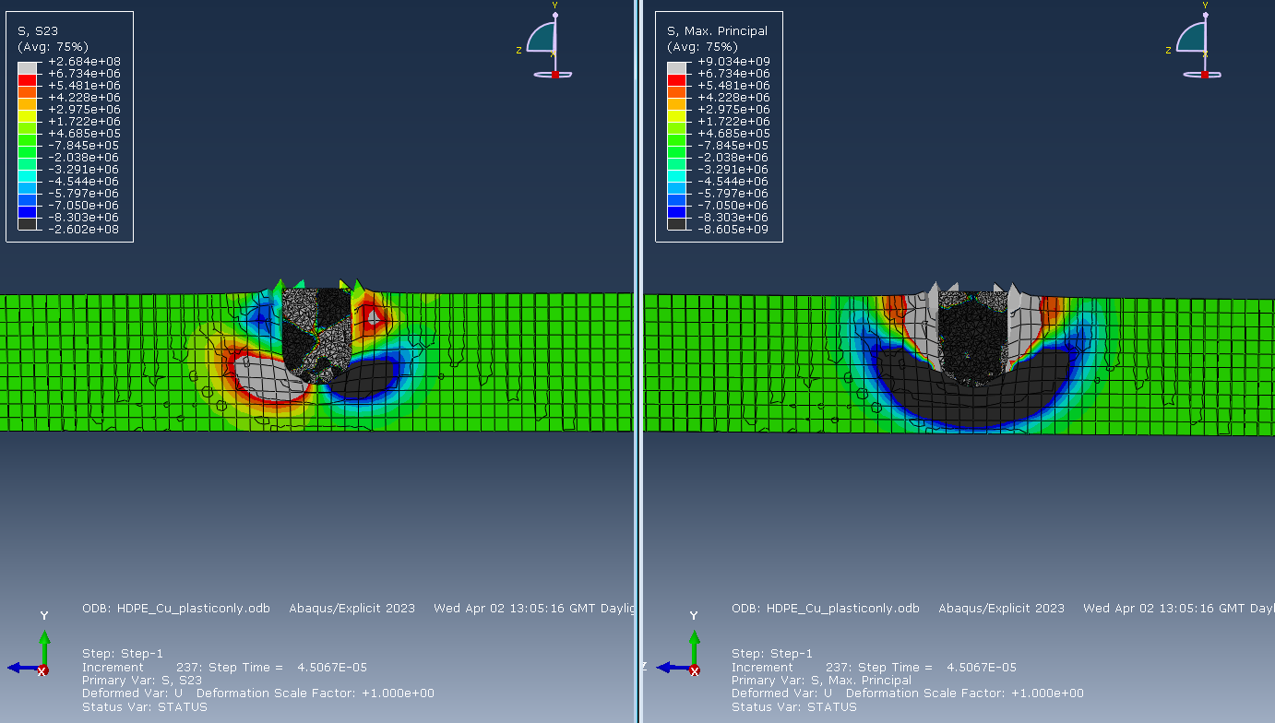
Figure 4 – Cross-section of frame 9 of the copper bullet impacting the HDPE plate.
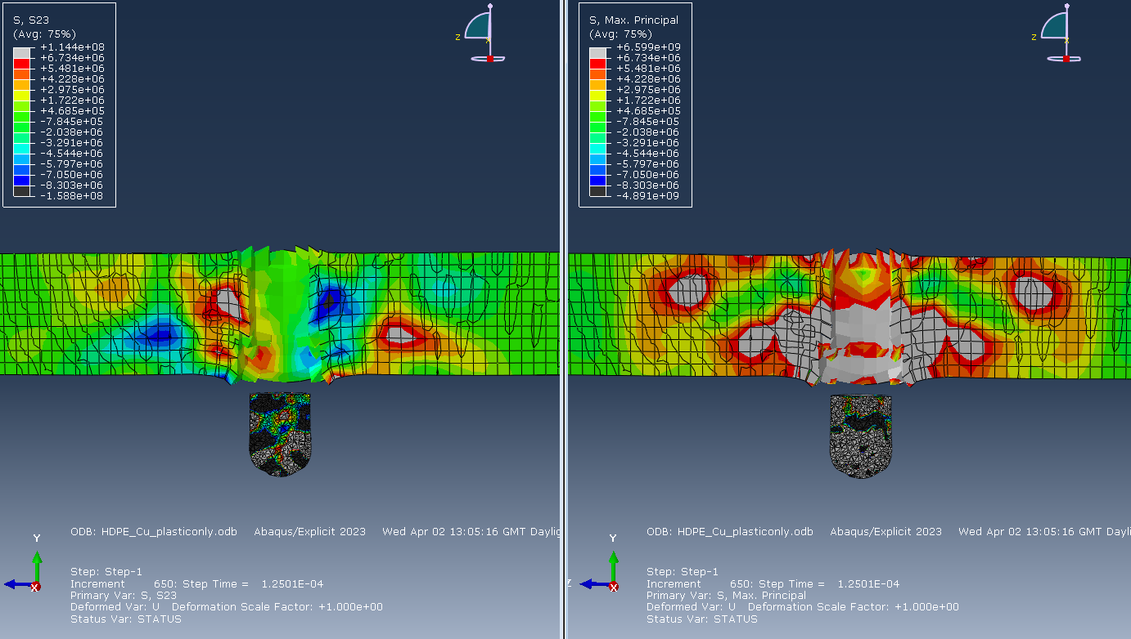
Figure 5 – Cross-section of frame 25 of the copper bullet impacting the HDPE plate.
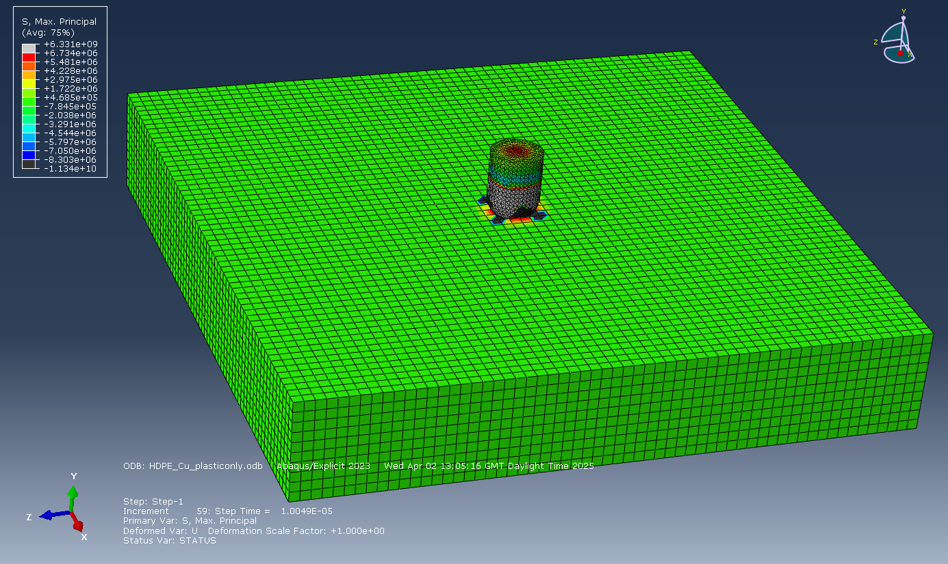
Figure 6 – View from above of frame 2 of the copper bullet impacting the HDPE, showing the direct stresses.
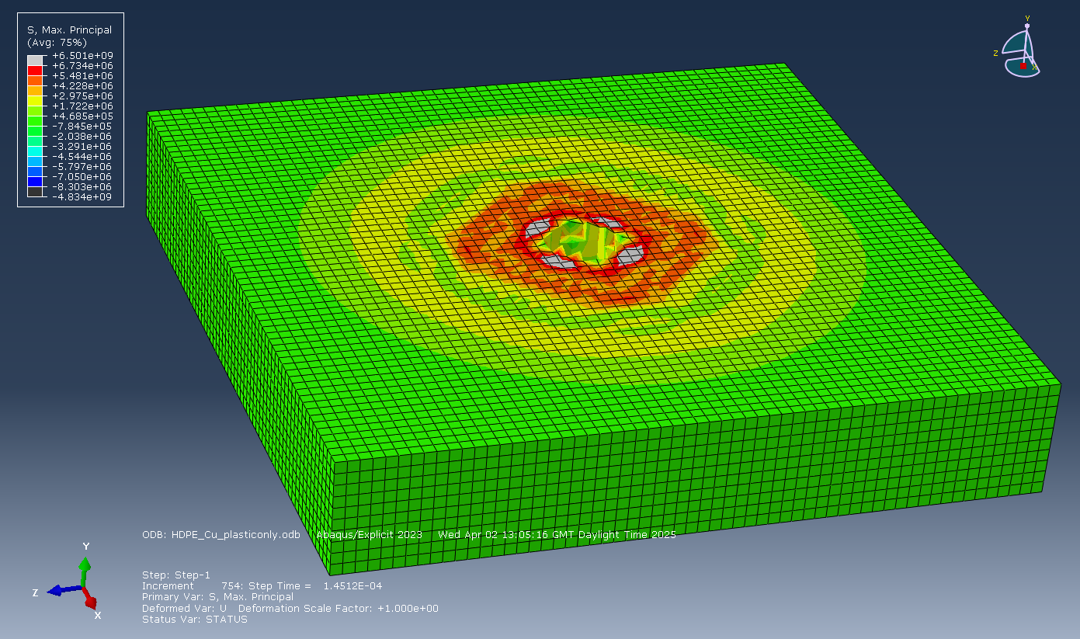
Figure 7 – View from above of frame 29 of the copper bullet impacting the HDPE plate.
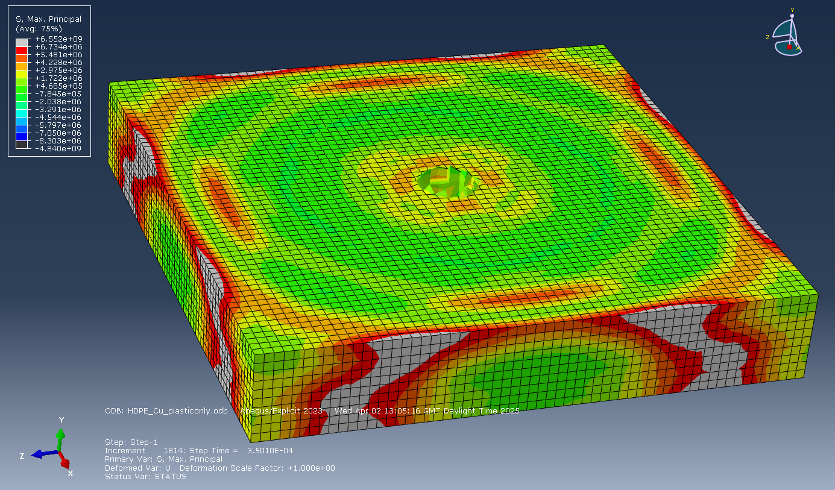
Figure 8 – View from above of frame 29 of the copper bullet impacting the HDPE plate.

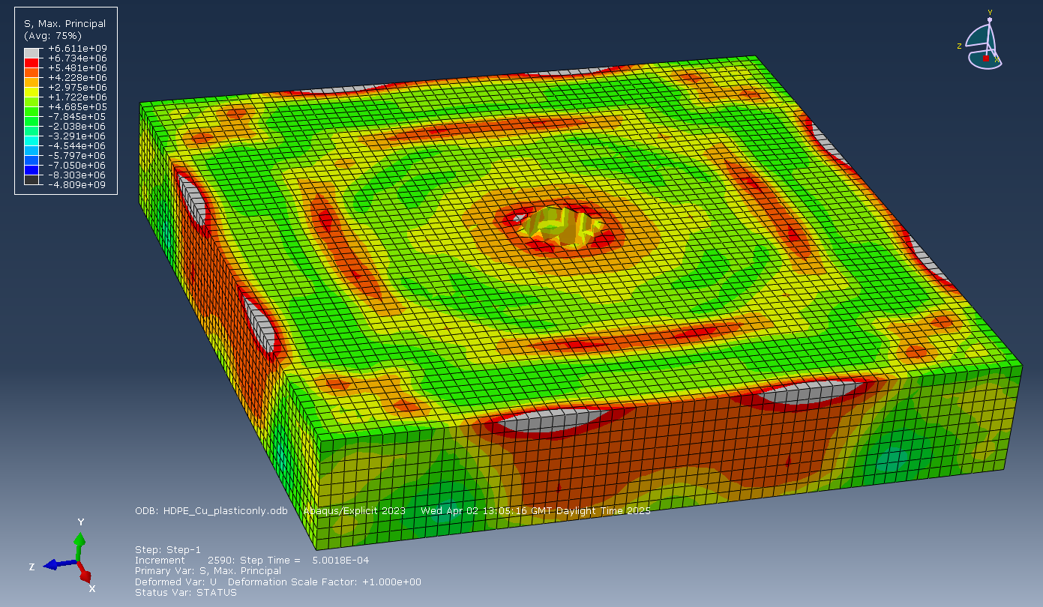
Figure 9 – View from above of frame 100 of the copper bullet impacting the HDPE plate.
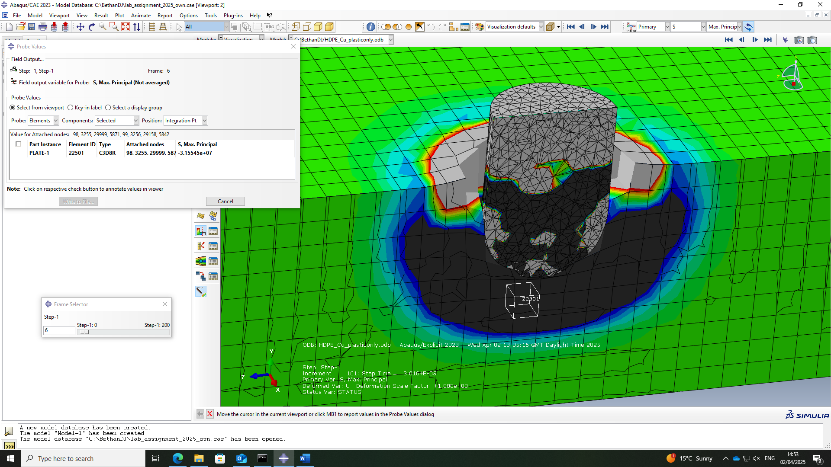
Figure 10 – Probe values for the direct stress acting on element 22501 of the HDPE target plate simulation in frame 6.
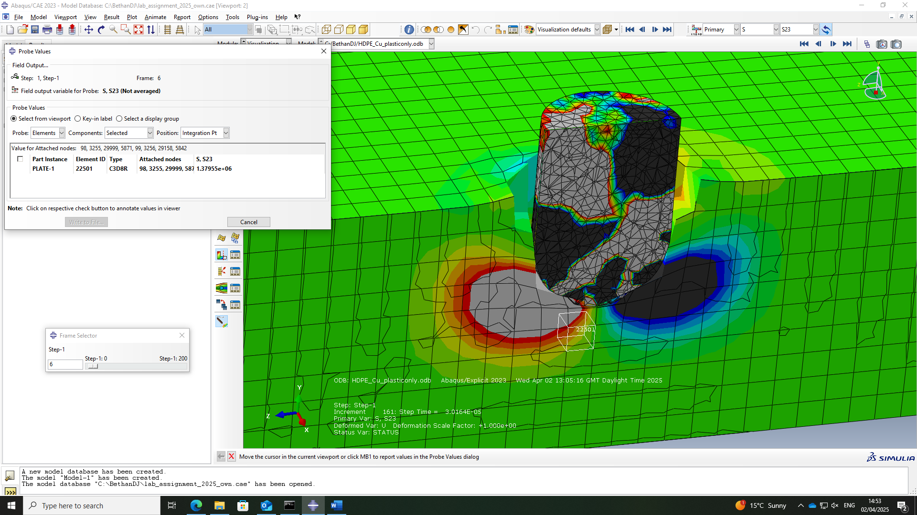
Figure 11 – Probe values for the shear stress acting on element 22501 of the HDPE target plate simulation in frame 6.

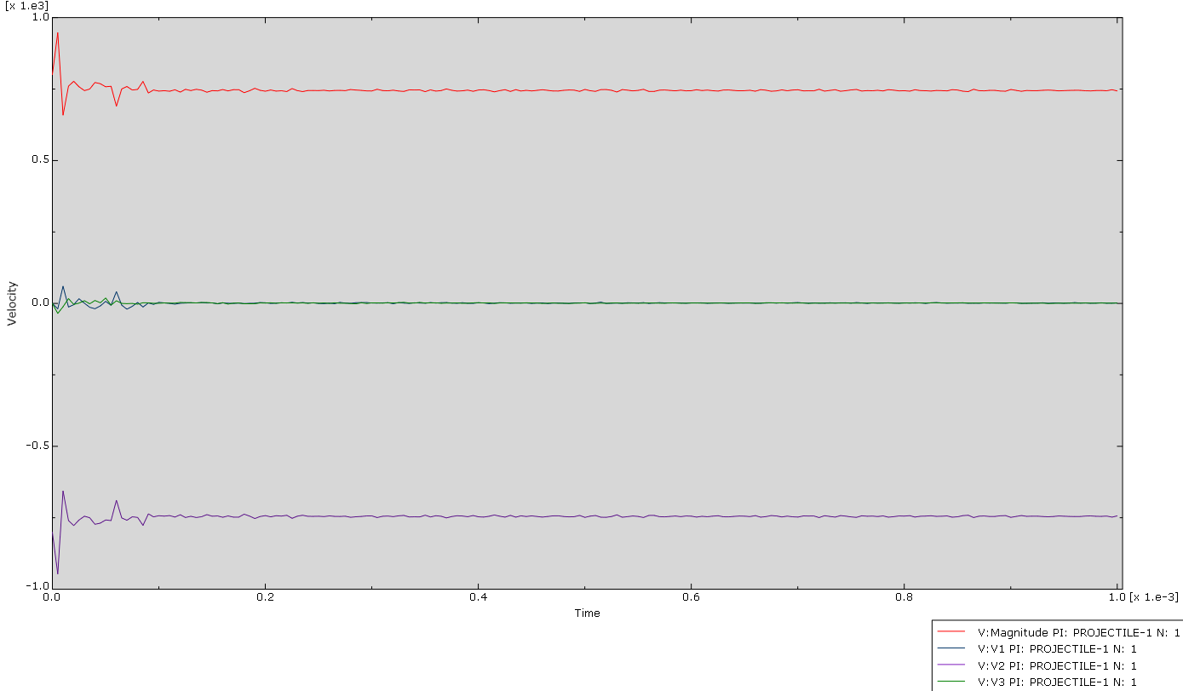
Figure 12 – Velocity-time graph for the copper bullet as it impacted the HDPE plate, with velocity in $ms^{-1}$ and time in $s$.

Impact of Copper Bullet onto Mild Steel Plate
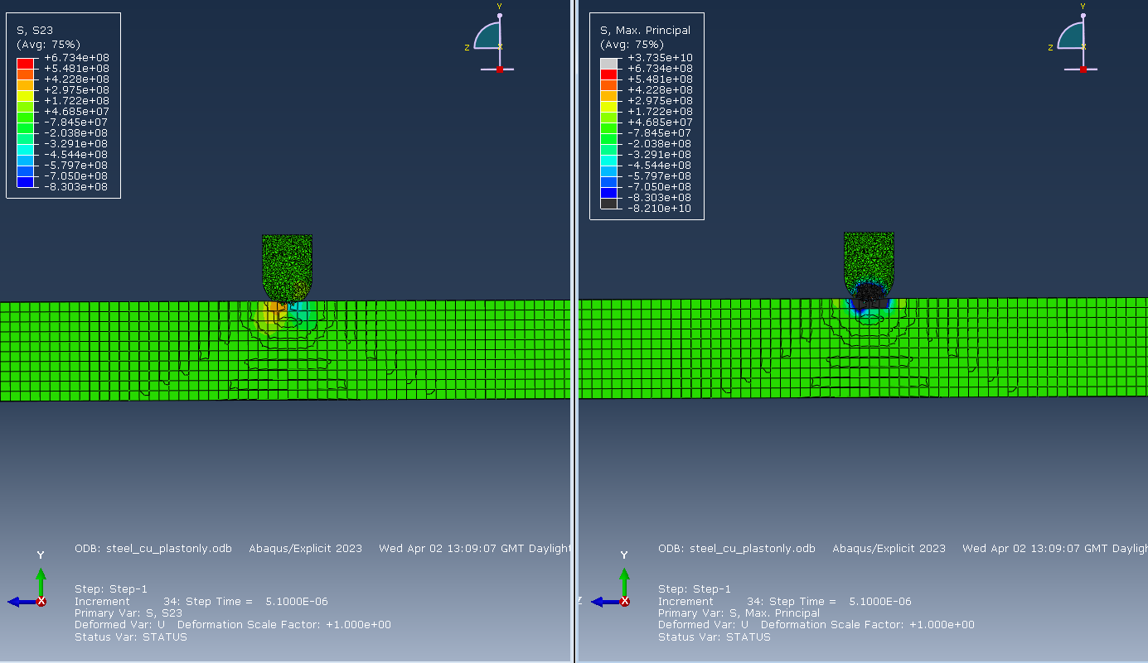
Figure 13 – Cross-section of frame 1 of the copper bullet impacting the mild steel plate.
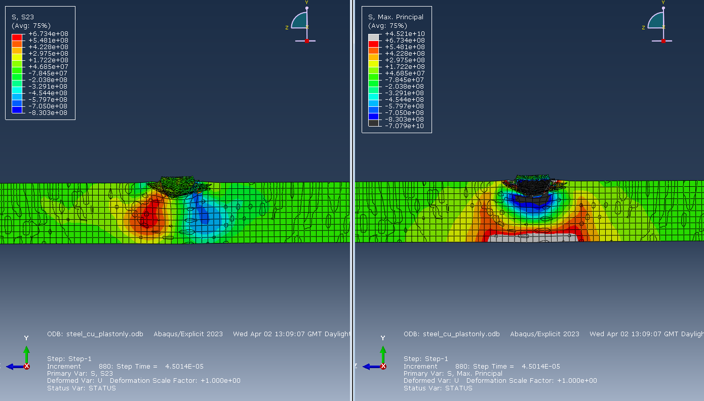
Figure 14 – Cross-section of frame 9 of the copper bullet impacting the mild steel plate.
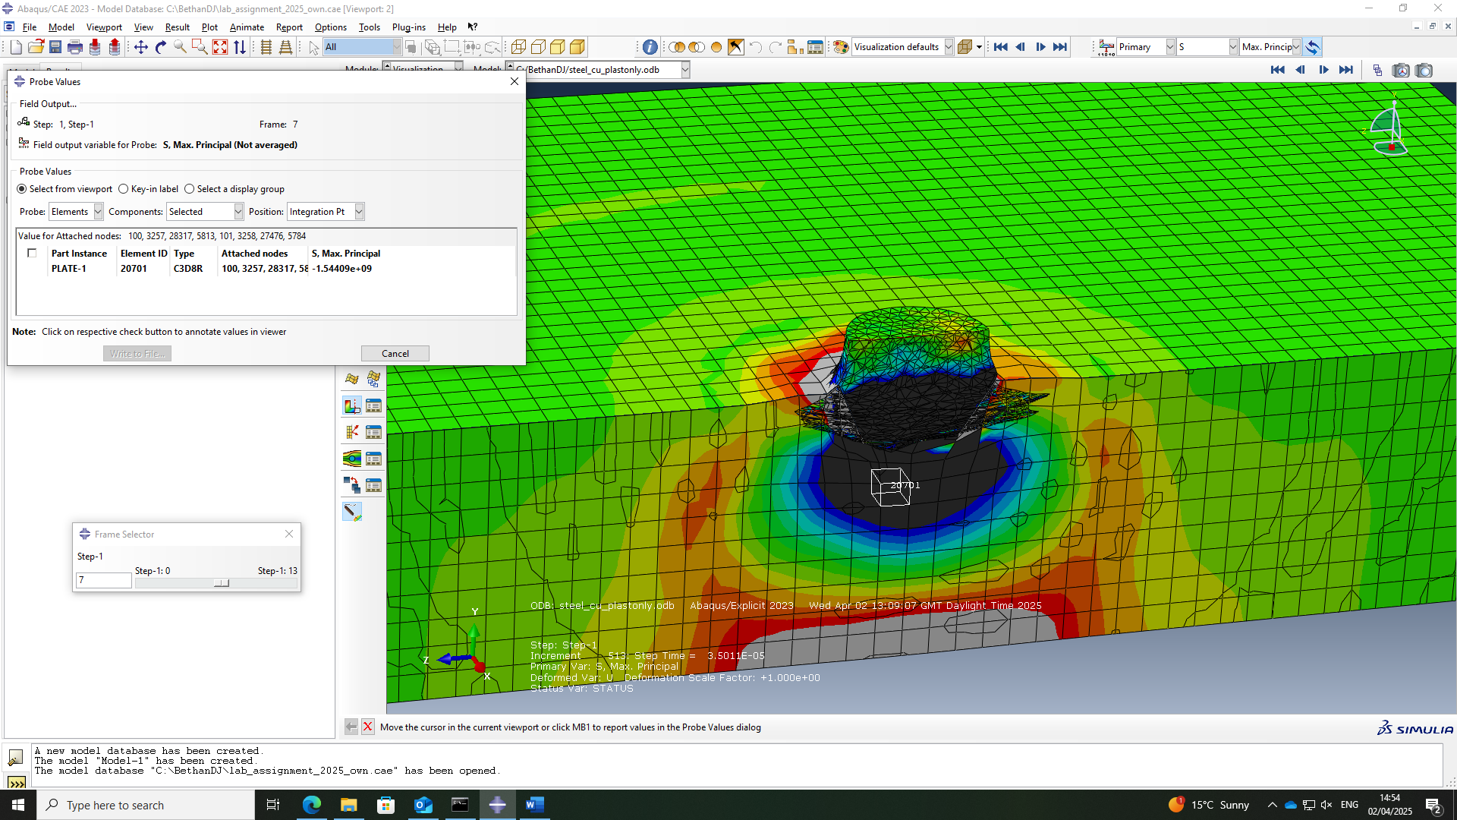
Figure 15 – Probe values for the direct stress acting on element 20701 of the mild steel target plate simulation in frame 7.
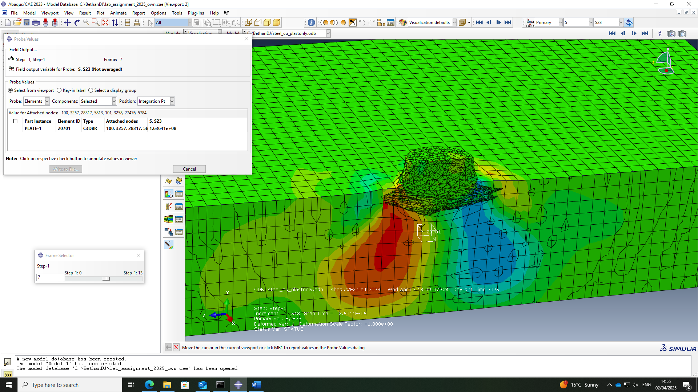
Figure 16 – Probe values for the shear stress acting on element 20701 of the mild steel target plate simulation in frame 7.
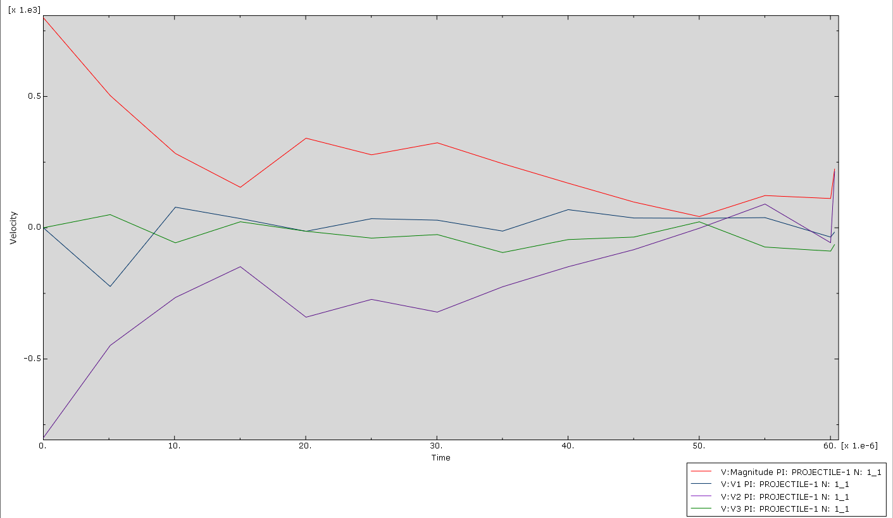
Figure 17 – Velocity-time graph for the copper bullet as it impacted the mild steel plate, with velocity in $ms^{-1}$ and time in $s$.

Discussion

Interpretation of Results
The simulation originally ran with the Johnson-Cook damage model applied to both the bullet and the steel plate. While this is technically a more accurate model of how the components would act in the real world, it had an impact on the behaviour of the bullet, preventing it from fully impacting the target plate to the intended extent (Section 3.1). Upon discovering this, the simulation was reprogrammed so that only the target plate had the Johnson-Cook damage model applied to it. The images of the simulation as it was running offer a visual representation of the stresses acting on the components, however quantitative values were obtained with the probe.

HDPE Target Plate
When the copper bullet first impacts the HDPE plate, the shear and direct stresses are both very high in the bullet and the plate, but cover a much smaller area in the plate comparatively. As the direct stress is very negative, it can be deduced that it is a compressive stress (Figure 3). As the bullet penetrates and moves through the plate, the values of the stresses increase. When the bullet is about halfway through the plate’s thickness, the direct stresses cover a significantly larger area than the shear stresses, almost surrounding it entirely, whereas the shear stresses act more towards the sides of the bullet (Figure 4). This is due to the fact that shear stresses are caused by forces acting parallel to the surface of a component [16]. As the bullet exits the target plate, the stresses disperse. The shear stresses are higher in the bullet, but the direct stresses are higher in the target plate. As they are very positive, they are tension stresses (Figure 5).
After the bullet exits the target plate, the tension stresses continue to move out from the point of penetration to the edge of the plate in waves, presenting as if it were rippling (Figures 7-9). This could be due to the dispersion of kinetic energy.
Probe values for both the direct and shear stresses were taken from frame six, element 22501 of the simulation. The values obtained were $-3.15545×{10}^{7}$Pa (Figure 10) and $1.37955×{10}^{6}$Pa (Figure 11) for the direct and shear stresses respectively. The negative value for the direct stress indicates that it is compressive. As the modulus of the compression is over an order of magnitude greater than the shear stress, it can be said that the cause of failure of the HDPE plate was a direct, compressive stress.

Mild Steel Target Plate
When the projectile first makes contact with the mild steel plate, the direct stresses are a lot higher than the shear (Figure 13). As the impact progresses and the bullet flattens against the target plate, both stresses increase. While the shear and direct stresses are of fairly similar magnitude within the main body of the plate, the bullet is experiencing significantly more direct stress, as well as the area of the plate directly below the point of contact, and the same place on its opposite face (Figure 14). As the values are very negative and very positive respectively, they are a compressive stress and tensile stress.
Probe values for both the direct and shear stresses were taken from frame 7, element 20701 of the simulation. The values obtained were $-1.54409×{10}^{9}$Pa (Figure 15) and $1.63641×{10}^{8}$Pa (Figure 16) for the direct and shear stresses respectively. The negative value for the direct stress indicates that it is compressive. As the modulus of the compression is over an order of magnitude greater than the shear stress, it can be said that the cause of failure of the mild steel plate was a direct, compressive stress.

Comparison
While both target plate materials failed due to compressive stress, the HDPE sustained a lot more damage than the mild steel, achieving complete penetration as opposed to the mild steel remaining fully intact.
This shows that from a strength perspective, mild steel is a significantly better option for body armour than HDPE. However, when considering the densities, the value for HDPE (Table 3) is over eight times smaller than mild steel (Table 6). This means that a much thicker plate of HDPE could be used, which would offer more protection than shown in the simulation, and would still have less mass than the steel plate. An alternative option for increased safety and mobility could be layering the two materials, reducing the mass with the lightness of the HDPE, while also providing an extra level of protection through the mild steel’s resistance to penetration.

Limitations
Running a simulation as a computational model means that the capacity of the software is limited to the capacity of the machine. As the simulation was carried out on computers that weren’t particularly advanced, this decreased the level to which Abaqus could run, meaning there was a limit on the number of nodes that could be within a single simulation before the software crashed.
Another limitation of the results was the fact that only one mesh was created for each simulation. If each simulation had been run again with a finer mesh, a higher or lower number of nodes, or different shaped nodes, then it would have been ascertained whether or not this had an impact on the results. If it did, then the simulation could have been meshed multiple times, incrementally, to obtain the most accurate result. As this was not done, however, it cannot be confidently said that these results are definitely accurate or precise.

Conclusion
In conclusion, the results did not fully support the hypothesis. The mild steel plate did fail due to compressive stress and the copper bullet did fully penetrate the HDPE plate, but it failed due to compressive stress rather than shear.
If the simulation were to be repeated to gain more accurate results, it would be run on a more powerful computer to allow for the use of more nodes. The simulation would also be run multiple times, to allow for finer meshing in increments to evaluate the accuracy and precision of the results.

References

[1] | “Polyethylene Body Armor: The Pros & Cons to PE Ballistic Plates,” Premier, 2025. [Online]. Available: https://premierbodyarmor.com/blogs/pba/polyethylene-body-armor?srsltid=AfmBOopBTT576CB1IOWe4FA-Ta2y0mEHHo72_aIi3SIhg_NP02CBuC0q. [Accessed 25 March 2025].
[2] | D. Ma, “Modeling approaches for ballistic simulations of composite materials: Analytical model vs. finite element method,” Composites Science and Technology, vol. 248, no. 1, 2024.
[3] | N. K. Naik, “Composite structures under ballistic impact,” Composite Structures, vol. 66, no. 1-4, pp. 579-590, 2004.
[4] | V. K. R. Sirigiri, “A review on Johnson Cook material model,” Materials today: Proceedings, vol. 62, no. 6, pp. 3450-3456, 2022.
[5] | G. University, “Determination of Johnson Cook Strength and Failure Parameters of EN-GJS-400 Spheroidal Graphite Cast Iron,” Journal of Institue Of Science and Technology, vol. 40, no. 2, p. 259, 2024.
[6] | H. S. Nam, “Ductile fracture simulation for A106 Gr.B carbon steel under high strain rate loading condition,” Recent Advances in Structural Integrity Analysis - Proceedings of the International Congress (APCF/SIF-2014), pp. 37-41, 2014.
[7] | M. Viedth, “Introduction to Abaqus Johnson-Cook Model: Accurately Model High-Strain rate Events,” CAE Assistant, 17 May 2024. [Online]. Available: https://caeassistant.com/blog/abaqus-johnson-cook-model-video/. [Accessed 13 May 2025].
[8] | A. Alhourani, “Development of Johnson Cook Plasticity and Damage Mode lParameters for the Time-dependent Behavior of High-Density Polyethylene,” in The 10th World Congress on Mechanical, Chemical, and Material Engineering (MCM'24) , Barcelona, 2024.
[9] | “What Is the Melting Point of PE Plastic?,” EuroPlas, 2025. [Online]. Available: https://europlas.com.vn/en-US/blog-1/what-is-the-melting-point-of-pe-plastic. [Accessed 25 March 2025].
[10] | A. H. Awad, “Mechanical and Physical Properties of PP and HDPE,” Engineering Science, vol. 4, no. 2, pp. 34-42, 2019.
[11] | A. Drai, “Analysis of plastic deformation behavior of HDPE during high pressure torsion process,” Engineering Structures, vol. 46, no. 1, pp. 87-93, 2013.
[12] | D. Systemes, Simulation of the ballistic perforation of aluminum plates with Abaqus/Explicit, Dassault Systemes, 2012.
[13] | “Overview of Materials for Low Carbon Steel,” MatWeb, [Online]. Available: https://www.matweb.com/search/DataSheet.aspx?MatGUID=034970339dd14349a8297d2c83134649&ckck=1. [Accessed 25 March 2025].
[14] | A. Abdollazadeh, “Advances in simulation and experimental study on intermetallic formation and thermomechanical evolution of Al–Cu composite with Zn interlayer: Effect of spot pass and shoulder diameter during the pinless friction stir spot welding process,” Journal of materials: Design and applications, vol. 237, no. 6, 2022.
[15] | D. M. Iordache, “Determination of Johnson-Cook material constants for Copper using traction tests and inverse identification,” IOP Conference Series: Materials Science and Engineering, vol. 1182, 2021.
[16] | K. J. Blose, “Chapter 13 - Bioreactors for Tissue Engineering Purposes,” in Regenerative Medicine Applications in Organ Transplantation, Academic Press, 2014, pp. 177-185.

Images of Earlier Versions of the Model Without the Correct Stresses Shown


