STILL LIFE
2021
2nd years

The WORK of Georgio Morandi
SEE Powerpoint

https://www.christies.com/features/Giorgio-Morandi-guide-10098-3.aspx

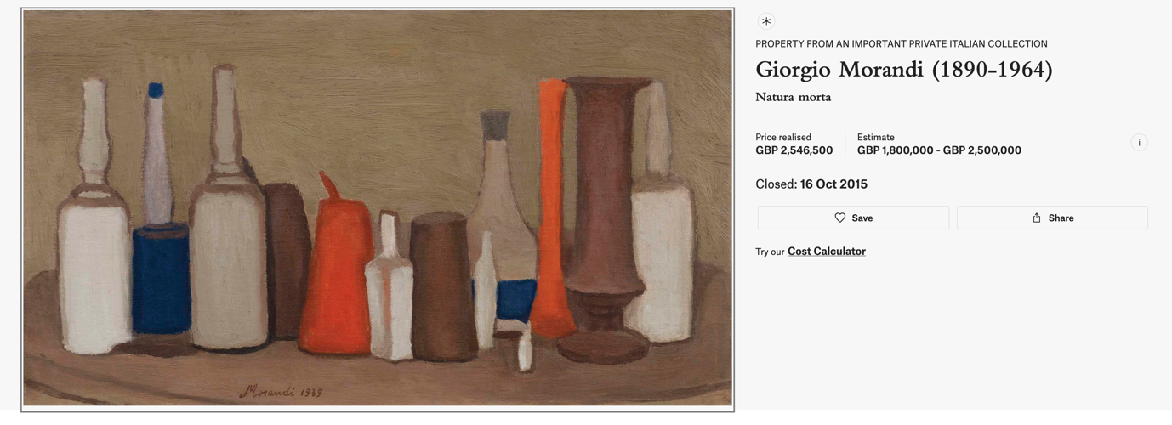

https://www.mlfineart.com/video/4-focus-on-art-giorgio-morandi/

https://seattleartistleague.com/2018/05/22/morandis-dust/

https://www.robilantvoena.com/video/32/

10am – 10.15am INTRO

10.15am – 10.45am – Monochrome Cut Out

10.45am – 11.30am – Cross Hatching – MORANDI STYLE

11.30 – 12.30 – ABSTRACT the still life

1.30pm – 2.30pm – Reconnect – GROUP PARTICIPATION

