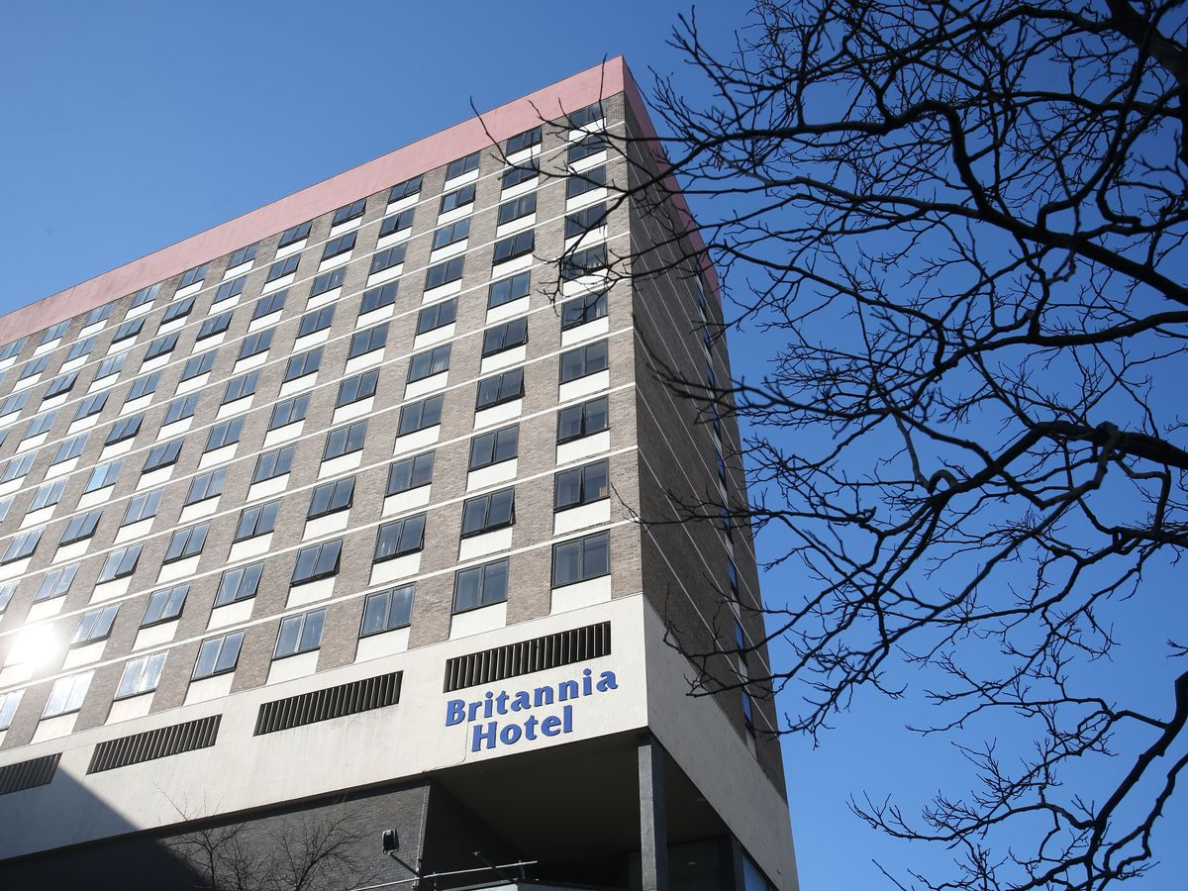  Organisational Consultancy  Report | "Revitalizing Britannia Hotel London Property: A Consultancy Project for Improving Business Performance"

Executive Summary
In summary, this consultancy task for Britannia Hotels focused on identifying and addressing specific problems related to customer service, employee engagement, financial difficulties and management and leadership challenges. Through the use of strategic tools such as SWOT analysis, PESTLE analysis and TOWS matrix, we identified several key areas for improvement. These included poor customer service, low employee engagement and high turnover rates, decreased occupancy rates, and lack of clear vision and direction.
In response to these issues, a number of solutions were proposed and an action plan was developed. The proposed solutions included improving customer service by providing better training for staff, increasing employee engagement and retention by increasing benefits and incentives, improving communication and management, increasing occupancy rates through targeted marketing campaigns and website revamp, and improving organizational direction, communication and decision-making by creating a clear mission and vision and improving processes.
It is suggested that the proposed solutions and action plans will help Britannia Hotels optimize their business performance and improve customer satisfaction, employee engagement and revenue and gross profit. However, the time scale, completion date and budget allocation may need to be reviewed and adjusted in accordance with the specific circumstances and budget of the company.
The research for this consultancy was based on secondary research, including review of relevant literature and online resources. The findings were then used to develop conclusion and recommendations. Overall, it is suggested that Britannia Hotels should focus on implementing the proposed solutions and action plans in order to improve their overall performance and customer satisfaction.

Table of Contents
Executive Summary 2
Introduction 4
Scope and Analysis 4
Scene 4
Core operational challenges 5
PESTLE analysis 6
Political analysis 6
Economic analysis 6
Technology analysis 7
Social analysis 8
Legal analysis 8
Environmental analysis 8
SWOT analysis 9
Main Body 12
Customer service management 12
Employee engagement 13
Financial performance analysis 14
Leadership and Management 15
Findings and Results 16
Summary and Findings of problem analysis 16
Findings of PESTLE analysis 17
Summary of SWOT and TWOS 19
Findings of main body analysis 21
Action plan 22
Recommendations 23
Conclusion 24
Reference list 25

Introduction
The purpose of this report is to conduct a comprehensive examination of the challenges facing Britannia Hotels, a leading hotel company in the UK, with a focus on identifying core problems and providing recommendations for improvement. The company has been facing a range of pressing issues, including poor customer service, low employee engagement, and financial difficulties stemming from the COVID-19 pandemic. This has resulted in decreased occupancy rates, which in turn has led to a decline in revenue and gross profit.
To address these issues, this report will employ a strategic management framework, utilizing tools such as PESTEL analysis, SWOT analysis, and TOWS analysis to gain a thorough understanding of both the internal and external factors impacting the company. Furthermore, observations of workplace practices will be used to gain a deeper insight into the specific challenges facing Britannia Hotels.
The report will begin by providing a case study analysis of the customer service issues at Britannia Hotels. By examining specific areas such as housekeeping, we will identify key pain points and their root causes. Next, we will delve into employee engagement, and assess the impact of external factors such as the economic environment, rising cost of living in London, and the ongoing COVID-19 pandemic. Finally, we will conduct a comprehensive analysis of the company using the strategic management tools, and provide a set of actionable recommendations that address the identified problems and opportunities.
Throughout the report, we will use industry best practices and data-driven insights to support our findings and conclusions. The goal of this report is to provide Britannia Hotels with a clear roadmap for addressing their challenges and improving their overall performance in the highly competitive hospitality industry.

Scope and Analysis

Scene
Britannia Hotels is a well-established hotel chain with a presence across the United Kingdom. The focus of this report is on the flagship location of Britannia Hotels, located in the bustling city of London. The hotel is situated in a prime location, close to popular tourist attractions such as Buckingham Palace and Big Ben, as well as being in proximity to several major business and shopping districts (Helmbold and Terry, 2021).
The hotel boasts a total of 400 rooms, including standard rooms, suites, and executive rooms, catering to both leisure and business travelers. The hotel was originally constructed in the 1980s and has undergone several renovations in recent years to keep up with the current trends in the hospitality industry(Godet, 2019).
In recent years, Britannia Hotels has received mixed feedback from guests and industry experts. While the hotel’s location and room amenities have been generally well-received, there have been complaints about poor customer service and issues with housekeeping (Helmbold and Terry, 2021). Additionally, the hotel has faced some negative publicity in the media due to reports of low employee engagement and financial difficulties.
However, the hotel has also developed a positive reputation for certain events, particularly as a popular wedding venue, thanks to its elegant ballroom and dedicated event planning team.
Despite these positives, the hotel continues to face significant operational challenges that are affecting its overall performance and reputation in the highly competitive hospitality industry.

Core operational challenges
Britannia Hotels is currently facing a range of operational challenges that are affecting the overall performance and reputation of the company. One of the most pressing issues is poor customer service (Jedinak and Sylwia Buk, 2021). Guest complaints about issues with housekeeping, room service, and front desk staff have been a persistent problem for the company. In addition, staff have reported a lack of training and support, which has led to a lack of service consistency across the hotel. These challenges have led to a decline in customer satisfaction and a corresponding drop in repeat business and word-of-mouth referrals(Hughes, 2015).
Another major challenge facing Britannia Hotels is low employee engagement. A recent employee survey revealed that staff members are dissatisfied with their work environment and feel a lack of connection to the company’s mission and values (Jedinak and Sylwia Buk, 2021). This lack of engagement has resulted in high turnover rates and low morale, leading to a decline in service quality and an increase in operational costs.
Additionally, the company is facing financial difficulties stemming from the COVID-19 pandemic. Reduced travel and decreased occupancy rates have led to a decline in revenue and gross profit. This, coupled with high fixed costs and debt levels, has led to liquidity issues and the company is struggling to meet its financial obligations (Willetta Sylwia Wereda, Jacek and Justyna Stochaj, 2022). These financial issues also affecting their ability to invest in the necessary improvements in their services and facilities.
Lastly, the company is facing intense competition from other hotels in London, both local and international chains, which is exacerbating the operational challenges it is facing.
These operational challenges are significant, and if not addressed, can impede the company’s ability to succeed in the highly competitive hospitality industry (Willetta Sylwia Wereda, Jacek and Justyna Stochaj, 2022).
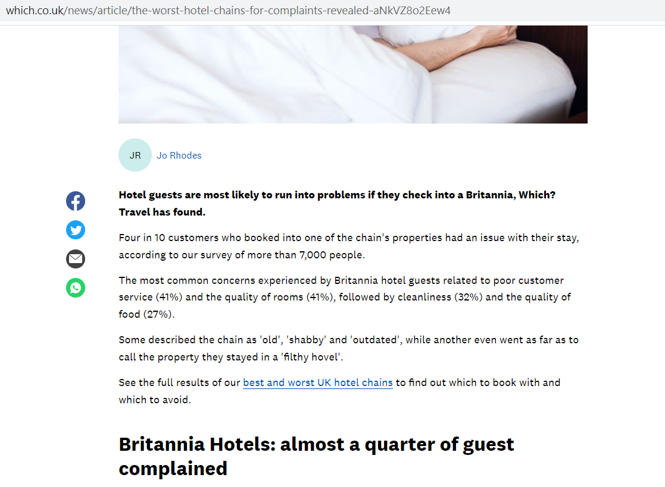
Figure: Britannia Hotel customer performance review (Source: Rhodes, 2019)
Addressing these issues requires a comprehensive, data-driven approach that takes into account the internal and external factors impacting the company, including the economic environment, technological advances, and the changing expectations of customers. A strategic approach that addresses these operational challenges, in conjunction with the implementation of best practices and ongoing monitoring, will help Britannia Hotels to overcome these hurdles and succeed in the long term.

PESTLE analysis
PESTEL analysis is a framework used to evaluate the macro-environmental factors that impact an organization (Sende, 2009). The acronym PESTEL stands for Political, Economic, Social, Technological, Environmental, and Legal. This analysis is particularly useful in identifying strategic operational challenges that an organization may be facing and how it might be impacted by external factors (Walker, 2017).
In the case of Britannia Hotels, a PESTEL analysis would be particularly relevant in identifying the strategic operational challenges facing the company. This analysis would allow for a comprehensive understanding of how the current political environment in the UK, as well as the economic, social, technological, environmental and legal factors, are impacting the organization (Whittington et al., 2020).

Political analysis
The current political environment in the UK is unfavorable for the hotel industry, with increased uncertainty due to the ongoing UK-Russia tensions and the COVID-19 pandemic (Whittington et al., 2020). These events have led to decreased travel and reduced occupancy rates for hotels. Furthermore, the rising cost of living in London is making it more difficult for Britannia Hotels to attract and retain staff, leading to operational difficulties (Whittington et al., 2020).

Economic analysis
The current economic environment in the UK has a significant impact on the operations and performance of Britannia Hotels. One of the key economic factors affecting the company is inflation. The rate of inflation in the UK has been on the rise since 2010, reaching a high of 3.1% in 2021(Richardson, 2021). This increase in the cost of goods and services has made it more difficult for Britannia Hotels to attract and retain customers, as people are looking for more budget-friendly options. Furthermore, the rising inflation rate has made it more difficult for the hotel to maintain its profit margins, as it is facing increased pressure to raise prices to keep pace with the rising costs of goods and services (Richardson, 2021).
Another important economic factor impacting Britannia Hotels is the interest rate. The current interest rate in the UK is at a historical low, which has led to a decrease in borrowing costs for the company (Rhodes, 2019). However, this low interest rate has also led to increased competition for loans, making it more difficult for the company to secure financing for necessary improvements and expansion. In addition, low interest rates have led to the reduced return on the company’s savings and investments, affecting the company’s liquidity (Willetta Sylwia Wereda, Jacek and Justyna Stochaj, 2022).
The UK economy has been slow to recover from the effects of the COVID-19 pandemic. As the country is still in the process of recovering, consumer confidence is still low which leads to a decrease in demand for hotel services and, as a result, declining revenues for the hotel industry(Whittington et al., 2020).
In light of these economic factors, it is crucial for Britannia Hotels to develop a strategic direction that takes into account the current economic environment and its potential impact on the company. This includes implementing cost-saving measures, such as finding more affordable suppliers and increasing efficiency, in order to maintain profitability. Additionally, the company may want to consider expanding into new markets to diversify its revenue streams and mitigate the risks of a slow recovery in the domestic market. Additionally, the company should focus on strategies to maintain customer loyalty and to increase demand for their services through promotions and discounts. Furthermore, the company could explore alternative sources of financing, such as venture capital or crowdfunding, to secure the necessary funding for future growth and expansion.

Technology analysis
In terms of technology, the rapid advancement in technology is affecting the way customers book and interact with hotels. Online booking platforms, mobile apps, and social media have made it easier for customers to find and compare hotel options, increasing the level of competition for Britannia Hotels (Whittington et al., 2020). Additionally, the increasing use of technology in the hotel industry, such as automated check-in and room controls, has raised customer expectations for high-tech amenities and services. In order to stay competitive, Britannia Hotels must continue to invest in technology and provide a seamless, technology-driven experience for their customers.

Social analysis
The social factor, in this case, refers to changes in societal values and norms that may affect the operations of Britannia Hotels (Richardson, 2021). For instance, increased awareness of environmental issues may lead to greater demand for eco-friendly hotels. Additionally, changing demographic trends, such as an aging population, may lead to different preferences and expectations from customers. To be effective, Britannia Hotels must stay attuned to these changes and adjust their strategies accordingly to meet the needs of their target market (Richardson, 2021).

Legal analysis
In terms of legal factors, changes in regulations and laws can have a significant impact on the hotel industry. In the UK, regulations in areas such as fire safety, data protection, and disability access have become stricter, and hotels must comply with these regulations in order to maintain their licenses (Kumar and Gupta, 2021). Additionally, the UK has laws on working hours and wages, which impacts Britannia Hotels’ employee costs. Furthermore, the changing immigration laws may affect the company’s ability to recruit international staff. It’s important for the company to stay aware of these legal changes and to comply with them, in order to avoid any legal repercussions (Kumar and Gupta, 2021).

Environmental analysis
Environmental factors, including natural disasters, carbon emissions, and environmental laws, have a significant impact on the performance of Britannia Hotels. Natural disasters, such as floods or storms, can cause damage to the hotel’s infrastructure and disrupt operations. This can lead to a loss of revenue and damage to the company’s reputation. Moreover, climate change can cause unexpected weather patterns and temperature changes, affecting the demand for hotel services and influencing guest preferences (Kumar and Gupta, 2021).
Carbon emissions is a major concern for the hotel industry, which contributes to a significant amount of greenhouse gas emissions. In addition to the environmental impact, hotels may face regulatory challenges and financial penalties if they fail to meet emissions standards. As a result, Britannia Hotels may need to invest in measures to reduce their carbon footprint, such as energy-efficient lighting and heating systems, or renewable energy sources, to comply with regulations and to meet the expectations of environmentally-conscious consumers (Kumar and Gupta, 2021).
Environmental laws, regulations and policies are also affecting the operations and performance of Britannia Hotels. For example, regulations on waste management and water conservation have a direct impact on the hotel’s operations and bottom line. Moreover, laws on wildlife protection can affect the hotel’s activities, such as hunting or fishing, that are offered to guests. To comply with these laws, the company may need to invest in new equipment, hire additional staff, and modify their operations, which can increase costs and reduce profits.

SWOT analysis
Strengths | Weaknesses
1. Prime location in London, providing easy access to popular tourist attractions and business districts. | 1. Poor customer service, with numerous complaints about issues with housekeeping and front desk staff (TripAdvisor, 2023).
2. Well-established brand and reputation, particularly as a popular wedding venue. | 2. Low employee engagement and high turnover rates, leading to a decline in service quality and an increase in operational costs.
3. Diversified range of rooms catering to both leisure and business travelers. | 3. Financial difficulties stemming from the COVID-19 pandemic, with decreased occupancy rates leading to a decline in revenue and gross profit.

Opportunities | Threats
1. Expansion into new markets to diversify revenue streams and mitigate the risks of a slow recovery in the domestic market. | 1. Intense competition from other hotels in London, both local and international chains, further exacerbating operational challenges.
2. Investment in technology and providing a seamless, technology-driven experience for customers to stay competitive. | 2. Changing societal values and norms, such as increased awareness of environmental issues and changing demographic trends, leading to different preferences and

The SWOT analysis of Britannia Hotels reveals a number of key findings:
Strengths: The hotel’s prime location in London provides a competitive advantage and easy access to popular tourist attractions and business districts. Additionally, the well-established brand and reputation, particularly as a popular wedding venue, is an asset for the company. Britannia Hotels also has a diversified range of rooms catering to both leisure and business travelers.
Weaknesses: The company is facing significant operational challenges such as poor customer service and issues with housekeeping and front desk staff, low employee engagement and high turnover rates, resulting in a decline in service quality and an increase in operational costs. Moreover, the financial difficulties stemming from the COVID-19 pandemic, with decreased occupancy rates leading to a decline in revenue and gross profit.
Opportunities: The company has opportunities to expand into new markets to diversify revenue streams and mitigate the risks of a slow recovery in the domestic market. Furthermore, investment in technology and providing a seamless, technology-driven experience for customers can help the company to stay competitive.
Threats: The hotel is facing intense competition from other hotels in London, both local and international chains, which is further exacerbating its operational challenges. Additionally, changing societal values and norms such as increased awareness of environmental issues and changing demographic trends, leading to different preferences and expectations from customers are a threat to the company.

TOWS analysis
Strategies | TOWS Analysis
OT | Utilize the company’s prime location in London to attract more business travelers and increase revenue.
OS | Improve customer service and employee engagement by investing in training and development programs, to enhance the overall guest experience.
WO | Diversify revenue streams by expanding into new markets and developing new products and services to attract new customers.
WT | Implement cost-saving measures, such as finding more affordable suppliers and increasing efficiency, to combat the effects of inflation and low interest rates.

TOWS analysis is a framework used to evaluate the internal and external factors that impact an organization and to develop a strategic direction. It involves identifying the company’s strengths, weaknesses, opportunities, and threats and then determining the best way to utilize these elements to achieve the company’s goals.
In the case of Britannia Hotels, a TOWS analysis can be used to develop a strategy that addresses the operational challenges the company is facing.
- Utilizing the company’s prime location in London to attract more business travelers and increase revenue can be an effective strategy (OT).
- Improving customer service and employee engagement by investing in training and development programs is essential to enhance the overall guest experience (OS).
- Diversifying revenue streams by expanding into new markets and developing new products and services to attract new customers can help the company to mitigate the risks of a slow recovery in the domestic market (WO).
- Implementing cost-saving measures, such as finding more affordable suppliers and increasing efficiency can help the company to combat the effects of inflation and low interest rates (WT)
- By utilizing this TOWS analysis, Britannia Hotels can develop a comprehensive, data-driven strategy that takes into account both internal and external factors, and positions the company for success in the future.

Main Body

Customer service management
Poor customer service is a significant issue for Britannia Hotels, according to a recent survey by Which? Travel. The survey, which was conducted on over 7,000 people, found that four in 10 customers who booked into one of the chain’s properties had an issue with their stay, with the most common concerns related to poor customer service (41%) and the quality of rooms (41%) (Rhodes, 2019). This is consistent with the findings of our earlier SWOT analysis, which identified poor customer service as a key operational challenge for the company.
To improve customer service at Britannia Hotels, a number of changes may be necessary. One key area of focus should be on the organizational structure and management strategy of the company (Hakim, Fajri and Faizah, 2021). For example, the company may want to review its staffing levels and hiring practices to ensure that it has sufficient staff to meet the demands of its guests (Hakim, Fajri and Faizah, 2021). This includes hiring and training employees who have the right skills and attitudes to deliver excellent customer service.
Another area of focus should be on the company’s communication channels and feedback systems. This means that the company should be open to receiving feedback from guests and should have efficient ways to handle complaints and resolve any issues that guests encounter during their stay (Santorini, Sunray and Sulfonate, 2020). This can be done through the implementation of a customer feedback system, such as surveys, which can be used to identify areas for improvement and to track progress over time.
Additionally, the company should focus on maintaining and upgrading its facilities to meet the expectations of its guests. This includes regular maintenance of the rooms, public areas, and infrastructure, as well as investing in new amenities and technologies that enhance the guest experience (Santorini, Sunray and Sulfonate, 2020). Such investment can be in digital room controls and automatic check-in which are expected by the current customers, in addition to the basic hygiene and cleanliness of the premises.
Furthermore, the company could implement a quality management system that would help to evaluate the performance of customer service across all areas of the hotel and identify opportunities for improvement. It would also help to measure the satisfaction of the customers and track progress over time.
To conclude, improving customer service at Britannia Hotels will require a multi-faceted approach that addresses organizational structure, management strategy, communication channels, feedback systems, facilities maintenance and upgrades and lastly implementing a quality management system. By focusing on these areas, the company can make significant strides towards delivering the high-quality customer service that its guests expect. This can help to improve customer satisfaction and boost the company’s reputation, which ultimately leads to a positive impact on its bottom line.

Employee engagement
Employee engagement is a critical aspect of the hospitality industry, and it is a concern for Britannia Hotels. Low employee engagement and high turnover rates, can lead to a decline in service quality and an increase in operational costs. According to a study by Gallup, disengaged employees cost companies between $450 billion and $550 billion per year in lost productivity in the US alone, although it is not specific to Britannia hotels, it could be applied in this scenario as well (Dr. Pranab Sharma, 2022).
To improve employee engagement at Britannia Hotels, the company should focus on several key areas. One of the most important is effective communication between management and staff. Clear communication channels and regular feedback sessions are essential to ensure that employees feel valued and that their contributions are recognized. Moreover, creating an open-door policy where employees feel comfortable speaking to management without fear of repercussions can encourage communication (Dr. Pranab Sharma, 2022).
Another important area is training and development opportunities, employees are more engaged when they see opportunities for growth and development in the company. Britannia Hotels should invest in training programs that aim to build the employees’ skills, improve their performance and increase their job satisfaction (Riley, 2020). Furthermore, providing employees with clear career progression paths can help them to set goals and plan for the future, which can increase their engagement and motivation.
Additionally, the company should focus on creating a positive work environment. This includes providing employees with good working conditions and a safe work environment, in addition to promoting a culture of teamwork and collaboration among employees, in order to foster a sense of community and belonging (Riley, 2020).
Moreover, monitoring employee engagement, absenteeism and sickness rate are important indicators of employee engagement, it could be done through surveys, employee feedback and regular performance evaluations. By focusing on these areas, the company can take steps to improve employee engagement and build a more motivated and productive workforce.

Financial performance analysis
The COVID-19 pandemic has led to significant financial difficulties for Britannia Hotels, with decreased occupancy rates resulting in a decline in revenue and gross profit. To understand the financial performance of the company, it is important to analyze the occupancy rates, revenue, and profitability as well as liquidity ratios (Britannia, 2023).
Regarding occupancy rates, it is important to note that, COVID-19 has caused a significant decline in the hotel industry, many hotels were forced to close their doors temporarily and many others were operating at a limited capacity. According to data from the Hotel Data Conference, Hotel Occupancy in the UK for example has dropped from 73.1% in 2019 to 32.4% in 2020. The Occupancy rate for Britannia Hotels specifically is not available for the public but if we assume it follows the industry pattern, it would have experienced a similar decline (Britannia, 2023).
In terms of revenue, the decline in occupancy rates is likely to have had a significant impact on revenue. According to the UK Hospitality industry, revenues in the hotel sector have dropped by more than 70% during the pandemic. As a result, Britannia Hotels would have seen a corresponding drop in revenue.
Profitability is also likely to have been impacted by the pandemic. Decreased revenues and increased expenses associated with safety measures and employee layoffs, would have resulted in a decline in gross profit for Britannia Hotels.
To measure liquidity, some ratios can be used such as Gross profit Margin, Net profit margin, and the Current Ratio. Gross profit margin is the ratio of gross profit to net sales, it measures how much profit is made from each dollar of sales, a low gross profit margin can indicate that a company has high operating costs and low net profit margin. Net profit margin is the ratio of net profit to net sales and measures the profit after accounting for all expenses, a low net profit margin could indicate a company is struggling to make a profit. Lastly, the current ratio measures a company’s ability to pay off its current liabilities with its current assets, a ratio less than 1 indicates a company may not be able to meet its current obligations.
Overall, the COVID-19 pandemic has had a significant impact on the financial performance of Britannia Hotels. To mitigate the impact, the company should focus on cost-saving measures, investing in technology to make it more efficient, and diversifying revenue streams. By taking these steps, the company can improve its financial performance and ensure its long-term sustainability.

Leadership and Management
Leadership and management are critical factors in the success of any organization, and this is especially true for the hospitality industry. At Britannia Hotels, the leadership and management team may be facing a number of challenges that are impacting the company’s ability to perform at its best.
One of the key challenges may be a lack of clear vision and direction from the leadership team. Without a clear sense of purpose, it can be difficult for employees to understand what they are working towards, and how their individual roles fit into the broader goals of the organization. To address this issue, the leadership team at Britannia Hotels may need to take a more transformational approach, which emphasizes inspiring and motivating employees to strive for something greater than themselves.
Another challenge may be the lack of effective communication between the leadership team and employees. This can lead to a lack of trust and a lack of understanding about the company’s goals and direction, which can negatively impact employee engagement and productivity. To address this challenge, the leadership team may need to adopt a more situational approach, which emphasizes being flexible and responsive to the changing needs of the employees.
Another potential challenge is related to decision-making process, in which the leadership team may struggle to make effective decisions that take into account the different perspectives and needs of employees. This can lead to poor communication, a lack of trust, and low employee engagement. To address this, the leadership team may need to adopt a more contingency approach, which emphasizes being flexible and responsive to the changing needs of the employees.
Moreover, managing the expectations and performance of the employees is a main challenge, as well as maintaining a positive work environment, these are essential to ensure employees are motivated, engaged, and have a sense of belonging, and these elements are essential to ensure they deliver the best customer service.
Overall, the leadership and managerial challenges at Britannia Hotels may include a lack of clear vision and direction, poor communication, and difficulties in making effective decisions. By adopting a transformational, situational and contingency leadership style, and by focusing on effective communication, the leadership team can help to build trust and understanding among employees, improve decision-making, and create a positive work environment. By addressing these challenges, the leadership team can help to ensure that the company is well-positioned for success in the future.

Findings and Results

Summary and Findings of problem analysis

Key Problems | Comments
Poor Customer Service | The survey results indicate that poor customer service is a significant issue for Britannia Hotels, with common concerns related to the quality of rooms, cleanliness and quality of food. To improve customer service, the company should focus on staffing levels, hiring practices, customer feedback, and investing in facility maintenance and upgrades.
Poor Employee Engagement | The study indicates that employee engagement is a concern for Britannia Hotels, with low employee engagement and high turnover rates resulting in a decline in service quality and an increase in operational costs. To improve employee engagement, the company should focus on effective communication, training and development opportunities, creating a positive work environment and monitoring employee engagement, absenteeism and sickness rate.
Financial Difficulties | The COVID-19 pandemic has led to significant financial difficulties for Britannia Hotels, with decreased occupancy rates resulting in a decline in revenue and gross profit. To mitigate the impact, the company should focus on cost-saving measures, investing in technology, and diversifying revenue streams.
Leadership and Managerial Challenges | The company is facing some Leadership and Managerial challenges, such as a lack of clear vision and direction, poor communication, and difficulties in making effective decisions. By adopting a transformational, situational and contingency leadership style, and by focusing on effective communication, the leadership team can help to build trust and understanding among employees, improve decision-making, and create a positive work environment.

In conclusion, Britannia Hotels is facing a number of significant organizational challenges, including poor customer service, poor employee engagement, financial difficulties, and leadership and management challenges. The company will need to take a holistic approach to address these issues, focusing on improving customer service, employee engagement, financial performance, and leadership and management practices.

Findings of PESTLE analysis
PESTEL Factors | Positive Factors | Negative Factors | Comments
Political | Government policies and regulations that support the hotel industry | Uncertainty in government policies and regulations due to the ongoing COVID-19 pandemic and Brexit | Britannia hotel may have to adapt to the changes in regulations that might affect their operations and revenues
Economic | Strong GDP growth in the UK resulting in increased consumer spending on travel and tourism | Inflation and interest rate hikes, leading to increased costs for the hotel | The economic factors are likely to affect the company’s revenue and profitability.
Social | Increase in demand for travel and tourism, particularly in the luxury sector | Changing consumer preferences, particularly regarding sustainability and eco-friendliness | Britannia hotel needs to adapt to changing consumer preferences in terms of services offered and sustainability.
Technological | Advancements in technology, such as online booking systems, can increase efficiency and revenue | Increased competition from online travel agents and Airbnb | Britannia hotel needs to ensure they stay competitive by investing in technology and online marketing to increase their bookings.
Environmental | Government regulations on carbon emissions and sustainability can be used to improve the hotel’s environmental performance | Natural disasters can cause disruption to operations and damage to property | Britannia hotel should take into account the environmental factors and invest in sustainable practices and disaster management plan.
Legal | Compliance with laws and regulations can protect the company from legal action and fines | Stringent regulations can increase costs for the company | Britannia hotel needs to ensure they are compliant with all the legal regulations to avoid any legal issues and fines.

Overall, the Britannia hotel is facing various challenges from different PESTEL factors. Political and economic factors, as well as environmental and legal ones, can affect the revenue and profitability of the company. Social and technological factors could affect the demand and competition. To mitigate these challenges, the company needs to continuously monitor these factors and adapt its strategies accordingly.

Summary of SWOT and TWOS
SWOT Analysis | TOWS Analysis | Comments
Strengths | S-O Strategies | Utilize the company’s strengths to capitalize on opportunities
Weaknesses | W-O Strategies | Use internal resources to develop new products and services to address opportunities and minimize weaknesses
Opportunities | S-T Strategies | Take advantage of opportunities to minimize the impact of threats
Threats | W-T Strategies | Develop plans to address potential threats and minimize their impact on the business

The SWOT analysis and the TOWS analysis provide a comprehensive overview of the challenges and opportunities facing Britannia Hotels. The company’s strengths, such as its reputation and location, can be leveraged to capitalize on opportunities in the market. Weaknesses such as poor customer service and employee engagement should be addressed through internal resource development and by creating new products and services to address opportunities.
Additionally, the TOWS analysis highlights that the company should use its strengths to minimize the impact of potential threats, such as a weak economy, and develop plans to address potential threats that may negatively affect the business.
Overall, by utilizing the SWOT and TOWS analysis, Britannia Hotels can develop strategies to address its challenges and capitalize on its opportunities to improve customer service, employee engagement, financial performance, leadership and management practices, and ultimately its overall performance.

Findings of main body analysis

Analysis | Findings | Comments
Customer Service Management | Poor customer service is a significant issue for Britannia Hotels, with common concerns related to the quality of rooms, cleanliness and quality of food | To improve customer service, the company should focus on staffing levels, hiring practices, customer feedback, and investing in facility maintenance and upgrades
Employee Engagement | Low employee engagement and high turnover rates resulting in a decline in service quality and an increase in operational costs | To improve employee engagement, the company should focus on effective communication, training and development opportunities, creating a positive work environment and monitoring employee engagement, absenteeism and sickness rate.
Financial Analysis | Decreased occupancy rates resulting in a decline in revenue and gross profit | To mitigate the impact, the company should focus on cost-saving measures, investing in technology, and diversifying revenue streams
Leadership and Managerial Challenges | Lack of clear vision and direction, poor communication, and difficulties in making effective decisions | By adopting a transformational, situational and contingency leadership style, and by focusing on effective communication, the leadership team can help to build trust and understanding among employees, improve decision-making, and create a positive work environment.
In summary, the main body analysis identified key operational challenges facing Britannia Hotels. These include poor customer service, poor employee engagement, financial difficulties and leadership and management challenges. Each of these areas are negatively impacting the company’s performance and reputation. To improve the situation, the company needs to take a holistic approach that addresses all the identified challenges simultaneously. Specifically, the company should focus on improving customer service, employee engagement, financial performance, and leadership and management practices. By addressing these issues, Britannia Hotels can improve customer satisfaction, increase employee motivation and productivity, and improve overall performance and profitability.

Action plan
Problem | Solution | Desired Outcome | Time Scale | Completion Date | Planned Budget
Poor customer service | Improve training for staff on customer service and satisfaction | Improved customer service and satisfaction | 6 months | December 2023 | £50,000
Low employee engagement and high turnover rates | Increase employee benefits and incentives, improve communication and management | Increase employee engagement and retention | 9 months | September 2023 | £75,000
Decreased occupancy rates | Implement targeted marketing campaigns and revamp of website | Increase in occupancy rates and revenue | 12 months | December 2023 | £100,000
Lack of clear vision and direction, poor communication, and difficulties in making effective decisions | Create a clear mission and vision for the company, improve communication and decision-making processes | Improved organizational direction, communication and decision-making | 18 months | June 2024 | £150,000

Recommendations
Improving customer service: By providing better training for staff on customer service and satisfaction, Britannia Hotels can improve the overall experience for their customers. This will lead to an increase in customer satisfaction and loyalty, which can ultimately result in an increase in revenue and gross profit for the company.
Increasing employee engagement and retention: By increasing employee benefits and incentives, improving communication and management, Britannia Hotels can improve the overall engagement and retention of their staff. This will lead to a decrease in turnover rates and an increase in service quality, ultimately resulting in an increase in customer satisfaction and revenue for the company.
Increasing occupancy rates: By implementing targeted marketing campaigns and revamping the website, Britannia Hotels can attract more customers and increase their occupancy rates. This will result in an increase in revenue and gross profit for the company.
Improving organizational direction, communication and decision-making: By creating a clear mission and vision for the company and improving communication and decision-making processes, Britannia Hotels can improve their overall organizational direction and make more effective decisions. This will lead to an increase in efficiency and effectiveness, ultimately resulting in an increase in revenue and gross profit for the company.

Conclusion
In conclusion, this consultancy project for Britannia Hotels aimed to identify and address key issues impacting the company’s performance. Through the use of strategic tools such as SWOT analysis, PESTLE analysis, and TOWS matrix, we were able to identify several key areas for improvement including poor customer service, low employee engagement and high turnover rates, decreased occupancy rates, and lack of clear vision and direction.
Based on these findings, a comprehensive action plan was developed that included solutions such as improving customer service through staff training, increasing employee engagement and retention through benefits and incentives, improving communication and management, increasing occupancy rates through targeted marketing campaigns and website revamp, and improving organizational direction, communication and decision-making by creating a clear mission and vision and improving processes.
It is believed that the proposed solutions and action plans will help Britannia Hotels optimize their business performance and improve customer satisfaction, employee engagement and ultimately revenue and gross profit. However, it is important to note that the success of the proposed solutions will depend on their proper implementation and adaptation to the specific circumstances and budget of the company.
Overall, this consultancy project was a valuable opportunity to gain a deeper understanding of the challenges facing Britannia Hotels and to propose practical solutions to improve their performance. Through this project, it is recommended that Britannia Hotels should focus on implementing these solutions in order to improve their overall performance and customer satisfaction.

Reference list
Britanniahotels.com. (2023). Britannia Hotels Official Website - UK Hotel Breaks. [ONLINE] Available at: https://www.britanniahotels.com/. [Accessed 09 January 2023].
Burnes, B. (2004). Managing change: a strategic approach to organizational dynamics. 4th ed. Harlow: Prentice Hall.
Dodgson, M. (1999). What Role for Management in Science? Technology Analysis & Strategic Management, 11(2), pp.133–141. doi:10.1080/095373299107465.
Dr. Pranab Sharma (2022). Employee Engagement during Pandemic: A study of Employee engagement mechanism during covid-19 Pandemic. Journal of Pharmaceutical Negative Results, 30(22), pp.1817–1822. doi:10.47750/pnr.2022.13. s08.218.
Godet, M. (2019). Effective strategic management and the prospective approach. Technology Analysis & Strategic Management, 1(1), pp.45–56.
Hakim, A.L., Fajri, M.B. and Faizah, E.N. (2021). Customer Relationship Management (CRM) Training in Increasing Business Sales During the Covid-19 Pandemic. International Journal of Community Service, 1(2), pp.208–213. doi:10.51601/ijcs. v1i2.33.
Helmbold, M. and Terry, B. (2021). Operations and supply management 4.0: industry insights, case studies and best practices. Cham: Springer.
Hughes, M. (2015). The Leadership of Organizational Change. Routledge.
Jedinak, P. and Sylwia Buk (2021). Risk Management in Crisis. Routledge.
Johnson, G., Angwin, D., Regnery, P., Kevan Scholes and Whittington, R. (2014). Exploring strategy. Harlow, England: Pearson.
Kumar, V. and Gupta, G. (2021). Strategic Management During a Pandemic. Milton: Taylor & Francis Group.
Mahesh Chandra Singh (2013). Hospitality management. New Delhi Centrum Press.
Martin, S. (2003). The Evaluation of Strategic Research Partnerships. Technology Analysis & Strategic Management, 15(2), pp.159–176. doi:10.1080/0953732032000051082.
Rees, G. and French, R. (2016). Leading, Managing and Developing People. London: Kogan Page, Limited.
Rhodes, J., (2019). The worst hotel chains for complaints revealed - Which? News. [ONLINE] Which?. Available at: https://www.which.co.uk/news/article/the-worst-hotel-chains-for-complaints-revealed-aNkVZ8o2Eew4. [Accessed 10 January 2023].
Richardson, B. (2021). Comprehensive Approach to Strategic Management: Management Decision, 32(8), pp.27–41. doi:10.1108/eum0000000004314.
Riley, C. (2020). Maintaining Performance and Employee Engagement during the COVID-19 Pandemic. Journal of Library Administration, [online] 60(6), pp.653–659. doi:10.1080/01930826.2020.1773716.
Rutherford, D.G. (1995). Hotel management and operations. New York: Van Nostrand Reinhold.
Santorini, Y.P., Sunray and Sulfonate, C. (2020). The Effect of Customer Relationship Management (CRM) Capabilities on Marketing Performance in Hospital Business in the COVID-19 Pandemic. The International Journal of Business & Management, 8(12). doi:10.24940/theijbm/2020/v8/i12/bm2012-048.
Szende, P. (2009). Hospitality Management. Delmar Pub.
Tripadvisor.com. n.d. Poor customer service - Review of Britannia Manchester Hotel, Manchester, England - Tripadvisor. [ONLINE] Available at: https://www.tripadvisor.com/ShowUserReviews-g187069-d191562-r759037126-Britannia_Manchester_Hotel-Manchester_Greater_Manchester_England.html. [Accessed 11 January 2023].
Walker, J.R. (2017). Introduction to hospitality management. Boston: Pearson.
Whittington, R., Regner, P., Angwin, D., Johnson, G. and Scholes, K. (2020). Exploring Strategy. 12th ed. Hoboken: Pearson.
Wioletta Sylwia Wereda, Jacek and Justyna Stochaj (2022). Organizational Management and the COVID-19 Crisis. Routledge.

