Modelling and analysis of a Shaped Charge Design

John Gallacher

Modelling of Shaped Charges

Wales Institute for Science and Art
University of Wales Trinity Saint David



Declaration

The work of this report completed under the supervision of Kelvin Donne. I declare this that this report is the product of my own work and is not being submitted for any other degree.

Signature:
John Gallacher (signed electronically)

Acknowledgement
I would like to thank Kelvin Donne, the lecturer at the University of Wales Trinity Saint David for the Advanced physics of OME module. I was provided extensive knowledge and personal experiences within the field, that has been utilised and drafted from to complete this report.

Abstract

The purpose of this report is to research into the history of shaped charges, analyse the literature and develop its design via knowledge obtained and initiative. This will all be done using the computer simulated software ABAQUS in which is widely used in industry. This software will be used to create, design, simulate and analyse the shaped charge performance. The writer will run various simulations before analysing the effects, this report is to develop knowledge and designs behind shaped charges and how they can be developed on a software effectively. The writer will break down the design, that was generated in 2Dimensional initially and developed further into a 3D design before commenting on various aspects of the design and software used.

Introduction
This assignment emphasises the modelling and critical analysis aspects of a shaped charge device, consisting of a steel casing, high explosive charge and a conical shape for the liner. The writer will analyse various designs from industry and use the literature to generate a shaped charge which should operate effectively in theory and will eventually adopt the ABAQUS software to analyse the effectiveness of the design in simulation. Before simulating the various designs, the writer will give some of the history into shaped charges and what components have an impact on their performance.
Shaped charges are devices adopted for the purpose of cutting into or penetrating different materials whether that be an aerial, on land, and underwater target, based on the concentration of the explosion energy to the liner.
A Shaped charge is a tubed shape with one hollow metallic liner on one side and a detonator on the other side. The metallic liner could have various shapes such as hemispherical, conical, trumpeted, and curvilinear or such shapes [1]. As described the conical shape will be used for this report, this geometry causes all the energy being provided by the High Explosive to be completely focused on the Liner material (See figure 1). As all the energy is being forced into one area at around 5000 ft per second this allows there to be a greater penetration force and compromise the eventual target.
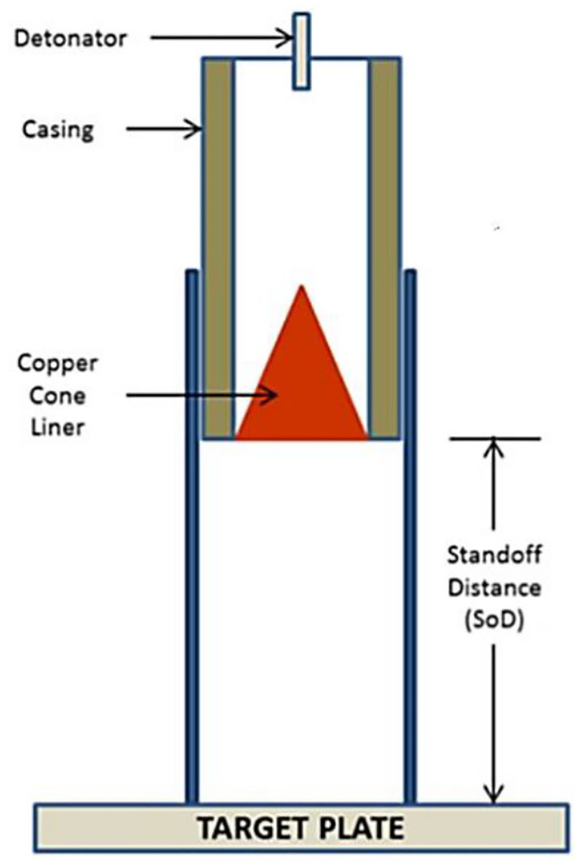
(Figure 1- A basic labelled shaped charge design
Shaped charges immediately suggest military use in penetrating enemy vehicles, infrastructure and threats however they are widely used in industries such as oil and gas for perforator use. Shaped charges alleviate various frac problems encountered when perforating with deep penetrating perforators [2]. While explosives and shaped charges have valuable applications, their potential for harm necessitates responsible handling, regulation, and ethical use. Advances in materials science and engineering continue to refine their design and applications across various industries.

Background

As we research into the history of shaped charges its key to define what it is to generate a reliable and credible design, we can describe it as, “cylinder of explosive with a hollow cavity at the end opposite the initiation train. If the cavity does not contain a liner, it is referred to as a hollow charge or an unlined-cavity charge. If the cavity contains a liner made from a metal, an alloy, glass, ceramic, wood, or another material, the device is termed a shaped charge or cumulative charge” [3]. From this definition we can determine the key components necessary in creating an explosive charge a cylinder like shape which will contain a high explosive train which will uniform its explosive energy into the liner made from its designated material. A shaped charge can be described in various ways, known as an explosively forming penetrator, ballistic disk or Miznay-Schardin device for their antitank research to combat the German arsenal during World War 2 [4].

The History of shaped charges goes as far back as the late 1700’s but its key breakthrough was made via Charles Munroe in popularising the “Hollow charge”, one of the most famous experiments, The explosive charge had the initials USN inscribed on the charge opposite the initiation point. The initials were reproduced on the steel plate. This is known as explosive engraving and von Foerster conducted similar experiments [3]. Today known as the “Munroe Effect” or for German natives the “Neuman Effect” which is defined as, “the greatly increased penetration of an explosive into a surface (as of metal or concrete) that is caused by shaping a conical or hemispherical hollow in the forward end of an explosive cartridge” [5].

As we move further down the timeline the evidence is clear that the key components and methodology remain the same, however as patents are introduced and systems become more mature and researched it begins to paint a picture into the key areas in creating an effective shaped charge. A good example of its effectiveness is shown during warfare, Germany in 1941 a hollow cavity charge, a lined cavity charge, and a lined cavity charge detonated at a certain standoff distance above an Armor plate were compared. The target plate was shipping Armor steel, and the explosive mixture was 50% TNT and 50% cyclonite. The hollow cavity was a hemisphere with a cylindrical extension at its base equal to one-half of the diameter of the cavity (D). The liner was made of iron. The explosive contour was of the same geometry as the cavity, and the explosive thickness at the base of the liner was 0.15 times the cavity diameter. For the unlined hollow charge, the penetration (P) = 0.4 D at zero standoff. For the lined cavity, P = 0.7 D at zero standoff and P = 1.2 D for standoffs between 0.5 and 1.5 D. For the iron-lined shaped charge, D represents the inside diameter of the liner. These formulas are not universal laws, but they illustrate the increase in penetration in going from hollow charges, to lined cavity charges, to lined cavity charges with a nonzero standoff distance [3]. This experiment demonstrates the effectiveness of shaped charges in a field environment and the positive input a liner has on the output of the shaped charge’s goal in penetration.
As the research increased and manufacturing improved, such as using around 2-4mm in diameter of copper for the liner to optimise the materials properties, as it can offer the lowest total engine mass, despite its density, strength and stiffness able to operate effectively in hydrodynamic environments. As copper is highly referenced in the literature the writer has analysed various other materials in terms of the hydrodynamics and how they behave in varied temperature and pressure environments when applying a shock, in this case an explosive shock wave. Figure 2 analyses different material effects in the particle velocity of various materials and steel during the state of an explosive shock.
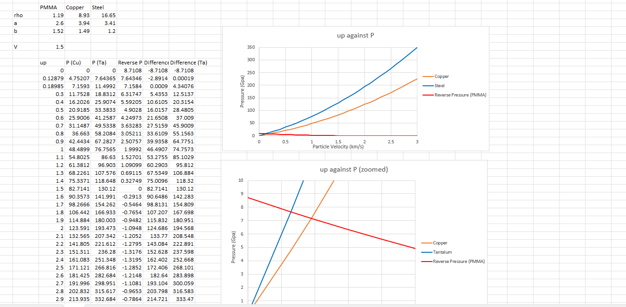
(Figure 2- Shock hydrodynamic calculations using excel)
(Figure 2- Particle velocity of materials in shock state)

These values allow the writer to generate the Huguenot and Rayleigh line (See figure 3) for each material to determine their nature in these environments, these calculations give an idea into some of the methodology and figures used within the computer software in compiling a simulation. They will give marking points from when a material will move from deflagration into detonation. Ultimately this will give a figure to determine the most suitable materials for simulation and field testing.

(Figure 3- Hugoniot and Rayleigh of Steel, Up being particle velocity and P for pressure)

From these various calculations it is possible to simulate the performance of your design and see its fit for manufacturing. This is widely used in industry to ultimately cut cost, save resource and determine if the product will work in operation. This along with other treaties provides enough evidence into why computer simulating the shaped charges are important. Other than using the product the complex equations used not only provide a quantitative and qualitative analysis, but they also give the user a visualisation of product performance which will be shown in this report.

Design
From researching the history of shaped charges and gaining an understanding of where they came from it allows us to develop our own design based on the literature. There are various shapes as described earlier but this report will be opting for the conical or cone shape (see figure 4) for the shaped charge.

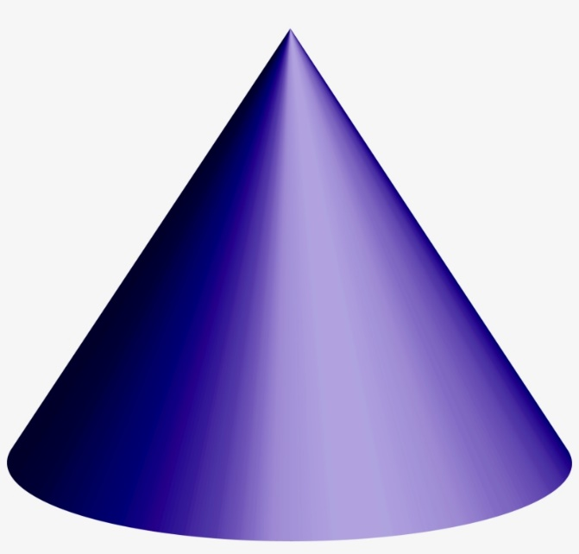
(Figure 4- Conical/Cone shape)

This has been the adopted design for various reasons however those to consider are its reliability on ignition and cutting jet performance that it provides It is widely used in industry and has been described as, “simple and technically sound” [6] which is a priority when you consider its operation and safety implications. The angle that the shaped charge will align at is between 40-60 degrees as described in the literature as it provides greater penetration at smaller stand off distances, with the maximum wall thickness able to penetrate would be around 4% of the shaped charges critical diameter [7].
From the conical like design this can be crossed over into the software to begin with to generate what the shaped charge will look like using the information described. The adopted software is ABAQUS which is industry recognized and is capable of not only developing the design of the shape charge but can simulate it in whatever conditions the product is put under, under the job section of the software. To start developing our design it is important to generate the various parts of the shaped charge before assembling them into its completed product. For simplicity let’s list out the key components of the shaped charge and begin to develop a 2Dimensional part list. This will be created in half sections and eventually rendered as a 360-degree model.
- Casing (See figure 5)- The casing in a shaped charge is what contains the other components such as the high explosives and liner etc. This must be a durable and strong material to withstand the explosive energy and allow the jet to form, if the casing is disrupted to early this could cause the jet to misalign or not for and ruin the shaped charges performance. As described previously steel will be adopted for the purposes described earlier in the report and has a withstand in high pressure environments as shown in the calculations.
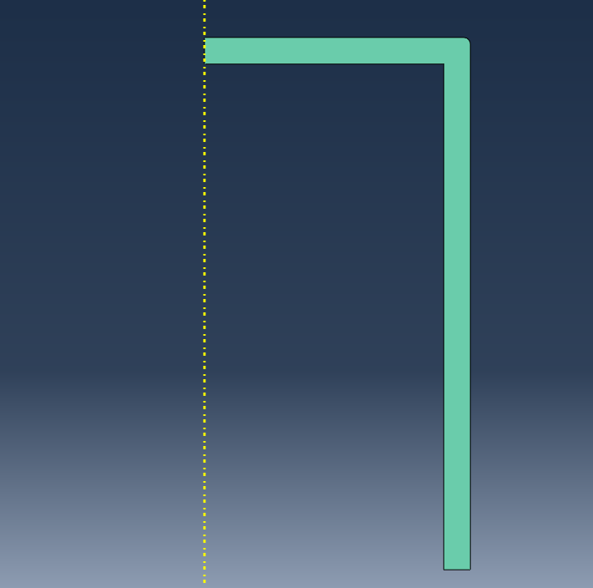
(Figure 5- Casing)
- High Explosive (HE) (See Figure 6)- The shaped charge in this case 2,4,6-Trinitrotoluene, but any HE can be used if it provides the right amount of explosive energy to collapse the Liner material and generate a jet to penetrate the target area. The red circle below highlights the initiation area, this is added via coordinates on ABAQUS. The initiation point will be the node at the highest point highlighted in the circle.
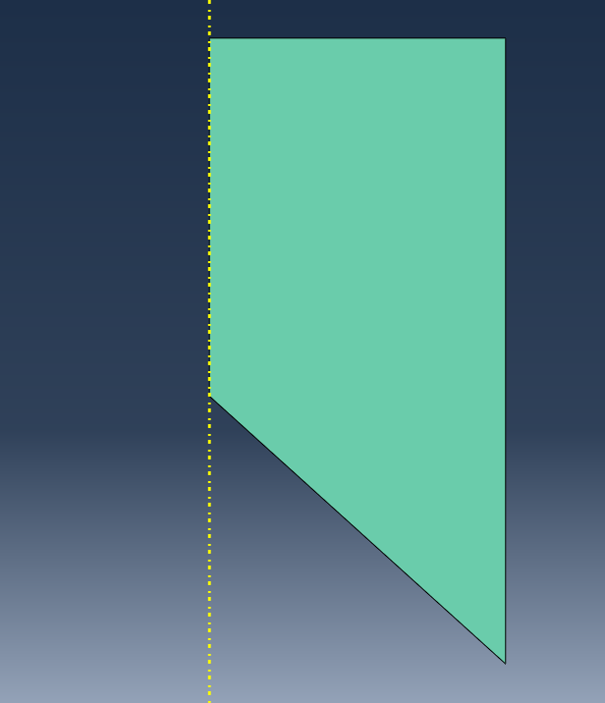
(Figure 6- HE and ignition point)
- Liner (See Figure 7)- The Liner in the shaped charge is a metal that will be at the forefront of the jet and penetrate the target. In terms of properties, it is important the liner is dense, ductile and a durable material for performance. In this case Copper will be used as its widely recommended and used in various case studies in research. Its important to read back and remember the performance of a shaped charge must be simple but technically sound, therefore using well proven materials is the approach the writer will follow with.
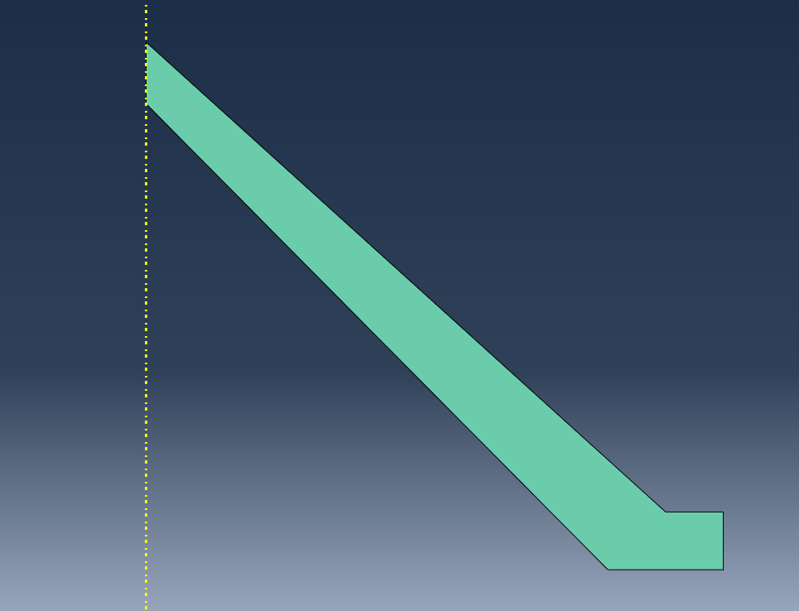
(Figure 7- Liner)

Now the parts have been created, they can be assembled and allow for properties to be assigned. As described above the following materials that will be used for simulations.
- Casing- Steel
- HE- TNT
- Liner- Copper
The material properties were selected and applied with various values such as Johnson-Cook damage, this is a model used in material science and engineering to describe the evolution of damage in materials subjected to high strain rates and elevated temperatures with increasingly high pressure, conditions commonly encountered in impact, crash, or explosive events. Developed by George R. Johnson and William H. Cook, this model extends the Johnson-Cook plasticity model by incorporating damage mechanics [8]. Density was also applied as it’s crucial in various scientific, engineering, and everyday applications. It is used to identify materials, design structures, understand fluid dynamics, and even determine the composition of substances making it a key component to creating a real-life environment.

To reiterate, all the parts have been analysed and researched to determine what properties are needed for each section. Whether it be for stability or how the material behaves under various pressures they have been chosen based on the requirement of the product and industry papers that back up their effectiveness. So, in theory all these materials should operate as intended.

Meshing
As the design has been created for our 2Dimensional design the next step is to create a mesh for the assembled product. Meshing plays a crucial role in ensuring the accuracy of simulations using Finite Element Analysis (FEA). In FEA, a mesh is composed of elements, each containing nodes that represent coordinate locations in space and can vary based on the element type. Irregular shapes are not easily handled by FEA solvers; however, the process of meshing transforms these irregular shapes into well-defined volumes known as "elements." The solver is more adept at working with standardized shapes like cubes, making meshing essential for effective simulation [9]. Due to the complexity of meshing its very much a trial-and-error approach even for those who are experts. There are common errors such as part distortion and using too many nodes in which the software can’t run as it would expand the number of calculations it can generate. Some meshes take hours, days and even weeks to run depending on the scenario and piece of equipment you’re trying to simulate. In meshing the shaped charge each part can be seen to have different sizes, see figure 8.

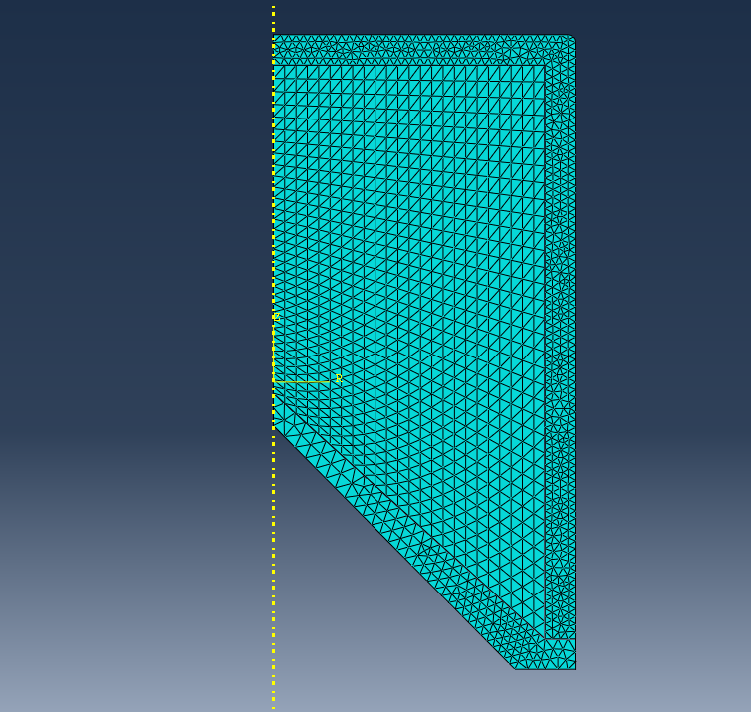
(Figure 8- Meshed shaped charge design)

In the realm of simulation, the convergence of various mesh sizes is a pivotal aspect, orchestrating a harmonious interplay between precision and computational efficiency. The mesh, composed of discrete elements, serves as the foundation for Finite Element Analysis simulations. Different regions of a model may necessitate distinct mesh resolutions to accurately capture intricate details or variations in material behaviour. As these diverse mesh sizes seamlessly integrate, they contribute collectively to the overall simulation, enabling a balanced representation of the physical system. The strategic amalgamation of fine and coarse meshes optimizes computational resources by allocating refined resolutions where needed while maintaining a streamlined simulation process. This intricate dance of mesh sizes exemplifies a meticulous approach, ensuring that the simulation captures both global trends and localized nuances, thereby enhancing the reliability and accuracy of the analytical results.
In the overlap in meshing the writer wanted to generate results for all sections but was more concerned about the HE is going into the Liner; this is where the jet will begin to form and really give an idea into the performance of the shaped charge. In the trial-and-error approach this was the mesh that provided the best results, despite being overpopulated in the casing section good results were obtained moving from the HE into the Liner. This indicates the meshes weren’t overly coarse and could communicate with each other for results.

Job
The job section in ABAQUS refers to the portion of the input file where users define the analysis steps, settings, and overall simulation parameters for FEA job. ABAQUS is a widely used software for FEA, and the job section plays a crucial role in configuring and controlling the simulation. A serious of jobs were completed using Explicit dynamics. It is a numerical simulation technique used in finite element analysis to solve dynamic problems where the time duration of the event is short, and the inertia forces are significant. In the context of structural mechanics, explicit dynamics is particularly suitable for simulating high-speed impact events, crash simulations, and transient dynamic phenomena where the time step size is small. So, this works perfectly in the instance a shaped charge would go of and the instantaneous reaction to occur quick and fast. Explicit dynamics simulations may become computationally expensive for problems with long-duration events or when the time step size becomes very small to maintain stability. In such cases, implicit dynamics methods, which solve the equations of motion using iterative solvers, might be more efficient [10].

As all the conditions have been assigned, assembly, properties managed, this is when you would run a job. From the meshing and properties discussed in this assignment the job section has a visualisation section, (See Figure 9).

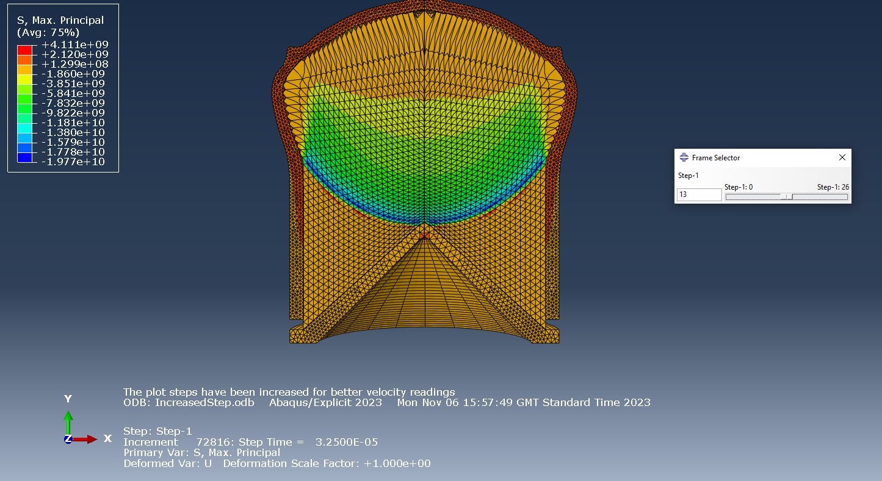
(Figure 9- Simulation)
In the first instance the explosive has been initiated, the picture above shows the shaped charge performing as intended. It has a shock wave moving across the HE as can be seen with the blue wave at the forefront. The casing is intact and is being protruded upwards with the force. The wave eventually connects with the Liner as intended (See Figure 10).
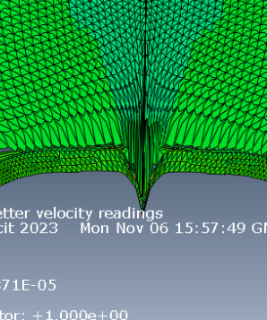
(Figure 10- Jet Formation)
As the HE penetrates the Liner it starts to collapse, and the metal Liner begins to head for its target in a jet/slug formation as explained previously. Again, the simulation acting as intended and giving an idea into the performance of the Shaped charge itself. From this the simulation crashed due to distortion (See Figure 11). This could be down to a multitude of reasons, ABAQUS simulations can crash or encounter convergence issues for various reasons, and diagnosing the specific cause often requires a detailed analysis of the simulation setup, model geometry, material properties, and numerical parameters.

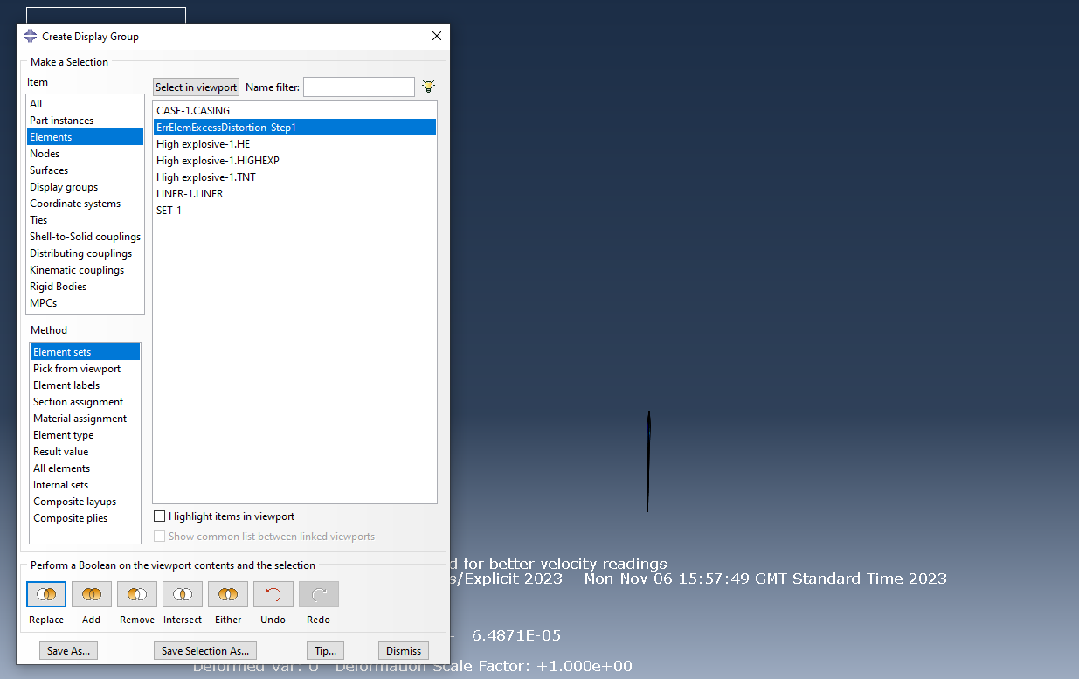
(Figure 11- Error message and area of distortion)

An example of some of the information that can be obtained by ABAQUS can be found below (See Figure 12). A spatial velocity graph typically represents the velocity of an object or particle as a function of its position in space. It provides a visual representation of how the velocity of the object changes as it moves through different spatial coordinates. Spatial velocity graphs are commonly used in physics and engineering to analyse the motion of objects. They can be generated experimentally or through mathematical modelling, and they help in understanding how velocity varies with position, providing valuable information about the kinematics of the system [11].

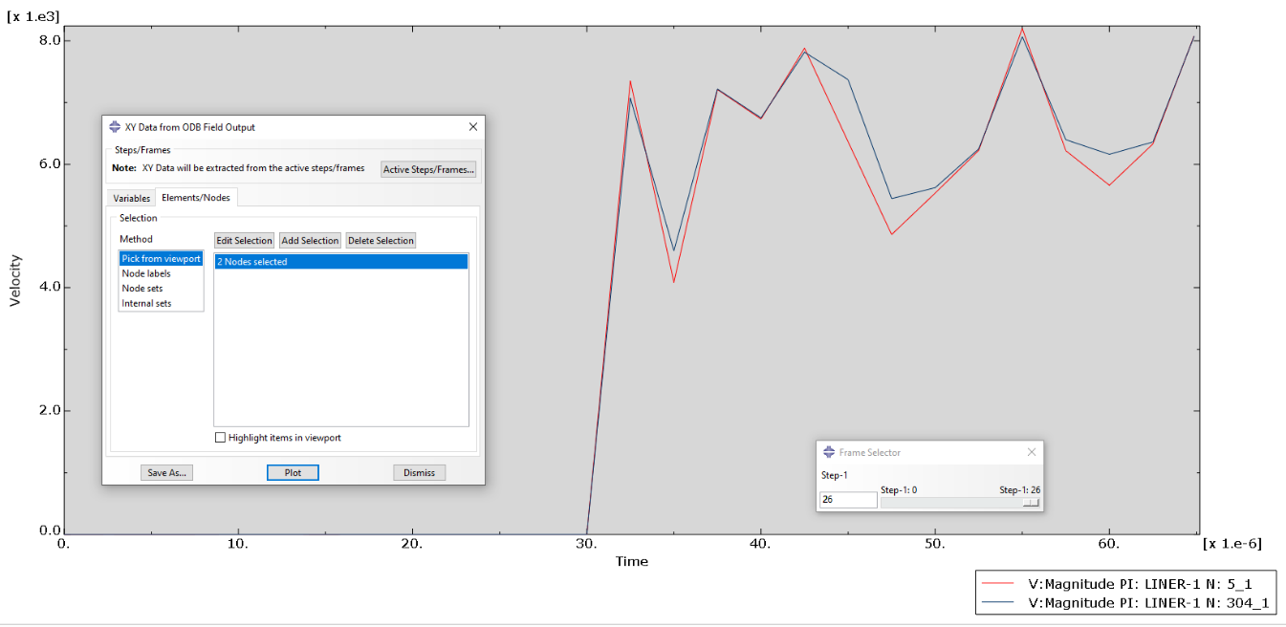
(Figure 12- Spatial velocity graph)

From the graph above 2 nodes were selected at the front of the shaped charge jet as shown in the diagram. The graph shows the large spike representing the mass increase in kinetic energy over a short period of time by the blast at immense speeds as shown in the velocity column. From the visualisation and this graph it is undisputed the HE gives of great amounts of energy in which the material can sustain at high temperatures and pressures, it has the large peak after initiation before levelling off again at the end off the graph. It does have various drops but that is down to meshing issues, the graph clearly shows a pattern of increased velocities and provides enough energy to be effective.

- 3Dimensional
From the previous 2D design the same steps were created but for a 3D model. All the properties and processes to complete the 3D design were very much transparent however another axis was introduced into the creation. From this the same process was followed, create the parts, assemble, assign properties in which have been kept the same to see the transition from the 2D design. There was great complexity and challenge in generating a reliable mesh for the 3D design, this has considerably more calculations and factors to consider and was more complex than the 2D previously. As this required more resources and the increased nodes made it easier for the system stop simulating with distorted nodes or more commonly exceeding the 350,000-node limit. The challenge in 3D simulation is getting an idea of the core elements and understanding what you want to get from the simulation to be able to give up elsewhere, such as focusing most of your nodes towards the overlap in HE to Liner.

Despite the complications and multiple failed jobs, the data from the 3D simulation was recorded and some good insight is obtained.
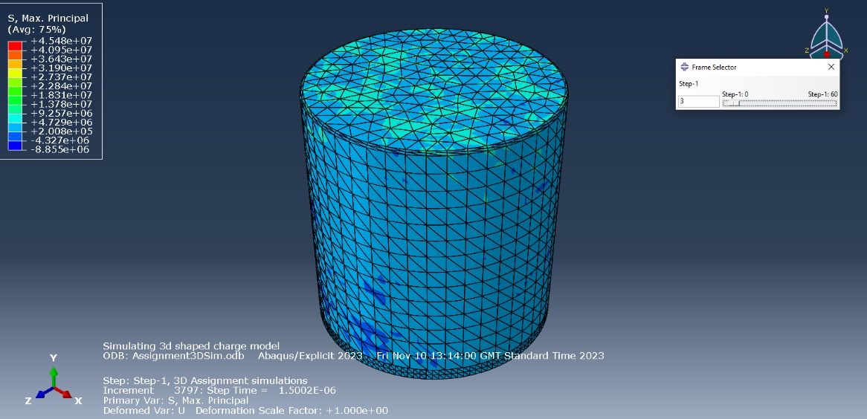
(Figure 13- 3D initiation)

Figure 13 provides the initiation phase, as we can see the max principal is still very low, but the shades suggest the shock waves have influenced the casing and it’s not been penetrated or miscued in anyway. So far showing a reliable steel casing. As we remove the casing and look at the HE (See Figure 14).

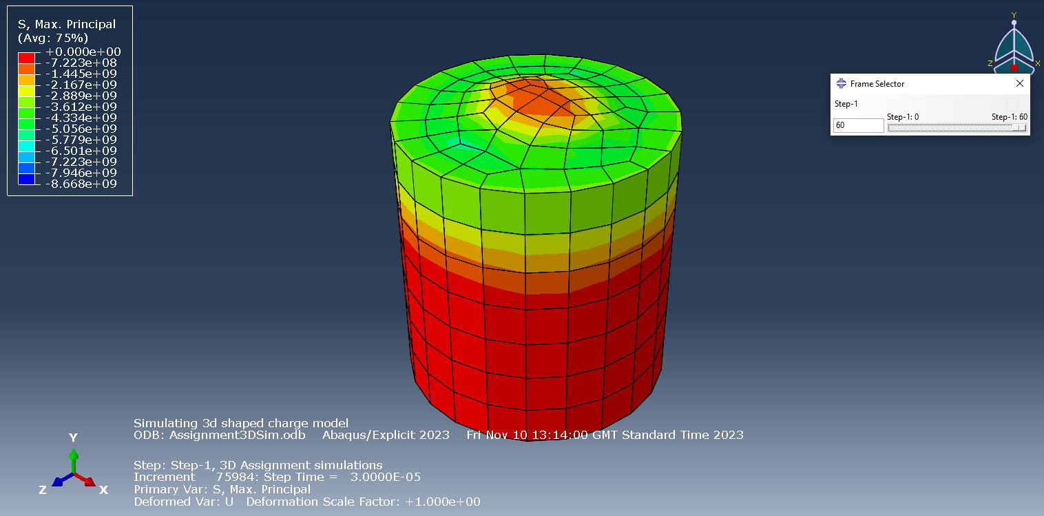
(Figure 14- HE)
From the picture above it shows the end of the job sequence, as intended there is a clear pattern that shows the wave moving from the initiation zone in which the max principal begins to decrease as the wave moves further towards the liner and into the red zone for when it penetrates and begins to for the jet. These are further examples of a good, shaped charge, wave formation, penetration and a clear increase in energy throughout the HE.
From the outside perspective it provides a good picture and performance, ABAQUS also allows the assembly to be look at from 180 degrees for a look inside the components (See Figure 15).

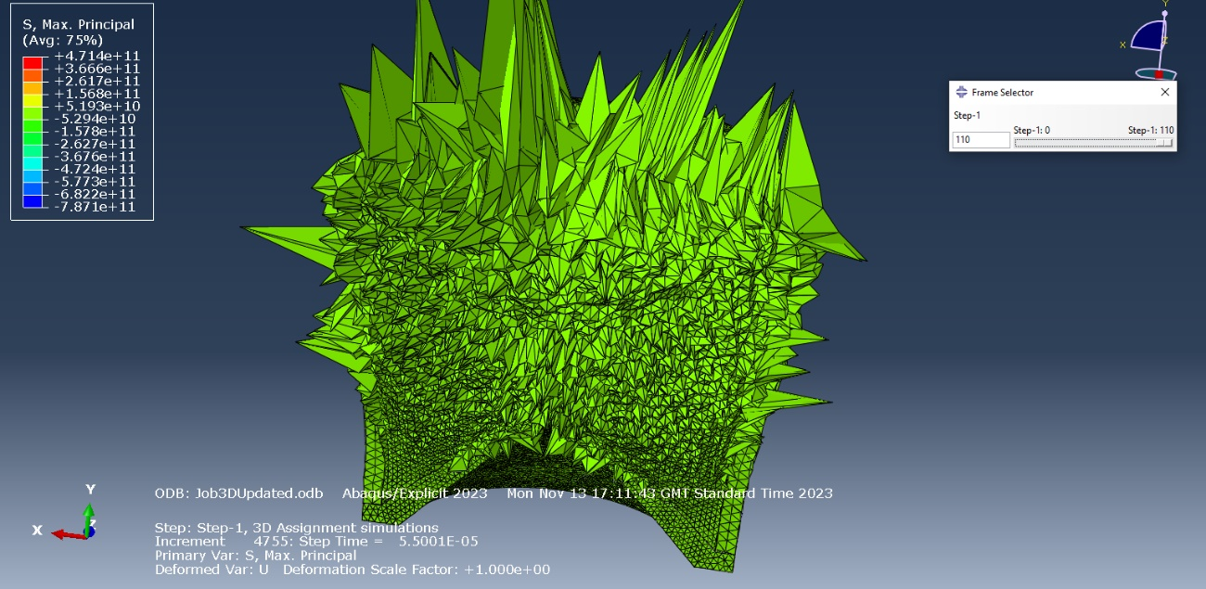
(Figure 15- 180-degree view)

From the diagram above it paints a different picture of what was previously described. As you can see the HE has successfully penetrated the Liner and begins to form a jet, this is only slightly show within this simulation. Again, this is what we want from a shaped charge, a formation of wave that impacts the liner and ultimately forms a jet. However, the messiness of the HE and casing suggests that the energy is escaping at all angles- this would have a detrimental effect on the design, wasting more energy on the excess debris. Therefore, the energy will not be focused on the liner as intended and cause the shaped charge to misfire.
From this the writer looked through each section of ABAQUS, from the design phase through to the Job section, the issue was in the boundary conditions (See Figure 16). Understanding and accurately applying appropriate boundary conditions are essential for obtaining meaningful and realistic simulation results in ABAQUS or any other finite element analysis software. Careful consideration of the physical behaviour of the system being modelled is crucial for setting up appropriate boundary conditions.

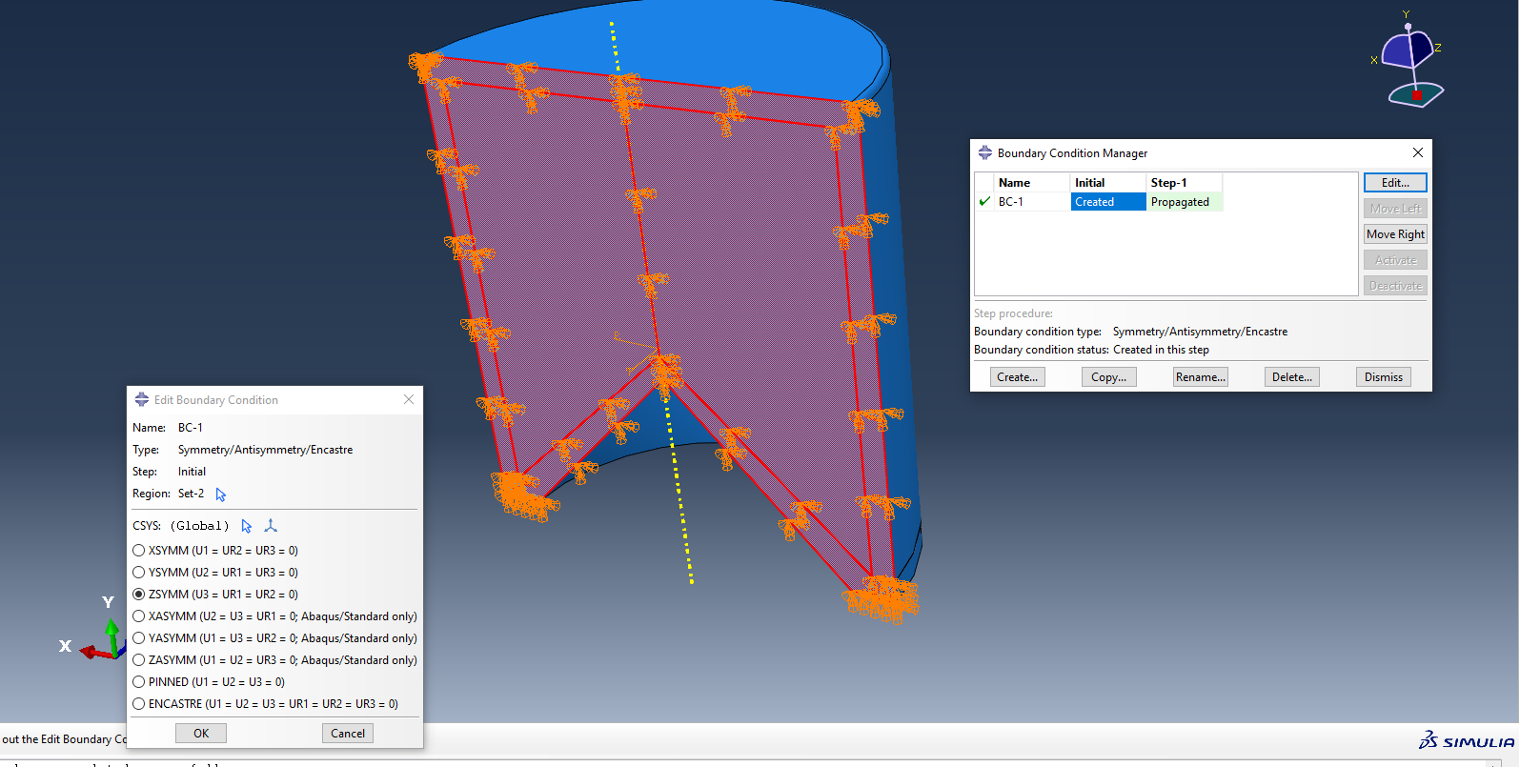
(Figure 16- Boundary Conditions)

The boundary conditions in this instance were the flow of the HE and it being on a different symmetry in the 180-degree view. Once resolved this allowed the HE energy to operate as intended by manoeuvring it towards the Liner before it begins to jet.

.

Conclusions
In this report the writer has developed a shaped charge through the literature and engineering judgment. They have gone for a basic concept using tried and tested designs to draft from and materials that are well known and used in industry. As you begin to familiarize yourself with the complex software’s there is a multitude of ways to improve and develop the shaped charges. Therefore, the next steps in this process would be to develop new designs using various ideas. This could be done by changing the shape to some of the ones mentioned previously, develop a bi-angular Liner for more specific results and velocities. Using different attachments such as tampers are a good way of ensuring all the energy you have is kept in the environment for the best results. Even increasing or decreasing the size of your product, varying the velocities and focusing on testing a simple and sound piece of equipment for the best results.

References

[1] | R. A. N. M. L. G. Mehmannavaz H, “A practical review study on shaped charge in the last two decades,” International Journal of Protective Structures, pp. 665-693, 2021 .
[2] | Baker Hughes, “Perforating Charges,” 2024. [Online]. Available: https://www.bakerhughes.com/completions/perforating/tubingconveyed-perforating/perforating-charges#:~:text=These%20shaped%20charges%20alleviate%20some,exposes%20more%20of%20the%20formation.. [Accessed 2024].
[3] | W. Walters, “A Brief History of Shaped Charges,” Army Research Labratory, vol. 1, pp. 3-10, 2008.
[4] | “ Misznay Schardin effect,” Wayback Machine, 2016.
[5] | Dictionary, “the greatly increased penetration of an explosive into a surface (as of metal or concrete) that is caused by shaping a conical or hemispherical hollow in the forward end of an explosive cartridge,” Dictionary , 2024.
[6] | EBAD, “Conical Shaped Charge (CSC),” [Online]. Available: https://www.ebad.com/conical-shaped-charge-csc/#:~:text=For%20use%20in%20Flight%20Termination%20Destruct%20Charge%2C%20the,both%20for%20initiation%20reliability%20and%20cutting%20jet%20performance.. [Accessed 21 Dec 2023].
[7] | M. Ahmed, “A Review of Works on Shaped Charges,” Engineering, Technology & Applied Science Research, vol. 7.
[8] | “Numerical and experimental investigation of Johnson–Cook material models for aluminum (Al 6061-T6) alloy using orthogonal machining approach,” Advances in Mechanical Engineering, no. 1, 2018.
[9] | Ansys, “The Fundamentals of FEA Meshing for Structural Analysis,” Ansys, 28 Apr 2021. [Online]. Available: https://www.ansys.com/en-gb/blog/fundamentals-of-fea-meshing-for-structural-analysis#:~:text=Meshing%20is%20the%20process%20of,to%20begin%20the%20simulation%20process..
[10] | “Comparison of implicit and explicit finite element methods for dynamic problems,” J.S. Sun, K.H. Lee, H.P. Lee, vol. 105, no. 1-2, pp. 110-118, 2000.
[11] | A. Zola, “SPATIAL GRAPH DEFINITION,” [Online]. Available: https://www.techtarget.com/searchdatamanagement/definition/spatial-data. [Accessed 22 Dec 2024].
[12] | J. C. Drury, Ultrasonic Flaw Detection for Technicians, Silverwing Ltd., 2004.
[13] | P. D. -I. V. Deutsch, “History of NDT - Instrumentation,” Rome, 2000.
[14] | “History of Ultrasonics,” Iowa State University, [Online]. Available: http://www.ndt-ed.org/EducationResources/CommunityCollege/Ultrasonics/Introduction/history.htm. [Accessed 17 February 2011].

