Name:_Tia Willock

Student Number: 2514120
__________________________________________________________

WORKSHEET 2 – TESTING (Tiles)

- Original code:

[Copy and paste your original code from Moodle into this box. Do not change it.]
import math

tileHeight = 20
tileWidth = 20
tile = tileHeight * tileWidth
wallWidth = int(input("What is the wall length in cm?"))
wallHeight = int(input("What is the wall length in cm?"))

heightRequired = math.ceil(wallHeight / tileHeight)
widthRequired = math.ceil(wallWidth / tileWidth)

tilesNeeded = (heightRequired * widthRequired)

print("You require", tilesNeeded, "Tiles")

# if tileHeight == '' or tileHeight >=0 :
# print (input("Please input a number higher than 0"))
# elif tileWidth == '' or tileWidth >= 0:
# print (input("Please input a number higher than 0"))
# else:

# userNeed = wallWidth * wallHeight
#
# tilesPreValue = (userNeed / tile)
# potentialTileBreakage = tilesPreValue * 0.1
# tilesRequired = potentialTileBreakage + tilesPreValue

# math.floor(potentialTileBreakage + tilesPreValue)
# if tilesRequired % 2 == 0:
# print(tilesRequired)
# else:
# print(math.floor(potentialTileBreakage + tilesPreValue))

# print("You need a minimum of", tilesRequired, "Tiles if you don't mind the pattern being different on each tile")

- Code Testing

For each test below (i – vii), run your code and enter the values provided. Present a screenshot of the of what happened when the programme ran. Did the programme behave correctly or did it do something unexpected, and if so, why?

Input:

- Enter dimensions of wall: Width 40 Length 45
- Enter dimensions of wall: Width 100000 Length 200000
- Enter dimensions of wall: Width -16 Length -20

Logic:
- Enter dimensions of wall: Width 80 Length 80. The result should be 16 tiles
- Enter dimension of wall: Width 40 Length 45. The result should be 6 tiles
- Enter dimensions of wall: Width 85 Length 90. The result should be 25 tiles.
- Enter dimensions of wall: Width 15 Length 15. The result should be 1 tile.

Note: If you decided to include logic within your program to allow a tile to be cut such that 2 pieces can be used from the same tile where possible (therefore reducing the total number of tiles required), your results may differ from the above. In this case, explain your logic as part of your answer. If you did not, consider adding this logic to your final code.

Fill in a box for each test above. You should present 7 separate boxes, 1 for each test. (Note: the first box is provided as a template)

Test i:
Input i. - Enter dimensions: Width 40 Length 45
Screenshot(s) of output:

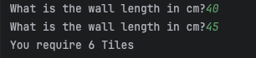
Result: Did the programme behave as expected ie syntactically and logically correct?

Pre Fix Comment
The code behaved as expected but I made a grammatical error which meant the user saw the same question twice, which would cause confusion. The first line was supposed to say, “What is the wall width in cm?”. Furthermore, I would change the use of “wall length” in the user message, to match the variable name of wall height. The message would then read “What is the wall height in cm?”

Post Fix Comment
I updated the user input messages and variable messages as previously mentioned, the code still behaved as expected. However, I subsequently changed the functionality of my code to include the calculation of leftover tiles, which I will explain in Section 3.

Test ii:
Input ii. Test: Enter dimensions of wall: Width 100000 Length 200000
Screenshot(s) of output:

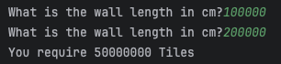
Result: Did the programme behave as expected ie syntactically and logically correct?

Pre Fix Comment
Yes, it did behave as expected, however as previously stated in test 1, I realised I made a grammatical mistake.

I was unsure whether to put a maximum limit on the width and length of a room, because these are dependent on the size of the room. However, for this exercise, I will stick a limit of 100000 as tiles are mostly used in smaller spaces. I will validate the number through arrange constraint, specifying the maximum width and height measurements.

Post Fix Comment
I redid this test after adding the range constraint to the code and the programme behaved as expected. It allowed the first input, but failed the second input, showing the user, the ValueError message for the exceeded maximum number.

Test iii:
Input iii: Enter dimensions of wall: Width -16 Length -20

Screenshot(s) of output:

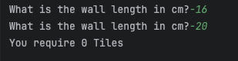
Result: Did the programme behave as expected ie syntactically and logically correct?

Pre Fix Comment
Logically and syntactically, it does behave as expected. It knows that tiles cannot be in minus figures and therefore 0 tiles are required.
As seen in the field with the original code, I was working on a validation solution, but I couldn’t get it to work in the allotted time.
I think to improve it and get it working, I would turn it into a try catch using try and except ValueError to combine the above issue and this one, to ensure it has a minimum of 1 and a maximum of 1000000 for both width and height.

Post Fix Comment
I merged this validation with the previous test; I added the range constraint with a minimum and maximum number.
I redid the test after merging the range constraints. It behaved as expected and raised the ValueError validation message.

Test iv:
Logic: iv. Enter dimensions of wall: Width 80 Length 80. The result should be 16 tiles

Screenshot(s) of output:
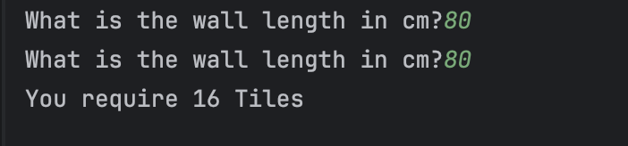
Result: Did the programme behave as expected ie syntactically and logically correct?

Pre Fix Comment
Yes, it shows the two values inputted and the value outputted matches the expected result of 16 tiles.

Post Fix Comment
I improved my code by displaying a different message if only whole tiles were required. This was done via an if statement. To test this improvement, I inputted the values from this test, and it behaved as expected and outputted the correct message for the number of full tiles required.

Test v:
Logic v. Enter dimension of wall: Width 40 Length 45. The result should be 6 tiles

Screenshot(s) of output:
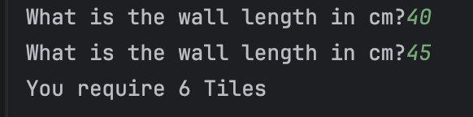
Result: Did the programme behave as expected ie syntactically and logically correct?
Pre Fix Comment
Yes, it behaved correctly, it shows the two values inputted and the value outputted matches the expected result of 6 tiles.

Post Fix Comment
Once I added the improvements to my code, it displayed the expected result for both sections, which was that 6 full tiles were required, or 5 if the user didn’t mind splitting the tiles.

Test vi:
Logic vi. Enter dimensions of wall: Width 85 Length 90. The result should be 25 tiles.
Screenshot(s) of output:
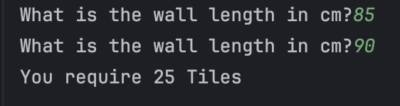
Result: Did the programme behave as expected ie syntactically and logically correct?

Pre Fix Comment
Yes, the programmed behaved as expected. It shows the two values inputted and the value outputted matches the expected result of 25 tiles.

Post Fix Comment
I tested this again with the code changes, and the code behaved as expected. Displaying 25 full tiles or a minimum of 21, if the tiles were being split.

Test vii:
Logic vii. Enter dimensions of wall: Width 15 Length 15. The result should be 1 tile.

Screenshot(s) of output:

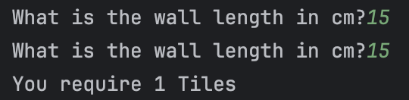
Result: Did the programme behave as expected ie syntactically and logically correct?

Pre Fix Comment
Yes, the programme behaved as expected. It shows the two values inputted and the value outputted matches the expected result of 1 tile. However, to cover all cases, I think I would put the ‘s’ in brackets to cover if only 1 tile is needed it is still grammatically correct. Or I could have two paths, if the tile is equal to 1, it has this specific message and if it’s bigger than 1 it has another message.

Post Fix Comment
I added an if statement so if only 1 tile was required, it would print a different message. I will explain this in section 3.
I tested this improvement to my code, and it worked as expected. When 1 was input, it outputted the message above.

- Consider the results of the above tests and revisit your code in order to solve any problems discovered at the testing phase. (Note: you may not be able to solve all of them but solve as many as you can.)

The functionality changes made:
To create a better working solution, I validated the user’s input so non-number inputs would be rejected using try-except blocks. The ValueError informed the user through personalised messages why the programme failed. I created two functions, one that validated the input and the other displayed it. I originally validated both the width and height individually, however I realised I was running the same validation on both, so I combined them to make the code more efficient by reducing code duplication. Furthermore, I went through the code and changed the names, as I learned through research that syntactically you can use camel case, but snake case is preferred in python.

The original working solution I had was:
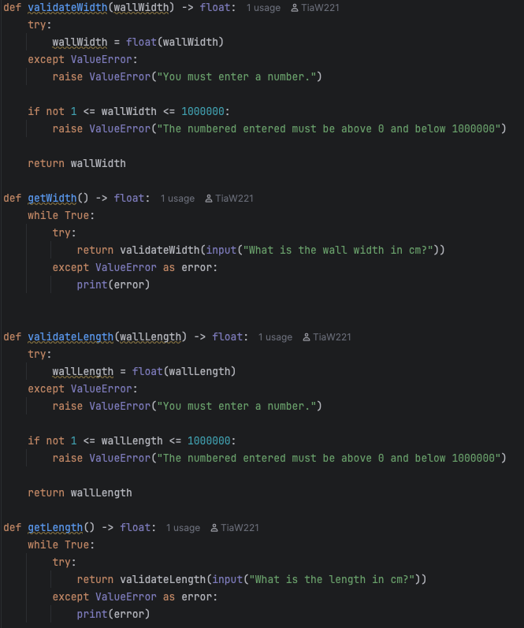

The final working solution I settled on was:
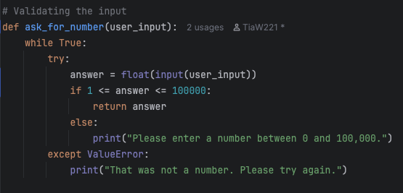

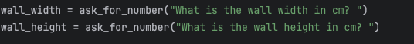
I changed my code to show the minimum number of tiles required depending on whether the user wanted to split the wall tiles.

As the user can have quarter tiles, I created a variable for the dimension of the tile, (in this case 10 x 10) and then created a dimension for a quarter tile under the variable name ‘halfTile’ because it was half the tile length and tile width. This was the basis of my calculations.

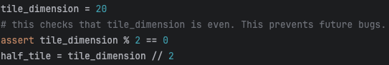
Next, I used this to calculate how many full tiles fitted both vertically and horizontally on the wall, then added these together to get the measurement for the full tile required.

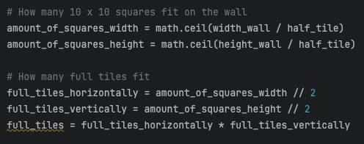
I calculated how many half tiles were required horizontally and vertically by creating an if statement for each, stating if the number was odd a half tile was required. Then I calculated the sum of both, to create the total number of half tiles required. Following that, I devised that if both the number of squares required on the wall horizontally and vertically were odd, a quarter tile was required.

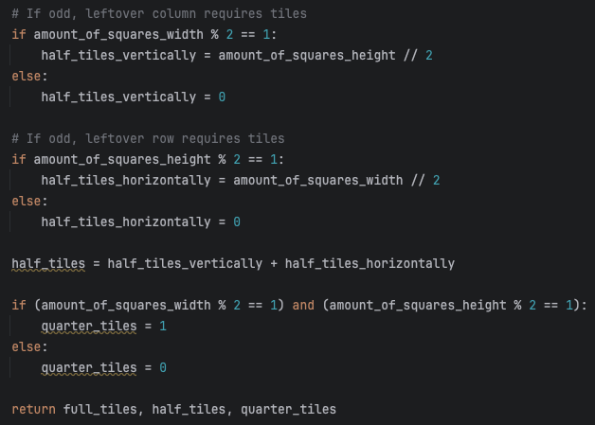
I created one function called ‘symmetricalTiles’ that that does all these calculations, then feeds me the three results which I save in three variable names via tuple unpacking.

Last of all, I changed the output to print three different messages depending on how many tiles are required using two an if statement.

If the user only requires one tile, it prints out a message saying “you require {no} tile”. If the user requires only whole tiles, it adds an ‘s’ to the original message to say “tiles” and lastly, if the user requires whole tiles, half and/or quarter tiles, it prints another message. I originally had two if statements, but I simplified it using an inline ternary statement and concatenation.
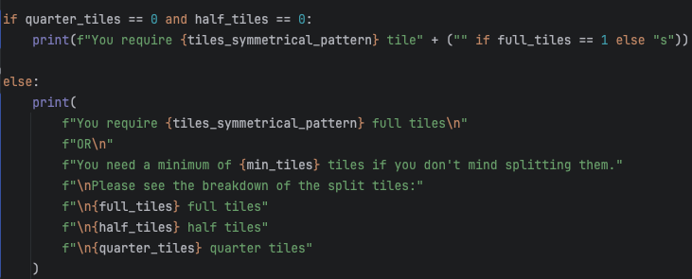

The last message gives the user the choice of whether they want to use only whole tiles per wall or split the tiles, and the different numbers required for both.

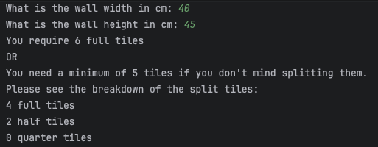

Final copy of the revised code:
Paste your revised code here:

[Copy and paste your revised code here – note, do not use a screenshot]
import math
tile_dimension = 20
# this checks that tile_dimension is even. This prevents future bugs.
assert tile_dimension % 2 == 0
half_tile = tile_dimension // 2
# Validating the input
def ask_for_number(user_input):
while True:
try:
answer = float(input(user_input))
if 1 <= answer <= 100000:
return answer
else:
print("Please enter a number between 0 and 100,000.")
except ValueError:
print("That was not a number. Please try again.")
# Getting information on how many full tiles, half tiles and quarter tiles are needed
def symmetrical_tiles(width_wall, height_wall):
# How many 10 x 10 squares fit on the wall
amount_of_squares_width = math.ceil(width_wall / half_tile)
amount_of_squares_height = math.ceil(height_wall / half_tile)
# How many full tiles fit
full_tiles_horizontally = amount_of_squares_width // 2
full_tiles_vertically = amount_of_squares_height // 2
full_tiles = full_tiles_horizontally * full_tiles_vertically
# If odd, leftover column requires tiles
if amount_of_squares_width % 2 == 1:
half_tiles_vertically = amount_of_squares_height // 2
else:
half_tiles_vertically = 0
# If odd, leftover row requires tiles
if amount_of_squares_height % 2 == 1:
half_tiles_horizontally = amount_of_squares_width // 2
else:
half_tiles_horizontally = 0
half_tiles = half_tiles_vertically + half_tiles_horizontally
if (amount_of_squares_width % 2 == 1) and (amount_of_squares_height % 2 == 1):
quarter_tiles = 1
else:
quarter_tiles = 0
return full_tiles, half_tiles, quarter_tiles
wall_width = ask_for_number("What is the wall width in cm: ")
wall_height = ask_for_number("What is the wall height in cm: ")
# Full-tile pattern layout (20x20 only)
tiles_symmetrical_pattern = (
math.ceil(wall_width / tile_dimension) *
math.ceil(wall_height / tile_dimension)
)
# Use the symmetrical tile function
full_tiles, half_tiles, quarter_tiles = symmetrical_tiles(wall_width, wall_height)
# Convert half and quarter pieces into full tile total
full_tiles_conversion = full_tiles + (half_tiles * 0.5) + (quarter_tiles * 0.25)
min_tiles = math.ceil(full_tiles_conversion)
if quarter_tiles == 0 and half_tiles == 0:
print(f"You require {tiles_symmetrical_pattern} tile" + ("" if full_tiles == 1 else "s"))
else:
print(
f"You require {tiles_symmetrical_pattern} full tiles\n"
f"OR\n"
f"You need a minimum of {min_tiles} tiles if you don't mind splitting them."
f"\nPlease see the breakdown of the split tiles:"
f"\n{full_tiles} full tiles"
f"\n{half_tiles} half tiles"
f"\n{quarter_tiles} quarter tiles"
)
)

