

LCMB7035
Dissertation
Research Proposal

The Role of Brand Purpose in Building Consumer Resilience during a Cost-of-Living Crisis: A Study of UK Supermarket Retailers

Submitted by:
Name- Nishat Hossain
ID - 2437429

Table of Contents
1. Introduction 3
1.1 Research Title 3
1.2 Study Background 3
1.3 Problem Statement 4
1.4 Research Rationale 5
1.5 Aims, Objectives and Questions 5
1.6 Research Hypothesis 6
1.7 Structure of Dissertation 7
2. Literature Review 8
2.1 Brand Purpose: Theoretical Foundations 8
2.2 Consumer Resilience and Economic Adversity 9
2.3 CSR, Brand Purpose, and Consumer Trust in UK Retail 10
3. Methodology 12
3.1 Research Onion Layer 12
3.2 Secondary Data Collection Method 13
3.3 Data Analysis Method 14
3.4 Ethical Problems and Concerns 15
4. Expected Findings 15
6. Timeframe 16
6.1 Work Breakdown Structure (WBS) 16
6.2 Gantt Chart 17
7. Conclusion 18
8. References 19

1. Introduction

1.1 Research Title
The Role of Brand Purpose in Building Consumer Resilience during a Cost-of-Living Crisis: A Study of UK Supermarket Retailers

1.2 Study Background
The UK Cost-of-Living Crisis
There has been a major cost of living crisis in the United Kingdom, especially after 2021, because of increases in energy prices, supply chain challenges, post-pandemic economic impacts and inflationary pressures. All households in the country have had to reassess their spending habits and one of the hardest hits is grocery retail.
Brand Purpose as a Strategic Response
As the economic climate has become more challenging, several UK supermarket retailers such as Tesco, Sainsbury's, Aldi, Lidl and Morrisons have focused more on brand purpose in order to tap into consumers' more emotional and ethical levels of engagement.
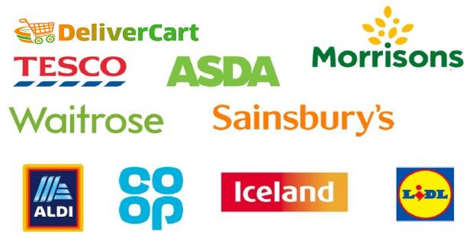
Figure: UK retail market (Titis, 2022)

Retail Delivery of Consumer Resilience
The consumer resilience as the ability to adjust the buying behavior as well as brand relationship under negative circumstances, have become an important concept in the field of marketing. Within the UK-grocer context, and given the impoverished (supply) situation, this looks like maintaining the purchase behavior, trust in the brand, and participation in the supermarket's wider social program.

1.3 Problem Statement
The disconnect between Brand Purpose and consumer behavior
There is little knowledge about whether brand purpose in reality a significant impact on consumer resilience has especially when economic conditions are challenging, although its prominence is increasing as a marketing tactic for supermarkets in the UK.
An analysis of the risk-performance of brand purpose
One salient issue in this area is the difference between two types of purpose-driven communication: what the brand really needs to do versus what it merely pretends needs to happen. When finances are tight, consumers are savvier about authenticity and when retailers don't match purpose with action, they risk loss of consumer confidence and trust.
Limited quantitative evidence in the UK supermarket sector
Previous studies about brand purpose are generally associated with premium or lifestyle brands, and there is little research available in the literature on value brands which are grocery retailers within the cost driven consumer market.

1.4 Research Rationale
Relevance to academic and practical context
There is rationale academically and practically for this research. Academically, it helps drive the ongoing debate of brand purpose, consumer resilience and value-based marketing in the particular context of the economic adversity.
Timeliness of the investigation
This research is timely in the context of the present ongoing cost of living crisis in the UK. Supermarket brands are in a particular position in the public mind with food inflation impacting millions of households.

1.5 Aims, Objectives and Questions
Research Aim
The aim of this research is to examine how brand purpose is utilized to boost the resilience of UK supermarket consumers through the cost-of-living crisis and to explore the understanding of the relationship between brand purpose and consumer resilience theoretically and empirically.
Research Objectives
- To identify and critically analyses the current state of research and literature on brand purpose, consumer resilience and cost of living behaviors in a retail environment.
- To examine how and why big supermarket retailers in the UK are using brand purpose as a strategy in the cost-of-living crisis.
- To offer some of the best strategic advice to supermarket retailers looking to bolster consumer resiliency in an intentional brand positioning.

Research Questions
- How does brand purpose play a role in creating consumer resilience for UK supermarket shoppers in the cost-of-living crisis?
- What has been the approach of the UK's biggest supermarket groups as they try to tell us what they stand for through the cost-of-living crisis?
- Are there quantitative relationships between indicators of brand purpose and outcomes of consumer resilience in supermarket retail in the UK?

1.6 Research Hypothesis
Proposed Hypotheses
Hypothesis | Statement
H1 | During the cost-of-living crisis, there is a statistically significant positive relationship between brand purpose strength and consumer loyalty.
H2 | Consumer perception of brand authenticity positively moderates the relationship between brand purpose and consumer resilience.
H3 | Supermarkets that have a clearly defined social brand purpose are found to have higher customer retention during the crisis.
H4 | This value-added messaging, in and of itself, is a shaky way of developing consumer resilience over the long term, without a purposeful brand story.

1.7 Structure of Dissertation
Chapter | Title | Focus
1 | Introduction | Outline a background, reasons, objectives, questions
2 | Literature Review | Theoretical frameworks and prior research.
3 | Methodology | The focus on research design and data analysis approach
4 | Expected Findings | Predictions and trends
5 | Limitations | Include study limits/boundary conditions in the calculations.
6 | Timeframe | WBS and Gantt Chart
7 | Conclusion | The article concludes with a summary, implications, and future.

2. Literature Review

2.1 Brand Purpose: Theoretical Foundations
Defining Brand Purpose
Brand purpose is a broad definition as the reason it exists beyond profit and goes deep into a brand's cultural, social and ethical identity. For brand purpose, it has revealed itself in six British shopping trends of the supermarket retail sector: REDUCE, RESTORE, REKINDLE, RENEW, REWRITE, and RE-IMAGINE - the commitment of affordability, sustainability, community welfare, and employee wellbeing which are all particularly motivational during a crisis. A key question in the theory and practice of CSR is how to differentiate between "purpose" and "purpose-washing," that is, between the perception of the brand's values and the actual behavior of its stakeholders (Hoa and KHANH, 2021).
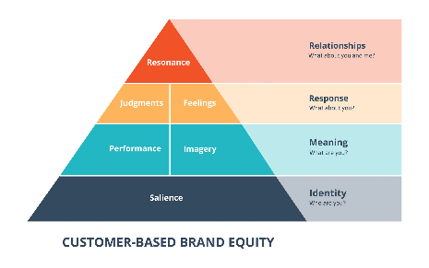
Figure: Keller’s brand equity model (Otola et al., 2023).
Brand Resonance Model (Keller)
Keller's Brand Resonance Model provides a laddered framework of four levels of consumer-brand relationships - each directly relevant to the challenge of creating supermarket resilience with purpose - for brand-to-business marketers.
- To make these ends meet, the name and principal outlets of a supermarket will have to be recognized and associated by consumers with the supermarket's purpose (Lee and Hammant, 2024).
- When first it comes to placing purpose on the map of brand value and then connecting it with your audience during a crisis, branding for meaning is built on price credibility.
- This is where buyers' perceptions of quality, credibility and relevance come to be engaged; the purpose-led brands that have a commitment and perform themselves will evoke (Mikkelsen, 2022).
- Brand Resonance to highest rating level in psychological resonance represented with a commitment to the brand; the brands having attained such level are most likely to benefit.

2.2 Consumer Resilience and Economic Adversity
Conceptualising Consumer Resilience
Consumer resilience is the ability of consumers to withstand economic hardship and continue to consume and remain loyal to their brands (Manocha and Manocha, 2024). In UK grocery retail, one aspect of resilience is seen in patronage but not brand defection – while there may be times when consumers did try to switch, they did not, and there are also occasions when consumers are finding it hard to pay for their brands, they still are being loyal to them (Mikkelsen, 2022).

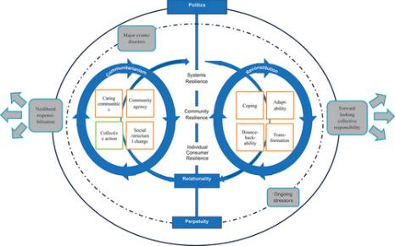
Figure: Customer resilience (Nishi et al., 2021).
The socio-economic analysis of Maslow's Hierarchy of Needs in context of cost of living
Supermarket retail is at the very core of basic need fulfilment, which Maslow's Hierarchy can help to explain when looking at consumer prioritisation during financial hardship.
- At the base of this Hierarchy are the Physiological Needs: Food and household necessity - consumers' survival strategy has been put on hold during the Crisis and affordability.
- Safety Needs Consumers look for brands who are committed to prices in addition to services, along with community support which includes food bank partners.
- Social and Esteem Needs: Despite a tougher economic climate, consumers are still hoping to find brands that represent them and will support them in developing their social values.
- When shopping under financial pressure, integrating sustainability commitments and values aligned consumption with a desire to feel good helps achieve brand resonance (Manocha and Manocha, 2024).

2.3 CSR, Brand Purpose, and Consumer Trust in UK Retail
CSR​‍​‌‍​‍‌ as a means to express Brand Purpose
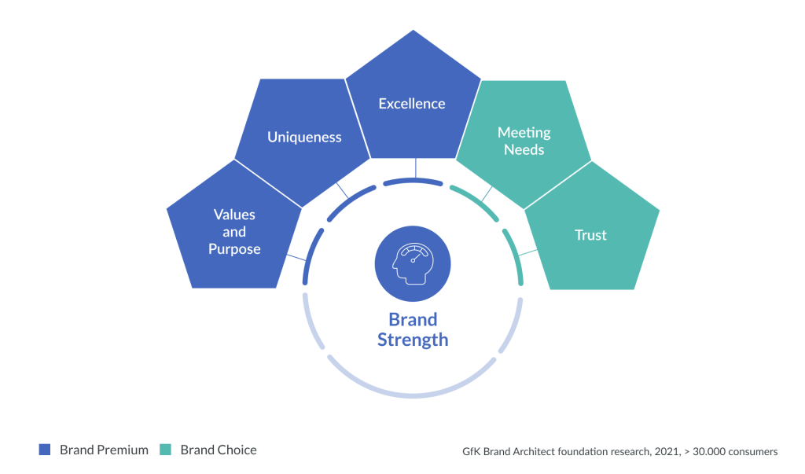
Corporate Social Responsibility is the actual implementation of the brand purpose by means of tangible policies and actions, for instance, food poverty programmes, supplier fairness pledges, and employee wage guarantees. The presence of CSR in UK supermarket retail during the cost-of-living crisis has been a major proof of purpose authenticity, which in turn has had a direct impact on consumer trust perceptions (Titis, 2022).

Figure: Brand strength (Deedenkeeratisakul, 2021).

Supermarket | Key Brand Purpose Initiative | CSR Focus | Consumer Resilience Impact
Tesco | Food bank partnerships | Food poverty | High loyalty retention
Aldi | Everyday low prices campaign | Affordability and access | Strong value-driven retention
Sainsbury's | Local sourcing and sustainability | Environmental ethics | Moderate purpose-loyalty alignment
Morrisons | Community champions programme | Local community support | Growing purpose recognition
Lidl | "Big on quality" affordability | Value and transparency | Increasing consumer trust

Transformations in consumer behavior and value perception
Financial concerns have resulted in tangible changes such as greater own-brand consumption, changes to loyalty programs and the adoption of new brands as categories have shifted in favor of discounter (Deedenkeeratisakul, 2021). Financial pressures have led to measurable shifts in how consumers relate to brands, with greater own-brand uptake, changes to the use of loyalty schemes, and adopting new brands as categories have switched in favor of the discounters. Employing brand purpose to increase the perceived value, offering consumers dimensions beyond monetary aspects (Hoa and KHANH, 2021).

3. Methodology

3.1 Research Onion Layer
1. Philosophy – Positivism
The study is based on the positivism paradigm where brand purpose and consumer resilience are measurable variables which can be analysed objectively from the secondary data collected using quantitative methods in order to arrive at generalizable conclusion (Nishi et al., 2021).
2. Approach – Deductive
The research was conducted using deductive method which begins from the theories that have been stated (Brand Resonance Model, Maslow's Hierarchy) to formulate hypotheses (H1 – H4) and then tested with empirical secondary data (Dubash and Holland, 2025).
3. Strategy – Quantitative Secondary Analysis
Research approach will include analysing the existing data, numerical and textual ones collected from Kantar, IGD and annual reports as a measurement of brand purpose relationship with resilience indicators in NVivo software.
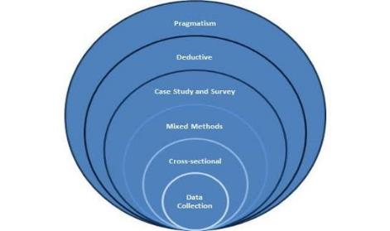
Figure: Research Onion Layer (Walter et al., 2024).

4. Choice – Mono-method (Quantitative)
Mono method quantitative design is used without using qualitative interview/mixed method. This is based on the availability of existing data on brand performance and consumer behaviour in UK supermarkets, which is deemed to be rich, and also on the limitations to conducting primary research within the scope of this project (Otola et al., 2023).
5. Time Horizon – Cross-sectional
A cross-sectional time horizon is used, looking at data for the cost-of-living crisis period (2021 - 2023) to provide a snapshot of consumer behaviour and brand performance for this specified timeframe.
6. Techniques & Procedures – Secondary Data Analysis using NVivo
The data source comes from the published consumer sentiment reports, brand equity survey reports, and industry reports. The thematic density mapping, content frequency, and sentiment analysis is done with NVivo to get quantitative insights.

3.2 Secondary Data Collection Method
Sources and Selection Criteria
Consumer sentiment reports, brand equity surveys, annual supermarket reports, industry reports, such as Kantar Brand Footprint, IGD Retail Analysis, and academic papers available at EBSCO, Scopus and Google Scholar are used for secondary data collection (Hu and Yin, 2025). The sources are chosen owing to four factors (relevance to the research topic, temporal relevance in relation to the time frame (2021 to 2023), the credibility of the publishing body, and the availability of quantitative data points that can be analysed in NVivo).
The benefits of secondary data
Secondary data can also give access to national datasets of large size, and representative of the population, such as longitudinal brand tracking studies and national consumer surveys. It also decreases many of the ethical issues that occur when collecting primary data including informed consent and participant privacy, which is important for this research setting and time frame (Youn et al., 2022).

3.3 Data Analysis Method
NVivo for Quantitative Secondary Analysis
The analytical tool used will primarily be NVivo software which is designed to manage huge secondary textual and numerical data and generate numerical outputs from content and sentiment analysis (Balsas, 2023). This structured deductive coding approach is based on the literature and is informed by theoretical constructs such as brand purpose authenticity, CSR visibility, consumer trust, perceived value and indicators of brand loyalty (Benton and Stasch, 2024).
Analysis Dimension | NVivo Function | Data Source
Brand Purpose Strength | Content frequency coding | Annual reports, brand communications
Consumer Sentiment | Sentiment analysis | Consumer reviews, media reports
CSR Visibility | Thematic density mapping | CSR reports, news articles
Loyalty Indicators | Pattern analysis | Kantar loyalty data, industry reports (Hu and Yin, 2025).

For​‍​‌‍​‍‌ purposes of standardization and in order to replicate the research, codes were initially described in a way that could be practically applied during the analysis. Through this method, the study can identify measurable outcomes in secondary text-based sources and relate textual evidence with the quantitative research ‍​‌‍​‍‌framework (Vetlesen, 2025).

3.4 Ethical Problems and Concerns
Data Provenance and Integrity
While secondary data collection mitigates some primary research ethical issues, it can present interesting concerns of ‘data provenance’ or trying to ensure that all data is properly published, publicly available and accurately presented (Petratos et al., 2024). This study engages in honest citation of others, and upholds faithful re-representation(s) of others' secondary work, recognizing the presence of conflicting evidence without unduly attending to only those data that would support advancement of pre-specified conclusions (Teye and Nikoi, 2021).
Data Privacy Considerations
There is no personal information collected, but some consumer sentiment datasets are collected in an aggregated manner from surveys or social media (Fobi et al., 2024). It is someone's duty to ensure that no personally identifiable information is extracted or reported from it and that all aggregated data is covered by the principles of GDPR, remaining compliant to the relevant data protection standards throughout the analytical process (Rosca et al., 2025).

4. Expected Findings
Its main drawback is the use of secondary sources, as this means the results are only as good as the available published sources and do not fully reflect the subtlety of the attitudinal aspects to consumer resilience. The focus on grocery retail among retailers in 2021–2023 means that the data cannot be generalised to other retailers, locations, or periods of time. As powerful an analytical tool as NVivo is, it's designed for analysing structured interpretive codes of secondary textual data, and as with any coded data, there is always some room for analytical subjectivity in the interpretation of the results that should be recognized.

6. Timeframe

6.1 Work Breakdown Structure (WBS)
Phase | Task | Duration
Phase 1: Planning | Topic finalisation, research design | Week 1–2
Phase 2: Literature Review | Source identification, critical review writing | Week 3–6
Phase 3: Methodology | Framework development, NVivo setup | Week 7–8
Phase 4: Data Collection | Secondary data gathering and organisation | Week 9–11
Phase 5: Data Analysis | NVivo coding and quantitative analysis | Week 12–14
Phase 6: Findings | Writing expected findings and discussion | Week 15–16
Phase 7: Writing | Full dissertation draft, editing, proofreading | Week 17–19
Phase 8: Submission | Final formatting and submission | Week 20

6.2 Gantt Chart
Task | Week 1-4 | Week 5-8 | Week 9-12 | Week 13-16 | Week 17-20
1. Planning | ✓
2.Literature Review |  | ✓
3. Methodology
4. Data Collection
5. Data Analysis |  |  | ✓
6. Writing |  |  |  | ✓
7. Submission |  |  |  |  | ✓

7. Conclusion
This​‍​‌‍​‍‌ research proposal outlined a logical and theory-based plan to study how brand purpose can help UK supermarket shoppers develop consumer resilience during the cost-of-living crisis. Using now a positivist, deductive, and secondary data-driven approach, the study will be able to produce valuable quantitative insights into how purpose-driven brand communication impacts consumer behavioural and attitudinal resilience in one of the UK's most economically sensitive retail sectors. Also, theoretically, the research adds to the knowledge on brand purpose and consumer resilience by using Brand Resonance Model and Maslow's Hierarchy to crisis retail scenario which has not been extensively explored.

8. References
Balsas, C.J.L. (2023) ‘Enthralling Prefigurative Urban and Regional Planning Forward’, Land, 12(11), p. 1973. https://doi.org/10.3390/land12111973.
Benton, R. and Stasch, S.F. (2024) ‘The U.S. Government's Program of Welfare for the Wealthy’, Journal of Macromarketing, 44(2), pp. 250–257. https://doi.org/10.1177/02761467231225129.
Constance, C.Z. (2017) ‘What if the trucks stop coming? exploring the framing of local food by cooperative food retailers in New Mexico’, Wageningen University. https://doi.org/10.18174/413760.
Deedenkeeratisakul, K. (2021) ‘Domestic customers' perceived value toward Thai cultural products’, Chulalongkorn University. https://doi.org/10.58837/chula.the.2021.122.
Dubash, F. and Holland, S. (2025) ‘P069 Eczema and the UK cost-of-living crisis’, British Journal of Dermatology, 193(Supplement_1). https://doi.org/10.1093/bjd/ljaf085.097.
Fobi, D., Waldman, K.B., Dwyer, M.B., Robeson, S.M. and Blekking, J. (2024) ‘Negligible impact of supermarkets on food security (so far) in low-income neighborhoods of Accra, Ghana’, PLOS Sustainability and Transformation, 3(10), p. e0000133. https://doi.org/10.1371/journal.pstr.0000133.
Hoa, D.P. and KHANH, N.H. (2021) ‘Applying the Circular Economy Model to Urban Waste Management in Singapore and Experiences for Vietnam’, Advances in economics, business and management research/Advances in Economics, Business and Management Research, 196. https://doi.org/10.2991/aebmr.k.211119.026.
Hu, L. and Yin, R. (2025) ‘Brand Building in the Pay-Later Era: A Study on Trust Construction and Consumer Psychological Contracts’, Proceedings of the 2nd International Conference on E-commerce and Modern Logistics, pp. 408–416. https://doi.org/10.5220/0013846000004719.
Lee, C. and Hammant, C. (2024) ‘How could businesses with anchor positioning contribute to community wellbeing? A study of supermarket community support actions in the UK’, Wellbeing Space and Society, 6, p. 100188. https://doi.org/10.1016/j.wss.2024.100188.
Manocha, R. and Manocha, N. (2024) ‘UK Cost of living crisis: An overview’, GBS Impact: Journal of Multi-Disciplinary Research, 10(1), pp. 161–168. https://doi.org/10.58419/gbs.v10i1.1012411.
Mikkelsen, B.E. (2022) ‘Fighting Food Waste—Good Old Boys or Young Minds Solutions? Insights from the Young Foodwaste Fighters Club’, Youth, 3(1), pp. 1–17. https://doi.org/10.3390/youth3010001.
Nishi, M., Subramanian, S.M., Gupta, H., Yoshino, M., Takahashi, Y., Miwa, K. and Takeda, T. (2021) ‘Fostering Transformative Change for Sustainability in the Context of Socio-Ecological Production Landscapes and Seascapes (SEPLS)’, Research Repository (University of Gloucestershire). https://doi.org/10.1007/978-981-33-6761-6.
Otola, I., Grabowska, M. and Krupka, Z. (2023) ‘Building Organizational Resilience Through Brand Trust’, Trust and Organizational Resilience, pp. 43–59. https://doi.org/10.4324/9781003433798-8.
Petratos, P., Smith, C. and Kassem, R. (2024) ‘Resilience during the COVID-19 Pandemic’, Building Resilience in Global Business During Crisis, pp. 232–248. https://doi.org/10.4324/9781032719870-15.
Rosca, E., Pullman, M. and Pagell, M. (2025) ‘Brokering for the Benefit of Others: How Purpose‐Driven Organizations Create Sustainable Supply Chains’, Journal of Supply Chain Management, 61(4), pp. 77–97. https://doi.org/10.1111/jscm.70002.
Teye, J.K. and Nikoi, E. (2021) ‘The Political Economy of the Cocoa Value Chain in Ghana’, Figshare. https://doi.org/10.19088/apra.2021.007.
Titis, E. (2022) ‘Quantifying the Impact of Supermarket Distance on Childhood Obesity in Greater London, United Kingdom: Exploring Different Access Measures and Modification Effects of Transportation’, Childhood Obesity, 19(7), pp. 479–488. https://doi.org/10.1089/chi.2022.0126.
Vetlesen, A.J. (2025) ‘Building resilience in a neoliberal society’, Living with Disappointment in the Face of Environmental Crisis, pp. 104–148. https://doi.org/10.4324/9781003660743-4.

Walter, N., Föhl, U., Sander, F. and Nies, A. (2024) ‘Act as you preach! Authentic brand purpose versus “woke washing’s” impact on brand credibility: The moderating role of cause involvement and consumer skepticism’, Journal of Business Research, 184, p. 114868. https://doi.org/10.1016/j.jbusres.2024.114868.
Youn, S., Rana, M.R.I. and Kopot, C. (2022) ‘Consumers going online for big‐box retailers: Exploring the role of feeling disconnected during a pandemic’, International Journal of Consumer Studies, 46(6), pp. 2383–2403. https://doi.org/10.1111/ijcs.12793.

