

Assignment 2

Strategy and Organizational Structure Change of Jiangxi Science & Technology Normal University

Student Number: 1806568
Module Title: Strategic Change and Organizations (LCDB7005)
Module Lecturer: Dr. Gladius Kulothungan

Introduction
Jiangxi Science and Technology Normal University is located in Nanchang City, Jiangxi Province. There are 1665 faculty members, 1371 full-time teachers, 637 deputy senior professional and technical personnel, 1142 doctoral and master degree teachers and 551 master tutors. Since its establishment, more than 120,000 graduates have been trained and made positive contributions to the economic and social development of Jiangxi (Jiangxi Science and Technology Normal University, 2019). In order to conform to the trend of internationalization of education, schools insist on opening up and actively carry out cooperation and exchanges with foreign countries. In recent years, the school has recognized friendly and cooperative relations with many schools around the world, and carried out cooperation and exchange projects such as Sino-Foreign Cooperative projects, mutual credit recognition, teacher visits, student exchanges, academic research and so on. In addition, the university has long employed foreign teachers, well-known experts and scholars to teach and lecture in university, and sent its teachers abroad for further study, teaching and cooperative research, and encouraged students to study and exchange in overseas universities. Although Sino-foreign cooperative projects have been introduced to China for a long time, they have not developed for a long time in Nanchang. Jiangxi Science and Technology Normal University actively promotes the development of international education globalization and strives to adapt to the changing external environment. In 2011, the university began to adopt a new strategy. It has cooperated with Edge Hill University, Columbia College and New York Film Academy. It has opened financial management, tourism management, early childhood education, visual communication and so on. It is in line with the international standards in curriculum and teaching management. The university has taken an important step on the road of internationalization.

New Change Program in Jiangxi Science and Technology Normal University

2.1 McKinsey 7S Analysis

Figure 1: McKinsey 7S Model
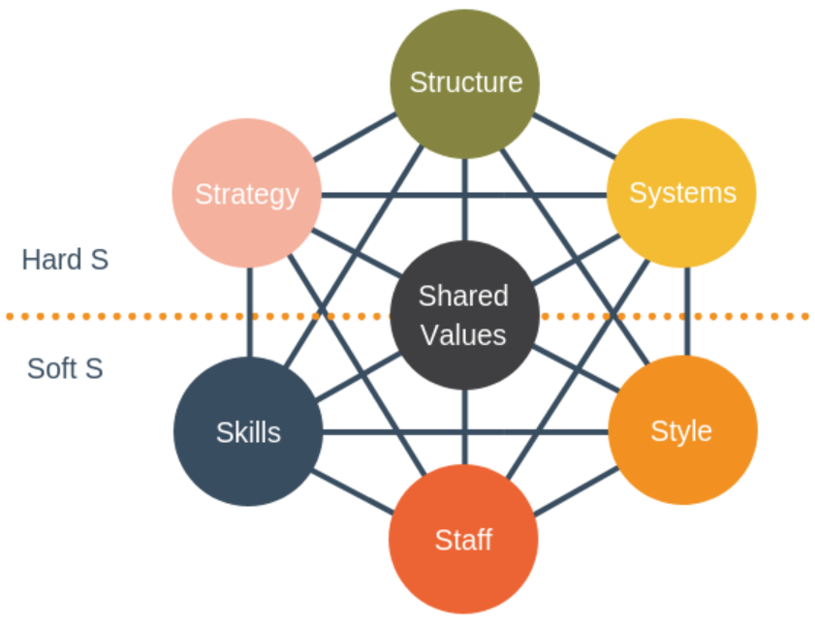
Source: Hanafizadeh, Payam & Ravasan, Ahad Zare (2011)

In the process of development, an organization must consider all aspects, and it is not enough to have only a clear strategy. The McKinsey 7S model, developed by two McKinsey consultants in the early 1980s, has been used to analyze the case studies of many large organizations. These seven variables start with S, namely "Structure", "Strategy", "System", "Skills", "Style", "Staff", "Shared Values" ( Hanafizadeh, Payam & Ravasan, Ahad Zare, 2011; Alshaher, 2013). Although Shiri et al. (2014) expanded 7S to 9S, what are enterprise analysis used more is still a 7S model. Since Jiangxi Science and Technology Normal University introduced the Sino-foreign cooperative project, the changes have taken place in all aspects, which marks a substantial step in the teaching reform. The key point of the McKinsey model is that all seven domains are related, and changes in one domain require changes in other domains to work effectively (Ravanfar, 2015). The following seven aspects of McKinsey are used to analyze the strategic changes of the university. These seven elements play an important role in enhancing the competitiveness of the university to determine whether these elements are effectively combined.

Strategy
The emerging global economy is often referred to as the knowledge economy, because its core is higher education, which is regarded as the key to creating and disseminating knowledge. Governmental decision-makers around the world increasingly believe that higher education is essential to national economic development (Wanger and Sornlertlumvanich, 2012). The introduction of Sino-foreign cooperative projects has gradually become a new part of China's higher education personnel training (Chi, 2018). In order to achieve the goal of internationalization of education, Chinese universities actively introduce educational projects with world characteristics, such as excellent curriculum, teaching methods, management system, assessment system, high-quality teaching staff and more effective ways of personnel training (Lin and Liu, 2007). Since Jiangxi Science and Technology Normal University implemented the cooperative project strategy, the following points reflect the overall mission of the university - to improve the quality of teaching, enhance competitiveness:
- Make full use of the strategy closely combined with local advantages to develop special cooperation projects. The major of Tourism Management in the project cooperated with Edge Hill University combines local characteristics with the university's international project development planning and changes in the talent market. Jiangxi Province is a tourism province with its own characteristics. Students can learn international tourism information while learning domestic tourism expertise. Furthermore, foreign teachers' teaching can improve students' English level and broaden their international horizons, which is conducive to the cultivation of multi-faceted special talents in universities.
- Because the cooperative project is a good way to talk directly with foreign universities and explore educational ideas, if it can be implemented smoothly, it can gradually promote the reform of Chinese universities and improve the level of universities (Wen, 2015). Interaction between university and foreign universities can promote communication and enhance the level of the whole university, not just a few colleges.
- In view of the current cooperative projects, universities regularly summarize and analyze the quality of teaching, maintain friendly and cooperative relations with foreign universities, and gradually improve the quality of the cooperative projects, which is a way of keeping pace with the times. Because with the advancement of university construction in China, the environment in which universities are situated is also fiercely competitive. Only by constantly learning and improving can they be consistent with the changing external environment and conform to the process of internationalization (Huang, 2007).

Structure
Organizational structure is very important for Sino-foreign cooperative projects in universities. It is a new project entering the existing organizational structure. Organizational structure is an effective arrangement and combination of organizational elements, such as objectives, collaboration, personnel, positions, mutual relations, information, etc. Only when these elements are carried out in an orderly manner can the smooth progress of Sino-foreign cooperative projects be guaranteed (Alshaher, 2013). In order to integrate these projects, Jiangxi Science and Technology Normal University has made some changes on the basis of its previous organization. Following the introduction of the project, a new institute, the Institute of International Education, has been added to the teaching units, which is specially responsible for the management of international cooperation projects (Jiangxi Science and Technology Normal University, 2019). At the same time, the structure is also the hierarchy of responsibilities and responsibilities within the organization (Ganesh, 2017). Sino-foreign cooperative projects are defined by the Center for International Exchange and Cooperation of the University and the International College of Education together with foreign universities. The strategy of international cooperation in university is divided into objectives and tasks, which are allocated to specific posts, and then integrated into corresponding departments or offices.
Figure 2：Organization Structure of International Education Institute

Source: By Author

First of all, it is necessary to determine the central link role of the Institute of International Education in the whole Sino-foreign cooperative project. The Institute of International Education is a new part of the whole university. Its organizational structure showed in Figure 2. In the initial stage of the project and the implementation of the project, the teachers of the project office have been communicating and cooperating with other schools on specific matters, linking curriculum arrangements, credit exchange and so on. The School Work Office is responsible for the daily learning and teaching of the project students. The Department is responsible for the management of the teaching situation of Chinese and foreign teachers in the College. The League Committee and the College Office handle some other daily matters. In addition, excellent teachers' courses are introduced into international education institutes in order to optimize the teaching quality of the project and cultivate internationalized talents. These structural changes and arrangements are closely related to the strategy of internationalization of education.

Systems
The system defines the activities involved in daily business operations, including core processes and support systems (Ganesh, 2017). Teaching and administrative work is the most important work as well as a systematic project. The factors affecting the quality of teaching and the quality of administrative implementation are complex and diverse. For Sino-foreign cooperative projects, in order to ensure teaching and administration, the university must first understand the factors affecting these two activities and adopt corresponding strategies.
The progressive system was originally a practical system in management and organization, which could be used in schools with limited resources. Change is necessary if the expected and experienced courses are not related to each other (Erarslan, 2019). Compared with the professional construction of the university itself, the number of cooperative projects and the number of students only account for a small proportion. Project students have particularity and complexity for teachers, which is different from the conventional management system and mode of domestic universities (Wen, 2015). First of all, Jiangxi Normal University of Science and Technology must formulate rules and regulations suitable for the requirements of colleges and schools according to the actual situation. Moreover, because the cooperative school-running project will introduce foreign teachers, full-time teachers will be required when the project enlarges enrollment. Thirdly, there should be relevant regulations in job responsibilities, curriculum arrangement, working procedures, class requirements, reward and punishment system, job commitment system and so on. However, good rules and regulations emphasize construction and development rather than constraints and jurisdiction. These systems must be in line with the strategy.

Skills
Universities and businesses alike, students are like products, and teachers are like employees. Good products need not only good staff to design and produce, but also good staff to plan, package and sell. Only then can these good products go to the market, even to the international market. However, there is still a gap between Chinese teachers and world-class universities. The introduction of foreign courses will bring some pressure to university teachers (Gao, 2018). Stress, however, is not necessarily a bad thing. In an efficient supervisory team, it helps to improve employees' skills and better serve the organization (Ganesh, 2017). To implement the strategy of internationalization of education smoothly, the teachers who implement the strategy must have certain skills. The training and application of these skills come from systematic training, professional training and so on. In recent years, Jiangxi Science and Technology Normal University has strengthened the training of teachers' quality. Since 2013, teachers have been sent to Finland, the United States to visit universities and learn from advanced foreign educational experience. At the beginning of 2018, the university has implemented a preferential policy of studying abroad to encourage teachers to study abroad for doctoral degrees. The aim is to cultivate more excellent talents with better teacher resources and improve the teaching level of universities (Jiangxi Science and Technology Normal University, 2019). These skills have laid the foundation for the strategy of internationalization of education.

Style
Style is actually the way top managers manage organizations and observe how they interact, but it also needs to be a hierarchical and authoritative management approach (Ravanfar, 2015; Kirschenboim, 2018). There are many problems in the curriculum of Sino-foreign cooperative education programs. First of all, the advanced nature is insufficient and the characteristics are not outstanding. The courses offered by Sino-foreign cooperative project in some universities are not advanced in breadth and depth. Secondly, the system is not enough and there is a patchwork phenomenon. Research and development found that some Sino-foreign cooperative projects have scattered curricula and lack of overall design. Thirdly, there is a lack of localization. The internationalized talents trained by Sino-foreign cooperation in universities are the internationalized talents of the Chinese people themselves. They should have national consciousness, national consciousness and responsibility consciousness. Jiangxi Science and Technology Normal University should build international cooperation projects of its own style. The school's cooperative enrollment program is a 3 + 1 joint training mode. After students have graduated from Chinese-foreign cooperative colleges and universities, they can obtain the corresponding academic qualifications and degrees (Jiangxi Science and Technology Normal University, 2019). This is a feature of its own project. In teaching, the introduction of foreign high-quality teaching resources, the use of original English textbooks, bilingual and foreign teaching professional teaching.

Staff
In McKinsey's strategic analysis, employee elements focus on what type and number of employees an organization needs and how to recruit, train, motivate and reward employees (Ravanfar, 2015). Jiangxi Science and Technology Normal University, while adhering to the strategic transformation, deeply implements the strategy of strengthening the university by talents, adheres to the people-oriented principle, and actively creates a good environment conducive to the growth of talents. The university’s main human resource is the teacher, and the teacher is a link between the students and the school, which plays a decisive role in improving and reforming the work. In the context of the internationalization of education, the faculty should also be in line with the world. When introducing foreign teachers, the quality of teachers should be considered. Some foreign teachers are retired or temporarily recruited from foreign universities. Many foreign teachers are language teachers, and there are few specialized course teachers sent by foreign universities. It is difficult to meet the requirements stipulated by the ministry of education that "the number of specialized core courses and teaching hours undertaken by teachers of foreign educational institutions should account for all courses and teaching hours of Chinese-foreign cooperative education projects. In addition, we should respect the teaching rules, avoid foreign teachers to focus on teaching, and ensure the quality of teaching. Universities should also pay attention to the construction of Chinese teachers. Many Chinese-foreign cooperative programs are managed in the international school of the university, and Chinese teachers are recruited from other schools or from society. It is necessary to consider the heavy burden on teachers in other colleges because they need to complete the teaching tasks in their own colleges and Sino-foreign cooperative education programs, which leads to the reduction of the exchange frequency with students in Sino-foreign cooperative education programs. Some colleges and universities recruit teachers from the society, responsibility and ability are likely to exist and quality assurance contradictory problems. In addition, Sino-foreign cooperative education projects in universities and colleges should include teacher exchange and training. In many cases, due to the consideration of cost, both sides of the cooperation do not pay enough attention to this, and it is difficult to guarantee the improvement of teachers' ability.
The Institute of International Education has recruited a large number of faculty members with overseas study background, and also employed full-time foreign teachers. Each organization needs to assign suitable jobs to different people. Give full play to their personal skills and abilities to realize the value of human resources needed (Ganesh, 2017; Kirschenboim, 2018).

Shared Values
Common values have an obvious guiding and cohesive effect, and can connect people together (Ganesh, 2017). However, an organization must be consistent with its strategy in building common values (Chen & Liu,2010). Because it can stimulate the enthusiasm of all employees, unify their will and desire, and then move towards the same goal. In the university's Sino-foreign cooperation projects, the realization of the university's education internationalization strategy is the common goal of all. In order to achieve this, Jiangxi Science and Technology Normal University has made many field visits to foreign cooperative universities in the implementation of the strategic plan of Sino-foreign cooperation program. It has also consulted with relevant foreign leaders and sent teachers to overseas training. So that all the leaders and teachers involved in Sino-foreign cooperation projects can deeply understand the common value, master it, and actively use it to guide their work. In order to promote the internationalization of education, they need to do the following (Lin and Liu, 2007):
- Firstly, it should be targeted: to enable teachers and leaders in Sino-foreign cooperative program to understand the significance of the project.
- Secondly, get the feedback in time. Universities should constantly examine the teaching effect of the cooperative school-running projects of the Institute of International Education, the rate of foreign students going abroad, the rate of foreign students going abroad, and so on. It can also put forward suggestions for improvement in time to ensure the significance of the implementation of Sino-foreign cooperative education program.
- Thirdly, we should publicize and strengthen Sino-foreign cooperative projects according to different situations, and adopt a combination of spiritual encouragement and material encouragement to achieve long-term and lasting results. Once the Sino-foreign cooperative projects stabilize, the organizations will naturally accept the values of this behavior, and the concept of international education will be accepted by the whole university, so that Sino-foreign cooperative projects can be sustained and healthy development.

Organization Structure Change of Jiangxi Science and Technology Normal University
Organizational structure determines how to coordinate individual and teamwork and allocate resources reasonably. Key decisions must be made when organizational strategies change (Rothaermel, 2015). Many scholars have different definitions of organizational structure: Daft (1995) stated that “Structural dimensions provide labels for describing the internal characteristics of an organization. One can mention commonly cited structural dimensions as centralization, specialization, standardization, formalization, hierarchical levels, and span of control.” However, (Ravanfar, 2015) defines organizational structure as a mechanical organization and organic organization. From the scope of organizational structure, it can be divided into simple, functional, multispectral and matrix structure (Rothaermel, 2015). In the above, the 7S analysis of the organizational structure emphasizes the structural adjustment for the sake of strategy. The new Institute of International Education is added and the whole organizational structure of the college is analyzed after the change of the organizational structure of the university. This part focuses on the overall organizational change of Jiangxi Science and Technology Normal University.

3.1 Past Organizational Structure
With the purpose of adapting to the new strategy, Jiangxi Science and Technology Normal University has partially adjusted its organizational structure so as to optimize it and better adapt to the goal of internationalization of education. Before the introduction of Sino-foreign cooperative projects, Jiangxi Science and Technology Normal University adopted a linear functional structure. According to its field expertise, its employees were divided into different functional areas, such as party and mass departments, administrative departments, independent colleges, scientific research departments and teaching units. As shown in Figure 3, each department is subdivided into different sub-departments. The department leaders are responsible for coordinating and integrating the work of each functional department.

Figure 3: The Former Organizational Structure of Jiangxi Science and Technology Normal University
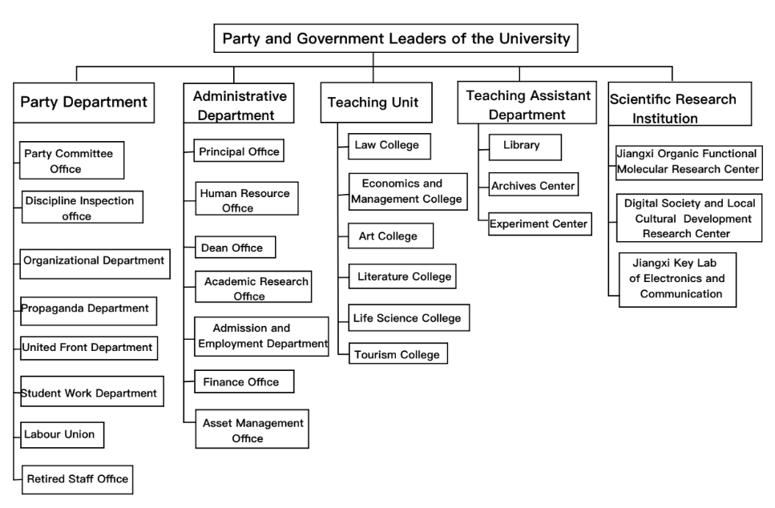
Source: By Author

Although the work of functional structure is also specialized, it is centralized and coordinated by executing superiors, which is relatively dependent on a relatively flat structure (Rothaermel, 2015). The past organizational structure has the following shortcomings:

Waste of Resources
Leaders and subordinates have their own real powers and responsibilities, and they are responsible for all kinds of specific matters of their departments. Each teacher is only responsible for matters related to his own subject or administration. Each department is doing the same administrative work. The major of tourism management and financial management introduced by Jiangxi Science and Technology Normal University already exists in other colleges of this university. If teachers are rearranged according to the previous organizational structure, it is easy to waste the resources of teachers.

Lack of Holistic Concept
Every Department attaches great importance to its own interests, does not care about other departments of the whole organization, and lacks the overall situation and overall concept. In this way, the departments responsible for the Sino-foreign cooperative school-running projects will easily be left out, and the project will not get enough support, and the enthusiasm of the relevant teachers will be affected.

Insufficient Coordination
It is difficult to communicate and coordinate among various functional departments, which increases the workload of senior leaders in coordinating various functional departments. Each functional department can issue orders to the lower departments. If the instructions are not uniform, the lower departments will be at a loss (Shen and Shen, 2004). If the situation of coordination and chaos continues, it will affect the development of the project, and the quality of teaching will inevitably decline.

3.2 Transformed Organizational Structure
Matrix structure improves the information processing capability of an organization by building new information to complement existing structures (Joyce, 1986). With the emergence of new problems, every era of management will develop a new form of organization, a rectangular structure can make up for the shortcomings of the original organizational structure (Galbraith, 1971). After introducing Sino-foreign cooperation projects, Jiangxi Normal University of Science and Technology has changed its organizational structure in the past. Organizations now adopt a matrix organizational structure in some areas, mobilizes cooperation among colleges, and optimizes resources. Nowadays, many private or public organizations, in order to meet the complexity of the environment, are turning their organizational structure into a complex matrix. However, in order to achieve the success of matrix organization, we need to consider three factors: first, we must have a strong purpose and reason to choose the matrix organization structure; second, we must grasp the unexpected events, such as information technology, incentives and so on. Finally, the matrix structure needs to be processed at each connection (Burton, Obel and Håkonsson, 2015). Considering the above factors comprehensively, we can give full play to the optimum organizational structure.
Matrix structures are very general because managers can use different functional areas along vertical and horizontal axes (Rothaermel, 2015). On the basis of the original vertical system, the University also establishes a horizontal system, which combines the two to form a new matrix structure. It strengthens collaboration between departments and organizations, and combines vertical and horizontal linkages. It is a form of organizational structure that emphasizes both division of labor and cooperation (Shen and Shen, 2004). It is characterized by problem solving as the goal, task and work as the center, and information exchange between organizations is mainly horizontal, supplemented by vertical. This form is very common in universities, especially in interdisciplinary and inter-unit research projects.
Figure 4: Matrix Organizational Structure of Institute of International Education
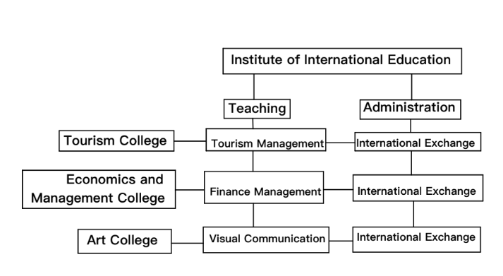
Source: By Author
The Sino-foreign cooperative project is mainly under the responsibility of the Institute of International Education, which is a newly-added college specializing in various international cooperation projects, including financial management, tourism management, early childhood education with Columbia University and New York Film Academy. Major in visual communication. There are full-time administrative officers and teachers in the college. But the setting of teaching posts is coordinated by schools and colleges. It is a matrix structure centered on teaching. The changed organizational structure is shown in Figure 4. It is such diversity that flexible teaching matrix ensures the quality of University Sino-foreign cooperation projects and reaches a high level. Teachers come from different colleges, such as Management College, Tourism College, Art College and so on. In this matrix, international exchange also constitutes another matrix. Foreign universities often visit universities, making them closely connected with the outside world and maintaining long-term and pleasant cooperation with cooperative universities.

Conclusion
This paper analyses the implement ability of Sino-foreign cooperative project strategy from seven aspects: strategy, structure, personnel, skills, common value, style and system. Each factor is closely linked to prepare for the change of strategy. The organizational structure adjustment of Jiangxi Science and Technology Normal University is to conform to the strategy of internationalization of university education and ensure its advantages in fierce competition. In the organizational structure, the Institute of International Education has been added to the teaching unit, which is responsible for all international cooperation projects. The administrative department is responsible for maintaining cooperation with the outside world and dealing with daily work. In terms of teaching, teachers from different colleges are assigned to teach, which optimizes the educational resources. The university centers on Sino-foreign cooperation projects and combines them vertically and horizontally to form a rectangular organization with a division of labor and cooperation.

References
Alshaher, A. A. (2013) ‘The Mckinsey 7S Model Framework for E-Learning System Readiness Assessment’, International Journal of Advances in Engineering & Technology, 6(5), pp. 1948–1966.
Burton, R. M., Obel, B. and Håkonsson, D. D. (2015) ‘How to get the Matrix Organization to Work’, Journal of Organization Design, 4(3), pp. 37–45. doi: 10.7146/jod.22549.
Chen Jing-Xin, and Liu Wei. "Research on Operational Risk Management Framework for Commercial Banks in Internet World - Based on McKinsey 7S Model." 2010 International Conference on Internet Technology and Applications (2010): 1-6. Web
Chi, H. (2018) ‘How to achieve development of chinese-foreign cooperation program’, China Adult Education, 9, pp. 72–74.
Daft, R.L., 1995. Organization Theory and Design, 5th ed. West Publishing Company, St. Paul, MN
Erarslan, A. (2019) ‘Progressive vs modular system in preparatory school English language teaching program: A case of system change at a state university in Turkey’, Journal of Language and Linguistic Studies, 15(1), pp. 83–97. doi: 10.17263/jlls.547624.
Galbraith, J. (1971) ‘Matrix Organization Designs’, Business Horizons, 1, pp. 29–39.
Ganesh, A. (2017) ‘Exploring to Map Competencies with Specific Application of 7S Model’, International Journal on Learship, 5(1), pp. 31–41.
Gao, C. (2018) ‘University’s Organisational learning’, Journal of Changchun Normal University, 37(7). doi: https://doi.org/10.1093/mnras/183.3.341.
Hanafizadeh, Payam & Ravasan, Ahad Zare, (2011), "A McKinsey 7S Model-Based Framework for ERP Readiness Assessment", International Journal of Enterprise Information Systems, 7(4), 23-63.
Huang, F. (2007) ‘Internationalization of higher education in the developing and emerging countries: A focus on transnational higher education in Asia’, Journal of Studies in International Education, 11(3–4), pp. 421–432. doi: 10.1177/1028315307303919.
Jiangxi Science and Technology Normal University (2019) Introduction of University. Available at: http://www.jxstnu.edu.cn/news-show-1.html (Accessed: 10 September 2019).
Joyce, W. F. (1986) ‘Matrix Organization : A Social Experiment’, Academy of Management Journal, 29(3), pp. 536–561.
Kirschenboim, Y. (2018) ‘Rabbi Hirsch values and principles and McKinsey 7 S model. Past and Future in Israeli School Management’, Review of International Comparative Management, 19(3), pp. 306–312.
Lin, J. and Liu, Z. (2007) ‘Importing quality higher education resources through Chinese-foreign cooperation in running schools’, US-China Education Review, 4(3), pp. 1–7.
Ravanfar, M. M. (2015) ‘Analyzing Organizational Structure based on 7s model of McKinsey’, Global Journal of Management and Business Research, 15(10), pp. 7–14. doi: 10.6007/ijarbss/v5-i5/1591.
Rothaermel, F. T. (2015) Strategic Management. 2nd edn. New York: Mc Graw Hill Education.
Shen, X. and Shen, H. (2004) ‘The organizational structure of a research university’, Journal of Northeastern University, 6(4), pp. 290–293.
Shiri, S., Anvari, A. and Soltani, H. (2014) ‘An assessment of readiness factors for implementing ERP based on agility’, International Journal of Management, Accounting and Economics, 1(3), pp. 229–246. Available at: www.ijmae.com.
Wanger, S. P. and Sornlertlumvanich, K. (2012) ‘Leading Educational Change in Thailand: Implementing National Public Policy in a Multi-Campus University System’, Journal of Higher Education Theory and Practice, 12(1), pp. 11–19.
Wen, H. (2015) ‘Construction of Internal Quality Assurance System for Sino-foreign Cooperative Projects’, Journal of Inner Mongolia Radio & TV University, 3, pp. 335–340. Available at: http://www.math.bas.bg/smb/2015_PK/tom_2015/pdf/335-340.pdf.

