

Postgraduate/Distance Learning
Assignment coversheet & feedback form

THIS SHEET MUST BE THE FIRST PAGE OF THE ASSIGNMENT YOU ARE SUBMITTING (DO NOT SEND AS A SEPARATE FILE)

For completion by the student:
Student Name:
Kyle T. Cobb, Jr.
Module code: HPCA7027  Module title:  Cosmology, Magic and Divination | Student ID number:  2317833 |  |  | Educational support needs:  Yes/No  Dyslexia
Module tutor:
Dr Dorian Greenbaum and Dr Dawn Collins

Assignment due date: 29 April 2024
If your module has multiple submissions please indicate which piece of work this is.

1st 2nd X 3rd 4th 5th 6th
I confirm that this is my original work and that I have adhered to the University policy on plagiarism.
Signed ………Kyle T. Cobb, Jr.……………………………
Email submission: if you are submitting this form via email, please tick this box X
(as a substitute for your signature) to confirm that you agree to the above declaration.
Assignment Mark
1st Marker’s Provisional mark
2nd Marker’s/Moderator’s provisional mark
Agreed Internal Mark:

External Examiner’s mark (if relevant)
Final Mark

NB. All marks are provisional until confirmed by the Final Examination Board.

For completion by Marker 1 :
Comments:

Marker’s signature: |  |  | Date:
For completion by Marker 2/Moderator:

Comments:

Marker’s Signature: |  | Date:
AGREED INTERNAL MARK (where necessary):

Comment on process of arriving at agreed mark:

External Examiner’s comments (if relevant)

External Examiner’s Signature: |  | Date:

Analyse the roles of, and relationship between, cosmology and divination in Ancient Mesopotamia
Mesopotamian Prognostication through Divination and Cosmology
By Kyle T. Cobb, Jr.

An evolving order
The tale of Mesopotamia reaches back to before decipherable written words. Yet every day, the potential of greater understanding rises from the ruins of upper Mesopotamian settlements, reaching back into the Neolithic, into the Palaeolithic, and into potentially far earlier epochs. While sites like Tell Qaramel, Jerf el-Ahmar, Çatalhöyük, and settlements of the Göbekli culture may one day give up the secrets of their large and their smalls signs to unlock even a more robust Mesopotamian origin, for now the first decipherable written history stretches back to the city-states like Uruk, Ur, and Lagash. The Sumerian culture, built upon these cities, represents one of the most important of the currently known ancient cultures. It is without refute that the Sumerians sparked innovations and a cultural legacy that spanned millennia.
The greatest achievement of the Sumerian people was the creation of the cuneiform writing system. With samples dating back prior to 3000 BCE, archaic cuneiform served as the alphabet across the Near East for three thousand years. While the direction of the writing, the actual words formed, and possibly the pronunciation changed, cuneiform became the script of diplomats and the cipher of government documents. It is the proliferation and the longevity of this script form that provides a window into the evolution of the Mesopotamian culture’s religious beliefs and methods of prognostication across the millennia.
Thanks to antiquity’s preservation of cuneiform tablets, the understanding of the evolving Mesopotamian worldviews survived in the large library caches such as the 30,000 tablet Library of Ashurbanipal. These great libraries, supplemented with the survival of smaller personal collections, provide a window into the evolution of religion, cosmology, and divination across the Sumerian, Akkadian, Babylonian, and Neo-Assyrian periods in Mesopotamia. Beyond looking at these three areas in philosophical silos, it is possible to see the interplay of these cultural foundations to create a comprehensive, evolving worldview that would later inspire and complement the Hellenistic world, while establishing the foundations for modern astrology.

The greater gods
Before discussing divination, a quick review of the most prominent deities throughout the history of Mesopotamia is in order. Anu, the ruler of the gods as well as the Sumerian sky god, while holding prominence in the Sumerian period, found decreasing favour as a worshipped deity. Along with Enlil, Ninurta, and Marduk, Anu is part of the old order of gods that while respected became less important in daily worship. Šamaš the sun god, and judge of heaven and earth, maintained popularity throughout Mesopotamian history as the protector of humanity and the revealer of oracles, Šamaš’s twin, the moon god Sin, was key in maintaining time, and, as a result, was viewed as a symbol of truth and justice. Adad the storm god, while having no devoted city, gained popularity cross culturally throughout the Mediterranean and the Near East.Aššur, as god of the capital city of the Assyrian empire, enjoyed prominence but not necessarily true devotion.

Messages from the gods
In Mesopotamia, omens were viewed as communications from the gods. Rather than being regarded as extraordinary events, these communications were considered a universal constant readily open to being read by skilled experts, usually reporting to the king. The divine messages, in the form of oblativa and impetrita, formed the basis of the transmissions. While the gods did not often directly speak, they continually sent messages graphically with signs in the heavens, in the parts of animals, in bowls of water and oil, and a variety of other mediums open to the interpretation of the diviner. From an uninitiated perspective, the relationships between the omens, the interpretation, and the recommended abatements may prove obtuse.
By the Old Babylonian period, diviners used oil, birth defects, animal organs, physiognomy, and early forms of astrology for prognostication. As the art of divination matured, observations were recorded in cuneiform and gathered into small collections often based on the identified omens. Some of these early recordings persist as part of the later Akkadian divination series the Šumma ālu.
Fundamentally, divination hinges on the belief that there is a pre-determined possible future that may be altered with the proper placations to the gods. According to the “Diviner's Prayer” included in Old Babylonian diviner’s rituals, Šamaš and Adad are directed by the council of gods to create the hidden dialog allowing humanity an escape from certain fates. Many prayers for guidance are addressed to the duo as well.
While divine messages could exist anywhere, the favoured locations resided in the exta of sacrificed animals extracted by the haruspice. Traditionally, after the sacrificial rituals, the diviner would first examine the liver, followed by the spleen, and conclude with the entrails. By the beginning of the second millennium, organ models began to be used to identify “standardized” zones in the organ for interpretation and reference in the omen texts. Considered as the art of hepatoscopy, directly reading “the tablet of the gods, the liver, a secret of heaven and earth” that Šamaš handed down to Enmeduranki, divination is a natural extension of the sacrificial ritual. Through the offering of the animal, the god is celebrated. In exchange for the observance, portents of the future may be extracted. In the case of a successful divination, the diviner would receive kudos. However, in a divination failure, the diviner could always claim, “Enlil deceitfully changed the fate that he had established.”
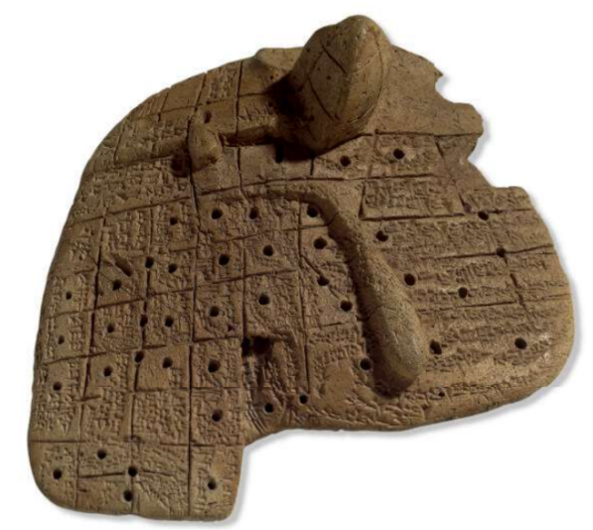
Figure 1 Old Babylonian Liver Tablet BM-92668 (1900 BCE-1600 BCE).
The origin of Sumerian extispicy remains ill-defined. While a few third century possible divination texts may exists, later accounts suggest that celestial divination as well as practical divination began before the Old Babylonian period. While it is likely that existing Sumerian omens are later reconstructions, the existence of early Akkadian terminology supports a contemporary existence. During the reign of Ur-Nanshe, the mid-third millennium BCE king of Lagash, there is suggestion that the high priests were determined by extispicy, however this is based on the titles of participants.
By the Old Babylonian period, diviners had grown integral in the operations of the state bureaucracy where they served in military and diplomatic capacities. Thanks to reports and to bureaucratic documents, it is clear that the bārû served along with magical-medical specialists ensuring the prosperity of the king. Upon receiving his igirtu, he not only practiced extispicy, but also practiced aleuromancy with flour and oil, libanomancy with smoke and incense, and ornithomancy performing divination from the flights of birds. By this point, the extended training and the need to maintain prophecy secrets encouraged hereditary preferences in selection.
While the daily divination records from the Assyrian and the Middle Babylonian periods remain sparse, royal titles imply the operation of working diviners. In sharp contrast, the Neo-Assyrian rulers fully embraced the tradition. Divination was so important to the kings that Ashurbanipal boasted that the gods had taught him extispicy. To bolster his collection of divination knowledge, Ashurbanipal directed the transfer of large caches of scholarly texts from Babylon to Nineveh. Thanks to his dedication to this endeavour, copies of exorcists’ tablets, of omen tablets including the Šumma izbu and the Šumma ālu, of the EAE, as well as dozens of dream omen and extispicy tablets were preserved. From the divination perspective, the most important elements that the Neo-Assyrians safeguarded is the first millennium Bārûtu (the Art of the Seer) extispicy series. The quasi-standardized series features ten sections on exta utilizing one hundred tablets. While only a fraction of the original tablets exists, thanks to tablet number systems on the manuscripts, it is possible to reconstruct the series as new tablets are recovered.
Even though extispicy and other forms of practical divination could use the protasis-apodosis “if-then” format to obtain understanding when simple scenarios arose, fundamentally there was a need to provide the king with a greater scope of knowledge. With hopes of finding insight, the jasper skies and the “wandering sheep” of their stars became the focus of study. The journey would not be an easy one. The ability to predict the movements of celestial bodies would take generations of careful observation, meticulous record keeping, and the expansion, or creation, of mathematics.

The prophesy and the heavens
While scant proof of third-century Sumerian celestial divination and astronomy currently exists, there are indications supporting the emergence of a foundation. While the Sumerian worldview was earth-centred and not concerned with prospicience, later period omen copies utilize Sumerian-Akkadian names for celestial bodies, referencing this period. Scholars speculate that Sumerian foundations for celestial observation possibly manifest in the worship of Nisaba, their goddess of agriculture, of accounting, and of resource management, who was charged with measuring the heaven and the earth with secret calculations. Supporting this idea, Nisaba is presented as the “good woman who consults the stars of heaven,” who carries the "tablet with the stars of the heavens" and keeps a temple in Ereš called the “House of the Stars.” Nisaba’s stellar linkage potentially focuses on the agricultural aspects generated by the synodic calendar.
Though the Akkadian period guards its astronomical advances, by the emergence of Babylon, structured omen texts focusing on lunar eclipses appear. At this point, astrology and astronomy were interwoven disciplines, dependent in mathematical advancements, with only subtle terminological differences. The highly organized eclipse texts, as well as transient celestial objects texts, analyse variables with a consistent organization based on time, magnitude, shadow direction, duration, and date. Based on the quadrants of the moon covered in the shadow and the direction of the movement of the shadow, diviners could make predictions. In later text replications, the basic structure remained but the regional designations could change (e.g., Elam replaces Akkad). Beyond astronomical predictions, stellar references from Babylon appear across the archaeology. Cylinders feature the sun, the moon, and the seven points of the Pleiades. Extispicy diviners invoke the “Prayer to the Gods of Night” to ensure the truth in their results.
Unfortunately, the astrological records from the Middle period are mostly absent. Thanks to reports to the court of Marduk-nadin-ahhe, there is evidence that astrology existed and, at least, examined solar eclipses. In Babylon, deities possess an astral aspect, therefore when a kudurra curse inscription asks, “May the Igigi-gods change his star on the sky, may the Anunna­gods tear away his position on earth,” they are invoking the power of both the god and the celestial realm. Another small evidentiary element is a possible imgiddu tablet on a meteorological event. It is worth noting that many of the proto-forms of future elements in the zodiac emerge during the late Old Babylonian period (see below).
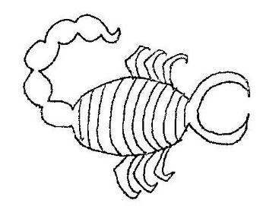 | 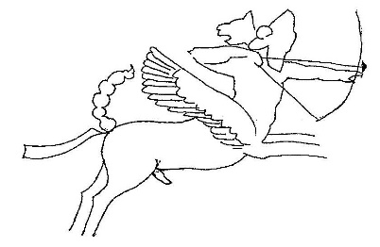
Figure 2 Išara, represented by the scorpion, (mul.gír.tab) becomes Scorpio. | Figure 3 The Lion-horse hybrid creature with wings and bow (mul.pa.bil.sag) becomes Sagittarius.
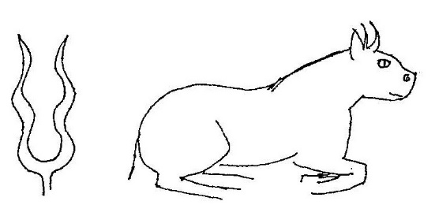 | 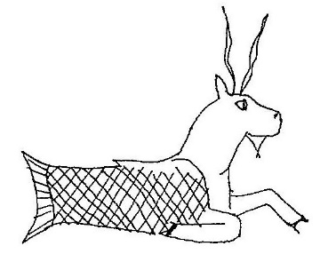
Figure 4 The lightning bundle and the bull (mul.gu4.an.na) become Taurus. | Figure 5 The Goat fish (mul.su ḫur.maš) becomes Capricorn.
The Middle period eclipse texts fall into two primary categories, those that follow the EAE path and the transitional text characterized with protasis defined with logograms. EAE-type texts appear to be the predecessors of tablets such as EAE 15 and 20. Additionally, two Babylonian references to EAE have been identified, a Middle Assyrian tablet with the EAE title in the colophon and a later inclusion in the “Exorcist's Manual” (KAR44) copy dating to 1068-1047 BCE. Thanks to its spreading influence as a cultural centre, outside of Babylon proper there is additional important evidence of astrology’s emergence. Archaeology in Hattusas, the capital of the Hittite Empire, reveals a high percentage of astrological texts in its divinatory collection. Many of these texts are copies of Old Babylonian originals that were replicated circa 1300 BCE. A Hittite translation of a Hattusas copy of EAE focuses on the “treaties and rituals” while “astrological texts receive cursory treatment.”A second Hattusas discovery presents the “Prayer to the Gods of Night,” representing one of the earliest versions of division of the night sky into the paths of Ea, Anu, and Enlil.
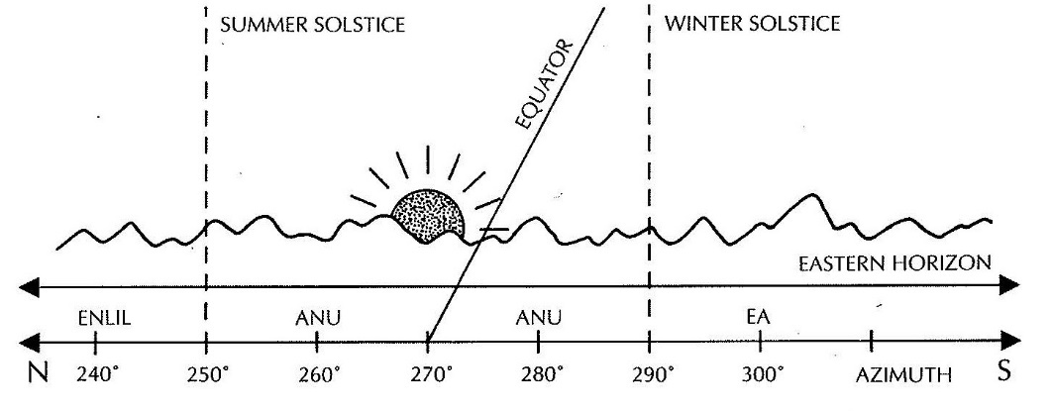
Figure 6 Illustration of the paths of Ea, Anu, and Enlil.
The details of astronomy and of astrology for the leading three hundred years of the First Millennium remains a mystery. This lacuna potentially could reflect a lack of interest in astrology by those Assyrian kings. Fortunately, interest in astronomy and astrology returned with the beginning of the reign of Sargon and ending with the death of Assurbanipal. Between the reigns of these two rulers, documented astrology reached its zenith for classical Mesopotamia. This period established the “canonical” version of EAE as a “required” component of royal libraries.
One of the Neo-Assyrian intrinsic features is a love of the use of writing and the establishment of bureaucracy to manage it. In addition to vast libraries established by kings and by wealthy families, a plethora of astrologic correspondence and scholarship survives. Reports are direct and short, on horizontally oblong u’litu focusing on observations related to EAE or hemerologies. Letters are vertically oblong. The scholastic documents include commentaries on EAE, extraneous prophetic observations, parts of hemerologies, and Iqqur īpuš. From 670 until 669 BCE, the was a notable increase in celestial divination related to an increasing prosperity in the kingdom and the illness of the king.
Under the Sargonid rule, astrology and divination provided a complementary service. Astrologers presented general predictions based on the prescribed formulae and celestial observations. Extispicy allowed clarification and affirmations of specifics. With seeming more importance, court astrologers had the “ear of the king” as part of their role in protecting his interest. Astrologers stationed outside the capital, may have found their messages improperly communicated to the king, after all, “Maybe the scribe who reads to the king did not understand. Summa izbu is difficult!” Since all the astrologers served at the pleasure of the king, even though there were temporal limits applied to royal legitimacy, it was in everyone’s interest to present the king with elements most favourable to maintaining his, and subsequently, their positions. There was an element of competition and fear among astrologers to ensure that their predictions were superior.
As part of the ascension through the ranks of the astrologers, one portion of the learning cycle was the transcription of manuscripts. While the texts were not considered the “words of the gods,” the transcriptions strove to preserve fidelity in the reproduction but allowed for minor corrections. No single version of the texts hold superiority over the others.

Enüma Anu Enlil (EAE)
The “Enüma Anu Enlil” compendium opens with two paragraphs designed to capture the feel of old Sumerian-Babylonian as well as Akkadian.
(From Sumerian]
When An, Enlil and Enki, the great gods, by their decision established the eternal order of heaven and earth and the boat of Suen [Sin], the new moon to wax, to give birth to the month and the sign(?) of heaven and earth, the celestial boat they caused to appear and to come forth in the heavens, to be seen.
[From Akkadian]
When Anu, Enlil and Ea, the great gods, by their decision laid down the design of heaven and earth, and assigned to the great gods their functions, to create the day, to renew the month for mankind to behold, they saw Shamash [Šamaš] in (his) gate, they made him appear regularly in heaven and earth.
With a similar but slightly divergent opening, EAE presents fourteen omnia focusing on general lunar events. Tablets 15 through 22/23 focus on lunar eclipses. Tablets 23/24 through 39/40 deal with solar omnia. Tablets 40 through 49/50 focus on meteorological conditions. The remaining twenty-plus tablets examine the planets and star clusters like the Pleiades. Mukallimtu commentaries accompany the core text to provide explanations, alternative interpretations, and specifications for the protasis. The protasis is then followed with its apodosis. The Šumma Sîn ina tāmartīšu (“If the moon at its appearance…”) is the only mukallimtu granted a title with a serialized commentary. Additional materials, ahû, are extraneous materials designed to extend core text with comments after EAE had been edited. The Great Star list is a series of astronomical tables assembled from other texts.
Some of the EAE tablets are marked as “the one who knows.” Essentially marking the tablet as containing secret information, this “Geheimwissen” formula supposedly restricts access to secret lore and scribal arts. While all astrology was considered the secrets of the gods, certain scholarly elements were more important and, in some cases, legally punishable to disclose. However, the Geheimwissen formula lacks uniformity and seems haphazardly applied.
From a practical perspective, there is a standard methodology in celestial divination. According to Koch-Westenholz, the “crucial phenomena in divination: heliacal and acronycial risings and settings, stationary points, conjunctions and other positions in relation to a particular celestial body, eclipses, colours and other optical phenomena, all derive from actual observation rather than speculation.” Logically, the divination applies a series of opposites (schematization) to approach scenarios (e.g., left-right, front-back, bright-faint, et cetera). The various time factors are considered as well as the “paths of the Ea, Anu, and Enlil” are factored into the equation. The concepts of good and bad in astrology are more fluid than in other forms of divination. When a good portent planet is bright, then the omen is good. When the same planet is dim, then the omen is bad. There seems to be deliberate ambiguity in certain cases to allow the astrologer room for interpretation. With eclipses, the region of the Sun or the moon darkened by the “shadow” can be used to determine the target of the specific omen. Other methodological factors like the time of the event, the direction of the shadow, and the duration of the event also altered the interpretation.
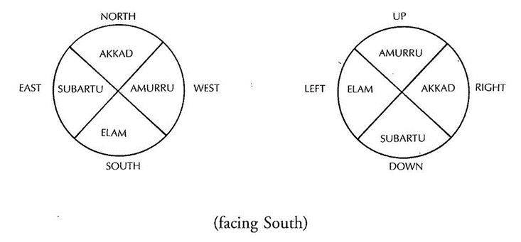
Figure 7 Celestial quadrants as a determination of the target of the divination.

Celestial bodies
While the creation and the re-creation stories of the Mesopotamian realm evolved, their worldview was based on an earth-centric model covered by a revolving jasper sky, adorned with fixed stars. The heavens are composed of three layers. KAR307 discusses the arrangement:
The upper heavens are luludanītu-stone, of Anu. He settled the 300 lgigi therein. The middle heavens are of saggilmut-stone, of the Igigi. Bel sat therein on a lofty dais in a chamber of lapis lazuli, he lit a lamp of elmēšu-stone. The lower heavens are of jasper, of the stars. He drew the constellations of the gods thereon. He made the souls of mankind reside on the terra firma of the upper earth.

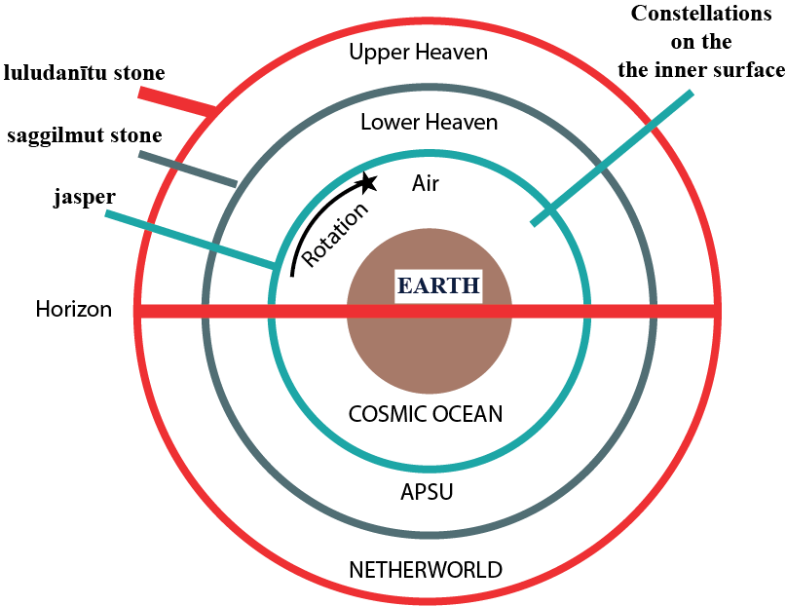
Figure 8 The multi-levelled Mesopotamian Cosmos.
Esharra, the lowest heaven, serves as a ceiling of stars, filling the sky for the earth below. The seven planets (the Sun, the Moon, Saturn, Jupiter, Mars, Venus, and Mercury) moved beneath the fixed stars on the jasper above as likenesses of the gods. Above the mortal sky, each of the two celestial heavens stretches infinitely from one to another, with one level’s floor forming the sky of the below level. The Enūš Eliš tells the story of Marduk creating the world by building the Esharrain, the lower heaven, as a copy of the Apsu, upper heaven. One manuscript of EAE 22 offers an addendum suggesting that Anu, Enlil, and Ea are the celestial architects.
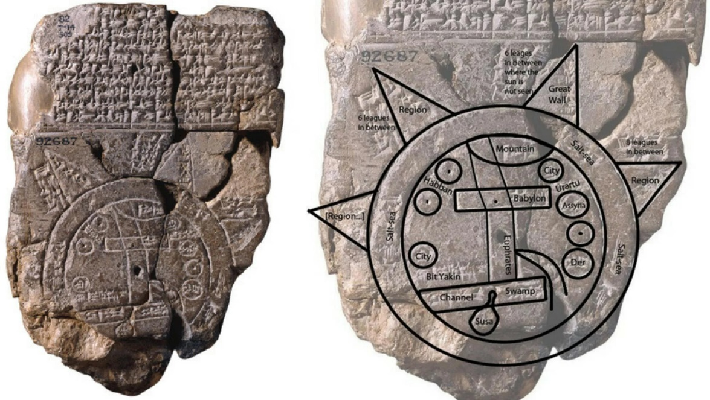
Figure 9 An enhanced version of BM.92687 presents the Imago Mundi showing the human level of existence as the centre circle, surrounded by the Great Salt Sea. Beyond the sea exists mystical lands.

Moon
The sun and the moon lord over the skies like no other celestial bodies. It is only natural that the moon plays a central figure in Neo-Assyrian and Babylonian astronomy. Omens given by the moon are directly declared by the god Sin. For example:
These are the oracles when Sin (i.e., the moon) makes a decision, the great gods of heaven and earth decide the doings of mankind and their […] eclipse, flood, illness, death, the great gallû-demons, Sebettu always block the way in front of Sin.
Even in the Marduk dominated Enūma eliš, Marduk grants Sin the power to give judgment. Additionally, Sin’s association with the decision process prompts the moon’s invocation during haruspicy liver inspection prayers.
The most obvious property of the visible moon is the lunar cycle. The new moon’s first observation marks the beginning of a new month, regardless of the length of the previous month. This first day and the fourth day of the month always are favourable. The day of the moon’s disappearance serves as Sin’s monthly re-birth day.
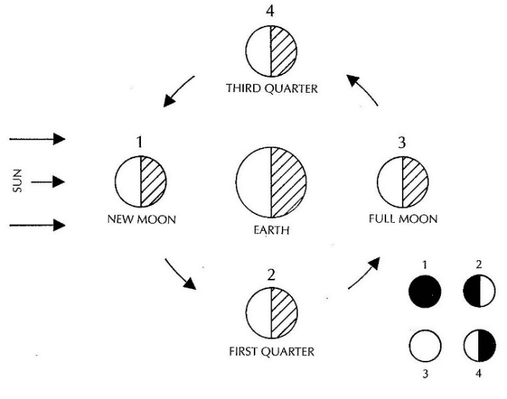
Figure 10 Diagram of lunar cycle.
There are times when the moon can bring bad omens. For example, “If the moon is seen on the 30th day: destruction of Akkad. If the moon is seen on the first day: good luck for Akkad.” If the moon is faint or dusky, or blocked by the clouds these can be bad omens. This is also true if the moon has certain types of halos.
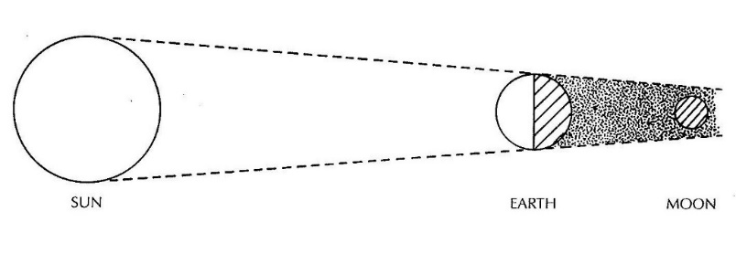
Figure 11 Diagram of lunar eclipse.
As a rule, eclipses function as bad omens. Beginning in the Old Babylonian period, hepatoscopy and lecanomancy forecasted eclipses. The Šumma ālu even mentions the threat. Both solar and lunar eclipses could bring death to a king, danger to his kingdom, or the same to his enemies. The direction of the shadow, or an interloping planet, in the path of the eclipse can be used to interpret who will suffer its wrath (see Figure 7 above). The movement of the shadow across the moon is considered the most important element in interpretation. The hope in the case of a negative omen is that Jupiter is present to cancel the effect. Arguably, he Babylonians never pondered an astronomical cause of the lunar eclipses, instead they believed that the demon messengers of Anu surrounded the moon. The Neo-Assyrian scholars lacked the ability to calculate lunar eclipses, but they were skilled enough to know that the event only occurred during a full moon, with a maximum of one in every sixth synodic months, and between the 13th and 16th day.

Sun
While the Sun lords over the lapis sky, there are very few solar omens other than the solar eclipses covered in EAE. Most mentions of the Sun in EAE utilize Saturn as the nighttime sun surrogate. Solar eclipses are believed to be positive. Just as with the lunar eclipses, the solar eclipse interpretation was based on the perceived coverage of the disc. The twilight rising sun always marks a positive event, marking the “place where fates are determined” as the uncertainty of night is broken.”
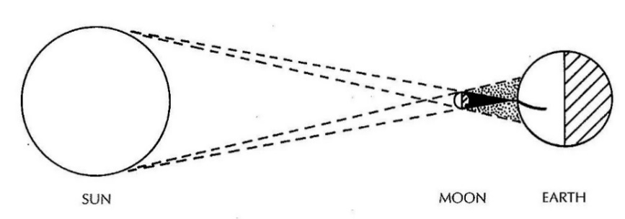
Figure 12 Diagram of solar eclipse.

Jupiter
As the star of Marduk, Jupiter plays a variety of astrological roles. While the standard name for the planet is sag.me.gar (the bearer of signs to the inhabited world), it boasts epithets such as the “Lord of bright rising” or “heroic one.” Traditionally, Jupiter in astrology is the symbol of peace and prosperity. When invoked with Šamaš, Jupiter serves as the “Lord of the secrets of Akkad.” A bright Jupiter brings prosperity to the king and “the angry gods become reconciled with Akkad.” Like many Mesopotamian astrology elements, the direction of Jupiter determines the meaning of the omen (e.g., “Jupiter in the path of Enlil means that the king of Akkad will grow strong [SM 8 54]; in the path of Anu, that the king's son will revolt and usurp the throne”). When Jupiter encounters the moon, other than during an eclipse, the omens may predict a king’s death or hardship for the kingdom. The negative consequences can be averted, with luck, if the bīt rimki is performed or the substitute king is sacrificed.

Saturn
From an astrological perspective, Saturn’s proper name is (udu.idim).sag.uš (the steady), Occasionally, it also appears with references as being the night’s sun, ^{d}utu, or the star of the sun. Saturn is strongly associated in divination geographically with Akkad and Amurru. This planet also represents the king, especially as it concerns the will of Šamaš, as the embodiment of truth and justice. As a substitute for the Sun supporting the halo of the moon on the 14th, Saturn mitigates the negative omen from the preceding day. It is worth noting that by the second half of the first millennium, Saturn, the “dark star,” had lost favour in Hellenistic divination and astrology, where it joined Mars as being considered “malefic.”

Venus
As the brightest of the wandering “stars,” Venus consumes four EAE tablets. The proper name of Venus is ^{d/mul}dil-bat as well as Ishtar. The role of Ishtar as an astral figure, as well as part of the “celestial triad” with Šamaš and Sin, is presented in tablet 16 of the utukku Lemnūtu where Enlil installs the three in the šupuk šamê to rule with Anu. The triad becomes a common motif on period kudurra. Observations of Venus form the earliest EAE inclusions. As a result of these careful studies, the eight-year Venusian cycle obtained accuracy by the seventh century.
A sighting of Venus is most often positive. The location in the path determines which region received favour, often with the grace of rain and fertility. Conversely, sightings of Venus with other wandering stars suggests a bad omen, indicating the possibility of war or issues for the king.

Mercury
Mercury, identified with the deities Ninurta and Nabû, is known as the “jumping one.” Because of its speed, Mercury earned frequent mention as one of the celestial “wild sheep” in the Great Star List. The “wild sheep” are the “six gods who have the same positions, who touch the stars of the sky and keep changing their positions.” As a princely star, Mercury provides good omens for princes but depending on the observations can warn of insurrection by a prince. Mercury heralds rain and, at times, brings with it floods. By the Neo-Assyrian period, the initial stages of Mercurial observations had begun but the predictions lacked accuracy.

Mars
Possibly because of its bloodlike colour, Mars, linked to Nergal, is a treacherous omen and consider the bringer of evil. While its regular name was salbatānu, it earned the monikers of “the fox star,” “the wolf star,” “different” (i.e., hostile), “enemy,” “liar,” “evil,” and “strange.” Malevolent associations stretch back to Old Babylonian omen texts forecasting the death of cattle. Martian astronomical observation interpretations evaluate, among other factors, the intensity. When Mars is brightest, evil is afoot, and strife is at hand. When Mars is dull, there is opportunity for prosperity.

The Fixed Stars
Star constellations including the Pleiades, Scorpio, Cancer, and Leo received tablets dedicated to them in EAE. The linkage of individual stars into constellations was a definitive innovation in Babylonian astrology. While omen texts speak of constellations reaching to each other, these most likely refer to planets associated with the constellations. Most constellation omens mentioning colour possibly reference the colour of the planet moving through the constellation. The Pleiades constellation, in addition to receiving its own Akkadian shuilla-prayers, assumed a special status beyond astrology, undertaking the context of war with its linkage to the Sebitti, a group of minor war gods.
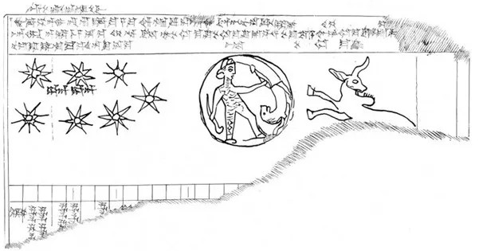
Figure 13 Hellenistic cuneiform tablet from Uruk with Pleiades, the moon, and Taurus.
Although the later period zodiac did not exist in the Neo-Assyrian empire, the tracking of the planets within named constellations had already emerged as a practice (for a constellation list, see the appendix). Omen tables recounted the effects of the entry or exit of a planet from a constellation. While much of the difficult work of tracking the movements of celestial bodies daily over centuries may not have survived, what is clear is that, by fifth century BCE, the division of the ecliptic into twelve 30° sections, with twelve subsegments, had been standardized by diviners. While the names and symbols of some of the twelve divisions would transform over time, the fundamentals of the modern zodiac and of modern astrology had been created. Babylonian astrologers used the terms bīt nişirti or ašar nişirti to refer to a “safe/secret place” where a planet had the greatest impact. The following table compares ašar nişirti to the Hellenistic concept.
 | ašar nişirti: | Hypsoma: | Calendric event:
sun: | Aries | Aries | - Spring equinox
moon: | Pleiades | Taurus | - Intercalation
Jupiter: | Cancer | Cancer | - Summer solstice
Venus: | Pisces/Leo | Pisces | - Precursor of spring
Saturn: | Libra | Libra | - Fall equinox
Mercury: | Virgo | Virgo | - Precursor of fall
Mars: | Capricorn | Capricorn | - Winter solstice

The Persian and Seleucid periods brought a radical change to the concepts of astronomy and astrology. Thanks to extensive celestial observations, as well as the expansion of mathematical principles, celestial motions could be calculated. This changed the understanding of celestial divination fundamentally, dismantling the belief that the gods communicated through willed celestial manipulation. Conceptually, this idea was supplanted by the belief that the location of celestial objects impacted individual fate by their presence during life events beginning with their birth. While the old texts continued to be copied, their significance was marginal.

Conclusion
Although the story of Mesopotamia may have begun in distant antiquity, the impact on the evolution of world religions never ended. While the practice of extispicy may have faded, the study of the various organs certainly lay the foundations for later biological science. Those early astronomer-astrologers recording the movements of the planets and the stars, lay the foundations of the understanding that would eventually deliver humanity into space. Even thousands of years later, there remain remnants of the symbology from Babylonia Kudurrus which millions of individuals use to self-identify with their birth. While the messages of the old gods hidden in entrails and rising smoke on earth may go unread, their legacy remains one of the cornerstones of modern civilization.

Appendix

Mesopotamian names for modern zodiac constellations
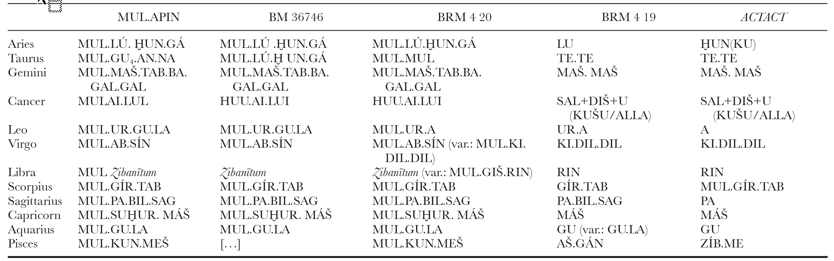

Bibliography
ABUSCH, T., 2018. The Form and History of a Babylonian Prayer to Nabû. In: C.J. CRISOSTOMO, E.A. ESCOBAR, T. TANAKA, N. VELDHUIS, and F. ROCHBERG, eds, The scaffolding of our thoughts : essays on Assyriology and the history of science in honor of Francesca Rochberg. Leiden: Brill, pp. 169-182.
ALSTER, B., 1976. On the Earliest Sumerian Literary Tradition. Journal of cuneiform studies, 28(2), pp. 109-126.
ALSTOLA, T., ZAIA, S., SAHALA, A., JAUHIAINEN, H., SVÄRD, S. and LINDÉN, K., 2019. Aššur and His Friends: A Statistical Analysis of Neo-Assyrian Texts. Journal of cuneiform studies, 71(1), pp. 159-180.
ARBØLL, T.P., 2021. Kiṣir-Aššur’s mašmaššu-phase. Medicine in Ancient Assur. Brill, pp. 124-152.
ARCHAEOLOGIST EDITOR GROUP, 2022-last update, Imago Mundi: The Oldest Known Map. Available: https://www.thearchaeologist.org/blog/imago-mundi-the-oldest-known-map [Apr 27, 2024].
ATKINSON, J.S., 2015. Prophecy in Mari, Neo-Assyrian, and Hebrew sources: a comparative study, The University of Edinburgh.
BAHRANI, Z., 2008. Rituals of war the body and violence in Mesopotamia. New York: Zone Books.
BEERDEN, K., 2013. Chapter 7- Time and Divination-Divination and Time. BRILL, pp. 171-193.
BEN-DOV, J., 2008. The Astronomical Book and Babylonian Astronomy: Mul.Apin And EAE. Head of All Years. BRILL, pp. 153-196.
BOTTÉRO, J., 1992. Mesopotamia: Writing, Reasoning, and the Gods. Chicago, IL: University of Chicago Press.
BRACK-BERNSEN, L., 2007. The 360-Day Year in Mesopotamia. In: J.M. STEELE, ed, Calendars and Years. Oxbow Books, pp. 83-100.
BRACK-BERNSEN, L., 2020. Babylonian astronomy: a new understanding of column Φ: Schematic astronomy, old prediction rules, riddles, loose ends, and new ideas. Archive for History of Exact Sciences, 74(6), pp. 605-640.
BRITISH MUSEUM, Liver Tablet BM-92668. Available: https://www.britishmuseum.org/collection/object/W_1889-0426-238 [Apr 25, 2024].
BROWN, D., 2006. Astral Divination in the Context of Mesopotamian Divination, Medicine, Religion, Magic, Society, and Scholarship. East Asian Science, Technology, and Medicine, (25), pp. 69-126.
BROWN, D., 2000. Mesopotamian Planetary Astronomy-Astrology. Leiden: BRILL.
CAPLICE, R., 1970. Namburbi Texts in the British Museum IV. Orientalia, 39(1), pp. 111-151.
ÇELIK, B., 2011. Karahan Tepe; a new cultural centre in the Urfa area in Turkey. Documenta Praehistorica, XXXVIII, pp. 241-253.
CHASE, P.G., 1991. Symbols and paleolithic artifacts: Style, standardization, and the imposition of arbitrary form. Journal of Anthropological Archaeology, 10(3), pp. 193-214.
COLLINS, D., 2008. Mapping the Entrails: The Practice of Greek Hepatoscopy. American journal of philology, 129(3), pp. 319-345.
COOLEY, J., 2008. Early Mesopotamian Astral Science and Divination in the Myth of Inana And Šukaletuda. Journal of ancient Near Eastern religions, 8(1), pp. 75-98.
DE ZORZI, N., 2017. Teratomancy at Tigunānum: Structure, Hermeneutics, and Weltanschauung of a Northern Mesopotamian Omen Corpus. Journal of Cuneiform Studies, 69, pp. 125-150.
ELLIS, M.D.J., 1989. Observations on Mesopotamian Oracles and Prophetic Texts: Literary and Historiographic Considerations. Journal of Cuneiform Studies, 41(2), pp. 127-186.
FERRY, D. and MORAN, W.L., 1990. Prayer to the Gods of the Night. Arion: A Journal of Humanities and the Classics, 1(1), pp. 186.
FINCKE, J.C., 2007. Omina, die göttlichen "Gesetze" der Divination. Journal of the Ancient Near Eastern Society "Ex Oriente Lux", 40.
FINKEL, I.L., 1988. Adad-apla-iddina, Esagil-kin-apli, and the series SA.GIG. In: E. LIECHTY, M.D.J. ELLIS, P. GERARDI and O. GINGERICH, eds, A scientific humanist: studies in memory of Abraham Sachs. Philadelphia: University Museum, University of Pennsylvania, pp. 143-159.
FRAHM, E., 2013. Rising Suns and Falling Stars: Assyrian Kings and the Cosmos. In: J.A. HILL, P. JONES, and A.J. MORALES, eds, Experiencing Power, Generating Authority. University of Pennsylvania Museum of Archaeology and Anthropology, pp. 97-120.
GELLER, M.J. and GEUS, K., 2014. Esoteric Knowledge in Antiquity- Some Thoughts. Esoteric Knowledge in Antiquity. Berlin: Max-Planck-Institut für Wissenschaftsgeschichte, pp. 3-6.
GEORGE, A. and LAMBERT, W.G., 2013. Babylonian Divinatory Texts Chiefly in the Schøyen Collection. CDL Press.
HALLO, W.W., 1970. The Cultic Setting of Sumerian Poetry. In: A. FINET, ed, Actes de la XVIIe Rencontre assyriologique internationale : Université libre de Bruxelles, 30 juin-4 juillet 1969. Bruxelles, Belgium: Ham-sur-Heure, pp. 117-134.
HINKE, W.J., 1907. A new boundary stone of Nebuchadrezzar I from Nippur. Philadelphia: University of Philadelphia.
HOOKE, S.H., 1955. Omens. Ancient and Modern. Folklore, 66(3), pp. 330-339.
HOROWITZ, W., 1990. Two Notes on Etana's Flight to Heaven. Orientalia, 59(4), pp. 511-517.
HOROWITZ, W. and WASSERMAN, N., 1996. Another Old Babylonian Prayer to the Gods of the Night. Journal of Cuneiform Studies, 48, pp. 57-60.
HULL, K.M., 2020. Divination as Translation: The Function of Sacred Stones in Ancient Mesopotamia and the Book of Ether. In: D.L. BELNAP, ed, Illuminating the Jaredite Records. Salt Lake City, UT: Religious Studies Center/Deseret Book Co, pp. 43-83.
HUNGER, H., PARPOLA, S. and READE, J., 1992. Astrological reports to Assyrian kings. Vol.8. Helsinki: Helsinki University Press.
HUNGER, H. and PINGREE, D., 1999. Astral sciences in Mesopotamia. Leiden: Brill.
HUNGER, H. and STEELE, J.M., 2018. The Babylonian Astronomical Compendium MUL.APIN. 1 edn. London: Routledge.
HUXLEY, M., 1997. The Shape of the Cosmos According to Cuneiform Sources. Journal of the Royal Asiatic Society, 7(2), pp. 189-198.
JIMÉNEZ, E., 2014. New Fragments of Gilgames and Other Literary Texts from Kuyunjik. Iraq, 76, pp. 99-121.
KILIÇ, Y., 2019. Göbekli Tepe D Tapınağı Dikilitaş Betimlemeleri ile Sümer Mit Anlatıları Arasındaki Benzerlikler. In: A.M. AGIR and A. OZTURHAN, eds, Doç. Dr. Samira Kortantamer Armağanı. Istanbul: Cizgi, pp. 357-376.
KOCH, U., SCHAPER, J., FISCHER, S. and WEGELIN, M., 1990. Eine neue Interpretation der Kudurru-Symbole. Archive for History of Exact Sciences, 41(2), pp. 93-114.
KOCH, U.S., 2010. Three Strikes and You Are Out! A View on Cognitive Theory and the First-Millennium Extispicy Ritual. In: A. ANNUS, ed, Divination and Interpretation of Signs in The Ancient World. Ann Arboir, MI: Edward Brothers, pp. 43-60.
KOCH, U., 2018. Converging Fortunes—Links between Celestial and Intestinal Divination. In: C.J. CRISOSTOMO, E.A. ESCOBAR, T. TANAKA, N. VELDHUIS, and F. ROCHBERG, eds, The scaffolding of our thoughts : essays on Assyriology and the history of science in honor of Francesca Rochberg. Leiden: Brill, pp. 120-147.
KOCH-WESTENHOLZ, U., 1999. The Astrological Commentary Šumma Sîn ina tāmartīšu Tablet 1. Res Orientales, 12, pp. 149-165.
KOCH-WESTENHOLZ, U.S., 2000. Babylonian Liver Omens: The Chapters Manzāzu, Padānu and Pān Tākalti of the Babylonian Extispicy Series Mainly from Aššurbanipal's Library. Museum Tusculanum Press.
KOCH-WESTENHOLZ, U.S., 1995. Mesopotamian astrology: an introduction to Babylonian and Assyrian celestial divination. Copenhagen: Museum Tusculanum Press.
LAMBERT, W.G., 1998. The Qualifications of Babylonian Diviners. In: S.M. MAUL and R. BORGER, eds, Festschrift für Rykle Borger zu seinem 65. Geburtstag am 24. Mai 1994 : tikip santakki mala bašmu-- / herausgegeben von Stefan M. Maul. Leiden, The Netherlands: Brill, pp. 141-158.
LANGE, A., 2007. Greek Seers and Israelite-Jewish Prophets. Vetus Testamentum, 57(4), pp. 461-482.
LAUINGER, J., 2016. Iqqur īpuš at Tell Tayinat. Journal of Cuneiform Studies, 68, pp. 229-248.
LENZI, A., 2011. Reading Akkadian Prayers & Hymns: An introduction. Atlanta: Society of Biblical Literature.
LENZI, A., 2008. Secrecy and the Gods: Secret Knowledge in Ancient Mesopotamia and Biblical Israel. Helsinki: Neo-Assyrian Text Corpus Project.
LIVINGSTONE, A., 2020-last update, State Archives of Assyria Online Corpus- KAR 307 [Homepage of University of Pennsylvania], [Online]. Available: https://oracc.museum.upenn.edu/saao/corpus [Apr 26, 2024].
MICHALOWSKI, P., 2005. How to Read the Liver—In Sumerian. In: M.W. WATERS, S. TINNEY, L. SASSMANNSHAUSEN, A.J. FERRARA, M. RUTZ, S. FREEDMAN, M. ELLIS and A.K. GUINAN, eds, If a Man Builds a Joyful House, Assyriological Studies. The Netherlands: BRILL.
MONROE, M.W., 2019. Mesopotamian Astrology. Religion Compass, 13(6).
MORENZ, L.D., 2014. Medienevolution und die Gewinnung neuer Denkräume: Das frühneolithische Zeichensystem 10./9. Jt. v.Chr.- und seine Folgen. Berlin: Hubert & Co.
NOEGEL, S.B., 2007. Nocturnal Ciphers: The Allusive Language of Dreams in the Ancient Near East. American Oriental Society.
OPPENHEIM, A.L. and REINER, E., 1974. Ancient Mesopotamia: Portrait of a Dead Civilization. 1977 Revised edn. Chicago: University of Chicago Press.
PARPOLA, S. and ASHURBANIPAL, 2007. Letters from Assyrian Scholars to the Kings Esarhaddon and Ashurbanipal Part II: Commentary and Appendix. Eisenbrauns.
PINGREE, I., STEELE, J.M., BURNETT, C., PINGREE DAVID and REINER, E., 2014. Pathways into the Study of Ancient Sciences. Transactions of the American Philosophical Society, 104(3), pp. i-503.
PODANY, A.H., 2022. Kings and Subjects. In: A.H. PODANY, ed, Weavers, Scribes, and Kings: A New History of the Ancient Near East. Oxford, UK: Oxford University Press.
POLONSKY, J., 2005. The Mesopotamian Conceptualization of Birth. In: M.W. WATERS, S. TINNEY, L. SASSMANNSHAUSEN, A.J. FERRARA, M. RUTZ, S. FREEDMAN, M. ELLIS and A.K. GUINAN, eds, If a Man Builds a Joyful House, Assyriological Studies. The Netherlands: BRILL, pp. 297-311.
PRICE, I.M., 1910. The Cult of the Moon-God, Sin. The American Journal of Semitic Languages, 26(2), pp. 309-311.
RETIEF, F.P. and CILLIERS, L., 2007. Mesopotamian medicine. South African medical journal, 97(1), pp. 27-30.
RICHARDSON, S., 2010. On Seeing and Believing: Liver Divination and the Era of Warring States. CHICAGO: Oriental Institute of the University of Chicago.
ROCHBERG, F., 2010. The Heavens and The Gods in Ancient Mesopotamia: The View from A Polytheistic Cosmology. In the Path of the Moon. United States: BRILL, pp. 317-338.
ROCHBERG, F., 2018. Science and Ancient Mesopotamia. pp. 7-28.
ROCHBERG, F., 2010a. In the Path of the Moon: Babylonian Celestial Divination and Its Legacy. 1 edn. Boston: BRILL.
ROCHBERG, F., 2010b. Scribes and Scholars: The tupšar Enuma Anu, Enlil. In the Path of the Moon: Babylonian Celestial Divination and Its Legacy. 1 edn. Leiden, The Netherlands: Brill, pp. 238-256.
ROCHBERG, F., 2004. The Heavenly Writing: Divination, Horoscopy, and Astronomy in Mesopotamian Culture. Cambridge UK: Cambridge University Press.
RUTZ, M., 2013. Bodies of Knowledge in Ancient Mesopotamia: The Diviners of Late Bronze Age Emar and Their Tablet Collection. 1 edn. Boston: BRILL.
RUTZ, M., 2018. A Late Babylonian Compilation Concerning Ritual Timing and Materia Medica. In: C.J. CRISOSTOMO, E.A. ESCOBAR, T. TANAKA, N. VELDHUIS, and F. ROCHBERG, eds, The scaffolding of our thoughts : essays on Assyriology and the history of science in honor of Francesca Rochberg. Leiden: Brill, pp. 97-112.
SCHMIDT, K., 2007. Göbekli Tepe En Eski Tapınağı Yapanlar. İstanbul: ARKEOLOJİ VE SANAT YAYINLARI.
SCHMIDT, K. and SCHMIDT, Ç, 2014. Like a Carpet of Snakes – Towards an Iconography of the PPN in Upper Mesopotamia. In: B. FINLAYSON and C. MAKAREWICZ, eds, Settlement, Survey, and Stone: Essays on Near Eastern Prehistory in Honour of Gary Rollefson. Berlin: ex oriente, pp. 73-77.
SCHREIBER, M., 2019. Late Babylonian astrological physiognomy. In: JOHNSON, ed, Visualizing the invisible with the human body. Berlin/Boston: De Gruyter, pp. 119-142.
SNELL, D., 2005. A Companion to the Ancient Near East. Oxford: Blackwell.
STARR, I., ARO, J., PARPOLA, S. and READE, J., 1990. Queries to the Sungod: divination and politics in Sargonid Assyria. Helsinki, Finland: Helsinki University Press.
STEELE, J. and GANGULI, S., 2022. Babylonian records of transient astronomical phenomena. Astronomische Nachrichten, 343(6-7).
STEELE, J.M., 2015. A Late Babylonian Compendium of Calendrical and Stellar Astrology. Journal of cuneiform studies, 67(1), pp. 187-215.
STEINERT, U., 2018. Catalogues, Texts and Specialists: Some Thoughts on the Assur Medical Catalogue, Mesopotamian Medical Texts and Healing Professions. In: U. STEINERT, ed, Assyrian and Babylonian Scholarly Text Catalogues. 1 edn. De Gruyter, pp. 158-200.
TAYLOR, J., 2018-last update, A library fit for a king. Available: https://www.britishmuseum.org/blog/library-fit-king [21 October, 2023].
THAVAPALAN, S., 2020. The meaning of color in ancient Mesopotamia. Leiden Boston: BRILL.
THOMPSON, R.C., 1937. Assyrian Prescriptions for the Head (Concluded). The American Journal of Semitic Languages and Literatures, 54(1), pp. 12-40.
ULANOWSKI, K., 2021. The neo-Assyrian and Greek divination in war. Volume 3, Ancient warfare. Leiden: Brill.
VASKO, R., 2020. Cuneiform System of Writing as Ancient Civilizations Value. In: C. WOODS, ed, Language. Culture. Discourse. Kharkiv, Ukraine: РС Тесhnology Сеntеr-Wiley Online Library, pp. 52-67.
VELDHUIS, N., 1995. On Interpreting Mesopotamian Namburbi Rituals. Archiv für Orientforschung, 42/43, pp. 145-154.
WEE, J.Z., 2014. Lugalbanda Under the Night Sky: Scenes of Celestial Healing in Ancient Mesopotamia. Journal of Near Eastern Studies, 73(1), pp. 23-42.
WEISBERG, D.B., 1969. An Old Babylonian Forerunner to Summa Alu. Hebrew Union College Annual, 40/41, pp. 87-104.
WINITZER, A., 2011. Writing And Mesopotamian Divination: The Case of Alternative Interpretation. Journal of cuneiform studies, 63(1), pp. 77-94.
WORTHINGTON, M., 2004. Planets, Livers and Omens in Mesopotamia. Early Science and Medicine, 9(2), pp. 136-143.

Abbreviations: EAE will be used as an abbreviation for “Enüma Anu Enlil” compendium. All dates specified in this paper, unless otherwise noted, refer to Before the Common Era, BCE.
Note: The term “Near East” will be used throughout in this document rather than the more common term “Middle East” based on Snell’s assertion that the term “Middle East” is “Eurocentric .” (Snell 2005, xviii)
Kılıç (2019, 357-376) argues that elements from the Göbekli Tepe pillars may be linked to the story of Inanna 𒈹 and of her husband Dumuzid 𒌉𒍣 based on the “H” small sign as a marriage representation.
Schmidt 2007, p. 149, 161-164, 230, 267-268. Schmidt, Schmidt 2014, p. 76. Chase 1991, p. 193-214. Morenz 2014, p. 26.
Vasko 2020, 61-62.
Vasko 2020, 60.
Taylor 2018.
Oppenheim, Reiner 1974, 194-195.
Šamaš is Utu in Sumerian.
Oppenheim, Reiner 1974, 195-196.
Frahm 2013, 101.
Oppenheim, Reiner 1974, 196.
Oppenheim, Reiner 1974, 196. Alstola and colleagues (2019, p. 162-166) note that while Aššur was the official Assyrian god, traditional gods like “Sîn, Marduk, Šamaš, and Ištar” continued being mentioned more in the extant texts.
Rochberg 2004, 48. It is important to note that by the Persian and Seleucid periods, the concept of willed celestial manipulation by the deities had been superseded. (Koch-Westenholz 1995, 51)
Parpola 2007, 6.
Oblativa are omens requiring no human interaction to initiate such as celestial movements. Impetrita are direct human actions for divination such as examining the liver of a sacrificed lamb (extispicy).
Hunger, Parpola et al. 1992, xiii. George, Lambert 2013, xv. Starr, Aro et al. 1990, xxxii. Lange 2007, 463. Ulanowski 2021, 169.
Bottéro 1992, 106. Hooke 1955, 332. Snell 2005, 321. Hull 2020, 52. Ulanowski 2021, 36. Koch 2010. 48.
The protasis is the identified omen. The apodosis acts as the diviner’s interpretation. Therefore, the protasis is the clause expressing the contention (e.g., “If x then…”). The apodosis is the result of the condition. So, combined, “If x then y.” (Rochberg 2010a, 399-409)
Weisberg 1969, 101-102.
George, Lambert 2013, xv-xvi. Weisberg 1969, 102. de Zorzi 2017, 125-146.
Oppenheim 1974, 216. Weisberg 1969, 102.
Weisberg 1969, 104. Atkinson 2015, 102.
Brown 2000, 138. Ulanowski 2021, 77. Brown 2006, 98, 108. Veldhuis (1995, 147) explains that on a personal level, bad fate was the result of sin against a personal god.
Ellis 1989, 139,171. Monroe 2019, 1. Rochberg 2018, 13. Rochberg (2010b, 242) finds it ironic that while the key diviners’ series is named EAE, that Šamaš and Adad present the secrets to the sage Enmeduranki, who then passes the secrets to “the men of Nippur, Sippar, and Babylon.”
Ellis 1989, 171. Oppenheim, Reiner 1974, 212, 217, 219. Rochberg 2010a, 75, 217-218. Ellis (1989, 171) notes that Assyrian requests are made to Šamaš, omitting Adad. Bahrani (2008, 185) and Fincke (2007, 139) reenforce this with examples.
Exta is the archaic term for internal organs.
Extispicy is the examination of the internal organs for omens. Snell 2005, 352. Ulanowski 2021, 36-37.
Collins 2008, 320.
Rutz 2013, 227-229.
ṭuppi ilī tākalta pirišti šamê u erṣeti
Jiménez 2014, 108. Lambert 1998, 148-149. Fincke 2007, 147. Ulanowski 2021, 53-54.
Ulanowski 2021, 37-38.
Michalowski 2005, 256.
British Museum, BM-92668. Photo © The Trustees of the British Museum.
Ulanowski 2021, 41. Cooley 2008, 88. Koch-Westenholz 1995, 34. Alster (1976, 115) reports that the 1963/1965 Tell Abū Ṣalābīkh excavations uncovered out of context liver omen fragments linked to the Ur III period.
Rutz 2013, 220. Ulanowski 2021, 41. Richardson 2010, 238. Michalowski 2005, 247.
máš.e pà
Richardson, 2010, 227. Podany 2022, 70.
Strictly speaking, bārû is the term for a diviner and while bārûtu is the name of the diviner series “the Art of the Seer.” Assyriologist use this term interchangeably in their work.
Lenzi 2008, 8. Ulanowski 2021, 91. Rochberg 2004, 49. Finkel 1988, 143–159.
An igirtu is a kind of certification. (Lenzi 2008, 79) (Ulanowski 2021, 96)
Noegel 2007, 32-34. Ulanowski 2021, 93. Bottéro 1992, 34. Weisberg 1969, 87-88.
Beerden 2013, 79–80. Ulanowski 2021, 102-103.
Ulanowski 2021, 77.
Koch-Westenholz 2000, 29. Ulanowski 2021, 96.
āšipūtu
Steinert 2018, 164.
Steinert 2018, 170-171. Winitzer 2011, 77-79.
Koch-Westenholz 1995, 58. Rochberg 2010a, 326.
Çelik ( 2011, 250) notes the discover of tally marks at Karahan Tepe that suggest counting.
Koch-Westenholz 1995, 33.
Koch-Westenholz 1995, 34.
Alster 1976, 117.Koch-Westenholz 1995, 32-33.
dub mul-an-kù
Alster 1976, 117, 119. Alster considers the tablet to be a symbol of the sky. Koch-Westenholz 1995, 32-33.
é-mul-mul
Alster 1976, 119. Alster cites a house of Nisaba referenced by Hallow as “the House of Wisdom” (Hallo 1970, 116-36, lines 29-31).
Koch-Westenholz 1995, 33. Koch-Westenholz notes that Nisaba is paired with Suen (Sin) in counting the days.
Koch-Westenholz 1995, 36-37. Koch-Westenholz, citing (Rochberg-Halton 1988, 7), suggests that these texts may form the core of the EAE texts.
Steele and Ganguli (2022) present a fascinating look at transient objects such as Halley’s comet, complete with examples of observation records. While the possible dates of the lunar eclipses presented are from the 14th until the 21st in the texts, the 17th is excluded and the 21st is not possible, according to Koch-Westenholz (1995, 38).
Koch-Westenholz 1995, 38. Territorially in Old Babylon, “South = Akkad, West = Amurru, North =Akkad, East = Subartu” meant that these regions would be affected by the omen.
Koch-Westenholz 1995, 38.
Koch-Westenholz 1995, 39.
Horowitz, Wasserman 1996, 57-60. Koch-Westenholz 1995, 39-40. A copy of the prayer can be found at (Ferry, Moran 1990, 1).
Koch-Westenholz 1995, 41.
Marduk-nadin-ahhe reigned circa 1099-1082 BCE.
Kudurra is a class of irregular disorders. (Koch, Schaper et al. 1990, 93)
Horowitz 1990, 517. Huxley 1997, 189. Koch-Westenholz 1995, 115.The Igigi are a type of lesser deity serving Anu.
Koch, Schaper et al. 1990, 113. Koch-Westenholz 1995, 41.
An imgiddu tablet is a single-column tablet used for reports to the king’s court.
Koch-Westenholz 1995, 42.
Koch, Schaper et al. 1990, 95-106. Koch-Westenholz 1995, 41.
Koch, Schaper et al. 1990, 100. ©1990 and drawing by unidentified.
Koch, Schaper et al. 1990, 98. ©1990 and drawing by Hinke (1907, 98-99) .
Koch, Schaper et al. 1990, 98. ©1990 and drawing by Hinke (1907, 98-99) .
Koch, Schaper et al. 1990, 98. ©1990 and drawing by Hinke (1907, 98-99) .
Koch-Westenholz 1995, 44. Rochberg-Halton (1988) is mentioned by Koch-Westenholz, but no specific page is cited.
Koch-Westenholz 1995, 44.
Koch-Westenholz 1995, 42.
Koch-Westenholz 1995, 44-45.
Koch-Westenholz 1995, 46.
Hunger and Pingree (1999, 58) note that sixty constellations are listed in the MUL.APIN as falling in the paths of Ea, Anu, and Enlil.
Koch-Westenholz 1995, 25. ©1995 and drawing by Koch-Westenholz.
Koch-Westenholz 1995, 51.
Koch-Westenholz 1995, 51.
Koch-Westenholz 1995, 55. The Iqqur īpuš is “a Mesopotamian scholarly series that specified the favourable months for a variety of human activities and celestial phenomena.” (Lauinger 2016, 229)
Brown 2000, 28.
Koch 2018, 122-124. Koch-Westenholz 1995, 58.
Koch-Westenholz 1995, 59.
Ellis 1989.177.
Koch-Westenholz 1995, 62-63,71.
Koch-Westenholz 1995, 75.
Monroe 2019, 6.
Ben-Dov 2008. 9, 17-19, 22-30. Brack-Bernsen 2020, 605-606.
Ben-Dov 2008. 7, 9.
Ben-Dov (2008, 35) notes that that the weather tablets, mostly dedicated to Adad as the god of the weather and of the storms, mostly comment on the omens based on the wind type and the wind direction.
Koch-Westenholz 1995, 77-79.
Winitzer 2011, 78. Rochberg 2010a, 326. The protasis is the clause expressing the contention. (e.g., “If x then…”) The apodosis is the result of the condition. So, combined, “If x then y.” Winitzer (2011, 77-94) suggests that the typical formula has variations in certain omen cases.
Koch-Westenholz 1995, 82.
Koch-Westenholz 1999, 165.Koch-Westenholz 1995, 84. Schreiber (2019, 121) references an omen from this series on a combined astrology and physiognomy tablet fragment.
Koch-Westenholz 1995, 92.
Koch-Westenholz 1995, 94.
nişirtu
tupšarrūtu
Arbøll 2021,134. Geller, Geus 2014, 6. Koch-Westenholz 1995, 96. Richardson 2010, 237.
Koch-Westenholz 1995, 95.
Arbøll 2021,134. Koch-Westenholz 1995, 96.
Koch-Westenholz 1995, 97.
Koch-Westenholz 1995, 97.
Koch-Westenholz 1995, 97.
Koch-Westenholz 1995, 98. This parallels extispicy in that a spot on the good side is good, but on the bad side, the same spot can be negative.
Brown 2006, 78, 87.
Koch-Westenholz 1995, 109. ©1995 and drawing by Koch-Westenholz .
Oppenheim, Reiner 1974, 27. Rochberg (2010a, 345) quickly reviews the creation story from the Enūma Eliš that presents the battle between Marduk and Tiamat creating the world.
Huxley 1997, 189. Livingstone 2020.
Thavapalan (2020, 281) states that “the colors of the luludanītu-stone are given as red with white and black markings in the stone list.” The luludanītu stone is mentioned, as well, in the Namburbi Texts. (Caplice 1970, 122).
Horowitz 1990, 517. Huxley 1997, 189. Koch-Westenholz 1995, 115.The Igigi are a type of lesser deity serving Anu.
Thompson (1937, 28) equates saggilmut to iron sulphide.
Thavapalan (2020, 270) explains that elmēšu is the Akkadian word for “amber.”
Author created graphic based on a similar illustration by Barbara Buining (Huxley 1997, 197). Huxley adds “Apsu” to his original illustration as the realm of Ea and the original Apsu used to create the cosmos.
Huxley 1997, 189-190. Koch-Westenholz 1995, 115.
Brown 2000, 7. Rochberg 2010a, 327, 331.
Huxley 1997, 190.
The Esharra is the lowest of the heavens above the earth. The Apsu is the upper heaven. (Huxley 1997, 190). Snell 2005, 321.
Koch-Westenholz 1995, 117-118.
Huxley 1997, 190-191. Enhanced BM92687 uncredited but found at (Archaeologist Editor Group 2022).
Rochberg 2010a, 28. Rochberg (2010a, 345) notes that in the Enūma Eliš, Sin was one of the gods charged to keep order.
Koch-Westenholz (1995, 100) speculates that this is a reference to an eclipse myth.
Price 1910, 310. Rochberg 2010a, 28. Koch-Westenholz 1995, 100-101.
Rochberg 2010, 326.
Brack-Bernsen 2007, 83. Koch-Westenholz 1995, 101-102. Brack-Bernsen (2007, 83-100) advances that there were two concurrent calendars in use, the cultic moon variable calendar and the administrative fixed 30-day calendar.
Rochberg 2010a, 219-220, 306, 419. Koch-Westenholz 1995, 102.
Koch-Westenholz 1995, 26. © 1995 and drawing by Koch-Westenholz.
Koch-Westenholz 1995, 102-103.
Hunger, Pingree 1999, 154. Monroe 2019, 7. Koch-Westenholz 1995, 102-103. Steele 2015, 208.
Brown 2000, 71, 77, 80. Koch-Westenholz 1995, 28. ©1995 and drawing by Koch-Westenholz.
Frahm 2013, 109. Rutz (2018, 106) notes that lunar eclipses predicted on certain would initiate food prohibitions.
Koch 2018, 124-125.
Koch-Westenholz (1995, 104-105) quoting CT 39 32:28.
Koch-Westenholz 1995, 105. Worthington (2004, 139) cites an account of an eclipse being blocked by clouds that is interpreted as the gods interceding to relieve the king of concern.
Brown 2006, 78, 87. Koch-Westenholz 1995, 107-108.
Brown 2000, 90. Brown (2000, 95) points out that the “lunar latitude largely determines the amount by which the Moon is eclipsed, which quadrants are covered, and influences somewhat the direction in which the shadow moves.”
Koch-Westenholz 1995, 109. However, if Jupiter is present, there is a namburbû ritual required by the king to prevent harm. (Koch-Westenholz 1995, 113)
Koch-Westenholz 1995, 110. Brack-Bernsen (2020, 634-637) refutes this with the examination of “six special time intervals [that] were observed regularly over hundreds of years” by the Babylonians to predict eclipses.
Koch-Westenholz 1995, 110.
Koch (2018, 126) notes that extispicy to predict eclipses would take place in the morning when Šamaš was in place.
Koch-Westenholz 1995, 113.
Wee 2014, 40. Polonsky (2005, 300, 304-305, 308-309) notes that childbirth incantations are incorporated with rising sun rituals in hopes of determining a positive fate for future rulers.
Koch-Westenholz 1995, 27. ©1995 and drawing by Koch-Westenholz.
šul.pa.è.a
mul.ud.al.tar In Akkadian, mul.ud.al.tar is translated as dapinu. (Koch-Westenholz 1995, 120)
Koch-Westenholz 1995, 121.
Hunger, Steele 2018 5-6. Brown 2006, 78, 87. Brown 2000, 82.
Koch-Westenholz 1995, 121.
Koch-Westenholz 1995, 111-112.
In Akkadian, Saturn’s name is kajamānu.
Koch-Westenholz 1995, 122-123.
Brown 2000, 54. Frahm 2013, 109. Koch-Westenholz 1995, 124.
Hunger, Pingree 1999, 30. Koch-Westenholz 1995, 124, 173. Frahm 2013, 110.
Frahm 2013, 107.
Rochberg 2010a, 323. Wee (2014, 25) reminds us that before Venus was associated with Ishtar, the planet represented ^{d}Inanna (𒈹).
Abusch 2018, 345.
Koch-Westenholz 1995, 125.
Rochberg 2010a, 314-315.
Koch-Westenholz 1995, 126.
Rochberg 2010a, 45.
Koch-Westenholz 1995, 126.
Abusch 2018, 345. Koch-Westenholz (1995, 127) states that because Nabû is the son of Marduk, being a prince of heaven, Mercury is also considered “the star of the Crown prince.”
udu.idim.gu₄.ud or šihţu
Abusch 2018, 345.
udu,idum,meš in Sumerian. The Akkadian term for “wild sheep” is bibbu.
Manzāzu in Sumerian.
Koch-Westenholz 1995, 119. Brown 2000, 57, 68. Lenzi 2011, 411.
Mercury is considered the princely star based on the linkage to Nabû, the son of Marduk (Abusch 2018, 173).
Koch-Westenholz 1995, 127-128.
Brown 2000, 56. Frahm 2013, 108-109.
šanûmma
nakru
sarru
lemnu
ahû
Brown 2006, 89. Brown 2000, 15, 56. Frahm 2013, 108-109. Koch-Westenholz 1995, 128.
Koch-Westenholz 1995, 129.
Koch-Westenholz 1995, 129. Thavapalan (2020, 86-87) mentions that the Enūma Anu Enlil contains a colour referred to as “Multihued” as part of its standard colour pallet.
Steinert 2018, 158. Rochberg 2018, 15-17. Oppenheim and Reiner (1974, 308) mention that as early as the Old Babylonian period specific constellations and the relations to planets were named in prayers.
Pingree, Steele et al. 2014, 74-75, 81-84. Hunger, Pingree 1999, 52.
Bahrani 2008, 205. Koch-Westenholz 1995, 133-134. Lenzi (2011, 33) explains that shuilla-prayers were targeted to the high gods, as opposed to personal gods, and that “the Zappu, the constellation Pleiades, and Kakkabū, ‘all stars’” received them.
Line drawing courtesy of the Vorderasiatisches Museum, Berlin.
Koch-Westenholz 1995, 132-133.
Koch-Westenholz 1995, 133.
Steele, Ganguli 2022, 5. Snell 2005, 324-325. Koch-Westenholz 1995, 52.
Hunger, Pingree 1999, 28-29. Koch-Westenholz (1995, 134) demonstrates that ašar nişirti is comparable to the Hellenistic concept of hypsoma.
Rochberg (2010a, 15) points out that personal birth astrology was extremely sophisticated and widely practiced during the Babylonia and Neo-Assyrian periods. Hunger and Pingree (1999, 30) note that by the late period, personal omens proliferate the Šumma ālu as well as the Iqqur īpus. Koch-Westenholz 1995, 51.
Koch-Westenholz 1995, 52-53.
From a Mesopotamian contemporary view, the āšipū as magician-exorcist divine the cause of illnesses while the asûtu served as a form of healer. For more information on the medical aspects, see (Retief, Cilliers 2007).
Table from Rochberg (2010a, 36)

