What helps a child learn language and mathematics? : A literature review of how a child learns in mathematics and language with recommendations for ensuring progress.
Word count: 3500
A child will learn most of what they know in their early years through play, where they will gain valuable physical experiences and memories that will serve them for a lifetime. Whilst going through their education a child will have Mathematics and English lessons nearly every day and each child will learn these skills in a different way. Factors such as diet, physical exercise, sleep, social interaction and stimulating environment, all contribute to all round healthy development. (Grigg, 2015 p 120). Without these things how can we expect children to be learning at their best, and regardless of the way a child learns if they are not well rested, fed and comfortable, then everything that follows will be substandard.
According to the national sleep foundation children need between 10 and 11 hours of sleep each night, with napping further improving performance. Sleep is vital for the brain to restore, process and strengthen. While we are sleeping the brain works on transferring your short term memories to long term memories. These long term memories are stronger and are what you need to build upon to continue your learning. Diet is another important factor; without the correct food a body cannot function to its full capacity. Children should be eating a healthy mix of fruit, vegetables, proteins, fats and carbohydrates along with ensuring they have a high enough intake of water. This is something that parents and school have to take into account, with children whose parents are packing a lunch they need to be aware of the correct types of food that are conducive to a good learning attitude. Water should be readily available to everyone throughout the school setting and schools should be promoting drinking water throughout the day rather than sugary drinks like squash or juice. It is vital for children to get exercise as they grow, as children who move more have better gross motor skills which often leads into good fine motor skills, it also allows for children to learn to multitask.
There are three main theories that link in with the way people learn; these are constructivism, behaviourism and humanism. Constructivism is a theory that is largely based on the work done by Jean Piaget throughout his life and links strongly with mathematics. Through his work Piaget discovered that there are four main developmental stages in a person’s life, from birth through to adulthood, (Pound, 2006 pp 36-37). The first of these stages is the Sensorimotor stage, this is where baby’s knowledge of the world around it is drawn from physical movement and their senses. This is from birth to around two years old where children are mainly still egocentric. The next stage is the preoperational stage, from the age of two to around six or seven years of age. Here children learn to manipulate the world around them, with their logic being based on incomplete knowledge and therefore their imagination. Objects start getting represented through words which from here supports play with ideas. Concrete operational stage, the third stage, from six or seven through to around age eleven, here logical thought is developing. Children are able to start classifying things using what they see as similarities and differences, they are also able to start using logic in everyday life with objects or scenarios that can be seen and experienced. The last stage is the formal operations stage, which begins around the age of twelve. At this stage children can start to make more sense of abstract concepts and ideas and use logic to make decisions on these, their egocentrism is at its lowest as they are starting to fully grasp the world around them. Piaget claimed that this stage was characterised by orderly thinking and mastery of logical thought (Pound, 2012).
Constructivism is based on Piaget’s idea that each stage is building on the last, practicing the skills an individual already has and building and improving at each stage. For example, within mathematics children have to learn basic shapes and their rules before going onto geometry, at each point they are recalling what they already know and making new links to the new information they are learning, building and constructing their ideas. Koshy (2000) states all new knowledge is built up from existing ideas and knowledge extended or put together in a new way. This means that we only understand new things in terms of what we already know. Piaget likened a developing child to a scientist, constantly hypothesising, researching and developing.
The term active learning is used to describe learning that ‘engages and challenges children’s learning using real life techniques and imaginary scenarios’ Grigg (2015). This is the type of learning that children do and thrive from in mathematics at an early age. If you can use real life scenarios to explain then it is more likely that the short term memory created will be transferred into a long term memory, another way to help this is with repetition. Figure 1 shows how J B Watsons research on repetition and memory effects memory. During a lesson you should reiterate you point 10 minutes after you have first made it, again at the end of the day, again at the end of the week, at the end of a month and then after six months that memory should have been transferred into your long term memory allowing the information to be remembered, recalled and used when needed in context. Another theorist that agreed with the use of real life experiences and the impact they can have on a child’s memory is Edgar Dale. In 1969 he released his cone of experience, see fig 2. This shows you what has the highest impact on a child’s learning, as you can see, direct purposeful experiences is at the widest part and is said to be one of the best ways for a child to learn. Figure 3 shows you a simplified version of the same cone looks like and on this it really shows the percentages (%) and how those experiences can be used.
With children learning mathematics it is important that you do use real life activities, get the children involved. For example, when doing pattern work, get the children to thread different colour beads onto string, use beads and string appropriate to each child’s level. If an individual has poor fine motor skills, then use larger beads or cotton reels and thicker string. You can ask children to copy patterns using counters previous to this so they gain an understanding.
Behaviourism is derived from the writings of J B Watson and focuses on the connection between stimulus and response. Introducing the law of frequency and recency, the more frequently a stimulus and response are associated the stronger the habit will become (Grigg 2015, p 135). The behaviour of a child can be promoted through repetition and positive reinforcement after the fact, for example, when a child does something well and you reward or praise them, they will see that as a positive thing, so after a handful of times getting praise a child will realise that they are doing that activity in the correct way and continue to do so from then on. In 1927 Ivan Pavlov conducted his most famous experiment. Pavlov started to feed dogs and every time he fed them, he rang a bell, he carried this on for some time. Eventually he stopped feeding the dogs but continued to ring the bell, every time he rang the bell the dogs started to salivate as they expected food to arrive. This is learnt behaviour which has been learned by association. The dogs had learned to associate the ringing of the bell with food, so when the food was taken away if the bell rang they would still expect it to appear.
Years later both B F Skinner and Edward Thorndike took ideas from Pavlov’s work with dogs and conducted their own experiments, Skinner with rats and Thorndike with cats. Thorndike would put a cat in a puzzle box and leave some fish outside as a treat, eventually the cat would come across a lever to push to let it out of the box. Each box would be slightly different but each time there would be a lever to let the cat out. Over time the cats realised this and would eventually go straight for the lever.
From this we can learn that repetition really is one of the keys to learning, one a child has grasped the understanding then repeating that action will help that child remember the skill.
With children learning mathematics you have to be prepared to teach in a number of different ways, some children learn better by doing, some by seeing, some by listening. It is imperative that we realise that to help our children progress. You have to ensure alongside being able to do things in a physical interactive way this can then be transformed into using those skills and understanding to solve problems logically, both in real life and on paper. This is where language skills tie in.
As a lesson ‘English’ covers many fronts. In the Foundation Phase curriculum, it is known as Language, Literacy and Communication as it covers all of those parts. Didau (2014 ) states the secret of literacy is making the implicit explicit. Giving children the skills and ability to shar what they know with everyone around them.
You have phonics, moving into reading, there is letter formation moving into writing moving into sentence structure etc. Phonics is one of those topics that works well taught alongside letter formation, it gives a structure as to an order to teach in with children learning to read, sound and form the same letters all at the same time. For a child to be able to confidently read then they need to be able to sound out every letter and blend the words together where necessary. With phonics you move through six different phases, with phase one children start listening to sound they can hear around them, the noises they can make and look at stamping and clapping. Phase two children will start to learn the phonemes, the noises that letters make, each school may go in a different order of phonemes depending on school policy. At the end of this phase children should start to be able to read some vowel-consonant words and come consonant-vowel-consonant words and also start to spell these out. They may also learn some high frequency words like ‘the’ ‘and’ and ‘go’. Moving onwards children are taught the more difficult phonemes, ones which are commonly made up of two letters and start to recognise trickier words, ‘you’, ‘they’, ‘me’ etc. It is with stage three that the children will learn the names of the letters and know them as a, b, c, d rather than ah, buh, cuh, duh. Phase four children should now be more confident and know each phoneme and be capable of blending them to create and read words. Children should be able to read high frequency word without sounding them out and should have a solid grasp on their letter formation alongside. Phase five usually occurs in year one, where children are learning different graphemes, different spellings that make the same sound, split diagraphs are learnt and children should now be able to choose the correct spelling for words. Phase six takes place throughout year two, where children are teaching themselves to read fluently and spell accurately. Children should be able to read hundreds of words using the skills that they have been taught throughout the previous phases. Come the end of year two children should be fluent readers, able to read words for themselves allowing their reading to progress to the point that they could in theory pick up any book and read the words inside aloud even if they do not know the meaning of those words. (theschoolrun.com)
With writing children start to mark make at an early age, it is likely that a child will first scribble, making jilted marks, mostly straight, across a page with no particular order. These marks will then move onto becoming more joined together, slightly curvier more wave like. From here children start to gain more fine motor skills, giving them the ability to control their writing implement more and make more precise marks. It is from this point that children will start to write letters, overwriting what an adult has done to understand the movements their body needs to learn. This overwriting will become tidier and tidier as the child progresses and from there they can start to copy write, copying underneath something that has been scribed for them. Some children may struggle with keeping place of what they have just written so may need an adult to point to the next letter to allow them to follow along. This is the same with a child’s reading. From here, a child will learn slowly to write independently sounding out the words they want and spelling them in the way that makes most sense to them. Children will start to copy writing they see in their immediate environment possibly adding pictures as a narrative, he next few steps are where a child starts to form sentences, ending with a child writing in full sentences, adding necessary punctuation and details. From here a child should be able to write fluently.
Oracy, the art of speaking, communicating with others and the world around you. As James Britton one quoted ‘Talk is the sea upon which all else floats.’ A child will make noise from the moment it is born, a baby cries to let its mother know it needs something. They cry as they are unable to do anything else, so this is how they communicate. As a child develops, they will start to make non sensical noises to speak to people, a child will start to laugh at around the age of three or four months, yet another way that they can communicate a feeling without using words. Around the six to seven month mark babies babbling will start to sound more speech like as their tongues and mouths are developed more. These early months are where children learn that conversation is a two way thing, they will start to pause to allow you to respond and so forth. Some children when they come to school are unable to hold a conversation and this may be due to lack of talking at home with parents. A child will quickly learn these skills in school with their peers when they play and chat to each other. Children like to model their behaviours, be that from other children or adults around them, so it is just as important that we model our speech. Using correct English and correct pronunciation of words. This can however vary depending where in the world you are, even within Wales you will find different people within the same school pronouncing a word differently just because of where those people grew up. We magpie a lot of our speech patterns and pronunciation from the people we surround ourselves with. Some children, who spend a lot of time with only adults, will sound much more intelligent just by the words they use, the social class of a child can also affect the language they use. If a child’s parents are highly educated, then this child’s language may differ from a child’s whose parents do not have any qualifications.
When a child is learning language skills it may be helpful for ‘scaffolding’ to be provided. In his book David Didau (2015 ) discusses a teaching cycle, see fig 4, where at first you explain the concept to the children, given them the information they may need to be successful, then you move onto modelling what you wish them to do, showing the children a good example sets high expectations and showing a bad one tells the children what you do not want to see. From here you scaffold, give children the blocks they need to succeed in their task, this may be keywords, sentence structure, ideas to support a child’s thinking and general encouragement. Scaffolding should be used to allow a child to accomplish something that would be too difficult for them otherwise. This links in with Vygotsky’s ZPD, the zone of proximal development. This is the gap between what a child can do alone and what they can do with the help of someone else, an adult or similar (Pound, 2006). Vygotsky stated that what children could do alone was nothing compared to what they could do with just a small amount of help, or scaffolding.
The final part of Didau’s cycle is practice, practise makes better, practise cannot make perfect. For practise to make perfect then the practise must also be perfect, and no one is capable of that. This is where it falls into the repetition, doing something again and again will make the habit stick.
Overall, I think the main points to remember when teaching mathematics and literacy are that repetition is something you cannot forget about. Quite literally! Repetition implants the long term memories into the brain, writing and re-writing those neuro- pathways giving the memories something to cling to. It is important to keep reminding children of things they have learnt and skills they have gained over the last day, last week, last month even the last year. These skills will be constantly revisited and built upon day after day year upon year. We cannot learn anything new without having that baseline knowledge there to build from first. Children’s brains are built to learn, they are aching for new information all of the time wanting to keep re writing those pathways. We cannot forget that children need sleep, exercise and nutrition to perform at their best and perhaps if they are not at their best then something else may be wrong. Parents also need to take accountability, ensuring that school is not the only place their child learns, learning can take place anywhere at anytime with anyone. Fresh new environments which are stimulating and exciting topics to discuss with a child can make a child’s day. Let children explore, for who knows what new language they may come across and start to use, the different skills they may learn or what new fascination they may find.

Appendices
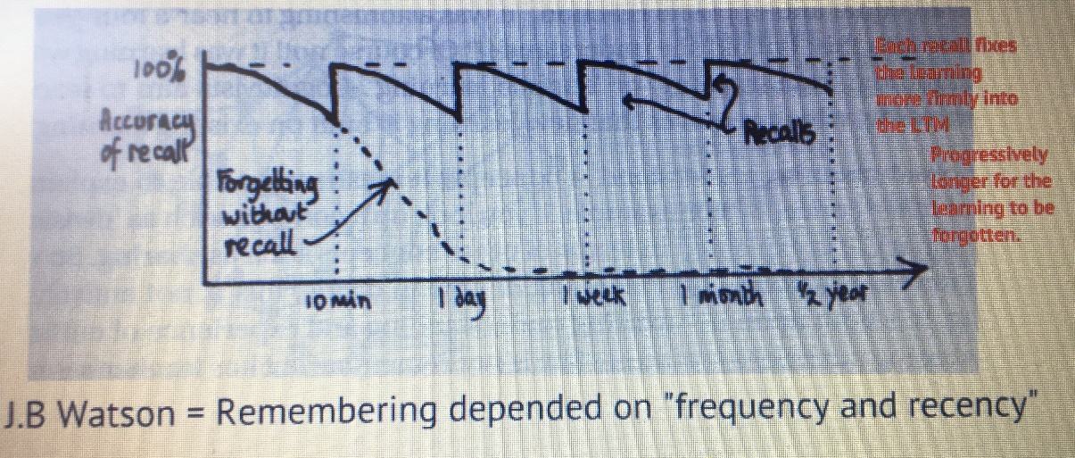
Figure 1
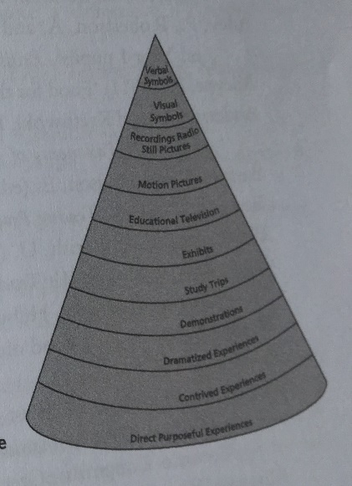
Figure 2
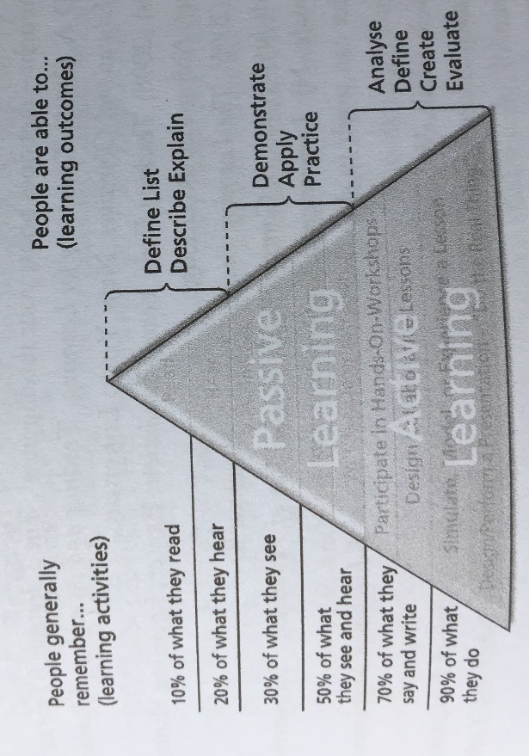
Figure 3
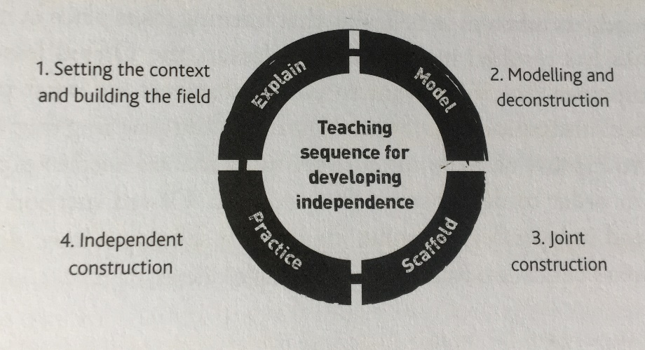
Figure 4

References
Barnes, J. (2007). Cross-Curricular Learning 3-14. 3rd ed. London: Sage.
Carruthers, E. and Worthington, M. (2009). Children's mathematics. 2nd ed. London: SAGE.
Didau, D. (2014). The Secret of Literacy. New York: Crown House Publishing.
Goddard, G. and Walton, A. (2012). Supporting every child. 2nd ed. London: Learning Matters, p.51.
Goepel, J., Childerhouse, H. and Sharpe, S. (2015). Inclusive Primary Teaching. 2nd ed. Northwich: Critical Publishing Ltd.
Grigg, R. (2015). Becoming an outstanding primary school teacher. 2nd ed. Oxon: Routledge.
Koshy, V., Ernest, P. and Casey, R. (2000). Mathematics for Primary Teachers. New York: Routledge.
Pound, L. (2006). How Children Learn - Book 1. Luton: Andrews UK.
Pound, L. (2012). How Children Learn - Book 2. Luton: Andrews UK.
Sleepforkids.org. (2019). Sleep and You. Sleep for Kids - Teaching Kids the Importance of Sleep. [online] Available at: http://sleepforkids.org/html/you.html.

