

Developing a Self-Service Dashboard to Support Data Quality Monitoring Aligned with HESA Rules in Welsh Higher Education

by
Amina Meah

Supervisor: Nik

Project submitted as part of the requirements for the award of
BSc (Hons) Computing (Data and information systems)

24th July 2026
DECLARATION FORM & CONSENT FORM
DECLARATION

I, Amina Meah declare that I am the sole author of this Project; that all references cited have been consulted; that I have conducted all work of which this is a record, and that the finished work lies within the prescribed word limits.

This work has not previously been accepted as part of any other degree submission.

Date : 23/07/2026

FORM OF CONSENT

I Amina Meah hereby consent that my Project, submitted in candidature for the B.Sc.(Hons) Computing (Data and information systems) degree, if successful, may be made available for inter-library loan or photocopying (subject to the law of copyright), and that the title and abstract may be made available to outside organisations.

Date : 23/07/2026

ABSTRACT
This project designed, developed and evaluated a self-service dashboard to support the monitoring and investigation of Higher Education Statistics Agency (HESA) validation failures within a Welsh higher education institution. The existing process relied on a large error extract and separate sources for assignments, investigation notes, tolerance requests and target information, making it difficult to obtain a consistent overview and preserve operational context between imports.
A design science approach, pragmatic mixed-method evaluation and Feature-Driven Development were used. Microsoft SQL Server provided persistent rule, assignment, notes, tolerance and archive structures, while Power BI provided the semantic model and eight task-based report pages. Wide and sparse validation data was reshaped into populated field-name and field-value records to support detailed investigation without displaying hundreds of empty columns.
Evaluation combined developer testing, ten structured usability tasks, the System Usability Scale (SUS) and qualitative feedback. Five questionnaire responses and three complete task-rating matrices were analysed. All 30 self-reported rated task attempts were completed, with 83.3% completed without difficulty. The mean SUS score was 88.5 and mean satisfaction was 4.6 out of 5. Participants valued the Overview and detailed investigation pages. The principal usability issue concerned interpretation of the archive-change icons, while ambiguous wording affected some task-sheet responses.
The project substantially achieved its aim and produced a usable prototype that links current validation failures with persistent operational evidence. Before wider deployment, the dashboard requires formal access controls, clearer user guidance, production performance testing and additional genuine archive snapshots to support meaningful trend analysis.

Table of Contents
ABSTRACT 3
Table of Figures 8
Table of Tables 8
CHAPTER 1 - INTRODUCTION 9
1.1 Background 9
1.2 Problem Definition 9
1.3 Aim 10
1.4 Objectives 10
1.5 Structure of the Report 10
Chapter 2 - Research & Review Of Literature 11
2.1 Introduction 11
2.2 Dashboard Theory and Data Visualisation 11
2.2.1 Definition and Purpose of Dashboards 11
2.2.2 Design Principles 12
2.3 Technologies Used in Dashboard Development 14
2.3.1 Business Intelligence Platforms 14
2.3.2 Data Warehousing and Integration 15
2.4 Data Sources in Higher Education 16
2.4.1 Institutional Data Systems 16
2.4.2 External Reporting and Benchmarking 16
2.5 Implementation and Adoption 17
2.5.1 Planning and Adoption Factors 17
2.5.2 Training and Change Management 18
2.5.3 Evaluation Frameworks 18
2.6 Data Governance and Ethics 18
2.6.1 Data Protection, Anonymisation and Access 19
2.7 Critiques of Dashboards 19
2.7.1 Oversimplification, Misinterpretation and Metric Fixation 19
2.8 Synthesis of Key Themes, Research Gap and Conclusion 20
CHAPTER 3 - RESEARCH AND DEVELOPMENT METHODOLOGY 21
3.1 Research and Development Methodology 21
3.1.1 Project Strategy 21
3.1.2 Project Deliverables 21
3.2 Risks and Limitations 22
3.3 Ethical Issues 23
3.4 Validity, Reliability and Generalisability 24
3.4.1 Validity 24
3.4.2 Reliability 24
3.4.3 Generalisability 25
3.5 Data and Evaluation Methods 25
3.5.1 Data Sources and Preparation 25
3.5.2 Evaluation Design 26
3.5.3 Analysis of Evaluation Data 27
3.6 Development Methodology 27
3.6.1 Feature-Driven Development 27
3.7 Resources 28
3.7.1 Hardware Resources 28
3.7.2 Software Resources 28
3.7.3 Information and Human Resources 29
3.8 Chapter Summary 29
CHAPTER 4 - DESIGN & IMPLEMENTATION 30
4.1 Requirements Analysis 30
4.1.1 Stakeholder Identification 30
4.1.2 Functional Requirements 31
4.1.3 Non-Functional Requirements 31
4.1.4 Requirements Summary 31
4.2 System Design 31
4.2.1 System Architecture 32
4.2.2 Data Model 33
4.2.3 Dashboard Design Decisions 35
4.3 Implementation 41
4.3.1 Data Preparation 42
4.3.2 Dashboard Development 43
4.3.3 Iterative Development 44
4.3.3.1 Design Evolution 44
4.3.4 Challenges and Solutions 46
4.4 Chapter Summary 49
CHAPTER 5 - EVALUATION 50
5.1 Method and Technical Testing 50
5.2 Participant Results 50
5.3 Requirements, Discussion and Limitations 51
5.4 Chapter Summary 52
CHAPTER 6 - CONCLUSIONS AND RECOMMENDATIONS 53
6.1 Achievement of the Aim and Objectives 53
6.2 Contribution and Main Findings 53
6.3 Recommendations and Further Work 54
6.4 Chapter Summary 54
CHAPTER 7 - REFLECTION 55
7.1 Technical and User-Centred Learning 55
7.2 Project Management and Problem-Solving 55
7.3 Improvements and Professional Development 56
7.4 Use of Artificial Intelligence Tools 56
7.5 Chapter Summary 56
APPENDICES 61
Appendix Contents 61
Appendix A - Full Requirements Specification 62
A.1 Functional Requirements 62
A.2 Non-Functional Requirements 63
Appendix B - Extended Testing Data 64
B.1 Technical Test Cases 64
B.2 End-to-End System Tests 65
B.3 Task-Completion Results 66
B.4 System Usability Scale Results 66
B.5 Anonymised SUS Item Responses 68
B.6 Qualitative Feedback 68
B.7 Anonymised Open-Text Survey Responses 69
B.8 Anonymised Task-Sheet Feedback 69
Appendix C - Questionnaire and Participant Materials 70
C.2 Microsoft Forms Questionnaire 74
Appendix D - Selected Code Snippets 77
D.1 Running the Synchronisation Procedure 77
D.2 Reviewing Archive Runs 77
D.3 Key DAX Measures 78
Appendix E - Data Dictionary 79
E.1 Main SQL and Power BI Objects 79
E.2 Key Field Definitions 80
Appendix F - Full Dashboard Screenshots 81
Figure F.1 - Home page 81
Figure F.2 - Overview page 81
Figure F.3 - Rule Detail page 82
Figure F.4 - Error Detail page 82
Figure F.5 - Notes History page 83
Figure F.6 - Tolerance Detail page 83
Figure F.7 - Search Errors by Student page 84
Figure F.8 - Management Page 84
Figure F.9 - Power BI data-model view 85
Appendix G – Dashboard Demonstration Video 86

Table of Figures
Figure 1: Contrasting examples of dashboard design: (a) Wave dashboard; (b) London City dashboard. 11
Figure 2: Comparison of visual encodings for the same category values. 12
Figure 3: Layered architecture of the HESA Data Quality Dashboard 28
Figure 4: Conceptual data model and principal relationship paths. 29
Figure 5: Final Home page. 31
Figure 6: Final Overview page. 32
Figure 7: Rule Detail 32
Figure 8: Search Errors by Student 34
Figure 9: Final Management Page 34
Figure 10: Data preparation and reporting pipeline 36
Figure 11: Archive-based rule-count change indicator on the Overview page. 37
Figure 12: Evolution of the Home page from Version 4 to Version 8 39
Figure 13: Evolution of the Management Page from Version 4 to Version 8 40

Table of Tables
Table 1: Evaluation criteria and evidence 23
Table 2: Hardware resources used during development. 25
Table 3: Example structure of the unpivoted populated error fields. 30
Table 4: Key implementation challenges and solutions 40
Table 5: Summary of participant results 43
Table 6: Final assessment of project objectives 45

CHAPTER 1 - INTRODUCTION

1.1 Background
Higher education institutions depend on accurate student information for operational management, statutory reporting and institutional decision-making. In the United Kingdom, the Higher Education Statistics Agency (HESA) defines data structures and validation rules used to quality-assure sector returns. Validation failures can identify missing, inconsistent or out-of-coverage values that require investigation before a return is finalised. The volume and technical structure of these outputs can make it difficult for staff to identify the most important issues and coordinate corrective work efficiently.
The project was undertaken within the data-reporting environment of a Welsh higher education institution. The existing process involved reviewing a large validation-error extract alongside separate information about rule ownership, investigation notes, tolerance requests and target rules. Microsoft SQL Server and Power BI were selected because they were compatible with the university environment and supported a governed route from data preparation to interactive analysis.
A self-service dashboard was considered appropriate because it could provide a concise view of the current error position while allowing authorised users to move from summary measures to rule-level and record-level evidence. The intended outcome was not to replace professional judgement or the source student-record system, but to organise the evidence required for prioritisation and investigation.

1.2 Problem Definition
The existing monitoring process was fragmented. Current validation failures were stored in a wide extract in which the same rule could occur across many records, while assignments, notes, tolerances and targets were maintained separately. This made it difficult to answer basic operational questions consistently, including how many errors were present, which rules contributed the largest volumes, who was responsible for them and what previous investigation had taken place.
The source extract also represented only the latest position. When a rule was resolved and disappeared from a later file, information held only within that extract would no longer be available. In addition, the file contained hundreds of possible HESA fields, most of which were blank for an individual failure. Presenting this structure directly in a dashboard would create poor performance and an unusable interface.
The problem therefore required both a technical and a user-centred solution: persistent structures were needed to preserve operational history, while the interface needed to support rapid monitoring, prioritisation and detailed investigation without overstating what the underlying identifiers represented.

1.3 Aim
To design, develop and evaluate a self-service Power BI dashboard that supports the monitoring and investigation of HESA validation errors within a Welsh higher education institution.

1.4 Objectives
- Analyse the existing HESA validation-error process and identify the functional and non-functional requirements of intended users.
- Design a maintainable SQL Server and Power BI architecture that combines the current validation-failure snapshot with persistent operational information.
- Develop a self-service dashboard that supports high-level monitoring and detailed investigation of rules, records, and authorised student-code searches.
- Support operational continuity through assignments, investigation notes, tolerance information, targets and archived rule-level counts.
- Evaluate the functionality, effectiveness and usability of the completed dashboard using technical testing, structured tasks, the System Usability Scale and qualitative feedback.

1.5 Structure of the Report
Chapter 2 reviews the relevant literature, Chapter 3 explains the methodology, and Chapter 4 describes the dashboard’s design and implementation. Chapter 5 evaluates the artefact, Chapter 6 presents the conclusions and recommendations, and Chapter 7 reflects on the project. Supporting evidence is provided in the appendices.

Chapter 2 - Research & Review Of Literature

2.1 Introduction
This chapter reviews literature concerning dashboard design, Business Intelligence technologies, higher education data, implementation, governance and dashboard limitations. It identifies principles relevant to the development and evaluation of a self-service dashboard for monitoring HESA validation failures and establishes the research gap addressed by the project.

2.2 Dashboard Theory and Data Visualisation
Dashboard theory and data visualisation provide the basis for presenting complex information in a form that users can interpret and act upon. For HESA data-quality monitoring, users must be able to move from a summary of the current position to individual rules and records.

2.2.1 Definition and Purpose of Dashboards
Dashboards are widely recognised as a core component of Business Intelligence (BI) systems, providing a visual interface through which users can monitor and analyse key information. Few [1] defines a dashboard as "a visual display of the most important information needed to achieve one or more objectives, consolidated and arranged on a single screen". This definition emphasises focus and rapid interpretation: a dashboard should present the information required for a particular purpose without requiring the user to search through multiple disconnected reports.
Alternative perspectives extend this definition beyond visual presentation. Eckerson [3] describes dashboards as performance-management tools that enable organisations to measure, monitor and manage key indicators, while Howson [4] emphasises their role in self-service analytics, through which users can explore governed data with reduced dependence on technical specialists. These perspectives position dashboards as decision-support systems rather than simply collections of charts.
Tufte [2] introduces an important critical perspective by demonstrating that visual presentation can distort meaning when decoration, scale or chart selection takes priority over accurate communication. A dashboard therefore does not automatically improve decision-making. Its value depends on whether the design directs attention towards relevant evidence, explains the meaning of the measures and allows users to examine the underlying context.
Practical examples demonstrate how these principles influence dashboard usability. Matillion [47] presents the Wave dashboard as an effective example because it uses a simple structure, a clear colour scheme and an appropriate amount of information without appearing cluttered. In contrast, the London City dashboard is criticised for presenting excessive information within a limited space, using distracting colours and including several visualisation types without clear relationships between them. Figure 1 illustrates these contrasting approaches to dashboard design.
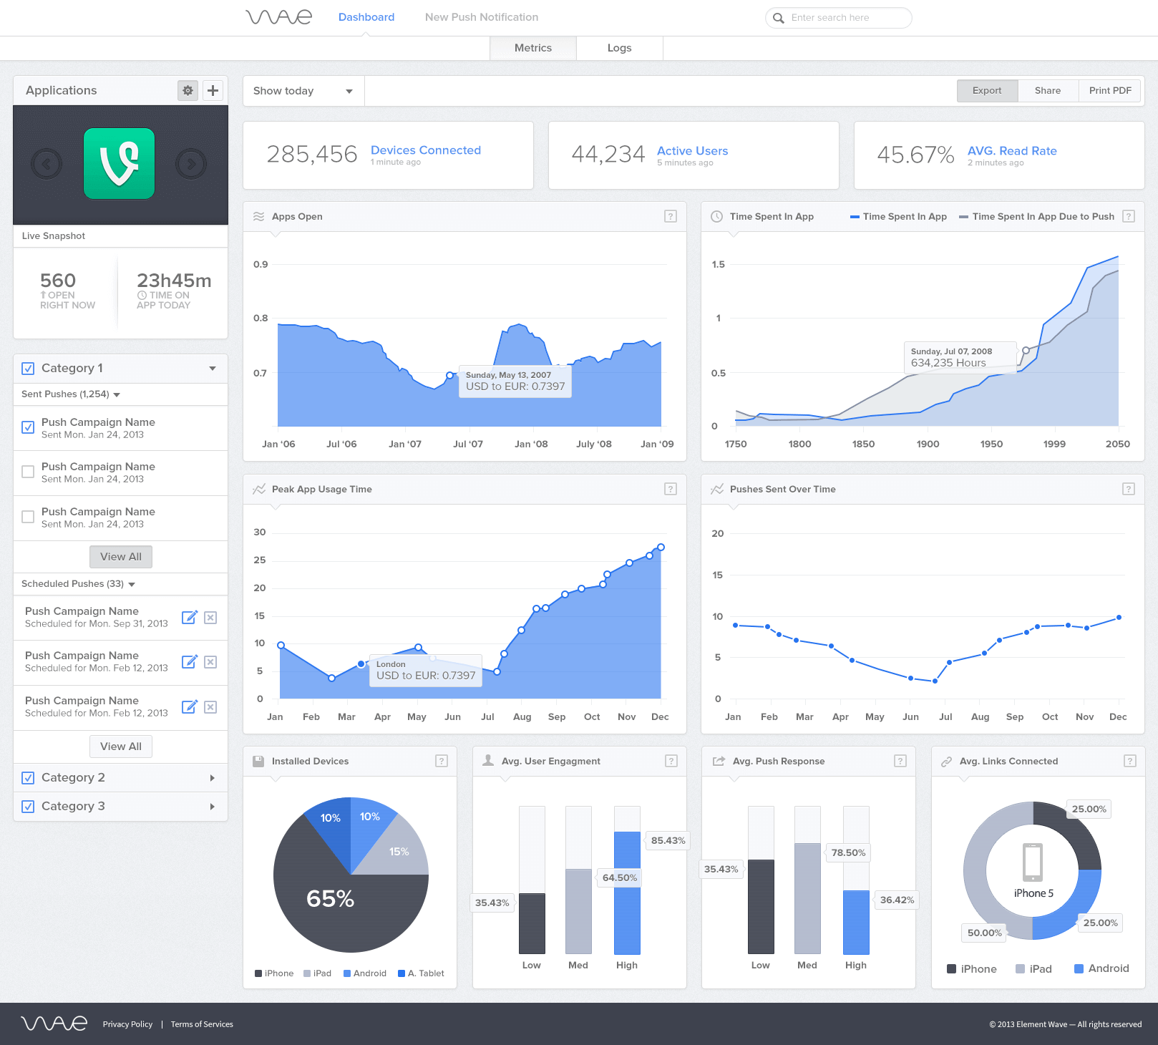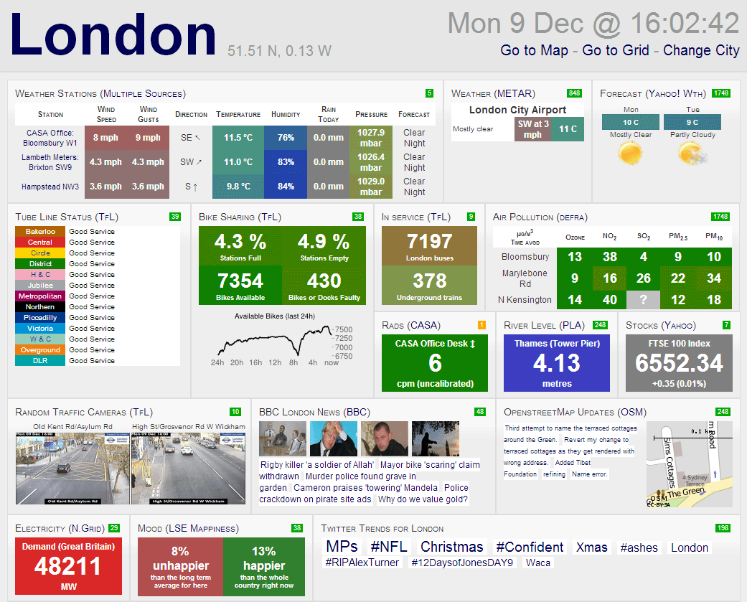
Figure 1: Contrasting examples of dashboard design: (a) Wave dashboard; (b) London City dashboard.
Source: Matillion [47].
In this project, these principles support a dashboard that combines current error volumes with access to rules, assignments, notes, tolerances and record-level evidence.

2.2.2 Design Principles
The effectiveness of a dashboard is strongly influenced by its visual and interaction design. Few [1] argues that dashboards should prioritise essential information and minimise elements that compete for attention. This supports the reduction of cognitive load, allowing users to identify the current position and the actions required without having to decode an unnecessarily complex interface. Krug [34] expresses a similar usability principle through the instruction "don't make me think", arguing that interfaces should be self-evident and should not force users to spend avoidable effort working out how to proceed.
Tufte [2] reinforces this position through the concept of the data-ink ratio, which encourages designers to maximise the proportion of a visual devoted to communicating data and to remove decorative material that does not improve understanding. This does not mean that every dashboard should be visually sparse; rather, colour, icons, labels and spacing should have a clear informational or navigational purpose.
Yigitbasioglu and Velcu [5] extend dashboard design beyond visual minimalism by emphasising user-centred design, task alignment and the differing needs of user groups. Nielsen [6] similarly highlights consistency, visibility of system status and recognition rather than recall as important usability principles. Applied to dashboards, these principles support consistent page layouts, clear feedback when filters are applied, familiar navigation controls and terminology that reflects the users' operational language.
Chart selection also affects how accurately users interpret information. Cleveland and McGill [7] found that graphical judgements based on position and length are generally more accurate than those based on angle, area or colour intensity. Consequently, bar charts are often more suitable than pie or area charts when users must compare the sizes of several categories precisely. Figure 2 demonstrates the practical effect by presenting the same values using bars and a pie chart.
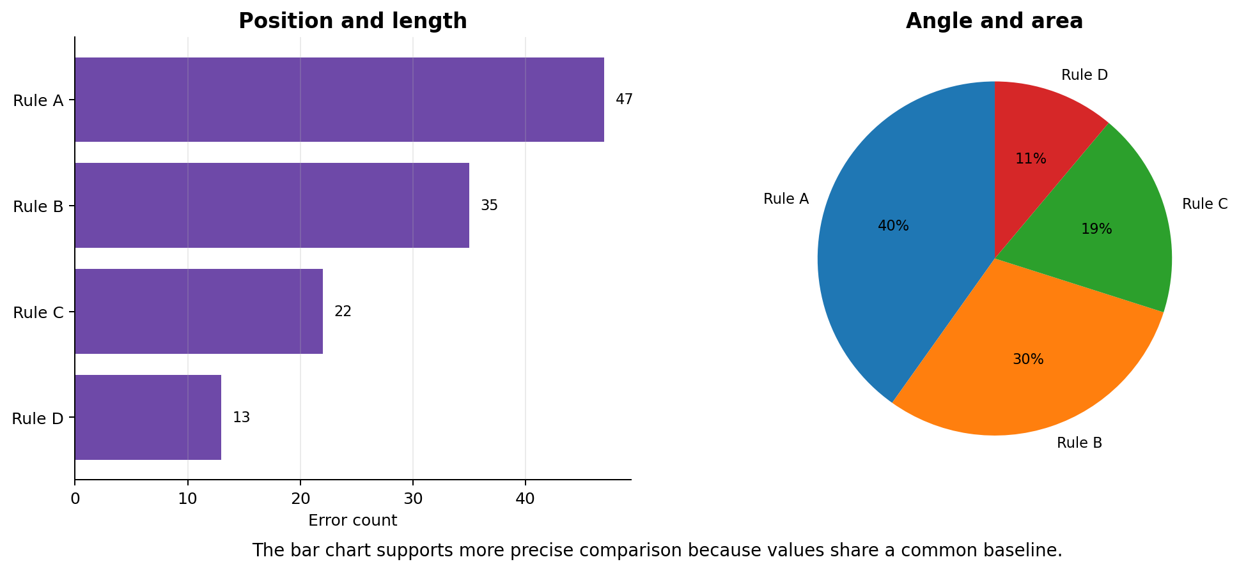
Figure 2: Comparison of visual encodings for the same category values.
Source: Author-created illustration informed by Cleveland and McGill [7].
Effective dashboards balance concise quantitative summaries with access to contextual detail. Cards and ranked charts can communicate the current position, while slicers, tables and dedicated detail pages support investigation. These principles informed the separation of the project’s summary and investigation pages, the use of bar charts for comparison and the progressive disclosure of notes and populated source fields.

2.3 Technologies Used in Dashboard Development
Modern dashboards depend on a combination of technologies for data extraction, transformation, storage, modelling and visual presentation. Their effectiveness is therefore shaped not only by the reporting interface but also by the reliability of the back-end data processes that supply it. In higher education, where information may be distributed across operational systems and external reporting structures, integration and governance are central to producing trustworthy dashboard outputs [8], [9].

2.3.1 Business Intelligence Platforms
Business Intelligence (BI) platforms combine capabilities for connecting to data, preparing and modelling it, creating visual reports and distributing information to users. They support self-service analysis by enabling authorised users to explore governed datasets interactively rather than relying solely on static reports or repeated requests to technical teams [4].
The major commercial platforms provide these capabilities through different interfaces and analytical models. Microsoft describes Power BI as a platform for connecting to, transforming, visualising and sharing organisational data [35]. Tableau places particular emphasis on visual analytics, allowing users to ask and refine questions through direct interaction with visual representations [36]. Qlik Sense supports exploratory analysis through its associative engine, which enables users to navigate relationships within a data model without following a single predefined query path [37].
Technical capability alone does not determine whether a BI platform will be effective. Sequeira et al. [9] identify ease of use, data accessibility, user training and organisational readiness as important factors in higher education BI implementation. This presents dashboard adoption as a socio-technical process in which the software, data practices and users must be considered together.
Sorour and Atkins [8] further note that higher education institutions must manage growing volumes and varieties of data. BI platforms must therefore be assessed in relation to scalability, integration, refresh requirements and the complexity of the institution's existing systems rather than on visual features alone.
BI platforms also have limitations. Their outputs remain dependent on the quality, consistency and interpretation of the underlying data; poorly integrated or inaccurately defined data can produce misleading results even when the visual report functions correctly [8], [9]. Self-service flexibility may also increase the possibility of inconsistent interpretation when users lack knowledge of institutional definitions or do not receive sufficient guidance [9].
For this project, Power BI was selected because it could connect to the existing Microsoft SQL Server environment, support Power Query and DAX development, and provide interactive reporting using software already available within the university. This was therefore a context-dependent selection based on compatibility, development access and user familiarity, rather than a claim that one BI platform is universally superior.

2.3.2 Data Warehousing and Integration
Data warehousing and integration are fundamental components of a dashboard's back end because they consolidate, clean and structure data before it is presented to users. A data warehouse is a central analytical repository designed to support reporting and historical analysis, whereas operational databases are primarily structured to support day-to-day transactions [10].
Data integration commonly uses Extract, Transform, Load (ETL) processes. Data is extracted from relevant sources, transformed through operations such as validation, standardisation, deduplication, and restructuring, and then loaded into a model suitable for analysis [10]. The reliability of the dashboard therefore depends on the transparency and consistency of these processes.
Sorour and Atkins [8] and Sequeira et al. [9] identify integration as a particular challenge in higher education because institutional information is often distributed across multiple operational systems and may use inconsistent formats or definitions. Combining these sources without appropriate preparation can introduce duplication, missing values and contradictory results.
The design of the analytical model also affects usability and performance. Kimball and Ross [10] advocate dimensional structures such as star schemas, in which measurable events are organised around descriptive dimensions. Such structures can simplify filtering and improve query efficiency, although the most appropriate design depends on the grain and relationships of the available data.
In this project, the back-end design combines the current HESA quality rule failure extract with persistent SQL structures for master rules, assignments, investigation notes, tolerance requests, targets and archived rule counts. SQL views provide simplified reporting datasets, while Power Query performs additional reshaping for detailed error fields. This architecture allows the dashboard to present a current operational position without losing supporting information when a new error extract is imported.

2.4 Data Sources in Higher Education

2.4.1 Institutional Data Systems
Higher education dashboards commonly draw on several institutional systems rather than a single source. Student information systems, virtual learning environments, attendance-monitoring tools, library systems and assessment platforms can each contribute evidence about institutional activity and student processes [11], [15]. Jisc [38], the UK digital, data and technology agency focused on tertiary education, research and innovation, also emphasises the value of bringing data from different institutional sources together to support planning, compliance and informed intervention.
A central challenge is that these sources are often fragmented across separate operational systems. Different structures, definitions and levels of data quality can create inconsistency, duplication and incomplete reporting when information is combined. Dixon et al. [11] identify integration and institutional context as important considerations in higher education analytics, while Afzaal and Nouri [12] similarly report recurring challenges relating to infrastructure, interoperability and data quality. These findings demonstrate that a dashboard cannot be assumed to be reliable simply because it presents data visually; the preparation and governance of the source information remain fundamental.
Institutional systems are valuable because they contain the operational evidence required for activities such as monitoring enrolment, engagement, assessment and statutory reporting [11], [15]. However, system activity should not automatically be interpreted as a complete representation of student experience or performance. Behavioural indicators, for example, may function only as partial proxies and require contextual interpretation [11].

2.4.2 External Reporting and Benchmarking
Alongside internal systems, higher education institutions use external reporting frameworks and sector datasets to support standardisation, assurance and comparison. HESA collects, quality-assures and publishes information about UK higher education, including student data, official statistical releases and analytical tables [13]. These standardised definitions allow institutions to interpret internal information within a wider regulatory and sector context.
Benchmarking is valuable because institutional performance should not always be interpreted from raw totals alone. HESA publishes definitions and benchmark methodology for selected performance indicators [14]. These approaches can account for factors such as student background, subject of study and entry qualifications, reducing the risk of drawing misleading conclusions from direct comparisons between institutions.
Jisc's Heidi Plus service [39] provides higher education users with direct access to HESA datasets through an interactive Business Intelligence and data-visualisation environment. It supports benchmarking, planning and strategic analysis by allowing authorised users to explore HESA information across subject, institution and time. This illustrates how externally assured datasets can support purposes beyond statutory submission, including institutional planning and sector comparison.
The present project is operational rather than a sector-benchmarking dashboard. Nevertheless, HESA rules, data definitions and reporting structures provide the external framework against which institutional records are validated. The dashboard therefore combines institutional error information with HESA-aligned rule metadata so that users can monitor the current quality position, investigate validation failures and support the correction process.

2.5 Implementation and Adoption
Dashboard implementation is a socio-technical process shaped by the quality of the system, the readiness of the organisation and the confidence of its users [16], [17]. Technical functionality alone does not guarantee adoption; the dashboard must support real tasks, use trusted information and fit established working practices.

2.5.1 Planning and Adoption Factors
Requirements gathering should identify the decisions and tasks supported by intended users rather than presenting every field available in the source data. Hilliger et al. [16] emphasise the importance of establishing intended uses, data practices and governance before concentrating on software, while Tsai et al. [17] link adoption to institutional priorities and perceived usefulness. Olszak and Ziemba [23] additionally identify management support, user participation, skills and organisational culture as critical factors in Business Intelligence implementation.
These findings informed the project’s requirements analysis. Observation of the existing HESA validation process and discussions with MIS Data and Information colleagues identified the need for a concise overview alongside access to rules, assignments, notes, tolerance requests, targets and record-level evidence. The dashboard was therefore designed around operational tasks rather than the complete technical structure of the source file.

2.5.2 Training and Change Management
Users must understand the dashboard’s measures, filters and limitations if self-service access is to improve rather than confuse decision-making. Consistent labels, feedback and concise guidance reduce the effort required to interpret an interface [17], [23], [40]. For this project, these findings support a consistent navigation structure and the future provision of a short user guide explaining filters, key measures and change indicators.

2.5.3 Evaluation Frameworks
Evaluation should consider whether a dashboard is technically functional, understandable and useful for its intended tasks. Tretow-Fish and Khalid [19] identify usability testing, surveys, interviews and log analysis as common dashboard-evaluation methods. TAM and UTAUT emphasise perceived usefulness and ease of use [20], [21], while the DeLone and McLean model considers system quality, information quality, satisfaction and benefits [22].
A mixed-method evaluation was therefore appropriate. Technical tests assessed data and system behaviour, structured tasks examined whether participants could complete representative activities, the System Usability Scale measured perceived usability, and qualitative questions identified useful or confusing features. Guerra et al. [18] also demonstrate that dashboard evaluation should reflect local practices and expectations, supporting evaluation within the intended institutional context.

2.6 Data Governance and Ethics
Dashboards containing student information must comply with data-protection law and be designed around privacy, transparency and appropriate institutional use [24]-[27].

2.6.1 Data Protection, Anonymisation and Access
The UK GDPR and Data Protection Act 2018 require personal data to be processed lawfully, transparently and only for specified purposes [24], [25]. Data minimisation is therefore important: including every available field may increase privacy risk without improving the user’s task. The ICO also identifies identification numbers as potential personal identifiers, meaning that student numbers and source-record identifiers may remain personal data even when names are removed [41].
Anonymisation and pseudonymisation are not equivalent. Pseudonymised information remains personal data where re-identification is possible, while aggregation can reduce disclosure risk by presenting information at group level [28], [29]. However, excessive aggregation may remove evidence needed for investigation, creating a balance between privacy and operational usefulness.
The project addresses this balance through progressive access to detail. Overview and management pages present aggregated measures, while authorised operational users can access record-level fields and search using Student.OWNSTU where necessary. Evaluation materials use supplied anonymised values, and formal deployment would require controlled Power BI distribution, dataset permissions and database security.

2.7 Critiques of Dashboards
Dashboards improve access to information but can also oversimplify complex issues, encourage misinterpretation and create excessive focus on measured indicators [30].

2.7.1 Oversimplification, Misinterpretation and Metric Fixation
Few [1] argues that dashboards should prioritise essential information, but Muller [30] warns that organisations may focus on what is easily measured rather than the wider objective. A concise dashboard may therefore become analytically weak if it removes definitions and contextual detail. Effective designs should combine summaries with routes to supporting evidence.
Interpretation is also shaped by design choices and user knowledge. Tufte [2] and Cleveland and McGill [7] show that scale, colour and visual encoding can influence conclusions, while Matheus et al. [32] argue that decisions about measures and categories shape what users notice. Correct data does not guarantee correct interpretation, particularly where users have different knowledge of HESA definitions.
Metric fixation is especially relevant to data-quality monitoring. Prioritising only high-volume rules could obscure lower-volume failures with greater regulatory significance. Error counts should therefore be interpreted alongside descriptions, status, ownership, notes and tolerance information. Broader dashboard research also shows that analytical systems are selective representations rather than complete accounts of complex institutional activity [31], [33].
For this project, these critiques support the combination of headline measures with detailed investigation pages. The dashboard is intended to organise evidence and support professional judgement, not replace it.

2.8 Synthesis of Key Themes, Research Gap and Conclusion
The literature identifies three connected requirements for an effective dashboard. First, visual clarity, appropriate chart selection, consistent navigation and progressive access to detail influence whether users can interpret information accurately [1], [2], [5]-[7], [40]. These principles informed the project’s cards, ranked bar charts, task-based pages and detailed investigation routes.
Second, self-service analysis depends on reliable integration, structured modelling, common definitions and governance [8]-[10]. This is particularly important because the HESA validation extract is wide, sparse and replaced over time, while assignments, notes, tolerances and historical counts must persist independently. Adoption additionally depends on usefulness, user confidence, organisational support and evaluation [16]-[23].
Finally, student identifiers and detailed records require data minimisation and controlled access [24]-[29], [41], while dashboard measures must be recognised as selective and open to misinterpretation [30]-[33]. A gap remains between general dashboard and learning-analytics research and institutionally specific tools for HESA validation workflows. This project addresses that gap by applying established design, integration, governance and evaluation principles to a self-service Power BI dashboard supporting both high-level monitoring and detailed operational investigation.

CHAPTER 3 - RESEARCH AND DEVELOPMENT METHODOLOGY

3.1 Research and Development Methodology
This project used a development-based methodology centred on the design, construction and evaluation of a self-service HESA data-quality dashboard using Microsoft SQL Server and Power BI. A design science approach was appropriate because the project produced an information-systems artefact intended to address an identified organisational problem. Hevner et al. [42] emphasise the relationship between practical relevance, research rigour and artefact evaluation, while Peffers et al. [43] describe a process of problem identification, objective definition, design, demonstration, evaluation and communication. These stages reflected the progression of the project from requirements analysis and literature review to implementation and user evaluation.
A pragmatic orientation supported the selection of methods according to their usefulness within the institutional context [46]. Technical testing, quantitative usability measures and qualitative feedback were therefore combined. The work also contained deductive and inductive elements: established dashboard, Business Intelligence, governance and usability principles guided the design, while observation of existing practices and stakeholder feedback informed new features and refinements.

3.1.1 Project Strategy
The project combined four activities: literature review, requirements analysis, artefact development and evaluation. The literature established the academic basis, requirements analysis translated operational needs into features, development produced the SQL and Power BI solution, and evaluation assessed its functionality, effectiveness and usability. This strategy was appropriate because the project aimed to create and assess a practical artefact rather than test a causal hypothesis.

3.1.2 Project Deliverables
The initial development target was a minimum viable product that fulfilled the essential “Must have” requirements. The completed project extended beyond the initial overview page and incorporated detailed investigation and management features. The principal deliverables are:
- A prepared institutional HESA quality rule failure dataset and supporting operational datasets;
- Persistent SQL tables for rules, assignments, investigation notes, tolerance requests, targets and archived rule counts;
- SQL stored procedures and reporting views used to synchronise, aggregate and expose the data;
- A Power BI semantic model incorporating relationships, Power Query transformations and calculated measures;
- A multi-page interactive dashboard containing Home, Overview, Rule Detail, Error Detail, Search Errors by Student, Notes History, Tolerance Detail and Management pages;
- Filters, slicers, navigation controls and conditional formatting that support self-service investigation;
- Task-based functional and usability testing materials;
- A System Usability Scale questionnaire and qualitative feedback questions;
- Technical documentation explaining the architecture, data model, SQL objects, DAX measures and dashboard design;
- User training material in the form of a concise guide to explain navigation, filters and interpretation of the principal measures.
- A recorded dashboard demonstration explaining navigation, filtering, principal measures and the main investigation workflows.
The feature list and its prioritisation are presented in Chapter 4 as part of the requirements and iterative design process. Features that depend on full institutional deployment, long-term historical snapshots or additional licensing are identified as future enhancements rather than being presented as completed functionality.

3.2 Risks and Limitations
Several risks were considered during development. The first concerned data quality and changing source structures. HESA validation extracts are large, wide and rule-dependent; different rules populate different fields, and imported snapshots can change as errors are corrected. This risk was mitigated by preserving the original imported data, separating persistent operational information from the current snapshot, using rule numbers as stable business identifiers and testing aggregated measures against the SQL source.
A second risk concerned performance. The source data contained many records and hundreds of possible detail fields. Loading and presenting this structure directly could have caused slow interactions and visually unusable tables. SQL views, selective imports, Power Query transformations, unpivoting of populated fields and task-specific pages were used to reduce unnecessary complexity.
A third risk was loss of operational history when a new error file was imported. Notes, assignments and previously observed rules needed to remain available even if a rule disappeared from the latest snapshot. Separate persistent tables and a synchronisation procedure were therefore implemented so that the current error extract could be refreshed without deleting historical information.
Time and scope were also constrained. The project was completed by one developer alongside employment and academic commitments. Feature-Driven Development and prioritised requirements were used to secure the core monitoring and investigation functions before optional enhancements. Formal institutional deployment, automated write-back for notes, production-level access management and long-term analysis across many genuine archive snapshots remained outside the available project period.
The evaluation also has limitations. It is expected to use a small purposive sample drawn from people familiar with, or representative of, the intended user context. The results will provide evidence about the usability of the prototype in this setting but cannot establish organisation-wide adoption or generalise statistically to every higher education institution. These limitations are acknowledged explicitly in Chapter 5.

3.3 Ethical Issues
The project used institutional data relating to HESA validation failures. Although the dashboard was designed for operational data-quality work rather than research into individual students, the source records can contain student identifiers, codes and other fields that may constitute personal data. The project was therefore treated as involving sensitive institutional information and was developed in accordance with UK GDPR principles and the Data Protection Act 2018 [24], [25].
Data minimisation was applied by presenting only information required for the relevant monitoring or investigation task. High-level pages use aggregated counts, while record-level detail is separated into dedicated investigation pages. Access to the operational dashboard is intended to be restricted to authorised university staff. Navigation controls improve the interface for different audiences but are not presented as a substitute for formal data access controls.
Usability testing is designed to avoid unnecessary disclosure. Participants are instructed to use only the anonymised test values supplied by the researcher and not to enter names, alternative student codes or other identifiable information. The task sheet and questionnaire use an anonymous participant identifier. Participants receive information about the purpose of the evaluation, participation is voluntary, and consent is obtained before the questionnaire begins.
The principal risk to participants is minor inconvenience or frustration while completing the tasks. The instructions make clear that the dashboard is being tested rather than the participant, and participants may stop at any time. Questionnaire results are used for academic evaluation and reported in aggregate, with open-text comments anonymised before inclusion in the dissertation.

3.4 Validity, Reliability and Generalisability

3.4.1 Validity
Validity concerns whether the project and its evaluation address the intended problem. The dashboard was designed around requirements derived from the existing HESA quality rule investigation process, including the need to monitor current error volumes, identify high-priority rules, distinguish Inside and Outside errors, review assignments and notes, inspect populated source fields and monitor tolerance requests. This alignment between the operational problem, requirements, implemented features and evaluation tasks supports content validity.
Construct validity is strengthened by evaluating several dimensions rather than relying on one subjective judgement. Functional correctness is assessed through test cases and reconciliation with SQL outputs. Effectiveness is assessed through task completion. Perceived usability is measured using the established System Usability Scale, while open-text feedback provides contextual explanation. Together, these measures address whether the artefact is technically correct, usable and capable of supporting its intended tasks.

3.4.2 Reliability
Reliability concerns the consistency and repeatability of the project outputs. SQL views and stored procedures provide documented and repeatable data preparation. DAX measures use defined calculations rather than manually entered totals. The same source snapshot and filter context should therefore produce the same dashboard result. Functional test cases record the expected result, actual result and pass or fail outcome so that tests can be repeated after later changes.
The usability evaluation also uses a standardised task sheet, supplied test values and the same SUS questionnaire for each participant. This reduces variation in the evaluation procedure and allows responses to be compared consistently. However, individual differences in HESA knowledge and Power BI experience may still influence performance; the questionnaire therefore records prior Power BI experience to help contextualise the results.

3.4.3 Generalisability
The specific dashboard is tailored to one institution’s HESA data-quality process, SQL environment and supporting datasets. The numerical findings and exact interface cannot therefore be assumed to transfer unchanged to every university. Nevertheless, the underlying approach is transferable: a changing validation-error snapshot can be combined with persistent rule ownership, notes, tolerance information and archived counts, then presented through task-based Power BI pages. Other institutions could adapt the architecture, requirements process and evaluation method to their own return structures, terminology and access controls.

3.5 Data and Evaluation Methods

3.5.1 Data Sources and Preparation
The primary secondary data source was an institutional HESA quality rule failure extract imported into Microsoft SQL Server. Each row represented an individual validation failure, meaning that the same rule could occur across many records. The extract included core fields such as rule number, rule description, status, regulator, row identifier, academic year and import date, together with many rule-specific fields from HESA entities.
Supporting institutional data included rule assignments, investigation notes, tolerance requests, target rules and archived rule-level counts. These sources were not treated as equivalent to general student-demographic or attainment datasets; they specifically described the operational management and investigation of validation failures. Data preparation consisted of SQL aggregation and joining, persistent rule synchronisation, data-type standardisation, removal of unnecessary fields and Power Query reshaping of sparse record-level data.
The project did not require a statistically representative sample of student records because its purpose was to develop and evaluate the dashboard artefact. The source data needed to be sufficiently complete to exercise the required functions, including filtering, rule ranking, assignment monitoring, notes retrieval, tolerance investigation, student-code search and populated-field inspection. The genuine institutional extract provided this functional coverage.

3.5.2 Evaluation Design
The evaluation uses a mixed-method design combining functional testing, task-based usability testing, the System Usability Scale and qualitative feedback. This responds directly to the project criteria of functionality, effectiveness and usability.
Table 1: Evaluation criteria and evidence
Evaluation criterion | Evidence and measure
Functional correctness | Documented test cases compare expected and actual behaviour for measures, slicers, navigation, filtering and record-level interactions.
Effectiveness | Ten representative tasks record whether each task was completed without difficulty, with some difficulty, after help, or could not be completed.
Efficiency | Optional start and end times provide an overall indication of task duration where participants choose to record them.
Perceived usability | The ten-item System Usability Scale produces a standardised score from 0 to 100 [44].
Qualitative experience | Open-text questions identify useful features, confusing elements and recommended improvements.
Participant context | Prior Power BI experience is recorded to support interpretation of task and questionnaire results.

Participants complete a structured task sheet using supplied rule numbers and an anonymised student code. The tasks cover the main user journey from reviewing overview measures and filtering by status to investigating a rule, searching for errors by student code, inspecting populated fields, locating notes, reviewing tolerance information and interpreting historical-change indicators. This task coverage provides direct evidence against the functional requirements rather than asking participants only for general opinions.
After the tasks, participants complete the online questionnaire. Brooke’s System Usability Scale [44] was selected because it is a concise, widely used ten-item instrument for obtaining a global assessment of perceived usability. It includes alternating positive and negative statements on a five-point agreement scale. The questionnaire also asks which feature was most useful, whether anything was difficult or confusing, what improvement should be made and whether all tasks were completed.

3.5.3 Analysis of Evaluation Data
Functional tests will be summarised as pass, partial pass or fail, with discrepancies explained. Task results will be reported using counts and percentages for each completion category. Tasks requiring assistance or producing incorrect answers will be examined to identify possible navigation, wording, filtering or visual-design issues.
SUS responses will be scored using Brooke’s method [44]. For each odd-numbered statement, one is subtracted from the response. For each even-numbered statement, the response is subtracted from five. The adjusted item scores are summed and multiplied by 2.5 to produce a score between 0 and 100. Individual scores, the mean, range and distribution will be reported; the SUS value will be described as a usability score rather than a percentage mark.
Open-text responses will be reviewed and grouped into recurring themes, such as navigation, terminology, visual clarity, filtering, information density and desired functionality. These qualitative themes will be compared with the task-completion evidence and SUS results. Agreement between methods will strengthen the conclusions, while conflicting findings will be discussed rather than removed.

3.6 Development Methodology

3.6.1 Feature-Driven Development
Feature-Driven Development (FDD) was selected as the software development methodology. FDD organises work around small, client-valued features and supports incremental planning, design and construction [45]. This was suitable for a single-developer dashboard project because the artefact could be decomposed into distinct, testable features, including data import, persistent rule synchronisation, KPI measures, assignments, notes, tolerance reporting, record investigation, student-code search, archive comparison and navigation.
Development proceeded feature by feature rather than attempting to implement the complete dashboard in one stage. Must-have requirements were prioritised to establish the data foundation and Overview page. Later iterations added assignments and notes, record-level investigation, tolerance and management information, historical comparison and visual refinement. Each feature was tested before the next group of functionality was introduced.
FDD provided a structured and manageable approach while retaining flexibility to incorporate stakeholder feedback. For example, the historical archive and change indicators were added after the need to compare current and previous error positions was identified. The project’s feature list, priorities and iterations are presented explicitly in Chapter 4 so that the connection between the selected methodology and the implemented artefact is visible.
A limitation of applying FDD in a single-developer academic project is that some roles and formal practices described for larger development teams are not directly applicable. The methodology was therefore adapted pragmatically: features remained the unit of planning and delivery, while stakeholder discussions, supervisor feedback and usability evaluation provided the principal review mechanisms.

3.7 Resources

3.7.1 Hardware Resources
Development was carried out on a personal computer capable of running Power BI Desktop, SQL Server Management Studio and Microsoft Office. To make the development environment reproducible, the final report should record the exact specifications shown below.
Table 2: Hardware resources used during development.
Hardware item | Specification used
Computer make and model | Microsoft Corporation Surface Laptop 4
Operating system | Microsoft Windows 11 Enterprise
Processor | 11th Gen Intel(R) Core(TM) i7-1185G7 @ 3.00GHz, 2995 Mhz, 4 Core(s), 8 Logical Processor(s)
Installed memory (RAM) | 16 GB
Storage | 475 GB
Network access | University network or VPN connection used to reach the internal SQL Server

3.7.2 Software Resources
Microsoft SQL Server and SQL Server Management Studio were used for persistent data storage, imports, stored procedures, views and validation queries. Microsoft Power BI Desktop was used to create the semantic model, relationships, DAX measures, interactive visuals and page navigation. Power Query provided additional data shaping, including field unpivoting and data-type preparation.
Microsoft Excel was used for initial inspection and preparation of supporting spreadsheets, including tolerance and target information. Microsoft Forms was used to implement the participant consent, Power BI experience question, SUS questionnaire and open-text feedback. Microsoft Word was used to prepare the usability task sheet and project documentation. A university VPN connection was required when accessing the internal SQL Server from outside the campus network.

3.7.3 Information and Human Resources
Information resources included the HESA validation extract, assignment, notes, tolerance and target data, HESA documentation and the literature reviewed in Chapter 2. The researcher designed and implemented the project, the supervisor provided academic guidance, MIS colleagues contributed domain knowledge, and participants evaluated the artefact.

3.8 Chapter Summary
This chapter explained the design science and pragmatic methodology, ethical safeguards, evaluation methods and Feature-Driven Development process used to create and assess the dashboard. It also described the project’s risks, data sources, validity, reliability, generalisability and resources. Chapter 4 explains how these methods were applied in the final design and implementation.

CHAPTER 4 - DESIGN & IMPLEMENTATION

4.1 Requirements Analysis
Requirements analysis identified the information, functionality and usability characteristics required for the HESA Data Quality Dashboard. Evidence was obtained from discussions with members of the MIS Data and Information team, observation of existing working practices and review of the spreadsheets, SQL outputs and operational documents used to monitor validation failures.
The existing process combined a large validation-error extract with separate sources for assignments, notes, tolerance requests and target rules. This fragmentation made it difficult to obtain a consistent overview, determine responsibility and retain investigation history between imports. The required solution therefore combined high-level monitoring with access to rule-level and record-level evidence.
Requirements were prioritised using the MoSCoW categories Must, Should and Could. In this report, a “failing rule” means a validation rule for which one or more records fail the specified check; it does not mean that the rule itself is defective.

4.1.1 Stakeholder Identification
The primary stakeholders were members of the MIS Data and Information team, who review HESA validation outputs, investigate failures and coordinate corrections. They required error totals, rule prioritisation, record-level evidence, assignments, notes and tolerance information.
Managers and senior team members required a more strategic view of assignment coverage, unassigned rules, target performance, tolerance activity and historical movement. An “unassigned rule” is a rule for which no team member has been allocated primary responsibility.
Indirect stakeholders included staff in student records, finance and academic administration who may contribute to correcting particular errors. Differences in technical knowledge reinforced the need for clear terminology, consistent navigation and progressive access to detailed information.

4.1.2 Functional Requirements
The functional requirements define what the dashboard must allow users to do. FR17 was added during iterative development after the value of direct student-code investigation was identified.
The complete functional requirements, priorities, implementation status and evidence are provided in Appendix A. The body of this chapter retains only the design implications needed to explain the artefact.
The Must requirements formed the minimum viable product and ensured that users could understand the current quality position, identify priority rules, investigate detailed records and establish operational responsibility. The Should requirements added workflow and management value through tolerance monitoring, historical comparison, field searching and student-code investigation. Comparison between genuine successive snapshots remained dependent on the availability of more than one independently imported error file.

4.1.3 Non-Functional Requirements
Non-functional requirements covered usability, accuracy, performance, maintainability, security, privacy, consistency, scalability, reliability and compatibility. Usability was important because the source was wide and sparse, while accuracy was necessary to prevent incorrect prioritisation. Persistent storage was also required so that new imports could not delete notes, assignments or archive history. The complete specification is provided in Appendix A.

4.1.4 Requirements Summary
The analysis established a need to combine strategic oversight with operational investigation. Users required summary measures and ranked rules, together with routes to descriptions, assignments, records, populated fields, notes, tolerances and student-code searches. Because the latest error file could replace earlier information, persistent operational tables were required independently of the imported snapshot. These requirements informed the architecture, page structure and development sequence.

4.2 System Design
The design used SQL Server for persistent storage and processing, while Power BI provided semantic modelling, interaction and presentation. The changing validation-failure snapshot was separated from persistent rule, assignment, note, tolerance and archive information. SQL views simplified common reporting logic, and Power Query reshaped sparse record-level fields for investigation. This separation supported maintainability while allowing users to move from summary monitoring to detailed evidence.

4.2.1 System Architecture
The completed solution uses five connected layers: source data, SQL processing and storage, SQL reporting views, the Power BI semantic model and the presentation layer. Figure 3 summarises this architecture.
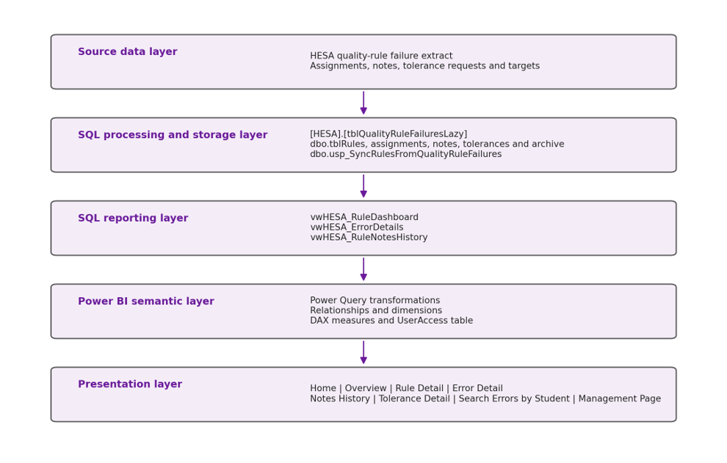
Figure 3: Layered architecture of the HESA Data Quality Dashboard

Source data layer. The principal source was the current HESA validation-failure extract imported into [HESA].[tblQualityRuleFailuresLazy]. Each row represented one validation failure and contained core rule, status, identifier, academic-year and import-date information, together with rule-specific HESA fields. Supporting sources included assignments, historical notes, tolerances and target rules.
SQL processing and storage layer. dbo.usp_SyncRulesFromQualityRuleFailures synchronised the latest import with persistent tables. It inserted new rules, updated existing information, marked rules absent from the current snapshot and created archive counts. The main persistent structures stored master rules, assignments, notes, tolerances, targets and archive snapshots.
SQL reporting layer. vwHESA_RuleDashboard, vwHESA_ErrorDetails and vwHESA_RuleNotesHistory exposed governed rule-level, record-level and notes-history datasets. Placing common joins and aggregations in SQL reduced duplicated Power BI transformations.
Power BI semantic layer. Power Query assigned data types, removed unnecessary fields and unpivoted populated source values. Relationships, dimensions and DAX measures supported totals, status breakdowns, assignments, targets, archive comparison and student search.
Presentation layer. The report contained Home, Overview, Rule Detail, Error Detail, Notes History, Tolerance Detail, Search Errors by Student and Management pages. Separating these tasks avoided presenting all information on one screen.

4.2.2 Data Model
The model supported rule-level, record-level and historical analysis while avoiding ambiguous relationships. The main datasets had different grains: the master rule table contained one row per rule, current errors contained many records per rule, notes contained multiple entries per rule, and the archive contained one row per rule and archive run. Figure 4 shows the conceptual model.
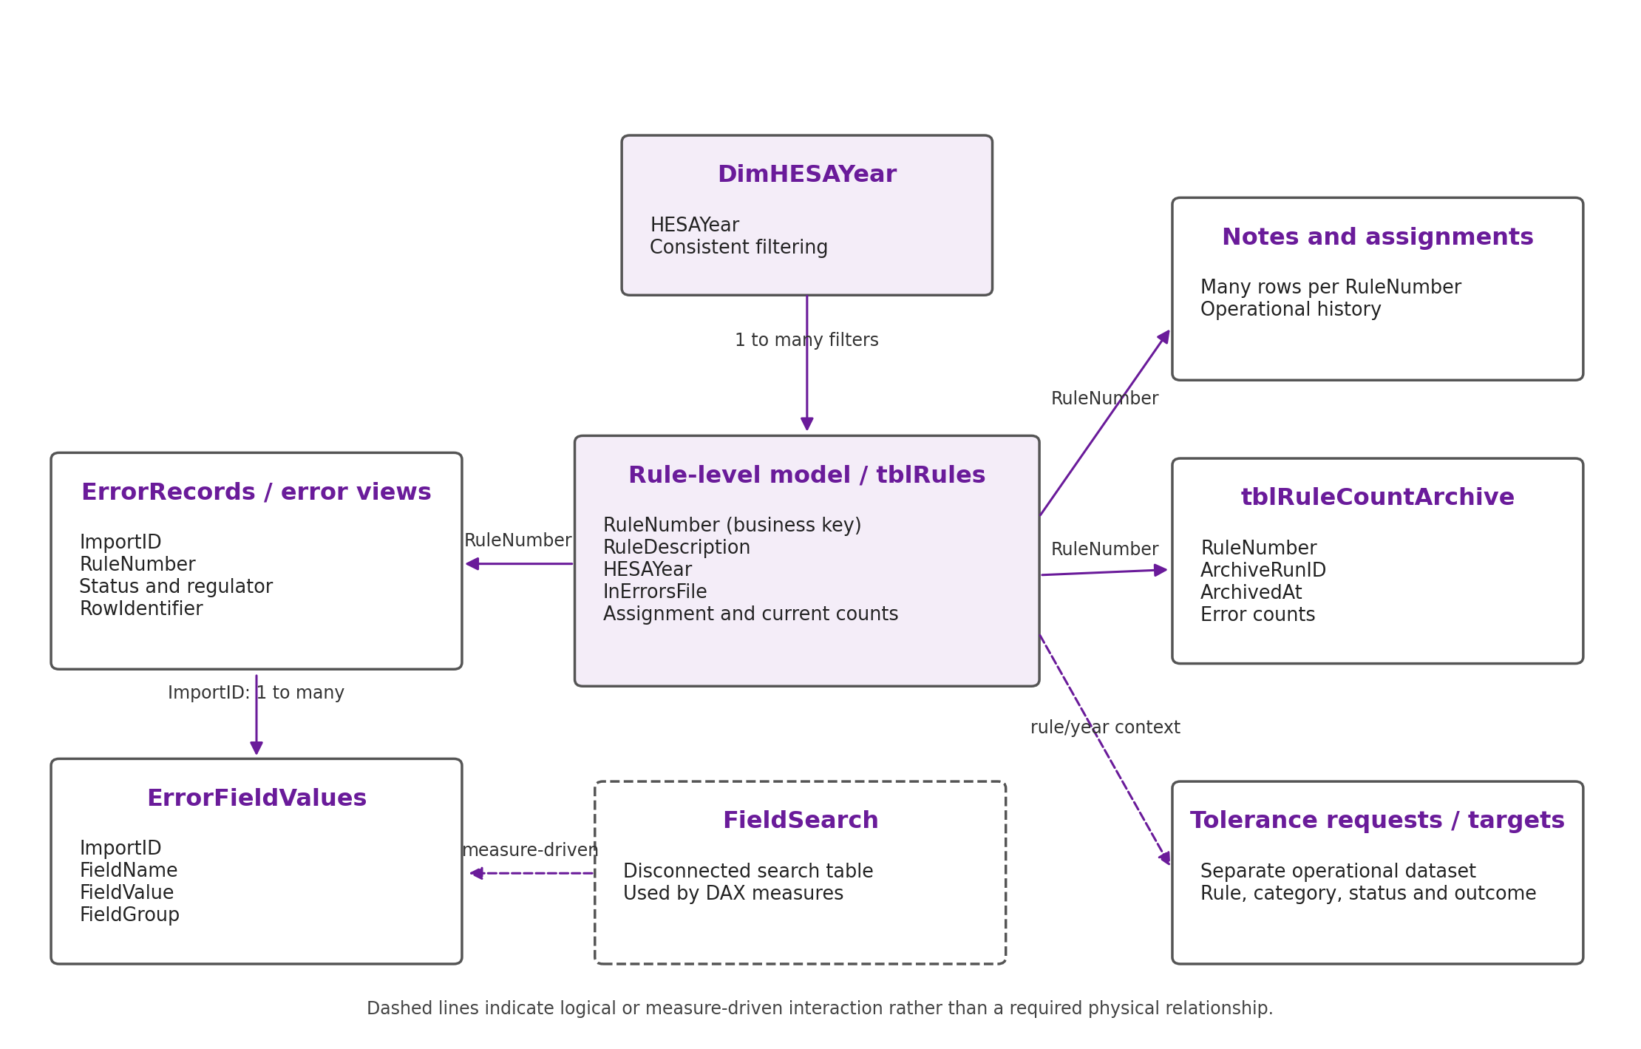
Figure 4: Conceptual data model and principal relationship paths.
RuleNumber was used as the main business identifier because descriptions may be repeated or revised. Rule-level information occupied the one side of relationships, while error, note, assignment and archive data occupied the many side.
DimHESAYear standardised filtering where the source used AcademicYear and supporting tables used HESAYear. This reduced the need for direct relationships between operational tables.
The wide error source was divided into ErrorRecords and ErrorFieldValues. ErrorRecords retained the identifying information for each imported failure, while ErrorFieldValues contained only populated fields after unpivoting. They were linked through the unique technical key ImportID. RowIdentifier was retained for investigation but was not treated as a student identifier because it can represent several HESA entities and may repeat.
FieldSearch remained disconnected from the physical model. DAX used the selected field to control the values shown in the Error Detail matrix without creating additional filter paths.

Table 3: Example structure of the unpivoted populated error fields.
ImportID | FieldName | FieldValue | FieldGroup
133303 | Student.SID | 24100078580053647 | Student
133303 | Student.RELIGION | 22 | Student
133304 | EntryProfile.PERMADDPOSTCODE | SA1 1AA | EntryProfile
The relationship is ErrorRecords[ImportID] 1 to many ErrorFieldValues[ImportID]. ImportID was used because it uniquely identifies an imported error row. RowIdentifier was retained for display and investigation but was not used as the relationship key because it can repeat and may identify a student, engagement, module instance, student course session or another entity.
Student-code search. The Search Errors by Student page uses Student.OWNSTU from the imported failure data as an operational search field. The page is intended for authorised investigation using a supplied or anonymised code. It does not redefine RowIdentifier as a student identifier and therefore remains separate from the Affected Records measure.
Archive model. tblRuleCountArchive has a grain of one row per rule, academic year and archive run. ArchiveRunID and ArchivedAt distinguish snapshots. Measures identify the most recent and previous runs and calculate the change as:
Latest rule count - previous rule count = rule error count change

A positive result represents an increase; a negative result represents a decrease and zero represents no change. The archive supplements rather than replaces the current error views: current views represent the live position, while the archive supports comparison and trend analysis.

4.2.3 Dashboard Design Decisions
The visual design was informed by the principles discussed in Chapter 2. Few [1] and Tufte [2] emphasise clarity and the removal of unnecessary visual elements, while Nielsen [6] and Shneiderman et al. [40] emphasise consistency, feedback and user control. Cleveland and McGill [7] demonstrate that position and length support more accurate comparison than area-based encodings. These principles informed the page hierarchy, chart selection and use of colour.
Task-based page separation. The report was divided into pages aligned with specific user tasks rather than attempting to display every function on one screen:
- The Home page provides a personalised welcome message, the latest import label and navigation to the report’s functional areas.
- The Overview page supports rapid monitoring and prioritisation.
- The Rule Detail page supports investigation of one selected validation rule.
- The Error Detail page exposes populated source fields for selected error records.
- The Notes History page provides chronological operational context.
- The Tolerance Detail page presents requests, reasons, categories, investigators, outcomes and status.
- The Search Errors by Student page supports targeted investigation through Student.OWNSTU.
- The Management Page presents target, workload, tolerance and archive information for management review.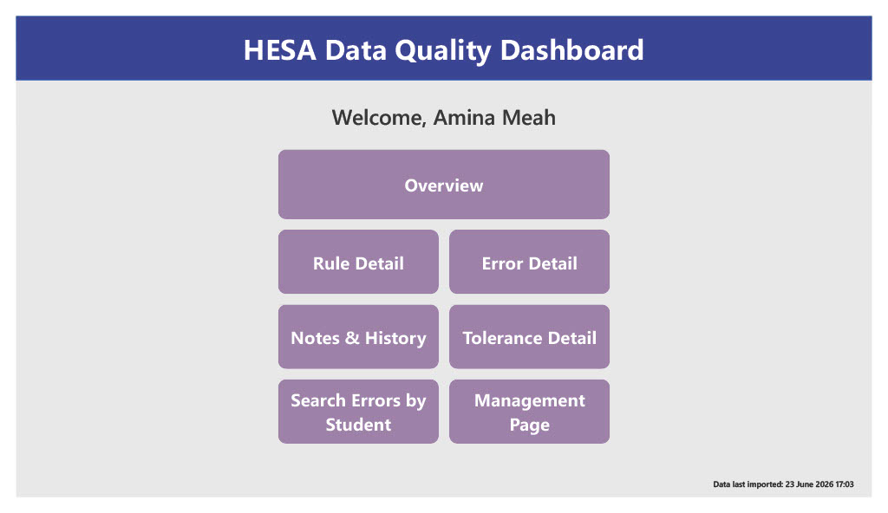
Figure 5: Final Home page.

Overview visual selection. Six headline cards were used for Total Errors, Failing Rules, Outside Errors, Inside Errors, Assignment Coverage and Unassigned Rules. Two horizontal bar charts show Errors by Assigned Person and the Top 10 Rules by Error Count. Bar charts were selected because users can compare position and length accurately [7]. A rule-level table retains exact operational values, including assignment status, current-error status, assigned person, target status and the archive-based change indicator.
The final Overview includes slicers for academic year, assigned person, whether the rule is present in the latest error file, status and target-rule status. Regulator data remains available in the model but was not exposed as a dedicated Overview slicer. Affected-record information is available in detailed analysis rather than as a headline card. These differences from the original requirements are evaluated transparently in Chapter 5.
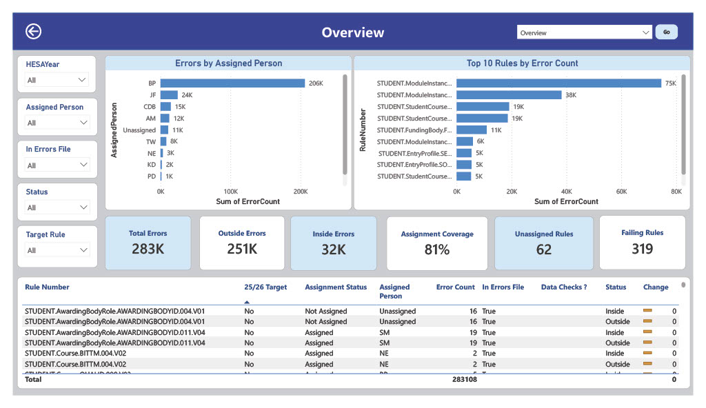
Figure 6: Final Overview page.
Rule Detail presentation. A searchable RuleNumber slicer is supported by academic-year, assigned-person, assignment-status and error-status slicers. The table displays the selected rule’s description, ownership, support information, current-file status, first- and last-seen dates and error count. This keeps the page focused on the rule rather than presenting all record-level fields immediately.
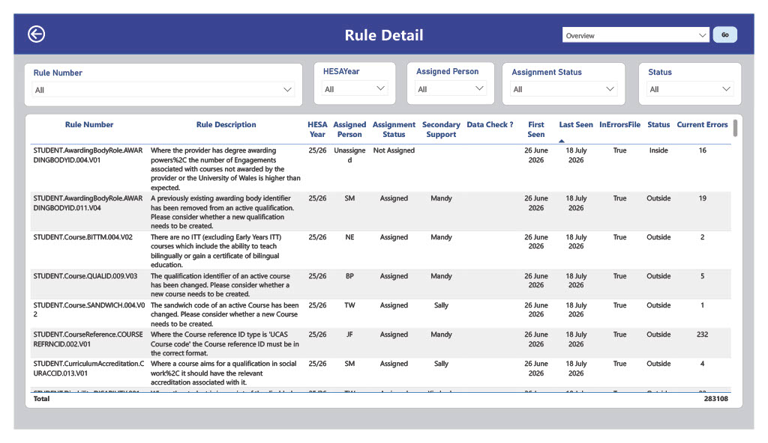
Figure 7: Rule Detail
Error Detail presentation. The final page contains a rule slicer, a searchable FieldName slicer, an error-count card, a compact rule summary and a populated-field matrix. The matrix uses ImportID as rows, FieldName as columns and a DAX measure as the displayed value. Although a matrix can become wide, the disconnected field search allows users to limit the fields displayed. This retained the ability to compare the same field across several selected error records while reducing the need to show hundreds of source columns simultaneously.
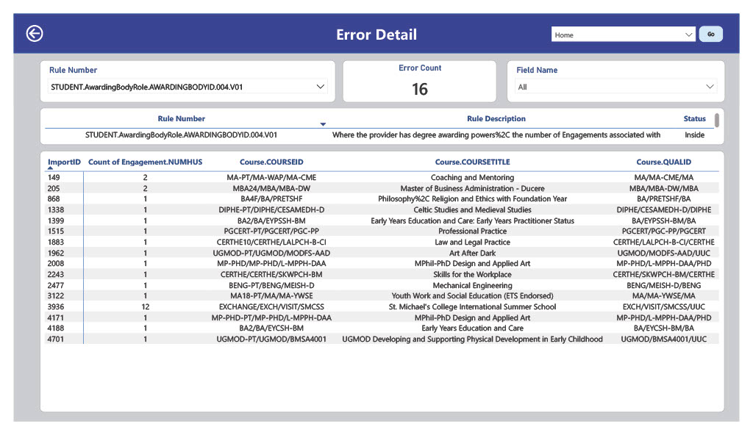
Figure 5: Final Error Detail page showing field search and the populated field matrix.
Search Errors by Student. A dedicated page was created because RowIdentifier cannot safely be interpreted as a student count. Users search for Student.OWNSTU, view the selected student’s error count, identify rules through a bar chart and inspect a detailed table containing rule number, description, status, academic year, import date and record count. This page is used only for authorised operational investigation, and the usability test supplies an anonymised code.
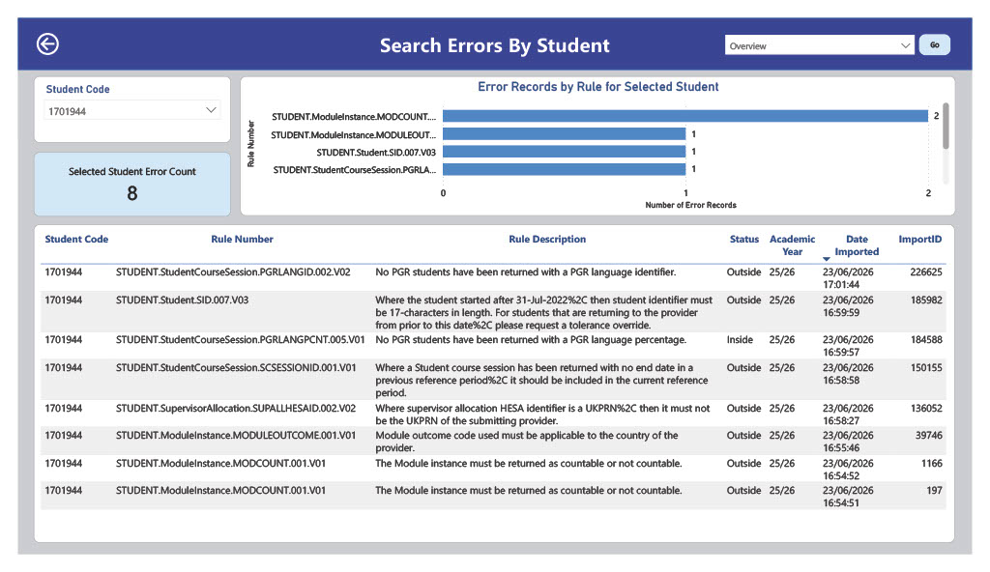
Figure 8: Search Errors by Student
Management information. The Management Page presents target-rule errors by assigned person, total archived errors by archive timestamp, target-rule counts by general category and tolerance requests by category. Cards show Target Rule Errors, Target Rules, Target Rules Currently Failing and Unassigned Target Rules. This separates strategic monitoring from the operational detail presented elsewhere.
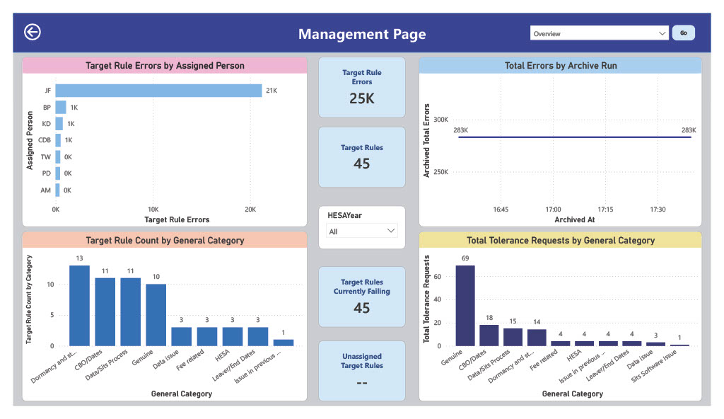
Figure 9: Final Management Page
Colour and conditional formatting. Purple was selected as the primary interface colour to provide a consistent visual identity across navigation controls, headings and page elements. White visual backgrounds and a light-grey page background provide contrast and maintain readability without adding unnecessary decoration. Red and green were reserved for directional change because they are commonly recognised as warning and improvement indicators. Numeric values and directional icons accompany colour so that meaning does not depend on colour alone.
Navigation and access. The Home page shown in figure 5 contains direct buttons for Overview, Rule Detail, Error Detail, Notes and History, Tolerance Detail and Search Errors by Student. Each functional page includes a Home control and a page-selection navigation control. USERPRINCIPALNAME() and the UserAccess table are used to display the logged-in user’s name and conditionally populate the Management button label.
This mechanism provides interface personalisation rather than page-level security. In the final PBIX, the Management button destination exists even when its label is blank and hidden or conditionally formatted navigation cannot prevent a user with report access from reaching a page by another route. Formal protection therefore depends on Power BI workspace or app permissions, report separation, dataset security and database permissions. This limitation is included in the evaluation rather than being presented as a completed security control.
Consistency and readability. Pages use consistent headers, Home controls, page navigation, typography, background colours and table formatting. Long descriptions and note text use wrapping, while internal technical fields are omitted where they do not support an end-user task. The overall interaction path moves from summary information to rule investigation, record-level evidence and management oversight without requiring users to understand the underlying SQL or Power Query implementation.

4.3 Implementation
Implementation converted the design into a functioning SQL Server and Power BI solution. Work included importing and understanding the source data, creating persistent SQL structures, developing reporting views, building the semantic model, implementing DAX measures and constructing the eight dashboard pages. Development followed the incremental Feature-Driven Development approach described in Chapter 3. Core data and overview features were completed first, followed by detailed investigation, student search, tolerance monitoring, management information, archive comparison and visual refinement.

4.3.1 Data Preparation
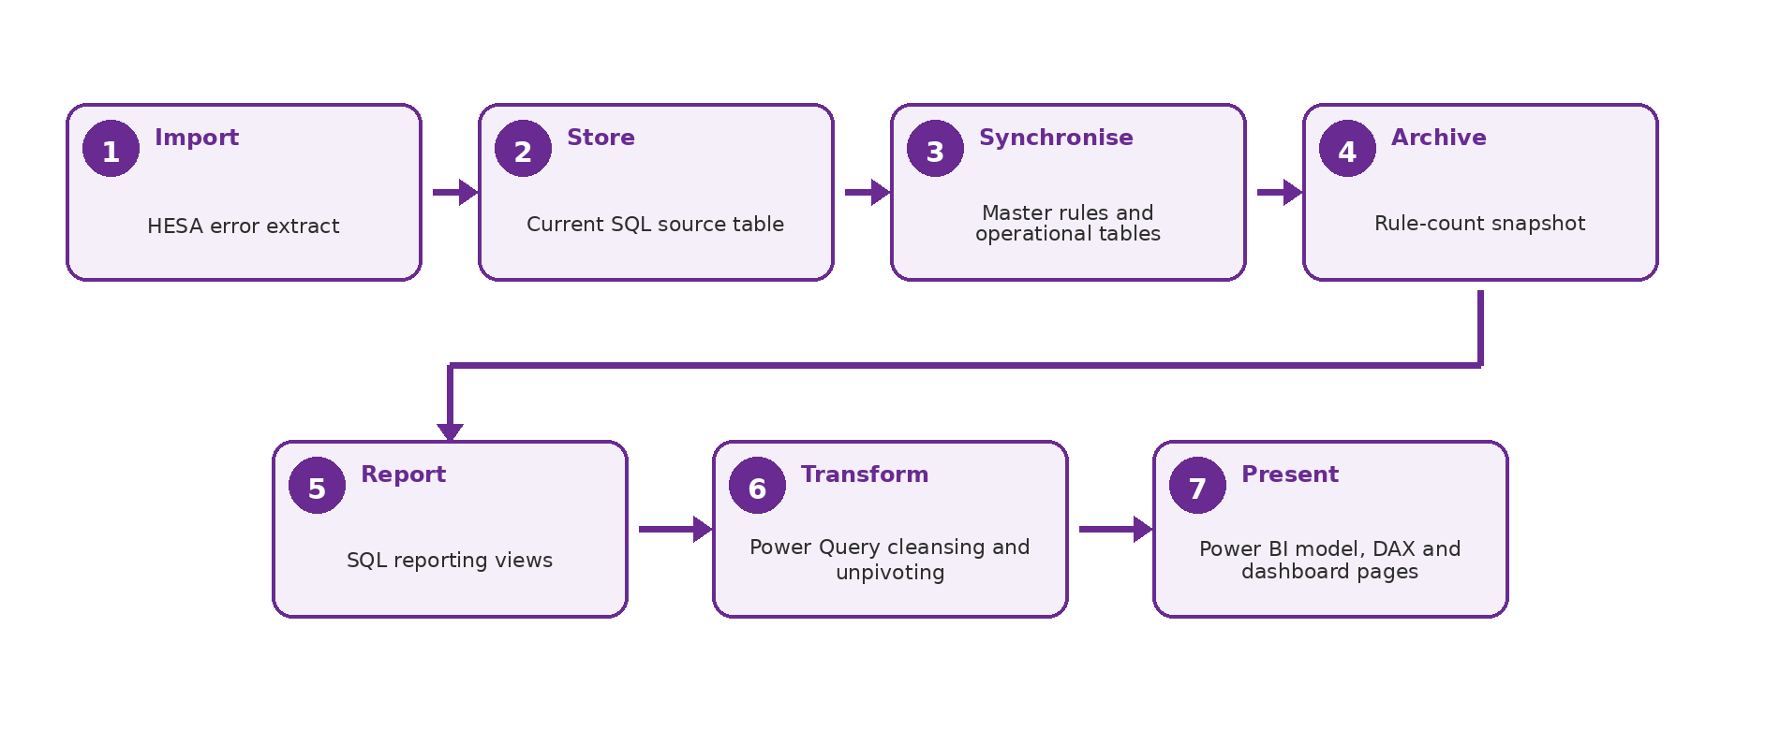
Figure 10: Data preparation and reporting pipeline.
Figure 10 summarises the data-preparation process.
The validation-failure extract was imported into [HESA].[tblQualityRuleFailuresLazy]. Its original wide structure was retained in SQL as the source evidence, but it was unsuitable for direct reporting because different rules populated different subsets of hundreds of fields.
dbo.tblRules provided one persistent row per rule, including its description, first- and last-seen dates and current-file status. The synchronisation procedure inserted unseen rules, updated existing information, marked rules absent from the latest import and generated an archive snapshot without deleting operational history.
Assignments were stored by rule and academic year, with visible placeholder records for unassigned rules. Investigation notes were stored as separate dated records so that multiple updates could be displayed chronologically. Tolerance requests and target rules remained separate because they described operational management rather than individual error records.
SQL reporting views supplied rule, record and notes-history information to Power BI. ErrorRecords retained one row per imported failure, while ErrorFieldValues was created by unpivoting the populated rule-specific columns. Blank values were removed, values were converted to text, and fields were grouped by entity.
tblRuleCountArchive stored rule-level counts for each synchronisation run, including total, affected-record, Inside and Outside counts. The first run contained 319 rule rows representing 283,108 errors. Repeated rules across snapshots meant that the archive occupied the many side of the rule relationship.

4.3.2 Dashboard Development
Home and access implementation. The Home page uses USERPRINCIPALNAME() with the UserAccess table to display the signed-in user’s name and conditionally populate the Management navigation label. This provides interface personalisation only; formal access control remains dependent on Power BI distribution, dataset permissions and database security.
Overview and rule analysis implementation. vwHESA_RuleDashboard supplies rule-level descriptions, ownership and aggregated counts. DAX measures calculate total errors, distinct failing rules, Inside and Outside totals, assignment coverage, unassigned rules and target-rule measures. Slicers apply academic-year, assignment, status and target contexts to the same governed rule-level dataset.
Record-level implementation. ErrorRecords retains the identifiers for each imported failure, while ErrorFieldValues stores only populated rule-specific fields after unpivoting. ImportID links the two tables. The disconnected FieldSearch table and a context-sensitive DAX measure control which field values appear in the Error Detail matrix without creating additional relationship paths.
Operational and management pages. vwHESA_RuleNotesHistory supplies persistent note and assignment context; the tolerance dataset supplies request, status and outcome information; Student.OWNSTU supports the authorised search page; and archive and target tables supply the Management Page. The detailed measure definitions and selected code are provided in Appendix D.
Navigation and historical comparison. Consistent Home and page-selection controls were configured across functional pages. Archive measures identify the latest and previous runs, calculate rule-level change and apply directional conditional formatting. The cropped Overview example in Figure 10 shows the neutral state produced when identical snapshots are compared.
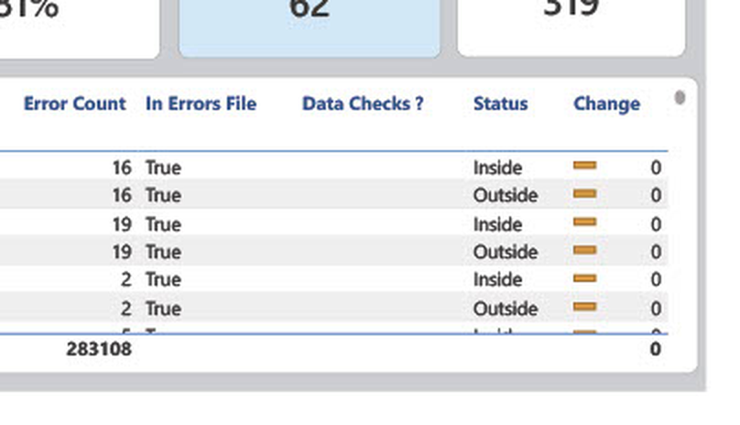
Figure 11: Archive-based rule-count change indicator on the Overview page.

4.3.3 Iterative Development
Development progressed through four broad phases. The first established the SQL data foundation, persistent rule structures and core Overview measures. The second added assignments, notes and rule-level investigation. The third reshaped the wide source table into ErrorRecords and ErrorFieldValues, then introduced Error Detail and the authorised student-code search. The final phase incorporated tolerance and target information, management reporting, archived rule counts, navigation and visual refinement. Features were tested after each phase, and stakeholder feedback led to the addition of student search and historical comparison. This feature-based sequence protected the minimum viable product while allowing later operational enhancements to be incorporated without redesigning the entire solution.
The interface also evolved from an early concept centred on a single monitoring page to the final task-based structure. As assignments, notes, record fields, tolerances and student search were added, retaining all content on one page would have reduced readability. The final design therefore separates summary monitoring from specialist investigation, as illustrated by Figures 5-9. This change demonstrates how stakeholder feedback and iterative development influenced the final layout.

4.3.3.1 Design Evolution
Figures 12 and 13 compare genuine screenshots from Version 4 with the final Version 8 dashboard. Version 4 already provided the core navigation and reporting functions, but the later design introduced a clearer visual hierarchy, more consistent page controls and a stronger separation between operational and management tasks. The comparison demonstrates how the interface changed through iterative development rather than presenting only the final artefact.
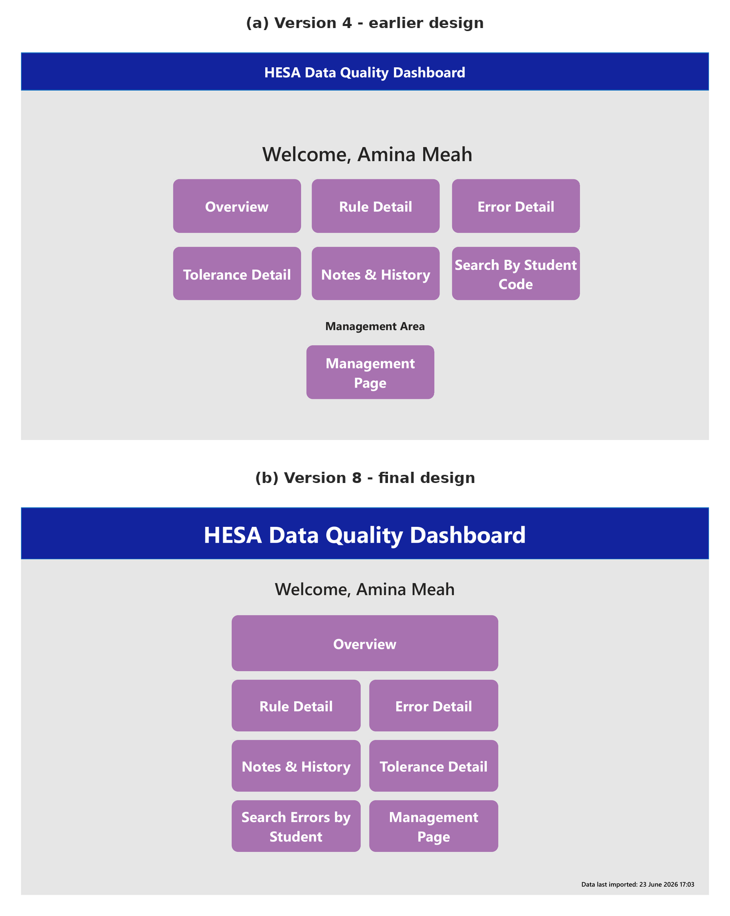
Figure 12: Evolution of the Home page from Version 4 to Version 8
Source: Author-created Power BI dashboard screenshots from Versions 4 and 8.
Version 8 replaced the three-column layout and separate Management Area with a clearer hierarchy: Overview became the main entry point, other pages used a two-column grid, management navigation was integrated for authorised users, and the latest import date was displayed.
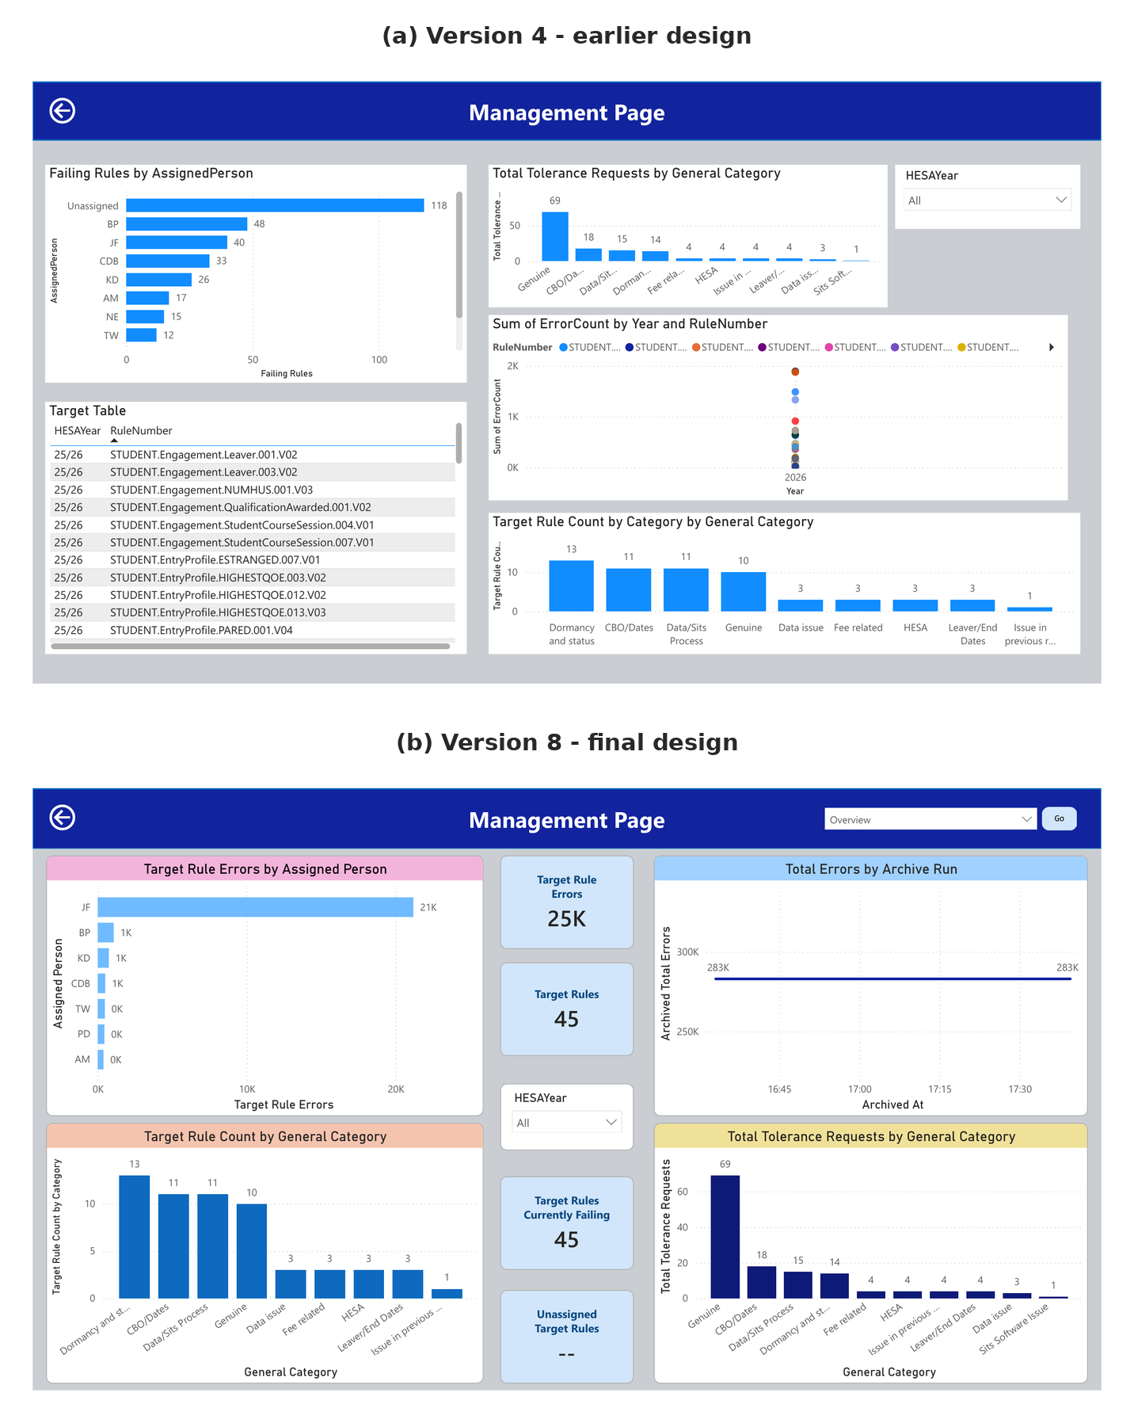
Figure 13: Evolution of the Management Page from Version 4 to Version 8
Source: Author-created Power BI dashboard screenshots from Versions 4 and 8.
The Version 4 Management Page combined a failing-rules chart, a detailed target table, tolerance categories and a single-year rule-count plot. Later requirements shifted the page towards concise strategic monitoring. Version 8 replaced the raw target list with summary cards, changed the assignment visual to target-rule errors, introduced an archive-run trend and retained category-level target and tolerance charts. This produced a more task-focused page that separates current target performance from historical movement.

4.3.4 Challenges and Solutions
Implementation presented several technical, data-modelling and interface-design challenges. Table 4 summarises the principal issues encountered and the solutions adopted to maintain accuracy, usability and operational continuity.
Table 4: Key implementation challenges and solutions
Challenge area | Challenge | Solution
Preserving operational information between imports | The latest source file can remove rules that have been resolved, which would otherwise separate them from notes and assignments. | Persistent rule, assignment and notes tables were created. The synchronisation procedure changes the current-status flag without deleting operational history.
Wide and sparse source data | The source contains hundreds of possible HESA fields, most of which are blank for an individual failure. | Rule-specific fields were unpivoted into FieldName and FieldValue rows, blank values were removed and fields were classified by entity.
Matrix readability | Displaying all populated field names as matrix columns created a wide and potentially overwhelming visual. | The matrix was retained for cross-record comparison but controlled through the disconnected FieldSearch slicer so that users can restrict the displayed fields.
Relationship duplication | The archive contains repeated RuleNumber values because each rule is stored once per archive run. Treating archive descriptions or rule numbers as unique produced duplicate-value errors. | The archive was placed on the many side of the RuleNumber relationship and relationships based on RuleDescription were removed.
Ambiguous filter paths | Several operational tables contain both rule and year fields. Directly relating every table introduced inactive relationships and ambiguity. | The model was simplified around rule-level and academic-year lookup structures, with single-direction filtering used where possible. FieldSearch remained disconnected
Difference between a record and a student | RowIdentifier initially appeared suitable for counting students, but it can represent different HESA entities and may repeat. | The measure was labelled Affected Records rather than Affected Students. ImportID was used as the technical error key, and Student.OWNSTU was used only on the dedicated authorised search page.
Inconsistent academic-year field names | The source uses AcademicYear while supporting tables use HESAYear. | Values were standardised and DimHESAYear was used to provide consistent filtering. The physical naming difference was documented.
Tracking historical changes | Refreshing the source table replaces the latest error position and does not retain earlier rule counts. | tblRuleCountArchive was added to the synchronisation process, with a unique run identifier and timestamp for every snapshot
Testing without a second genuine import | Archive-change measures require at least two snapshots, but initially only one independently imported file was available | The procedure was executed again against the same source to validate the measures and neutral icons. Genuine later imports are required to demonstrate meaningful increases and decreases.
Audience-specific navigation versus security | Power BI does not provide secure page-level access through a DAX-controlled button. A blank label does not remove the underlying navigation destination | The UserAccess measure was documented as interface personalisation only. Formal restriction must be implemented through authorised report distribution, app audiences or separate reports, dataset security and database permissions.
Remote SQL Server connection | Power BI could not resolve or authenticate to the internal SQL Server from a home network. | The university VPN, the server’s fully qualified internal address and Windows authentication were used. The internal hostname is intentionally omitted from the report because it is not necessary for academic explanation.
Requirement-to-interface trade-offs | Page-space and prioritisation decisions meant that the final Overview did not expose a dedicated regulator slicer or an Affected Records headline card. | The fields remain available in the model and detailed views. Their final level of achievement is evaluated explicitly in Chapter 5 rather than being overstated in the implementation chapter.

4.4 Chapter Summary
This chapter described the requirements, architecture, model and implementation of the HESA Data Quality Dashboard. The solution separated the changing validation snapshot from persistent operational information and used SQL views, Power Query and DAX to support monitoring and investigation. Eight task-based pages provided access to rule, record, note, tolerance, student-search and management information. Iterative development introduced historical comparison and improved the interface, while recognised limitations concerning security and genuine archive history were retained for evaluation in Chapter 5. A recorded demonstration of the completed dashboard and its principal user workflows is provided in Appendix G.

CHAPTER 5 - EVALUATION
This chapter evaluates the completed dashboard through developer testing, ten structured participant tasks, the System Usability Scale (SUS) and qualitative feedback. Combining these sources allowed technical operation, perceived usability and the accuracy of participant interpretation to be considered together.

5.1 Method and Technical Testing
Five valid questionnaire responses were received from participants whose Power BI experience ranged from none to advanced. Four task sheets were returned; three contained complete ratings for all ten tasks and one contained answers for Tasks 1-7 only. Task-completion percentages therefore use 30 rated attempts, while SUS findings use all five questionnaires. Fixed rules and an anonymised Student.OWNSTU code were supplied to support comparison and minimise privacy risk.
Detailed task ratings and SUS item responses are provided in Appendix B, while the exact task sheet and questionnaire used are reproduced in Appendix C.
SQL, Power Query and DAX checks reconciled source totals, rule counts, assignments and reporting outputs. Filters, field unpivoting, notes, tolerances, student search and archive measures were tested. Persistent tables retained notes and assignments when the current extract changed. Repeating the archive procedure against the same source correctly produced zero change, but meaningful increases and decreases could not be demonstrated because only one independent snapshot was available.

Participant Results
Table 5: Summary of participant results
Measure | Result
Rated task attempts | 30 completed; none marked unable to complete
Ease of completion | 25 without difficulty (83.3%); 4 with some difficulty (13.3%); 1 after help (3.3%)
SUS | Scores 95.0, 92.5, 97.5, 72.5 and 85.0; mean 88.5; median 92.5
Overall satisfaction | Mean 4.6 out of 5
Reported failures | No participant reported a dashboard feature failure

The anonymised student search produced the most consistent result, with all returned task sheets recording 17 errors. Participants were also able to locate rule, note and tolerance information. However, some answers omitted requested values despite the task being marked as completed, demonstrating that perceived ease did not always indicate fully correct interpretation.
The main difficulty concerned the archive-change indicator. One participant required help, another reported difficulty because only a zero-change example was available, and one incorrectly interpreted the indicator as representing Inside or Outside status. Tasks 7 and 8 were also affected by the instruction “use the supplied rule number”, because several rule values appeared in the test-value table. One participant recommended assigning each value a unique label to make the required rule clearer. No participant reported that a dashboard feature had failed.
Open-text survey feedback was generally positive. Participants valued the Overview page and the ability to move from summary information into Rule Detail, Notes History and tolerance information. The most common improvement was the addition of a visible legend or tooltip explaining the Change icons. Further suggestions included grouping information by business area and repeating the evaluation with newer data over a longer period. The complete anonymised survey responses are provided in Appendix B.7, while the full anonymised task-sheet feedback is presented in Appendix B.8.

5.3 Requirements, Discussion and Limitations
Twelve of the seventeen functional requirements were achieved and five were partially achieved. Partial areas were the missing Affected Records headline card and regulator slicer, deployment-level security, unclear change indicators and limited genuine historical data. Maintainability, reliability and compatibility were achieved; usability, accuracy, privacy and consistency were substantially achieved; and performance, security and scalability require production testing.
The findings support the value of concise monitoring, self-service exploration and consistent navigation discussed by Few [1], Howson [4] and Nielsen [6]. However, the Change icons show that symbols require explicit explanation. The difference between high SUS ratings and incomplete answers also supports DeLone and McLean’s view that system quality, information quality and user outcomes must be assessed together [22].
The study was limited by a small purposive sample, a short, scripted session, one incomplete task sheet and insufficient timing data. The supplied values improved comparability but did not reproduce an unscripted investigation. Formal load testing, production security and long-term benefits were outside scope, and only one genuine archive snapshot was available. The results therefore support the dashboard as a usable prototype rather than proving organisation-wide or long-term effectiveness.

5.4 Chapter Summary
The dashboard achieved a mean SUS score of 88.5, satisfaction of 4.6 out of 5 and completion of all 30 rated attempts. Its strongest features were the Overview page and guided access to detailed operational evidence. Priority improvements are clearer change indicators, less ambiguous terminology, formal deployment controls and further testing with genuine historical imports.

CHAPTER 6 - CONCLUSIONS AND RECOMMENDATIONS
The project produced a self-service SQL Server and Power BI solution for monitoring HESA validation failures and linking them to assignments, notes, tolerance requests, targets and record-level evidence. It replaced a fragmented process with a guided route from summary measures to detailed investigation while preserving operational history between imports.

6.1 Achievement of the Aim and Objectives
The project aim was to design, develop and evaluate a self-service Power BI dashboard supporting the monitoring and investigation of HESA validation errors within a Welsh higher education institution. This aim was substantially achieved: the artefact operated as intended in developer testing and received positive participant results, including a mean SUS score of 88.5.
Table 6: Final assessment of project objectives
Objective | Final assessment
O1: Analyse the existing process and requirements | Achieved through stakeholder analysis and prioritised requirements.
O2: Design a maintainable SQL and Power BI architecture | Achieved through persistent operational tables, reporting views, Power Query and DAX.
O3: Develop self-service monitoring and investigation | Achieved through Overview, rule, record, note, tolerance and student-search pages.
O4: Preserve operational continuity and history | Partially achieved: information persists, but long-term comparison needs more genuine snapshots.
O5: Evaluate functionality, usability and effectiveness | Achieved within scope through technical checks, tasks, SUS and feedback.

6.2 Contribution and Main Findings
The main practical contribution is a centralised prototype that combines current validation failures with persistent operational context. The architecture allows the latest extract to be replaced without deleting notes or assignments, while the unpivoted FieldName and FieldValue structure make a wide and sparse dataset usable for record investigation. The approach could be adapted to other institutional data-quality processes.
Evaluation showed that users valued both the concise Overview and the detailed investigation pages, including participants with limited Power BI experience. It also identified two important lessons: archive-change icons require explanation, and self-reported completion should not be treated as proof of accurate interpretation. These findings strengthen the conclusion by identifying specific weaknesses rather than relying only on the high SUS score.

6.3 Recommendations and Further Work
- Add a visible Change legend or tooltip and distinguish assignment status clearly from Inside/Outside error status.
- Supplement the dashboard demonstration video with concise written guidance covering page purpose, filter clearing, student-code restrictions and field search.
- Deploy through controlled Power BI audiences, dataset security and SQL permissions; UserAccess navigation should remain interface personalisation only.
- Document refresh, synchronisation, archive reconciliation, ownership and data-protection responsibilities before wider use.
- Collect multiple genuine imports and repeat usability testing with an answer key, observation and timing measures.
- Before production use, test performance, concurrency and accessibility and investigate approved write-back or alerting options.

6.4 Chapter Summary
The dashboard met its core aim and four objectives, with the historical-continuity objective partially achieved because meaningful trend analysis needs further snapshots. A controlled pilot, clearer guidance, formal security and repeated evaluation are the most appropriate next steps.

CHAPTER 7 - REFLECTION
This project developed my technical, professional and academic understanding of data-quality systems. The most significant learning was that a successful dashboard depends not only on correct calculations, but also on clear definitions, maintainable architecture, secure deployment and evidence that users interpret information correctly.

7.1 Technical and User-Centred Learning
I strengthened my SQL Server, Power Query, data-modelling and DAX skills by building an end-to-end Business Intelligence solution. Important decisions included separating replaceable source data from persistent operational tables, identifying table grain before defining relationships and unpivoting only populated source fields. I also learned to question labels that imply more than the data supports; for example, “Affected Students” was changed to “Affected Records” because RowIdentifier can represent different entities and may repeat.
Iterative page design improved the route from Overview to rule, record, note and tolerance evidence. Participant testing showed that the general journey worked, but that the Change icons were clear to the developer rather than to users. This reinforced the need to prioritise recognition over recall and to test labels, icons and terminology as carefully as measures and filters. It also showed that ease, correctness, assistance and completion time should be analysed separately.

7.2 Project Management and Problem-Solving
Scope control was a continuing challenge because the project expanded from validation monitoring to assignments, notes, tolerances, targets, archive comparisons, management content and student search. Feature-based development helped divide the work, but earlier prioritisation and a formal change log would have reduced late rewriting when technical changes affected the report.
The project improved my diagnostic approach. For the remote SQL connection, I separated network access, server resolution, authentication and Power BI configuration. For model errors, I examined uniqueness, relationship direction and table grain rather than adding more relationships. I also recognised that DAX-controlled navigation is not security and documented the need for formal Power BI and database permissions instead of overstating the feature.

7.3 Improvements and Professional Development
If repeating the project, I would establish a baseline for the existing process, collect genuine archive snapshots throughout development and conduct formative usability testing earlier. The task sheet itself should be piloted, with uniquely labelled test values, an answer key and checks that all participants complete every section. Observation or interaction logs and timing would provide stronger evidence than self-reported ease alone.
The project increased my confidence in handling an open-ended institutional data problem and communicating technical work academically. It required stakeholder interpretation, governance awareness and honest reporting of limitations. This is directly relevant to data-analyst work because useful analysis depends on both producing correct information and explaining its meaning and constraints clearly enough for others to act on it.

7.4 Use of Artificial Intelligence Tools
OpenAI ChatGPT was used as a supporting tool for exploring wording, structuring report sections, explaining SQL and Power BI errors and organising genuine survey and task-sheet results. AI suggestions were checked against the implemented system and source evidence and were not treated as authoritative research findings.
The requirements, implementation, participant materials and collected responses originated from the project. SUS scores were calculated from submitted responses, no participant results were invented, and responsibility for the final analysis and submission remained with the author.

7.5 Chapter Summary
The project strengthened my technical ability and my understanding of user-centred design, governance and evaluation. Its strongest lesson was that technical success, secure deployment and correct user interpretation are distinct requirements. Earlier testing, clearer terminology, stronger evaluation controls and more historical data would improve a future version.
CHAPTER 8 - REFERENCES
[1] S. Few, Information Dashboard Design: Displaying Data for At-a-Glance Monitoring, 2nd ed. Burlingame, CA, USA: Analytics Press, 2013.
[2] E. R. Tufte, The Visual Display of Quantitative Information, 2nd ed. Cheshire, CT, USA: Graphics Press, 2001.
[3] W. H. Eckerson, Performance Dashboards: Measuring, Monitoring, and Managing Your Business. Hoboken, NJ, USA: John Wiley & Sons, 2006.
[4] C. Howson, Successful Business Intelligence: Unlock the Value of BI and Big Data, 2nd ed. New York, NY, USA: McGraw-Hill, 2013.
[5] O. Yigitbasioglu and O. Velcu, “A review of dashboards in performance management: Implications for design and research,” International Journal of Accounting Information Systems, vol. 13, no. 1, pp. 41-59, 2012.
[6] J. Nielsen, Usability Engineering. San Francisco, CA, USA: Morgan Kaufmann, 1994.
[7] W. S. Cleveland and R. McGill, “Graphical perception: Theory, experimentation, and application to the development of graphical methods,” Journal of the American Statistical Association, vol. 79, no. 387, pp. 531-554, 1984.
[8] A. Sorour and A. S. Atkins, “Big data challenge for monitoring quality in higher education institutions using business intelligence dashboards,” Journal of Electronic Science and Technology, vol. 22, no. 1, 2024.
[9] R. Sequeira, A. Reis, P. Alves, and F. Branco, “Roadmap for implementing business intelligence systems in higher education institutions: A systematic literature review,” Information, vol. 15, no. 4, 2024.
[10] R. Kimball and M. Ross, The Data Warehouse Toolkit: The Definitive Guide to Dimensional Modeling, 3rd ed. Hoboken, NJ, USA: John Wiley & Sons, 2013.
[11] N. Dixon, J. Dettmer, E. Lee, and J. Foster, “Exploring learning analytics practices and their benefits through the lens of three case studies in UK higher education,” Research in Learning Technology, vol. 33, 2025.
[12] M. Afzaal and J. Nouri, “A systematic review of software for learning analytics in higher education,” International Journal of Emerging Technologies in Learning, vol. 19, no. 7, pp. 17-43, 2024.
[13] Higher Education Statistics Agency, “HE student data,” HESA, 2026. [Online]. Available: HESA website. [Accessed: Apr. 13, 2026].
[14] Higher Education Statistics Agency, “Benchmarks applicable to tables T1 to T3, T7 and E1,” HESA, 2026. [Online]. Available: HESA website. [Accessed: Apr. 13, 2026].
[15] Jisc, “Learning analytics,” Jisc, 2026. [Online]. Available: Jisc website. [Accessed: Apr. 13, 2026].
[16] I. Hilliger, M. Ortiz-Rojas, P. Pesántez-Cabrera, E. Scheihing, Y.-S. Tsai, P. J. Muñoz-Merino, T. Broos, A. Whitelock-Wainwright, D. Gašević, and M. Pérez-Sanagustín, “Towards learning analytics adoption: A mixed methods study of data-related practices and policies in Latin American universities,” British Journal of Educational Technology, vol. 51, no. 4, pp. 915-937, 2020.
[17] Y.-S. Tsai, V. Kovanović, and D. Gašević, “Connecting the dots: An exploratory study on learning analytics adoption factors, experience, and priorities,” The Internet and Higher Education, vol. 50, Art. no. 100794, 2021.
[18] J. Guerra, M. Ortiz-Rojas, M. A. Zúñiga-Prieto, E. Scheihing, A. Jiménez, T. Broos, T. De Laet, and K. Verbert, “Adaptation and evaluation of a learning analytics dashboard to improve academic support at three Latin American universities,” British Journal of Educational Technology, vol. 51, no. 4, pp. 973-1001, 2020.
[19] T. A. B. Tretow-Fish and M. S. Khalid, “Methods for evaluating learning analytics and learning analytics dashboards in adaptive learning platforms: A systematic review,” Electronic Journal of e-Learning, vol. 21, no. 5, pp. 430-449, 2023.
[20] F. D. Davis, “Perceived usefulness, perceived ease of use, and user acceptance of information technology,” MIS Quarterly, vol. 13, no. 3, pp. 319-340, 1989.
[21] V. Venkatesh, M. G. Morris, G. B. Davis, and F. D. Davis, “User acceptance of information technology: Toward a unified view,” MIS Quarterly, vol. 27, no. 3, pp. 425-478, 2003.
[22] W. H. DeLone and E. R. McLean, “The DeLone and McLean model of information systems success: A ten-year update,” Journal of Management Information Systems, vol. 19, no. 4, pp. 9-30, 2003.
[23] C. M. Olszak and E. Ziemba, “Critical success factors for implementing business intelligence systems in small and medium enterprises on the example of Upper Silesia, Poland,” Interdisciplinary Journal of Information, Knowledge, and Management, vol. 7, pp. 129-150, 2012.
[24] United Kingdom General Data Protection Regulation, “Article 5: Principles relating to processing of personal data,” legislation.gov.uk, 2016. [Online]. Available: UK GDPR on legislation.gov.uk. [Accessed: Apr. 13, 2026].
[25] Data Protection Act 2018. London, UK: The Stationery Office, 2018. [Online]. Available: legislation.gov.uk. [Accessed: Apr. 13, 2026].
[26] Jisc, Code of Practice for Learning Analytics. Bristol, UK: Jisc, 2015. [Online]. Available: Jisc website. [Accessed: Apr. 13, 2026].
[27] Jisc, Code of Practice for Wellbeing and Mental Health Analytics. Bristol, UK: Jisc, 2020. [Online]. Available: Jisc website. [Accessed: Apr. 13, 2026].
[28] Information Commissioner’s Office, “Pseudonymisation,” ICO, 2025. [Online]. Available: ICO website. [Accessed: Apr. 13, 2026].
[29] Information Commissioner’s Office, “Anonymisation,” ICO, 2025. [Online]. Available: ICO website. [Accessed: Apr. 13, 2026].
[30] J. Z. Muller, The Tyranny of Metrics. Princeton, NJ, USA: Princeton University Press, 2018.
[31] K. Williamson and R. F. Kizilcec, “A review of learning analytics dashboard research in higher education: Implications for justice, equity, diversity, and inclusion,” in Proc. 12th International Learning Analytics and Knowledge Conference, 2022, pp. 260-270.
[32] R. Matheus, M. Janssen, and D. Maheshwari, “Data-driven dashboards for transparent and accountable decision-making in smart cities: A systematic literature review,” Government Information Quarterly, vol. 37, no. 2, Art. no. 101284, 2020.
[33] L. Paulsen and K. McCormick, “Student-facing learning analytics dashboards in higher education: A systematic review of current trends,” Education and Information Technologies, vol. 29, pp. 1-31, 2024.
[34] S. Krug, Don’t Make Me Think, Revisited: A Common Sense Approach to Web Usability, 3rd ed. Berkeley, CA, USA: New Riders, 2014.
[35] Microsoft, “What is Power BI?” Microsoft Learn, 2026. [Online]. Available: Microsoft Learn. [Accessed: Jul. 22, 2026].
[36] Tableau, “Why visual analytics?” Tableau Help. [Online]. Available: Tableau Help. [Accessed: Jul. 22, 2026].
[37] Qlik, “Qlik Sense at a glance,” Qlik Help, 2026. [Online]. Available: Qlik Help. [Accessed: Jul. 22, 2026].
[38] Jisc, “About us,” Jisc, 2026. [Online]. Available: Jisc website. [Accessed: Jul. 20, 2026].
[39] Jisc, “Heidi Plus,” Jisc, 2026. [Online]. Available: Jisc website. [Accessed: Jul. 20, 2026].
[40] B. Shneiderman, C. Plaisant, M. S. Cohen, S. M. Jacobs, N. Elmqvist, and N. Diakopoulos, Designing the User Interface: Strategies for Effective Human-Computer Interaction, 6th ed. Harlow, UK: Pearson, 2017.
[41] Information Commissioner’s Office, “What are identifiers and related factors?” ICO. [Online]. Available: ICO website. [Accessed: Jul. 20, 2026].
[42] A. R. Hevner, S. T. March, J. Park, and S. Ram, “Design science in information systems research,” MIS Quarterly, vol. 28, no. 1, pp. 75-105, 2004.
[43] K. Peffers, T. Tuunanen, M. A. Rothenberger, and S. Chatterjee, “A design science research methodology for information systems research,” Journal of Management Information Systems, vol. 24, no. 3, pp. 45-77, 2007.
[44] J. Brooke, “SUS: A ‘quick and dirty’ usability scale,” in Usability Evaluation in Industry, P. W. Jordan, B. Thomas, B. A. Weerdmeester, and A. L. McClelland, Eds. London, UK: Taylor & Francis, 1996, pp. 189-194.
[45] S. R. Palmer and J. M. Felsing, A Practical Guide to Feature-Driven Development. Upper Saddle River, NJ, USA: Prentice Hall PTR, 2002.
[46] J. W. Creswell and J. D. Creswell, Research Design: Qualitative, Quantitative, and Mixed Methods Approaches, 5th ed. Los Angeles, CA, USA: Sage, 2018.
[47] Matillion, “Dashboard examples: The good, the bad and the ugly,” Matillion, Jan. 15, 2020. [Online]. Available: Matillion website. [Accessed: Jul. 20, 2026].

APPENDICES

Appendix Contents
Appendix | Content
Appendix A | Full Requirements Specification
Appendix B | Extended Testing Data
Appendix C | Questionnaire and Participant Materials
Appendix D | Selected Code Snippets
Appendix E | Data Dictionary
Appendix F | Full Dashboard Screenshots
Appendix G | Dashboard Demonstration Video

Appendix A - Full Requirements Specification
This appendix provides the complete functional and non-functional requirements used to assess the final dashboard. The shortened evaluation in Chapter 5 should cross-reference this appendix.

A.1 Functional Requirements
ID | Functional requirement | Priority | Final status | Evidence
FR01 | Display the total number of current validation errors. | Must | Achieved | Total Errors card on the Overview page and reconciliation with the SQL source.
FR02 | Display the number of distinct failing rules and affected records. | Must | Partially achieved | Failing Rules is shown as a headline card. Affected Records is available in detailed analysis but is not a headline Overview card.
FR03 | Break error counts down by Inside and Outside status. | Must | Achieved | Inside and Outside measures, cards and status filtering.
FR04 | Allow filtering by academic year, rule, status, regulator and assigned person. | Must | Partially achieved | Year, rule, status and assignment filtering are available. Regulator is held in the model, but no dedicated Overview regulator slicer was included.
FR05 | Rank rules by error count so that high-volume issues can be prioritised. | Must | Achieved | Ranked rule visual and Top Rules information on the Overview page.
FR06 | Provide a Rule Detail page containing description, assignment information, status and current error count. | Must | Achieved | Rule Detail page.
FR07 | Allow users to view populated source fields associated with an individual imported error record. | Must | Achieved | Error Detail page using ImportID, FieldName and FieldValue.
FR08 | Display the person assigned to each rule and identify unassigned rules. | Must | Achieved | Assigned Person fields and Unassigned Rules measure.
FR09 | Retain and display investigation notes when a rule is absent from the latest error file. | Must | Achieved | Persistent tblRuleNotes table and Notes History page.
FR10 | Display tolerance requests, categories, status, outcomes and target information. | Should | Achieved | Tolerance Detail and Management pages.
FR11 | Provide navigation between functional areas through a Home page and consistent page controls. | Must | Achieved | Central Home page and navigation buttons across the report.
FR12 | Provide audience-specific navigation to management information while relying on formal permissions for security. | Should | Partially achieved | UserAccess controls the visibility of management navigation, but this is interface personalisation rather than secure page-level access.
FR13 | Archive rule-level error counts whenever the SQL synchronisation procedure runs. | Should | Achieved | tblRuleCountArchive and archive logic within the synchronisation procedure.
FR14 | Indicate whether rule counts increased, decreased or remained unchanged between archive runs. | Should | Partially achieved | Change measures and icons were created, but participants required clearer explanation and only neutral changes could initially be tested.
FR15 | Support searching and filtering across the large number of possible error-detail fields. | Should | Achieved | Unpivoted error-detail structure and disconnected FieldSearch slicer.
FR16 | Support comparison between current and previous error snapshots. | Could | Partially achieved | Latest and previous archive measures exist, but meaningful comparison requires further genuine imports.
FR17 | Allow authorised users to search using an anonymised Student.OWNSTU code. | Should | Achieved | Search Errors by Student page.

Overall assessment: 12 functional requirements were achieved and five were partially achieved. No requirement was classified as wholly unachieved.

A.2 Non-Functional Requirements
ID | Requirement | Description | Final assessment
NFR01 | Usability | The interface should be understandable without specialist Power BI knowledge. | Substantially achieved; mean SUS score was 88.5.
NFR02 | Accuracy | Measures and visual totals must correspond with SQL data and documented definitions. | Substantially achieved through reconciliation checks.
NFR03 | Performance | Pages and filters should respond within a reasonable time. | Partially achieved; suitable during development testing but no formal load test was conducted.
NFR04 | Maintainability | SQL, Power Query and DAX objects should be logically named and documented. | Achieved.
NFR05 | Security | Access should be limited to authorised users through formal permissions. | Partially achieved; deployment security remains necessary.
NFR06 | Privacy | Personal information should be minimised and displayed only where necessary. | Substantially achieved through anonymised testing and restricted student-code search.
NFR07 | Consistency | Pages should use consistent titles, controls, colours and visual conventions. | Substantially achieved.
NFR08 | Scalability | The solution should accommodate additional rules, rows, years and snapshots. | Partially achieved; architecture supports growth, but production-volume testing is required.
NFR09 | Reliability | New imports must not delete notes, assignments or archive history. | Achieved through persistent operational tables.
NFR10 | Compatibility | The dashboard should operate within the university SQL Server and Power BI environment. | Achieved.

Appendix B - Extended Testing Data
This appendix contains the detailed technical, system and usability testing evidence summarised in Chapter 5.

B.1 Technical Test Cases
ID | Component tested | Expected result | Evidence / result | Outcome
UT01 | Total Validation Errors measure | Power BI total matches the SQL source count. | SQL and Power BI both returned 283,108 errors for the tested snapshot. | Pass
UT02 | Failing Rules measure | Power BI matches the distinct SQL rule count. | 319 failing rules were returned. | Pass
UT03 | Inside and Outside measures | Inside plus Outside reconciles to the total where all rows have a valid status. | Overview cards displayed approximately 251k Outside and 32k Inside errors; the archive process reconciled the status counts with the 283,108 total at source precision. | Pass
UT04 | Affected Records measure | Matches the distinct RowIdentifier count and is not labelled as students. | The DAX definition was reviewed, but a retained final SQL comparison value was not available in the project evidence. | Partial
UT05 | Rule synchronisation | Updates current status without deleting persistent information. | Notes and assignments remained after synchronisation. | Pass
UT06 | Archive change measure | Repeating the procedure against the same source produces zero change. | Neutral result returned as expected. | Pass
UT07 | Error-detail relationship | Selecting one ImportID returns only its populated fields. | Tested through the Error Detail page. | Pass
UT08 | FieldSearch interaction | Field selection reduces the fields displayed without incorrectly changing the error population. | Tested using the disconnected field slicer. | Pass
UT09 | User access and welcome measure | Signed-in identity is displayed, and management navigation follows UserAccess. | Signed-in identity and interface personalisation worked; the control was not treated as secure page-level access. | Partial

B.2 End-to-End System Tests
ID | Test | Requirement | Outcome
ST01 | Review Overview totals | FR01-FR03 | Pass
ST02 | Identify the largest rule and assigned person | FR05, FR08 | Pass
ST03 | Filter to Outside errors and clear the filter | FR03, FR04 | Pass
ST04 | Investigate a rule on Rule Detail | FR06 | Pass
ST05 | Search using anonymised student code | FR17 | Pass
ST06 | Interpret the selected-student rule chart | FR17 | Pass
ST07 | Examine populated fields for an error record | FR07, FR15 | Pass, although some participants found the task wording unclear.
ST08 | Locate an investigation note | FR09 | Pass, with some instruction ambiguity.
ST09 | Locate tolerance information | FR10 | Pass
ST10 | Interpret archive change and import information | FR13, FR14, FR16 | Partial; the feature operated, but the icon meaning was unclear and genuine historical variation was unavailable.

B.3 Task-Completion Results
Only the three returned task sheets containing complete task-rating matrices were used to calculate the ease-of-completion percentages. A fourth sheet contained answers for Tasks 1-7 but omitted Tasks 8-10 and the final rating matrix; it was treated as a partial response.
Task | Without difficulty | Some difficulty | After help | Unable
1 | 3 | 0 | 0 | 0
2 | 2 | 1 | 0 | 0
3 | 3 | 0 | 0 | 0
4 | 3 | 0 | 0 | 0
5 | 3 | 0 | 0 | 0
6 | 3 | 0 | 0 | 0
7 | 2 | 1 | 0 | 0
8 | 2 | 1 | 0 | 0
9 | 3 | 0 | 0 | 0
10 | 1 | 1 | 1 | 0
Total | 25 | 4 | 1 | 0
Percentage | 83.3% | 13.3% | 3.3% | 0%

B.4 System Usability Scale Results
Participant | Power BI experience | SUS score | Satisfaction
P1 | Regular user | 95.0 | 5
P2 | Moderate experience | 92.5 | 5
P3 | Advanced user | 97.5 | 5
P4 | Limited experience | 72.5 | 4
P5 | No previous experience | 85.0 | 4
Mean | - | 88.5 | 4.6
Median SUS | - | 92.5 | -

SUS scoring method: worded responses were converted to values from 1 to 5, where Strongly Disagree = 1 and Strongly Agree = 5. For odd-numbered statements, one was subtracted from the response value. For even-numbered statements, the response value was subtracted from five. The ten adjusted values were added and multiplied by 2.5.

B.5 Anonymised SUS Item Responses
The table below records the numeric values used in the SUS calculation, where 1 = Strongly disagree and 5 = Strongly agree. The alternating scoring adjustment was then applied as described in Section B.4.
ID | Q1 | Q2 | Q3 | Q4 | Q5 | Q6 | Q7 | Q8 | Q9 | Q10 | SUS
P1 | 5 | 2 | 4 | 1 | 5 | 1 | 5 | 1 | 5 | 1 | 95.0
P2 | 4 | 1 | 4 | 1 | 4 | 1 | 5 | 1 | 5 | 1 | 92.5
P3 | 5 | 1 | 5 | 1 | 4 | 1 | 5 | 1 | 5 | 1 | 97.5
P4 | 3 | 2 | 4 | 1 | 4 | 2 | 4 | 2 | 3 | 2 | 72.5
P5 | 5 | 1 | 4 | 1 | 5 | 1 | 4 | 3 | 4 | 2 | 85.0

B.6 Qualitative Feedback
Theme | Evidence from participants |  | Resulting recommendation
Overview usefulness | The Overview was described as providing a useful snapshot of important information. | Retain the concise headline layout.
Detailed investigation | Rule Detail, Notes History and tolerance information were identified as useful features. | Retain the guided route from summary to detail.
Change icons | Participants were unsure what the icons represented. | Add a visible legend or tooltip.
Task wording | "Use the supplied rule number" was ambiguous because several rules were supplied. | Give every test value a unique label or repeat the complete rule in each task.
Grouping by area | One participant suggested grouping information by business area. | Consider an Analyse By field or business-area grouping.
Longer-term testing | One participant wanted to use the dashboard with newer data for a longer period. | Repeat testing after several genuine imports.

B.7 Anonymised Open-Text Survey Responses
Participant | Most useful feature | Difficult or confusing aspects | Recommended improvement
P1 | “Rule Detail page and Notes History” | “No. Easy and simple to use” | “Honestly, I spent a while looking at it and was trying to think of something, but I think it’s great as it is.”
P2 | “The overview” | “N/A” | “It would be useful to be able to group by area on the overview page, i.e. for qualifications on entry.”
P3 | “All good” | “No” | “None”
P4 | “notes and tolerance” | “no” | “would need to use dashboard more, and with more recent data to make any useful suggestions”
P5 | “The overview page which provides a good snapshot of the most important information” | “I was unsure what the icons within the ‘Change’ column on the Overpage represent.” | “Adding a key to show what the icons within the ‘Change’ column on the Overpage represent.”

B.8 Anonymised Task-Sheet Feedback
Task-sheet respondent | Most difficult task and reason | Feature failure | Comments on instructions
T1 | No written response provided | No written response provided | No written response provided
T2 | No written response provided | No written response provided | No written response provided
T3 | “10 - there is currently only one value for change: 0, so a fully detailed answer couldn’t be given.” | “N/A” | “N/A”
T4 | “Task 7 and Task 8, which instruct ‘…use the supplied rule number’, and there are two rules shown in the Test Values table. The rule would have been easier to locate if the instruction was clearer…” | “No, all features work as expected to the best of my knowledge.” | The participant recommended highlighting the required test value or assigning each value a unique code. They also stated that a key would make the different Change values easier to understand.

Appendix C - Questionnaire and Participant Materials
This appendix reproduces the exact blank task sheet and Microsoft Forms questionnaire used during the evaluation.
C.1 Participant Usability Testing Task Sheet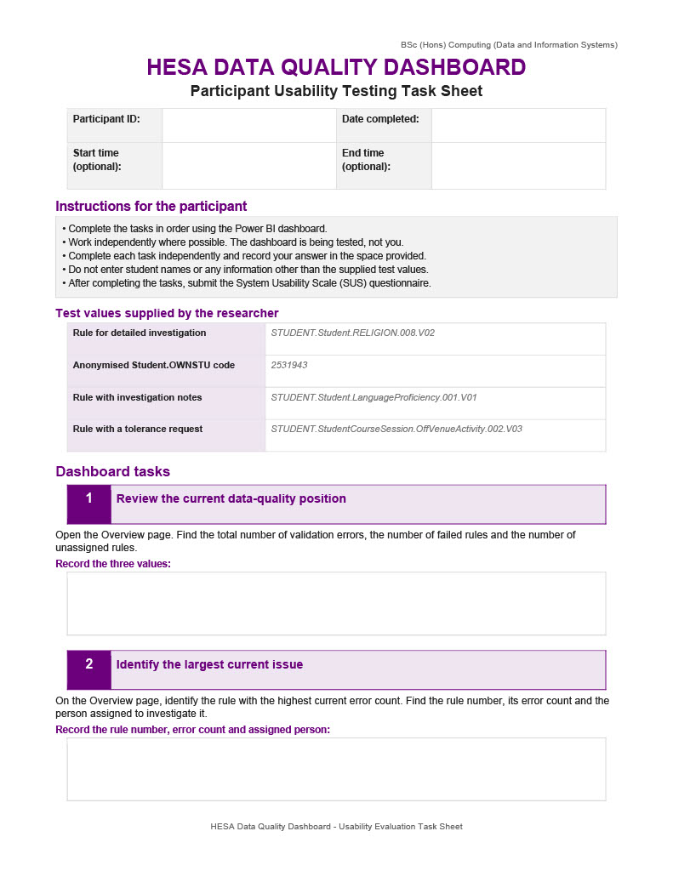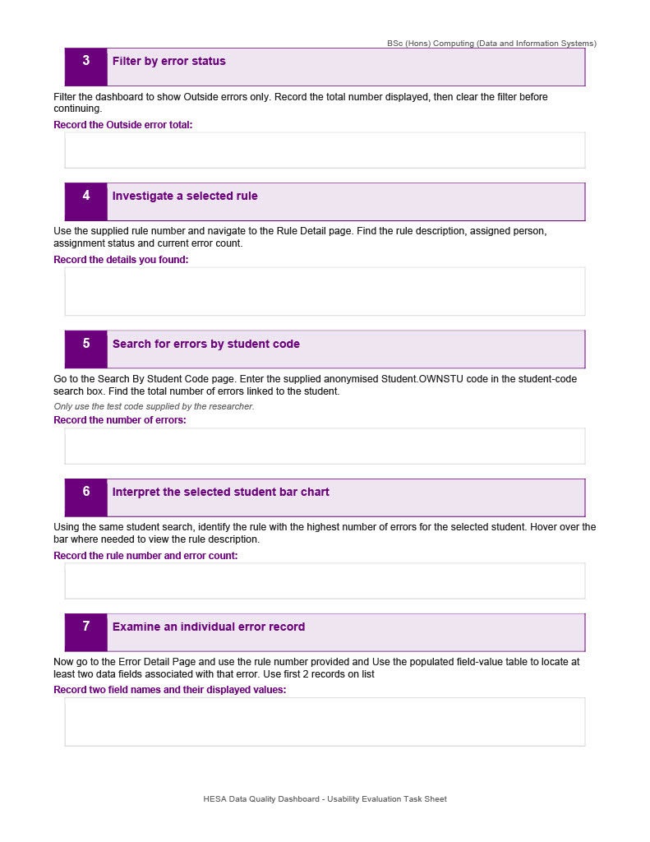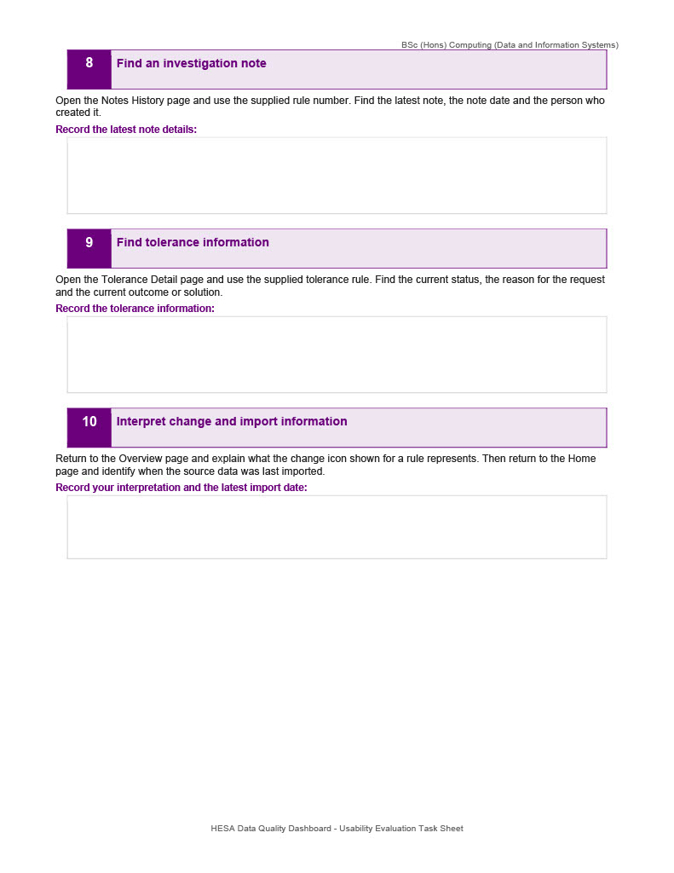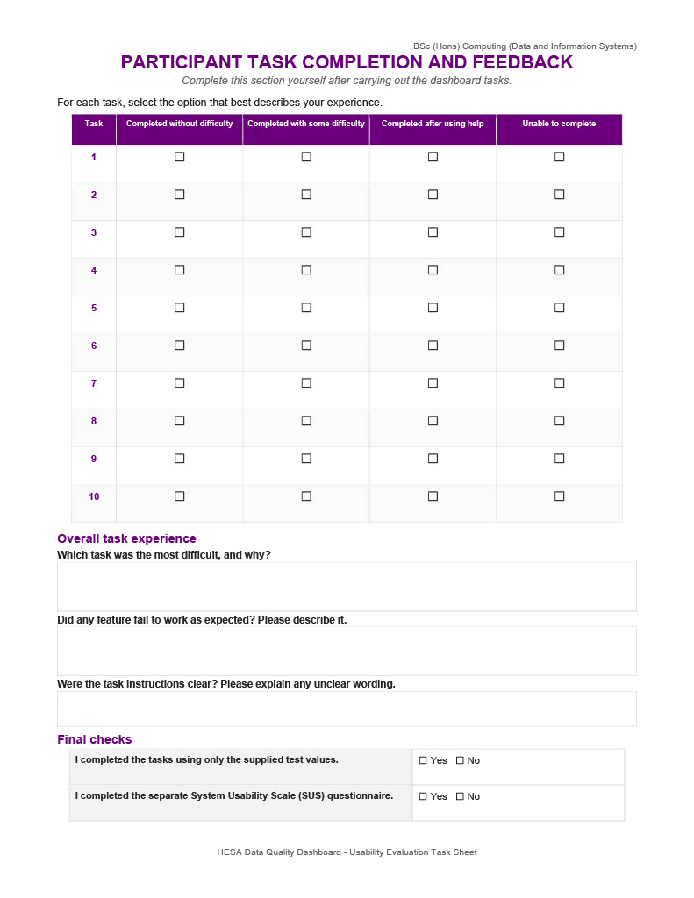

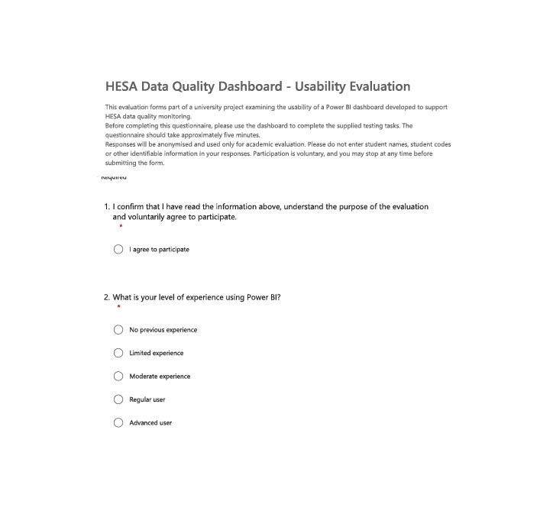
C.2 Microsoft Forms Questionnaire
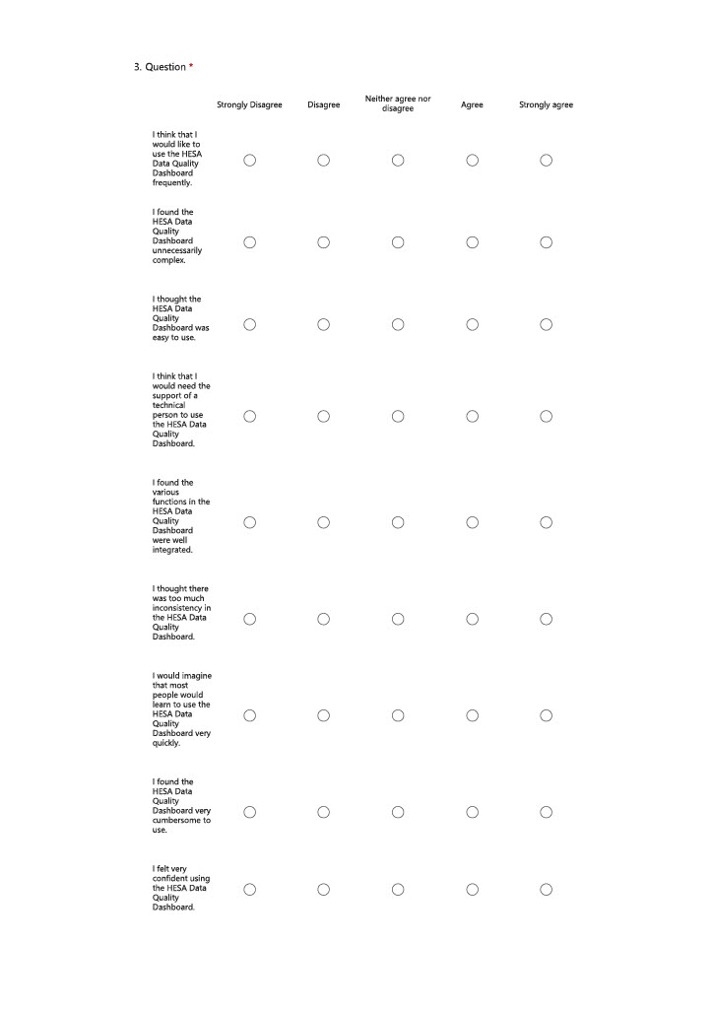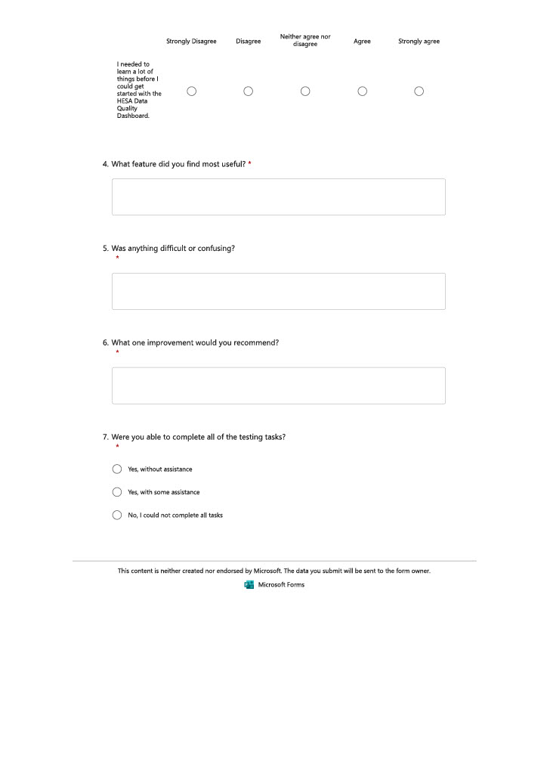

Appendix D - Selected Code Snippets
This appendix contains selected code excerpts that demonstrate the synchronisation, archive review and principal DAX calculations. Internal server names, connection strings and identifiable data are omitted.

D.1 Running the Synchronisation Procedure
USE [HESAOutputs];
GO
EXEC dbo.usp_SyncRulesFromQualityRuleFailures;
GO

D.2 Reviewing Archive Runs
SELECT
ArchiveRunID,
ArchivedAt,
HESAYear,
COUNT(*) AS FailedRules,
SUM(ErrorCount) AS TotalErrors,
SUM(InsideErrors) AS InsideErrors,
SUM(OutsideErrors) AS OutsideErrors
FROM dbo.tblRuleCountArchive
GROUP BY ArchiveRunID, ArchivedAt, HESAYear
ORDER BY ArchivedAt DESC;

D.3 Key DAX Measures
Total Validation Errors =
COUNTROWS('tblQualityRuleFailuresLazy')
Failed Rules =
DISTINCTCOUNT('tblQualityRuleFailuresLazy'[Rule Number])
Affected Records =
DISTINCTCOUNT('tblQualityRuleFailuresLazy'[RowIdentifier])
Rule Error Count Change =
VAR LatestCount = [Latest Archived Rule Count]
VAR PreviousCount = [Previous Archived Rule Count]
RETURN
IF(
ISBLANK([Previous Archive Run]),
BLANK(),
COALESCE(LatestCount, 0) - COALESCE(PreviousCount, 0)
)

Appendix E - Data Dictionary
This object dictionary documents the main SQL and Power BI structures, their key fields and their analytical purpose. The source contains hundreds of rule-specific HESA fields; these are represented through the FieldName and FieldValue structure rather than listed individually. Physical data types and constraints are governed by the final SQL schema.

E.1 Main SQL and Power BI Objects
Object | Key fields | Purpose
[HESA].[tblQualityRuleFailuresLazy] | ImportID, Rule Number, Rule Description, Status, Regulator Name, RowIdentifier, AcademicYear, DateImported, Student.OWNSTU | Current imported HESA validation-failure snapshot.
dbo.tblRules | RuleNumber, RuleDescription, FirstSeenDate, LastSeenDate, InErrorsFile | Persistent master list containing one row per rule.
dbo.tblRuleAssignments | RuleAssignmentID, RuleNumber, HESAYear, AssignedPerson, AssignedDate, AssignmentStatus, SecondarySupport, DCSupporting | Stores rule ownership and assignment information.
dbo.tblRuleNotes | RuleNoteID, RuleNumber, HESAYear, NoteText, NoteDate, CreatedBy | Stores dated investigation notes.
dbo.tblRuleCountArchive | ArchiveRunID, ArchivedAt, SourceDateImported, HESAYear, RuleNumber, ErrorCount, AffectedRecords, InsideErrors, OutsideErrors | Stores rule-level snapshots for historical comparison.
dbo.tblToleranceTargets | Rule, year and target fields | Stores target-rule information used by management reporting.
dbo.[Tolerance Requests 2425] | Rule, description, request date, approval date, reason, category, investigator, solution, outcome and status | Stores operational tolerance-request history.
vwHESA_RuleDashboard | RuleNumber and rule-level measures | Supplies the Overview and Rule Detail pages.
vwHESA_ErrorDetails | ImportID, RuleNumber, record and assignment fields | Supplies record-level investigation information.
vwHESA_RuleNotesHistory | RuleNumber, note and assignment fields | Supplies the Notes History page.
ErrorRecords | ImportID, rule, status, regulator, RowIdentifier, year | Contains one simplified row per imported validation failure.
ErrorFieldValues | ImportID, FieldName, FieldValue, FieldGroup | Contains only the populated HESA fields after unpivoting.
FieldSearch | Field name and group | Disconnected table controlling fields displayed in Error Detail.
DimHESAYear | HESAYear | Shared academic-year dimension.
UserAccess | Email, name and management-access value | Controls welcome text and interface personalisation.

E.2 Key Field Definitions
Field | Definition
ImportID | Technical identifier for one imported validation-failure row.
RuleNumber | Business identifier for a HESA validation rule.
RowIdentifier | Identifier for the entity or record affected by a rule; it is not always a student.
Student.OWNSTU | Student code used only on the authorised search page.
InErrorsFile | Indicates whether a rule is present in the latest imported file.
AcademicYear | Academic-year field used by the imported source.
HESAYear | Academic-year field used by supporting tables and reporting structures.
FieldName | Name of a populated HESA source field after unpivoting.
FieldValue | Value stored in the populated source field.
FieldGroup | HESA entity grouping such as Student, Engagement or ModuleInstance.
ArchiveRunID | Identifier shared by all rule rows stored during one archive run.
ArchivedAt | Date and time when the snapshot was created.

Appendix F - Full Dashboard Screenshots

Figure F.1 - Home page
Figure F.1: Home page
Shows the report introduction, import information, navigation and user welcome content.

Figure F.2 - Overview page
Figure F.2: Overview page
Shows headline validation-error measures, assignment information, rule ranking and links to detailed investigation.

Figure F.3 - Rule Detail page
Figure F.3: Rule Detail page
Shows the selected rule description, error count, assignment information and rule-level evidence.

Figure F.4 - Error Detail page
Figure F.4: Error Detail page
Shows the populated-field matrix or table used for record-level investigation.

Figure F.5 - Notes History page
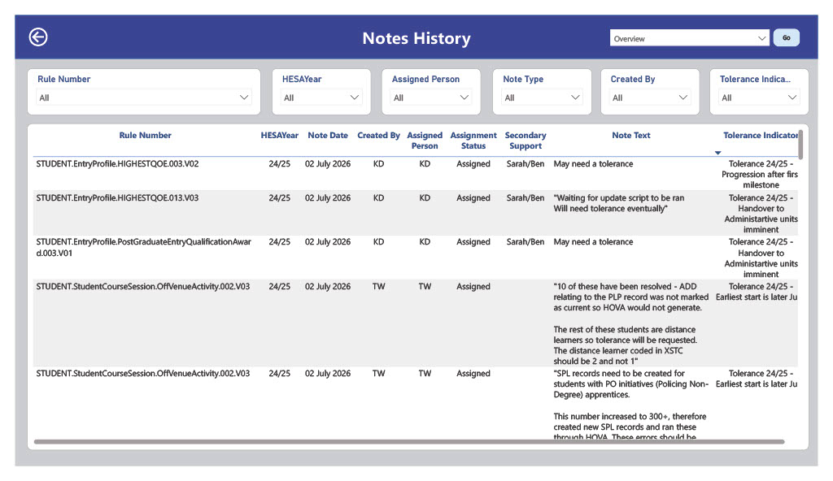
Figure F.5: Notes History page
Shows persistent dated investigation notes and the person who created each note.

Figure F.6 - Tolerance Detail page
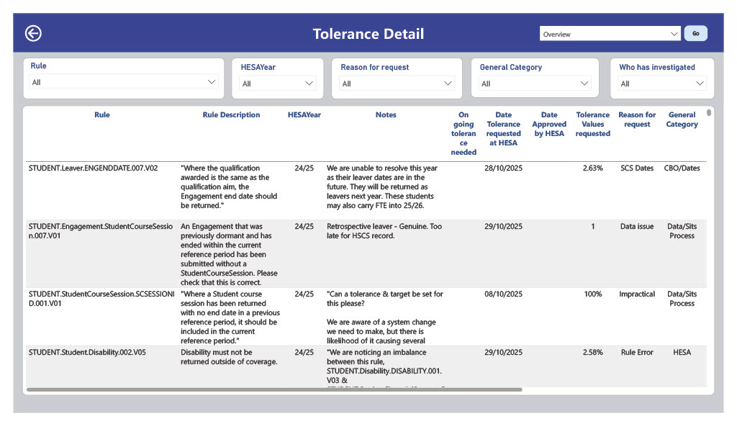
Figure F.6: Tolerance Detail page
Shows tolerance-request status, reasons, outcomes and related operational information.

Figure F.7 - Search Errors by Student page
Figure F.7: Search Errors by Student page
Shows authorised searching with the anonymised Student.OWNSTU code and associated rule counts.

Figure F.8 - Management Page
Figure F.8: Management Page
Shows management-level targets, tolerance or allocation information and audience-specific navigation.

Figure F.9 - Power BI data-model view
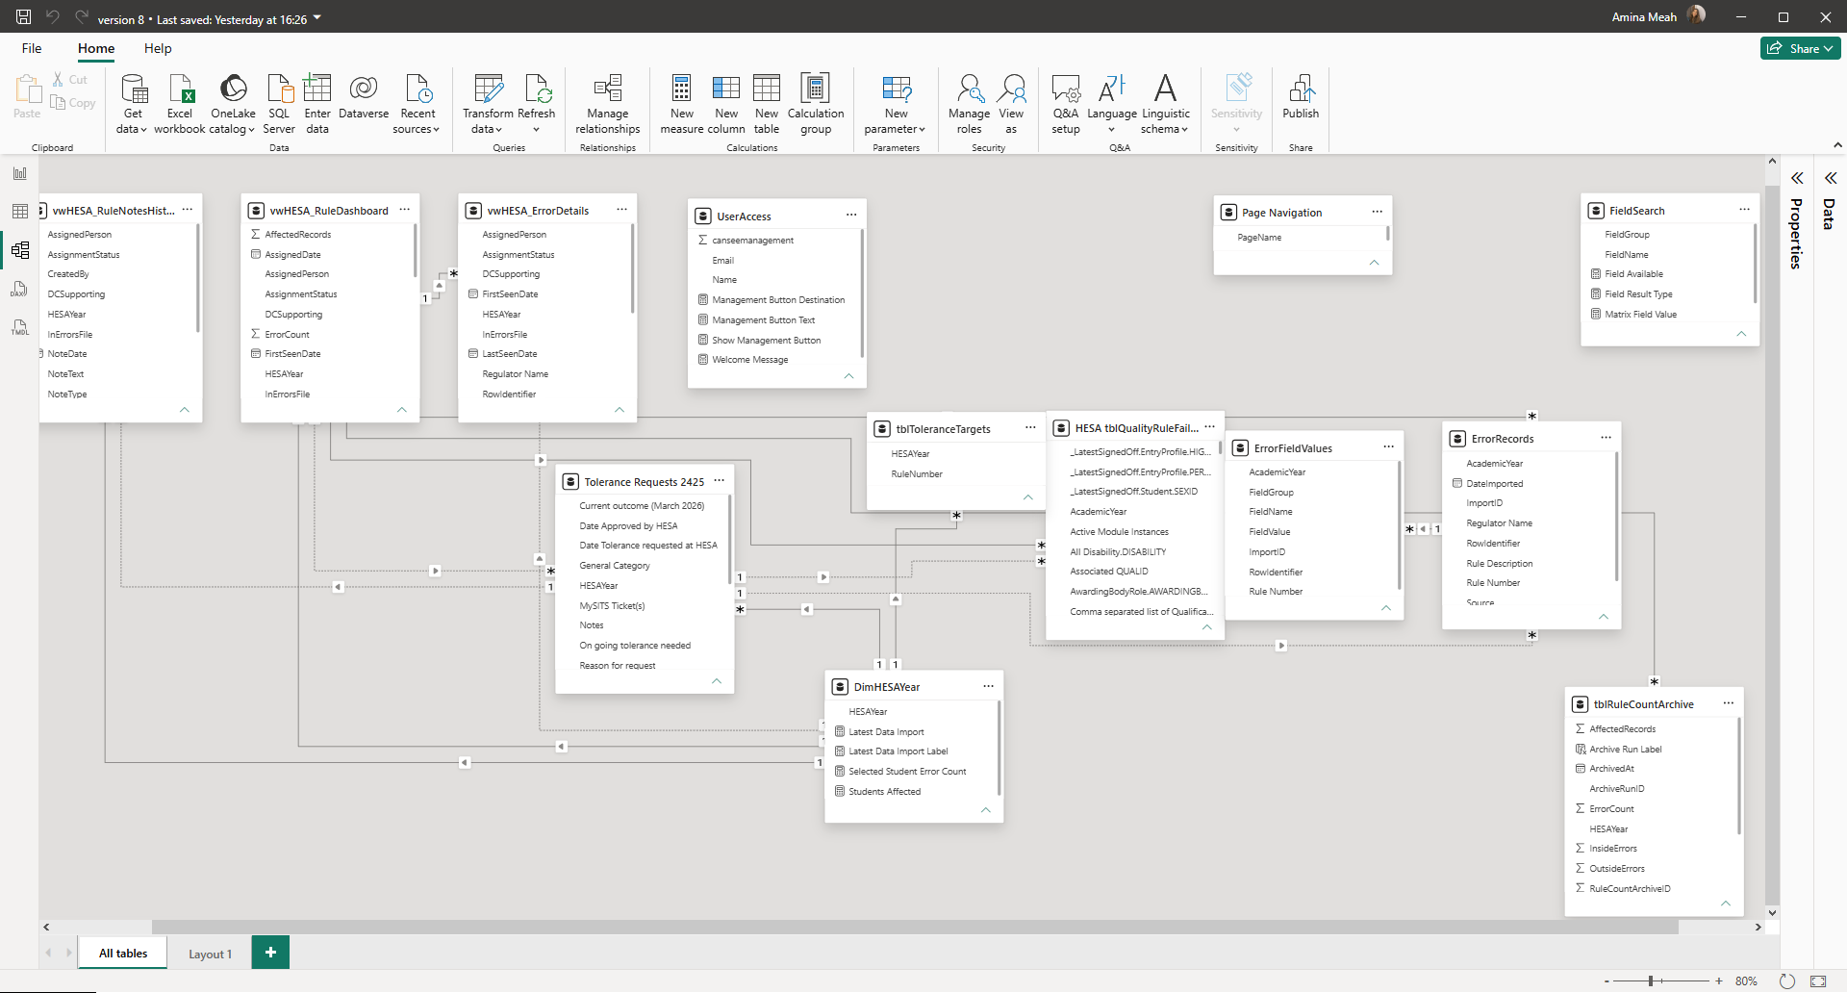
Figure F.9: Power BI data-model view
Shows the relationships between current errors, dimensions, archive data and operational tables.

Appendix G – Dashboard Demonstration Video
A recorded demonstration of the completed HESA Data Quality Dashboard is available using the link below:
https://www.loom.com/share/a3cacae2ed664d91a21259b162e046f1
The video demonstrates the main dashboard workflow, including the Home, Overview, Rule Detail, Error Detail, Notes History, Tolerance Detail, Search Errors by Student and Management pages. It also explains filtering, navigation, record-level investigation, archive-change indicators and the distinction between interface personalisation and formal access control.

