Problem Solving and Decision Making
Module Code: BMSW4004
Student name: Razvan Mucenic
Student Id: 2120426
Task 2
Contents
Introduction 3
The Workplace Problem 4
Analysing Information 4
Root Cause Analysis (RCA) 4
Applying Situational Analysis Models 5
SWOT Analysis 5
Range of Alternative Solutions 7
Evaluation of Alternative Solutions 7
Implementing the Solution 8
Communication Plan with Stakeholders 11
Monitoring and Review Technique 12
Conclusion 13
References 14

Introduction
Problem-solving abilities include the capacity to recognise problems, produce and assess potential solutions, and put into action the options that appear to hold the most promise (Carpenter and Moser, 2020). Interviewers tend to seek this quality in the recruitment process because it is important not only in the profession but also for personal development.
There are problems in each sector associated with each job title. Everyone in the organisation will eventually run into issues that cannot be easily resolved by conducting a quick search on the internet. Because of this, companies need to employ people who are capable of critical and innovative thinking even when faced with ambiguity, uncertainty, and pressure (Whimbey, Lochhead and Narode, 2013). Those who can think creatively and find solutions to problems are valuable to any team, as they are the ones most likely to come up with novel solutions that simplify processes, shorten learning curves, and save costs for end users. These individuals are the ones most likely to come up with solutions that simplify processes, shorten learning curves, and save costs for customers.
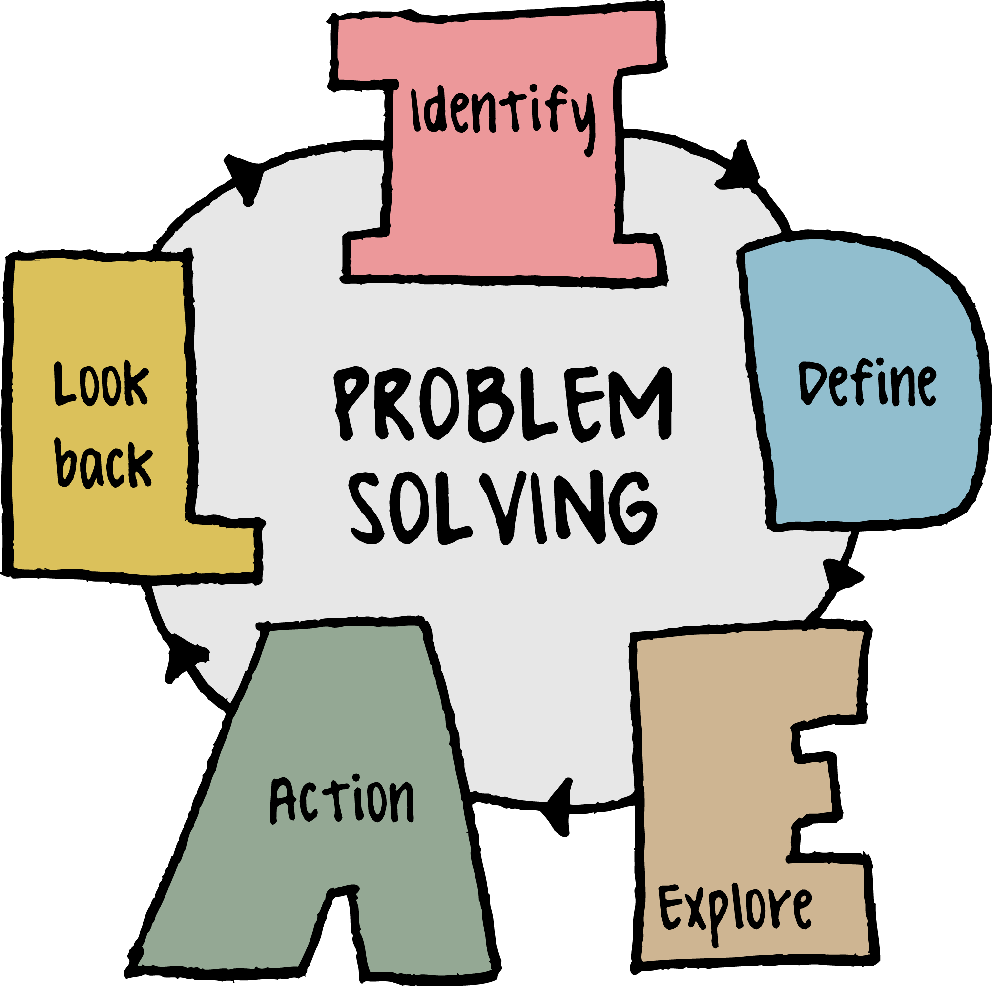
Figure 1: Aspects of problem-solving
Source: Charles (2019)
For this study, J. Sainsbury Plc. has been selected as an illustration of a business that currently struggles with a certain issue. J Sainsbury Plc. is the second largest supermarket chain in the United Kingdom, and the company is responsible for 14.6% of all retail sales in the country (Unite the Union, 2022). In 1869, John James Sainsbury started a grocery store on Drury Lane in London. By the middle of the 20th century, his business had grown to become the largest in the entire country. Its purpose is to assist customers in achieving a high quality of life at the lowest possible cost.

The Workplace Problem
Current Sainsbury's employees who have COVID are eligible for sick leave, which will not count against their absence total before disciplinary action is taken. If an employee at Sainsbury's misses more than 3% of their annual contractual hours of work, which is equivalent to nearly a week and a half of work, they run the risk of facing disciplinary action up to and including termination from their position. The new rule incorporates COVID-19 absences into the calculation for the 3% cap on total absences. Additionally, the policy allows employees who are infected with COVID to continue working (Unite the Union, 2022).
The actual outcome of this new strategy by Sainsbury’s is the dissatisfaction of employees which has threatened the working condition of the organisation. As employees having COVID are also bound to attend the workplace, it puts the customers at risk. The possible outcome of this can be increased employee turnover. As a result, the profitability and reputation of Sainsbury’s will be triggered and so the management needs a solution to this problem.

Analysing Information

Root Cause Analysis (RCA)
The problem arising in the organisation has clearly led to employee dissatisfaction which in turn can increase employee turnover. The possible cause for this problem can be the cost minimisation strategy of the firm as it doesn’t need to recruit additional employees to fill the position of the absent ones (Coccia, 2018). A part of this policy was also aimed at ensuring a higher rate of presence from the employees. However, ignorance about adequate safety measures and lack of concern related to employee motivation can also be held as the potential causes of this problem.
The actual root causes that have led to the dissatisfaction of employees will generate from underestimating the risk of COVID infection among shoppers and employees. Also, the fact that the leave for COVID infection will not be counted under the total granted leave leads to employee rage towards organisational policies. As a result of all these the turnover ratio is expected to go high which will cost Sainsbury’s in the long run (AlBattat and Som, 2013).
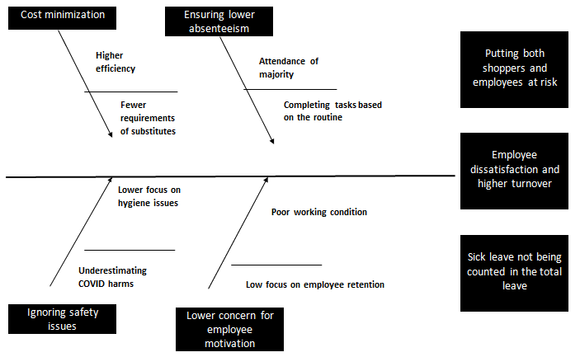
Figure 2: Fishbone diagram

Applying Situational Analysis Models

SWOT Analysis
Strengths
The superior quality of the company's products and services, as well as the company's attentiveness to client comments and requirements, is directly responsible for the company's success in attracting new customers and retaining the ones it already has (Benzaghta et al, 2021). Customers who leave positive feedback have a discernible effect on subsequent business.
One of the marketing strategies that Sainsbury's does is called "Brand Match," and it matches the store's own items against those that are sold by other retailers, such as Aldi and Tesco. This comparison demonstrates that not only are they more affordable, but also that they are of a higher quality.
Sainsbury's maintains consistent two-way engagement with its customer base through social media and routinely solicits their feedback through online surveys.

Weaknesses
The majority of stores experienced a decrease in business as a direct result of the high levels of competition that exist in their industries as well as the possible threat posed by internet merchants. Because there is so much competition in the market, Sainsbury's has chosen to maintain low pricing in order to reduce its profit margins (Xiao, Chen and Yu, 2021).
Switching brands is a practice that poses considerable risks to well-established names in the retail industry. Despite its comprehensive reward programmes and frequent incentives, Sainsbury's has a hard time keeping consumers as loyal as they once were.
Sainsbury's has been struggling with significant declines in revenue and net profit for the better part of the past two years, in comparison to estimates made for the year 2020.
Opportunities
Due to the fact that Sainsbury's needs to be open twenty-four hours a day, seven days a week, the grocery chain ought to install self-checkout technology so that customers can complete their purchases without assistance (FATRICIA, 2016). The utilisation of this strategy would result in an increase in sales as a direct consequence of how uncomplicated and successful it is.
It has recently become possible for the company to take advantage of a fantastic opportunity to expand its product line, establish new revenue sources, and enhance its earnings. The corporation should now attempt to expand its operations to other nations, as the consumer market in this country is the largest consumer market in the world.
Threats
Sainsbury faces dangers to its existence not only from businesses that compete with it on price but also from businesses that develop innovative technologies. However, the competitors who focus on specific niches in each of the many categories capture a significant share of the market demand (FATRICIA, 2016).
The new laws and restrictions that have been imposed on companies have been extremely detrimental to the corporation, as a result of which it has experienced significant losses. According to the regulations of several nations, differences in product liability law have been a source of potential danger for Sainsbury's goods and services.

Range of Alternative Solutions
The analysis of the problem eventually leads to the possible solutions developed considering a range of criteria. There can be formulated two strategies for Sainsbury’s to reduce employee dissatisfaction – considering the leaves for COVID-19 as a part of total leave and making some adjustments in the current policy given the current financial condition as the profitability is declining.
Option 1: Including all the leaves for COVID under the total permitted leave
Option 2: Not including COVID leave under total leave only for those employees who can be allowed to work from home

Evaluation of Alternative Solutions
The following table resembles the weighted decision-making matrix to value the options established to address the current problem. Here five criteria have been chosen which are expected to be the causes of this problem and the ratings on a scale of five infer to what extent the severity of these causes can be minimised by the options (Roszkowska, 2013).
Criteria | Weight | Alternatives
Criteria | Weight | Option 1 |  | Option 2
Criteria | Weight | Score | Total | Score | Total
Lower absenteeism | .20 | 1 | .2 | 4 | .8
Higher efficiency | .15 | 2 | .3 | 3 | .45
Higher profitability | .15 | 2 | .3 | 2 | .3
Reduced employee dissatisfaction | .30 | 5 | 1.5 | 4 | 1.2
Lower risk of customers | .20 | 1 | .2 | 3 | .6
 |  |  | 2.5 |  | 3.35
Table 1: Weighted average decision-making matrix

Implementing the Solution
The outcome of the weighted decision-making matrix leads to finalising option 2 which generates a higher value. Now to implement this problem the next steps should be designed carefully with the following processes.
Change Management
The change in the existing company policy that is expected to be introduced with option 2 now requires successful implementation. The following ADKAR model will be helpful to implement the changes throughout the organisation.
Outcomes | Explanation
Awareness | Firstly the relevant stakeholders including employees, management and the board should be aware of why change is necessary (Wong et al, 2019). Basically, this policy was creating dissatisfaction among employees and customers.
Desire | The management should take the initiative to propose the change keeping its necessity in mind as it keeps the employees satisfied and reduces risks for all.
Knowledge | The next step leads to developing a plan of how to change the existing policy. The whole implementation plan in the following section describes this process.
Ability | The behaviour of the related parties toward the change should be considered (Wong et al, 2019). If everyone has a positive attitude on this matter further steps need to be pursued.
Reinforcement | The change in policy should be communicated with and practised whenever an employee gets COVID infected.
Table 2: Description of ADKAR change management model
Implementation Plan
Defining goal: Here the goal is to reduce the current employee dissatisfaction due to the new policy regarding COVID leave as not being treated under normally permitted leaves. To reduce the level of dissatisfaction, a strategy needs to be determined.
Conducting research: The research includes that there are two aspects that should be considered. First of all, the employees who are infected with COVID seek paid leave to be counted under the total permitted days of leave (Ferreira and Kuniyoshi, 2015). However, the organisation has the urge to ensure efficiency and increased profitability since the financial condition is not very good.
Mapping out risks: Considering the aspects defined in the prior stage the risks and benefits associated with each alternative will be assessed. For example, option 2 which is being considered the optimum solution in this case will not be able to maximise employee satisfaction. However, it performs better to increase efficiency and reduce the risk of infection.
Scheduling milestones: The main tasks have been identified and time has been allocated using a Gantt chart.
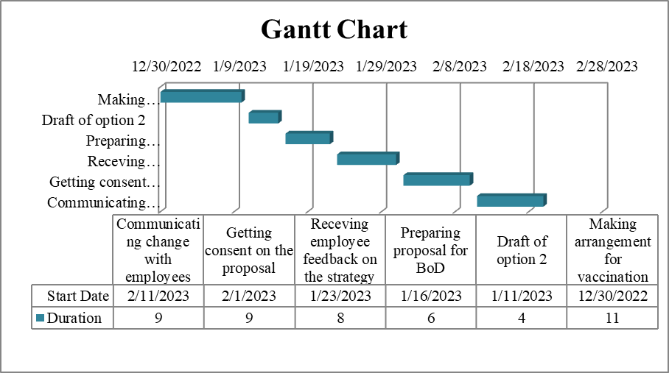
Figure 3: Gantt chart
Source: Geraldi and Lechter (2012)
Receiving recognition: Those who are relevant to the change such as the planning and execution committee will be held liable to get the consent of the upper management and the employees on the option to be implemented.
Communicating the new strategy: The new strategy will then be familiarised with the employees all over the organisation particularly those who will be directly impacted by its outcome.

Communication Plan with Stakeholders
There are a number of stakeholders of the company having direct or indirect associations and interests. The following are the most relevant stakeholders who are expected to be directly impacted by the change in the policy of the organisation to solve the problem of employee dissatisfaction.
- Directors
- Executives and management
- Customers
- Shareholders
Power/Interest Matrix
+  Level of Influence/Power  - | - Level of Interest +
+  Level of Influence/Power  - | Meet Their Needs  Executives and Management | Key Player  Directors
+  Level of Influence/Power  - | Low Priority | Keep Informed  Shareholders and Customers
Table 3: Power and interest matrix in Sainsbury’s
Stakeholder Communication Plan
Stakeholder | Power/Interest | Key Interests and Issues | Communication Vehicle | Frequency | Comments
Directors | High interest, high power | Fee and compensation | Board meeting | Once per year | Collaborate
Shareholders | High interest, low power | Share price | Annual general meeting | Monthly | Involve
Executives and management | Low interest, high power | Salary | Meeting and sessions | Quarterly | Consult
Customers | Low interest, high power | Quality products and service | Social media | Quarterly | Consult
Table 4: Stakeholder implementation plan in Sainsbury’s

Monitoring and Review Technique
The ADKAR gap model identifies any gap remaining in the five-component model. Among the five stages of implementation, Sainsbury’s is expected to lag behind in the ‘ability’ phase since it denotes the behaviour or attitude towards the change. The successful implementation of this change will require consent from relevant parties and their acceptance of the new leave policy. Otherwise, it will stick to ‘frustration’ and the transition will not be complete (Wong et al, 2019).
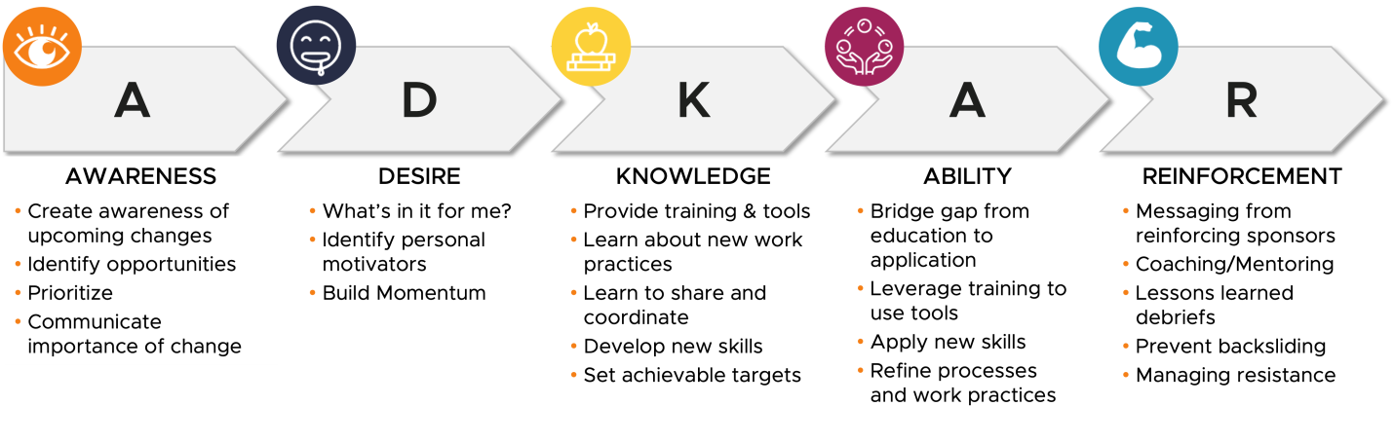
Figure 4: ADKAR gap model
Source: (Wong et al, 2019)

Conclusion
The report creates an opportunity to understand the core of problem-solving skills and apply it simultaneously. The understanding of the problem itself leads to the identification, solving and implementation of changes from the context of Sainsbury’s. there has been the application of crucial models and analysis tools to facilitate the presentation of facts. However, it needs to be realised by now that the problem Sainsbury’s is currently facing needs to be handled as soon as possible since it concerns both the internal and external parties of the business. At the same time, successful implementation of the change in policy should be ensured.

References
- AlBattat, A.R.S. and Som, A.P.M. (2013) Employee dissatisfaction and turnover crises in the Malaysian hospitality industry. International Journal of Business and Management, 8(5), p.62.
- Benzaghta, M.A., Elwalda, A., Mousa, M.M., Erkan, I. and Rahman, M. (2021) SWOT analysis applications: An integrative literature review. Journal of Global Business Insights, 6(1), pp.55-73.
- Carpenter, T.P. and Moser, J.M. (2020) The development of addition and subtraction problem-solving skills. In Addition and subtraction (pp. 9-24). Routledge.
- Charles, P. (2019) Five key problem solving skills for professionals, Transport Futures Institute. Available at: https://transportfutures.institute/key-problem-solving-skills/ (Accessed: December 22, 2022).
- Coccia, M. (2018) The Fishbone diagram to identify, systematize and analyze the sources of general purpose Technologies. Journal of Social and Administrative Sciences, 4(4), pp.291-303.
- FATRICIA, R.S. (2016) SWOT ANALYSIS OF SAINSBURY’S SUPERMARKET. Jurnal Manajemen Terapan dan Keuangan, 5(1), pp.19-35.
- Ferreira, A.A. and Kuniyoshi, M.S. (2015) Critical factors in the implementation process of integrated management systems. JISTEM-Journal of Information Systems and Technology Management, 12, pp.145-164.
- Geraldi, J. and Lechter, T. (2012) Gantt charts revisited: A critical analysis of its roots and implications to the management of projects today. International Journal of Managing Projects in Business.
- Peerally, M.F., Carr, S., Waring, J. and Dixon-Woods, M. (2017) The problem with root cause analysis. BMJ quality & safety, 26(5), pp.417-422.
- Roszkowska, E. (2013) Rank ordering criteria weighting methods–a comparative overview. Optimum. Studia Ekonomiczne, (5 (65)), pp.14-33.
- Unite the Union (2022) Sainsbury's Covid Absence Policy Change 'puts workers and shoppers at risk', Trade Union, Unions UK, Workers Union - Unite the union. Available at: https://www.unitetheunion.org/news-events/news/2022/april/sainsbury-s-covid-absence-policy-change-puts-workers-and-shoppers-at-risk/ (Accessed: December 22, 2022).
- Whimbey, A., Lochhead, J. and Narode, R. (2013) Problem solving & comprehension. Routledge.
- Wong, Q., Lacombe, M., Keller, R., Joyce, T. and O'Malley, K. (2019) Leading change with ADKAR. Nursing management, 50(4), pp.28-35.
- Xiao, B., Chen, Q. and Yu, Z. (2021) April. Research on the Investment Value of Sainsbury’s. In 2021 6th International Conference on Social Sciences and Economic Development (ICSSED 2021) (pp. 108-115). Atlantis Press.

