  Component One: Student Journal (learning log). | Student No: | T Thomas 2112910
 | Module Title: | International Hotel Management
 | Module Code: | BMIH4004
 | Lecturer: | Muhammad Casssamo
Summary of My Learning
According to Dahlan, (2023), there exists a strong correlation between the performance of a hotel's front office and the degree of client satisfaction. Throughout the course of a customer's visit, it is apparent that the front desk workers engage in the most extensive direct engagement with customers. Currently, I am participating in a professional placement at Premier Inn London Hackney Hotel. The implementation of a visually appealing presentation by the front office's operations personnel greatly increases the probability of customers making a repeat reservation and later crafting a positive evaluation. One might postulate that the front office has a direct influence on the entire efficacy of the company (Dahlan, 2023). The front office of a hotel plays a crucial role in its overall functioning, since it acts as the first point of contact for customers. The scope of this industry segment covers a diverse array of operations, such as managing bookings, facilitating guest interactions, conducting check-in and check-out processes, providing telephone services, handling financial transactions and payment processing, offering currency exchange services, assigning rooms, and addressing inquiries (Aprianto, 2018).
Throughout the lecture, I gained insights into the Front Office, often recognized as the key hub of a hotel. In the context of the hospitality industry, the term "hotel sector" is often used to denote the primary section of lodging establishments, including the main entrance and reception area of a building. The term "Front Office" pertains to the strategic positioning of this division inside the hotel's lobby, ensuring its conspicuousness to patrons, customers, and other relevant parties. This specific section bears the duty of combining all elements and efficiently communicating the results to other sectors (Woolard, 2016).
It is widely acknowledged that around two-thirds of a hotel's income comes from the sale of its accommodation facilities, rendering this department important to the overall profitability of the business. The provision of valuable services during each stage of the tourist experience, including pre-arrival, admission, occupancy, and departure, has significant importance.
The seminar facilitated the acquisition of a novel comprehension regarding the importance of the Front Office department inside the Premier Inn London Hackney Hotel (Woolard, 2016).
Skills required to work in the front office
According to Bailey, (2022), the front desk workers are responsible for overseeing the check-in and check-out processes for many customers. The first favourable impressions play a vital part in guaranteeing consumer pleasure. The mastery of effective communication skills is of utmost importance for those working in front office positions. I possess the capacity to engage in communication with others via both spoken and nonverbal modalities. The establishment of a connection with visitors necessitates the implementation of efficient and substantial interactions between the front office workers and customers. The proficiency of front desk personnel in communication is of utmost importance in managing visitor queries, addressing concerns, and promoting cooperation within the organization. According to Bailey, (2022), it is essential for front-desk professionals to possess effective problem-solving abilities.
The following talents are enumerated:
- Interpersonal skills and communication skills
Daily I interact with guests, employees, vendors, and other stakeholders as a front office manager.
- Cooperation and leadership abilities
Managing bellhops, concierge services, reservation agents, and receptionists are among my duties.
- Making decisions and addressing problems
Overbookings, crises, system malfunctions, and guest complaints may all arise in front office administration, which is a demanding field.
- Organizing and managing time
Front desk supervisors oversee many projects in hectic work settings. Good time management abilities are necessary to plan, prioritize, coordinate, and carry out your task in an accurate and effective manner (Proctor, 2018).
Personal Reflections
By actively engaging with the course content, particularly the chapter on nonverbal communication, I acquired a substantial amount of knowledge about human communication. Nonverbal communication refers to the use of nonverbal cues and gestures in order to transmit and comprehend meaning. This phenomenon is seen on a daily basis. Prior to reading this chapter, I lacked awareness about the frequency with which the behaviours described therein are used in our everyday talks. The front office relies on effective and unified communication as a fundamental need.
Applying the Theoretical Knowledge
Academic Knowledge is well recognized as a prominent leader in the academic writing industry. Since our establishment, our organization has seen significant growth, resulting in the inclusion of a diverse range of highly skilled writers and researchers from various parts of the world. According to J. et al., (2012), students across many academic disciplines might get advantages from using the custom-written sample answers provided by Academic Knowledge. We engage the most qualified academic professionals to cooperate with us on this endeavour. Our objective is to provide superior academic writing support. Our organization offers a specialized service in which we allocate the most proficient writer to each project, ensuring a highly tailored model answer. Our main areas of specialization include academic writing and research, with proofreading and assessment across several topic domains. Enhancing my communication abilities will facilitate proficient interaction with hotel visitors. The individual in question demonstrates the necessary skills and expertise to effectively engage with visitors, address any concerns or challenges that may arise, and provide them with precise and comprehensible information (J. et al., 2012).
Importance of The Topic in Hospitality
Apart from supervising visitor information and room statuses, the hotel front desk provides optimal client satisfaction. A hotel requires the proper staff, furnishings, structure, and training to function well. The front office is often made up of staff members from departments like marketing, sales, and customer service that interact directly with consumers. Since the front office deals with clients directly the most, it generates the bulk of the company's revenue. The system controls pre-arrivals, check-in, checkout, reservations, and visitor departure. Additionally, the department ensures the satisfaction of its guests. In order for a hotel to be successful, its front desk employees need to make guests feel special and provide exceptional service (Albayrak, 2015).

Component Two
Contribution to Overall Module Assessment: 25%
Trip Advisor Review Response
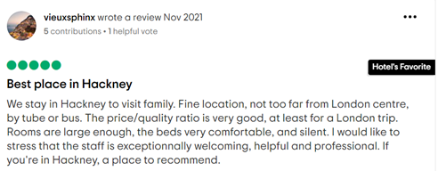

Dear valued customer,
Greetings, I really value your cooperation. We express our gratitude for your decision to choose our hotel as your accommodation choice. Our approach is founded on the prioritization of client needs and satisfaction. As an integral component of its comprehensive marketing strategy, Hilton Worldwide Holdings Inc. effectively leverages its loyalty program, namely The Premier Inn London Hackney Hotel Honours, to foster customer retention, enhance customer satisfaction, and provide a distinctive competitive advantage vis-à-vis its industry rivals. The primary objective of the Premier Inn London Hackney hotel is to cultivate an environment that promotes a cohesive and effortless encounter for its guests. This is achieved via the establishment of spaces that encourage social interaction, efficiency, and a feeling of inclusion. The Premier Inn London Hackney hotel garners diverse feedback from its patrons. The advantageous proximity to several transportation options is highly valued by numerous visitors due to the quick accessibility it provides to the urban core. The accommodations are often seen to include cleanliness, enough space, and comfort. However, a few individuals have reported minor cleaning concerns and antiquated furnishings. There exists a divergence of opinions on the service, whereby some visitors commend the amicability and effectiveness of the staff, while others express discontentment with the lack of uniformity and disregard. Certain customers have expressed dissatisfaction with the hotel, judging it to be excessively expensive due to perceived inadequacies in its amenities and service quality. Our establishment endeavours to cater to the needs of both corporate and recreational travellers, as well as host sizable gatherings. To acknowledge outstanding individuals and achievements, our recognition approach incorporates state-of-the-art technology, meticulous event coordination, and unique award presentation methods. The primary aim of our organization is to establish ourselves as the preeminent global supplier of hospitality services, effectively catering to the requirements of customers, employees, and stakeholders. Our organization places utmost importance on providing exceptional lodgings, meals, and drinks. The primary objective of our establishment is to provide our patrons affordable and pleasant accommodations, so enabling them to lead a satisfactory lifestyle, perform optimally in their professional endeavours, and make constructive contributions to the local community. In order to get a desirable return on investment, our organization acknowledges the need of cultivating a workforce comprised of competent, motivated, and enthusiastic employees. We appreciate the dedication and commitment you shown in sharing your feedback. We express our gratitude for your patronage and accommodation at our hotel.

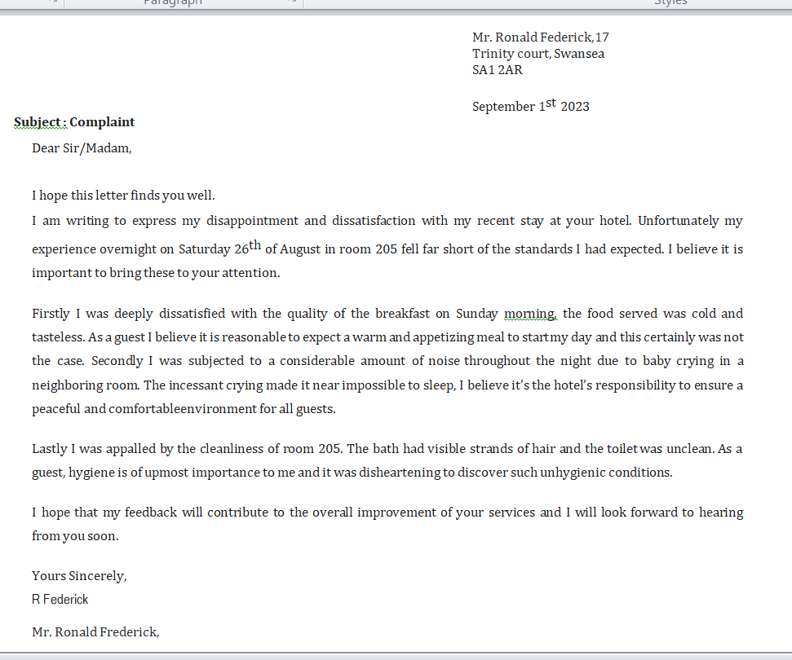
Screen shot of referenced Trip Advisor review used

Letter of complaint response
Sincere salutations Federick, Donald Ronald,
The Premier Inn London Hackney hotel strives to provide excellent guest experiences, so we're sorry your stay wasn't as enjoyable as you wanted. We've noted your suggestions and will improve. We apologize for the poor service. Instead of checking in, you write that your lodgings were unavailable, even though you had made arrangements. Additionally, the lodgings were clean, the food options were great, and adjacent residences were quiet. The Premier Inn London Hackney hotel's management apologizes for any issue’s guests encountered. Our front desk staff received further training to handle this issue. We are making significant efforts to find a solution. As a consequence of this, when clients arrive at the hotel, employees are required to store their baggage and receive meal tickets for the restaurant. According to your point of view, the noisier homes of your neighbors might be the source of greater disruption in the environment in which you live. Our first successes have been quite promising. The insulation of both walls and floors has benefited from recent developments in insulation technology. Concerns about housing were addressed with a number of preventative measures. It was decided to add soundproofing materials such as windows, curtains, wall and ceiling panels, and tiles. The proper fitting of doors is another crucial factor in ensuring a smooth shutting. The "floating bedroom" concept was first used in the hotel industry by Premier Inn London Hackney. As a result, the hotel was effective in managing the noise from the outside and the activities on the lower floor. In this arrangement, each bedroom is separate. Architectural changes attempt to exceed WHO noise reduction guidelines. Quadruple-glazed windows and wall and ceiling acoustic linings are among these enhancements. Other staff members keep the rooms and facilities tidy. The staff will change linens and towels, ventilate the room, and restock. Follow cleaning instructions to dust the lavatory and disinfect frequently touched surfaces. Finish carpet and upholstery cleaning with a hoover. Reduce or eliminate bathroom garbage. Our food is too warm or tasteless, according to reports. Besides chafing dishes, you may use hot warming trays, multicores, slow cookers, and toaster ovens to keep meals warm. We also ask the chef for advice to improve the dinner. The complainant alleges their accommodations were not changed after calling the front desk. After carefully reviewing our documentation, we could not help you. We apologize for the severity of the issue and for our inability to improve your evening. A gift ticket or coupon for a future visit is included with the fake pine. Our Premier Inn London Hackney hotel will also give you 50% off your next stay.
We appreciate your dedication and hard work in making well-considered suggestions.
Sincerely,
ABC
Front Desk Manager
The Premier Inn London Hackney hotel

Component Three
The whole sequence of activities that a visitor undergoes, commencing prior to their arrival and culminating with their departure, is sometimes referred to as the "guest cycle." The four stages of the guest cycle are defined by the interactions and activities that take place. The technique may be succinctly summarized into four phases. The process of traveling may be categorized into four distinct phases, namely arrival, pre-arrival, stay, and departure.
During the duration of a visitor's stay, it is essential that front desk personnel possess a comprehensive understanding of accounting regulations and guest service protocols. In order to provide exceptional service, it is essential for front desk personnel to possess a comprehensive understanding of hotel operations. One often used method in front desk management is known as the Guest Cycle (Jayanti, 2023).
Element 1 – Pre-Arrival
The guest chooses a hotel during the pre-arrival stage. Many factors can influence the decisions made by guests, such as past interactions with the establishment, recommendations from friends and colleagues, proximity to the hotel, promotions, business affiliation, reputation of the hotel brand, booking practices of travel agencies, and loyalty programmers.
The decision of a visitor to proceed with a reservation can be impacted by various factors, including the level of convenience offered and the proficiency of the agent in communication. These components have to include thorough details on the hotel's features and services, including accommodations, costs, leisure spaces, and neighboring points of interest (Hewson, 2017).
The sales office is the space set aside for single and non-group bookings. Hotel personnel have to have a strong focus on sales, and the hotel should provide a favorable exterior image.
A reservation is produced as soon as the hotel administration software confirms that a specific reservation is accepted. The creation of this reservation record marks the beginning of the restaurant's customer cycle. Because of the guest details provided in this registration, the hotel personnel may provide personalized service to the guest throughout their stay. In order to assign rooms and determine the appropriate room prices that visitors are liable for paying to their accounts throughout their stay, hotel staff gathers guest preferences during the reservation process (Hewson, 2017).
The application of reservation data allows for guest-beneficial anticipatory service. In spite of this, the main goal of booking is to ensure that a traveler will have a room when they arrive at the hotel (Hewson, 2017).
Element 2 – Arrival
The commencement of a visitor cycle is marked by the registration procedure and the assignment of lodging for a tourist. The first phase of the cycle has begun. Upon the visitor's arrival at the hotel, the front desk facilitates a commercial transaction between the guest and the hotel on behalf of the guest. The primary tasks of a front office staff member include two key areas: effectively handling guest queries related to hotel prices and bought packages, and giving comprehensive information about the hotel's rules relating to these packages.
The front desk staff is required to always verify the current status of the guest's reservation before initiating the check-in or registration process. Regardless of the reservation status of a client, walk-in customers, sometimes referred to as walk-in guests, may provide front desk workers with an opportunity to make cash via their efforts (Dcosta, 2003).
It is essential to provide a valid registration card or registration number while checking in. The card is received and filled out by the front desk as part of the registration procedure, with the purpose of expediting the gathering of necessary information. The registration card should have crucial facts, including billing and reservation information, personal information, credit card details, address particulars, passport and visa information for individuals from other countries, billing instructions, and the number of individuals occupying the residence. In order for the hotel and the visitor to avail themselves of particular legal advantages, it is essential for both parties to get the guest's signature on the registration card.
Upon verification and signing of the payment method and departure date, the registration procedure is considered to be completed. Guests are accompanied to their accommodations by guest service colleagues or guest service managers, who may also provide them with instructions and a key to their room. After successfully completing the check-in procedure and gaining access to the assigned room, the guest proceeds to the occupation phase of the visitor cycle (Dcosta, 2003).
Element 3 – Duration of stay
The front desk staff's portrayal of the hotel is important throughout occupancy.
The front office handles guest inquiries and is the hotel's main contact. Among visitors' information and supply providers (Dcosta, 2003).
Front desk workers must be diligent in answering visitors' questions and requests. Front desk workers strive to exceed visitor expectations with proactive service. This encourages guests to return to the hotel.
Security is crucial during guest stay. Protecting financial resources and valued assets is one worry. The front desk must follow the hotel's standard operating procedure for handling keys, property surveillance, safe deposit boxes, guests' possessions, and emergencies.
Restaurant, telephone, internet, and travel desk costs might affect the guest and hotel account during occupancy. Most of these costs will be posted to the guest account per front office policy. In most cases, lodging expenses are the largest expenditure on the guest folio.
In the occupancy stage, the front office must verify charges posted to guest accounts and examine accounts against assigned credit limits. Security is crucial during guest stays. Financial and asset protection are among the above reasons. The front desk staff must follow hotel operational procedures to organize hotel keys, monitor property surveillance, manage safe deposit boxes, handle guests' personal belongings, and respond to emergencies (Dcosta, 2003).
Guests and hotels may incur expenses for food, telecommunications, internet, and travel assistance under occupation. Most of these expenditures are posted to the guest's account per front office processes. In most cases, the guest's bill's main expenditure is lodging.
During occupancy, the front office reviews guest account charges and compares them to established credit limitations. It also emphasizes financial responsibility (Bailey, 2022).
Element 4 – Departure
The last step of the visitor cycle is often known as the departure stage, and it is at this stage that the guest services and guest accounting components are finished.
At the conclusion of their stay, guests are obligated to check out of the hotel, pay any outstanding bills in full, hand over their room keys to the front desk, and then exit the premises. After a visitor checks out of their hotel, the staff at the front desk immediately checks the availability of the other rooms and then tells the housekeeping staff of the situation described above as soon as possible. By using property management software, a hotel is able to effectively and automatically keep track of the state of each individual guest room.
During this time frame, hotel guests are also provided with an opportunity to provide feedback in the form of a guest feedback form (Bailey, 2022).
References
Albayrak, T. (2015) ‘Importance Performance Competitor Analysis (IPCA): A study of hospitality companies’, International Journal of Hospitality Management, 48, pp. 135–142. doi:10.1016/j.ijhm.2015.04.013.
Aprianto, E. (2018) ‘Need analysis and its implementation of English skills in front office department of Hotel Industry’, Education of English as A Foreign Language, 1(1), pp. 1–6. doi:10.21776/ub.educafl.2018.001.01.01.
Bailey, P. (2022) ‘The training and qualifications required for office work’, Mastering Office Practice, pp. 277–283. doi:10.1007/978-1-349-07876-9_19.
Dcosta, S. (2003) ‘The arrival of the Portuguese’, Tanegashima - The Arrival of Europe in Japan., pp. 16–41. doi:10.4324/9780203479575-10.
Fadia Lutfiana Dahlan, F. (2023) ‘Efforts of front office department to increase guest satisfaction at Padma Hotel Semarang’, The International Conference on Education, Social Sciences and Technology (ICESST), 2(2), pp. 115–128. doi:10.55606/icesst.v2i2.292.
Hewson, C. (2017) ‘A new arrival!’, Practical Pre-School, 2017(Sup196), pp. 7–8. doi:10.12968/prps.2017.sup196.7.
J., D., E., K. and Gary, J. (2012) ‘Applying social sciences research for public benefit using knowledge mobilization and social media’, Theoretical and Methodological Approaches to Social Sciences and Knowledge Management [Preprint]. doi:10.5772/37533.
Jayanti, J. (2023) ‘Cleaning procedure of a guest room’, Hotel Housekeeping Management [Preprint]. doi:10.23912/9781911635543-5503.
Proctor, T. (2018) ‘Decision making and problem solving’, Creative Problem Solving for Managers, pp. 281–298. doi:10.4324/9780429458255-14.
Woolard, A. (2016) ‘Everyone assumes the animals all know each other’, Colorado Review, 43(3), pp. 171–171. doi:10.1353/col.2016.0111.

