Contemporary Issues in leadership
Name
University

Table of Contents
Introduction 3
What is Leadership? 3
Human Resource Management 3
International Human Resource Management 4
Difference Between HRM and IHRM 4
Leadership in HRM 4
HRM issues in Capgemini 4
Issues at Human Resource Management (Capgemini) 5
Vision of HR maturity Model 5
Conclusion 6

Introduction

What is Leadership?
They say a leader is not built in a day. It is a practice of positivity and confidence and a process of fast decision-making. It is a quality that needs many other essential and strong qualities to become a leader.
Leadership is the process of becoming a leader. It is an exercise that is developed with practice over time. Leadership is a quality whereas a leader is a person who possesses this quality. Leadership can also be understood as an influence of a person on a crowd or a team.
Some important qualities of leaders are
- Confidence
- Observance
- Ambitious
- Positive
- Visionary
- Excellent Managers

Human Resource Management
Human Resource Management is one of the most prestigious departments of companies around the world. Human Resource Management is the most demanded management role in the world.
It includes recruitment of staff, interviewing human resources, processing payrolls, taking care of the needs of the employees, and arranging company meets and outings. Human Resource Managers also take care of training the staff as per the needs of the company. There are many functional units of HRM within the department. Everyone has a specific role. The most common ones are, recruiting, event management, training, and Health care.

International Human Resource Management
IHRM or International Human Resource Management system is a system of HRM Management that works in global firms. It is concerned with the issues of Human Resources Management across MNCs and international firms and businesses.
International Business needs Management of employees using International laws, language barriers, and visas for global offices.

Difference Between HRM and IHRM
Many factors distinguish between domestic HRM and International HRM.
Where HRM has simpler roles in terms of recruitment and management whereas International HRMs recruit people globally and are concerned with coordination, cross-country setting, and administrative processes regardless of the borders.
Most the IHRMs have various branches of Management. The International human resource management systems are more complex and handle a wide range of issues including pay scales according to countries, time zones and handling regional offices and managing virtual meetings.

Leadership in HRM
The leadership as a trait is the most essential to Human Resource Management system. The HR teams can positively affect the company culture which directly and indirectly affects the profits of the firm. A bad company culture can make employees and hence losses in the financial market.(Hughes, 2013)
The HR Manager's goal today is to create an environment that makes employees stay with the company. The cost of training an employee is high. The company does not wish to lose employees, so, logically, they would not want them to leave.

HRM issues in Capgemini
Capgemini is a global consulting organization that was established in 1967.
The consulting company offers services related to outsourcing, consulting, promotions, accounting, etc.
The organization has a high ethnic culture. They religiously follow seven values that they think is important for their firm. The leaders at Capgemini are expected to follow honesty, Boldness, Trust, Freedom , Fun, Modesty and ability to work in a team.(Chen, 1997)
Even though, there are several issues concerning HRM at the company.

Issues at Human Resource Management (Capgemini)

Capgemini had several management issues in HRM, internal as well as external. Because of digital revolution and borderless business and personalization of services. Capgemini faced several issues in Human Resource function –
- The paradox of being partner of business while being ahead of the business. This means that HR needs to look into the future needs of the people.
- Digital transformation in and across all the departments of the organization. The digital transformation becomes more important to support businesses across the borders. This require creating the right leadership capabilities for guiding employees to focus on the work through digital means.
- Being local plus global management of the business was getting challenging. HR have difficulty in managing tasks with labour laws, local services and simultaneously supporting HR reports for their global services
- Being data driven but employee focused. For Capgemini HR, staff data and information is extremely important. Thus, it sometimes become a problem in managing the current staff requirements and managing newcomers.
- Personalization of services smoothly regardless of boundaries.
- Providing High quality services at low cost.
The challenges were genuine. And hence needed a proper focus at evolution of the HR functioning.

Vision of HR maturity Model
The maturity model of Capgemini HR requires evolution using three excellent drivers of HR – excellence in service providing, excellence in providing HR expertise and excellence in translating business issues into people solutions. These three excellent drivers shape the maturity of the HR function and enable HR to cope with the challenges discussed above.
- Needed cost effectiveness and personalisation of the services. Capgemini standardized centralized HR service with “one HR portal entrance”. It gave opportunity to search and filter out information that is important to them.
- Centres of Expertise that helps HR expertise in business and solutions. CoEs are responsible for programs and process and integration of possibilities in functions of finances and legal business.
- Master data management system to integrate ‘big data’ to create better analytical system in the department functions.
- Complete digital transformation with integration of CoE to speed up the services online with accurate data and analytics.

Conclusion
The solutions provided by the Capgemini reports give corrective measures of HR service evolution. The HR hold a valuable position in the companies as they involve in maintaining Ethics and work culture in over all departments. The HR leaders must having compassion and caring attitude towards the employees. They must seek strategic and problem solving habits to provide better solutions to the firm employees. An HR leaders must be a better communicator and soft-spoken. This helps them build trust across the departments of various organizations. It is the HR department that provide Ethical values to the organization, so they have a life long learning to deal with different kinds of personalities at different time.

References
Hughes, R., Ginnett, R. C., & Curphy, G. J. (1993). Leadership. Public Health Nutrition, 12(8), 1029.
Arif, M. I., & Mehmood, Z. (2011). Leadership and HRM: Evaluating new leadership styles for effective human resource management. International Journal of Business and social science, 2(15), 236-243.
Chen, W. H. (1997). The human side of total quality management in Taiwan: leadership and human resource management. International Journal of Quality & Reliability Management.

Appendix
Appendix A
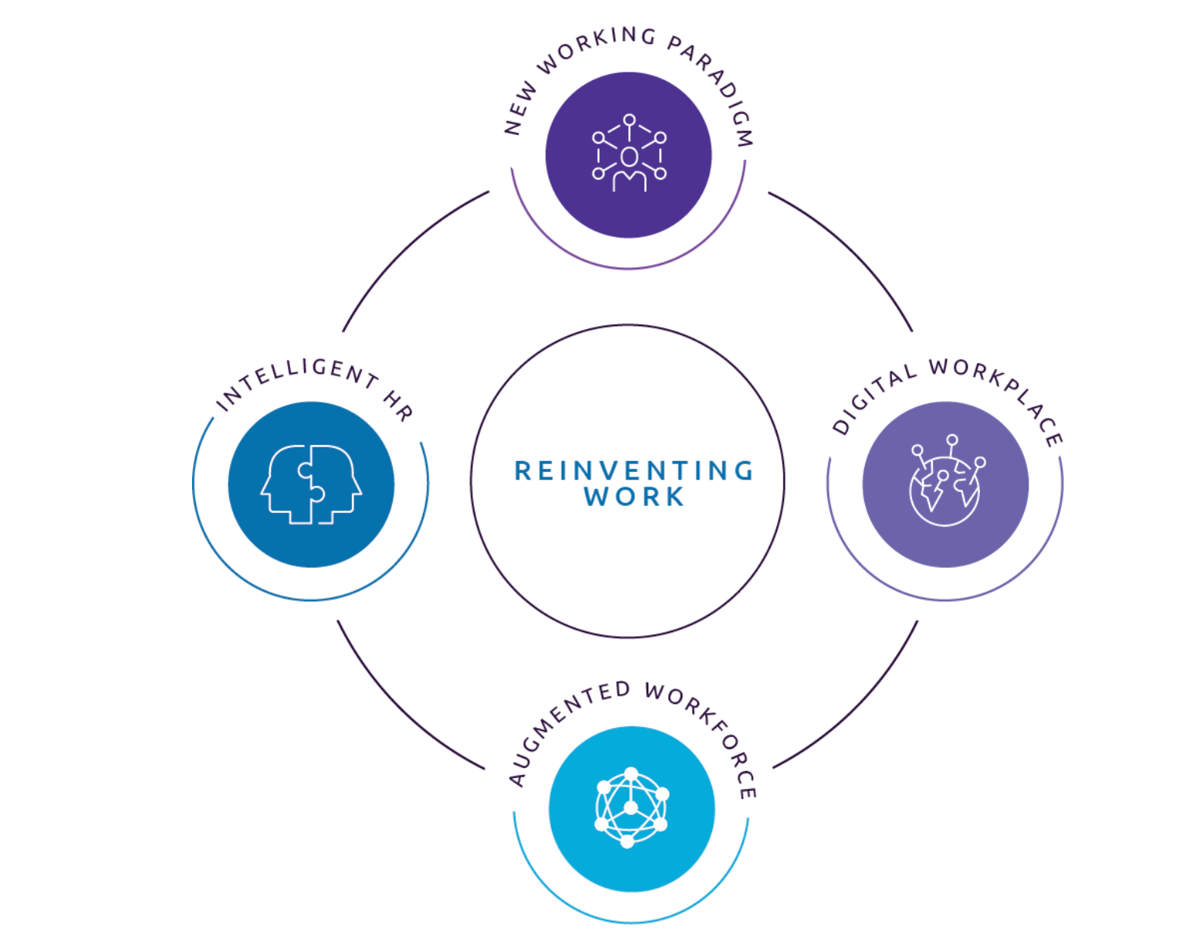
Reinventing Work theory by Capegemini
Source: https://www.capgemini.com/es-es/service/invent-old/people-organization/reinventing-work/

