
Module Name: Digital Skills for Personal and Professional Growth
Module Code: BMSW4008
Student Name: Daniela Zanfir
Student Number: 2411191
Lecturer: Philippa Fitzgerald

AI Statement
“I confirm that I have not presented any AI generated materials as my own work.
I confirm that I have copies of my drafts, notes, and other resources I used, which I may be asked to provide in evidence”.

Table of Contents
Task 1: Market Research and Website Development Project 3
Introduction 3
Questionnaire Creation and Data Collection: 3
Business Concept 5
2 page Website creation with Weebly 6
Marketing materials using CANVA 8
References 9,10
Task 2: Creation of a spreadsheet using Microsoft Excel 12
Importance of excel in the digital era and its implication in RenewWear 13
References 15

Task 1: Analysis Report
Introduction
RenewWear focuses on making stylish basics for women out of upcycled and organic materials while decreasing waste in fashion. The business idea was refined by conducting a questionnaire to find out what people thought about green fashion, their choices in fashion materials and their interest in recycling activities. The report analyses the main responses from the questionnaire, discusses how they affect the company’s business strategy, website, marketing and audience segmentation.
Findings from the key Questionnaire
The survey was distributed to 10 respondents who were 18 to 22 years old females, making the survey a good representation of the targeted audiences of RenewWear. Analysing key questions helps the brand learn important details to shape its strategy.

Questionnaire Creation and Data Collection:

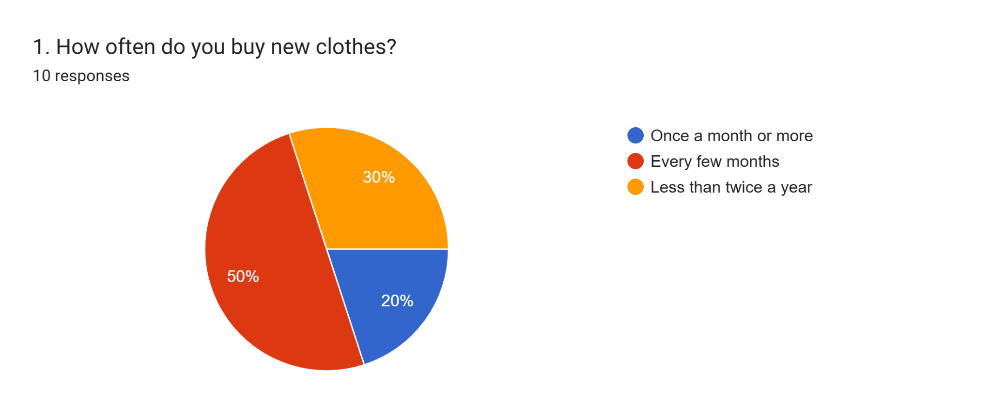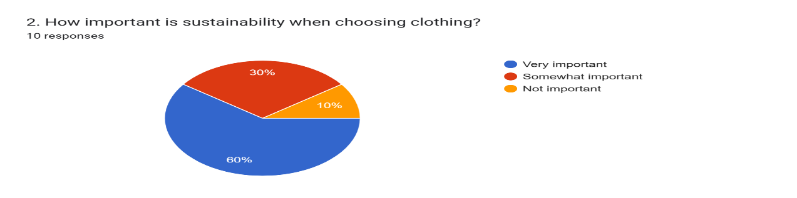

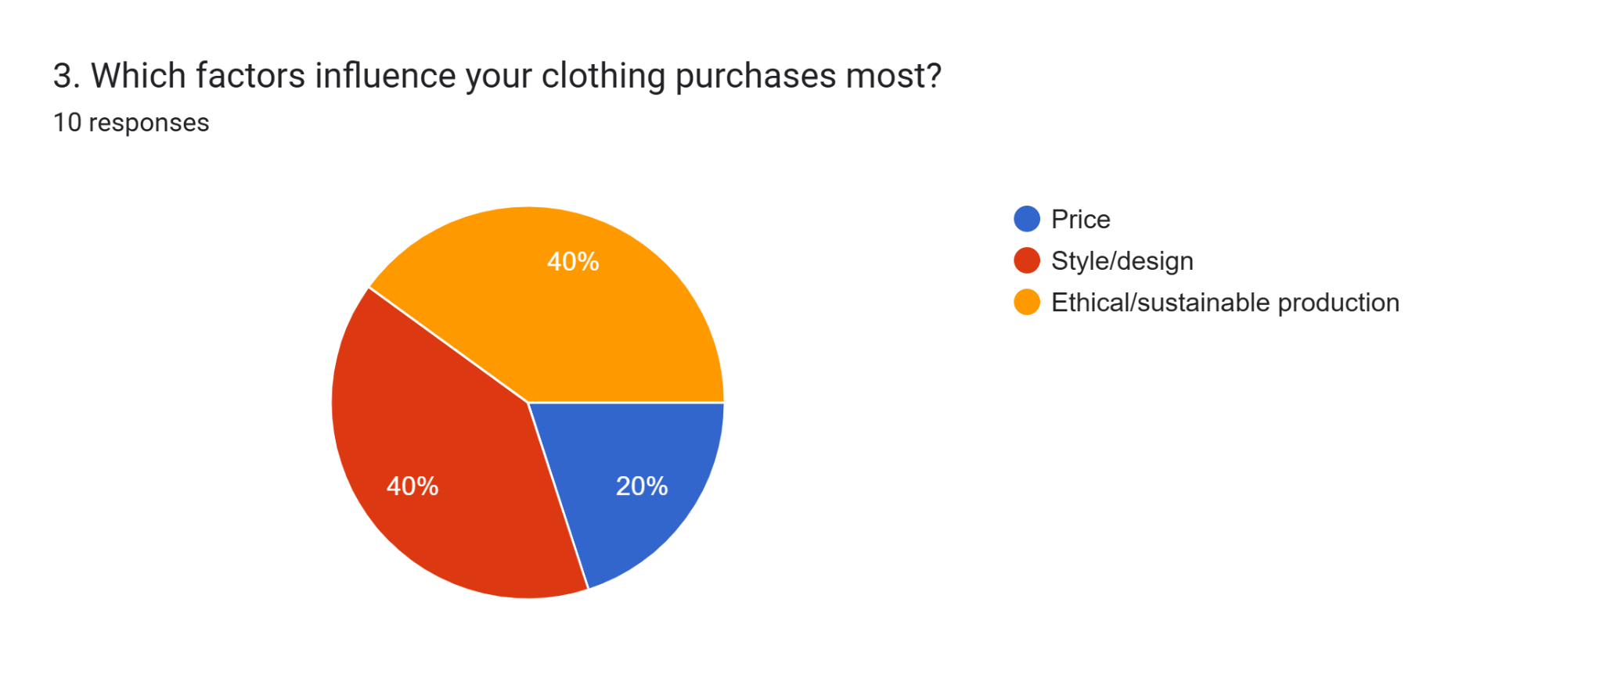

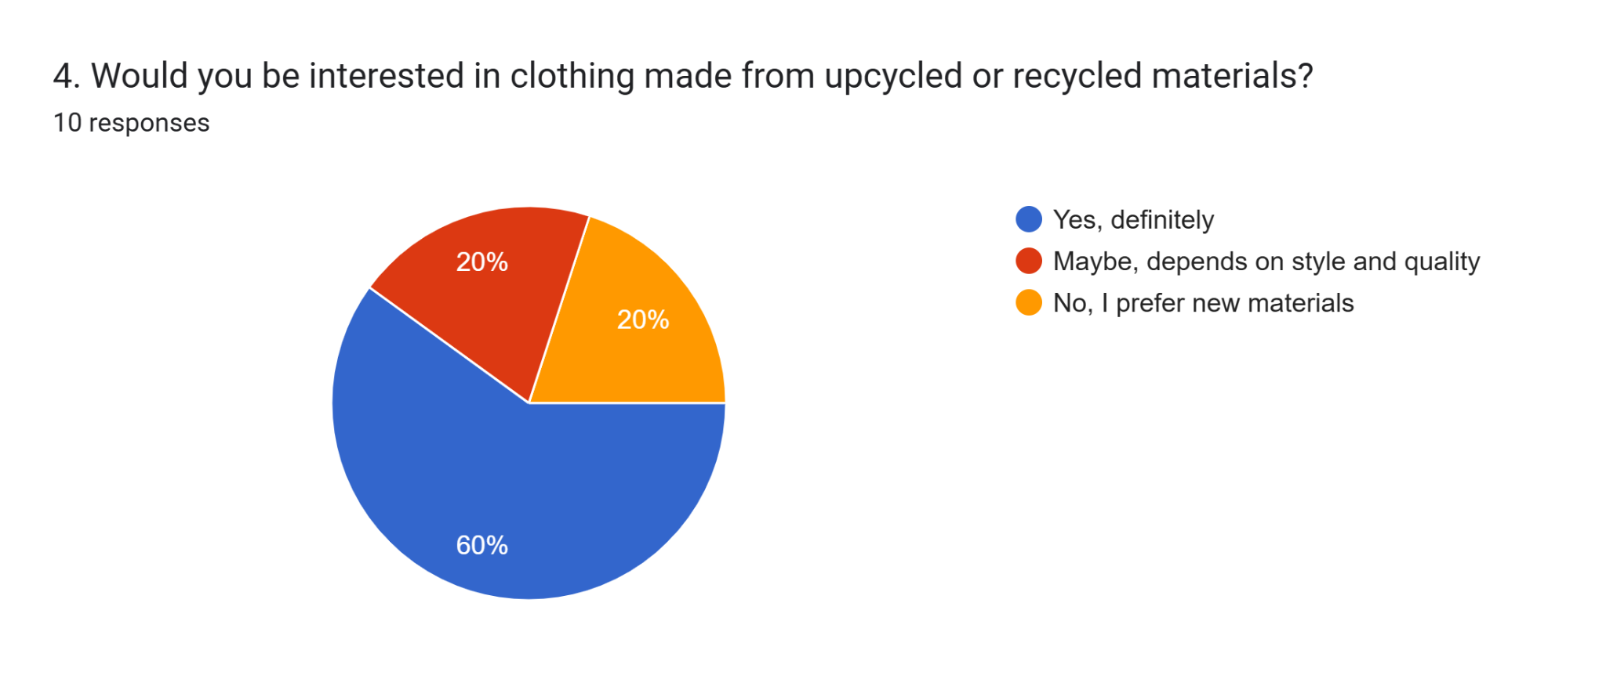
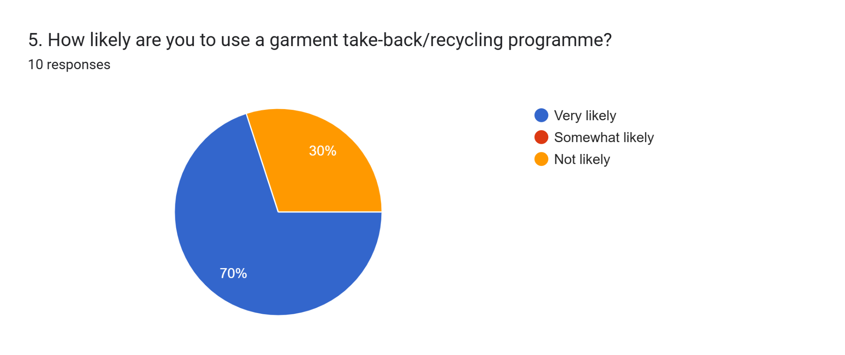
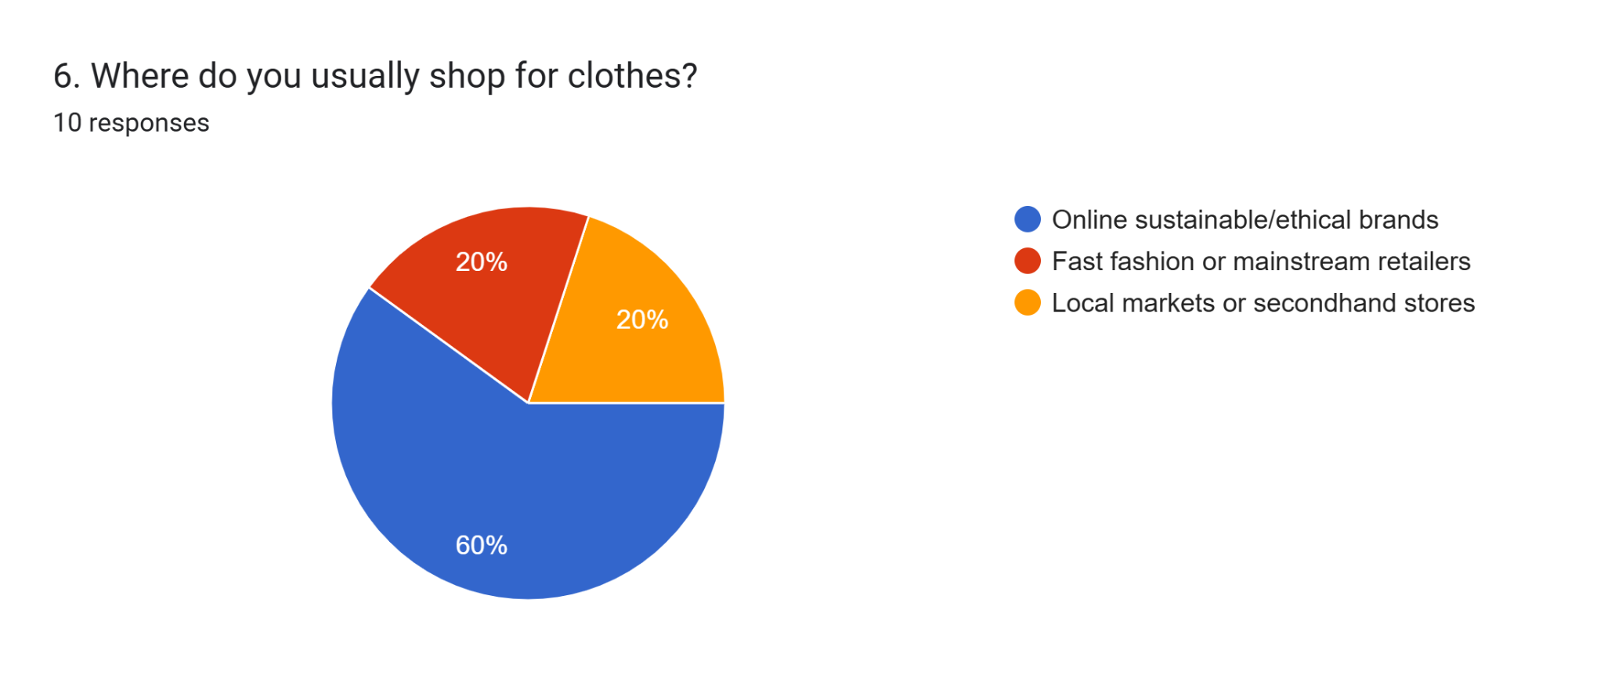
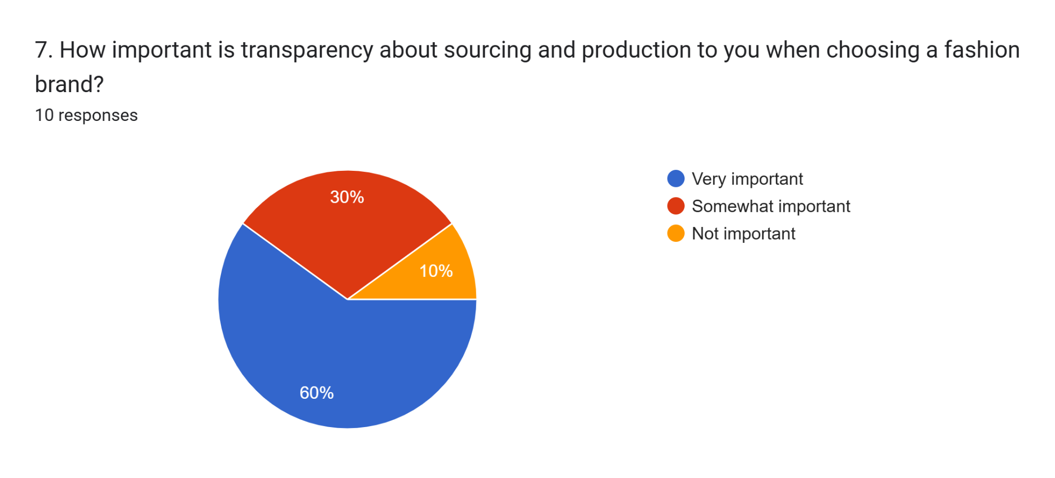

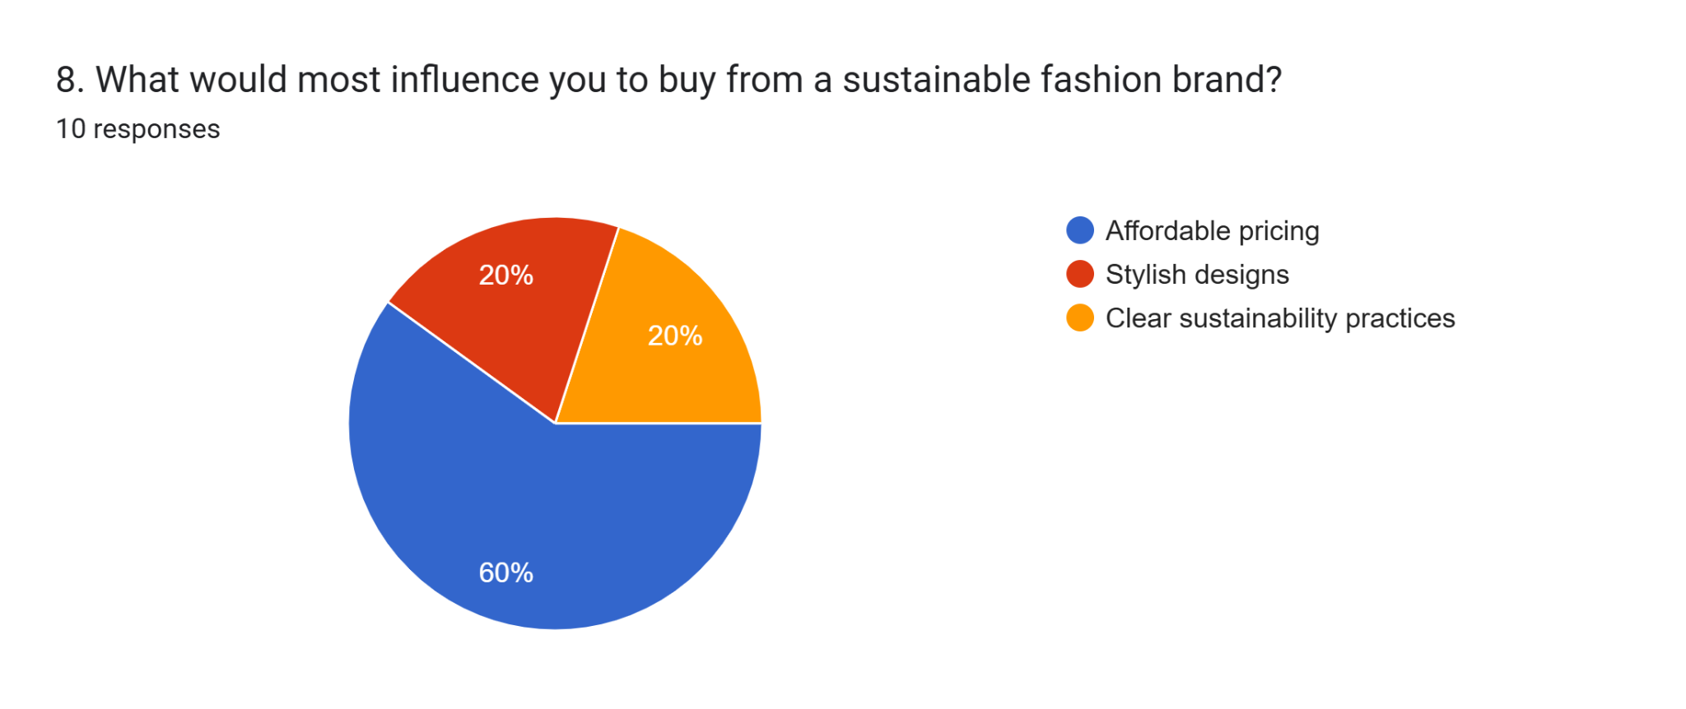
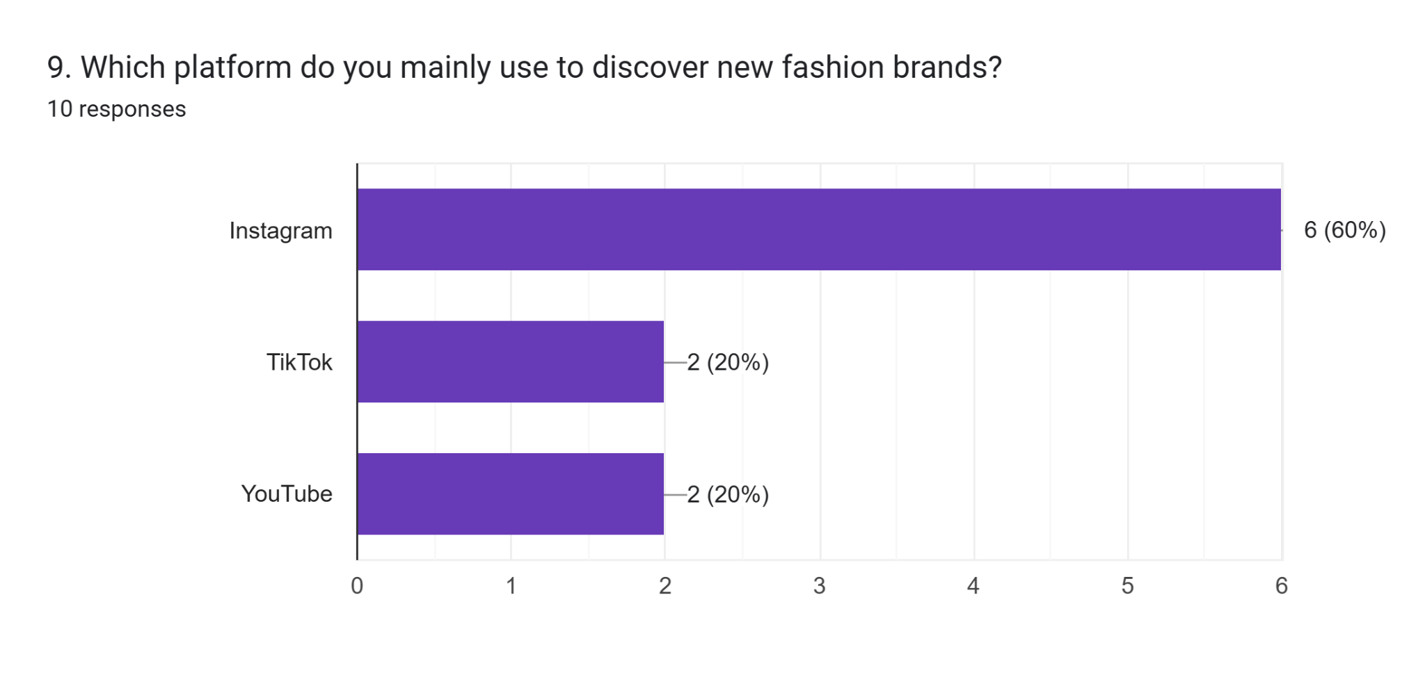
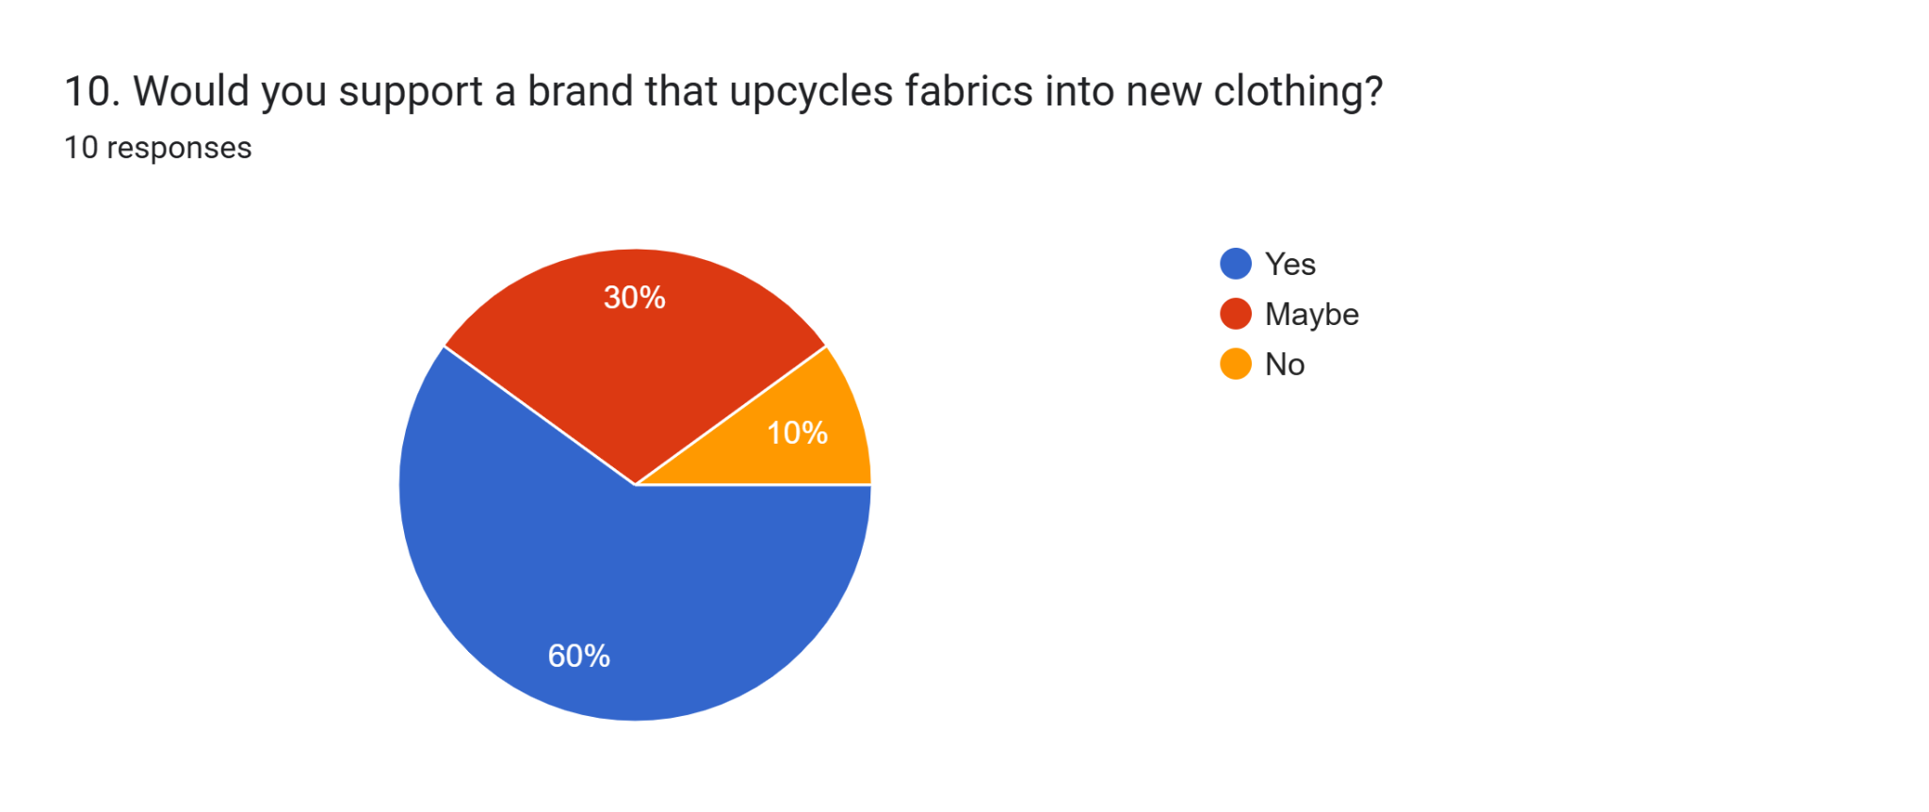
It was particularly noticeable how often people bought new clothes. About 50% replenish their wardrobes with new clothes every couple of months, but a similar number of people (30%) buy new clothes less than twice a year. It suggests that people prefer to buy clothes moderately which supports the need for durable and multifunctional garments that inspire less frequent, thoughtful buying. It was evident from the survey that people consider eco-friendly choices in what they wear to be very important.
Among all answers, 40% pointed out that ethical and sustainable production has the biggest impact on their purchase choices. After comfort, style and design were the most important factors for 40% percent of people and price had an impact on 20% of participants. It means that while people consider prices, what matters most are a style they like and its ethical benefits. So, these designs need to reflect eco-friendliness as well as be stylish so that people want to buy from them. Upcycled or recycled clothing caught the attention of respondents and 60% were likely to purchase them. Almost 20% thought their interest would depend on style and quality. With this result, RenewWear’s choice to work with upcycled textiles is seen as possible, as it lessens the effects on the environment than new cloth production and meets new consumer needs for eco-friendly fashion choices.
Implications for Business Concept
Information from the questionnaire leads to many beneficial insights for RenewWears business idea. Since products are bought fairly often, they should be made to be sturdy and able to last for years. Offering adaptable items that users like to wear again and again promotes keeping them longer and changes the mindset that throws away garments after a single use, common in fast fashion (Jiang et al., 2024). As sustainability is given such importance, it is clear that people want to find alternatives to regular clothing, confirming RenewWear’s eco-friendly focus (Rahaman et al., 2024).
Giving equal importance to ethics, sustainability, style and design proves that it is important to maintain a balance between being eco-friendly and fashionable (Dhir, 2022). RenewWear is required to make sure its clothes are created with sustainable materials and are also on-trend. New studies confirm that consumers want fashion and style more than they care about sustainable alternatives (Elmanadily and El-Deeb, 2022).
People wanting upcycled materials shows that recycled materials can form a key base for the company’s product line. Making garments in this way cuts down on discarded textiles and brings different individual qualities to your brand clothes. People’s excitement about the take-back service helps RenewWear bring circularity into its strategy, attract more loyal customers and prevent more textiles from going to landfills (Ellen MacArthur Foundation, 2021).
Audience Segmentation
The research from the survey and sustainability topics shows that RenewWear’s main audience can be divided into three main groups. Group one is formed by environmentally aware Millennials and young Gen Z members, who want their chosen brands to be sincere and environmentally focused. This group supports ethical fashion trends and stresses being upfront about how and where its products are made (McKinsey & Company, 2023).
In the second segment, consumers focus on the look of clothing and are ready to spend more for sustainable fashion when it fits their ideas about style. These customers prefer clothing that is trendy, useful and in line with their beliefs which shows why RenewWear’s blend of fashion and sustainability is important (Elmanadily and El-Deeb, 2022).
The third group involves people who are focused on circular economy approaches such as upcycling, recycling and supporting proper ways to look after clothes. This group responds well to brands trying to reduce waste which strengthens the company’s commitment to closed-loop systems (Chabowski et al., 2025).
Consideration of website design
The website needs to be both a source of sales and learning, emphasizing that everything is clear and makes users want to participate. The ability to pick colours, styles and fabrics might raise how users value the brand and relate to it. Each time someone makes a purchase, an interactive impact tracker can show how they helped to decrease waste and reduce their carbon impact (Kar et al., 2022). People should find the take-back website easy to use and rewarded with discounts or points. Showing the stories behind artisan work and ethical supply chain practices will connect with and reassure customers (Rana, 2024).

2-page Website creation with Weebly
Website link: https://renewwear-108730.weeblysite.com/
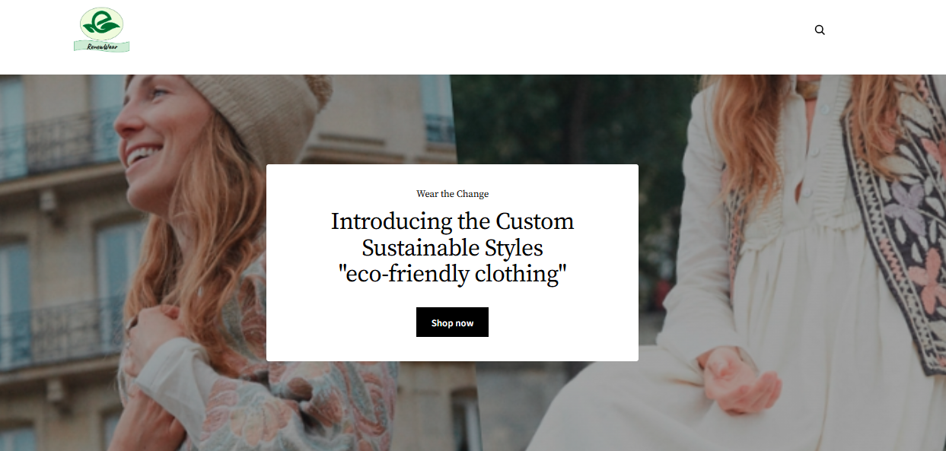
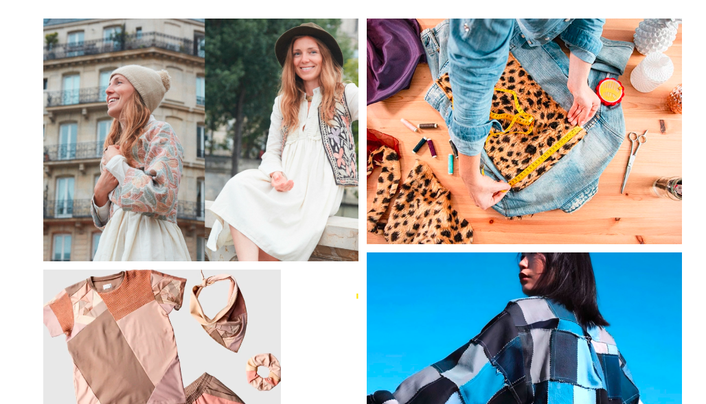

Marketing strategy and SEO.
The marketing approach of RenewWear will be combining educational information with inspiration. Posting blog articles about slow fashion strategies, upcycling ideas and sustainability topics will help stand out and reach higher in search results (wei et al., 2024). Posts on Instagram and TikTok can display new looks, mini buying guides and dresses made by real people tagging #RenewWear and #SlowFashionMovement.
Links with environmentally friendly influencers will expand the audience and make the brand more trusted. Because these phrases describe sustainability in the fashion industry, they should be given priority in SEO efforts (Confetto and Covucci, 2021).

Marketing materials using CANVA
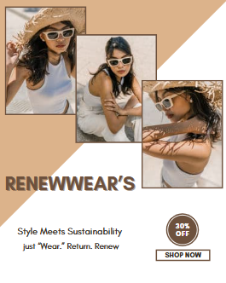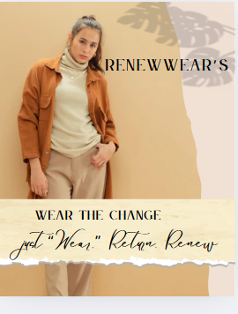
Fig01: Digital poster/social media post
(Source: Created by the learner)

Conclusion
Study of the questionnaire results shows that RenewWear can fit well into sustainable fashion, as its products suit what customers are seeking. Most people in the target group want clothing that is recycled, fashionable and lasts a long time and they are active in circular economy efforts like garment return. Based on these points, a business can build a model that prioritizes quality, options for customers, honesty and collaborating with the community.

References
Chabowski, B.R., Gabrielsson, P., Hult, G.T.M. and Morgeson III, F.V., (2025). Sustainable international business model innovations for a globalizing circular economy: a review and synthesis, integrative framework, and opportunities for future research. Journal of International Business Studies, 56(3), pp.383-402.
Confetto, M.G. and Covucci, C., (2021). “Sustainability-contents SEO”: a semantic algorithm to improve the quality rating of sustainability web contents. The TQM Journal, 33(7), pp.295-317.
Dhir, Y.J., (2022). Ethical Fashion: A Route to Social and Environmental Well-Being. In Sustainable Approaches in Textiles and Fashion: Consumerism, Global Textiles and Supply Chain (pp. 221-235). Singapore: Springer Nature Singapore
Ellen MacArthur Foundation. (2021). It’s time for a circular economy (no date) How to Build a Circular Economy | Ellen MacArthur Foundation. Available at: https://www.ellenmacarthurfoundation.org/ (Accessed: 2 June 2025).
Elmanadily, D. and El-Deeb, S., (2022). A Study on Consumers’ Purchase Intentions and Willingness to Pay More towards Eco-fashion Clothes. South Asian Journal of Management, 29(3).
Jiang¹, G., Macintyre¹, L., Carrigan, M. and Spanellis, A., (2024). Check for updates Consumer Perceptions of App Functions Designed to Reduce Unnecessary Fashion Purchases. In Fashion for the Common Good: Proceedings Global Fashion Conference November 16th-18th 2023 (p. 67). Springer Nature.
Kar, A.K., Choudhary, S.K. and Singh, V.K., (2022). How can artificial intelligence impact sustainability: A systematic literature review. Journal of Cleaner Production, 376, p.134120.McKinsey & Company. (2023). The State of Fashion 2023. Available at: https://www.mckinsey.com/~/media/mckinsey/industries/retail/our%20insights/state%20of%20fashion/2023/the-state-of-fashion-2023-holding-onto-growth-as-global-clouds-gathers-vf.pdf (Accessed: 2 June 2025).
Rahaman, M.T., Pranta, A.D., Repon, M.R., Ahmed, M.S. and Islam, T., (2024). Green production and consumption of textiles and apparel: Importance, fabrication, challenges and future prospects. Journal of Open Innovation: Technology, Market, and Complexity, p.100280.
wei, L., Hong, Y. and Zeng, X., (2024). Exploring the influence of content marketing strategies on the expansion of the fashion second-hand market: a theoretical prediction study. Journal of Fashion Marketing and Management: An International Journal, 28(5), pp.950-979.
Rana, N., (2024). Ethical Fashion Practices. In Threaded Harmony: A Sustainable Approach to Fashion (pp. 29-43). Emerald Publishing Limited.

Module Name: Digital Skills for Personal and Professional Growth
Module Code: BMSW4008
Student Name: Daniela Zanfir
Student Number: 2411191
Lecturer: Philippa Fitzgerald

AI Statement
“I confirm that I have not presented any AI generated materials as my own work.
I confirm that I have copies of my drafts, notes, and other resources I used, which I may be asked to provide in evidence”.

Task 2: Creation of a spreadsheet using Microsoft Excel
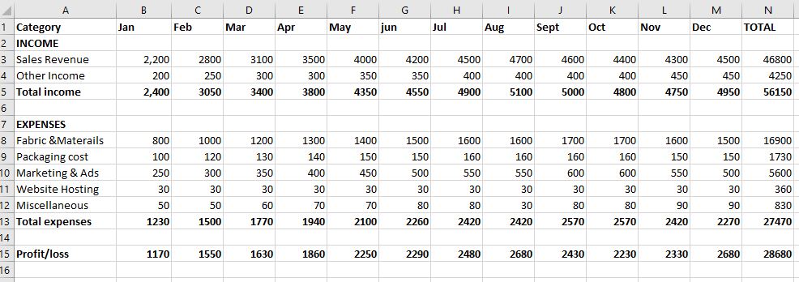 Fig 01: Spreadsheet of Projecting finances of one year in pound
Source: (Created by the learner)

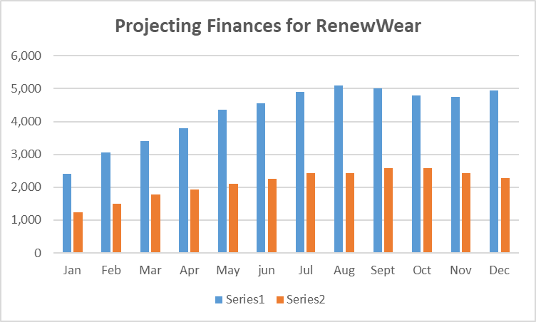 Fig 02: Projecting finances of one year in pound
Source: (Created by the learner)

Importance of excel in the digital era and its implication in RenewWear
In this new digital age, using data to guide decisions helps small businesses survive and grow. As Microsoft Excel combines versatility, ease of access and strong analytics, it remains a key part of digital business management. Excel enables RenewWear and similar startups and micro-enterprises to look after their finances, predict growth and develop campaigns, all at a basic level of technology.
Excel is a useful tool for Financial Management
Excel is important in business for financial purposes. Entrepreneurs can use Excel to review their income, expenses and profits over a period which makes their finances easier to understand. RenewWear, which operates on a tight margin as a sustainable brand, must closely watch its expenses like materials, packaging and marketing costs. RenewWear can use formulas like =SUM(), =IF() and =B4-B11 on special fields to estimate monthly earnings, review them throughout the year and select product lines that are financially suitable. As stated by Powell, (2023) small businesses which practice structured financial planning with spreadsheets in Excel tend to succeed in the long run with improved budgeting and forecasting.
Additionally, using Excel’s budgeting tools and pivot tables, RenewWear can test out different financial possible outcomes. The company could look at the effects that changes in materials or promotions might have on the net profit. With these simulations, companies can decide wisely and avoid taking too much risk which matters for green companies that commonly spend more on sustainable supplies (Abhinav and Rajesh, 2025).
Using visual tools to get insights from data
Graphics and charts options in Excel help small business owners to track their financial and marketing trends. The profit and loss summary in RenewWear includes a bar chart that shows income and expenses for every month which makes it easy to spot periods where marketing campaigns for sustainability lead to the greatest results. According to Adepoju et al. (2022), using visual data allows small businesses to manage decision-making and in-team communication more effectively since workers often handle different business duties.
Customisation makes it possible for dashboards in Excel to track major performance indicators (KPIs) such as the percentage of people who convert, amount spent per customer and return rates. Analysing these metrics allows us to assess how successful marketing is and what customers think, both important aspects of brand loyalty in the eco-fashion world (Kamarau et al., 2024).

Enhance Market Research and Forecasting
Compiling and analysing survey results can be done easily with Excel. To find out what customers want in sustainable fashion, a questionnaire was given to them as part of the project. Business owners collected and organized the responses in Excel to find out more about product demand, what materials are in demand and how price affects their buying decision. This is in line with what Okeke et al. (2024) point out, that with Excel’s tools, small businesses can target customers and offer them personalized experiences. This involves making sure lines are designed for all genders among younger buyers and including special eco-themed releases for concerned environmentalists
Supporting processes of inventory and supply chain
Besides money matters and marketing tasks, Excel is great for tracking inventory, overseeing suppliers and scheduling when things will be made. Using a spreadsheet is an easy way to check the amount of fabric available, the order status and when orders will be fulfilled. As the business expands, Excel can be used with cloud services or switched to Power BI or Microsoft Dynamics, allowing facts to blend together and capabilities to improve (Wang, 2023).
Support strategic planning and fostering growth for the business
Excel does calculations and can also help with strategic thinking. In Excel, business planning files—cash flow forecasts, break-even analyses and pricing models—can be built and improved. They make it possible to choose the right time for a new collection or spending on online advertising. Scenario modelling enables RenewWear to analyze how expanding production or offering discounts changes their financial situation and so helps to manage risks. Furthermore, Excel helps to raise the professional standards in business. Showing reliable and well-organized data to people such as investors, suppliers or partners in sustainability helps the brand gain trust and greater credibility. Because transparency and sustainability are now often connected, managing financial and supply chain data on Excel can make RenewWear appear more ethical to buyers (McGrath et al., 2021).

References
Abhinav, P. and Rajesh, R., (2025). Forecasting sustainability performances of firms using grey theory and Markov models. Benchmarking: An International Journal.
Adepoju, A.H., Austin-Gabriel, B.L.E.S.S.I.N.G., Eweje, A.D.E.O.L.U.W.A. and Collins, A.N.U.O.L.U.W.A.P.O., (2022). Framework for automating multi-team workflows to maximize operational efficiency and minimize redundant data handling. IRE Journals, 5(9), pp.663-664.
Kamarau, R., Yapp, E.H. and Jamil, N., (2024). Determinants of customer loyalty in sustainable fashion. Global Business & Management Research, 16.
McGrath, P., McCarthy, L., Marshall, D. and Rehme, J., (2021). Tools and technologies of transparency in sustainable global supply chains. California Management Review, 64(1), pp.67-89.
Okeke, N.I., Alabi, O.A., Igwe, A.N., Ofodile, O.C. and Ewim, C.P.M., (2024). AI-driven personalization framework for SMES: Revolutionizing customer engagement and retention. Journal name if available.
Powell, G., (2023). Business Financial Planning with Microsoft Excel. Chapman and Hall/CRC.
Wang, X., (2023). Enhancing Business Processes through Dynamics Solutions with Microsoft Power Platform.

