Module name: Financial Management for the Hotel Industry
Assignment Title: Business Report - Comparison of Two Hospitality Organizations
Student Name: Golam Mohammed Polash
Student ID:2238997

Executive Summary
The financial positions of Shangri-La Hotels and Premier Inn will be analyzed in this report. Shangri-La hopes to attract high-end travelers with luxury services, whereas Premier Inn serves the cost-conscious customer. Furthermore, the report analyzes turnover, market position in organic trace minerals (market share), the growth rate of the industry, and key trends that will impact these marketing channels and production capacities. Shangri-La benefits from the luxury travel money shot but is exposed to geopolitics whereas Premier Inn’s domestic discounts provide some stability. Shangri-La has been sustainable in its CSR work, while Premier Inn does so by cost-saving measures. The strategy for both companies must include expansion opportunities in emerging markets and digital growth.
Table of Contents
Executive Summary 2
Introduction 4
Main Body 5
Total Revenue Analysis 5
Market Position 6
Growth Potential 7
Financial Commitment to CSR 10
Conclusion 11
Recommendations 12
Reference list 13

Figure 1: Bowman’s Strategy Clock for Premier Inn 8
Figure 2 Bowman's Strategy Clock for Shangri-La Hotel 10

Introduction
Shangri-La Hotels and Premier Inn Hotels, both of which are companies that shutter doors all over the world to manage businesses at levels targeting different strata in the market. Shangri-La, a well-known luxury hotel chain established in 1971 specializes in lavish hospitality services with an international presence, especially in Asia, Europe, and the Middle East (Johnson and Vanetti, 2005). Whitbread PLC is the UK's largest budget hotel chain, activated mainly in domestic hotels and under the Premier Inn brand.The primary objective of this report is to analyze the financial strategies between two hotel groups, covering 4 main topics: Turnover, marketplace, development potential, and commitment in terms of corporate social responsibility,this report will analyze these areas to provide insight into how each organization can maintain its financial performance and sustains its future growth (Azfar and Cadwell, 2003).

Main Body

Total Revenue Analysis
Shangri-La Hotels and Premier Inn respectively cover two revenue points in the hospitality market. As a luxury player, Shangri-La makes most of its money from room bookings, lavish in-house dining options, spa treatments, conferences, and five-star events. Conversely, Premier Inn focuses on room occupancy, food and beverage sales, and meeting space hire for its earnings.Shangri-La in an annual report for 2023 said it returned to revenue that nearly equaled USD 1.75 billion pre-pandemic levels after a range of factors were responsible for a decline from 2020-2021 caused by the COVID crisis. International travel, mainly in Asia and Europe, also affects its revenue growth. And things like Luxury tourism, business travel, and the ability to draw high-net-worth individuals. Shangri-La's robust sales mix from high-end food and beverage, as well as wellness segments - backed by a diverse geographical footprint contributes to its revenue resilience but exposes it to the vagaries of geopolitics and travel restrictions (Ju et al., 2013).
By comparison, Premier Inn recorded a total income of GBP 1.4bn in 2023, supported by a buoyant UK domestic market with a boost from the period it reopened post-lockdown. The brand's value price point keeps its occupancies high, especially with the money-conscious consumer. Much of the revenue increase at Premier Inn has been down to its expansion plan, with new hotels sprouting up across the UK (Goh, 2007). Both companies' revenue trends are broadly in line with those in the industry as a whole. The pandemic hammered Shangri-La's revenue, but it has improved as international travel restrictions were lifted. But while the hotel is recovering quickly, there are challenges ahead as business travel and luxury tourism remain slow to return in some regions. By contrast, Premier Inn has been able to benefit from the 'staycation' boom in the UK during the pandemic, with domestic holidaymakers flocking to low-cost hotels(Ramadhani, Raka and Tavio, 2017).

Market Position
The global positioning, target markets, and regions served are two completely different kinds for both Shangri-La Hotels and Premier Inn. Shangri-La – a luxury hotel brand covering the Asia, Europe, and Middle East regions aimed at serving high-end customers. Elsewhere, Premier Inn is a UK-focused budget chain with small operations in Germany and the Middle East. Shangri-La has fewer properties, and more expensive rooms and targets a niche segment of high-net-worth individuals for whom its unique offerings such as personalized service are especially enticing. (Goh, 2007).
In contrast, Premier Inn is a large UK budget hotel chain that captures around 10 % of the mid-market hotel segment. Renowned for being cheap, reliable, and convenient — ideal accommodation if you are traveling with family, on business or just sticking to a budget. With Britons embracing staycations during the pandemic, Premier Inn has benefited from a large slice of the domestic travel market. It is still one of the favorite choices for affordable lodging in over 800 locations across the UK. Shangri-La is a global niche high-end player with luxury offerings primarily catering to wealthier travelers.(Kotur and Dixit, 2022).

Growth Potential
Shangri-La's Expansion Strategy: Shangri-La is currently going through the largest developmental phase across Asia, Middle East, and Africa, with prime locations in major global cities as well as hotels situated among some of the world's most sought-after resort holiday destinations. A higher-end brand positioning, able to demand premium pricing whilst keeping the company focused on emerging markets, allowing customers a more exclusive experience. It also plans to enter other competitive markets, such as Europe and the US, capitalizing on its strong service ethos and premium facilities. But Shangri-La was hit hard by COVID-19 and therefore exposed as being vulnerable to short-term economic downturns or global crises. (Komunyakaa, 2005).
Premier Inn's Expansion Strategy: It had a different growth strategy around budget and midscale with Premier Inn. This initiative will focus on growing its presence in the UK by building new hotels, especially in areas without many available, and expanding into international markets (Enz, 2009). For example, Premier Inn has been quite successful in Germany and plans to open more hotels in the country, as demand for affordable sleeping options increases. Premier Inn's scaling ability also appeals because of similarities in budget hotel consumer demand between the UK and Germany. Premier Inn has the potential to grow organically by using its profits to help fund new developments(James et al., 2017).
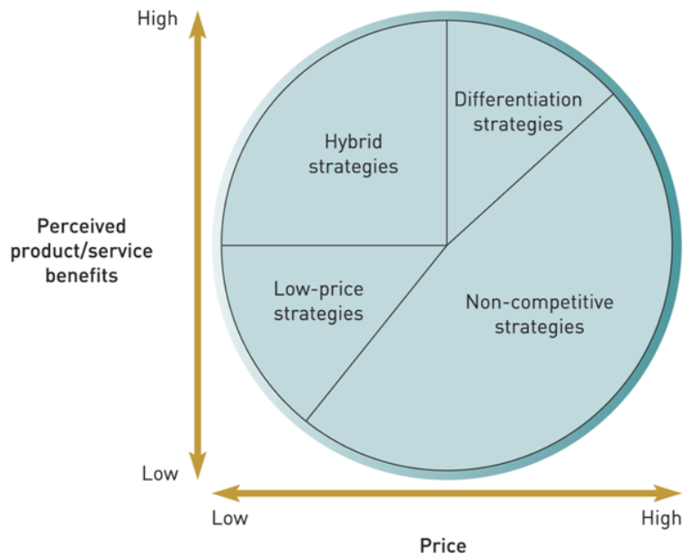
Figure 1: Bowman’s Strategy Clock for Premier Inn
Source: (Bailey and Milligan, 2019).

Bowman’s Strategy Clock (For Premier Inn)
- Low Price Strategy: Premier Inn works mostly within this segment, providing a cost-effective way to go with good service. This is aimed at the value-for-money segment, specifically targeting business travelers and others on a tight budget.
- Hybrid Strategy: This can be completed with Premier Inn providing simple accommodations. This USP is a prime location and has good guest service, as usual.
- Differentiation Strategy: Premier Inn has a humble offering. The restaurant chain would place more importance on brand promise and less on exclusivity, trading the concept of a luxury brand for that of a trusted and expected one.
- Non-competitive Strategies: Premier Inn differentiates with its "Good Night Guarantee" and competes less on price than through special offers. It creates customer attachment through corporate ties and programs like "Force for Good".
Premier Inn vs Competitors: Budget brands such as Travelodge, Ibis, and Holiday Inn Express are competitors of Premier Inn. In the UK, domestic rival Travelodge provides similar budget-style accommodation. However, one of the things that sets Premier Inn aside is their “Good Night Guarantee” and cost-saving CSR initiatives such as energy-efficient practices. Ibis broadened exposure through its brand, unlike Premier Inn which is UK-centric and all the better for doing so in a Covid era with sanctioning rising across destination marketing domestically.
Bowman’s Strategy Clock (Shangri-La Hotel):
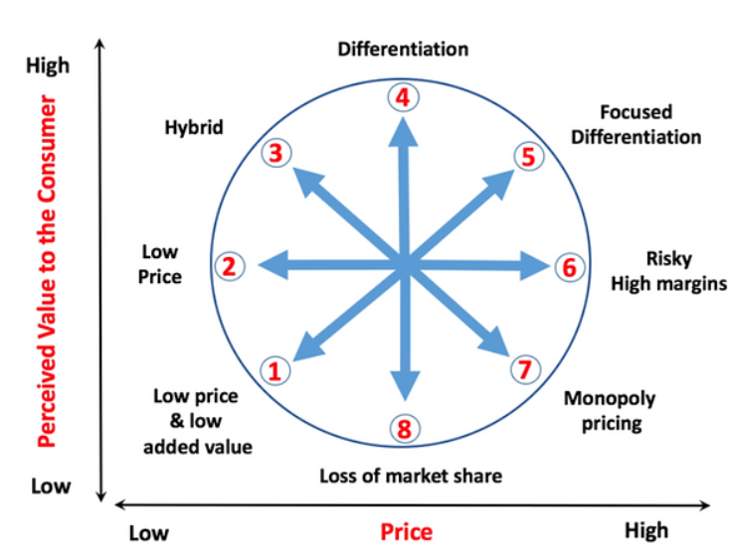
Figure 2 Bowman's Strategy Clock for Shangri-La Hotel
Source: (Kubersky, 2021)
- Low-Price Strategy: Not in this league. Instead, they rely on overpriced fees and enhanced offerings to support higher costs.
- Hybrid Strategy: The focus of Shangri-La is luxury and premium service; hence it does not compete on a price point level but rather creates a highly differentiated guest experience.
- Differentiation Strategy: The primary strategy for the hotel Shangri-La is a brand that specializes in luxury environments, personalized services, and specialized locations.
- Non-competitive Strategies: Shangri-La goes after niche differentiation -providing luxury experiences, and specialized services and partnering up with established wellness & food brands.
Shangri-La Hotels vs Competitors: Shangri-La Hotels features luxury brands such as Four Seasons, Ritz-Carlton, and Mandarin Oriental. These competitors are looking to provide a high-touch, customized offering at scale domestically or internationally. Top of the class for outstanding guest experiences and loyalty programs: Four Seasons, Ritz-Carlton Shangri-La: A decidedly Asian-flavored cut above, especially the environmentally friendly Shangri La has and "Sustainability Shangri La" initiative aimed at guilt-free luxury.

Financial Commitment to CSR
Shangri-La’s CSR Investment:CSR is a major focus for Shangri-La’s luxury brand, looking at it from sustainability, community engagement, and responsible business lens. The “Sustainability Shangri-La” framework, Carbon Reduction, Energy Conservation and Waste Management (Maxim et al., 2024). Shangri-La, for instance, has invested in energy-saving technologies and sustainable architecture throughout its buildings are expected to save long-term operational costs. Programs like "Rooted in Nature" guarantee that 25% of our food is sustainably harvested, so they help local farmers and Mother Earth too (Ojo, 2016).
Premier Inn’s CSR Investment:Whitbread-owned Premier Inn, whose CSR strategy "Force for Good" focused on energy, waste, and community sustainability is an example of this more pragmatic economic version of CSR. These investments include solar panels, water-saving technology, and energy-efficient lighting to reducecarbon emissions and support Whitbread's commitment to being a net-zero carbon emission company by 2040(Bailey and Milligan, 2019). Premier Inn has published targets from reducing food waste to recycling initiatives, all of which add to the bottom line(Maddi, 2001).

Conclusion
As a result, one can note that both Shangri-La Hotels and Premier Inn have very specific approaches to financial management that are well-suited for their positions on the market. The former is oriented on luxury and sustainability and invests in significant CSR beneficial to its strong, durable global brand and long-term profit. The latter utilizes a strategy of operation and budget-friendly cost that implies practical CSR reducing expenses and appealing to cheap customers (Mehmet Huseyin Bilgin et al., 2016). Thus, the results of the comparison highlight the necessity of financial strategies adjusted to the company’s context. Indeed, they both have to work on the market, but Shangri-La can grow by expanding to markets in developing countries, while Premier Inn can develop its digitalization services and expand to Europe.

Recommendations
Shangri-La Hotels:Taking cues from this analysis, it should advise Shangri-La Hotels to introduce their luxury services in the emerging markets of Asia and Africa because these both are
witnessing increasing demand for luxury hospitality(Nastasia Yakoub, 2020). The company could tap into the region's growing population of middle-class and high-income travelers with its powerful brand name. This fits well into Shangri-La's already focus on luxury and sustainability while providing an additional revenue stream. Globalizing the "Sustainability Shangri-La" initiative actually would provide the company with a competitive advantage by generating interest from environmentally conscious consumers in these new markets (Miguel Angel Gardetti and Ana Laura Torres, 2017).
Premier Inn: Premier Inn should also focus on improving its digital propositions, particularly around online booking platforms and customer data analytics (Bourne and Pippa Bourne, 2011). With a significant UK footprint, combined with the rapid growth of the brand in Europe, there was potential to tailor customer experience and pricing strategies through digital. On the other side, we believe that entering into more European markets with a demand for budget-friendly travel could accelerate growth andcategory forge forward (Grana, Benowitz and Glantz, 2014).
Reference list
Azfar, O. and Cadwell, C. (2003). Market-augmenting Government. University of Michigan Press.
Bailey, S. and Milligan, A. (2019). Myths of Branding. Kogan Page Publishers.
Bhagyasri, Y., reddy, Nv., Dattatrya, M., Divya, K. and Subramanian., Ns. (2017). PHYTOCHEMICAL SCREENING AND IN-VITRO ANTI-FUNGAL ACTIVITY OF “TRIDAX PROCUMBENS L. International Journal of Advanced Research, 5(7), pp.2131–2137. doi:https://doi.org/10.21474/ijar01/4952.
Bourne, M. and Pippa Bourne (2011). Handbook of corporate performance management. Chichester, West Sussex: Wiley.
Enz, C.A. (2009). Hospitality strategic management : concepts and cases. 2nd ed. Hoboken, N.J.: John Wiley & Sons.
Ford, J. and Overdrive, I. (2009). Hotel on the corner of bitter and sweet : a novel. New York: Ballantine Books.
Goh, E. (2007). Southeast Asian perspectives on the China challenge. Journal of Strategic Studies, 30(4-5), pp.809–832. doi:https://doi.org/10.1080/01402390701431915.
Grana, R., Benowitz, N. and Glantz, S.A. (2014). E-Cigarettes. Circulation, 129(19), pp.1972–1986. doi:https://doi.org/10.1161/circulationaha.114.007667.
James, K.J., Sandoval-Strausz, A.K., Maudlin, D., Peleggi, M., Humair, C. and Berger, M.W. (2017). The hotel in history: evolving perspectives. Journal of Tourism History, 9(1), pp.92–111. doi:https://doi.org/10.1080/1755182x.2017.1343784.
Johnson, C. and Vanetti, M. (2005). Locational strategies of international hotel chains. Annals of Tourism Research, 32(4), pp.1077–1099. doi:https://doi.org/10.1016/j.annals.2005.03.003.
Ju, Y., Zhuo, J., Liu, B. and Long, C. (2013). Eating from the wild: diversity of wild edible plants used by Tibetans in Shangri-la region, Yunnan, China. Journal of Ethnobiology and Ethnomedicine, 9(1), p.28. doi:https://doi.org/10.1186/1746-4269-9-28.
Komunyakaa, Y. (2005). from Shangri La. Callaloo, 28(3), pp.612–615. doi:https://doi.org/10.1353/cal.2005.0120.
Kotur, A.S. and Dixit, S.K. (2022). The Emerald handbook of luxury management for hospitality and tourism. Bingley, U.K.: Emerald Publishing Limited.
Kubersky, S. (2021). The Unofficial Guide to Universal Orlando 2022. The Unofficial Guides.
Maddi, S.R. (2001). Personality theories : a comparative analysis. Prospect Heights, Il: Waveland Press.
Maxim, C., Morrison, A.M., Day, J. and Coca-Stefaniak, J.A. (2024). Handbook on Sustainable Urban Tourism. Edward Elgar Publishing.
Mehmet Huseyin Bilgin, Ugur Can, Hakan Danis and Ender Demir (2016). Business Challenges in the Changing Economic Landscape - Vol. 1 : Proceedings of the 14th Eurasia Business and Economics Society Conference. Cham: Springer International Publishing.
Miguel Angel Gardetti and Ana Laura Torres (2017). Sustainability in Hospitality. Routledge.
Nastasia Yakoub (2020). Dame Traveler. Ten Speed Press.
Ojo, M. (2016). Analyzing the relationship between corporate social responsibility and foreign direct investment. Hershey, PA: Business Science Reference.
Ramadhani, F., Raka, I.G.P. and Tavio, T. (2017). Desain ModifikasiStruktur Gedung Hotel Premier Inn Surabaya denganMenggunakan Beton Prategang dan Sistem Rangka Pemikul Momen Khusus (SRPMK). Jurnal Teknik ITS, 6(2). doi:https://doi.org/10.12962/j23373539.v6i2.26800.
Wang, J., Feng, L., Palmer, P.I., Liu, Y., Fang, S., Bösch, H., O’Dell, C.W., Tang, X., Yang, D., Liu, L. and Xia, C. (2020). Large Chinese land carbon sink estimated from atmospheric carbon dioxide data. Nature, [online] 586(7831), pp.720–723. doi:https://doi.org/10.1038/s41586-020-2849-9.

