Student name: Olly Overton
Student ID number: 1910610
Programme: Ordnance, Munitions & Explosives
Module: Instrumentation and Control
Module code: ACDA5011
Assignment title: Control System Design

Abstract:
The large turrets you would typically find on a Naval attack ship often implement a complex closed loop electrical system to give the turret commands in order for it to be somewhat automated. For example, the turret has a specific role/job to eliminate incoming targets. These targets could be detected by either heat sensors or pressure sensors. However, they are much more advanced. Gun turrets use a nose-mounted radar first to detect the target in the search domain designated by the Air Defence system at a distance ranging from 30 to 100 NM [1]. A simplified version of a turret can be constructed in Simulink using a closed loop circuit. In this report, I will be comparing closed and open loop systems, then analysing one made in Simulink. I produced a turret that had a settling time of less than 2.0 seconds and an overshoot less than 5%.
Introduction:
A control system regulates the behaviour of other electrical components by using control loops. [2] Typically, a control system will alter the direction or rate of flow of energy (mainly electrical) to regulate the behaviour of the electrical components to produce a desired output. The most common example used is a simple heating system found in most domestic households.
There are two main types of control systems, these are open and closed loop control systems. The distinct difference between the two comes down to whether or not feedback is incorporated into the loop. Open loop control does not involve feedback, so it is not at any time conscious of the current state of the system in question. Whereas closed loop control involves feedback, therefore the system is ‘aware’ of its conditions and state. Because the closed system is ‘aware’, it will regulate itself from control variables. I.e. temperature, pressure, altitude etc. [3] For a closed loop system to alter depending on an external condition I.e. temperature a sensor is required. For our common example of a heating system this sensor would be a bimetallic strip.
Essentially control systems restore a system to an equilibrium (often referred to as the set point) once they have reacted to the external stimulus/stimuli.

Types of closed loop control systems:
Discrete control: In this control method, an error signal is generated from the difference between the set point and the process value. [4] To understand this, first we need to know some definitions. An error signal is a signal purposefully generated by a controller, which is equal to the difference between the set point, and the process value. The set point is the equilibrium or desired state we wish to achieve for example a set temperature in a house during winter. The process value is therefore the output we get from our system (it will not always be the set point).
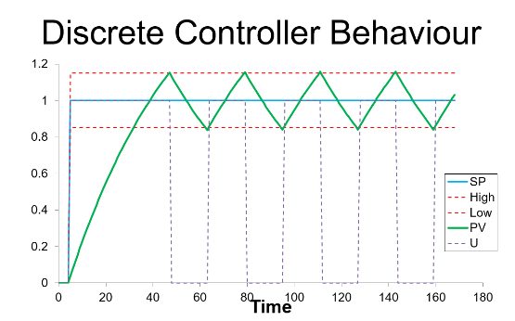

Figure 1. – The behaviour of a discrete controller represented on a line graph. [4]
To start with the controller output (U) is off, this is because there is no current demand from a set point. Once the set point is introduced, the controller output turns on. This raises the process value towards the set point. Once the set point has been reached the controller is turned off. This makes the process value drop. Once it drops to the low threshold the controller is switched back on again. The process value then increases. This type of control is simple, cheap and easy to maintain but also repair. However repairing will be common as the system is exposed to lots of wear from constantly being switched on and off. The system also never rests on the set point. [4] Discrete control would be used in light switches or power switches.
Three state controller: Three state control is a replica of discrete control however, it has three settings. Whereas discrete control can be on or off. Three state control can be on, off and half on. The behavioural characteristics follow that of discrete control to some extent. The controller output is off until a demand is created by introducing a set point. The controller is 100% switched on allowing the process value to increase rapidly. When the process value reaches the minimum threshold the controller switches to say 50% so the process value increases more slowly. Once the set point is reached the controller is turned off and the process value will slowly drop to that lower threshold again where it can be switched back on to 50%. Like discrete control, it is cheap and simple. However, the system still never settles on the set point and wear/fatigue will still occur (just at a slower rate than discrete control). It is also more complicated to implement. [5] An example of three state control is a boiler providing hot water to radiators in a house.
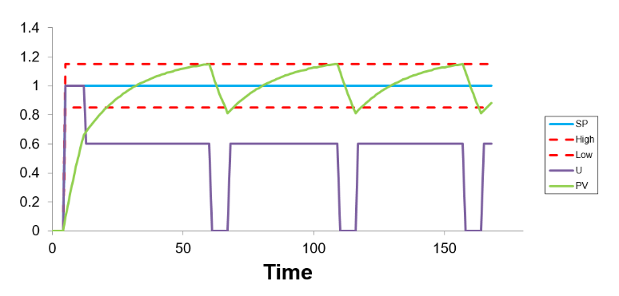

Figure 2. – Behavioural characteristics of three state controller. [4]

Proportional control: Proportional control uses a proportion of the error signal to control the output. Proportional control is used when you want to maintain a process value to a finer degree of tolerance. In other words, the process value doesn’t fluctuate around the set point like we’ve seen in other control systems.
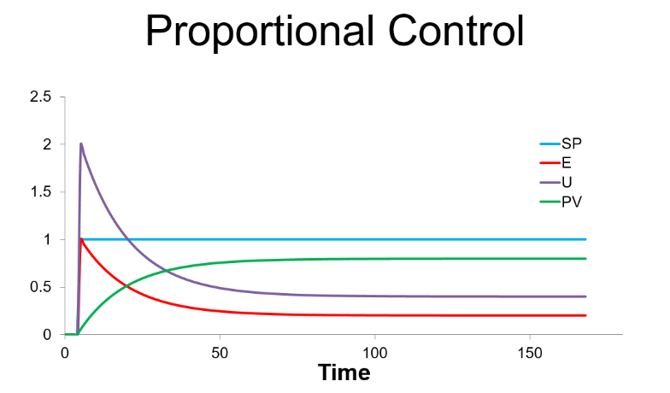

Figure 3. – Behavioural characteristics of a proportional control system. [4]
Proportional control works by creating a set point. The process value increases rapidly as the controller is turned 100% on. As the process value increases, the controller output is reduced causing the process value to increase more slowly. This results in the process value never reaching the set point. Although it is more complex than the systems we’ve seen previously, it is still easy to implement. However, it has a long settling time. An early example of a p-controller is the fly ball governor where steam was regulated in steam engines. [6]
Proportional integral control: The proportional controller only takes into account current error which leads to a large steady state error whereas the P-I controller uses the integral of the error to remove the steady state error.
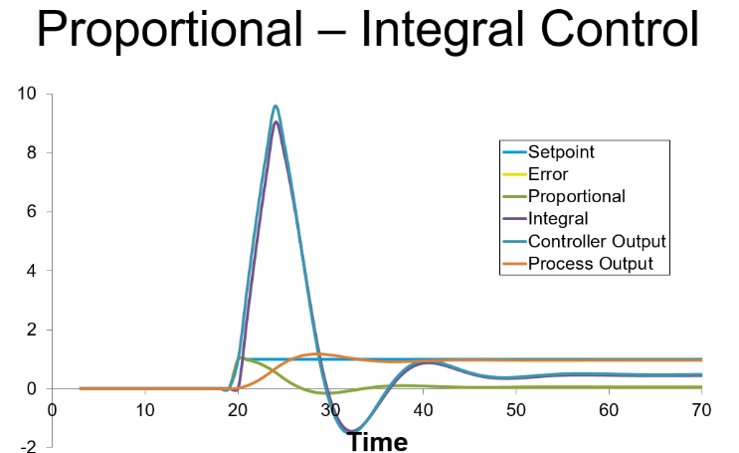

Figure 4. – Behavioural characteristics of a PI controller. [4]

Whereas before with the p controller only using a proportion to contribute to the controller ouput. The PI controller uses a proportion and integral to contribute to the controllers output. This makes the controller output rapidly increase which makes the process value increase. As the process value increases, the error signal reduces causing a reduction first in the proportional element – causing a reduction in controller output. However, the integral is still contributing to the controller output. [4] When the error value reaches zero, the integral contribution will reduce to a value to compensate for the steady state error from the proportional control. This means we never get a steady state error. Disadvantages of PI controllers are that they are complex and have a narrower range of stability.
Proportional derivative control:
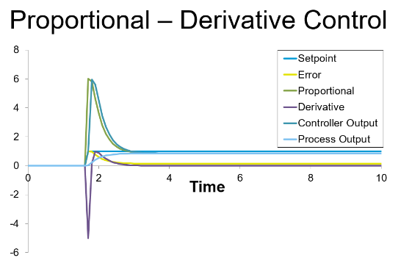
A set back of the previously mentioned PI controller was that they are often poor at keeping a good stability. A PD controller is implemented to improve the stability of said system without altering the steady state error. It does this by altering the rate of change of error signal to control any overshoot of the process value. Essentially PD control is a linear combination of the error signal and the derivative of that signal. [7]

Figure 5. – Behaviour of PD controller represented in a line graph. [4]
The PD controller needs an error signal to ‘read’, which is generated by changing the set point to change the demand. This error signal will produce a proportional response from the controller. There will be a high rate of change in our error signal, which in turn reduces the output from the controller. The process value rises towards the set point. Once the set point is reached, the error signal reduces, in turn reducing the proportional component of the controller output – slowing the error rate reducing the derivative component of the controller output towards zero. Because of this the process value will never reach our set point. However, this also means the system is stable because the rate of the error signal determines the controller output.
Proportional Integral Derivative control: a PID controller uses both the integral of the error value. Then also uses the derivative of the error value to control the output, as well as the absolute error value. The three ‘processes’ each hold their own responsibility. The derivative controls overshoot by ‘predicting’ future errors. The integral takes into account the sum of previous errors. Finally, the proportional control deals with current state errors. The three components are summed to give the final controller output.
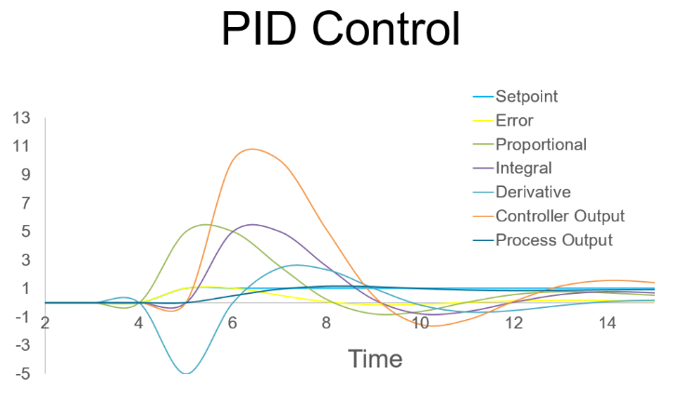

Figure 6. – Behaviour of a PID controller represented on a line graph. [4]

The PID controller can give an output of a range of different characteristics. This is why it is used for cruise control on a car (not adaptive cruise control). A basic cruise control system will hold the engine at a constant steady rpm with no fluctuation. On a level surface with no wind this will mean the car is at a constant speed. However, in real scenarios inclines and wind will slow the car. This is where the PID controller can set a new output to a higher rpm to maintain the set speed. However, this is difficult to initially tune and implement as well as being more complex than previous controller types seen. [8]

Simulation Setup:
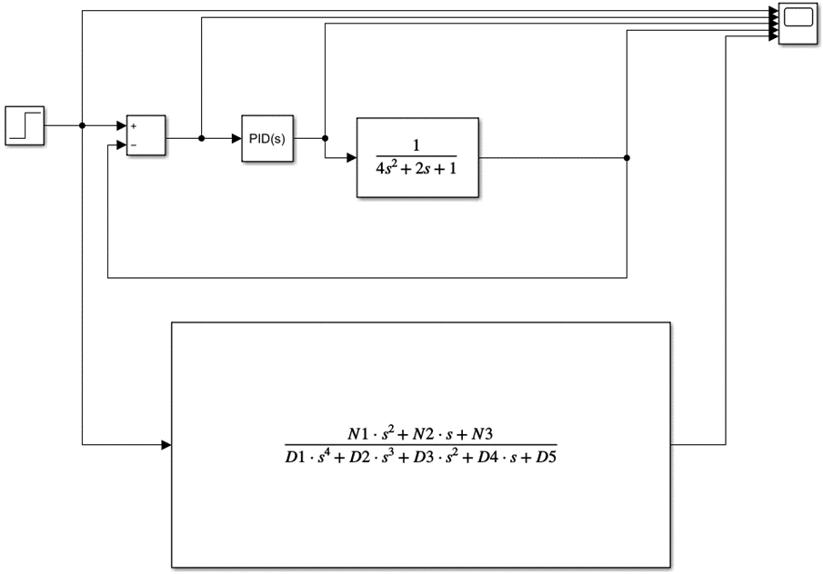

Figure 7. – Simulation setup on Simulink of a closed loop system.

On Simulink, I constructed a closed loop system including the main components of a PID controller and also a transfer function. The transfer function modifies input signals, and essentially models the systems output for every possible type of input. Overall, our transfer function characterises our system. In my specific transfer function 4 2 & 1 were used for A B & C in our quadratic formula. This 4 2 & 1 would go on to determine the stability of the system to return to 0 after being stimulated by a disturbance.
Results:
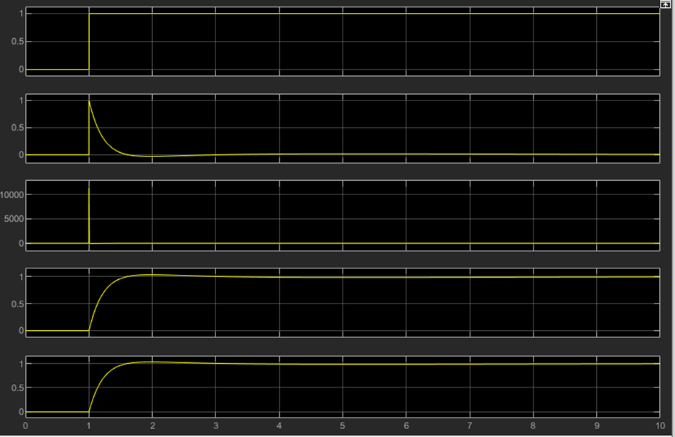
After running the simulation 3 times in order to make sure the same result was displayed on the scope and in the ‘Performance and Robustness’ display the final results were obtained:

Figure 8. – Results from our 5-port scope.

Discussion:
From our results, we can plot a series of graphs to show data, which reflects our performance of the turret/simulation.
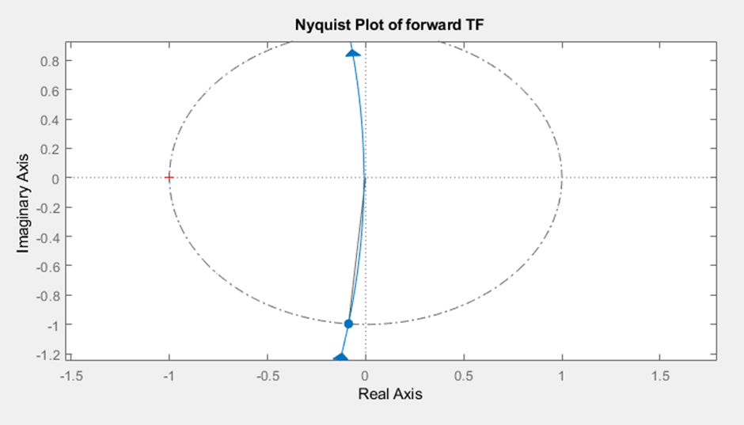

Curved grey line used to calculate PM.

Figure 9. – Nyquist plot from simulation.

A Nyquist plot is defined as the “representation of the vector response of a feedback system (especially an amplifier) as a complex graphical plot showing the relationship between feedback and gain.” [9] Our Nyquist plot in Figure 9 shows the gain and phase margin. Our phase margin was 85 degrees. The greater the phase margin of a system the better the stability of that system. The phase margin refers to the amount of phase, which can be increased or decreased without making the system unstable.
The phase margin can also be directly calculated from the Bode diagram (figure 10). This is done by calculating the vertical distance between the phase curve and the x-axis at the frequency where the Bode magnitude plot = 0 dB. This point is known as the gain crossover frequency [10].
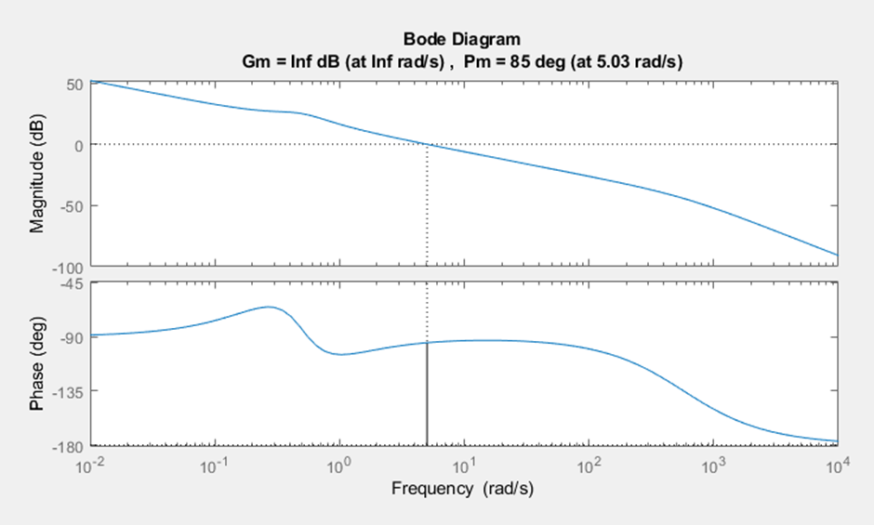

Figure 10. – Bode plot from simulation.

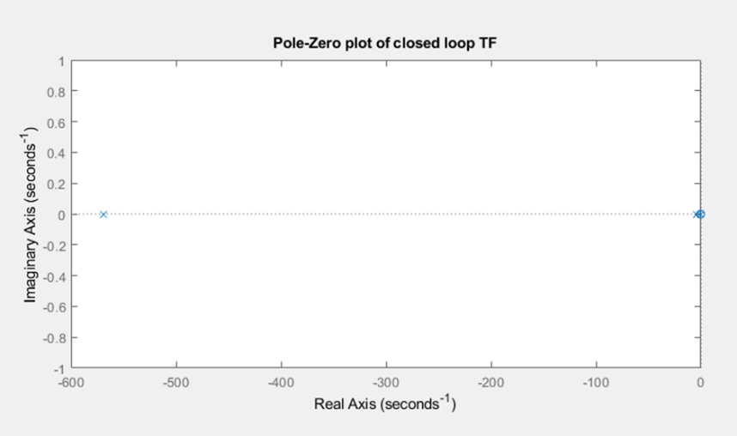

Figure 11. – Pole-Zero plot of closed loop transfer function.

As previously mentioned the transfer function in our closed loop simulation had the numbers 4 2 and 1 assigned to it. These numbers would further go on to determine the stability and response time of our system in question. Because we know the transfer function of our system we can use a pole zero diagram to help us visualise how our system will behave to stimuli.
This pole zero plot (figure 11) would’ve been plotted in the s-plane. Therefore frequency and damping will be on the axis. The x on our graph shows the point of which our transfer function tends towards infinity. Whereas the 0 on our graph shows the point of which our transfer function tends towards zero. The location of these poles can be used to predict the time domain response of our system. The dominant pole (furthest from 0 in the real axis) determines the systems fastest response time from a stimuli. In our case it shows we have quick exponential decay which is a good performance indicator.

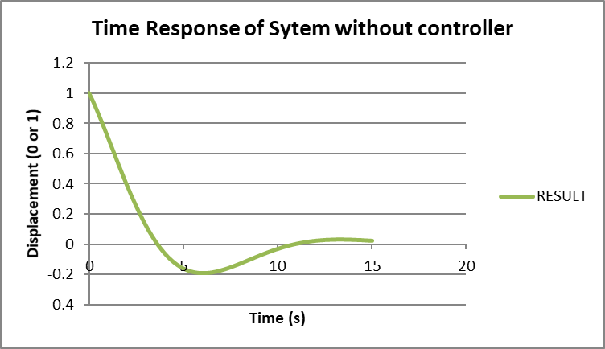

Figure 12. – Time response without the controller.

Using the dominant pole (-569) from our p-z plot we can use this as Sigma to plot the time response of our system with the controller in a closed loop. We can also plot the time response without the controller (figure 12). From figure 12, we can see the system once disturbed takes 10 seconds to settle around the 0 point. Whereas it only takes 0.2 seconds with the controller (figure 13). This shows that with the controller the system can recover from external disturbance significantly faster.
Putting this into context with our turret, an external disturbance could be recoil from firing. These guns fire large masses at high velocity. When considering Newton’s 3rd Law, the recoil of these forces from firing would disturb the gun and potentially alter the position of it. Therefore implementing a controller helps the turret reset in order to maintain its parameters. If a controller wasn’t implemented the gun may not be pointed towards the desired target and therefore be unable to take it out.
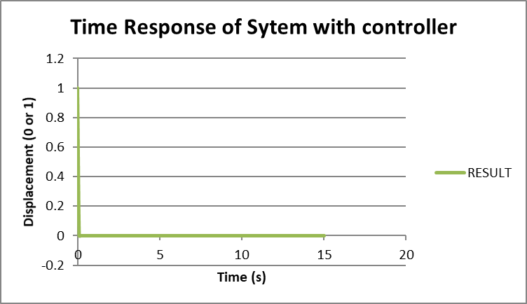

Figure 13. – Time response with controller (same axis as figure 12).

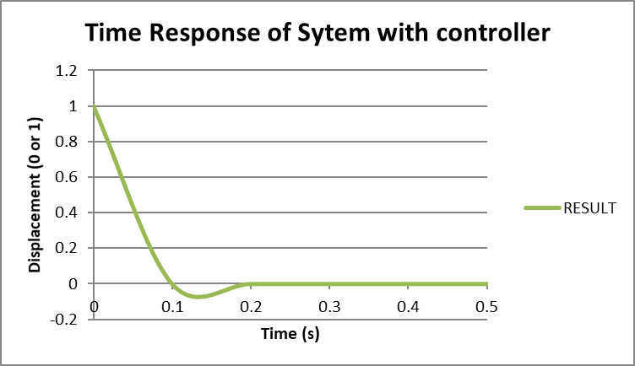

Figure 14. – Time response with controller (new axis to show curve clearer).

Conclusion:
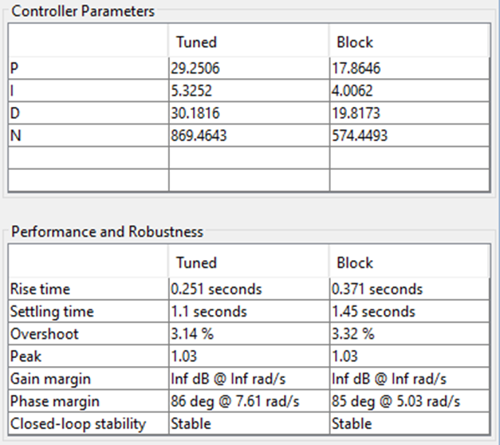

< 2.0s
< 5.0%

Figure 15. – Final output of performance and robustness.

From our table of final outputs we can clearly see that the task brief has been met. The settling time is less than 2 seconds at 1.1 seconds. The overshoot is less than 5% at 3.14%. However, these figures in the real world are not good enough. An overshoot over even just 1% would fail to hit a target. The typical gun turret on a naval ship fires hundreds of small rounds. These small rounds therefore do not cover a lot of area meaning just 1% overshoot could end up failing to hit a target. Thus meaning if a small target was to be a threat such as a small drone, the gun would fail to eliminate due to the large overshoot. However, if the target was large such as a large missile then the small overshoot would not be as significant as a factor due to the target covering more area.
Overall, after tuning the block and updating it, the task brief was met. If I were to do this again, I would like to explore with changing the pre-decided numbers that were assigned to me to see how the properties of the transfer function change.

References

[1] | F. H. Raab, "Switchmode RF and Microwave Power Amplifiers (Third Edition)," 2021.
[2] | K. &. K. I. O. T. &. SCIENCES, "KITS GUNTUR," KITS, 2017. [Online]. Available: http://kitsguntur.ac.in/site/admin/up_files/DCS%202017-18.pdf. [Accessed 02 11 2021].
[3] | Dstl, "Open-loop versus closed-loop control of MEMS devices: choices and issues," IOP science, 19 August 2005. [Online]. Available: https://iopscience.iop.org/article/10.1088/0960-1317/15/10/018/meta. [Accessed 02 11 2021].
[4] | D. S. Mosey, "Controller Types," UWTSD, Swansea.
[5] | H. H. H. J. Xu Yang, "Three State Controller Design of Shaking Table in Active Structural Control System," IEEE Xplore, 2007. [Online]. Available: https://ieeexplore.ieee.org/document/4376324. [Accessed 02 11 2021].
[6] | T. E. o. E. Britannica, "Control System Technology," Britannica, [Online]. Available: https://www.britannica.com/technology/control-system#ref199536. [Accessed 02 11 2021].
[7] | P. W. (. e. a. M. university), "P, I, D, PI, PD, and PID control," Engineering/Libre texts, March 2021. [Online]. Available: https://eng.libretexts.org/Bookshelves/Industrial_and_Systems_Engineering/Book%3A_Chemical_Process_Dynamics_and_Controls_(Woolf)/09%3A_Proportional-Integral-Derivative_(PID)_Control/9.02%3A_P%2C_I%2C_D%2C_PI%2C_PD%2C_and_PID_control. [Accessed 03 11 2021].
[8] | "Cruise Control: PID Controller Design," Matlab&Simulink, [Online]. Available: https://ctms.engin.umich.edu/CTMS/index.php?example=CruiseControl&section=ControlPID. [Accessed 04 11 2021].
[9] | J. He, "Model Analysis," 2001.
[10] | "Electrical 4 U," 24 January 2021. [Online]. Available: https://www.electrical4u.com/bode-plot-gain-margin-phase-margin/. [Accessed 12 December 2021].

