
Custom Controller with RS232 Communication for an Industrial Oven Testing Bench

By
Damian Walczak [2015478]
Supervisor: Jenifer Prince Deveraj

Project submitted as part of the requirements for the award of

BEng (Hons) Electrical and Electronics Engineering

May 2026

DECLARATION

I, Damian Walczak declare that I am the sole author of this Project; that all references cited have been consulted; that I have conducted all work of which this is a record, and that the finished work lies within the prescribed word limits.

This work has not previously been accepted as part of any other degree submission.

FORM OF CONSENT

I Damian Walczak hereby consent that my Project, submitted in candidature for the B.Sc.(Hons) Electrical and Electronics degree, if successful, may be made available for inter-library loan or photocopying (subject to the law of copyright), and that the title and abstract may be made available to outside organisations.

Date : 27/04/2026
Abstract
The design and implementation of a custom embedded control system with RS232 connection for an industrial oven testing bench are presented in this project. The goal was to create a scalable, affordable substitute for conventional PLC-based systems that would still be safe, dependable, and designed with consideration of relevant industrial safety standards.
Multiple output channels for load control, real-time temperature, voltage, and current monitoring, and integrated safety features like emergency stop and watchdog protection are all features of the system, which was created using a PIC18F46J50 microcontroller. Data logging and system control are made possible by communication with a PC-based interface.
All system components were shown to operate reliably during experimental testing, with consistent switching performance, precise sensor measurements, and efficient fault detection. The system performed well when operating continuously and accomplished all of the project's goals.
The findings verify that, for small to medium-sized industrial applications, embedded microcontroller-based systems can offer a flexible and far less expensive substitute for PLC solutions. Future projects will incorporate enhanced user interfaces and contemporary communication technologies.
Contents
1. Introduction 6
1.1 Background 6
1.2 Problem Statement 6
1.3 Project Aim and Objectives 7
2. Research & Review of Literature 8
2.1 Introduction 8
2.2 Industrial Automation and the Role of PLCs 8
2.2.1 Limitations of PLC Systems 8
2.2.2 PCs and Embedded Controllers as alternatives. 9
2.3 Distributed Control Systems (DCS) 9
2.4 Microcontroller-Based Systems 10
2.4.1 Power Conversion and Voltage Regulation 11
2.4.2 Digital/Analogue Input Signal Level Conditioning 11
2.4.3 Communication Interfaces 11
2.4.4 Expandable I/O 12
2.4.5 Safety 12
2.4.6 Load Switching and Protected MOSFETS 12
2.5 FPGA-Based Controllers 12
2.6 Comparative Analysis of Control System Architectures 13
2.7 Summary and Rationale for Selected Approach 13
3. Research & Development Methodology 15
3.1 Introduction 15
3.2 Methodological Rationale Based on Literature Review 15
3.3 Research Design Approach 15
3.3.1 Development Process 16
3.4 System Development Methodology 17
3.4.1 Hardware Design Method 17
3.4.2 Firmware and Control Logic Development 18
3.5 Testing and Validation Methodology 19
3.6 Ethical, Safety, and Compliance Considerations 19
3.6.1 Risk Assessment and Mitigation 20
4. Design & Implementation 20
4.1 Overview of System design 20
4.2 Hardware Design and Implementation 20
4.2.1 Microcontroller Selection 20
4.2.2 Design Challenges and Continual Enhancements 24
4.2.3 Power Supply and Voltage Regulation 24
4.2.4 Output Control and Load Switching 28
4.2.5 Signal Conditioning Design and Calculations 28
4.2.6 Signal Conditioning and Noise Filtering Improvements 29
4.2.7 Safety Features and Compliance Implementation 31
4.2.8 PCB Design and Layout Considerations 33
4.2.9 Enclosure Considerations 35
4.2.10 Communication Protocol (RS232) 35
4.2.11 Current Transformer Signal Conditioning and Interface 35
4.3 Firmware Implementation 37
4.3.1 Firmware Overview 37
4.3.2 System Initialisation 38
4.3.3 Flow of Program Processing 39
4.3.4 Serial Communication Interface 40
4.3.5 Sensor Acquisition 41
4.4 System Integration and Development Process 46
4.5 Testing and Validation Implementation 47
4.5.1 Functional Testing Implementation 47
4.5.2 Sensor Calibration Procedure 47
4.5.3 Safety and Fault Testing 49
4.5.4 Voltage Regulation Verification 49
4.5.5 Reliability and Stress Testing 50
4.6 Design Validation Against System Requirements 50
4.7 Signal Stability and Measurement Accuracy (Stage 1 vs Stage 2) 51
4.8 Build costs 52
5. Evaluation 55
5.1 Overview 55
5.2 Evaluation Against Project Aim and Objectives 55
5.3 Performance Evaluation 56
5.5 Evaluation of Iterative Improvements (Stage 1 to Stage 2) 57
5.6 Limitations 57
5.7 Evaluation of System Scalability 57
5.8 Overall Evaluation 58
6. Conclusions and recommendations 59
6.1 Project Summary 59
6.2 Recommendations for Future Work 59
7. Reflections 61
8. References 63
9. Bibliography 67
10. Appendices 68
10.1 Schematics 68
10.2 Code 74
10.2.1 Main.c 74
10.2.2 Main.h 88

1. Introduction

1.1 Background
Manufacturers must use testing that simulates actual operating conditions while keeping an eye on critical metrics like temperature, voltage, and current to make sure such ovens or other appliances are safe to use and function properly to guarantee that they meet performance and safety criteria.
Programmable Logic Controllers (PLCs) have historically been used to control these testing benches because of their reliability, durability, and proven connection with industrial systems[1][2]. But PLC-based solutions have significant disadvantages as well[2], primarily high costs, restricted flexibility, and vendor lock-in, all of which impact small and medium-sized business capacity to grow. On the other hand, PC-based control systems and embedded microcontrollers have become acceptable, affordable substitutes that provide more flexibility and personalisation[3][4].
An alternative approach is provided by embedded microcontrollers, such as the STM32 and PIC families. These devices enable custom real-time control for applications by combining I/O control, ADC modules, communication interfaces, and timers on a single chip[6][7][8][15].
Mid-range PLC systems with HMI and I/O expansions often cost ~£400 or more, according to market data. [9]

1.2 Problem Statement
Despite their benefits, PLCs frequently provide much more functionality than is necessary for specialised testing applications. They are ineffective for custom systems due to their cost structure, which includes hardware, license, and programming[2][5]. In addition, closed architectures limit compatibility with sensors and newer communication technologies[5]. Therefore, there is a significant industrial requirement for a specialised, modular controller that may function similarly to a PLC[4][3][10].
An affordable, adaptable, and dependable control system is needed by industry. [10]. Such a system should comply with PUWER 1998[11], BS EN 61439[12], IEC 60204-1[13], and IEC 62061/ISO 13849[14].

1.3 Project Aim and Objectives
To develop, build, and evaluate an embedded control system for an industrial oven testing station that is based on microcontrollers. The system will include contactor control to route load to PC-selected sockets, RS232-based PC connection, and real-time sensor monitoring. It will maintain cost-effective and modular performance equivalent to commercial PLC systems while incorporating extensive safety features, automatic fault protection, and designed in alignment with relevant UK and international safety standards. All objectives can be found in Table 1 Objectives Summary.
Table 1 Objectives Summary
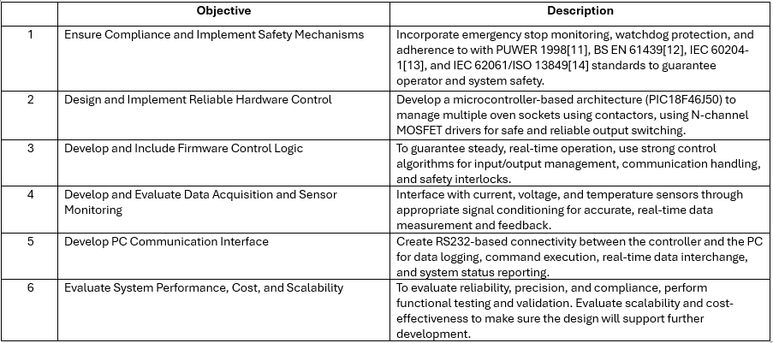1.4 Significance
This project has the potential to reduce system costs by approximately 80–90% compared to PLC-based solutions, it provides a cost-effective substitute for PLCs. Because of its open architecture and modular design, it is more accessible to small and medium-sized businesses and promotes sustainability through reduced power consumption and less overengineered approach which requires fewer components. The work contributes to the affordable modernisation of test benches in small-scale manufacturing by proving that embedded controllers can meet industrial safety and performance standards.

Research & Review of Literature

2.1 Introduction
Over time, industrial automation has changed dramatically, moving from relay-based logic to programmable [15]. Developing a dependable and cost-efficient embedded control system for industrial oven testing requires an understanding of current automation technologies, their limitations, and their suitability for small to medium-sized companies.
PLCs, distributed control systems (DCS), microcontroller-based solutions, open-source boards (Arduino, Raspberry Pi), and FPGA-based controllers are among the control architectures covered in this chapter. The technical abilities, safety compliance, affordability, scalability, and adaptability of each system are examined. The review highlights why microcontroller-based embedded systems are particularly suited to small-scale, multi-socket oven testing benches.

2.2 Industrial Automation and the Role of PLCs
PLCs have established standards for industrial automation since their inception in the late 1960s. intended to take the place of relay logic in manufacturing processes[15], PLCs combine digital and analogue I/O modules with a programmable CPU, which performs programs and controls system communication[5].
PLCs are programmed using IEC 61131-3 languages such as Ladder Logic, Function Block Diagrams, and Structured Text, which provide visual and textual control logic representation[5].

2.2.1 Limitations of PLC Systems
Despite these advantages, Table 2PLC's Challenges for small-scale testing applications. demonstrates that PLCs have a number of drawbacks for small-scale testing applications.
Table 2PLC's Challenges for small-scale testing applications.
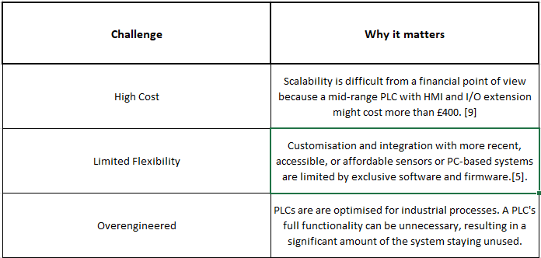
They are less appropriate than microcontroller-based systems for a small-scale oven testing bench due to their expense, complexity, and limited adaptability for quick prototyping, particularly when the main functions include socket switching, temperature monitoring, and data logging. In these situations, a microcontroller system can offer more flexibility and adequate capability at a lesser cost.

2.2.2 PCs and Embedded Controllers as alternatives.
Controllers and PCs are becoming more affordable and adaptable options. Higher processing power, extensive data storage, and flexible software development platforms are all provided by PCs, which enable the integration of numerous serial communications and fully integrated HMI systems[31][4]. However, PCs lack integrated switches or relays to regulate parts like contactors, which are necessary for testing station power distribution.

A microcontroller-based control system for a tiny induction-generator wind turbine, for example, was created by Ahshan et al. According to the study, an embedded solution was more economical, satisfies computing requirements, and avoids needless hardware complexity, even though a PLC might have been used. Whilst a particular study highlights embedded systems as cost-effective [3], majority of current research does not address PC-based monitoring and safety interlocks.

2.3 Distributed Control Systems (DCS)
A DCS coordinates and manages process subsystems in real-time, acting as the brains behind industrial processes. It enables automated decision-making and instructions throughout a plant by integrating several components, including sensors, actuators, and PLCs, via a communication network. DCSs are made to handle complicated procedures in large-scale production settings, providing advantages including increased productivity, reduced risk, and better cybersecurity and safety[17].
However, a DCS is not suitable for small appliance testing benches. Since a DCS is intended for large-scale industrial operations with complicated process control requirements, its implementation would add excessive complexity and cost. A DCS is an impractical and ineffective option since its infrastructure, software, and maintenance requirements considerably exceed the needs of a small appliance testing environment.

2.4 Microcontroller-Based Systems
Microcontrollers (MCUs) provide an integrated, low-cost platform that combines a CPU, memory, timers, and I/O interfaces on a single chip[18]. Any device that measures, stores, controls, or displays data uses them extensively in embedded control applications[18].
Table 3 Modern MCUs offering and why it matters [18] shows Modern MCUs, such as ATmega, Raspberry Pi Pico, Arduino devices, and what they offer:
Table 3 Modern MCUs offering and why it matters [18]
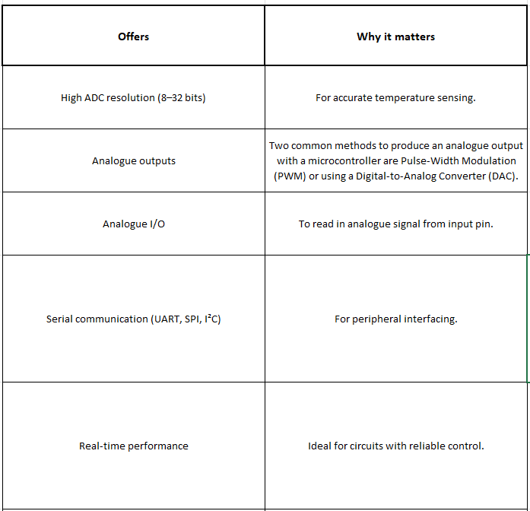
MCUs are an affordable, small, and reprogrammable option with embedded data logging and real-time control[18]. They have been successfully used for environmental monitoring[19]. Therefore, they can offer data logging, current sensing, and socket control for an oven testing bench without the cost or complexity of an industrial controller.
MCUs must be developed and function with other subsystems in order to accomplish a particular purpose because they cannot function as standalone units. Usually, they function at low logic-level voltages, such as 3.3 V or 5 V[18], meaning that in order to properly operate devices powered through the electrical supply, additional driver circuits are required. Additionally, various integrated circuits for communications, such as RS232 or I²C, and signal conditioning circuits for sensor signals are required.

2.4.1 Power Conversion and Voltage Regulation
MCUs operate at low logic-level voltages (3.3V or 5V)[18]. In industrial environments with 24V control lines or power rails, designers must implement robust voltage regulation. Voltage regulator choice was based on Table 4 Regulator Choice.
Table 4 Regulator Choice
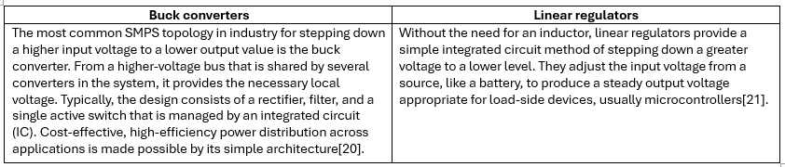

2.4.2 Digital/Analogue Input Signal Level Conditioning
The system must read and interpret external digital signals into the MCU's logic domain, including 24 V control signals, fault signals, and sensor digital thresholds. Table 5 Signal Conditioning Considerations takes it into account.
Table 5 Signal Conditioning Considerations
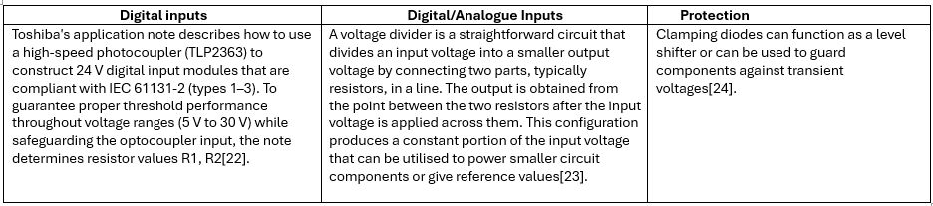

2.4.3 Communication Interfaces
MCUs in industrial applications often communicate with PCs, sensors, or other controllers. Different choices can be found in Table 6 Communication Interface
Table 6 Communication Interface Summary
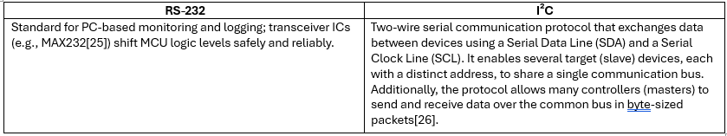

2.4.4 Expandable I/O
MCUs have limited access to inputs and outputs, to obtain more i/o is essential.
- The MCP23017[17] provides additional GPIO lines without consuming MCU pins.

2.4.5 Safety
Safety summary can be found in Table 7 Microcontroller Safety Consideration.
Table 7 Microcontroller Safety Consideration
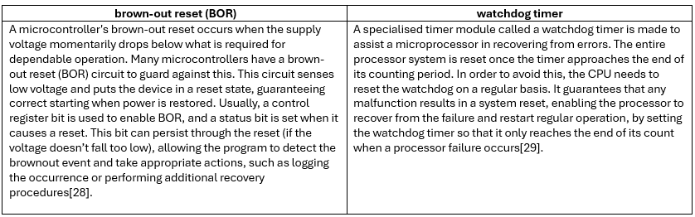

2.4.6 Load Switching and Protected MOSFETS
Simple discrete transistors may not be as secure as protected low-side MOSFET drivers when MCUs need to switch 24 V inductive loads, like contactor coils. By implementing Self-Protected Low Side Driver with Temperature and Current Limit protection, and ESD robustness, devices like the Onsemi NCV8401 provide direct MCU control of 24 V loads without the need for external protective components. Protected switches are more reliable than relays or unprotected MOSFETs[32].

2.5 FPGA-Based Controllers
An FPGA (Field Programmable Gate Array) is a very flexible semiconductor IC that may be modified after it is manufactured. Its foundation is a matrix of Configurable Logic Blocks (CLBs), which can be interconnected according to the user's design. Hardware Description Languages (HDLs) like VHDL or Verilog are commonly used for programming, and loading code onto an FPGA is comparable to programming a PROM[30].
The usage of FPGAs in some applications is limited by a number of their drawbacks. They are difficult to program and require specific expertise in digital system design and Hardware Description Languages (HDLs), as well as familiarity with simulation tools. Additionally, they often use more power than ASICs and have less options for power optimisation. Additionally, the resources on the chosen chip limit an FPGA's design capabilities, therefore selecting the appropriate device early in the design process is crucial. Lastly, FPGAs are more expensive for large-scale manufacturing than ASICs, even though they are more affordable for short production runs and prototyping[30].

2.6 Comparative Analysis of Control System Architectures
Table 8 Comparison and Evaluation of Control System Designs.
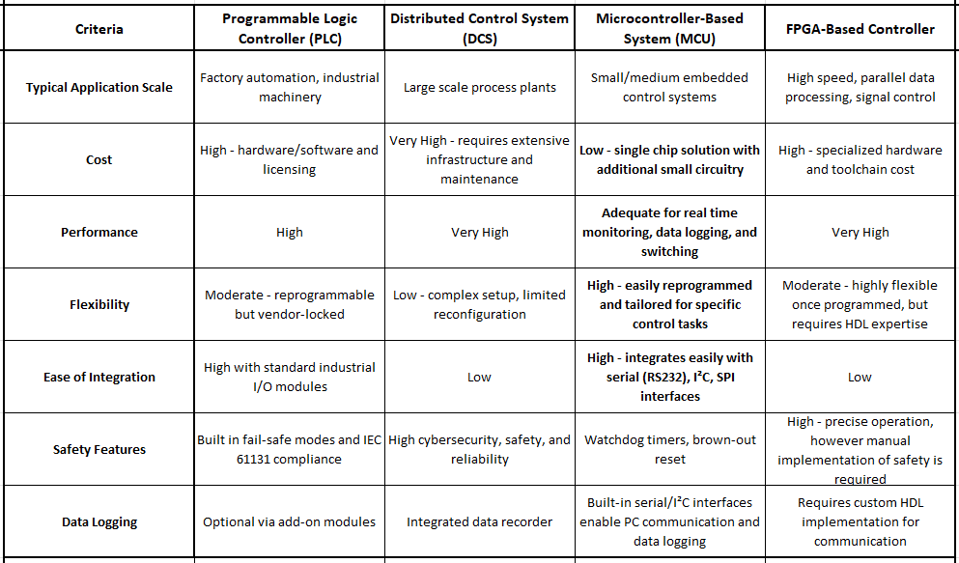

2.7 Summary and Rationale for Selected Approach
The review of current automation and control architectures demonstrates how programmable and embedded solutions have replaced conventional relay-based systems. Depending on application scale, performance needs, and financial considerations, each technology PLCs, DCSs, microcontrollers, and FPGAs offers unique benefits and limitations.
Because of their dependability, adaptability, and adherence to global standards, PLCs have long dominated industrial automation (IEC 61131-3). However, they are less appropriate for small-scale testing applications due to their high cost, restricted flexibility for quick prototyping, and dependence on lock-in programming environments. Similar to this, DCSs add unnecessary complexity and infrastructure expenses that beyond the requirements of an oven testing bench, despite their power for large-scale continuous process facilities.
FPGA-based controllers, though offering exceptional speed and parallel processing capabilities, demand specialized design skills in hardware description languages (HDL) and carry high development overheads, making them impractical for some applications.

MCU’s on the other hand, offer the best possible balance of cost, performance, scalability, and design flexibility. MCU’s enable effective real-time control of numerous oven outlets, temperature sensors, and switching circuits by combining a CPU, memory, and I/O peripherals into a single device. They facilitate easy data logging and PC interface by supporting fundamental communication protocols including RS-232 and I²C. Additionally, scalable I/O modules enable system scalability without requiring major redesign, while safety features like watchdog clocks and brown-out monitoring improve reliability.
MCU's modular and reprogrammable design may meet the needs of small and medium-sized businesses involved in thermal testing and product validation, where cost control, flexibility, and ease of modification are essential. By connecting low-voltage digital control with 24 V industrial inputs, additional circuitry such as voltage regulation, signal conditioning, and isolation guarantees safe operation in mixed-voltage situations.
As a result, the chosen architecture for the oven testing bench controller is the microcontroller-based embedded system. It provides an affordable, reconfigurable, and technically sound solution that can accurately and consistently execute temperature monitoring, data logging, and multi-socket control. This strategy maintains low overall system complexity and lifecycle cost while enabling flexible experimentation and future development.
While PLC systems provide certified safety and robustness, their cost and limited flexibility make them less suitable for small-scale testing applications. Conversely, microcontroller-based systems offer flexibility and cost benefits but require careful design to ensure safety and reliability. Therefore, the chosen approach represents a trade-off between cost efficiency and the absence of formal industrial certification.

Research & Development Methodology

3.1 Introduction
The research and development process used to build and develop the microcontroller-based control system for the industrial oven testing bench is presented in this chapter.
The results of the literature review, which highlighted the drawbacks of PLC-based testing systems and the benefits of embedded microcontroller solutions in terms of cost, modularity, and adaptability, served as the basis for the technique. In order to provide a dependable and secure control system, the research uses a practical engineering and experimental development strategy that combines continuous design, simulation, and testing.

3.2 Methodological Rationale Based on Literature Review
The literature review demonstrated several important gaps and opportunities that shaped the research direction of this project. Key findings can be found in Table 9 Key Literature Findings Informing the Methodology
Table 9 Key Literature Findings Informing the Methodology
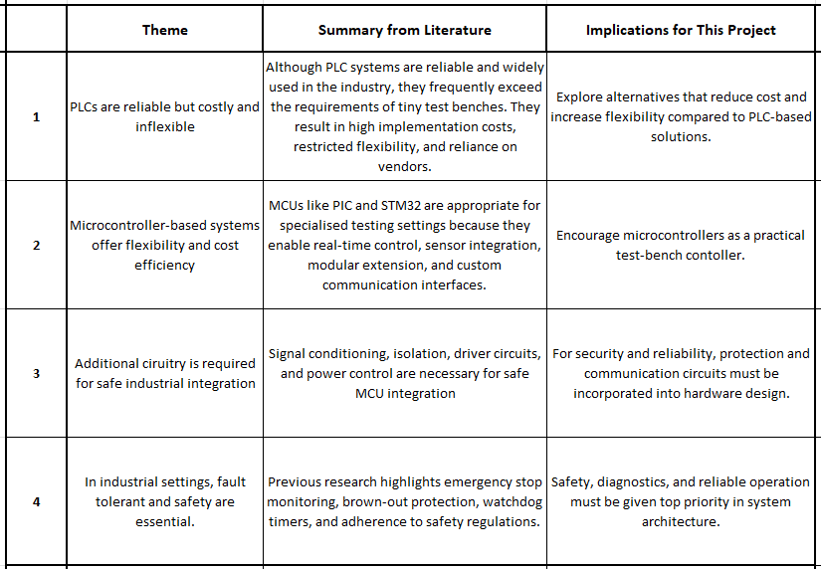

3.3 Research Design Approach
This project uses an experimental development and practical engineering methodology:
- Engineering development: To address the industrial oven testing issue, a new embedded control system is developed that combines hardware and software to satisfy project specifications.
- Experimental evaluation: To ensure that the system satisfies functional, performance, and safety goals, it is tested under actual working situations.

3.3.1 Development Process
This project followed a step-by-step development process. The system was improved over time by building it, testing it, finding problems, and making changes until it worked as required.
The process included the following stages as seen in flowchart in Figure 1 Development process flowchart.
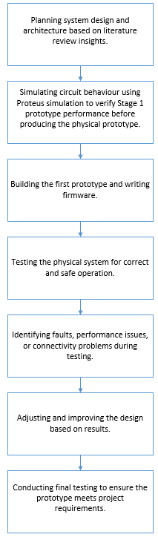
Figure 1 Development process flowchart
This approach allowed the system to develop and improve gradually, rather than being completed in a single build, helping to increase its performance, reliability, and safety.

3.4 System Development Methodology

3.4.1 Hardware Design Method
Implementing the features listed in the literature review is the main goal of the hardware design process, which includes:
- Microcontroller-based I/O control
- Signal conditioning for inputs
- Expandable I/O module based on I2C
- Regulated multi-voltage power supply design
- Protected MOSFETS
Recommended guidelines found in investigated research on embedded industrial control hardware were used to support design choices for PCB layout, filtering, grounding, and modular expansion.

3.4.2 Firmware and Control Logic Development
The firmware was created in C to give the oven testing system safe, dependable control and monitoring. To ensure that each task runs consistently and is easily maintained, the code is divided into separate functions for sensing, switching control, communication, and safety logic.
The firmware reads measurements from the LM35 temperature sensor, thermocouple module, current sensors, and voltage sensors.
- To lower noise and increase accuracy, analogue values are sampled via the ADC and averaged.
- The firmware uses Serial Peripheral Interface (SPI) to read the MAX31855 thermocouple and looks for wiring and connection issues.
- To ensure that the readings accurately reflect electrical and temperature values, bias correction, calibration factors, and RMS calculations are used.
The MCP23017 I²C I/O expander is used to control digital outputs, while RS-232 is used to communicate with the PC. Commands have the ability to read data, control test activities, and switch outputs.
The firmware shown in Figure 2 Safety-Critical Features includes several safety-critical features
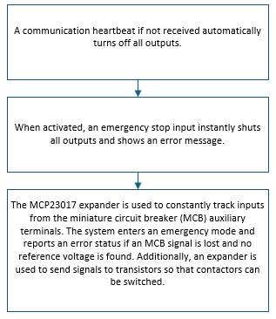
Figure 2 Safety-Critical Features
These features ensure that the controller fails safely and prevents unsafe operation during fault or abnormal conditions.

3.5 Testing and Validation Methodology
The Stage 2 controller's testing approach is intended to carefully assess its performance, reliability, and safety in order to make sure it satisfies the functional goals set down in Stage 1 and complies with industry standards. The literature highlighting the drawbacks of PLC’s and the benefits of microcontroller-based systems guides testing.
Key testing activities include:
- Functional testing involves the process of confirming that all outputs, such as MOSFET-driven contactor switching, emergency stop functionality, and auxiliary MCB feedback monitoring, are operating correctly. This guarantees that under typical operational conditions, control logic operates as planned.
- Testing for sensor accuracy includes Verifying measurement accuracy and the validity of signals involves comparing voltage sensor, current transformer, and Type-K thermocouple values to calibrated reference instruments.
- In order to evaluate long-term stability, thermal behaviour, and the robustness of RS232 communication, reliability and stress testing involves repeated switching cycles and continuous operation.
- In order to confirm the functionality of safety interlocks, watchdog clocks, and automated shutdown mechanisms, fault and safety testing simulates abnormal conditions such overloads, over-temperature occurrences, and signal disruptions.
- Comparative evaluation compares the system's cost, scalability, modularity, adaptability, and applicability for industrial oven testing scenarios to PLC-based systems.
This carefully structured process guarantees that the controller meets the safety and usability standards determined during Stage 1 and the literature evaluation as well as making it operationally effective.

3.6 Ethical, Safety, and Compliance Considerations
Safety and compliance are of the highest priority because it interacts with industrial electrical systems. Among the methodological factors are:
- Testing for safe laboratory practices will be carried out in a controlled environment using the appropriate fusing, electrical isolation, and safety equipment.
- To lower the risk of overvoltage or component damage, electrical protection circuit design includes regulated DC-DC power stages, watchdog timers, and emergency stop capabilities.
- To ensure operator and equipment safety, all design, testing, and operational procedures follow relevant UK and international standards, such as PUWER 1998, BS EN 61439, IEC 60204-1, and IEC 62061/ISO 13849.
- Ensure the integrity of recorded data by using precise sensor calibration, dependable RS232 connectivity, and detailed logging to support appropriate reporting and analysis.
These elements support the safety goals highlighted in earlier research and bring the methodology into line with industry best practices.

3.6.1 Risk Assessment and Mitigation
A structured risk assessment was conducted to identify key hazards associated with the system and to implement appropriate mitigation strategies, as summarised in Table 10 Risk Assessment and Mitigation Summary.
Table 10 Risk Assessment and Mitigation Summary
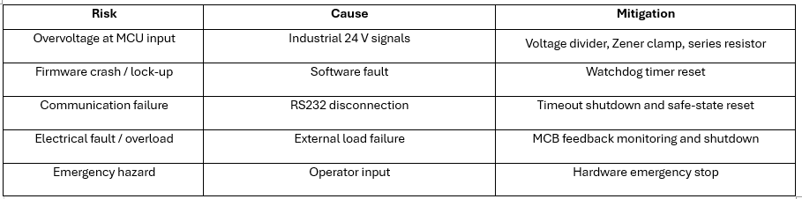

Design & Implementation

4.1 Overview of System design
The entire design and implementation of the custom embedded controller created for the industrial oven testing bench are presented in this chapter. The design aims to provide a reliable, secure, and affordable substitute for a PLC-based system while adhering to key industry standards, building on the specifications and justification presented in Chapters 1-3. In order to provide real-time monitoring, control, and fault handling within a modular design, the system combines hardware, firmware, and PC-based communication.

4.2 Hardware Design and Implementation

4.2.1 Microcontroller Selection
It was essential to understand the operating principles of the microcontroller and evaluate all features before making a selection. Tables 5–8 summarize all the considerations taken into account, and from the analysis of memory requirements, I/O resources, and other factors in the subsections, most suitable microcontroller for the system could be chosen.
The PIC18F46J50 offers its advantages and adaptability. This 8-bit microcontroller provides 28 ADC channels, above the minimum need of 7, making it perfect for many sensor inputs. It also contains two independent UART modules (TX/RX) ideal for RS232 communication support, enabling simultaneous communication. With up to 35 GPIO pins, the microcontroller gives flexibility for additional digital input/output operations. It guarantees wide compatibility with a variety of sensors and modules by operating at a voltage range of 1.8V to 5.5V. Its 65 KB of Flash memory provides program code storage, and its 8-bit and 64 MHz clock speed provide enough processing capability to manage numerous inputs and serial communications[39].

Table 11 Sensor Mechanisms for Data Acquisition of internal Temperature
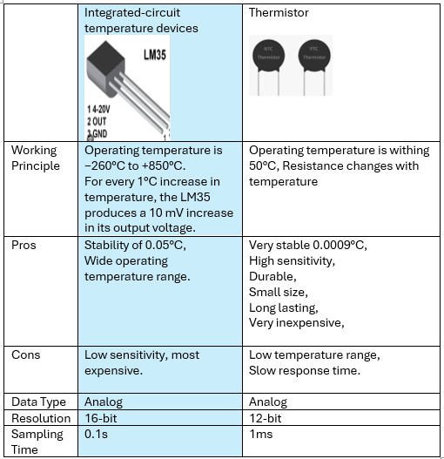 [33] [34]
Table 12 Sensor Mechanisms for Data Acquisition of oven Temperature
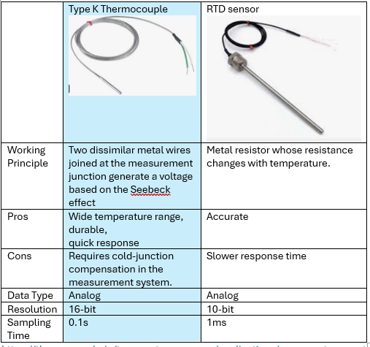 [35][36]
Table 13 Sensor Mechanisms for Data Acquisition of oven Current
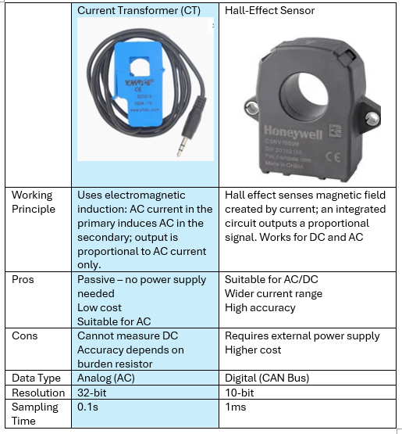 [37]
Table 14 Sensor Mechanisms for Data Acquisition of oven Voltage
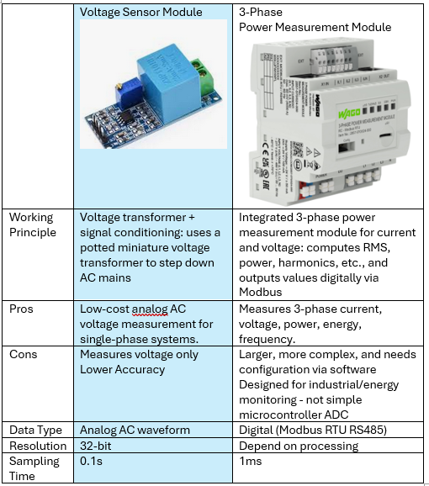 [38]

4.2.1.1 Memory requirements
The resolution, sampling frequency, and data format of each sensor in the system require certain memory challenges. All requirements are listed in Table 15 Interface Requirements
Table 15 Interface Requirements
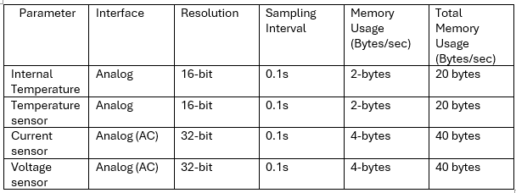
Total memory usage = 0.12kB/s
The system will need about 120 bytes of memory per second with this configuration in order to store data from every sensor. This calculation helps in determining the memory requirements for the microcontroller and for any external storage needed
Given the variety of sensors involved, a microcontroller with at least 32 KB of program memory is recommended. This makes room for the firmware and any future additions, such extra sensors or features.
RAM is needed to temporarily store sensor reading before they are processed, each sensor reading is 16/32 bits depending on accuracy and precision of the sensor. As previously calculated, memory use per second will be approximately 120 bytes. To implement communication protocols and temporarily store data, the microcontroller should have at least 1024 bytes of RAM.

4.2.1.2 I/O resources
The microcontroller must supply the following I/O resources in accordance with the system's requirements, see Table 16 Pin Count Summary on PIC.
Table 16 Pin Count Summary on PIC
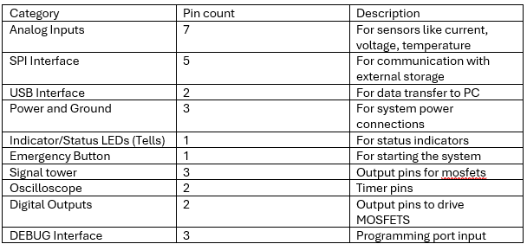
To allow more inputs and outputs, an I/O expander was used. This was necessary since the PIC microcontroller does not have a sufficient number of pins to accommodate all required signals. I/O pins of expander can be found in Table 17 Pin Count Summary on I/O expander
Table 17 Pin Count Summary on I/O expander
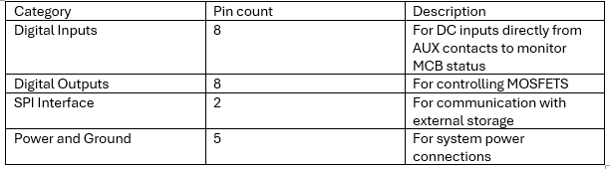

4.2.2 Design Challenges and Continual Enhancements
The controller was developed via a progressive design method, whereby early prototype problems were found through testing and then fixed in the final implementation. A number of real-world issues with manufacturing, signal integrity, and thermal performance were identified by the first Stage 1 prototype.
Using small surface-mount components in the power regulation stage was one of the main problems. The narrow component footprints and exposed thermal pads made manual assembly challenging and raised the possibility of faulty solder joints, even though the original design reduced PCB size. Concerns about reliability in operation and long-term heat dissipation were also brought up by these restrictions. To improve manufacturability and heat dissipation, the PCB layout was changed, component footprints were expanded, and thermal pathways were enhanced in the Stage 2 design.
Early testing also revealed problems with signal integrity. Analogue sensor readings were impacted by electrical noise, especially for low-level thermocouple observations. In order to stabilise communication and lessen electromagnetic interference, various filtering methods were adopted, such as pull-up resistors, ferrite beads, and RC filtering. Measurement precision and stability were greatly improved by these changes.
To better separate high-current switching circuits from sensitive analogue measurement lines, PCB architecture and component location were improved further. The final design satisfied the functional and operational objectives set during the research phase thanks to the continuous improvement strategy, which allowed for gradual improvements in system performance, reliability, and safety.

4.2.3 Power Supply and Voltage Regulation
To reduce PCB footprint, the DC-DC buck converter step was implemented in step 1 using small surface-mount components. Despite being electrically functional, this design presented serious difficulties for testing and physical assembly. Important parts, such as the power inductor and buck regulator IC (LMR33620), were delivered in compact, high-density packages that were challenging to solder consistently by hand. Specifically, the regulator used an exposed thermal ground pad on the underside of the package, requiring a strong solder contact to the PCB ground plane for heat dissipation and electrical performance. It was difficult to get proper solder wetting on this pad using manual soldering techniques, which resulted in unpredictable assembly quality.
Furthermore, the inductor's small package size and the surrounding passive components made rework difficult and raised the possibility of soldering errors. The Stage 1 power circuit's manufacturing limits were brought to light by these assembly issues, which also raised questions about the circuit's long-term thermal performance and dependability under continuous operation.
The Stage 2 redesign, which increased component footprints, enhanced thermal pathways, and changed the PCB architecture to make it easier manual assembly and heat dissipation without sacrificing electrical performance, was directly influenced by the problems found during Stage 1 testing.

4.2.3.1 Individual Device Power Consumption
An individual device power consumption study was performed for both the 5 V and 3.3 V supply rails in order to confirm the suitability of the chosen voltage regulation devices and to evaluate worst-case thermal loading. Based on normal operating currents obtained from manufacturer datasheets, the study makes the assumption that all connected loads operate continuously.
The total system power consumption is confirmed to be well within the capacity of the LM2596 switching regulators used in the design by the combined power demand of both rails. The analysis confirms that, even in the worst-case operating circumstances, no single rail exceeds the regulator's current or temperature limits by measuring the contributions of individual devices.
5 V Rail Load
The current usage of devices that are powered by the 5 V rail is summarised in Table 18 5V Rail Load. The MCP23017 I/O expander and external sensing modules are the main sources of load current. Because of its large maximum supply current during full I/O operation, the MCP23017 is the major load on this rail. The RS-232 transceiver, analogue sensors, and indication LED all require more electricity.
It is determined that the 5 V rail's total load current is 180 mA, which translates to a power usage of roughly 0.9 W. This is a sensible worst-case scenario that guarantees enough design margin for startup and unexpected circumstances.
Table 18 5V Rail Load
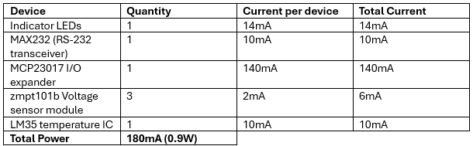
[40][25][41][42][43]

3.3 V Rail Load
The current consumption of devices powered by the 3.3 V rail is shown in Table 13. With nearly all of the total current flowing through it, the MAX31855 thermocouple interface IC is the dominating load on this rail. The EEPROM, the PIC18F46J50 microcontroller, the logic-level inputs of the NCV8401A devices, and indication LEDs provide additional loads.

With 173 mA of total current used from the 3.3 V rail, the overall power usage is roughly 0.6 W.
Table 19 3.3V Rail Load
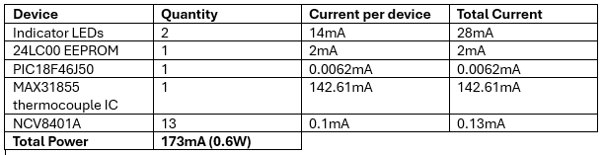
[40][44][39][45][46]

4.2.3.2 Heatsink Justification
Using thermal resistance data from the manufacturer, a worst-case thermal analysis was performed to evaluate the thermal performance of the chosen LM2596 switching regulators. The TO-220 package without a heatsink typically has a junction-to-ambient thermal resistance of 50 °C/W, while the LM2596 is rated for a maximum junction temperature of 150 °C.
The result suggests that, without the need for a heatsink, the LM2596 can safely dissipate up to 2.5 W of power at room temperature of 25 °C.
Only a small portion of the 1.5 W total output power drawn from the 5 V and 3.3 V rails is dissipated internally by the switching regulators because of their high efficiency, according to the power consumption analysis shown in Table 18 5V Rail Load, Table 19 3.3V Rail Load. Consequently, the predicted maximum allowed dissipation is far higher than the actual regulator power dissipation.
Therefore, thermal calculations verify that the LM2596 devices function well within safe temperature limits under typical and extreme loading situations, and that a heatsink is not strictly required for proper performance.
Nevertheless, as a precaution, each regulator was equipped with a little heatsink. In the event of high external temperatures, reduced ventilation inside an enclosure, or unexpected increases in load current, this choice offers extra thermal buffer. By lowering junction temperature during continuous operation, the heatsink also increases long-term dependability, which is consistent with excellent engineering practice for industrial control applications.

The thermal resistance was calculated using Equation 1[48]:
Equation 1 Thermal Resistance
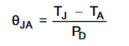
Rearranging to determine the maximum power dissipation gives Equation 2[48]:
Equation 2 Max Power Dissipation
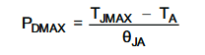
Where:
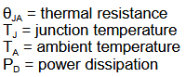
Substituting the relevant values[47]:
$$Pdmax=\frac{150-25}{50}$$
$$Pdmax=2.5W$$

$$QJA=\frac{150-25}{2.5}$$
$$QJA=50°C/W$$

4.2.4 Output Control and Load Switching
Output control is achieved using protected low-side N-channel MOSFET drivers, which energise contactor coils connected to the oven sockets. Compared to conventional relay-based designs, this method offers a number of benefits, such as quicker switching, less mechanical wear, and built-in protection against thermal and overcurrent faults.
Each output channel is controlled either directly from the microcontroller or via an I²C-based I/O expander, allowing the system to scale beyond the native I/O limitations of the MCU.

4.2.5 Signal Conditioning Design and Calculations

4.2.5.1 Voltage divider design for 24V inputs
A number of the controller's inputs, including MCB auxiliary connections, come from 24 V industrial signals. Resistors are needed to scale these signals to an appropriate level because the PIC18F46J50 runs with a maximum safe input voltage of 3.3/5 V on its pins.
The output voltage of a typical two-resistor divider is determined by:
Equation 3 Voltage Divider
$$V_{OUT}=V_{IN}.\frac{R_{2}}{R_{1}+R_{2}}$$
As seen in a Figure 3 Safe Voltage Scaling the resistor divider scales the 24 V input to approximately 9.3 V. This voltage is intentionally higher than the MCU input range and is not applied directly to the microcontroller. Instead, it is further conditioned by a protection stage (Section 4.2.4.2), where a Zener diode clamps the signal to approximately 4.3 V and a series resistor limits current. This two-stage design ensures robust operation under industrial voltage variation while protecting the microcontroller input.
$$R_{54}= 21kOhm$$$R_{62}=13.3kOhm$
$$V_{OUT}=24.\frac{21k}{13.3k+21k}$$
$V_{OUT}=$9.3V
This voltage is not delivered directly to the microcontroller; rather, it is purposefully higher than the permitted range of PIC controller. Rather, it guarantees sufficient clearance to consistently power the following safety circuitry in all predicted operating circumstances.
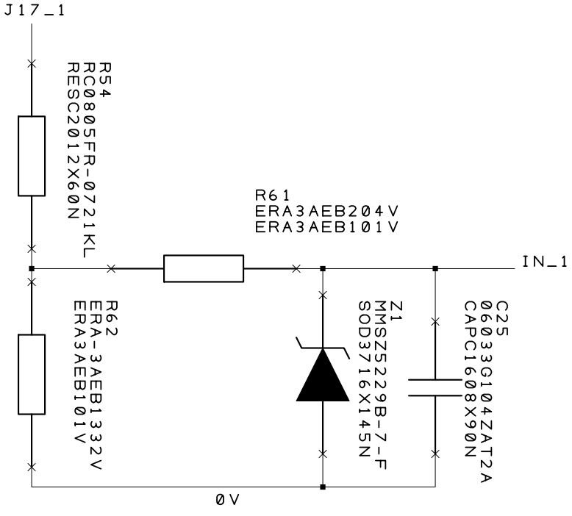
Figure 3 Safe Voltage Scaling

4.2.5.2 Input Protection and Filtering
A series resistor R61 (200 kΩ) is positioned after the divider, between the analogue input pin IN_1 and the divider output. R61 is mostly used as a current-limiting resistor to safeguard the microcontroller input in the event of a failure or a brief overvoltage. When the input voltage rises over acceptable thresholds The input terminal of a Zener diode Z1 (MMSZ5229B-7-F), which has a nominal breakdown voltage of 4.3 V, and is linked to ground clamps the voltage to ground.
Z1 connects and clamps the voltage at IN_1 to about 4.3 V when the divider output is higher than the Zener voltage, keeping the microcontroller from receiving too much voltage. The voltage across R61 at a 24 V input is:
$$V_{R61}=9.3-4.3=5.0\text{ V}$$
In order to reduce high-frequency noise and switching transients that may otherwise impair ADC accuracy, R61 additionally forms a low-pass RC filter with capacitor C25 0.1µF. This filtering increases measurement stability while maintaining a sufficient reaction time.

4.2.6 Signal Conditioning and Noise Filtering Improvements
Compared to the Stage 1 design, more signal conditioning and noise filtering techniques were used in the Stage 2 to increase the precision and dependability of the temperature readings. Because thermocouples produce low-level voltage signals, the system's Type-K thermocouple interfaced with the MAX31855KASA thermocouple-to-digital converter is vulnerable to electrical noise. In order to avoid measurement mistakes, appropriate filtering and signal stabilisation were required.
4.2.6.1 Ferrite Bead and Capacitor Noise Filtering
Ferrite beads (FB1, FB2) with an impedance of 470 Ω were added in series with the thermocouple input lines in the revised design, as shown in Figure 4 Ferrite Bead and Capacitor Noise Filtering, together with a 0.01 µF capacitor (C8) to ground. This arrangement creates a low-pass filter that lets the low-frequency thermocouple signal through while suppressing high-frequency noise.
Ferrite beads function as resistive components that change with frequency. They provide little resistance at low frequencies, therefore the thermocouple signal is unaffected. Their impedance dramatically rises at higher frequencies, such as electromagnetic interference (EMI) or switching noise from surrounding circuitry, reducing unwanted signals.
For high-frequency noise, the capacitor offers a low-impedance path to ground. An RC low-pass filter is produced when the ferrite bead is added, and its cutoff frequency is defined by Equation 4 Cutoff frequency:
Equation 4 Cutoff frequency
$f_{c}=\frac{1}{2πRC}$
where C is the capacitance value and R is the ferrite bead's effective impedance at high frequencies.
Using R ≈ 470 Ω and C = 0.01 µF (10 nF):

$$f_{c}=\frac{1}{(2π × 470 × 10 × 10⁻⁹)}$$
$$f_{c}= 33.9 kHz$$

This shows that whilst the thermocouple signal, that changes slowly with temperature, passes through undisturbed, noise components over about 34 kHz are significantly suppressed. The filtering minimises temperature reading errors, enhances signal stability, and reduces electromagnetic interference.
Because the thermocouple generates very little voltage change, it is especially vulnerable to noise pickup from power lines, digital switching signals, and environmental interference, requiring the addition of this filtering stage. As a result, the filter increases measurement accuracy 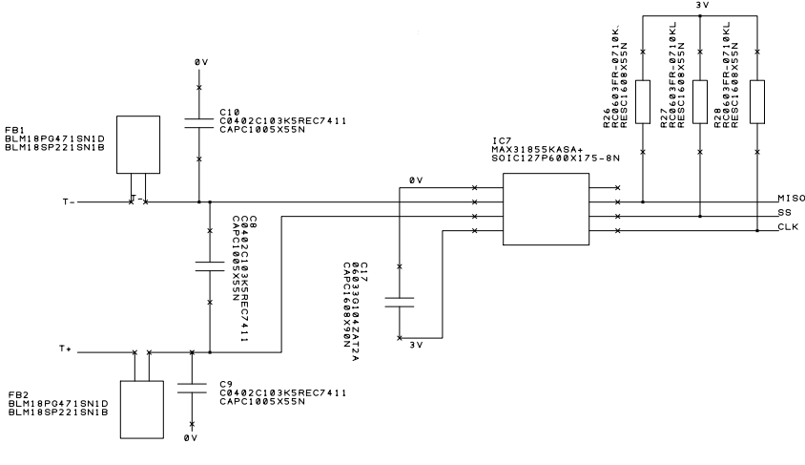
Figure 4 Ferrite Bead and Capacitor Noise Filtering

4.2.6.2 Addition of Pull-Up Resistors
The addition of 10 kΩ pull-up resistors (R26,R27,R28) on the communication lines, as shown in Figure 4 Ferrite Bead and Capacitor Noise Filtering, was another enhancement made to the Stage 2 design. In the past, erroneous readings and erratic communication with the thermocouple interface were caused by floating or poorly defined logic levels.
When no device is actively driving a signal line, pull-up resistors make sure that the line defaults to a specified logic HIGH state. The converter or microcontroller's input pins may float in the absence of pull-up resistors, leaving them vulnerable to electrical noise. This may result in:
  - Digital signals being falsely triggered
  - Inaccurate data transfer
  - Measurement results that are erratic or inconsistent
Noise immunity and power consumption are balanced by the chosen value of 10 kΩ. The resistance is high enough to limit current draw while remaining low enough to prevent interference and maintain a constant logic level.

4.2.7 Safety Features and Compliance Implementation
Multiple levels of safety are incorporated into the hardware architecture to guarantee safe operation when connecting industrial power circuits to low-voltage embedded devices. These safety measures were put in place to reduce operator danger, safeguard machinery, and guarantee adherence to pertinent industrial electrical and machinery safety regulations.
While the system incorporates design practices aligned with relevant standards, formal certification and compliance testing were outside the scope of this project.

4.2.7.1 Emergency Stop Integration
When an emergency stop (E-stop) input is triggered, it instantly shuts all output switching devices since it is implemented as a safety-critical hardware interrupt. All MOSFET drivers that control the contactors are forced into a safe OFF state by the emergency stop circuit, which works separately of normal control logic.
When activated:
  - Every contactor output is de-energised right away.
  - The system goes into a failure condition that stops it from working.
  - To notify the operator, a fault signal is sent to the PC interface.
  - Only after a manual reset can normal functionality be resumed.

4.2.7.2 MCB Auxiliary Feedback Monitoring
The I²C I/O expander is used to monitor auxiliary contacts from MCB’s to confirm the correct functioning of the power path. This enables the detection of electrical faults without the need for software control.
The monitoring system detects:
- Loss of supply voltage
- Overcurrent trip conditions
- Unexpected disconnection of load circuits
If a discrepancy between commanded output state and MCB feedback is detected, the system:
- Disables outputs
- Enters emergency mode
- Logs the fault condition
- Prevents automatic restart
This closed-loop verification improves operational reliability and ensures that power switching occurs only under safe conditions.

4.2.7.3 Watchdog Timer Protection
To identify firmware issues or system lock-up, a hardware watchdog timer is used. During regular operation, the firmware updates the watchdog on a regular basis. If, within the specified time frame, the refresh signal is not received:
  - The microcontroller resets itself on its own.
  - Every output goes back to a secure state.

4.2.7.4 Electrical Isolation and Overvoltage Protection
To protect the microcontroller from higher voltage levels and sudden accidents, several electrical protection measures are implemented:
- Voltage divider networks for safe input scaling.
- Zener diode clamping for overvoltage protection.
- Series current-limiting resistors.
- RC filtering to suppress transients and noise.
- Protected MOSFET drivers with integrated thermal and current protection.
These measures ensure reliable operation in mixed-voltage environments and reduce the risk of component damage.

4.2.7.5 Safety Fuse
A T500 mA time-delay fuse was installed at the 24 V power input to give the controller main overcurrent protection. The control electronics and auxiliary switching circuitry's relatively low current requirements led to the selection of this figure. The combined load of the 5 V and 3.3 V rails is roughly 1.5 W, as demonstrated in the previous power consumption analysis. This only represents a tiny input current from the 24 V supply. The input fuse does not need to be sized for the main PSU load because the MOSFETs are only used as switching components for the control side and the main load current is not carried through the controller. Therefore, a 500 mA time-delay fuse offers adequate protection while permitting brief inrush currents during startup and switching transients without causing nuisance.

4.2.8 PCB Design and Layout Considerations
In order to guarantee electrical reliability, thermal stability, and noise tolerance in a mixed-voltage environment, the printed circuit board (PCB) layout was improved in response to problems found during Stage 1 assembly. Larger component footprints to make manual soldering easier, better thermal pad accessibility, more space between components, and modified power routing for better heat dissipation are all included in the redesigned design. Furthermore, the arrangement ensures safe power distribution, better signal integrity, increased assembly reliability, and long-term operational stability by clearly separating sensitive analogue and digital control circuitry from higher-current switching circuits.
The final PCB layout is shown in Figure 5 PCB Layout.
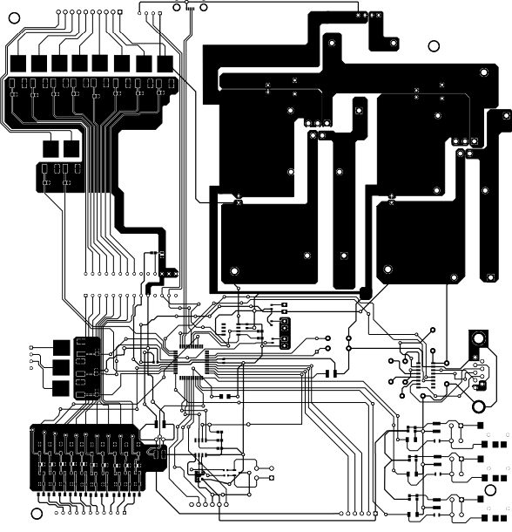
Figure 5 PCB Layout

4.2.8.1 Separation of the Signal and Power Components
The PCB layout follows a functional zoning approach, dividing the board into zones:
- Higher-current power switching zone - contactor and load switching circuitry
- Control and processing zone - microcontroller and communication circuits
- Signal conditioning zone - sensor interfaces and analogue inputs
- Power converter zone – dc-dc converter to convert 24 V to 3.3 V and 5 V
According to the PCB layout, the microcontroller and low-voltage circuitry are in the middle and bottom sections of the board, while the power converter area is in the upper section using wide copper pours. Sensitive measuring circuits are shielded from switching noise and electromagnetic coupling by this physical separation.
To minimise noise pickup and measurement mistakes, sensitive analogue traces such as temperature and voltage sensing signals were moved from switching elements and higher-current traces.

Grounding Strategy
Extensive copper ground planes were used to create a strong common ground reference in order to improve noise immunity and guarantee low impedance return pathways. These improves analogue measurement stability and enhances thermal dissipation.

4.2.8.3 Decoupling and Power Stability
To stabilise supply voltage and reduce switching noise, decoupling capacitors were positioned between microcontroller supply pins and communication IC’s.
Bulk capacitors were included near voltage regulators to smooth supply variations caused by dynamic load changes.

4.2.8.4 Signal Routing and Noise Reduction
Signal routing conforms to mixed-signal embedded systems:
- Separate routing of digital and analogue signals
- For sensitive inputs, short signal pathways are used.
- Very little high-current trace crossing
- Filtering elements positioned near signal entrance locations
To reduce electromagnetic interference, the analogue sensing circuits and thermocouple interface were placed away from switching components.

4.2.8.5 Thermal Management Considerations
Power components and regulators were positioned with consideration for thermal performance. Large copper regions were used to improve thermal transfer, and high power devices were placed far enough apart to allow heat dispersion.
To enhance airflow and minimise temperature buildup, the load drivers and switching regulators were positioned close to the board's edges.

4.2.9 Enclosure Considerations
The PCB includes mounting holes positioned around the board edges to allow secure installation within an enclosure. This allows the board to be mounted and protect the board from vibration during operations.
Adequate spacing between mounting points and electrical traces was maintained to ensure electrical isolation.
The system is intended for installation inside a protective enclosure to provide:
- Protection from dust and moisture
- Prevention of accidental contact with live circuits
- Compliance with industrial electrical safety practices

4.2.10 Communication Protocol (RS232)
Because of its ease of use, dependability, and compatibility with industrial systems, RS232 was selected. RS232 provides reliable point-to-point communication with little implementation complexity, even if newer protocols like RS485 or Ethernet offer greater data speeds and flexibility. This choice, however, restricts networked applications' scalability.

4.2.11 Current Transformer Signal Conditioning and Interface
The circuit shown in Figure 6 Current Transformer Signal Conditioning Circuit implements the signal conditioning stage for the current transformer (CT), specifically the SCT013G 100A/1A device. This stage is responsible for converting the raw current signal from the CT into a safe, measurable voltage suitable for the microcontroller ADC input (CT1).
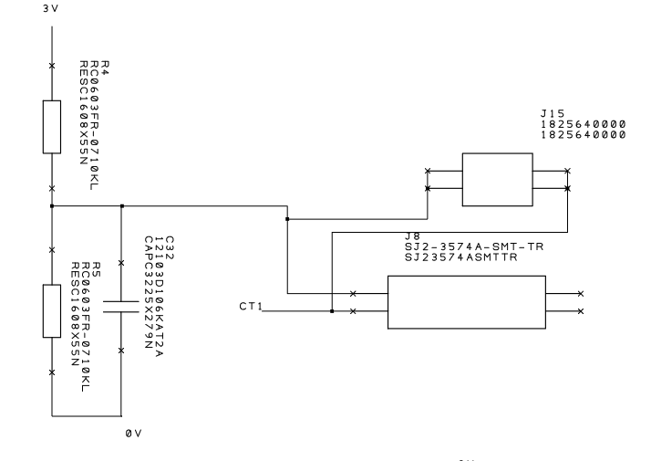
Figure 6 Current Transformer Signal Conditioning Circuit

4.2.11.1 CT Signal Conversion and Burden Resistor
As a current-output transformer, the SCT013G generates a secondary current that is proportional to the main current being measured (100 A:1 A ratio). A burden resistor is needed to transform this current into a voltage that can be measured. There is no need to include a burden resistor into the design because it is already present in the SCT013G.

4.2.11.2 Midpoint Biasing for ADC Compatibility
The AC signal needs to be shifted into the positive voltage range because the microcontroller ADC is unable to measure negative voltages. This can be done by creating a midpoint bias at about 1.5 V (from a 3 V supply) using a voltage divider made up of R4 and R5.
The AC signal from the CT oscillates above and below this reference level rather than actual 0 V since this midpoint serves as a virtual ground. Consequently:
- Above 1.5 V, positive half cycles are visible.
- Negative half cycles appear below 1.5 V (but still above 0 V)

4.2.11.3 AC Coupling and Filtering
The CT signal is AC-coupled into the bias network using capacitor C32 (10 µF).
Additionally, the capacitor and surrounding resistances form a high-pass filter, ensuring that low-frequency drift or DC offsets do not affect the measurement.
4.2.11.4 Connector Interface, Noise Reduction, and Design Improvement
As a design enhancement from Stage 1 to Stage 2, the CT is connected to the PCB via a 2-pin terminal block (J8) instead of a conventional 3.5 mm audio jack. Poor mechanical contact reliability, greater vulnerability to electrical noise, and sporadic unstable or inconsistent readings were among the problems the audio jack connection created during Stage 1 testing.
In order to solve these issues, Stage 2 introduced a 2-pin terminal block that increases tolerance to electromagnetic interference (EMI), lowers contact resistance range, and offers a more reliable and secure electrical connection. This change emphasises a crucial development lesson: the quality of analogue signals is greatly impacted by connector selection. Overall, the terminal block approach greatly increased system reliability and measurement stability.

4.3 Firmware Implementation

4.3.1 Firmware Overview
To enable real-time monitoring, control, and safety management for the custom controller hardware, the firmware was created in C. Sensor acquisition, power control, hosting PC connectivity, and system protection measures are all managed by the software that runs on the microcontroller.
The modular structure of the firmware architecture can be seen in Figure 7 Software flowchart: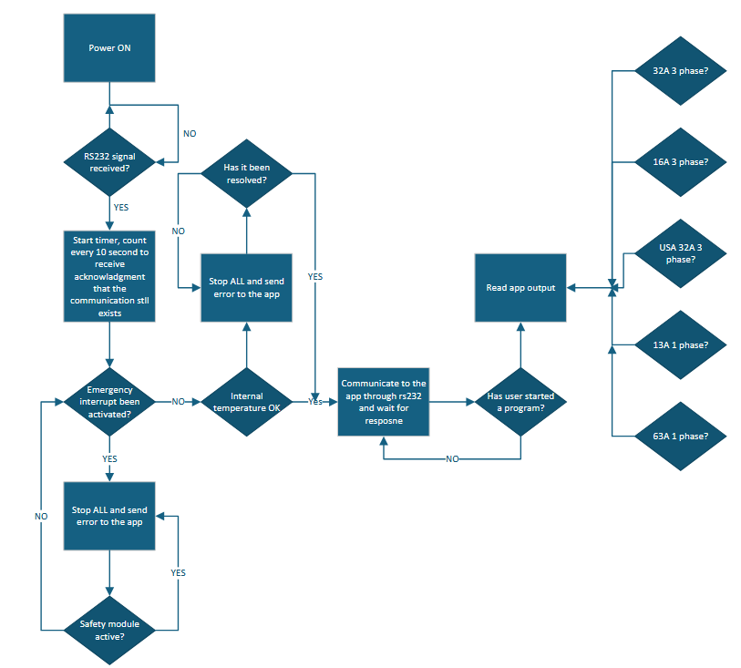
Figure 7 Software flowchart

4.3.2 System Initialisation
Before the main loop launches, the firmware configures all hardware and ensures safe functioning.
The startup process in Figure 8 System Initialisation Flowchart includes:
- Configuring ADC channels
- Initialising RS-232 communication (9600 baud)
- Setting up I²C communication for the MCP23017 I/O expander
- Initialising SPI for thermocouple measurement
- Configuring GPIO output pins
- Setting all outputs to OFF for safety
- Waiting 3 seconds for current sensors to stabilise
The startup delay prevents incorrect readings during power-up. All outputs remain OFF to avoid unintended activation.
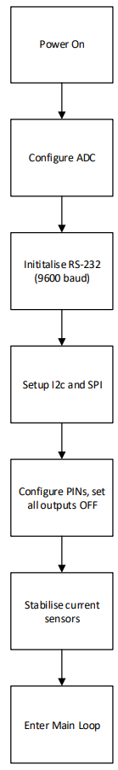
Figure 8 System Initialisation Flowchart

4.3.3 Flow of Program Processing
The firmware runs continuously using a control loop. The main sequence can be seen in Figure 9 Main Program Execution Flow :
- Check emergency stop status
- Verify heartbeat signal
- Measure temperature, voltage, current
- Report system status
The system continuously monitors a hardware emergency stop. Upon being activated, a status message is sent, output switching is stopped, the system goes into emergency mode, and all outputs are instantly disabled. Only after the emergency situation has been resolved can regular operations continue.

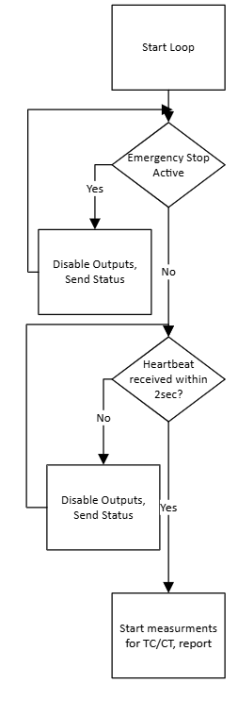
Figure 9 Main Program Execution Flow

4.3.4 Serial Communication Interface
The controller communicates with a host PC through RS-232 using simple command-based control.
Command Functions
- 0–7 Toggle MCP23017 outputs
- 8 Toggle RD4 output
- 9 Toggle RB1 output
- C Turn off all outputs immediately
- H Heartbeat signal from host
Communication Watchdog
If no command or heartbeat is received within a set time:
- All outputs are disabled
- Output drivers reset
- System enters a safe state
This prevents unsafe operation if communication fails.
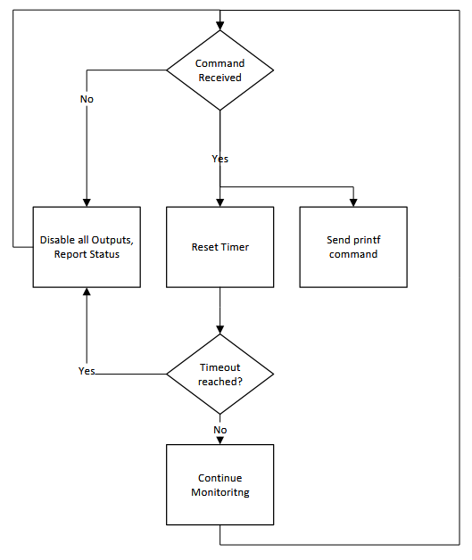
Figure 10 Serial Communication Flowchart

4.3.5 Sensor Acquisition
The system uses a variety of sensor techniques to monitor voltage, current, and temperature. A thermocouple read via Serial Peripheral Interface (SPI) with cold junction compensation, fault detection, and calibration, as well as an LM35 sensor via ADC with 10 mV/°C scaling, are used to measure temperature. The results are averaged for stability. Current transformers with high speed sampling, RMS calculation, automatic zero calibration, and channel scaling are used to measure current across three channels in order to lower noise and increase accuracy. ZMPT101B sensors with RMS calculation, calibration scaling, and noise filtering values suppressed to avoid measurement errors are used to detect voltage.
The current measurement algorithm shown in Figure 11 current measurement algorithm flowchart calculates the present transformer signal's RMS value by high-speed ADC sampling. In order to ensure signal stability, an adaptive settling check is used before sampling. This involves comparing successive ADC values and starting sampling when the difference between readings is less than a threshold set. After removing the DC bias, the real current is obtained by scaling the corrected RMS voltage using the transformer gain and calibration factor. To increase measurement stability, a rolling average filter is used, and results below a predetermined limit are suppressed to lessen the impact of noise.
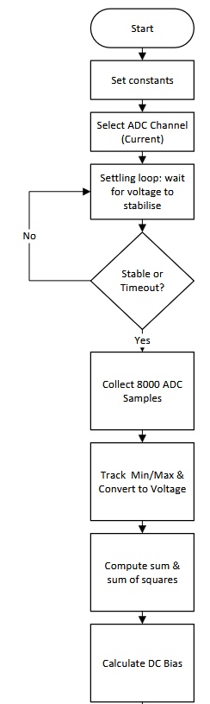
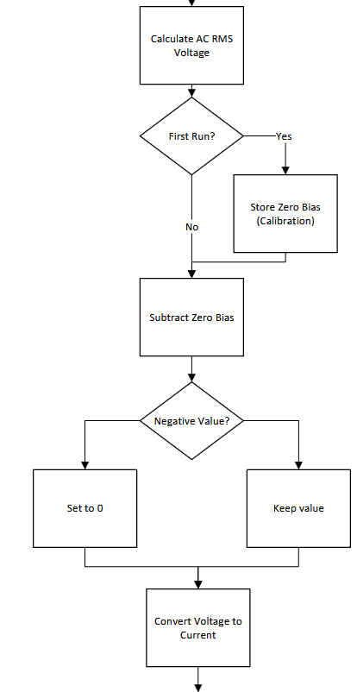
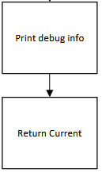
Figure 11 current measurement algorithm flowchart
A similar method is employed in the voltage measurement procedure, as demonstrated in Figure 12 Voltage measurement algorithm flowchart, where the RMS voltage is calculated by gathering several ADC samples. The real mains voltage is obtained by scaling the result using a calibration factor, and low-level noise is filtered using a threshold condition.
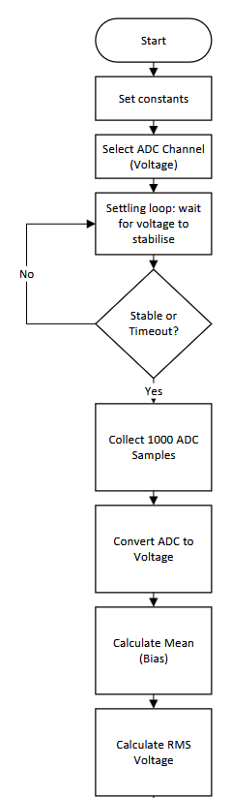
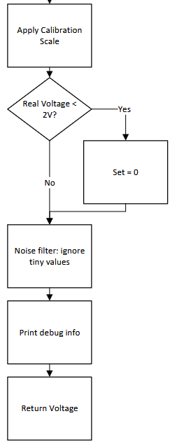
Figure 12 Voltage measurement algorithm flowchart

4.4 System Integration and Development Process
The system was integrated through a structured design process to guarantee proper interaction between sensing, control, communication, and protection subsystems when individual hardware and firmware modules were finished. Because integration was done sequentially, each subsystem could be verified prior to the system operating as a whole.
Verifying connectivity between the microcontroller and peripheral devices, such as the I/O expander, temperature sensing modules, current transformers, and voltage sensors, are the main goal of the initial integration. Correct data flow over ADC, SPI, and I²C communication channels was verified by interface testing. In order to guarantee dependable command delivery and status reporting, serial contact with the host PC was then confirmed.
Communication noise and measurement instability were noted in the early stages of system integration. Additional signal filtering, better grounding, and updated PCB routing for reducing electromagnetic interference were used to address these problems. To confirm proper MOSFET operation and safe contactor control, output switching circuits were tested with controlled loads.
Validating safety features, such as communication watchdog timeout protection, and emergency stop operation, was another aspect of the integration process. Before confirming the overall system reaction to fault circumstances, each protection mechanism was evaluated separately.
Prior to final validation, this gradual integration strategy allowed for the thorough detection and repair of design mistakes and guaranteed reliable communication between hardware and firmware components.

4.5 Testing and Validation Implementation
To confirm functionality, accuracy, dependability, and safety, the implemented controller passed extensive testing. The methodology outlined in Chapter 3 was followed in the design of the testing procedures, which were carried out in a controlled laboratory environment with calibrated measuring tools.
The testing procedure assessed the system's performance in a variety of operational scenarios, such as long-term continuous operation, fault conditions, and normal operation. However, full industrial deployment would require formal validation under EMC and safety certification procedures.

4.5.1 Functional Testing Implementation
To ensure that all system features, such as output switching, communication interfaces, and monitoring functions, operated correctly, functional testing was carried out. Contactors and relays were used to evaluate output control circuits in order to verify that MOSFET drivers and contactor switching behaviour were operating correctly.
By turning on the emergency input while the system was operating and ensuring that all outputs shut down instantly, emergency stop functionality was confirmed. By sending commands from the host PC and confirming accurate system responses and status reporting, communication capability was tested.
The functionality of the MCB auxiliary feedback monitoring was also validated by simulating signal changes using a 24 V reference voltage and verifying that the system correctly detected each simulated signal state and responded accordingly. All other tests can be seen in Table 20 Functional Test Results
Table 20 Functional Test Results
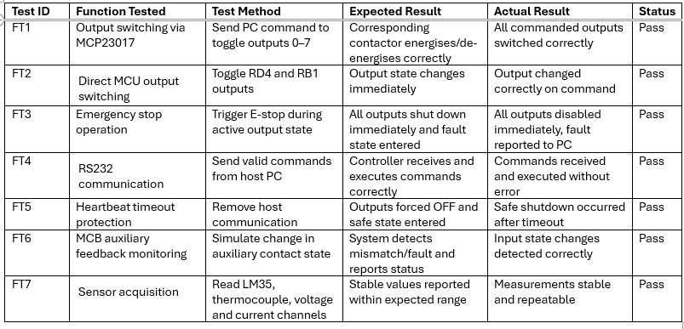

4.5.2 Sensor Calibration Procedure
To guarantee that physical properties were accurately displayed, sensor measurements were calibrated. To calculate measurement error and modify calibration settings inside the software, measurements of temperature, voltage, and current were compared to calibrated reference devices.
Calibrated Digital multimeter(AMP-220-EUR,DH00058) readings were used to verify voltage and current measurements under controlled circumstances. To confirm accuracy, temperature readings from the thermocouple module and LM35 sensor were compared with reference readings taken from calibrated hand held temperature reader(T2001,SM02604). To reduce systematic measurement error, calibration values, such as offset and scaling factors, were modified.
The measured results are presented in Table 21 Calibration Results Table
Table 21 Calibration Results Table
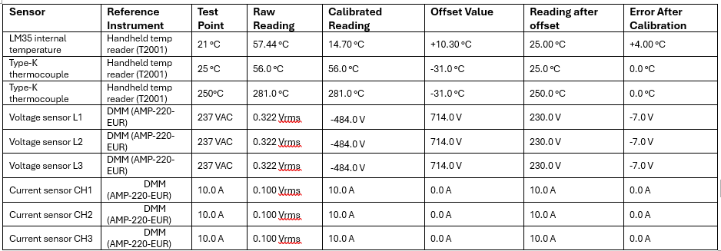

4.5.3 Safety and Fault Testing
By deliberately creating unusual operating situations, safety and fault-handling procedures were assessed. By cutting off the host connection, activating the communication watchdog, and confirming automatic output shutdown, communication loss was simulated.
By disconnecting inputs and confirming that the system accurately detected fault conditions and entered a safe state, automatic fault detection was evaluated. By repeatedly turning on the emergency input while the system was operating and verifying prompt system shutdown and fault reporting, the emergency stop capability was verified.
Tests found in Table 22 Safety and Fault Testing Results verifies that the controller prevents unsafe operation and reacts appropriately to dangerous situations.
Table 22 Safety and Fault Testing Results
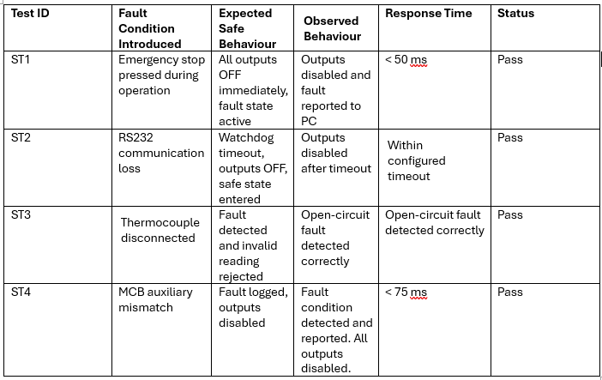

4.5.4 Voltage Regulation Verification
To guarantee dependable operation of the controller and sensing circuits, the power supply rails precision and stability were experimentally confirmed. A calibrated digital multimeter(AMP-220-EUR,DH00058) readings was used to measure the 5 V and 3.3 V rails under both no-load and full-load operating circumstances.
The measured results are presented in Table 23 Power Supply Validation Results.
Table 23 Power Supply Validation Results
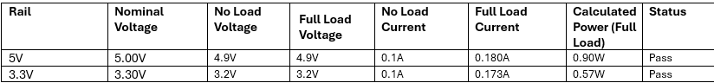

4.5.5 Reliability and Stress Testing
To evaluate the system's long-term operating stability and thermal behaviour, reliability testing was carried out. While keeping an eye on output switching performance, temperature stability, and communication dependability, the controller was run continuously for lengthy periods of time.
To evaluate the robustness of the output drivers and contactor control circuits, several switching cycles were carried out. To guarantee functioning within acceptable bounds under continuous load conditions, the thermal performance of power components and voltage regulators was monitored.
The outcomes verified the design's suitability for industrial testing applications and showed steady system operation.
Thermal observation test was carried out using calibrated thermal imager FLUKE TiS20, Cert NoDH00071.
The results are presented in Table 24 Reliability and Stress Test Summary.
Table 24 Reliability and Stress Test Summary
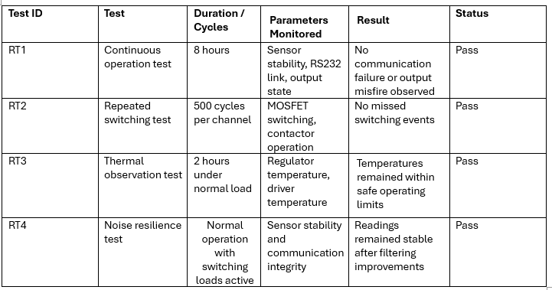

4.6 Design Validation Against System Requirements
The functional and performance requirements outlined in Chapter 3 were used to assess the final system design. The implemented controller supports dependable communication with a host PC, safe industrial load switching, and real-time temperature, voltage, and current monitoring.
Through the use of an I²C-based I/O expander, the modular architecture enables system scalability by enabling the integration of new inputs and outputs without requiring significant hardware modification. While maintaining similar control and monitoring capability, the microcontroller-based solution offers a more affordable option than traditional PLC-based systems.
Compliance with industrial safety procedures is ensured by a number of safety measures, such as emergency stop protection, watchdog monitoring, communication timeout handling, and electrical protection circuits. In electrically noisy settings, the applied filtering and calibration methods offer precise and reliable measurement performance.
All things considered, the system meets the design goals of cost-effectiveness, modularity, safety, and dependability that were set during the research and development phase.

4.7 Signal Stability and Measurement Accuracy (Stage 1 vs Stage 2)
For both the Stage 1 and Stage 2 prototypes, signal stability and measurement accuracy were evaluated in a controlled experimental setting to see how well the design changes worked. To create a performance baseline, experimental measurements were obtained from the Stage 1 prototype.
Table 25 Stage 1 Measurement Stability Results
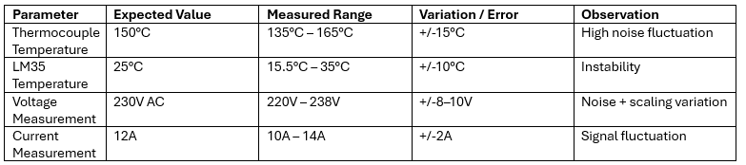
Following design improvements, the same tests were repeated on the Stage 2 prototype.
Table 26 Stage 2 Measurement Stability Results
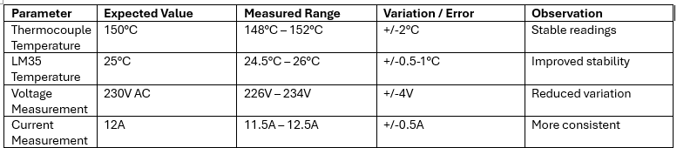

Results from Stages 1 and 2 show a significant improvement in measurement accuracy and stability. While LM35 temperature error dropped from +/-10°C to roughly +/-0.5–1°C, thermocouple variance was reduced from +/-15°C to +/-2°C. In the same way, voltage variation decreased from +/-8–10V to +/-4V and current measurement fluctuation improved from +/-2A to +/-0.5A. These findings verify that filtering, better PCB layout, and improved signal conditioning greatly increased system dependability and measurement accuracy in Stage 2.

4.8 Build costs
One of the primary objectives of the project was to provide a cost-effective alternative to traditional PLC-based control systems. To evaluate this, a detailed evaluation of the system build cost was performed, taking into account all hardware components used in the final design.
The system's overall cost is mostly determined by the microprocessor, power supply components, sensing modules, communication interface, and supporting circuitry. Table 27 Full BOM provides an approximate cost breakdown of the system's main components.
Table 27 Full BOM
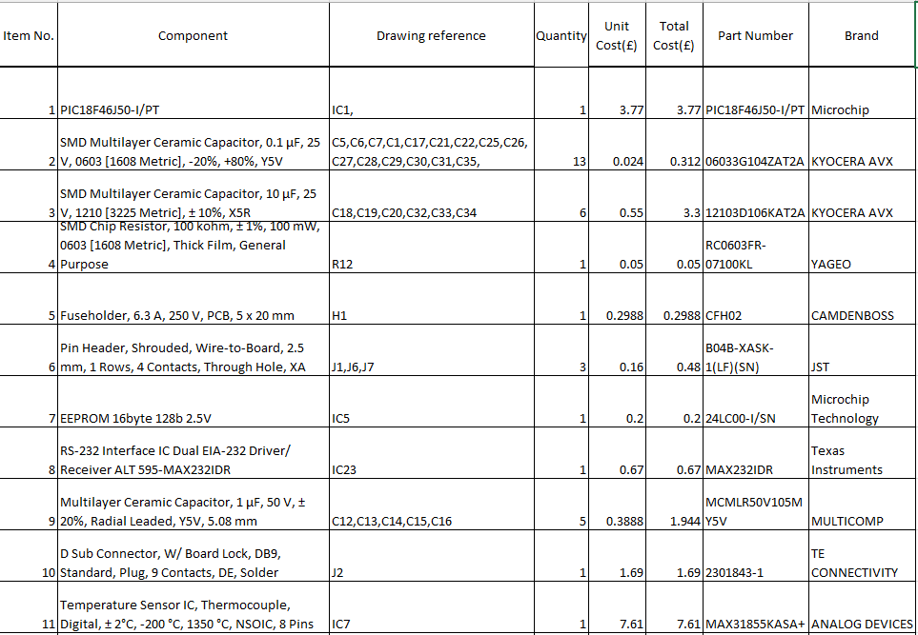
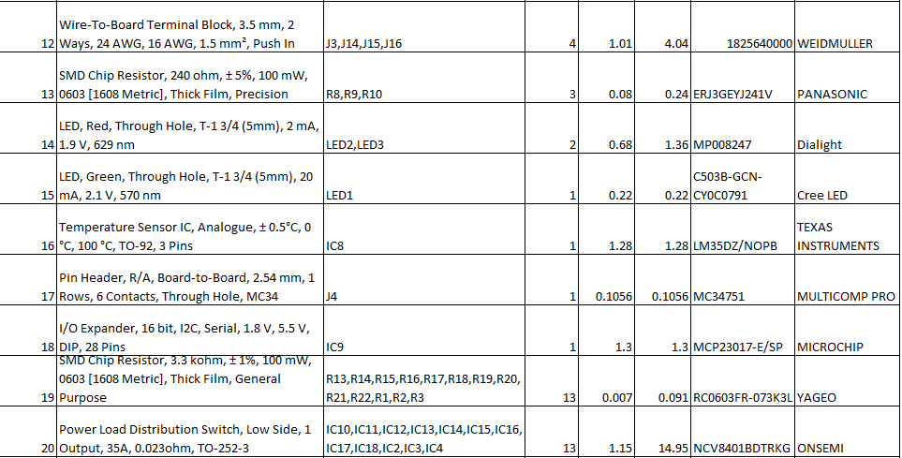
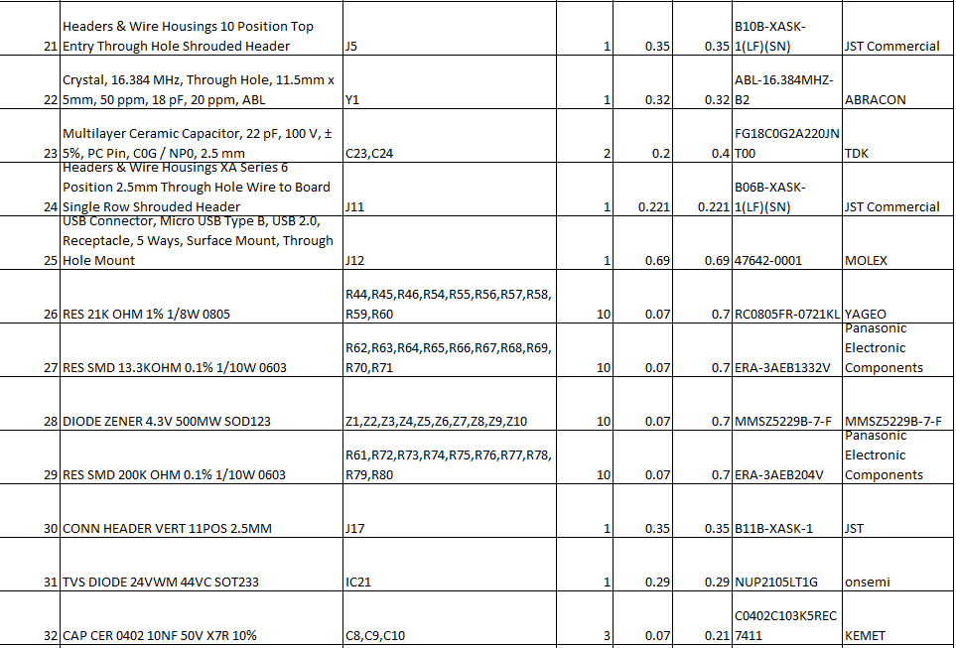
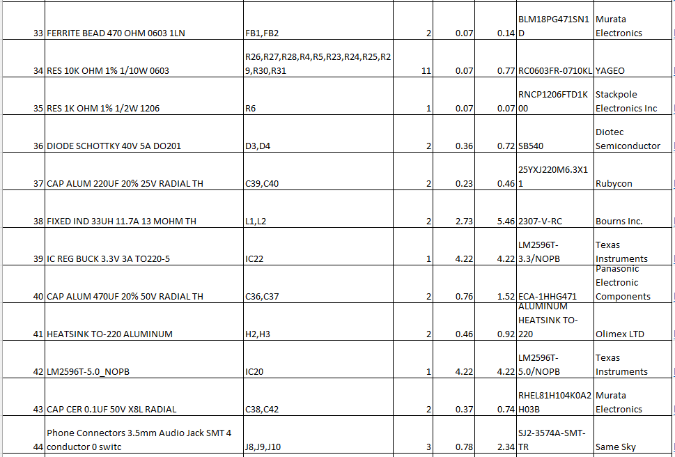


Evaluation

5.1 Overview
This chapter evaluates the built embedded control system's performance carefully in light of the project's initial goals and objectives. Functional testing, reliability analysis, comparison with current industrial solutions, and assessment of continuous improvements made during development are all used to evaluate the system.

5.2 Evaluation Against Project Aim and Objectives
This project's major goal was to design, develop, and evaluate an affordable embedded control system that might replace conventional PLC-based solutions for an industrial oven testing bench while maintaining functionality, safety, and dependability.
This goal was accomplished. The created system showed robust connection with a PC interface, precise real-time sensor monitoring, and dependable multi-channel control. By integrating fault detection and protection systems, the system also maintained compliance to important safety requirements.
The following is how the project's goals were assessed in Table 28 Evaluation Against Objectives.
Table 28 Evaluation Against Objectives
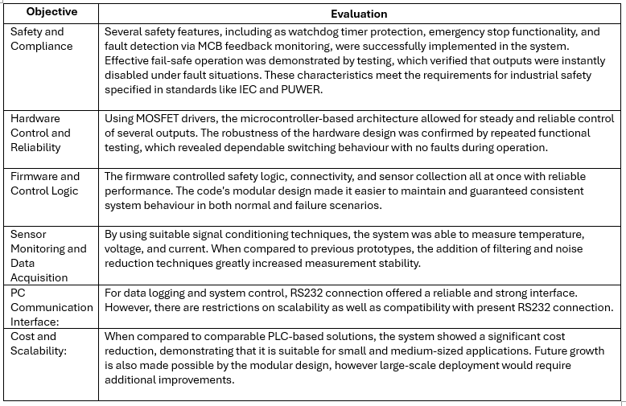

5.3 Performance Evaluation
System performance was evaluated through a combination of functional, reliability, and safety testing as found in Table 29 Performance Evaluation Summary.
Table 29 Performance Evaluation Summary
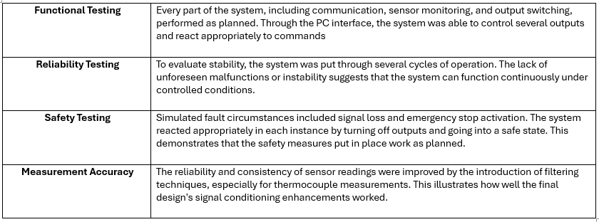5.4 Comparison with PLC-Based Systems
According to the literature analysis, PLC systems are reliable and often used in industrial settings, but they are constrained by their high cost, restricted flexibility, and reliance on vendors. Main differences are shown in Table 30 Comparison with PLC-Based Systems.
Table 30 Comparison with PLC-Based Systems
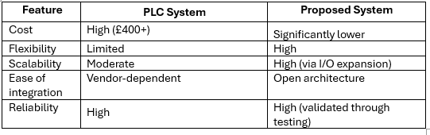
Although the developed system demonstrates comparable functional performance, it does not yet achieve the same level of certified reliability and industry acceptance as PLC systems. This represents a key limitation when considering deployment in safety-critical environments. PLC-based systems continue to be more suitable for large-scale or safety-critical environments needing certified solutions, even though the proposed system is highly suitable for small to medium-scale industrial applications.

5.5 Evaluation of Iterative Improvements (Stage 1 to Stage 2)
An original Stage 1 prototype was assessed and improved upon to create the final Stage 2 design as part of an iterative approach to system development. Key practical and performance-related concerns were identified and resolved thanks to this method.
Manufacturability was one of the main constraints found in Stage 1. Compact surface-mount components increased the risk of faulty solder junctions and made hand assembly challenging. Stage 2 involved increasing component footprints and improving PCB layout space. As a result, the design became more durable and strong, increasing long-term endurance and assembly dependability.
Signal instability was another major problem seen in Stage 1, especially with the use of low-level analogue measurements like thermocouple readings. Inaccuracies and irregular outputs were brought about by electrical noise. Ferrite beads, RC filtering, and pull-up resistors were used in Stage 2 to fix the issue. These enhancements resulted in more reliable and accurate sensor readings as well as improved signal integrity.
Additionally, thermal performance was improved. Because of its small layouts and few thermal routes, the Stage 1 design has difficulties on heat dissipation. To ensure safe operation under continuous load circumstances, the updated Stage 2 design included better component arrangement and thermal considerations.
System reliability was further increased by better separation between sensitive analogue components and high-current switching circuits, which decreased electromagnetic interference.

5.6 Limitations
Despite the successful implementation, several limitations were identified:
- The use of RS232 communication limits scalability and integration with modern network-based systems such as Ethernet,RS485 or IoT platforms.
- The system has not been validated in full industrial conditions, where additional elements like electromagnetic interference and environmental stress may impair performance; instead, it has been tested in a controlled environment.
- Compared to PLC systems, the solution lacks formal industrial certification, which may limit adoption in safety-critical applications.
- Some aspects of the system design, particularly manual assembly, may limit scalability for large-scale production.
These limitations highlight areas for further development and improvement.

5.7 Evaluation of System Scalability
Scalability was a major factor in the system's design, enabling future growth without requiring a major redesign. To facilitate the integration of external equipment, additional hardware connections have been added, such as RS232 and I²C communication interfaces and spare digital output channels. The system can interact with extra sensors, I/O expanders, or peripheral modules as needed thanks to these features. In future upgrades, the controller will be able to support more functionality, more testing stations, or more complicated control tasks thanks to the addition of these expanding communication paths and unused outputs. The system's long-term usefulness and adaptability are improved by this innovative design approach.

5.8 Overall Evaluation
Overall, the analysis demonstrates that an embedded system based on microcontrollers can offer a practical and affordable substitute for PLC-based solutions in industrial testing applications.
The system incorporates suitable safety safeguards, fulfils its design goals, and operates dependably under test conditions. System performance was greatly enhanced by the repeated development method, especially in terms of signal stability and manufacturability.
The system shows the promise of embedded control systems in industrial settings and offers a solid foundation for future development, despite certain restrictions.

Conclusions and recommendations

6.1 Project Summary
The purpose of this project was to design, construct, and assess an affordable embedded control system for an industrial oven testing bench as an alternative for traditional PLC-based solutions. The development of a microcontroller-based system with real-time monitoring, control, and fault protection has effectively accomplished this goal.
The study showed that an embedded system with the PIC18F46J50 microcontroller can accurately acquire sensor data, manage several outputs, and connect with a PC via RS232. The system effectively combines safety features and control logic with temperature, voltage, and current monitoring, offering a comprehensive solution for industrial testing applications.
The review of the literature revealed that although PLC systems are widely used because of their standardisation and dependability, their high cost, lack of flexibility, and vendor dependence frequently make them inappropriate for small to medium-sized applications. By providing a modular, reprogrammable, and substantially less expensive option, the created system overcomes these constraints.
Strong technical judgement was shown during the design and implementation phases, especially in areas like power regulation, safety integration, and signal conditioning. Measurement accuracy and system stability were greatly increased by the use of filtering techniques and better PCB layout. Moving from Stage 1 to Stage 2 of the iterative development process was crucial for improving overall reliability, thermal performance, and manufacturability.
The system satisfies its functional requirements, performs reliably under test settings, and reacts appropriately to fault scenarios, according to evaluation results. Safety features were successfully built and validated, including watchdog protection, fault detection methods, and emergency stop capabilities.
Overall, the project shows that in areas where cost, flexibility, and customisation are crucial criteria, embedded microcontroller-based systems can offer a practical and efficient substitute for PLC-based control systems.

6.2 Recommendations for Future Work
Although the system effectively achieves its goals, a number of areas for additional expansion and enhancement have been noted.
Replacing the RS232 communication interface with a more modern standard like RS485, Ethernet, or wireless communication is a crucial suggestion. Scalability, remote monitoring, and integration with Industrial Internet of Things (IIoT) platforms would all be made possible by this.
In order to improve usability and allow real-time data visualisation, future work might focus on creating an integrated system with an integrated HMI and graphical user interface (GUI). As a result, there would be no need for an external PC, making the solution more portable and self-contained and possibly lowering the total cost of the system.
The system could undergo official testing to see whether it satisfies formal certification criteria, such as industrial safety and electromagnetic compatibility (EMC) requirements, in order to increase its industrial usability. This would make the technology more suitable for use in commercial settings.
Furthermore, more inputs and outputs, modular extension, and support for additional testing stations might all be added to the system to provide greater scalability.
Implementing data logging and analysis tools, such cloud-based storage and automatic reporting, is another area that needs work. This would improve the system's potential for performance analysis and long-term monitoring.
Lastly, more hardware design optimisation, such as better PCB design for automated assembly and fewer components, might be carried out to facilitate mass manufacturing.
These suggestions offer a clear route for improving the system's usability, usefulness, and industrial application.

Reflections
Technically and professionally, this project has been an excellent learning opportunity. It required the use of engineering principles in a variety of fields, such as software development, embedded systems, electronics design, and system integration.
The ability to design and construct an entire embedded system from concept to final prototype was one of the most significant technical abilities acquired during this project. This involved choosing the right parts, creating hardware circuits, creating firmware, and incorporating communication interfaces. The project highlighted how crucial it is to comprehend how software and hardware interact when designing embedded systems.
Signal integrity and measurement stability were two of the project's main challenges. At first, it was overestimated how much electrical noise affected low-level analogue signals, especially those from the thermocouple. Early testing revealed inconsistent readings as a result, requiring more debugging and signal conditioning step modification. Insufficient filtering and PCB layout choices in particular, the closeness of high-current switching circuits to sensitive analogue inputs were shown to be the cause of the problem. This revealed a weakness in my early knowledge of mixed-signal design and showed how crucial it is to take electromagnetic interference into account early in the design process.
The significance of continuous development was a crucial learning consequence. The change from Stage 1 to Stage 2 demonstrated that testing is necessary to find problems in the actual world and that original concepts are rarely perfect. throughout the initial design phase, issues including signal noise, manufacturing difficulties, and thermal considerations were not entirely obvious, nevertheless, throughout implementation and testing, they became obvious. Resolving these problems greatly enhanced the system as a whole and showed the importance of ongoing improvement.
In the early stages of design, several choices were made primarily based on functionality rather than manufacturability. Compact surface-mount components, for instance, decreased the size of PCBs but made assembly extremely difficult, especially for those that needed to be properly grounded thermally. This made it harder to achieve dependable soldering and highlighted how crucial design-for-manufacture principles are. In the past, if assembly constraints had been taken into account earlier in the design process, these problems would have been prevented.
At first, it was believed that reliable real-world performance would follow from obtaining correct circuit functionality in simulation or schematic design. However, real-world testing showed that elements like physical design, grounding, and noise have a big impact on how the system behaves. This misunderstanding was made clear throughout testing phases, when steady operation needed multiple modifications to theoretically correct design. The significance of repeated testing and practical validation in engineering design was confirmed by this experience.
Ability to evaluate and resolve real-world engineering issues was also enhanced by the project. For instance, investigating filtering methods and giving circuit design serious thought were necessary to improve signal stability. In a same way, a fixing assembly and thermal problems required a thorough examination of PCB layout and component choices.

The project increased a number of transferable abilities in addition to technical ones. Because the project needed to balance research, design, implementation, and documentation within a set timeline, time management was very crucial. To guarantee consistent success, the capacity to efficiently organise and organise work was crucial.
Time estimation proved to be difficult from the standpoint of project management. Debugging hardware problems and improving the PCB design took longer than anticipated. Later on in the project, especially during testing and documentation, this resulted in more stress. Workflow would have been enhanced and time pressure would have decreased with a better organised planning strategy that included setting aside extra time for unanticipated technical problems.
Resilience and problem-solving skills were also important components of the project. During development, a number of difficulties were faced, such as hardware problems and debugging difficulty. Persistence, independent investigation, and methodical troubleshooting were necessary to overcome these difficulties.
Through the process of documenting the project and clearly and methodically presenting complicated technical knowledge, communication skills were built. This is a crucial ability for engineering practice, especially when speaking to audiences who are both technical and non-technical.
The project would be improved in a number of ways if it were to be redone. Early-stage testing and prototyping would be prioritised in order to detect possible problems earlier and minimise the need for further redesign. From the beginning, a more structured approach to development would be used, with a greater emphasis on risk assessment and mitigation. To increase reliability from the start, more work would be spent to initial design validation, especially in areas like PCB layout and signal integrity. Additionally, to improve the system's scalability and future applicability, contemporary communication protocols like Ethernet or RS485 will be taken into consideration in place of RS232.
At first, problem-solving with the goal of finding quick fixes was approached. But as the project progressed, this changed into a more analytical and repeated process where issues were carefully looked at and fixed using data and testing. This change was especially noticeable during debugging phases, when system performance became more stable and dependable as a result of repeated testing and small adjustments.
All things considered, this project has greatly improved technical expertise, capacity for problem-solving, and professional abilities. In addition to preparing for future work in embedded systems and industrial applications, it has given invaluable expertise in designing practical engineering solutions.
The ability to tackle technical problems in a more logical and critical way was also enhanced by the project. Instead than concentrating only on functionality, it became more conscious of aspects like cost, scalability, safety, and reliability. In a professional setting where trade-offs and limits must be carefully handled, this represents a change towards thinking more like an engineer.

References
[1]B. Pascual, “Development of a demonstration test bench based on a PLC and HMI,” Riunet.upv.es, Sep. 14, 2023. https://riunet.upv.es/entities/publication/e73697bf-d15c-482a-9b9b-ef4cd12b8630 (accessed Oct. 20, 2025).
[2]K. Standing, “Beginner’s View: Key PLC Advantages and Disadvantages Explored,” Industrial Electrical Warehouse, May 27, 2025. https://industrialelectricalwarehouse.com/blogs/news/plc-advantages-and-disadvantages?srsltid=AfmBOopF4MqvrNGX0PgXTrrOkf2gKb3wl-vpsB18NMEllmeevRt0Yzqs
[3]R. Ahshan, M. T. Iqbal, and George K.I. Mann, “Controller for a small induction-generator based wind-turbine,” Applied Energy, vol. 85, no. 4, pp. 218–227, Apr. 2008, doi: https://doi.org/10.1016/j.apenergy.2007.07.005.
[4]A. Rullán, “Programmable logic controllers versus personal computers for process control,” Computers & Industrial Engineering, vol. 33, no. 1–2, pp. 421–424, Oct. 1997, doi: https://doi.org/10.1016/s0360-8352(97)00127-7.
[5]P. Lemay, “Programmable Logic Controller: What Is a PLC and How Does It Work?,” Tulip, Jul. 31, 2022. https://tulip.co/blog/programmable-logic-controller-what-is-a-plc/
[6]“STM32 32-bit Arm Cortex MCUs - STMicroelectronics,” STMicroelectronics. https://www.st.com/en/microcontrollers-microprocessors/stm32-32-bit-arm-cortex-mcus.html
[7]Arrow Electronics, “PIC microcontroller programming: The basics for every designer,” Arrow.com, Feb. 12, 2024. https://www.arrow.com/en/research-and-events/articles/what-you-need-to-know-for-programming-pic-microcontrollers
[8]Arduino, “What Is Arduino?,” www.arduino.cc, Feb. 05, 2018. https://www.arduino.cc/en/Guide/Introduction/
[9]B. Hellman, “Top PLC Brands Ranked: Features, Costs, and Benefits,” Industrial Automation Co., Jan. 17, 2025. https://industrialautomationco.com/blogs/news/top-plc-brands-ranked-features-costs-and-benefits?srsltid=AfmBOopTVN_XyAqUw11DU9WZeMn-4aOxl8etv-4wNTrvor1oJZOra5vI (accessed Oct. 20, 2025).
[10]Poly, “The Advantages of Embedded Controls vs. A PLC Solution Poly Electronics Industry News,” Poly Electronics, Jan. 30, 2025. https://polyelectronics.us/the-advantages-of-embedded-controls-vs-a-plc-solution/ (accessed Oct. 20, 2025).
[11]HSE, “Provision and Use of Work Equipment Regulations 1998 (PUWER) - Work equipment and machinery,” Hse.gov.uk, 2024. https://www.hse.gov.uk/work-equipment-machinery/puwer.htm
[12]“GAMBICA Technical Guide LOW-VOLTAGE POWER SWITCHGEAR AND CONTROLGEAR ASSEMBLIES,” 2013. Available: https://www.gambica.org.uk/static/uploaded/7cce7df9-efb8-42bb-a7aba6bb1a7b824a.pdf
[13]“BS EN 60204-1:2018 | 31 Jul 2021 | BSI Knowledge,” Bsigroup.com, Jul. 31, 2021. https://knowledge.bsigroup.com/products/safety-of-machinery-electrical-equipment-of-machines-general-requirements-2
[14]“ISO 13849 and IEC 62061 - Manufacturing and Machinery,” TÜV SÜD, 2025. https://www.tuvsud.com/en-us/services/functional-safety/iso-13849-iec-62061
[15]D. News, “Is There Life without the PLC? Building a Better Embedded Controller,” Pmdcorp.com, 2025. https://www.pmdcorp.com/resources/type/articles/is-there-life-without-the-plc-building-a-better-embedded-controller (accessed Oct. 20, 2025).
[16]D. Peterson, “The Origin Story of the PLC - Technical Articles,” control.com, Mar. 02, 2022. https://control.com/technical-articles/the-origin-story-of-the-plc/
[17]T. Frost, “What is a DCS?,” Schneider Electric Blog, Jan. 30, 2024. https://blog.se.com/industry/2024/01/30/what-is-a-dcs/
[18]“Microcontrollers Overview - CPU, Memory, I/O, Timers, and Interrupts,” Datacapturecontrol.com, Sep. 25, 2022. https://datacapturecontrol.com/articles/io-devices/microcontrollers/overview (accessed Oct. 24, 2025).
[19]M. Bilal, “An Inexpensive Microcontroller Based Data Logging System,” PIC Microcontroller, Oct. 08, 2022. https://pic-microcontroller.com/an-inexpensive-microcontroller-based-data-logging-system/ (accessed Oct. 24, 2025).
[20]J. Ejury, “Buck Converter Design,” 2013. Accessed: Oct. 27, 2025. [Online]. Available: https://cdn.badcaps-static.com/pdfs/2a997c023d0eda74b0a3c42d4b38ca9c.pdf
[21]“What Are Linear Regulators,” Microchip.com, 2025. https://www.microchip.com/en-us/products/power-management/dc-dc-linear-regulator-ldos/what-are-linear-regulators (accessed Oct. 27, 2025).
[22]“The design guide for 24V Digital Input Modules for PLCs by using high-speed communication photocouplers.” Accessed: Oct. 27, 2025. [Online]. Available: https://toshiba.semicon-storage.com/info/application_note_en_20210325_AKX00763.pdf?did=70620
[23]Cadence PCB Solutions, “Voltage Dividers: Operations and Functions,” resources.pcb.cadence.com. https://resources.pcb.cadence.com/blog/voltage-dividers-operations-and-functions
[24]“Clamp Diodes and Transient Voltage Protection in Circuit Boards,” resources.pcb.cadence.com. https://resources.pcb.cadence.com/blog/2020-clamp-diodes-and-transient-voltage-protection-in-circuit-boards (accessed Oct. 27, 2025).
[25]“MAX232 Dual EIA-232 Drivers and Receivers.” Accessed: Oct. 27, 2025. [Online]. Available: https://www.ti.com/lit/ds/symlink/max232.pdf?ts=1761475061688&ref_url=https%253A%252F%252Fwww.mouser.co.uk%252F
[27]“MCP23017,” Microchip.com, 2025. https://www.microchip.com/en-us/product/mcp23017 (accessed Oct. 27, 2025).
[28]S. Colley, “What Is Brown Out Reset in Microcontrollers? How to Prevent False Power-Downs,” Allaboutcircuits.com, Oct. 10, 2019. https://www.allaboutcircuits.com/technical-articles/what-is-brown-out-reset-microcontroller-prevent-false-power-down/
[29]S. Colley, “Watchdog Timers in Microcontrollers,” Allaboutcircuits.com, Feb. 11, 2020. https://www.allaboutcircuits.com/technical-articles/watchdog-timers-microcontroller-timers/ (accessed Oct. 27, 2025).
[30]“FPGA Advantages and Disadvantages: A Comprehensive Overview,” Rfwireless-world.com, 2025. https://www.rfwireless-world.com/terminology/fpga-advantages-and-disadvantages (accessed Oct. 28, 2025).
[31]E. R. Alphonsus and M. O. Abdullah, “A review on the applications of programmable logic controllers (PLCs),” Renewable and Sustainable Energy Reviews, vol. 60, pp. 1185–1205, Jul. 2016, doi: https://doi.org/10.1016/j.rser.2016.01.025.
[32]“Self-Protected Low Side Driver with Temperature and Current Limit,” onsemi, 2026. https://www.onsemi.com/products/discrete-power-modules/protected-mosfets/ncv8401 (accessed Jan. 07, 2026).
[33]Wavelength Electronics, “THERMISTOR BASICS | Wavelength Electronics,” Teamwavelength.com, 2018. https://www.teamwavelength.com/thermistor-basics/ (accessed Feb. 02, 2026).
[34]“LM35 data sheet, product information and support | TI.com,” www.ti.com. https://www.ti.com/product/LM35#description (accessed Feb. 02, 2026).
[35]“How to Measure Temperature with Thermocouple and RTD - Thermocouple India,” Thermocouple.in, 2025. https://thermocouple.in/temperature-sensors/applications/measure-temperature-thermocouple-rtd/ (accessed Feb. 02, 2026).
[36]“Thermocouple: Know How They Work? Types, Advantages & Applications,” Testbook, 2024. https://testbook.com/electrical-engineering/thermocouple (accessed Feb. 02, 2026).
[37]iwonder, “Hall Effect Current Sensor vs. Current Transformer - CNMIBO,” CNMIBO, Sep. 26, 2025. https://www.mibotransformer.com/hall-effect-current-sensor-vs-current-transformer/ (accessed Feb. 02, 2026).
[38]Wago, “Data Sheet | Item Number: 2857-570/024-001,” wago.com. https://files.kempstoncontrols.com/files/d48789bf37a8605c72fb283458f24712/2857-570%2F024-000.pdf (accessed Feb. 02, 2026).
[39]“PIC18F46J50,” Microchip.com, 2026. https://www.microchip.com/en-us/product/pic18f46j50 (accessed Feb. 02, 2026).
[40]“5.0mm Round LED Lamp Absolute Maximum Ratings at Ta=25°C.” Accessed: Feb. 03, 2026. [Online]. Available: https://www.farnell.com/datasheets/3497844.pdf
[41]“MCP23017.” https://ww1.microchip.com/downloads/aemDocuments/documents/APID/ProductDocuments/DataSheets/MCP23017-Data-Sheet-DS20001952.pdf (accessed Feb. 03, 2026).
[42]T.K. Hareendran, “ZMPT101B AC Voltage Sensor Module Primer - EDN,” EDN, Feb. 27, 2022. https://www.edn.com/voltage-sensor/ (accessed Feb. 03, 2026).
[43]
Texas Instruments, “LM35 LM35 Precision Centigrade Temperature Sensors Calibrated Directly in Celsius (Centigrade) • Linear + 10-mV/°C Scale Factor • 0.5°C Ensured Accuracy (at 25°C) • Rated for Full −55°C to 150°C Range • Suitable for Remote Applications • Low-Cost Due to Wafer-Level Trimming • Operates From 4 V to 30 V • Less Than 60-μA Current Drain • Low Self-Heating, 0.08°C in Still Air • Non-Linearity Only ±¼°C Typical • Low-Impedance Output, 0.1 Ω for 1-mA Load 2 Applications • Power Supplies • Battery Management • HVAC • Appliances 3 Description,” Dec. 2017. Accessed: Feb. 03, 2026. [Online]. Available: https://www.ti.com/lit/ds/symlink/lm35.pdf
[44]“24LC00.” https://ww1.microchip.com/downloads/aemDocuments/documents/MPD/ProductDocuments/DataSheets/24AA00-24LC00-24C00-Data-Sheet-20001178J.pdf (accessed Feb. 03, 2026).
[45]“MAX31855.” https://www.analog.com/media/en/technical-documentation/data-sheets/MAX31855.pdf?ADICID=SYND_WW_P682800_PF-spglobal (accessed Feb. 03, 2026).
[46]“NCV8401.” https://www.onsemi.com/pdf/datasheet/ncv8401-d.pdf (accessed Feb. 03, 2026).
[47]Texas Instruments, “LM2596 SIMPLE SWITCHER ® Power Converter 150-kHz 3-A Step-Down Voltage Regulator,” Mar. 2023. Accessed: Feb. 03, 2026. [Online]. Available: https://www.ti.com/lit/ds/symlink/lm2596.pdf
[48]“Understanding Thermal Dissipation and Design of a Heatsink.” https://www.ti.com/lit/an/slva462/slva462.pdf?ts=1770046088178&ref_url=https%253A%252F%252Fwww.google.com%252F (accessed Feb. 03, 2026).

Bibliography

Appendices

10.1 Schematics
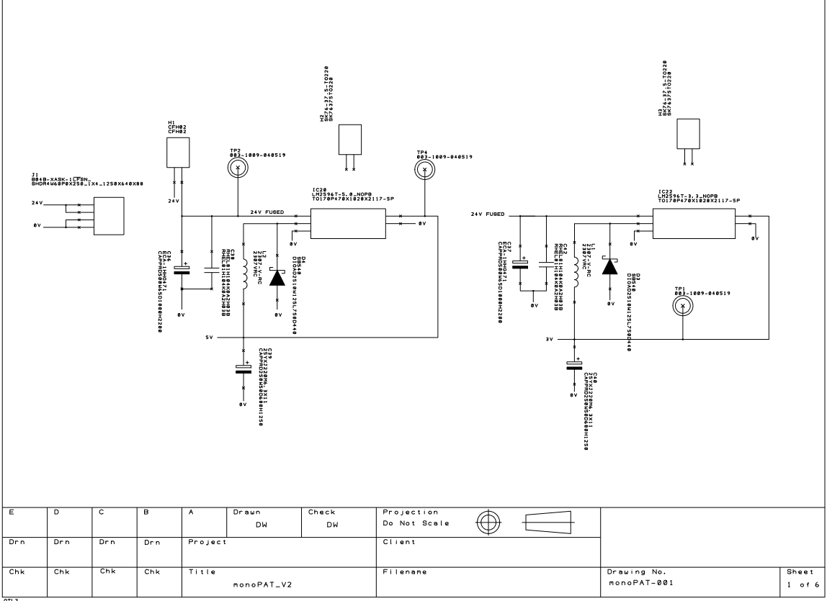
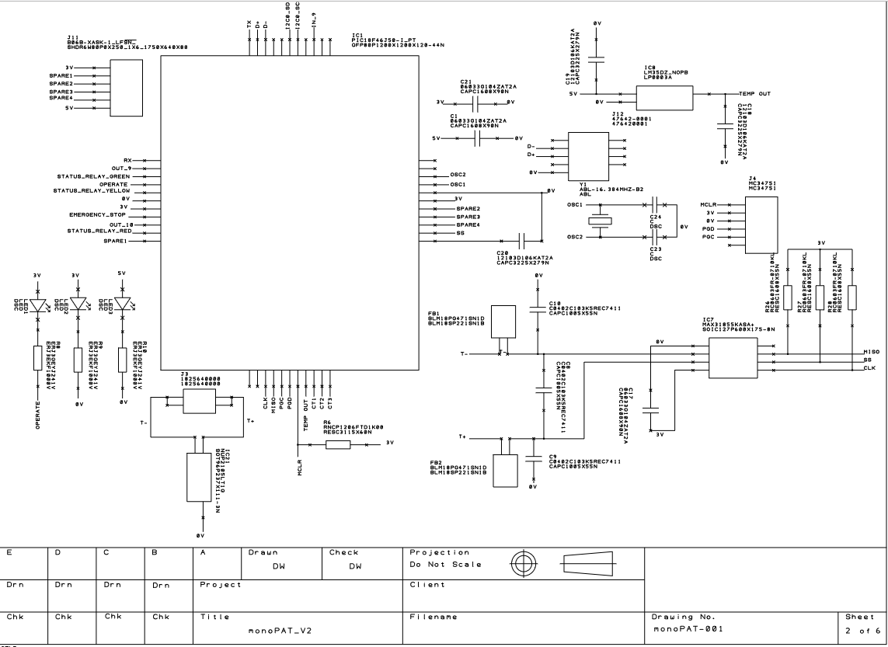
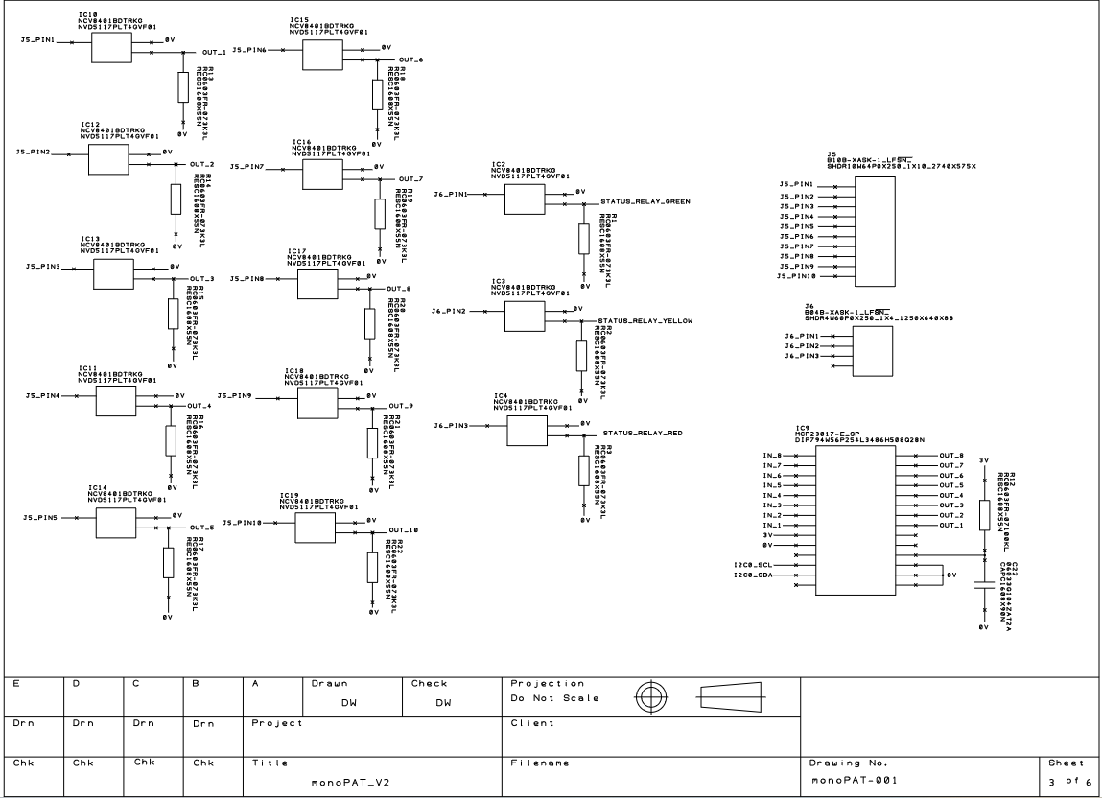
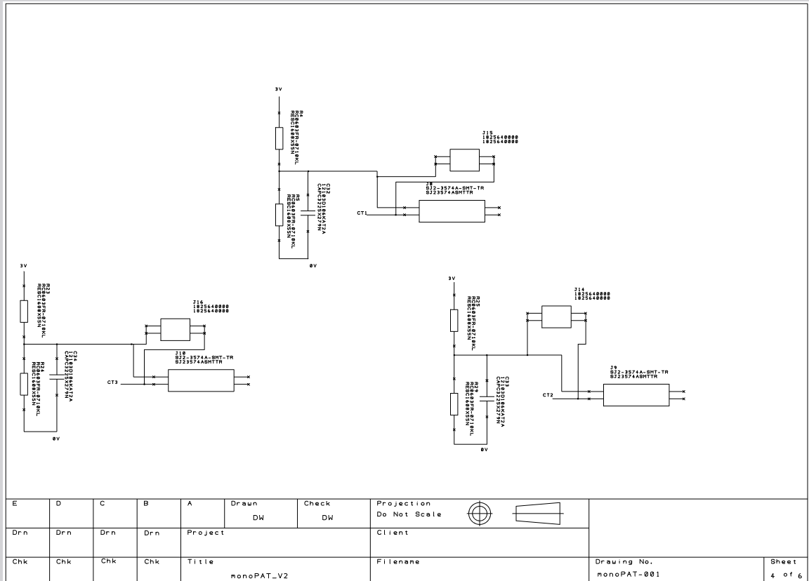
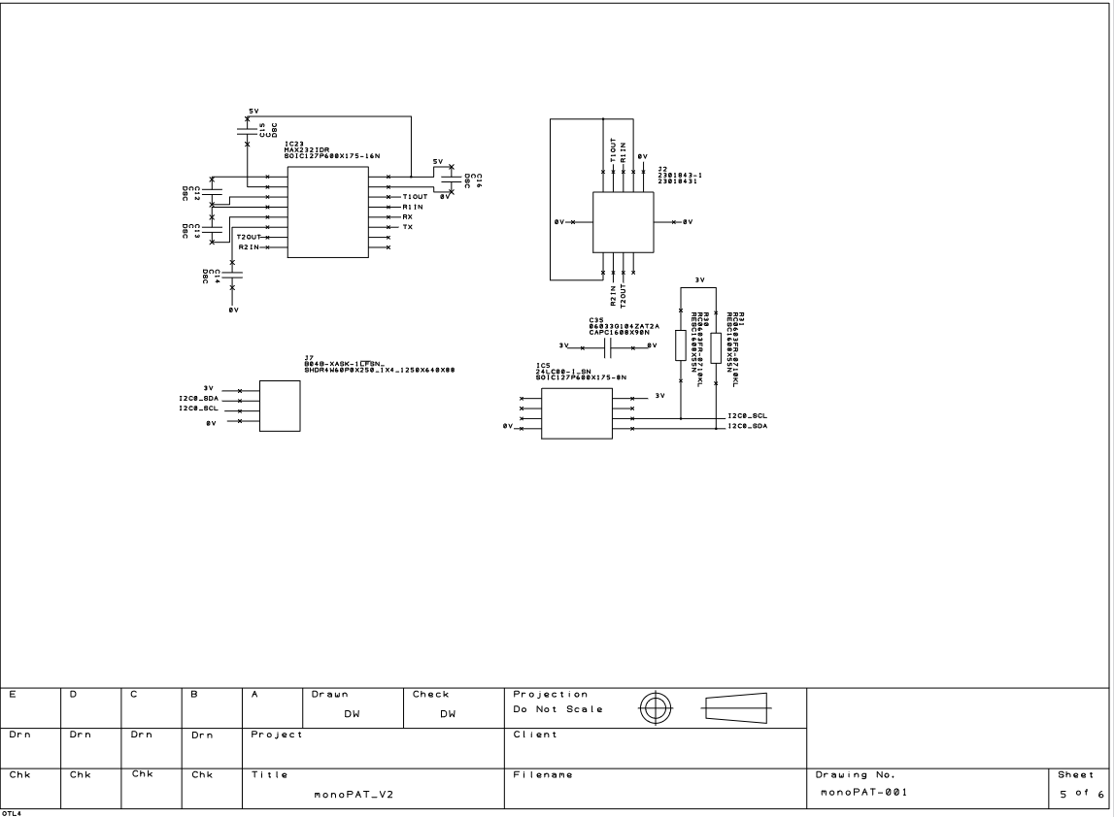
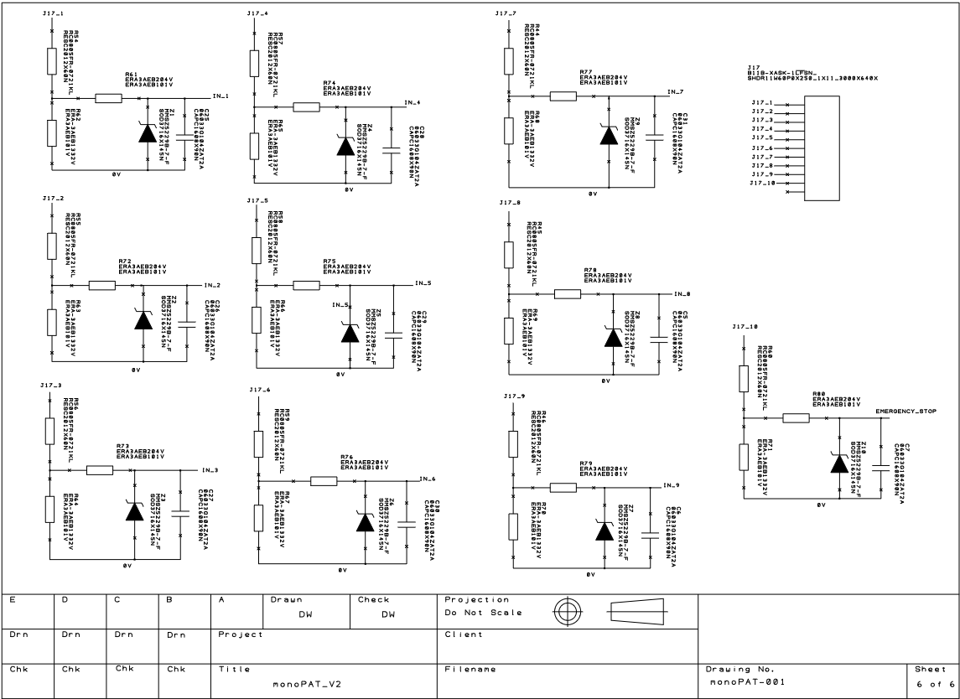

Code

10.2.1 Main.c
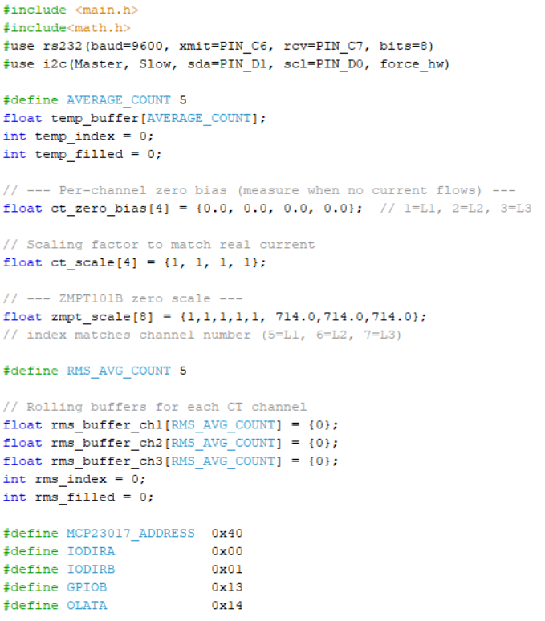
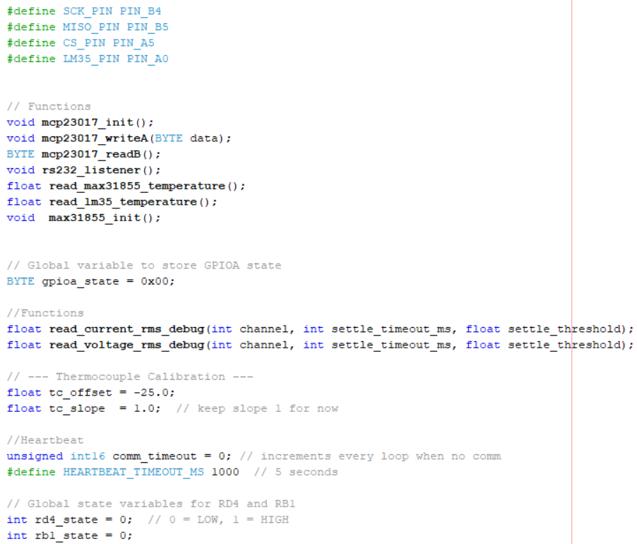
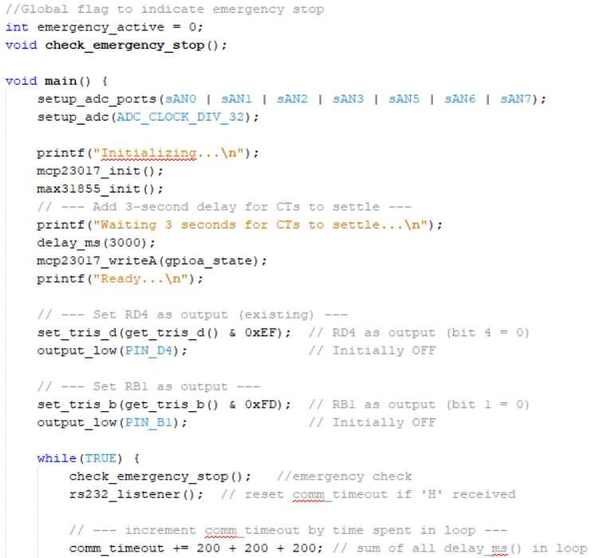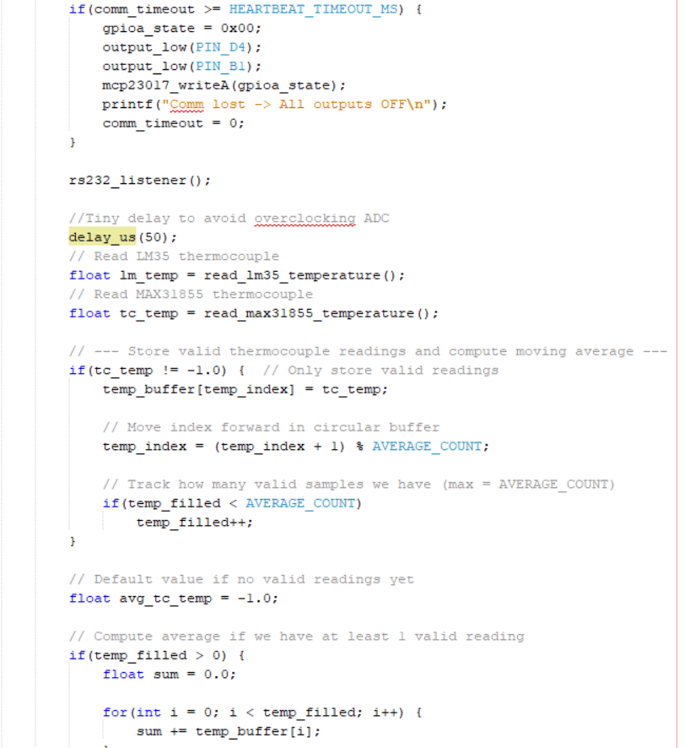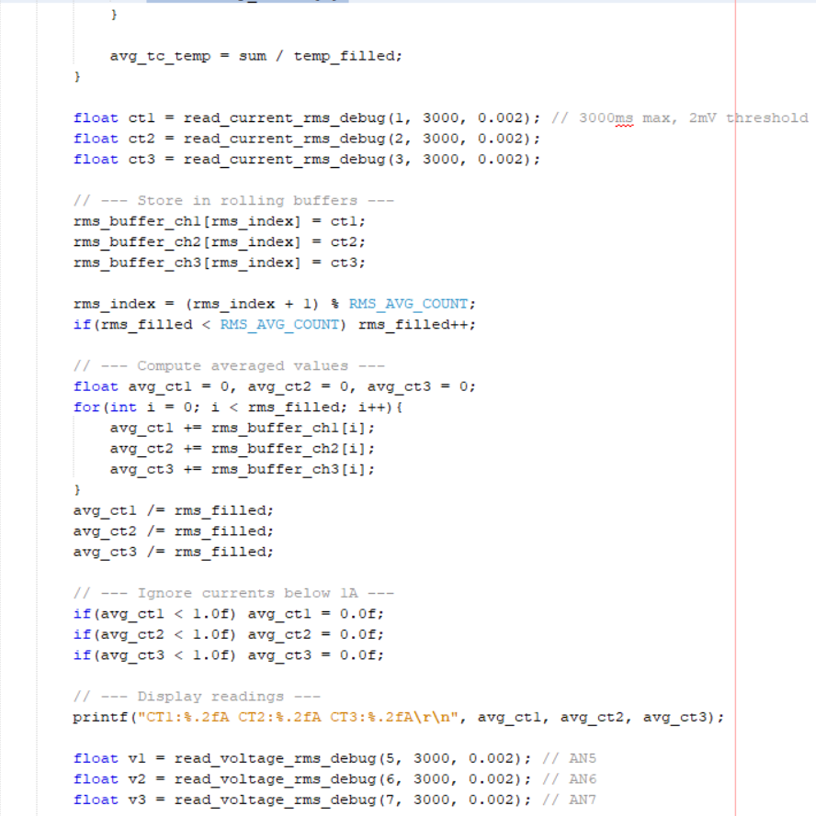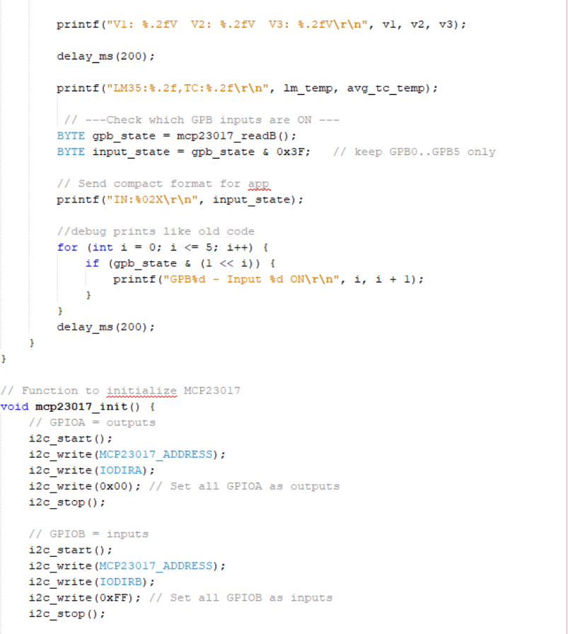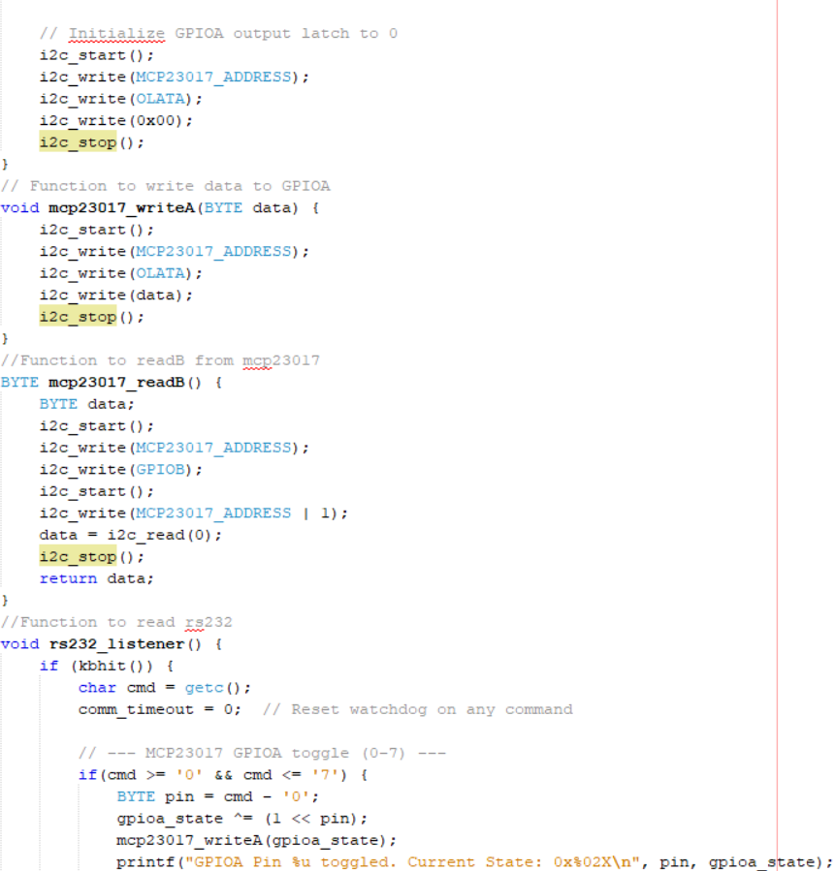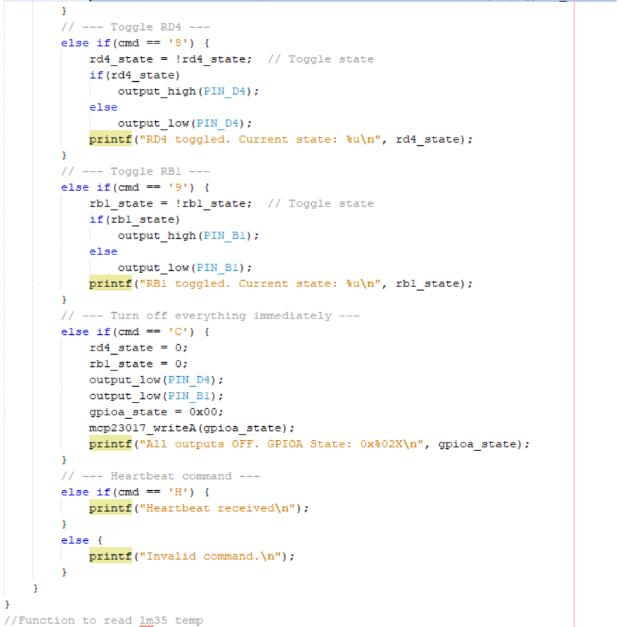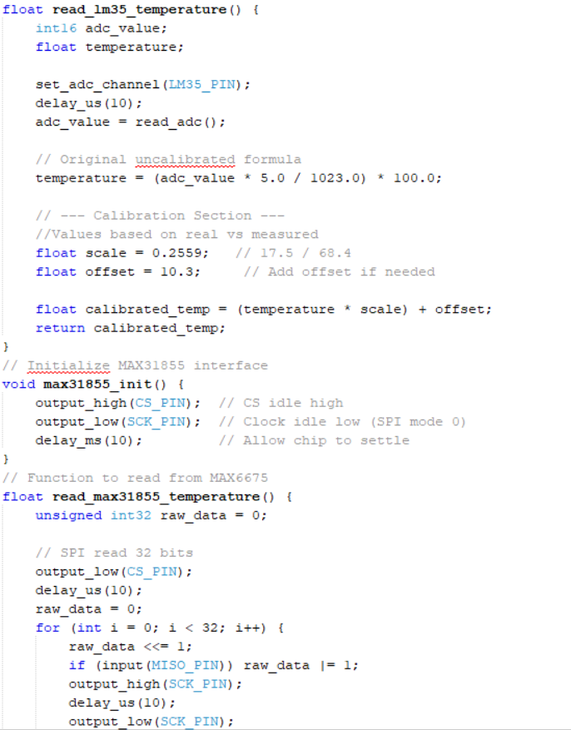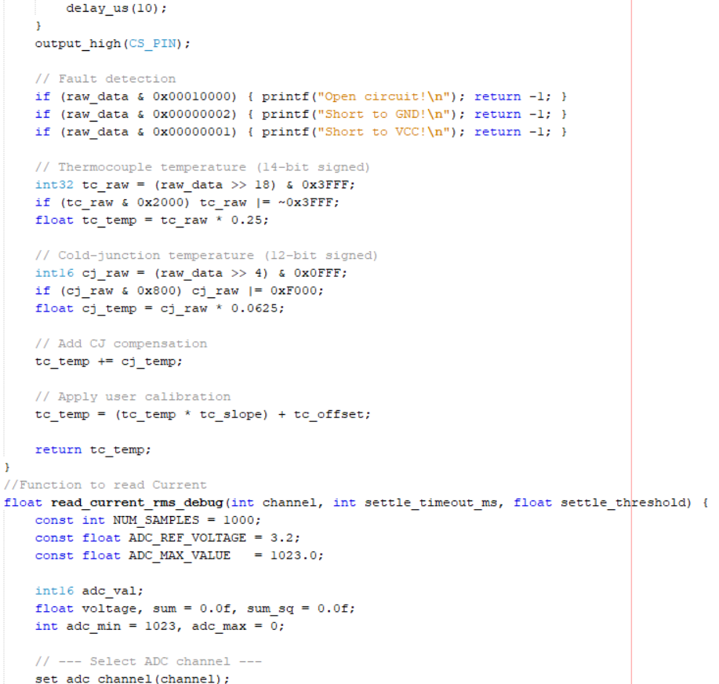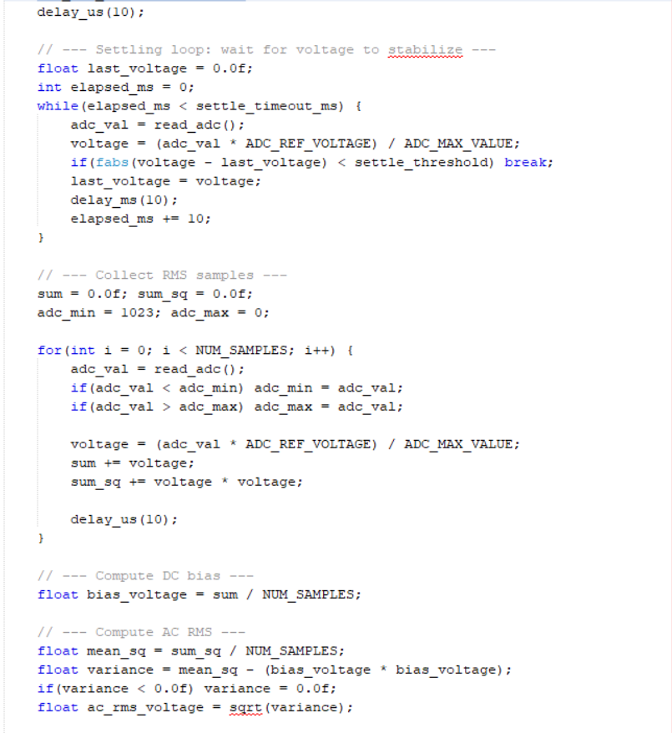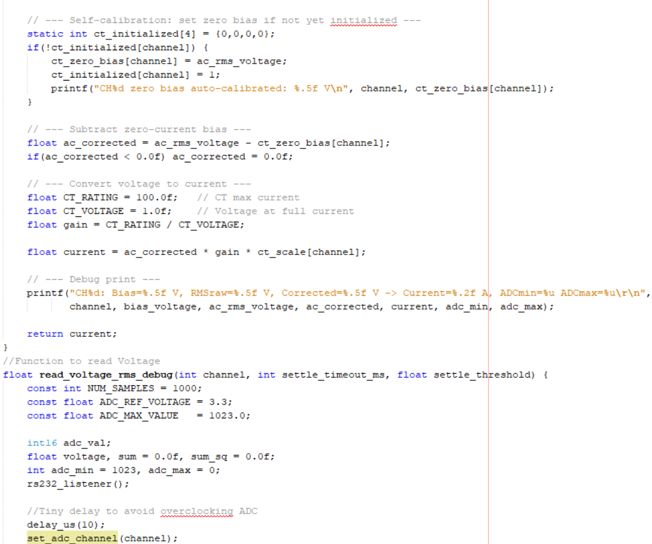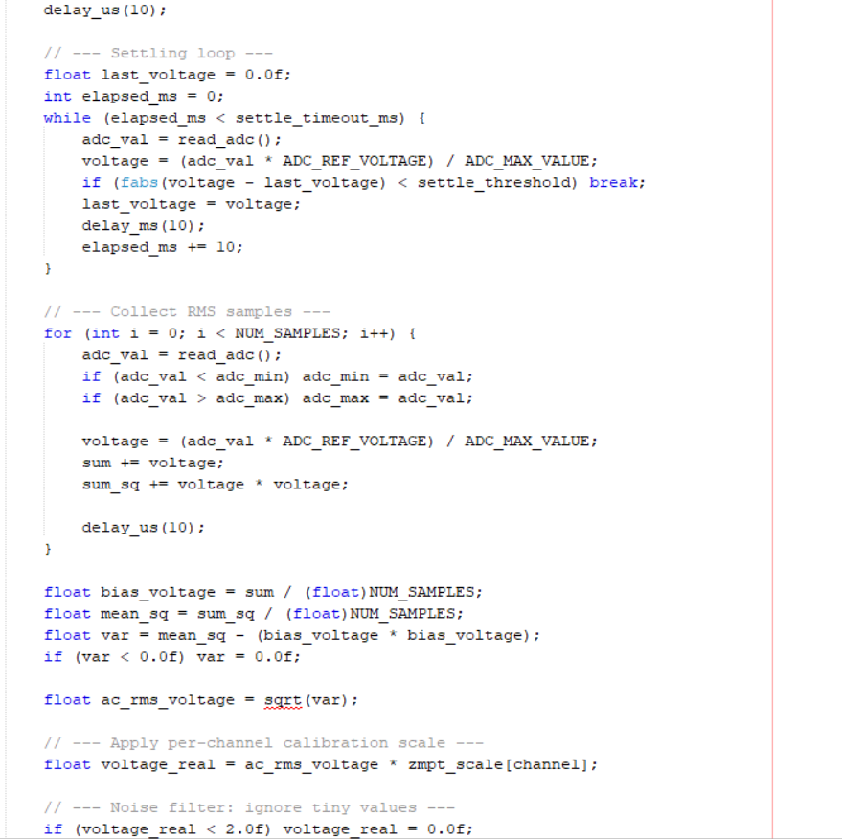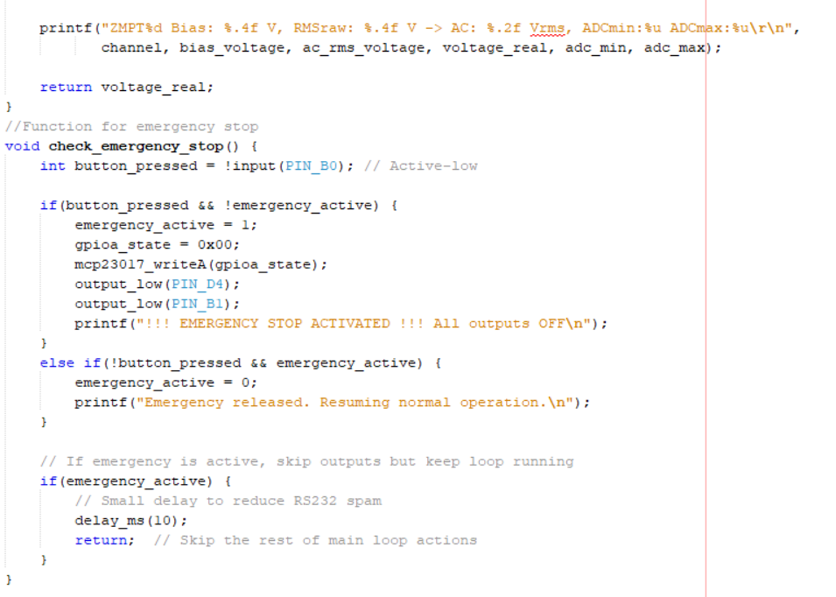

10.2.2 Main.h


