

SCHOOL OF HOSPITALITY & TOURISM MANAGEMENT
BA INTERNATIONAL HOTEL MANAGEMENT
MODULE HANDBOOK AUTUMN TERM 2024
BMIH5007
ASSESSMENT 1
FINANCIAL MANAGEMENT FOR THE HOTEL INDUSTRY
LEVEL 5
STUDENT NAME: ELENA CARAGICU
STUDENT ID: 2244881
I confirm that I have not used any AI tools in the research and the creation of this assignment. I confirm that I have not presented any AI generated materials as my own work. I confirm that I have copies of my drafts, notes, and other resources I used, which I may be asked to provide in evidence.

Table of Contents
2. Introduction 3
3. Total Revenue 3
4. Market Position 5
5. Growth Potential 6
Growth Potential of Shangri-La Hotels 6
Growth Potential of Premier Inn Hotels 7
6. Financial Commitment to CSR 7
8. Recommendation 9
9. Conclusion 10
References 11

2. Introduction
Hospitality is a vibrant industry very vital for the development of world economies. It provides accommodations, food and beverage, and entertainment. Agonizing competition, combined with sometimes fluctuating demand, makes financial management critical for supporting its operations, profitability, and long-run success. Effective financial strategies assist hospitality firms in managing incoming revenues, cost control, and resource allocation in order to secure strategic benefits in hospitality industries. This report draws a comparison between two prominent giants of the hospitality market, Shangri-La Hotels and Premier Inn Hotels (Premierinn, 2024). Shangri-La Hotels is one of the world's leading luxury brands owned by the Shangri-La Group, known more for upscale services and properties located mainly in Asia, the Middle East, and Europe (Shangri-la, 2024). Premier Inn, as part of Whitbread PLC, serves in the budget and mid-market hotel sectors and primarily caters to the United Kingdom but expands more globally over time. The report aims at doing an in-depth comparison of the financial management strategies that the two organizations exercise and involve four main themes total revenue, market position, growth potential, and commitment to corporate social responsibility as a part of their financial commitment. Through these themes, it will be able to analyze these differences to see how one company maintains financial performance better than the other while taking into account the hurdles of the hospitality industry.

3. Total Revenue
Shangri-La Hotels
Shangri-La Hotels, an operator in the luxury hospitality market, generates most of its revenues from room bookings, F&B services, events, and wellness-based activities. As most of its properties are located in key global cities, such premium travelers significantly drive revenue on this property. For the year 2023, Shangri-La announced consolidated revenues at USD 2.14 billion, up 46.5% year over year, underpinned by the strong recovery in global travel, in particular in Mainland China and Hong Kong (Sitecore-cd.Shangri-la, 2024). Here, RevPAR jumped an important 68% from USD 64 in 2022 to USD 108 in 2023, with Mainland China alone recording 105% recovery in RevPAR. Trends were also largely driven by the luxury travel boom after the pandemic and growth in corporate events and international tourism.
Diverse factors have an impact on the revenue performance at Shangri-La, which may be macroeconomic conditions of the world, demand for luxury service offerings, and market-specific tourism trends (Sitecore-cd.Shangri-la, 2024). Luxury hotels are usually more sensitive to the immediate changes in the economy, so the revenue streams of Shangri-La tend to be more volatile but offer an opportunity to create higher margins if the demand is strong.
Premier Inn Hotels
Premier Inn Hotels is Whitbread PLC's budget hotel division. Income generated is mainly in respect of room bookings and F&B revenue in integrated or nearby restaurants. Its business is aimed at providing decent accommodation at the lowest rates to people from the general public and corporate clients. In the financial year 2023/24, the Premier Inn business achieved revenues of £2.96 billion, which increased by 12% from that achieved in the previous financial year (Cdn.Whitbread, 2024). These positive results were enhanced by strong domestic demand in the UK and the growth of operations in Germany. Premiere Inn saw a 7% rise in RevPAR, with London and regions strongly outperforming.
Premier Inn's revenue growth would hinge on the trend of domestic travel, efficiency of operations, and positioning as a value brand (Cdn.Whitbread, 2024). On one hand, the chain experiences steady demand for budget accommodations, thereby making their revenue streams less volatile than that in the luxury market.
Comparison:
The Shangri-La and Premier Inn revenue models reflect the two companies' different market segments. Shangri-La, being a luxury brand, charges premium room rates but suffers much greater revenue volatilities tied directly to global economic shifts and international tourism trends (Shangri-la, 2024). On the other hand, Premier Inn positions itself as a budget brand more reliant on occupancy rates and stable demand from local markets to thereby deliver consistent but low-margin revenue growth. Shangri-La is very much a premium-driven business and an international-only operation. Premier Inn, by contrast, is driven on the emphasis of affordability and targeting a local market that makes a great deal of sense between the revenue strategy and the market strength (Premierinn, 2024).

4. Market Position
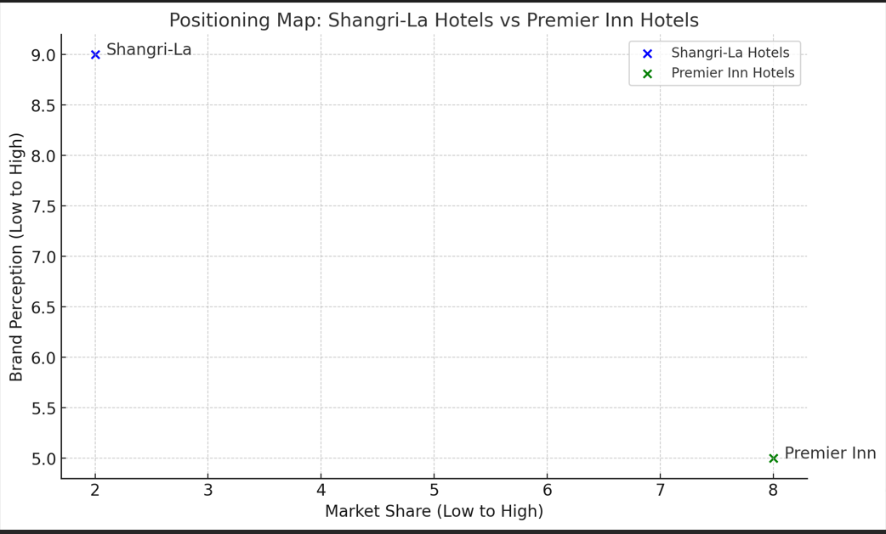
Figure 1: Positioning Map
(Source: Self-Created)
There are some glaring market positions of Shangri-La Hotels and Premier Inn Hotels, in terms of market share, customer demographics, and brand perception.
Shangri-La Hotels
Shangri-La Hotels is a luxury hotel brand that caters to high-end customers searching for high-end experiences. In fact, it offers luxurious services like fine dining, luxury accommodations, and state-of-the-art wellness (Vijayakumar et al. 2020). Its smaller market share implies niche positioning in the luxury segment, targeting a more selective group of customers. Despite this, Shangri-La enjoys a very positive brand perception from the fact that it promises quality of paramount quality, service customized for an individual's needs, and unique experiences. Such an appreciation position puts the company far above the rest in terms of competition in luxury hotel markets in regions such as Asia, and major global cities (Wall, 2022). Its target customers are mostly high-net-worth individuals, business travelers, and tourists who set luxury above cost.
The Premier Inn Hotels
The Premier Inn Hotels is in the budget to mid-price category. It appeals to the domestic travelers and families along with business customers in search of the accommodation's affordability along with consistencies (Butters and Hubbard, 2023). Premier Inn is cheaper since it caters for a higher level of the market and has its presence within the UK and expanding into Europe, thus reaching hundreds of thousands of potential customers. On the other hand, it is a modest brand perception in comparison with luxury brands such as Shangri-La because Premier Inn actually takes pride in value for money than with luxury services (Glasgow and Mayer, 2023). The reputation of Premier Inn is based on value for money, comfort, and convenience, which are highly sought after by budget travelers in travel markets. In summary, Shangri-La enjoys elite brand perception, while Premier Inn benefits from having a larger market share with broad customer capabilities. Both are highly successful within their specific market segment.

5. Growth Potential

Growth Potential of Shangri-La Hotels
Shangri-La Hotels' growth potential is therefore well associated with the expansion across the high-demand markets for luxury and the strong brand in the emerging regions. The expansion strategy will enable the company to sustain its presence in the major cities globally and the tourist destinations of luxury, mainly throughout Asia, Europe, and the Middle East (Wippel, 2023). As the global luxury travel market continues to emerge from the tail end of the pandemic, Shangri-La stands to have a great deal of opportunities in the premium segment due to such strong interest in upper-scale accommodations, wellness offerings, and corporate events. With the company's opportunities to tap emerging luxury markets, such as China's growing affluent middle class, and its potential to strengthen its presence in the Western luxury markets with focused expansion and partnerships, this company can maximize its long-term growth potential by developing new properties in underrepresented regions and investing in high-end services, such as wellness tourism (Caruso, 2023).
However, the further growth of Shangri-La comes with certain challenges. The first challenge is in the form of global economic uncertainty, which would negatively affect demand for luxury travel. Shangri-La also has its share of vulnerability to the international tourism trend change, geopolitical risks, and increased competition in the luxury hospitality industry (Hampton et al. 2024). Innovation will be the key to surpassing these challenges: innovation in making its products and offerings distinctive but controlling costs and the symbolic selective image of a brand.

Growth Potential of Premier Inn Hotels
Premier Inn Hotels is a brand with tremendous growth as it has maintained a robust expansion strategy in domestic as well as international markets. The company dominates the UK's budget hotel sector and expands vigorously into overseas markets, specifically in Germany, through its target to "build replica success in Germany” (Silverwood and Berry, 2023). With a pipeline of further properties in Germany and over 59 hotels already open for business, Premier Inn is strategically poised for steady growth in this large market. This strategy will only make it possible for Premier Inn to spread its multiple sources of revenue and reduce its dependence on the UK market. The brand also has the potential to further expand its footprint in Europe and internationally as demand for affordable, reliable accommodation there grows (Buhalis et al. 2023). Premier Inn's commitment to delivering a consistent guest experience at competitive price gives it a good foothold to attract business and leisure travelers in these regions.
Economic fluctuations could be another limiting factor. Also, the discretionary travel, especially in the budget sector; and with this, more competition that is arising about budget chains of hotels and also alternative accommodation providers like Airbnb (Amicucci, 2024). Further, Premier Inn should also handle costs very well while increasing its presence in regions; operational efficiency needs to remain at this level. With this balance between expansion and excellence in operations, Premier Inn has excellent growth prospects for the future.

6. Financial Commitment to CSR

1. Economic Responsibility
Two of them focus on profitability. Shangri-La reported a consolidated revenue of USD 2.14 billion for 2023, increasing by 46.5% from the previous year, driven by its focus on sustainability for luxury (Sitecore-cd.Shangri-la, 2024)​. In this regard, it is clear that Shangri-La believes that sustainability will be the source of generating profits in the long term because, at the end of the day, responsible luxury brings in luxury consumers. Premier Inn, owned by Whitbread PLC, ended 2023/24 with £2.96 billion revenue following 12% growth-the main reason being its sustainable business practice, including improved efficiency in energy consumption as well as minimizing waste​ (Premierinn, 2024).
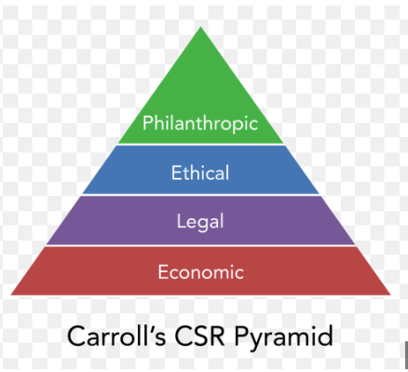
Figure 2: Carroll’s CSR Pyramid
(Source: Inspired by Kusyk, 2021)

2. Legal Responsibility
Both companies have complied with the legal requirements that govern issues on environmental and sustainability policies. Shangri-La has honored international environmental norms; in which efforts it has invested significantly in energy and water conservations in all its operation locations​ (Emmanuel et al. 2024). Premier Inn has also been firm in its commitment to adhering to the law, for example its commitment to achieving net-zero carbon emissions by 2040, demonstrating the company's commitment to advancing legal expectations on environmental performance (Breznik et al. 2021)​.

3. Ethical Responsibility
Shangri-La promotes ethical practices through its "Stay, Savor, and Shine" program: embedding sustainability in its practice at all levels (Zhang, 2020). The company would reduce carbon footprints and preserve ecosystems and go beyond legal requirements to act in a manner that is regarded as ethical​. Premier Inn touches the heart through attention to quality and responsible sourcing in procurement, based on reduction of plastic use and disposal (Gursoy et al. 2022). The company claims to have reduced food waste to 50 percent by 2025 and all its packaging to be recyclable, reusable, or compostable.

4. Philanthropic Responsibility
Shangri-La engages in corporate social responsibility through disaster relief and community projects. During 2023, the company donated to the regions of Turkey that were experiencing earthquakes and invested in the community welfare of the local region through a series of actions​ (Ahmed et al. 2023). Premier Inn possesses a strong sense of philanthropy as it has demonstrated a long-term partnership with Great Ormond Street Hospital, raising over £24 million for the healthcare of children​.

8. Recommendation
Diversify the revenue streams for Shangri-La Hotels by penetrating deeper into the wellness tourism market. Given the growing demand for wellness-oriented travel, Shangri-La will be able to maximize its luxury brand to offer integrated wellness services by offering specialized retreats and long-term wellness programs (Kozhukhіvska et al. 2022). This will be not only indicative of increased customer loyalty but also a way to tap into a rapidly growing luxury niche market. Shangri-La's existing wellness services can be scaled up to create a unique offering that leverages off the emerging global wellness industry, both generating revenue and differentiating the brand. Premier Inn needs to be nudged to increase its international presence, with Europe outside Germany being a priority region to expand in.
Given the comfort of success at home in the UK and early successes in Germany, further penetration of its market into other European markets could be a major revenue booster. The company should also have a keen emphasis on digital customer experience to book more through its direct website and its app instead of third parties (Mosa, 2022). That would increase profitability while reducing acquisition costs and gain more users savvy in technology.

9. Conclusion
Both Shangri-La and Premier Inn have shown considerable financial control and growth potential, but the strategies need to change taking into account the changes in dynamics of their respective markets. Shangri-La can capitalize on luxury travel growth trends by entering the wellness tourism market, while Premier Inn's international expansion and its move towards all things digital will make it very competitive in the budget market. Every recommendation follows the growth opportunities available from analysis with the strengths.

References
Ahmed, S.K., Chandran, D., Hussein, S., Sv, P., Chakraborty, S., Islam, M.R. and Dhama, K., (2023). Environmental health risks after the 2023 Turkey-Syria earthquake and salient mitigating strategies: a critical appraisal. Environmental Health Insights, 17, p.11786302231200865.
Amicucci, P. A. (2024). Evaluation and improvement of sustainable supply chains in the travel and tourism industry.
Breznik, K., Law, K. and Gorenak, M., (2021). Hotel branding exposed: a content analysis of related organisational values. Organizacija, 54(3), pp.180-191.
Buhalis, D., O’Connor, P. and Leung, R., (2023). Smart hospitality: from smart cities and smart tourism towards agile business ecosystems in networked destinations. International Journal of Contemporary Hospitality Management, 35(1), pp.369-393.
Butters, R.A. and Hubbard, T.N., (2023). Industry Structure, Segmentation, and Quality Competition in the US Hotel Industry. The Journal of Industrial Economics, 71(2), pp.491-537.
Caruso, L., (2023). Toward regenerative hospitality business models: the case of “Hortel”. Tourism and Hospitality, 4(4), pp.618-641.
Cdn.Whitbread, (2024), Whitebread PLC, Available at: https://cdn.whitbread.co.uk/media/2024/05/Whitbread-PLC-Annual-Report-and-Accounts-2023_Single_pages-1.pdf [Accessed on: 16th October, 2024]
Emmanuel, A.U., Hilda, O.O. and Adenubi, A., (2024). The Application of Eco-Aesthetic Principles into the Design Proposal of Hotels.
Glasgow, G. and Mayer, K., (2023). Disneyland on the Mountain: Walt, the Environmentalists, and the Ski Resort that Never was. Rowman & Littlefield
Gursoy, D., Buttle, F. and Bowie, D., (2022). Hospitality marketing: Principles and practices. Routledge
Hampton, M.P., Bianchi, R. and Jeyacheya, J., (2024). Dynamics of coastal tourism: drivers of spatial change in South‐East Asia. Singapore Journal of Tropical Geography, 45(1), pp.54-69.
Kozhukhіvska, R., Sakovska, О., Maslovata, S., Dluhoborskа, L. and Chuchmii, I., (2022), June. Managing innovation in tourism and hospitality industry: International experience. In AIP Conference Proceedings (Vol. 2413, No. 1). AIP Publishing.
Kusyk, S., (2021). Carroll’s CSR pyramid: An empirical investigation of SME CSR orientation. Journal of Leadership, Accountability and Ethics, 18(4).
Mosa, R.A., (2022). The Influence of E-Customer Relationship Management on Customer Experience in E-Banking Service. International Journal of Academic Research in Business and Social Sciences, 12(2), pp.193-215.
Premierinn, (2024), About Premierinn, Available at: https://www.premierinn.com/gb/en/home.html [Accessed on: 16th October, 2024]
Shangri-la, (2024), About Shangri-la, Available at: https://www.shangri-la.com/[Accessed on: 16th October, 2024]
Silverwood, J. and Berry, C., (2023). The distinctiveness of state capitalism in Britain: Market-making, industrial policy and economic space. Environment and Planning A: Economy and Space, 55(1), pp.122-142.
Sitecore-cd.Shangri-la, (2024), Project Shangri La Group, Available at: https://sitecore-cd.shangri-la.com/-/media/Project/Shangri-La-Group/Investor/Files/Public-Disclosures/Latest-Top-Publications/2023_Annual_Report_E.pdf [Accessed on: 16th October, 2024]
Vijayakumar, S., Nisthar, S. and Nufile, A.A.M., (2020). Tourism economics in sri lanka: a historic perspective.
Wall, W.P., (2022). Global competitiveness. Springer Singapore.
Wippel, S., (2023). Branding the Middle East: a review of regional manifestations of a global phenomenon. Branding the Middle East: Communication Strategies and Image Building from Qom to Casablanca, 38, p.55.
Zhang, Y., (2020). How did the Lost Shangri-La get lost? The tragedy of the groundwater commons in Lijiang, China. Water, 12(11), p.3131.

